**Experiment: Advanced Computation for Energy Engineering**

# Name: Abisoye Akinloye

Table of Contents

Name: Abisoye Akinloye 1

Particle Swarm Optimization (PSO) 1

Rastrigin Function 1

PSO Algorithm 2

General steps 2

Equations 2

Flowchart of PSO 4

Code Implementation 4

User defined parameters 4

PSO hyperparameters 5

Motion Visualization 6

Initialize Swarm 6

Create Figure Template 7

Main PSO Loop 7

Final Result 11

PSO Simulation Video 12

Source Code 12

# Particle Swarm Optimization (PSO)

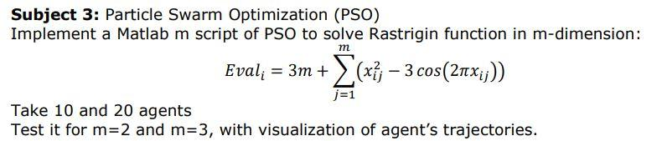

# Rastrigin Function

Create a m script for the rastrigin function

function val = rastrigin(x)

% the parameter x is the current position which is an array

% dimentionality (m)

m = length(x);

% rastrigin function Eval = 3m + summation(x^2 - 3cos(2*pi*x)

sum = 0;

% find the summation by looping through

for i = 1 : m

sum = sum + (x(i).^2 - 3*cos(2*pi*x(i)));

end

% fitness value of the rastrigin function

val = 3*m + sum;

end

**For a Rastrigin function:**

* The Rastrigin function has several local minima.
* It is highly multimodal, but locations of the minima are regularly distributed.
* The function is usually evaluated on the hypercube , for all 

**Reference:** <https://www.sfu.ca/~ssurjano/rastr.html>

# PSO Algorithm

## General steps

1. Initialize the algorithm parameter (). Algorithm parameter to be explained later
2. Initialize the population (swarm of particles) with random position  and velocity  (v can be otherwise initialized as zero)
3. Evaluate the fitness  of each particle using the fitness function
4. Update the particle's pbest and gbest using equation (a) and (b), respectively.
5. Generate random numbers 
6. Update the velocity of each particle using equation (c) as shown below
7. Update the position of each particle using equation (d) as shown below
8. Loop through **step 3 to 7** until a stopping criteria is met. Stopping criteria can be a user-defined number of iterations.

## Equations

*  is the personal best position of  particle in  generation. Assume minimization problem

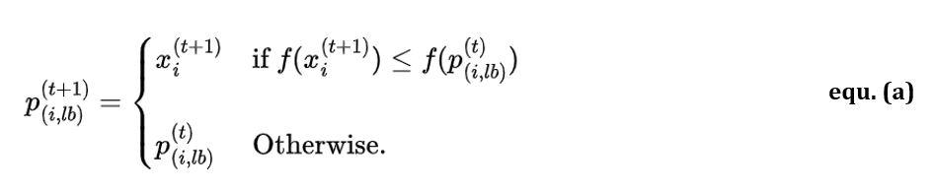

*  is the global best position in  generation. It is the minimum fitness which is calculated as:

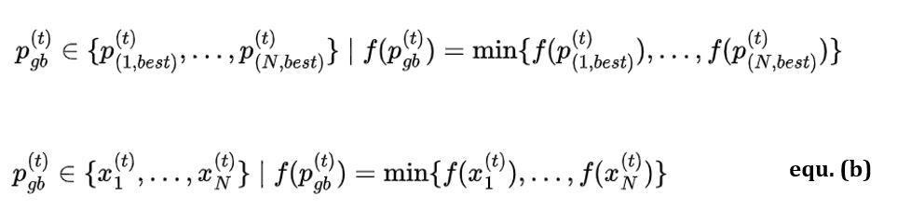

* Velocity and position update

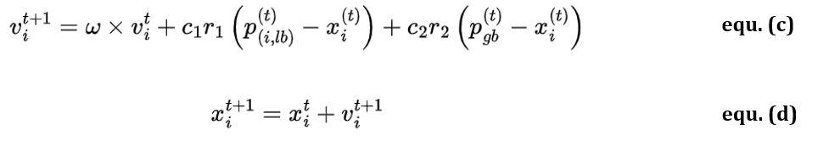

Where

* N is the number of particles in the swarm
*  is local (personal) best,  is the global best
*  is the number of iteration
* ω is the inertia weight
*  are the acceleration coefficients
*  are random numbers between 0 and 1 and are generated in each iteration for each dimension, and not for each particle.
* pbest is the best position achieved by the particle.
* gbest is the best position achieved by the whole swarm.
* T is the number of iteration

## Flowchart of PSO

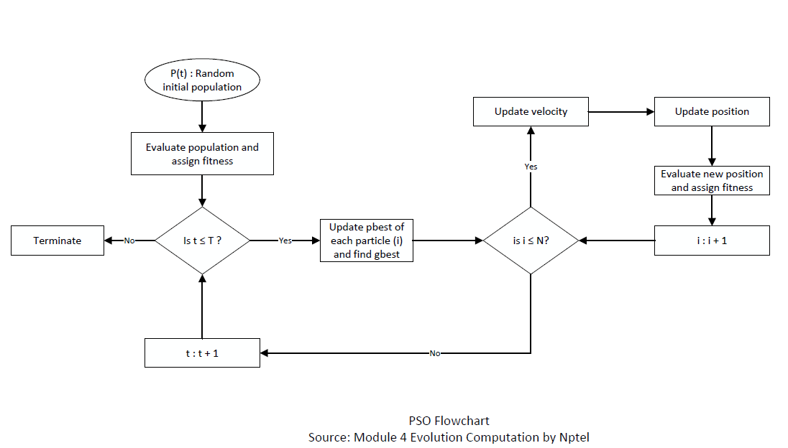

**Bibliography:**

* <https://www.udemy.com/course/bio-inspired-artificial-intelligence-algorithms-for-optimization>
* <https://www.oreilly.com/library/view/optimization-algorithms/9781633438835/>
* <https://drive.google.com/file/d/146EpYC6qX5Rk-GEGD6oRtH5TD8t9SmJK/view>
* <https://archive.nptel.ac.in/courses/112/103/112103301/>
* <https://www.researchgate.net/publication/379603938_Particle_Swarm_and_Genetic_Algorithms_applied_to_the_identification_of_Induction_Machine_Parameters>

# Code Implementation

### User defined parameters

%% User defined parameters

m = 2; % dimensionality (search space) for m = 2 or m = 3

n_particles = 10; % numbers of particles (agents) set for 10 or 20

max_iter = 100; % maximum iteration which is the stopping criteria

fprintf("User parameter for simulation defined!")

User parameter for simulation defined!

### PSO hyperparameters

%% PSO hyperperameters

w = 0.7; % inertia weight

c1 = 1.4; % cognitive (personal) coefficient

c2 = 1.2; % social coefficient

% for rastrigin problems, the search space boundaries is

% commonly [-5.12 5.12]

min_x = -5.12; % minimum search space boundary

max_x = 5.12; % maximum search space boundary

fprintf("PSO hyperparameter for simulation defined!")

PSO hyperparameter for simulation defined!

* **Inertia component (****):** The first part of the velocity update equation represents the influence of a particle’s inertia, taking into account that a particle (like a fish in a school or a bird in a flock) cannot abruptly change its direction. Large values of ω encourage **exploration**, while small values promote **exploitation**, allowing the cognitive and social components to exert greater control. A widely adopted value for **ω is 0.792.**
* **Cognitive component:** The second part of the equation (c), referred to as the cognitive component, represents the particle’s attraction toward its personal best position, or individual proximity (i-proximity). The cognitive component encourages particles to explore the areas around their personal best positions, allowing them to fine-tune their search in promising regions. Setting c1 to 0 reduces the PSO algorithm to a social-only or selfless PSO model. Hence, particles are solely attracted to the group best and ignore their personal bests. This leads to an emphasis on global exploration based on the swarm’s collective knowledge.
* **Social component:** The third part of the velocity update equation is the social component, which represents the particle’s attraction to the swarm’s collective knowledge or group proximity (g-proximity). The social component fosters collaboration among particles, helping them converge toward an optimal solution more effectively. Setting c2 to 0 results in a cognition-only model, where particles act as independent hill climbers, relying only on their personal bests.
* **Note:** In many applications, c1 and c2 are set to **1.49.** Although there is no theoretical justification for this specific value, it has been empirically found to work well in various optimization problems. Generally, the **sum of c1 and c2 should be less than or equal to 4** to maintain the algorithm’s stability and convergence properties.

### Motion Visualization

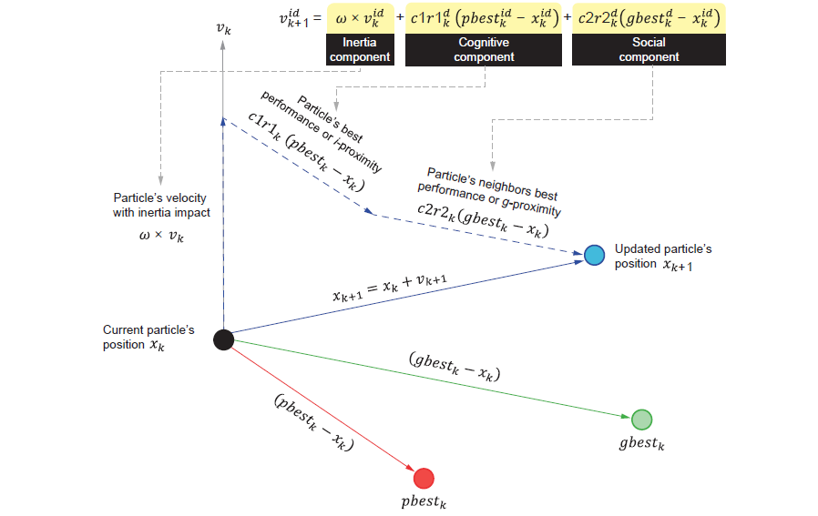

### Initialize Swarm

%% Initialize the Swarm

% initialize the position with random value with [min_x max_x]

x = min_x + (max_x - min_x) .* rand(n_particles, m);

% initialize the velocity to zero

v = zeros(n_particles, m);

% initialize the fitness funtion

fitness = zeros(n_particles, 1);

for i = 1 : length(x)

fitness(i) = rastrigin(x(i,:));

end

% personal best

p_best_pose = x; % personal best position

p_best_val = fitness; % personal best value

% global best

% the global best value is the minimum fitnes

[gbest_val, gbest_idx] = min(fitness); % find the index of the minimum fitness

% the index of minimum fitness is the global best position

gbest_pose = x(gbest_idx,:); % global best position

fprintf("Swarm initialization done!")

Swarm initialization done!

### Create Figure Template

* **Mesh grid:** <https://www.mathworks.com/help/matlab/ref/meshgrid.html>
* **Linspace:** <https://www.mathworks.com/help/matlab/ref/double.linspace.html>

%% Figure template

if m == 2

figure('Name','PSO Rastrigin 2D','NumberTitle','off');

elseif m == 3

figure('Name','PSO Rastrigin 3D','NumberTitle','off');

end

% figure template for precomputing grid for countor and surf

[X, Y] = meshgrid(linspace(min_x, max_x, 100), linspace(min_x, max_x, 100));

Z = zeros(size(X));

for i = 1:size(X,1)

for j = 1:size(X,2)

Z(i,j) = rastrigin([X(i,j), Y(i,j)]);

end

end

fprintf("Figure template for the plot created!")

Figure template for the plot created!

### Main PSO Loop

for iter = 1 : max_iter

% update velocities and positions of the particles (agents)

for i = 1 : n_particles

% random coefficients for behavior ranging from 0 - 1

r1 = rand(); r2 = rand();

% velocity update

v(i,:) = w*v(i,:) + c1*r1*(p_best_pose(i,:) - x(i,:)) + c2*r2*(gbest_pose - x(i,:));

% update the position

x(i,:) = x(i,:) + v(i,:);

% boundary conditions to make sure position isn't

% beyound [min_x max_x] limit

for d = 1:2

if x(i, d) > max_x

x(i, d) = max_x;

elseif x(i, d) < min_x

x(i, d) = min_x;

end

end

end

% evaluate fitness after updating positions

for i = 1 : n_particles

fitness(i) = rastrigin(x(i,:));

% update personal best

if fitness(i) < p_best_val(i)

p_best_val(i) = fitness(i);

p_best_pose(i,:) = x(i,:);

end

end

% update global best

[current_best, current_best_idx] = min(p_best_val);

if current_best < gbest_val

gbest_val = current_best;

gbest_pose = p_best_pose(current_best_idx, :);

end

% display iteration info

fprintf('Iteration %d \t| Global Best Value = %f\n', iter, gbest_val);

% plot the graph

if m == 2

clf;

contourf(X,Y,Z,80, 'LineColor', 'none'); hold on;

plot(p_best_pose(:,1), p_best_pose(:,2), 'ro', 'MarkerFaceColor','r');

plot(gbest_pose(:,1), gbest_pose(:,2), 'ro', 'MarkerFaceColor','g');

title(['Iteration ' num2str(iter)]);

xlabel('x_1'); ylabel('x_2');

axis([min_x max_x min_x max_x]);

drawnow; % for the plot animation

elseif (m == 3)

clf; % clear figure

surf(X, Y, Z, 'EdgeColor','none');

colormap('jet');

hold on;

view(45, 45); % view angle

% evaluate Rastrigin at each particle to show their 'height'

zPos = arrayfun(@(row) rastrigin(p_best_pose(row,:)), 1:size(p_best_pose,1));

scatter3(p_best_pose(:,1), p_best_pose(:,2), zPos, 40, 'r', 'filled');

title(['Iteration ' num2str(iter)]);

xlabel('x_1'); ylabel('x_2'); zlabel('Function Value');

drawnow; % plot animation

end

end

Iteration 1 | Global Best Value = 5.159142

Iteration 2 | Global Best Value = 2.398222

Iteration 3 | Global Best Value = 1.204072

Iteration 4 | Global Best Value = 1.204072

Iteration 5 | Global Best Value = 1.204072

Iteration 6 | Global Best Value = 1.204072

Iteration 7 | Global Best Value = 1.204072

Iteration 8 | Global Best Value = 1.204072

Iteration 9 | Global Best Value = 1.204072

Iteration 10 | Global Best Value = 1.204072

Iteration 11 | Global Best Value = 1.204072

Iteration 12 | Global Best Value = 0.201617

Iteration 13 | Global Best Value = 0.201617

Iteration 14 | Global Best Value = 0.201617

Iteration 15 | Global Best Value = 0.014447

Iteration 16 | Global Best Value = 0.014447

Iteration 17 | Global Best Value = 0.014447

Iteration 18 | Global Best Value = 0.014447

Iteration 19 | Global Best Value = 0.014447

Iteration 20 | Global Best Value = 0.014447

Iteration 21 | Global Best Value = 0.014447

Iteration 22 | Global Best Value = 0.014447

Iteration 23 | Global Best Value = 0.011929

Iteration 24 | Global Best Value = 0.011929

Iteration 25 | Global Best Value = 0.006460

Iteration 26 | Global Best Value = 0.006460

Iteration 27 | Global Best Value = 0.006460

Iteration 28 | Global Best Value = 0.006460

Iteration 29 | Global Best Value = 0.000836

Iteration 30 | Global Best Value = 0.000836

Iteration 31 | Global Best Value = 0.000836

Iteration 32 | Global Best Value = 0.000836

Iteration 33 | Global Best Value = 0.000836

Iteration 34 | Global Best Value = 0.000371

Iteration 35 | Global Best Value = 0.000371

Iteration 36 | Global Best Value = 0.000357

Iteration 37 | Global Best Value = 0.000357

Iteration 38 | Global Best Value = 0.000357

Iteration 39 | Global Best Value = 0.000357

Iteration 40 | Global Best Value = 0.000313

Iteration 41 | Global Best Value = 0.000313

Iteration 42 | Global Best Value = 0.000313

Iteration 43 | Global Best Value = 0.000313

Iteration 44 | Global Best Value = 0.000040

Iteration 45 | Global Best Value = 0.000040

Iteration 46 | Global Best Value = 0.000040

Iteration 47 | Global Best Value = 0.000040

Iteration 48 | Global Best Value = 0.000040

Iteration 49 | Global Best Value = 0.000005

Iteration 50 | Global Best Value = 0.000005

Iteration 51 | Global Best Value = 0.000000

Iteration 52 | Global Best Value = 0.000000

Iteration 53 | Global Best Value = 0.000000

Iteration 54 | Global Best Value = 0.000000

Iteration 55 | Global Best Value = 0.000000

Iteration 56 | Global Best Value = 0.000000

Iteration 57 | Global Best Value = 0.000000

Iteration 58 | Global Best Value = 0.000000

Iteration 59 | Global Best Value = 0.000000

Iteration 60 | Global Best Value = 0.000000

Iteration 61 | Global Best Value = 0.000000

Iteration 62 | Global Best Value = 0.000000

Iteration 63 | Global Best Value = 0.000000

Iteration 64 | Global Best Value = 0.000000

Iteration 65 | Global Best Value = 0.000000

Iteration 66 | Global Best Value = 0.000000

Iteration 67 | Global Best Value = 0.000000

Iteration 68 | Global Best Value = 0.000000

Iteration 69 | Global Best Value = 0.000000

Iteration 70 | Global Best Value = 0.000000

Iteration 71 | Global Best Value = 0.000000

Iteration 72 | Global Best Value = 0.000000

Iteration 73 | Global Best Value = 0.000000

Iteration 74 | Global Best Value = 0.000000

Iteration 75 | Global Best Value = 0.000000

Iteration 76 | Global Best Value = 0.000000

Iteration 77 | Global Best Value = 0.000000

Iteration 78 | Global Best Value = 0.000000

Iteration 79 | Global Best Value = 0.000000

Iteration 80 | Global Best Value = 0.000000

Iteration 81 | Global Best Value = 0.000000

Iteration 82 | Global Best Value = 0.000000

Iteration 83 | Global Best Value = 0.000000

Iteration 84 | Global Best Value = 0.000000

Iteration 85 | Global Best Value = 0.000000

Iteration 86 | Global Best Value = 0.000000

Iteration 87 | Global Best Value = 0.000000

Iteration 88 | Global Best Value = 0.000000

Iteration 89 | Global Best Value = 0.000000

Iteration 90 | Global Best Value = 0.000000

Iteration 91 | Global Best Value = 0.000000

Iteration 92 | Global Best Value = 0.000000

Iteration 93 | Global Best Value = 0.000000

Iteration 94 | Global Best Value = 0.000000

Iteration 95 | Global Best Value = 0.000000

Iteration 96 | Global Best Value = 0.000000

Iteration 97 | Global Best Value = 0.000000

Iteration 98 | Global Best Value = 0.000000

Iteration 99 | Global Best Value = 0.000000

Iteration 100 | Global Best Value = 0.000000

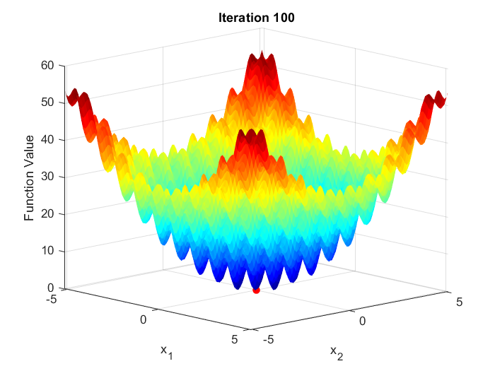

Rastrigin 2D Rastrigin 3D

**Note:**

* *arrayfun:* <https://www.mathworks.com/help/matlab/ref/arrayfun.html>
* It is used with an *anonymous* function: <https://www.mathworks.com/help/matlab/matlab_prog/anonymous-functions.html>
* This is done to avoid writing function m script and the output is turned to an array.

### Final Result

%% final result

fprintf('Best value found: %f\n', gbest_val);

Best value found: 0.000000

if m == 2

fprintf('Best position found: [%f, %f]\n', gbest_pose(1), gbest_pose(2));

Best position found: [0.000000, 0.000000]

elseif m == 3

fprintf('Best position found: [%f, %f, %f]\n', gbest_pose(1), gbest_pose(2), gbest_pose(3));

end

# PSO Simulation Video

**Click here:** [**https://drive.google.com/drive/folders/16-piIizYJNG8Ki1unexyFoG23p-lYtej?usp=sharing**](https://drive.google.com/drive/folders/16-piIizYJNG8Ki1unexyFoG23p-lYtej?usp=sharing)

# Source Code

* Copy the code in the code box below and name the m script file as rastrigin.m

function val = rastrigin(x)

% the parameter x is the current position and an array

% dimentionality (m)

m = length(x);

% rastrigin function Eval = 3m + summation(x^2 - 3cos(2*pi*x)

sum = 0;

% find the summation by looping through

for i = 1 : m

sum = sum + (x(i).^2 - 3*cos(2*pi*x(i)));

end

% fitness value of the rastrigin function

val = 3*m + sum;

end

* Copy the code below and name the m script file as PSO_Rastrigin.m

function PSO_Rastrigin(n_dim, n_agents)

%% User defined parameters

m = n_dim; % dimensionality (search space) for m = 2 or m = 3

n_particles = n_agents; % numbers of particles (agents) set for 10 or 20

max_iter = 100; % maximum iteration which is the stopping criteria

%% PSO hyperperameters

w = 0.7; % inertia weight

c1 = 1.4; % cognitive (personal) coefficient

c2 = 1.2; % social coefficient

% for rastrigin problems, the search space boundaries is

% commonly [-5.12 5.12]

min_x = -5.12; % minimum search space boundary

max_x = 5.12; % maximum search space boundary

%% Initialize the Swarm

% initialize the position with random value with [min_x max_x]

x = min_x + (max_x - min_x) .* rand(n_particles, m);

% initialize the velocity to zero

v = zeros(n_particles, m);

% initialize the fitness funtion

fitness = zeros(n_particles, 1);

for i = 1 : length(x)

fitness(i) = rastrigin(x(i,:));

end

% personal best

p_best_pose = x; % personal best position

p_best_val = fitness; % personal best value

% global best

% the global best value is the minimum fitnes

[gbest_val, gbest_idx] = min(fitness); % find the index of the minimum fitness

% the index of minimum fitness is the global best position

gbest_pose = x(gbest_idx,:); % global best position

%% Figure template

if m == 2

figure('Name','PSO Rastrigin 2D','NumberTitle','off');

elseif m == 3

figure('Name','PSO Rastrigin 3D','NumberTitle','off');

end

% figure template for precomputing grid for countor and surf

[X, Y] = meshgrid(linspace(min_x, max_x, 100), linspace(min_x, max_x, 100));

Z = zeros(size(X));

for i = 1:size(X,1)

for j = 1:size(X,2)

Z(i,j) = rastrigin([X(i,j), Y(i,j)]);

end

end

%% Main PSO Loop

for iter = 1 : max_iter

% update velocities and positions of the particles (agents)

for i = 1 : n_particles

% random coefficients for behavior ranging from 0 - 1

r1 = rand(); r2 = rand();

% velocity update

v(i,:) = w*v(i,:) + c1*r1*(p_best_pose(i,:) - x(i,:)) + c2*r2*(gbest_pose - x(i,:));

% update the position

x(i,:) = x(i,:) + v(i,:);

% boundary conditions to make sure position isn't

% beyound [min_x max_x] limit

for d = 1:2

if x(i, d) > max_x

x(i, d) = max_x;

elseif x(i, d) < min_x

x(i, d) = min_x;

end

end

end

% evaluate fitness after updating positions

for i = 1 : n_particles

fitness(i) = rastrigin(x(i,:));

% update personal best

if fitness(i) < p_best_val(i)

p_best_val(i) = fitness(i);

p_best_pose(i,:) = x(i,:);

end

end

% update global best

[current_best, current_best_idx] = min(p_best_val);

if current_best < gbest_val

gbest_val = current_best;

gbest_pose = p_best_pose(current_best_idx, :);

end

% display iteration info

fprintf('Iteration %d \t| Global Best Value = %f\n', iter, gbest_val);

% plot the graph

if m == 2

clf;

contourf(X,Y,Z,80, 'LineColor', 'none'); hold on;

plot(p_best_pose(:,1), p_best_pose(:,2), 'ro', 'MarkerFaceColor','r');

plot(gbest_pose(:,1), gbest_pose(:,2), 'ro', 'MarkerFaceColor','g');

title(['Iteration ' num2str(iter)]);

xlabel('x_1'); ylabel('x_2');

axis([min_x max_x min_x max_x]);

drawnow; % for the plot animation

elseif (m == 3)

clf; % clear figure

surf(X, Y, Z, 'EdgeColor','none');

colormap('jet');

hold on;

view(45, 45); % view angle

% evaluate Rastrigin at each particle to show their 'height'

zPos = arrayfun(@(row) rastrigin(p_best_pose(row,:)), 1:size(p_best_pose,1));

scatter3(p_best_pose(:,1), p_best_pose(:,2), zPos, 40, 'r', 'filled');

title(['Iteration ' num2str(iter)]);

xlabel('x_1'); ylabel('x_2'); zlabel('Function Value');

drawnow; % plot animation

end

end

%% final result

disp('==============================================');

disp('PSO optimization successfully done.');

fprintf('Best value found: %f\n', gbest_val);

if m == 2

fprintf('Best position found: [%f, %f]\n', gbest_pose(1), gbest_pose(2));

elseif m == 3

fprintf('Best position found: [%f, %f, %f]\n', gbest_pose(1), gbest_pose(2), gbest_pose(3));

end

end

* Save both files in the same folder and run this command in the command window

% m = 2, agents = 10

>> PSO_Rastrigin(2, 10)

% m = 2, agents = 20

>> PSO_Rastrigin(2, 10)

% m = 3, agents = 10

>> PSO_Rastrigin(3, 10)

% m = 3, agents = 20

>> PSO_Rastrigin(3, 20)

* Source code can be found on the GitHub page: <https://github.com/Abisoyesam/Computation-for-Energy/tree/main/PSO>