Matrix getting input from user and printing
import java.util.*;
class Matrix{
public static void main(String[] args){
Scanner s=new Scanner(System.in);
int[][] matrix=new int[3][3];
System.out.println("Enter the matrix:");
for(int i=0;i<3;i++)
{
for(int j=0;j<3;j++){
matrix[i][j]=s.nextInt();}}
System.out.println("Printing the matrix");
for(int i=0;i<3;i++)
{
for(int j=0;j<3;j++)
{
System.out.print(matrix[i][j]+" ");
}
System.out.println();
} }}
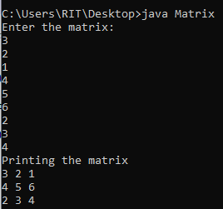

Transpose of a Matrix
import java.util.*;
class Matrix{
public static void main(String[] args){
Scanner s=new Scanner(System.in);
int[][] matrix=new int[3][3];
System.out.println("Enter the matrix:");
for(int i=0;i<3;i++)
{
for(int j=0;j<3;j++){
matrix[i][j]=s.nextInt();
}
}
System.out.println("Printing the matrix");
for(int i=0;i<3;i++)
{
for(int j=0;j<3;j++)
{
System.out.print(matrix[i][j]+" ");
}
System.out.println();}
System.out.println("Transpose of matrix:");
for(int i=0;i<3;i++){
for(int j=0;j<3;j++)
{
System.out.print(matrix[j][i]+" ");
}
System.out.println();
}
}
}
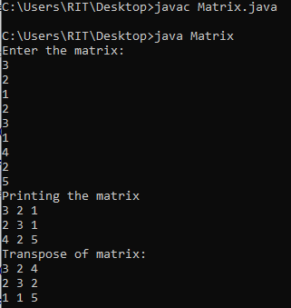
Addition of matrix
import java.util.*;
class Add{
public static void main(String[] args)
{
Scanner s=new Scanner(System.in);
System.out.println("Enter rows:");
int row=s.nextInt();
System.out.println("Enter columns:");
int col=s.nextInt();
int[][] a=new int[10][10];
int[][] b=new int[10][10];
int[][] sum=new int[10][10];
System.out.println("Enter the matrix1:");
for(int i=0;i<row;i++)
{
for(int j=0;j<col;j++)
{
a[i][j]=s.nextInt();
}
}
System.out.println("Enter matrix2");
for(int i=0;i<row;i++)
{
for(int j=0;j<col;j++)
{
b[i][j]=s.nextInt();
}
}
for(int i=0;i<row;i++)
{
for(int j=0;j<col;j++)
{
sum[i][j]=a[i][j]+b[i][j];
}
}
System.out.println("Printing the matrix");
for(int i=0;i<row;i++)
{
for(int j=0;j<col;j++)
{
System.out.print(sum[i][j]+" ");
}
System.out.println();
}
}
}
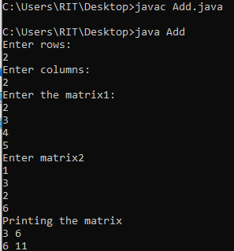
Spiral matrix
public class Spiral {
public static void main(String[] args) {
int[][] a = {
{1, 2, 3},
{4, 5, 6},
{7, 8, 9}
};
int top = 0;
int bottom = a.length - 1;
int left = 0;
int right = a[0].length - 1;
while (top <= bottom && left <= right) {
for (int i = left; i <= right; i++) {
System.out.print(a[top][i] + " ");
}
top++;
for (int i = top; i <= bottom; i++) {
System.out.print(a[i][right] + " ");
}
right--;
if (top <= bottom) {
for (int i = right; i >= left; i--) {
System.out.print(a[bottom][i] + " ");
}
bottom--;
}
if (left <= right) {
for (int i = bottom; i >= top; i--) {
System.out.print(a[i][left] + " ");
}
left++;
}
}
}
}
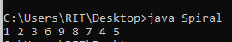

Saddle point
import java.util.Scanner;
public class Saddle {
public static void main(String[] args) {
Scanner sc = new Scanner(System.in);
System.out.println("Enter n:");
int n = sc.nextInt();
int[][] a = new int[n][n];
System.out.println("Enter the matrix:");
for (int i = 0; i < n; i++) {
for (int j = 0; j < n; j++) {
a[i][j] = sc.nextInt();
}
}
boolean found = false;
for (int i = 0; i < n; i++) {
int min = a[i][0];
int col = 0;
for (int j = 1; j < n; j++) {
if (a[i][j] < min) {
min = a[i][j];
col = j;
}
}
boolean saddle = true;
for (int k = 0; k < n; k++) {
if (a[k][col] > min) {
saddle = false;
break;
}
}
if (saddle) {
System.out.println("Saddle Point:" + min);
found = true;
break;
}
}
if (!found) {
System.out.println("No Saddle Point");
}
}
}
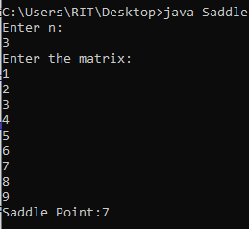
Pyramid Pattern
import java.util.Scanner;
public class Pyramid {
public static void main(String[] args) {
Scanner sc = new Scanner(System.in);
System.out.println("Enter number of rows:");
int n = sc.nextInt();
for (int i = 1; i <= n; i++) {
for (int j = 1; j <= n - i; j++) {
System.out.print(" ");
}
for (int k = 1; k <= 2 * i - 1; k++) {
System.out.print("*");
}
System.out.println();
}
}
}
