Brute force for max sum of subarray without window size
class Maxsum {
public static void main(String[] args) {
int[] arr = {-2, 1, -3, 4, -1, 2, 5, 100};
int maxSum = 0;
int n=8;
for (int i = 0; i < n; i++) {
int sum = 0;
for (int j = i+1; j < n; j++) {
sum += arr[j];
maxSum=Math.max(maxSum,sum);
}
}

System.out.println("Maximum Sum = " + maxSum);
}
}
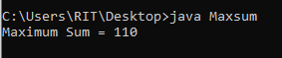
Kadane’s algorithm for max sum of subarray
class Kadane{
public static void main(String[] args)
{
int n=8;
int arr[]={-2,1,-3,4,-1,2,5,100};
int maxSum=0;
int sum=0;
for(int i=0;i<n;i++)
{
sum+=arr[i];
maxSum=Math.max(maxSum,sum);
if(sum<0)
{
sum=0;
}
}
System.out.println(maxSum);
}
}
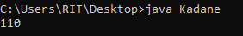
Sliding window
class Sliding {
public static void main(String[] args) {
int[] arr = {-2,1,-3,4,-1,2,5};
int n=7;
int k = 3;
int maxSum = 0;

for (int i = 0; i <= n- k; i++) {
int sum = 0;

for (int j = i; j < i + k; j++) {
sum += arr[j];
}

maxSum = Math.max(maxSum, sum);
}
System.out.println("Maximum Sum = " + maxSum);
}
}
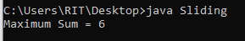
Sliding Window
class SlidingWindow{
public static void main(String[] args) {
int[] arr = {-2,1,-3,4,-1,2,5};
int n=7;
int k = 3;
int sum = 0;
for (int i = 0; i <k; i++) {
sum +=arr[i];
}
int max=sum;
for(int j=k;j<n;j++)
{
sum=(sum-arr[j-k]+arr[j]);
max=Math.max(max,sum);
}
System.out.println(max);
}
}
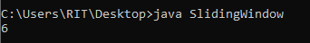
Last word length
import java.util.*;
public class length {
public static void main(String[] args) {
Scanner sc = new Scanner(System.in);
System.out.println("Enter a string:");
String s = sc.nextLine();
String[] words = s.trim().split(" ");
System.out.println("Last word length: " +words[words.length - 1].length());
}
}
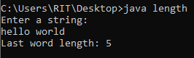
Repeat Characters
import java.util.*;
public class RepeatChar {
public static void main(String[] args) {
Scanner sc = new Scanner(System.in);
String str = sc.nextLine();

for (int i = 0; i < str.length(); i += 2) {
char ch = str.charAt(i);
int n = str.charAt(i + 1) - '0';

for (int j = 0; j < n; j++) {
System.out.print(ch);
}
}
}
}
