COPY CONSTRUCTOR
import java.util.*;
class Student
{
String name;
int age;
Student(String n,int a)
{
name=n;
age=a;
}
Student(Student s)
{
name=s.name;
age=s.age;
}
void display()
{
System.out.println("Name:"+name);
System.out.println("Age:"+age);
}
}
class copy{
public static void main(String[] args)
{
Student s1=new Student("Vashini",20);
Student s2=new Student(s1);
s1.display();

}
}
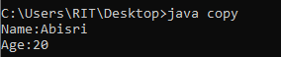

CHAIN CONSTRUCTOR
class Student{
String name;
int age;
Student(){
this("Abisri",20);
}
Student(String name,int age){
this.name=name;
this.age=age;
}
void display()
{
System.out.println("Name:"+name);
System.out.println("Age:"+age);
}
}
class chain
{
public static void main(String[] args)
{
Student s=new Student();
s.display();
}
}
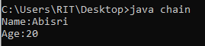
METHOD OVERLOADING
import java.util.*;
class poly{
int add(int a,int b){
return a+b;
}
int add(int a,int b,int c)
{
return a+b+c;
}
}
class overl{
public static void main(String[] args)
{
poly p=new poly();
System.out.println(p.add(10,20));
System.out.println(p.add(10,20,30));
}
}
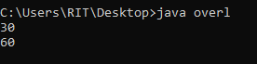

METHOD OVERRIDING
import java.util.*;
class Animal{
void sound(){
System.out.println("Animal sound");}
}
class Dog extends Animal{
void sound(){
System.out.println("sound");
}
}
class overr{
public static void main(String[] args)
{
Dog d=new Dog();
d.sound();
}
}
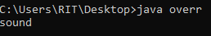
SINGLE INHERITANCE:
import java.util.*;
class Animal{
void sound(){
System.out.println("Animal sound");
}
}
class Dog extends Animal{
void bark(){
System.out.println("barking");
}
}
class Sample{
public static void main(String[]args){
Dog d=new Dog();
d.bark();
d.sound();
}
}
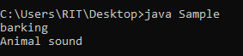
NON PARAMETERIZED:
import java.util.*;
class Student{
String name;
int age;
Student(){
name="abisri";
age=20;
}
void display(){
System.out.println("Name:" +name);
System.out.println("Age:" +age);
}

}
class NP{
public static void main(String[]args){
Student s= new Student();
s.display();
}
}
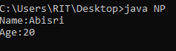

MULTIPLE INHERITANCE:
import java.util.*;
interface A{
public void Show();
}
interface B{
public void Display();
}
class Test implements A,B{
public void Show(){
System.out.println("method A");
}
public void Display(){
System.out.println("method B");
}
}
class Multiple{
public static void main(String[]args){
Test t=new Test();
t.Show();
t.Display();
}
}
