添加旅游景点
47.102.42.105:8456/Tour/AddTour
{
"tourName":"dasdasd",
"posLat":"11.111",
"poslng":"22.222"
}
{
"msg": "添加景点成功",
"flag": "1",
"tourCode": "tou1609760397049akQGT"
}
{
"msg": "添加景点失败.因为景点已存在",
"flag": "0"
}
posLat 经 poslng 纬

删除景点
47.102.42.105:8456/Tour/DeleteTour
{
"tourCode": "tou1609760397049akQGT"
}
{
"msg": "删除景点成功",
"flag": "1"
}

获取旅游名单
47.102.42.105:8456/Tour/GetTourList
{
"name":"龙"
}
{
"msg": "查询成功",
"flag": "1",
"resultList": [
{
"poslng": "22.222",
"posLat": "11.111",
"pic": [],
"tourCode": "tou1609759690270KiNeT",
"tourName": "恐龙园"
},
{
"poslng": "22.222",
"posLat": "11.111",
"pic": [],
"tourCode": "tou1609813210741lXegf",
"tourName": "井冈山带学"
},
{
"poslng": "22.222",
"posLat": "11.111",
"pic": [],
"tourCode": "tou1609813225327SEEkT",
"tourName": "常州带学"
},
{
"poslng": "88.123",
"posLat": "00.899",
"pic": [],
"tourCode": "tou1609813243446DNMvv",
"tourName": "苏州科技带学"
},
{
"poslng": "88.222",
"posLat": "11.899",
"pic": [],
"tourCode": "tou1609813259921JeIKL",
"tourName": "江苏信息职业技术带院"
},
{
"poslng": "7890.1",
"posLat": "00.11",
"pic": [
{
"picId": "http://47.103.135.104:8456/Tour/getPic?picId=PIC1609912344713Wguwb.svg"
},
{
"picId": "http://47.103.135.104:8456/Tour/getPic?picId=PIC1609912607426cqTYr.png"
}
],
"tourCode": "888979whus",
"tourName": "bababab"
}
]
}

获取心愿单
47.102.42.105:8456/Tour/GetDreamList
{
"userCode":"123123"
}
{
"msg": "查询成功",
"flag": "1",
"resultList": [
{
"tourCode": "tou1609759690270KiNeT",
"tourName": "恐龙园",
"dreamListCode": "DLC1609813320146GxYws",
"userCode": "123123"
},
{
"tourCode": "tou1609813225327SEEkT",
"tourName": "常州带学",
"dreamListCode": "DLC1609813309353CwYnx",
"userCode": "123123"
},
{
"tourCode": "tou1609813243446DNMvv",
"tourName": "苏州科技带学",
"dreamListCode": "DLC1609813313900BlkeI",
"userCode": "123123"
},
{
"tourCode": "tou1609813259921JeIKL",
"tourName": "江苏信息职业技术带院",
"dreamListCode": "DLC1609813320046GxYwg",
"userCode": "123123"
},
{
"tourCode": "888979whus",
"tourName": "bababab",
"dreamListCode": "DLC1609813305868dRsZD",
"userCode": "123123"
}
]
}

47.102.42.105:8456/Tour/DeleteDreamList
{
"dreamListCode":"DLC1609812877789DbGRv"
}
{
"msg": "删除心愿单成功",
"flag": "1"
}

添加心愿单
47.102.42.105:8456/Tour/AddDreamList
{
"tourCode":"tou1609813259921JeIKL",
"userCode":"123123"
}
{
"msg": "添加心愿单成功",
"flag": "1"
}

用户注册
47.102.42.105:8456/User/UserAdd
{
"loginName":"123456",
"loginPassword":"qweqwe",
"userPhone":"110"
}
{
"msg": "注册成功",
"flag": "1"
}
{
"msg": "注册失败",
"flag": "0"
}

用户登录
47.102.42.105:8456/User/Login
{
"loginName":"123456",
"loginPassword":"qweqwe"
}
{
"msg": {
"loginName": "123456",
"userPhone": "110",
"userCode": "123123"
},
"flag": "1"
}

{
"msg": "用户不存在",
"flag": "0"
}

修改用户信息
47.102.42.105:8456/User/UpdataUserInfo
{
"loginName":"123456swdwsd",
"userCode":"123123",
"userPhone":"890789"
}
{
"msg": "修改成功",
"flag": "1"
}

修改密码
47.102.42.105:8456/User/UpdataUserPwd
{
"userCode":"123123",
"loginPassword":"asdasd"
}
{
"msg": "修改成功",
"flag": "1"
}

添加用户评论
47.102.42.105:8456/Tour/addTourComment
{
"userCode":"123456swdwsd",
"tourCode":"asdas1d",
"commentText":"很好玩,下次还会过111111来"
}
{
"msg": "评论成功",
"flag": "1"
}

获取评论
47.102.42.105:8456/Tour/getTourComment
{
"tourCode":"asdas1d"
}
{
"msg": [
{
"commentCode": "COM1609847608798GnCDQ",
"loginName": "123456swdwsd",
"tourCode": "asdas1d",
"commentText": "很好玩,下次还会过来"
},
{
"commentCode": "COM1609847634281jGUyQ",
"loginName": "123456swdwsd",
"tourCode": "asdas1d",
"commentText": "很好玩,下次还会过111111来"
}
],
"flag": "1"
}

获取统计数据
47.102.42.105:8456/Tour/getTourStatistics 无参数
{
"msg": [
{
"numCount": 3,
"tourCode": "tou1609759690270KiNeT",
"tourName": "恐龙园"
},
{
"numCount": 3,
"tourCode": "tou1609813225327SEEkT",
"tourName": "常州带学"
},
{
"numCount": 1,
"tourCode": "tou1609813243446DNMvv",
"tourName": "苏州科技带学"
},
{
"numCount": 2,
"tourCode": "tou1609813259921JeIKL",
"tourName": "江苏信息职业技术带院"
},
{
"numCount": 1,
"tourCode": "888979whus",
"tourName": "bababab"
}
],
"flag": "1"
}

用户列表获取
47.102.42.105:8456/User/getUserList
{
"msg": [
{
"loginName": "123456swdwsd",
"userPhone": "890789",
"loginPassword": "asdasd",
"userCode": "123123"
},
{
"loginName": "123456777777",
"userPhone": "110",
"loginPassword": "qweqwe",
"userCode": "Usc1609841750365bpNVx"
},
{
"loginName": "ZyiqueYa",
"userPhone": "13247037719",
"loginPassword": "zy",
"userCode": "Usc1609858057589WAbdF"
}
],
"flag": "1"
}

上传图片
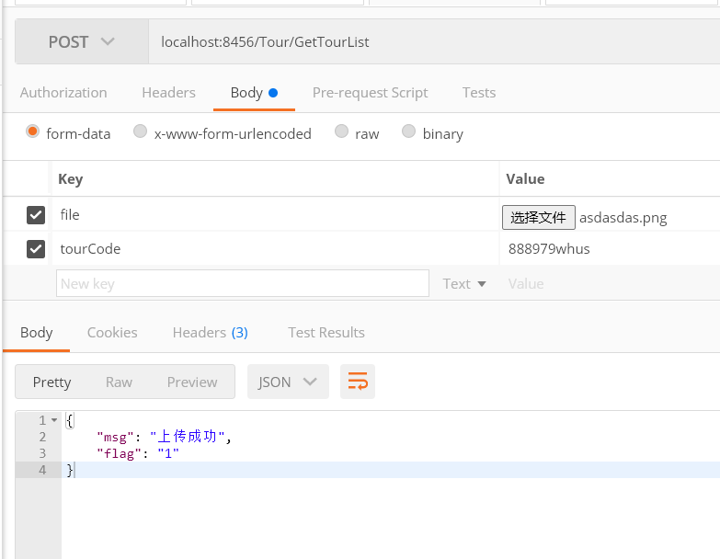
注意key的值以及Headers必须全部为空

获取图片GET方法即可

http://localhost:8456/Tour/getPic?picId=PIC1609912607426cqTYr.png

