CAREER TRANSITIONS AND CANDIDATE EVALUATION
THROUGH PROBABILISTIC MODELING


Cluster Innovation Centre, University of Delhi

This report is submitted as the fulfilment of the Practical Project of the DSC10 course “APPLIED PROBABILITY AND STATISTICS” at Cluster Innovation Centre, University of Delhi

SUBMITTED BY:
Abhimanyu Nain (152303)
Abitatha Roy (152304)
Anushka Sharma (152313)

SUBMITTED TO:
Dr. Sonam Tanwar
Dr. Nirmal Yadav

Acknowledgement

We would like to express our sincere gratitude to our project guide, Dr. Sonam Tanwar and Dr. Nirmal Yadav, for their invaluable guidance, support, and constructive feedback throughout this project. We also thank our faculty and department for providing us with the resources and encouragement needed to explore this domain. Special thanks to platforms like Kaggle for making real-world datasets accessible, which formed the backbone of our analysis. Lastly, we are grateful to our peers and mentors whose suggestions helped shape this project into a meaningful learning experience.

1. Abstract
In today’s evolving job market, understanding career transitions and effectively evaluating candidate profiles are crucial for organizations aiming to optimize hiring strategies and workforce planning. This project explores a probabilistic approach to analyzing career progressions and evaluating candidate profiles using real-world resume data.
The study begins with detailed data cleaning, including parsing inconsistent date formats, standardizing education qualifications, and extracting structured information on work experiences, skills, and degrees. Candidates' total professional experience was computed by aggregating periods of employment, while their academic levels were mapped into a standardized numeric scale to facilitate comparisons.
Career transitions between different roles were modeled using Markov Chains, capturing the likelihood of moving from one position to another based on observed data. To uncover natural groupings among roles, hierarchical clustering was applied, providing a visual structure of career paths and highlighting clusters of closely related job profiles. Transition heatmaps and network graphs further visualized career dynamics across industries and roles.
Candidate profiles were then evaluated using a composite scoring system, factoring in the number of skills, total experience, and educational attainment, and standardized through z-score normalization for fair comparison. Additionally, hiring probability for each candidate was estimated using a Bayesian framework, combining prior knowledge with evidence from their experience and education attributes.
This integrated analysis enables a data-driven understanding of career mobility, talent progression, and workforce trends. The probabilistic modeling approach not only aids in ranking and shortlisting candidates but also offers valuable insights into designing recruitment strategies, predicting career movements, and identifying high-potential roles within an organization.

2. Introduction
In today’s world, we live in a competitive job market where companies often receive hundreds, if not thousands of resumes for a single job opening. Manually reviewing these resumes is both time-consuming and prone to human bias. To streamline the recruitment process, resume parsing has emerged as a crucial automation tool that is increasingly being used by recruiters to shortlist promising candidates before they step in themselves to judge the candidates through procedures like interviews and group discussions. Resume parsing involves automatically extracting structured information—such as skills, experience, education, and certifications—from unstructured resume text and categorizing them for analysis, followed by tallying against the requirements of the opening and based on the match, assigning a score. This score is further used to slice the list of candidates depending on the number of them to be interviewed physically. This technology not only accelerates candidate screening but also ensures that critical qualifications are not overlooked during initial evaluations. Apart from the hiring process, resume parsing can also be used to study patterns in the job market among candidates such as the positions and companies in demand based on the job transitions they have aimed to achieve or have undertaken during their career. We can also study trends in terms of the professionals undertaking domain switches, for example, a person switching from Software Development to Data Science, five years into their corporate career.
When it comes to studying and analysing how professionals transition across roles during the course of their career, Markov Chains, a mathematical model that describes systems which transition between states with certain probabilities, serve as an effective tool for this analysis. By modeling job transitions as a Markov process, we can estimate the likelihood of professionals moving from one position to another. This provides valuable insights on what we already discussed, that is, into common career pathways and high-growth roles. Added to this, we have the tool to determine potential future positions for candidates. Mathematically, Markov Chains are defined by a set of states which constitute a transition probability matrix. This matrix captures the dynamics of movement between roles over time. This mathematical tool, built upon historical data of job switches, can be used to model how professionals are likely to move jobs in the future in search of stability and/or better opportunities, and answer questions such as, where a professional eventually finds stability. For example, we may ask, if a candidate begins his career as a Software Developer, in which role is he most likely to retire and after how many job switches will he take up that role? In our project, we leverage this concept to understand career progression trends and to further enhance the evaluation system.
Besides resume ranking and parsing, our system includes a naive application of Bayes' Theorem to approximate the probability of hiring a candidate, given his or her experience and educational qualifications. By taking advantage of past knowledge of hiring trends, we can estimate the probability of hiring for every candidate. This is achieved through hypothetical conditional probability of experience and education levels, based on assumed past recruiting history. While this is not a full Naive Bayes model or full machine learning training, it uses basic Bayes logic to arrive at the probability of hiring for a candidate's specific traits. This primitive model offers a quick and efficient way of assessing the suitability of a candidate for a vacancy, enhancing the decision-making process by sorting out applicants who have better opportunities of being hired based on qualifications.

Objectives

- To design and implement a probabilistic resume evaluation system that automatically parses unstructured resume data, extracts key candidate information such as experience, education and skills, and ranks candidates through a normalized scoring approach using z score.
- To estimate candidates' hiring probability using Bayes’ Theorem by combining prior assumptions with extracted candidate information from the dataset, predicting the likelihood of selection based on professional experience, academic qualification and skill sets.
- To model and analyze career transition patterns through Markov Chain modeling, capturing the likelihood of professionals moving between various job roles based on real-world career trajectory data and estimating the probabilities of role changes over time.
- To visualize career pathing patterns by making transition probability heatmaps, network diagrams and Dendrograms, thereby identifying probable career pathways, stable roles, and high-growth opportunities.

4. Working

4.1 Data Parsing and Pre-processing
The preliminary dataset was accessed from Kaggle (can be viewed from the appendix). It consisted of the different sections of resumes of thousands of candidates arranged in the different columns and stored in .csv format. The candidates included people from freshers all the way to seasoned professionals with decades of experience. Examples of such sections are one’s educational qualifications, experience and set of skills. In case a particular section contains multiple values, for example, a candidate who has done his B.Tech., M.Tech. and PhD, their educational qualifications were stored as a single string but resembling that of a Python list. In this example, it would look something like [‘B.Tech.’, ‘M.Tech.’, ‘PhD’]. Since it is not possible to work with such a format, data of this kind were parsed and brought into a workable form in R.

4.1.1 Extracting Data from Multivalued Columns
The common technique applied for all columns of this kind involved parsing and extracting the individual elements of the concerned resume section (stored in the column) and convert it into a vector containing those individual elements, and then storing the vector in a new column.
From our old example, [‘B.Tech.’, ‘M.Tech.’, ‘PhD’] was converted and stored as c(“B.Tech.”, “M.Tech.”, “PhD”).
The following code snippet applies this parsing technique, but on the date columns.

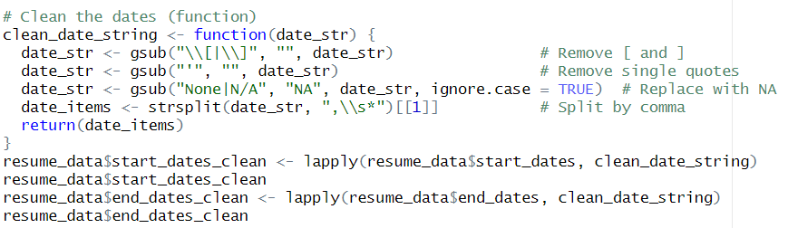

4.1.2 Parsing Dates
The dates we have used in this project were present in various formats, depending on the resume from which the data was extracted. Some examples of date formats we encountered:
- 2022
- 20xx
- March 2004
- Current/Present (while denoting an ongoing job role’s end date)
- N/A
- 24/03/2004

And many more! Before we started working on them, it was required to convert them into a homogeneous form, that is, the date object in R. The first step in this endeavour was to print the start and end dates of various jobs across one’s career in totality, copy them and feed them to a Gen AI tool to find out every unique date format in the dataset. After that was known, they were parsed and converted to R’s date object. To talk a bit about R’s date object, by default, it stores dates as an integer which measures the number of days from 1st January 1970. While displaying, we can see them in the standard format “YYYY-MM-DD”. The following snippet performs this function.

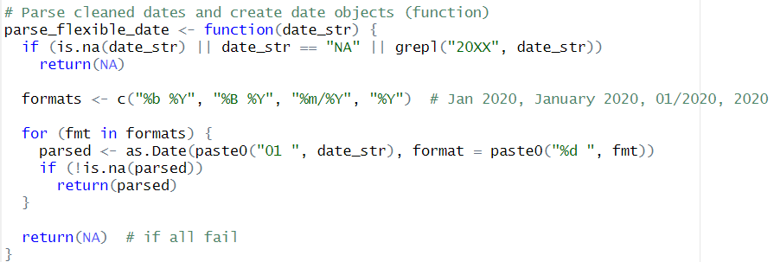

For now, the dates which ended up being NA, such as an inconclusive date 20xx, were replaced with the current date. This did lead to some more anomalies which have been handled further down the preprocessing journey.

We noticed some anomalies while viewing the dataset in the RStudio environment where some dates were stored as huge negative integers such as -390685, which indicates a date far before R’s threshold of 1st January 1970. As you can guess, it is an invalid date. To fix this, we dropped any row which contained a date before a given cutoff. In our case, the cutoff was 1st January 1900, which was suitable for the range of data our dataset contains.

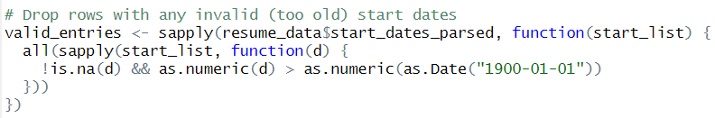

4.1.3 Calculation of Total Experience Years
As mentioned earlier, R stores dates as integers which denote the number of days after the threshold of 1st January 1970. The total experience years have been calculated by subtracting the start date of one’s first job and the current date. The result was stored in a new column as floating points denoting the precise number of years. Eg. An experience of 493 days will be stored as 1.350684 years.
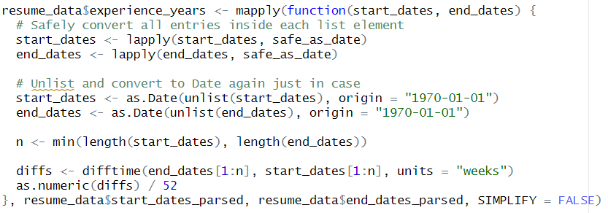

4.1.4 Calculation of a candidate’s Academic Level
Academic levels were assigned based on the following configuration.
- Below Class X – 1
- Class X – 2
- Class XII – 3
- UG – 4
- PG – 5
- PhD – 6
Some assumptions were taken, such as a Diploma being considered equivalent to the UG level and certifications being equivalent to Class XII.
In order to identify all unique educational “phrases” used in the different resumes, they all were fed to a Gen AI tool and categorised into six vectors. Here is an overview of them.
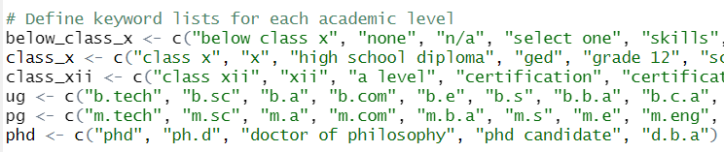

After that, the academic level is assigned to each candidate in a new column based on the highest level of education they have completed.
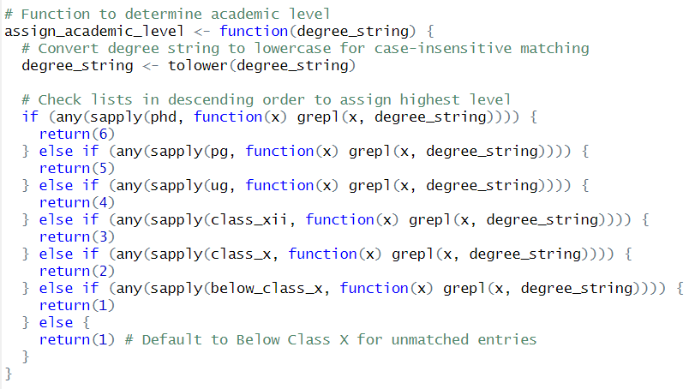

4.1.5 Filtering based on Required Experience and Education
The original dataset already contains the eligibility criteria of the job (for which each of these resumes were submitted) in terms of the required experience and education.
First, we have dropped every row where even a single degree or the experience years have been stored as NA due to lack of data.

To calculate the required academic level, a similar method has been used as above, but in this case, the minimum academic level among the list of required degrees has been assigned. For example, if a job has called for candidates possessing a B.Tech. or M.Tech., the minimum required academic level has been considered and has been assigned w.r.t. the UG level. However, our current model cannot yet differentiate between degrees of different domains. For instance, a B.Tech. holder will be deemed eligible for a job that requires candidates to possess a BBA or an MBA. This limitation shall be fixed in the future versions. After this step, ineligible candidate rows were dropped.

When it comes to the experience requirement, different job offerings presented their filters based on common formats, namely “at least x years”, “at most y years” and “between a and b years”. The following function parses these terms and stores the requirements as a vector c(min_years, max_years). For a job offering where only the least bound was mentioned, max_years was assigned to a large value (such as 100). If only the upper bound was mentioned, min_years was assigned to 0. Ineligible candidates were dropped.

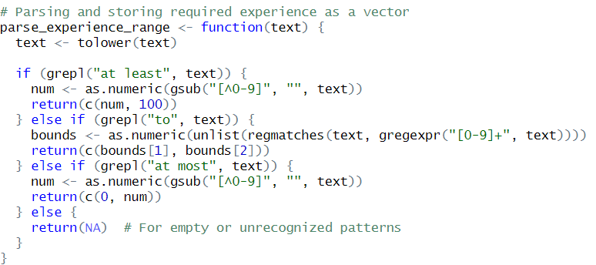

This concludes our preprocessing stage until later when some adjustments were still required while applying the different analysis techniques.

4.2 Markov Chain Modelling
In this project, Markov Chains were utilized to model the career transitions of candidates based on their resume data. A Markov Chain is a mathematical model that describes a system which transitions between different states with certain probabilities, under the assumption that the future state depends only on the current state and not on the sequence of events that preceded it. This property is known as the Markov Property. In the context of career modeling, the "states" are distinct job roles held by individuals, and the transitions represent movements from one role to another throughout a candidate's career journey.

4.2.1 Extraction of Career Histories and Transition Building
The first step involved extracting the career history sequences from the candidates' resumes. For each candidate, the series of job titles held over time was parsed and cleaned to establish clear current-to-next role relationships. These sequential pairs of job roles were then used to build a transition dataset, effectively recording observed movements between different positions across all candidates.

4.2.2 Construction of Transition Matrix
Using these observed transitions, a transition matrix was constructed. In this matrix, each row represents a "from role," each column represents a "to role," and each cell contains the probability of transitioning from the corresponding "from role" to the "to role." The probabilities were calculated by counting the number of observed transitions between roles and normalizing them by the total number of transitions originating from each role.
Transition probability =
(Number of times someone moved from State A to State B) ÷ (Total number of times someone was in State A)
To ensure the matrix satisfies the requirements of a Markov Chain, each row's probabilities were normalized to sum to 1. Special cases, such as roles with no observed outgoing transitions, were handled by assigning a self-transition probability of 1, preserving the mathematical consistency of the model.

4.2.3 Markov Chain Object Creation
Once the transition probability matrix was established, it was converted into a formal Markov Chain object using the markovchain package in R. Specifically, after calculating the transition counts between different job roles and normalizing them row-wise to obtain probabilities, the transition matrix was subsetted to focus on the top 10 most frequent roles for cleaner analysis. The top roles were determined by summing the outgoing transitions for each role and selecting the highest-ranking ones.
Code snippet :
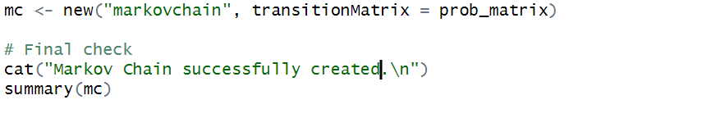
Explanation:
- new("markovchain", ...) is a constructor function from the markovchain package that creates a Markov Chain object.
- transitionMatrix = prob_matrix_top assigns the normalized transition probabilities among the top 10 selected roles.

Sample of the Transition Probability Matrix :
We extracted and displayed the top-left 5x5 portion of the complete transition matrix, offering a manageable view of the data.
Staff Accountant II Tax Analyst Senior Accountant
Staff Accountant II 0 1 0.0000000
Tax Analyst 0 0 1.0000000
Senior Accountant 0 0 0.4210526
Instrument Technician 0 0 0.0000000
Android Developer Intern 0 0 0.0000000

Instrument Technician Android Developer Intern
Staff Accountant II 0 0
Tax Analyst 0 0
Senior Accountant 0 0
Instrument Technician 0 0
Android Developer Intern 0 1

4.2.4 Transition Visualization and Analysis :

After constructing the Markov Chain object representing career transitions, various analyses and visualizations were performed to better understand the transition dynamics between job roles. The transition matrix, derived earlier, was utilized for visual exploration through heatmaps, network analysis, dendrograms, and hierarchical clustering. Additionally, analytical steps were implemented to explore promotions, lucrative positions, and simulation of career paths over multiple transitions.
4.2.4.1 Analysis of Lucrative Positions
The first step involved identifying the most and least lucrative job positions based on incoming transitions. To achieve this, the total incoming probability for each role was calculated by summing the transition probabilities along each column of the transition matrix. Roles were then sorted based on these summed probabilities, and the top 10 as well as bottom 10 roles were printed for preliminary understanding. Thus highlighting roles that tend to attract the highest number of transitions.
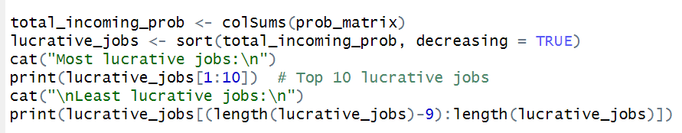
4.2.4.2 Analysis of Job Stability: Self-Transitions
Job stability was analyzed by examining self-transition probabilities, which measure the likelihood of candidates remaining in the same role over time. This was achieved by extracting the diagonal elements of the transition matrix. The self-transition probabilities were sorted to identify roles with the highest and lowest levels of stability.
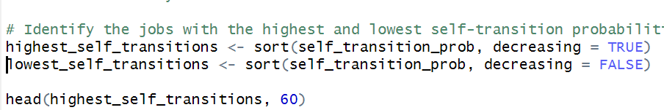
4.2.4.3 Specific Role Transition Analysis
Additionally, specific transitions between selected roles were manually checked. For instance, the transition probability from "Senior Accountant" to "Tax Analyst" was extracted directly from the transition matrix. This provides the ability to focus on targeted role-to-role movements of particular interest, allowing customized micro-analysis of career paths.
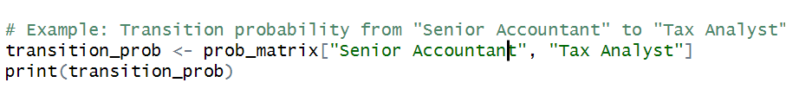
4.2.4.4 Heatmap Visualization of Transition Probabilities
A key component of the visualization involved creating heatmaps to depict the transition probabilities between roles. A heatmap was first generated for all roles and subsequently refined to focus on the top 10 most common roles, making the plot more interpretable. The heatmaps visually encode transition probabilities through a gradient color scheme, with darker blue shades indicating higher transition probabilities.
4.2.4.5 Detecting and Visualizing Promotions using Network Diagram
To explore promotions, the project defined a set of keywords such as "Senior," "Lead," "Manager," and "Director" that typically indicate higher-ranking positions. Using these keywords, transitions where a candidate moved from a lower to a higher title were identified. This involved creating a function that checks whether a promotion occurs between two roles based on the presence or absence of promotion-related keywords. Promotions were filtered, counted, and organized by originating role for further visualization.
Subsequently, a network diagram focusing exclusively on promotions was created using the igraph package. The promotion network visually represents roles and the directional movement from non-promotion titles to promotion titles.
4.2.4.6 Career Transition Network Diagram
A general career transition network diagram was also created. This involved building a directed weighted graph from the complete transition matrix, with nodes representing job roles and edges representing the likelihood of transition between roles. The network graph was initially plotted for all roles and then refined to visualize only the top 10 most frequent roles.
4.2.4.7 Hierarchical Clustering and Dendrograms
Role clustering was carried out using hierarchical clustering methods. A distance matrix was computed based on the transition probabilities, and hierarchical clustering was applied to group similar roles together. A full dendrogram was plotted initially, followed by a focused dendrogram on the top 30 most common roles. This helps to identify clusters of roles that candidates transition between more frequently, revealing patterns of closely related job positions.
4.2.4.8 Simulation of Career Transitions
Finally, a simulation function was developed to model hypothetical career paths over multiple steps. Given a starting role and a specified number of transitions, the function randomly samples the next role based on the transition probabilities.
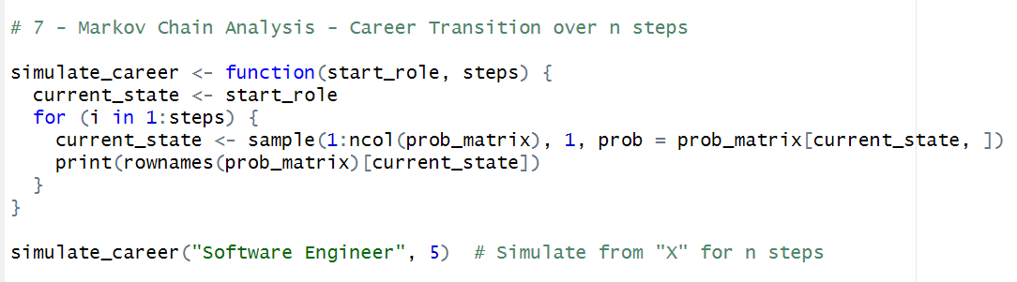

4.3 Z-Score
We applied the Z-score transformation to rank candidates based on a composite score that reflects key factors such as the number of skills, total years of experience, and academic level. The Z-score is a statistical tool that standardizes scores by converting them into a common scale, making it easier to compare values from different distributions.
4.3.1 Composite Score Calculation: For each candidate, we computed a composite score that combined three key factors: the number of skills, years of experience, and academic level. The composite score is calculated as follows:
composite_score=0.4×num_skills + 0.3×total_experience_years + 0.3×academic_level
This weighted sum reflects the relative importance of each factor in evaluating the candidate.

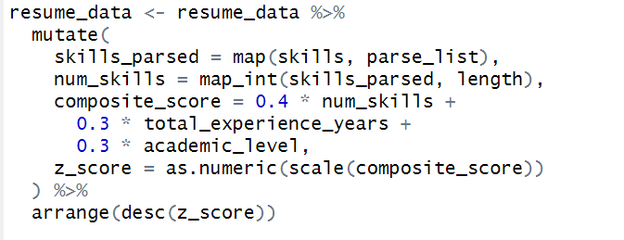

4.3.2 Z-Score Calculation: The composite score is then standardized using the scale() function in R, which transforms the scores to a standard normal distribution with a mean of 0 and a standard deviation of 1. This transformation allows us to compare candidates on a common scale regardless of the original scale of each component.
The Z-score is computed for each candidate’s composite score using the formula:
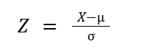
Where X is the composite score, μ is the mean composite score, and σ is the standard deviation of composite scores.
4.3.3 Sorting and Displaying Top Candidates: After calculating the Z-scores, candidates are sorted in descending order based on their Z-scores, which places the most qualified candidates at the top. The top n candidates are selected for display.

Reasoning Behind Z-Score Application:
- Standardization: By applying the Z-score, we ensure that all candidates are evaluated on a common scale, which allows for meaningful comparison even if their raw scores in different factors (e.g., skills, experience, education) are on different scales.
- Fair Comparison: Since the Z-score normalizes the data, it accounts for the inherent variability in each candidate’s composite score. This makes it easier to compare candidates who may have vastly different values in raw scores for experience or academic level but similar performance in overall composite scoring.
- Outlier Detection: The Z-score helps in identifying extreme candidates—those whose composite scores are significantly higher or lower than the average. Candidates with Z-scores far from 0 (typically beyond ±3) can be flagged as outliers, either exceptional or underperforming.

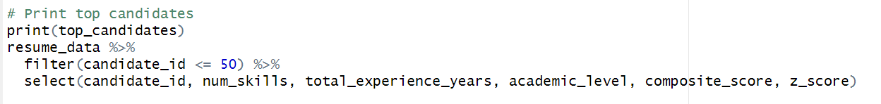

4.4 Estimation of Hiring Probability Using Naive Baye’s Theorem

We used an implementation of the Bayes’ Theorem to estimate how probable a given candidate is to be hired for a particular job. The parameters and probabilities used here are heuristic—we do not currently have the historical data to accurately determine these probabilities (about which we will talk next). Therefore, this implementation is merely a demonstration of how this approach can be utilized to predict the probability of a candidate who is willing to apply for a position to actually be selected for the same, depending on the resume they currently have. This analysis can help candidates in shortlisting positions for applying and not resort to cold-applying to thousands of jobs with no guarantee of converting an interview call or bagging the position.

4.4.1 Parameters considered
As already mentioned, the parameters chosen and their respective weightages are heuristic in nature and do not have a basis that conforms to actual historical data on hiring trends for a specific position in a particular company.

The selected parameters and their respective weightages are:
- Years of Experience
- Academic Level
- Number of Skills

The Bayes’ Theorem states:

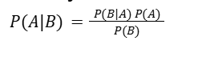
where P(A|B) is the posterior probability, P(B|A) is the likelihood, P(A) is the prior probability, and P(B) is the marginal likelihood.

We have considered the availability the following probabilities as parameters for our simplified demo case:
- P(Experience Satisfied | Hired)
If experience of 5 years or more – 0.8
If experience between 2 and 5 years – 0.6
Else – 0.3
- P(Education Satisfied | Hired)
If academic level of 5 or more – 0.9
If academic level between 4 and 5 – 0.7
If academic level between 3 and 4 – 0.5
Else – 0.2
- P(Skills Satisfied | Hired)
If 10 or more skills – 0.8
If between 5 and 9 skills – 0.6
Else – 0.4
- P(Hired) – 0.4

4.4.2 We want to calculate: Probability that the candidate was hired given that they fulfilled the educational, experiential and skill requirements
P(Hired | Education, Experience, Skills Satisfied)

Now, we do not have all the parameters required to use the standard Bayes’ Theorem, namely the probabilities of the cases where one or more requirements were not fulfilled but still the candidate was hired. To compensate for the same, we consider a set of Naive Bayes’ assumptions. Naive Bayes’ is actually a machine learning algorithm based on the Bayes’ Theorem which is used for predictive modelling of future events. We are not implementing that right now, just considering the assumptions.
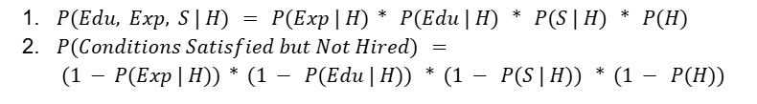
Therefore, our final formula becomes:

The following function implements this.
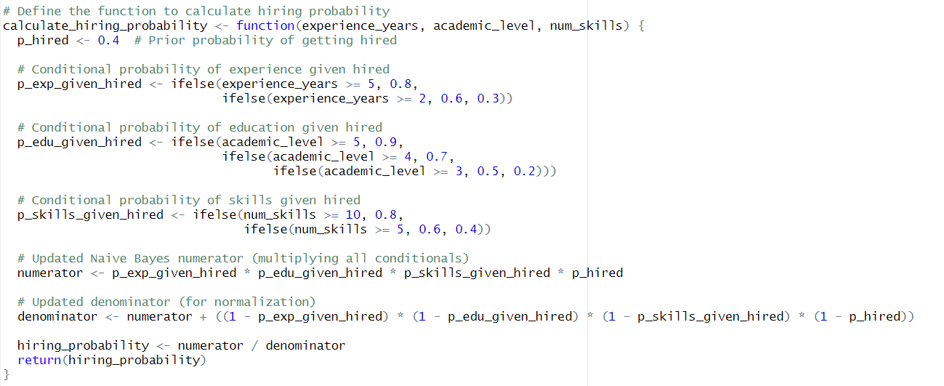

5. Results

5.1 Markov Chain Analysis

5.1.1 Most and least lucrative jobs :

One of the primary insights derived from the transition probability matrix was the identification of lucrative job roles — defined as those that attract a high volume of transitions from other positions. This was quantified by calculating the total incoming probability for each role, using column-wise summation of the transition matrix. The higher the cumulative incoming transition probability for a role, the more desirable or "lucrative" it is considered within the context of this dataset.
The most lucrative roles represent positions that serve as frequent career destinations for professionals. For instance, roles such as Accountant, Senior Accountant, and Engineering Supervisor exhibit high incoming transition probabilities, indicating they are common next steps in career progressions.
The least lucrative positions exhibit zero incoming transitions within the available data, suggesting that either they serve as terminal roles or that the dataset does not capture common transitions into these jobs. It's also possible that these roles are more specialized or operational in nature, limiting their visibility as upward or lateral career moves.

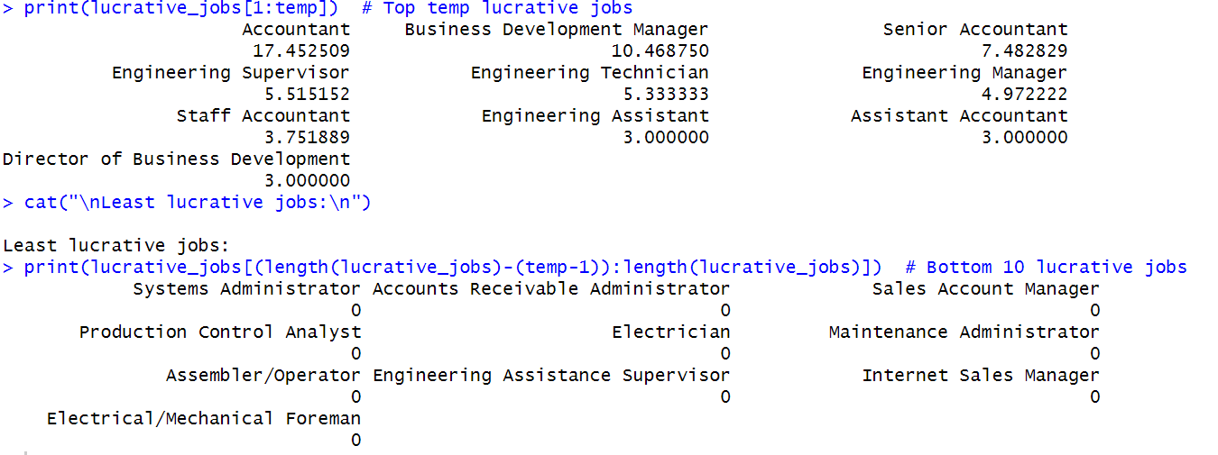
Fig. 1: Most and least lucrative jobs result

5.1.2 Job Stability using self-transition probabilities
Job stability within the career transition model was assessed by analyzing the self-transition probabilities in the Markov Chain. These probabilities reflect the likelihood that an individual remains in the same role rather than transitioning to a new one in the next career step. In a Markov Chain transition matrix, such probabilities are located on the diagonal — where the “from” and “to” roles are the same.
The output revealed that several roles had a perfect self-transition probability of 1.0, indicating complete stability. These roles include:
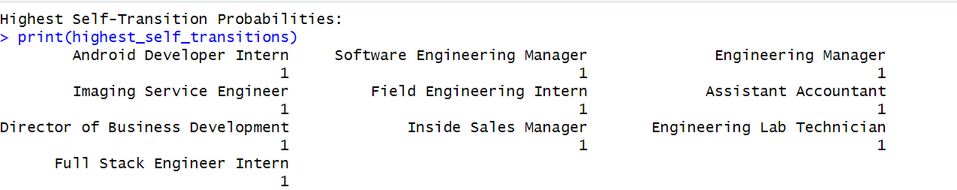 Fig. 2.1: Highest self-transition probability result

In these cases, the data indicates that individuals holding these roles typically remained in the same position during the observation period, or no transition out of the role was recorded. This may reflect either highly stable roles or dataset limitations in tracking role movement for these job titles.
Conversely, the following roles had a self-transition probability of zero, indicating no observed cases where individuals stayed in the same position:
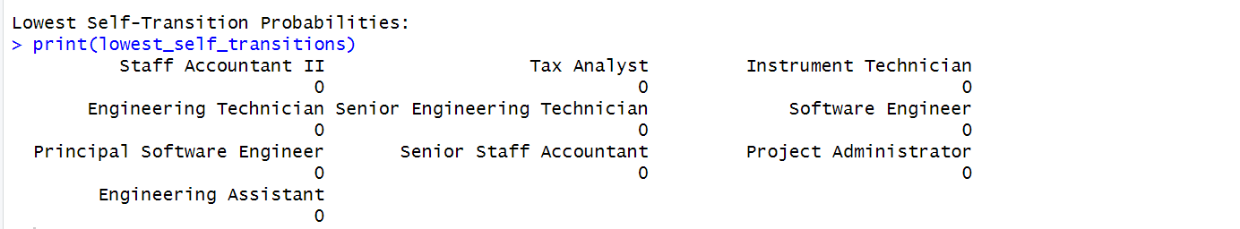 Fig. 2.2: Lowest self-transition probability result

These zero values suggest that, for these roles, individuals consistently transitioned into different positions, which may indicate career growth, job rotation, or structural shifts within the organization.

5.1.3 Transition between specific roles

To better understand specific career progressions captured in the Markov Chain model, individual role-to-role transition probabilities were queried directly from the transition matrix. One such example is the transition from “Engineering Technician” to “Senior Engineering Technician.” This transition represents a natural upward movement or promotion within the engineering career path.
Fig. 3: Transition probability between specific roles

This result indicates that, based on the historical resume data analyzed, 50% of individuals who were previously employed as Engineering Technicians transitioned to the role of Senior Engineering Technician. This is a significant proportion and suggests that this upward movement is a highly common and expected progression within the dataset.

5.1.4 Heat map visualisation of Top Roles transitions
To further analyze and visually communicate the dynamics of career transitions, a heatmap was generated to display the transition probabilities between the most commonly observed job roles in the dataset. Since the complete transition matrix contains a large number of roles and may appear cluttered, the matrix was filtered to include only the top 10 roles based on the frequency of outgoing transitions.
This selection was performed by calculating the row-wise sum of the transition matrix and selecting the roles with the highest totals.The heatmap was plotted using the ggplot2 library, where each cell represents the probability of transition from one role to another. The fill color of each cell encodes the transition probability on a gradient scale from white (zero probability) to deep blue (high probability).
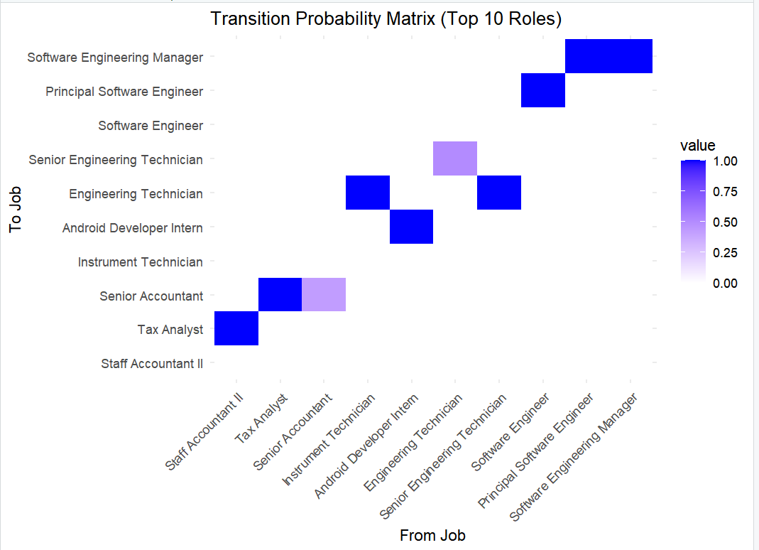 Fig. 4: Heat map of top 10 roles based on outgoing transitions

Notable patterns include strong diagonal elements, indicating high role stability or self-transitions, and several prominent off-diagonal cells, which suggest frequent upward or lateral movements. For example, transitions such as “Staff Accountant II” to “Tax Analyst,” “Tax Analyst” to “Senior Accountant,” and “Engineering Technician” to “Senior Engineering Technician” appear clearly in the heatmap, visually reinforcing the typical paths observed in earlier matrix and probability analyses.

5.1.5 Detecting Promotions and visualizing using network graph
In this analysis, we focus on detecting promotions within the organization using Markov Chain transitions. To identify promotions, we define a set of keywords that indicate a promotion in the job title. These keywords include terms such as "Senior," "Manager," "President," "Director," "VP," "Executive," and others that suggest higher-ranking roles.
A function was implemented to check whether a transition from one position to another indicates a promotion. This function works by checking if the "from" position does not contain any promotion-related keywords and the "to" position does.
The detected promotions are summarized as :
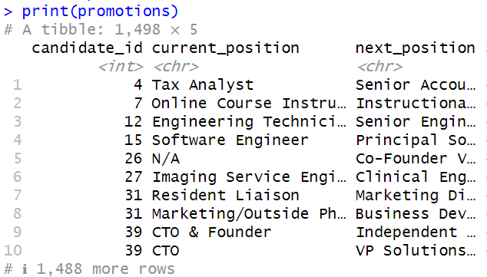
Fig. 5.1: Detected promotions

Promotion Counts:
The following table summarizes the number of promotions detected for each current position:
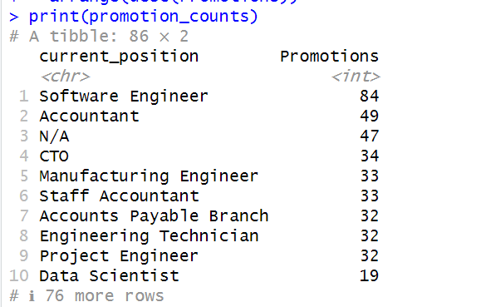
Fig. 5.2: Promotion count in each job role

This Markov Chain analysis successfully detected promotions based on job title transitions. The results indicate key roles, such as "Software Engineer" and "Accountant," have the highest promotion frequencies.
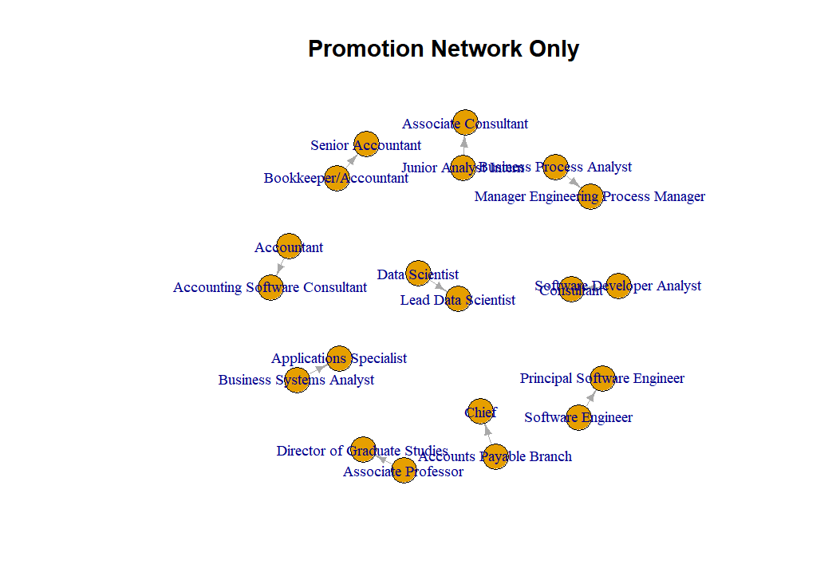 Fig. 6: Network graph representing potential promotions paths

Clear Upward Trajectories: The arrows clearly indicate potential promotion paths. For example, an Accountant can potentially move to Senior Accountant or Accounting Software Consultant.
Potential "Feeder" Roles: Some roles seem to act as common stepping stones to other positions. For instance, the "Consultant" role has arrows leading to "Associate Consultant" and "Manager Engineering Process Manager," suggesting it might be a versatile role for moving into different specializations or management.
Movement Across Domains: The diagram suggests some potential for movement between different functional areas. For example, a "Business Systems Analyst" could potentially move to "Applications Specialist," indicating a shift within the business and technology domains.

5.1.6 Career Transition Network Diagram
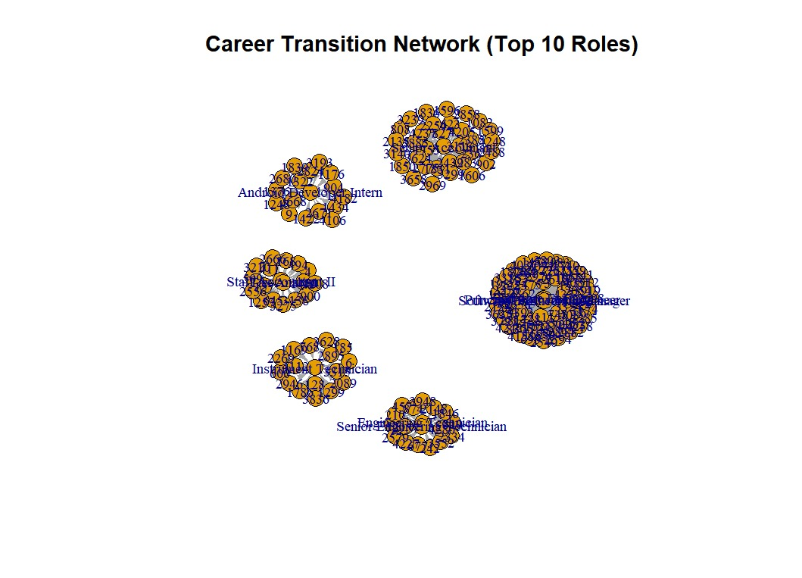
Fig. 7: Cluster representation of career transition paths

Clustered Representation: Instead of a directed graph showing individual transitions, this plot likely displays clusters of roles. Each cluster probably represents a group of roles that have a high degree of transition probability within the cluster.
Roles within the same cluster probably see more movement amongst themselves than with roles in other clusters. Clusters with fewer connections to other clusters might represent more specialized or siloed career paths, where movement is primarily within the group. If roles A, B, and C are tightly clustered, it suggests frequent movement between these roles.

5.1.7 Hierarchial Clustering and Dendogram

To uncover patterns in role similarity and to identify job clusters based on transition behavior, hierarchical clustering was applied to the transition probability matrix. This technique groups job roles based on how similar their transition profiles are, without the need to predefine the number of clusters.
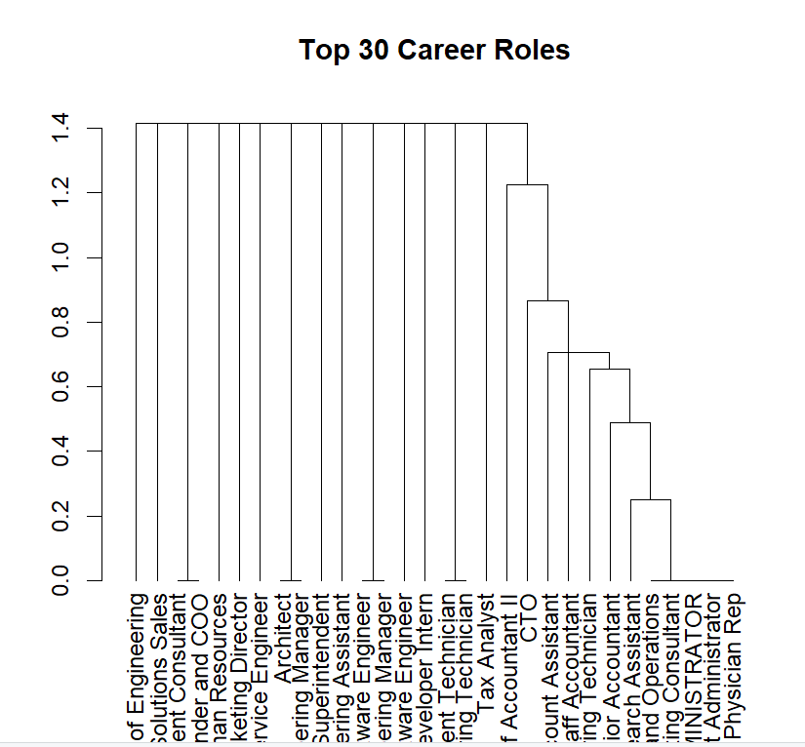
Fig. 8: Dendrogram of top 30 career roles

A dendrogram is a tree diagram that shows how things (like jobs) group together based on similarity.
In our case:
- It shows which job roles have similar career transition patterns.
- Similar = candidates move between them frequently or have similar movement behavior
Interpretation :
- Bottom leaves (labels): represent individual job roles.
- Branches merging together: jobs grouped because they behave similarly.
- Height of a merge (y-axis):
- Low height merge → roles are very similar (more career transition between them).
- High height merge → roles are less similar.
General Rule:
The closer jobs merge at the bottom, the more naturally connected they are in the real career paths.
From the dendogram :
On the right side: Roles like: Physician Rep, ADMINISTRATOR, Consultant, Research Assistant, Senior Accountant,these merge very quickly (at low height). These roles are highly similar in how people move across them — strong internal mobility.
On the left side: Roles like: VP of Engineering, Chief Solutions Consultant, Sales Consultant, Founder and CEO, Marketing Director,these stand alone longer before merging. These are very distinct roles with specialized career paths, fewer transitions to other fields.
Middle merging around Accountant, Staff Accountant II, Tax Analyst, etc. These merge at moderate heights. Mid-level finance roles have moderate similarity — some but not huge transition overlap.

5.1.8 Simulation of career transitions over n steps

To further understand the dynamics of career progression, we utilized a Markov Chain framework to simulate career transitions over multiple steps. This allows us to model a potential career trajectory starting from a given role and observe how it evolves over time based on historical transition probabilities.
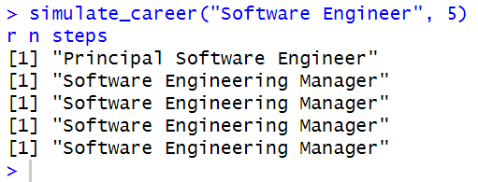
Fig. 9: Result of career transitions over n steps

Starting from the role of Software Engineer, the simulation suggests a likely progression towards more senior and managerial positions. In this run, the individual moved to Principal Software Engineer and subsequently stabilized in the role of Software Engineering Manager, indicating high retention or transition probabilities within that managerial path.
The Markov Chain simulation effectively models likely career trajectories. This tool can be used to:
- Predict future roles of employees based on historical data.
- Identify roles that act as hubs or common end-points in career progression.
- Assist in career path planning and workforce development strategy.

5.2 Z-score Analysis
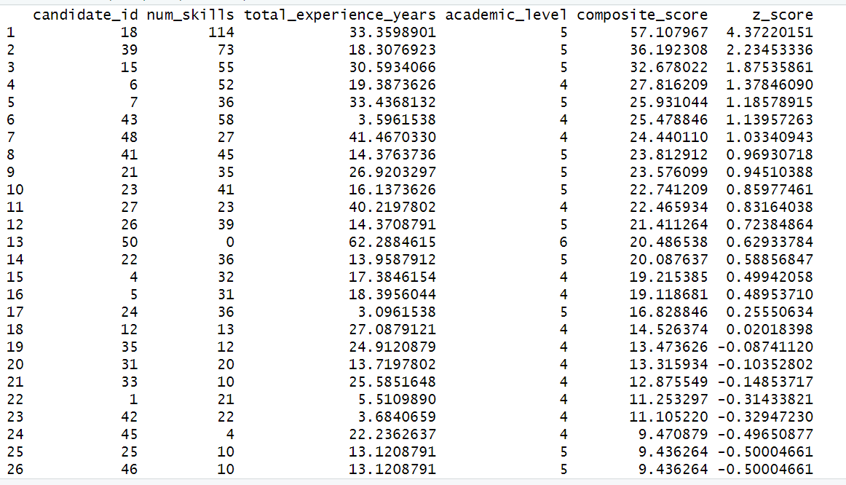 Fig. 10.1: Z-score result of top 1-26 candidates

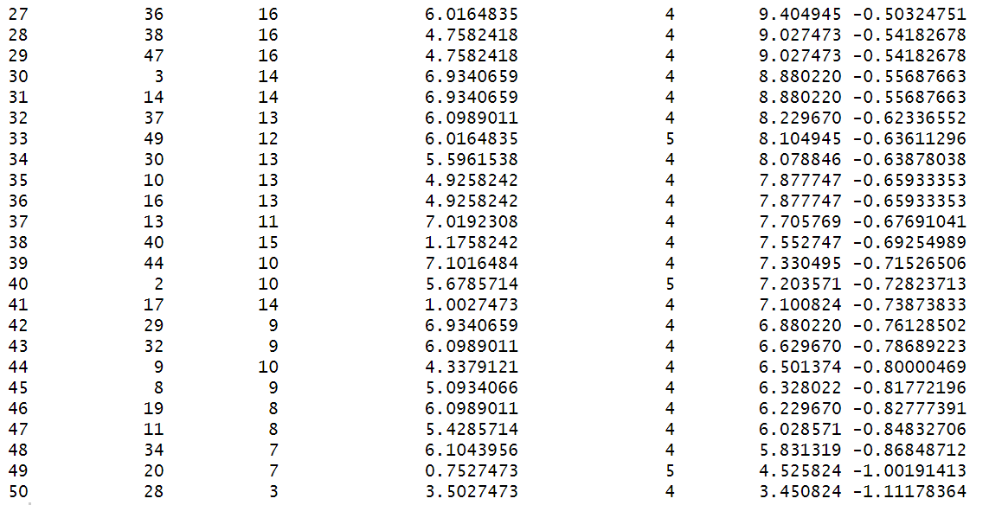 Fig. 10.2: Z-score result of top 27-50 candidates
5.2.1 Interpretation :
- The top performer is Candidate 18, with a Z-score of 4.37, indicating an exceptionally high combination of skills (114), extensive experience (~33 years), and high academic standing.
- Candidates such as 39, 15, and 6 also stood out, each with Z-scores above 1.3, demonstrating strong overall profiles suitable for advanced roles or leadership transitions.
- The top 10 candidates all had Z-scores above 0.85, making them prime targets for further exploration in internal mobility or promotion scenarios.
- At the lower end, Candidate 28 had the lowest Z-score (~-1.11), highlighting a profile with limited skills, experience, or academic credentials compared to the cohort.
Candidates with Z-scores above 1.0 can be considered high-potential employees for targeted development or immediate career advancement. Those significantly below the mean (Z < -0.5) may benefit from upskilling programs or mentoring support.

5.3 Bayes Theorem Analysis
In the following figure, the first 20 unique results under this category have been displayed.

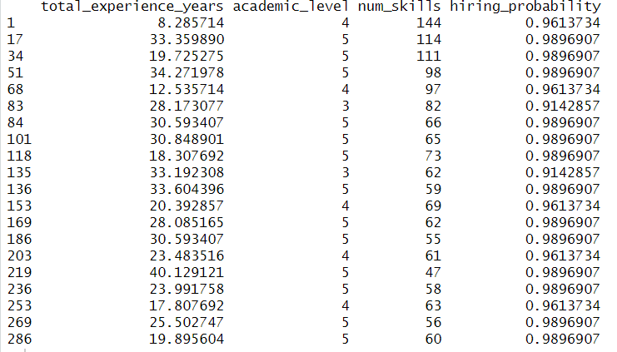 Fig. 11: Hiring probabilities of top 20 candidates

5.3.1 Interpretation
Based on the data and heuristics we have, from our output displayed, we can infer the following:
- A candidate with academic level 4, about 8 years of experience and 144 skills has about 96% chances of getting selected.
- A candidate with academic level 5, about 33 years of experience and 114 skills has about 99% chances of getting selected.
- And so on.
Do the probabilities look anomalous? In our opinion, yes. But that’s what our simplistic hypothetical parameter values yield. When processed using adequate real-world data, the values calculated here are expected to be more realistic.

Future Prospects

6.1. Real-Time Resume Processing:
Future versions of our model aim to support real-time ingestion and processing of new resumes. Instead of analyzing only static datasets, the system will be designed to automatically parse incoming resumes, extract key features, and generate predictive insights instantly.
6.2. Integration with Historical and Dynamic Data Sources:
Currently, our model depends on heuristics due to the absence of detailed historical hiring data. Future developments will involve training on vast, real-world historical datasets sourced from industry partners or anonymized repositories. This will help calibrate probability estimates using real hiring behavior rather than assumed likelihoods, increasing accuracy and reliability.
6.3. Advanced Scoring and Recommendation Engines:
Instead of using a basic weighted sum or z-score, advanced scoring engines can be built using supervised learning models that learn the optimal combination of features (skills, experience, education) from past hiring data.
6.4. Enhancing Parsing Capabilities with NLP and Gen AI:
A significant limitation of the present model lies in its inability to fully comprehend domain-specific educational qualifications and diverse phrasing used in resumes. Future versions will employ Natural Language Processing (NLP) techniques, integrated with Gen AI APIs, to standardize educational qualifications, skillsets, and job titles.

7. Conclusion
In the modern world, digitisation and automation are the talk of the town. With an enormous increase in the amount of electronic data produced everyday, automating the systems that filter them is not intended to replace the human brain entirely but to assist it and reduce its load such that it can be used to perform tasks which require more creativity and a human touch to convene.
In the age where lakhs of resumes are submitted for a very limited number of openings, softwares called Application Tracking Systems (ATS) are used to automatically shortlist candidates for the physical screening rounds. They use much advanced versions of similar techniques that we have used in our project. Our month-long project is a demonstration of how statistical tools and techniques can be used in this automation endeavour.
The current version of our project tries to draw insights from a database of already submitted resumes and can be used to understand trends in the market and among people. As a future direction, we aim to make this model more flexible such that it can input new resumes in real time, perform the required analyses and provide the results. The model shall have the support of more historical data to value parameters instead of arbitrary heuristics, and shall not have the limitations with respect to parsing and matching the educational eligibility criteria with a candidate’s education, which our current model version has.
The future versions of our model shall have the integrated support of Machine Learning for drawing predictive inferences about a candidate’s future and Natural Language Processing through Gen AI API(s) to automate the process of creating our vector dataset against which key phrases related to parameters such as one’s education will be compared while assigning a more homogeneous value to the concerned candidate in order to make the comparison with all other candidates much easier. (For example, education parsed to derive academic level).

8. Appendix

8.1) Original Dataset – resume_data.csv
Can be accessed at – https://github.com/AbitathaRoy/AI-Job-Matching/blob/main/resume_data.csv (30/04/2025)

8.2) Main Program – candidate_scoring.R
Can also be accessed at – https://github.com/AbitathaRoy/AI-Job-Matching/blob/main/candidate_scoring.R (30/04/2025)
# Load required libraries
# Install these packages only if you haven't already
# install.packages("tidyverse")
# install.packages("markovchain")

library(tidyverse)
library(markovchain)

# --- Data Loading and Initial Cleaning ---

# Load the dataset
resume_data <- read.csv("D:\\Projects with Git\\AI-Job-Matching\\resume_data.csv", stringsAsFactors = FALSE)
head(resume_data)

# Clean column names (remove special characters like hidden BOM)
names(resume_data) <- str_replace_all(names(resume_data), "[^[:alnum:]_]", "")
names(resume_data)

# --- Date Handling ---

# Clean the dates (function)
clean_date_string <- function(date_str) {
date_str <- gsub("\\[|\\]", "", date_str) # Remove [ and ]
date_str <- gsub("'", "", date_str) # Remove single quotes
date_str <- gsub("None|N/A", "NA", date_str, ignore.case = TRUE) # Replace with NA
date_items <- strsplit(date_str, ",\\s*")[[1]] # Split by comma
return(date_items)
}
resume_data$start_dates_clean <- lapply(resume_data$start_dates, clean_date_string)
resume_data$start_dates_clean
resume_data$end_dates_clean <- lapply(resume_data$end_dates, clean_date_string)
resume_data$end_dates_clean

# Parse cleaned dates and create date objects (function)
parse_flexible_date <- function(date_str) {
if (is.na(date_str) || date_str == "NA" || grepl("20XX", date_str))
return(NA)

formats <- c("%b %Y", "%B %Y", "%m/%Y", "%Y") # Jan 2020, January 2020, 01/2020, 2020

for (fmt in formats) {
parsed <- as.Date(paste0("01 ", date_str), format = paste0("%d ", fmt))
if (!is.na(parsed))
return(parsed)
}

return(NA) # if all fail
}
resume_data$start_dates_parsed <- lapply(resume_data$start_dates_clean, function(date_vec) {
lapply(date_vec, parse_flexible_date)
})
resume_data$end_dates_parsed <- lapply(resume_data$end_dates_clean, function(date_vec) {
lapply(date_vec, parse_flexible_date)
})
resume_data$start_dates_parsed
resume_data$end_dates_parsed
class(resume_data$start_dates_parsed[[1]][[1]])

# Replace NA end dates with the current date
resume_data$end_dates_parsed <- lapply(resume_data$end_dates_parsed, function(date_vec) {
# Replace NAs with today's date
date_vec[is.na(date_vec)] <- Sys.Date()

# Convert each element of date_vec to Date
date_vec <- lapply(date_vec, function(d) as.Date(d)) # Convert each date in the vector

return(date_vec)
})
resume_data$end_dates_parsed

# Drop rows with any invalid (too old) start dates
valid_entries <- sapply(resume_data$start_dates_parsed, function(start_list) {
all(sapply(start_list, function(d) {
!is.na(d) && as.numeric(d) > as.numeric(as.Date("1900-01-01"))
}))
})

resume_data <- resume_data[valid_entries, ]

# Calculate experience in years
safe_as_date <- function(x) {
if (inherits(x, "Date")) return(x)
if (is.numeric(x)) return(as.Date(x, origin = "1970-01-01"))
if (is.character(x)) return(as.Date(x))
return(NA)
}

resume_data$experience_years <- mapply(function(start_dates, end_dates) {
# Safely convert all entries inside each list element
start_dates <- lapply(start_dates, safe_as_date)
end_dates <- lapply(end_dates, safe_as_date)

# Unlist and convert to Date again just in case
start_dates <- as.Date(unlist(start_dates), origin = "1970-01-01")
end_dates <- as.Date(unlist(end_dates), origin = "1970-01-01")

n <- min(length(start_dates), length(end_dates))

diffs <- difftime(end_dates[1:n], start_dates[1:n], units = "weeks")
as.numeric(diffs) / 52
}, resume_data$start_dates_parsed, resume_data$end_dates_parsed, SIMPLIFY = FALSE)

# Testing
class(resume_data$start_dates_parsed[[2]])
head(resume_data$start_dates_parsed)
head(Map(function(s, e, x) list(start = s, end = e, experience = x),
resume_data$start_dates_parsed,
resume_data$end_dates_parsed,
resume_data$experience_years), 5)

# Calculating total experience years

resume_data$total_experience_years <- sapply(resume_data$experience_years, function(x) {
if (all(is.na(x))) {
return(NA_real_)
} else {
return(sum(x, na.rm = TRUE))
}
}) # In our simplified case, while comparing years and stuff, we will consider the total experience gained till date
# Not the number of years in xyz role or abc field or things like that

# --- Education Level Mapping ---

head(resume_data$degree_name, 15)

# Converting data to lists
parse_degrees <- function(degree_str) {
# Remove brackets and split by commas
degrees <- gsub("\\[|\\]|'", "", degree_str) # remove [ ] and '
degrees_split <- strsplit(degrees, ",")[[1]]
# Trim whitespace
degrees_trimmed <- trimws(degrees_split)
return(degrees_trimmed)
}
resume_data$degree_name_parsed <- lapply(resume_data$degree_name, parse_degrees)

head(resume_data$degree_name_parsed, 15)

# Define keyword lists for each academic level
below_class_x <- c("below class x", "none", "n/a", "select one", "skills", "course", "general courses", "seminar", "esol program", "kcpe", "correspondence/distance learning", "attending", "minor", "course revisions")
class_x <- c("class x", "x", "high school diploma", "ged", "grade 12", "school certificate", "kcse")
class_xii <- c("class xii", "xii", "a level", "certification", "certificate", "diploma", "technical diploma", "general diploma", "certificate of completion", "lean certification", "six sigma", "epa certification", "aws brazing", "poke-a-yoke", "neec building", "applied industrial ergonomics", "shipboard firefighting", "waste heat boilers", "class facilitator", "food handler", "project management graduate certificate", "business certification", "certified professional coach", "cacc certification", "pharmacy technician", "acca ii", "testing computer software", "principles of management", "association of business executive", "engineering common core", "engineering mechanical", "engineering electrical", "gas turbine mechanical/electrical", "shipbd gage cal", "machinery control system", "marine maintenance", "waste heat boilers")
ug <- c("b.tech", "b.sc", "b.a", "b.com", "b.e", "b.s", "b.b.a", "b.c.a", "bachelor", "bs", "ba", "be", "bba", "bca", "btech", "associate", "a.a", "a.s", "a.a.s", "honours bachelor", "integrated b.tech", "integrated b.e.", "bsc", "honors", "international business", "business development", "executive management")
pg <- c("m.tech", "m.sc", "m.a", "m.com", "m.b.a", "m.s", "m.e", "m.eng", "master", "msc", "ms", "mba", "mca", "post graduation", "pg diploma", "graduate certificate", "executive mba", "masters", "integrated m.tech", "integrated m.e.", "mbm", "mcom")
phd <- c("phd", "ph.d", "doctor of philosophy", "phd candidate", "d.b.a")

# Function to determine academic level
assign_academic_level <- function(degree_string) {
# Convert degree string to lowercase for case-insensitive matching
degree_string <- tolower(degree_string)

# Check lists in descending order to assign highest level
if (any(sapply(phd, function(x) grepl(x, degree_string)))) {
return(6)
} else if (any(sapply(pg, function(x) grepl(x, degree_string)))) {
return(5)
} else if (any(sapply(ug, function(x) grepl(x, degree_string)))) {
return(4)
} else if (any(sapply(class_xii, function(x) grepl(x, degree_string)))) {
return(3)
} else if (any(sapply(class_x, function(x) grepl(x, degree_string)))) {
return(2)
} else if (any(sapply(below_class_x, function(x) grepl(x, degree_string)))) {
return(1)
} else {
return(1) # Default to Below Class X for unmatched entries
}
}

# Apply the function to create the new column
resume_data$academic_level <- sapply(resume_data$degree_name_parsed, function(degree_vec) {
degree_string <- paste(degree_vec, collapse = " ")
assign_academic_level(degree_string)
})

head(resume_data$academic_level)

# --- Data Filtering ---

# Drop rows where all experience values are NA and where academic_level is NA
# Step 1: Identify which rows have all NAs in experience_years
# all_exp_na <- sapply(resume_data$experience_years, function(x) all(is.na(x)))
# Step 2: Subset the dataframe manually (using indexing)
# resume_data <- resume_data[!all_exp_na & !is.na(resume_data$academic_level), ]

# Drop rows where even one experience value is NA or where academic level is NA
library(tidyr)
resume_data <- resume_data %>%
drop_na(experience_years, academic_level)

# Checking if it worked. Should return 0.
# sum(sapply(resume_data$experience_years, function(x) all(is.na(x))))
# sum(is.na(resume_data$academic_level))
sum(is.na(resume_data$experience_years))
sum(is.na(resume_data$academic_level))

# --- Educational Requirements ---

assign_required_academic_level <- function(degree_string) {
# Convert degree string to lowercase for case-insensitive matching
degree_string <- tolower(degree_string)

# Check lists in ascending order to assign lowest level
if (any(sapply(below_class_x, function(x) grepl(x, degree_string)))) {
return(1)
} else if (any(sapply(class_x, function(x) grepl(x, degree_string)))) {
return(2)
} else if (any(sapply(class_xii, function(x) grepl(x, degree_string)))) {
return(3)
} else if (any(sapply(ug, function(x) grepl(x, degree_string)))) {
return(4)
} else if (any(sapply(pg, function(x) grepl(x, degree_string)))) {
return(5)
} else if (any(sapply(phd, function(x) grepl(x, degree_string)))) {
return(6)
} else {
return(1) # Default to Below Class X for unmatched entries
}
}
resume_data$required_academic_level <- sapply(resume_data$educationaL_requirements, function(degree_vec) {
degree_string <- paste(degree_vec, collapse = " ")
assign_required_academic_level(degree_string)
})

# --- Required Experience Years ---

# Renaming (well, not exactly)
resume_data$required_experience <- resume_data$experiencere_requirement

unique(resume_data$required_experience)

# Parsing and storing required experience as a vector
parse_experience_range <- function(text) {
text <- tolower(text)

if (grepl("at least", text)) {
num <- as.numeric(gsub("[^0-9]", "", text))
return(c(num, 100))
} else if (grepl("to", text)) {
bounds <- as.numeric(unlist(regmatches(text, gregexpr("[0-9]+", text))))
return(c(bounds[1], bounds[2]))
} else if (grepl("at most", text)) {
num <- as.numeric(gsub("[^0-9]", "", text))
return(c(0, num))
} else {
return(NA) # For empty or unrecognized patterns
}
}
resume_data$required_experience_range <- lapply(resume_data$required_experience, function(exp_str) {
parse_experience_range(exp_str)
})

# Drop ineligible candidates (based on academic level and experience)

ranges <- resume_data$required_experience_range
experiences <- resume_data$total_experience_years

# Apply logic element-wise
valid_rows <- mapply(function(range, exp) {
if (is.null(range) || length(range) == 0 || all(is.na(range))) {
return(TRUE) # Keep rows with NULL or empty `range` or all NA's
}

# Ensure that 'range' is a vector with exactly two values
if (length(range) != 2 || any(is.na(range)) || is.na(exp)) {
return(FALSE) # Filter rows with invalid range or experience NA
}

# Check if the experience falls within the specified range
exp >= range[1] && exp <= range[2]
}, ranges, experiences)

# Filter the data based on the valid rows and academic level condition
resume_data <- resume_data[valid_rows & resume_data$academic_level >= resume_data$required_academic_level, ]

# --- Markov Chain Modeling for Career Transitions ---

# Assign candidate IDs
resume_data$candidate_id <- seq_len(nrow(resume_data))

# Parsed job positions held into vectors
parse_positions <- function(pos_string) {
if (is.na(pos_string)) return(NA)

# Remove square brackets and single/double quotes
cleaned <- gsub("\\[|\\]|'", "", pos_string)

# Split by comma
positions <- unlist(strsplit(cleaned, ","))

# Trim whitespace
positions <- trimws(positions)

return(positions)
}
resume_data$positions_parsed <- lapply(resume_data$positions, parse_positions)

library(dplyr)
library(tidyr)
library(purrr)

# Diagnostic: Check vector lengths for mismatches
resume_data <- resume_data %>%
mutate(
pos_length = map_int(positions_parsed, length),
start_length = map_int(start_dates_parsed, length),
end_length = map_int(end_dates_parsed, length),
length_mismatch = pos_length != start_length | pos_length != end_length
)

# Print rows with mismatched lengths for review
mismatch_rows <- resume_data %>%
filter(length_mismatch) %>%
select(candidate_id, pos_length, start_length, end_length, positions_parsed, start_dates_parsed, end_dates_parsed)
print("Rows with mismatched vector lengths:")
print(mismatch_rows)

# Function to pad vectors to the same length
pad_vectors <- function(pos, start, end) {
max_len <- max(length(pos), length(start), length(end))
list(
positions = c(pos, rep(NA, max_len - length(pos))),
start_dates = c(start, rep(NA, max_len - length(start))),
end_dates = c(end, rep(NA, max_len - length(end)))
)
}

# Prepare data by padding vectors
resume_data_padded <- resume_data %>%
mutate(
padded = pmap(list(positions_parsed, start_dates_parsed, end_dates_parsed), pad_vectors),
positions_parsed = map(padded, "positions"),
start_dates_parsed = map(padded, "start_dates"),
end_dates_parsed = map(padded, "end_dates")
) %>%
select(-padded)

# Create the transitions data frame
transitions <- resume_data_padded %>%
# Select relevant columns
select(candidate_id, positions_parsed, start_dates_parsed, end_dates_parsed) %>%
# Filter out rows with empty positions_parsed
filter(map_int(positions_parsed, length) > 0) %>%
# Unnest the vector columns into rows
unnest(cols = c(positions_parsed, start_dates_parsed, end_dates_parsed)) %>%
# Group by candidate_id to process each candidate's job history
group_by(candidate_id) %>%
# Arrange by reverse index to process from earliest to latest (since vectors are most recent first)
arrange(desc(row_number()), .by_group = TRUE) %>%
# Create current_position and next_position
mutate(
current_position = positions_parsed,
next_position = lead(positions_parsed)
) %>%
# Select final columns and rename dates
select(
candidate_id,
current_position,
next_position,
start_date = start_dates_parsed,
end_date = end_dates_parsed
) %>%
ungroup() %>%
# Remove rows with NA in current_position
filter(!is.na(current_position))

# -- MARKOV CHAIN --

library(dplyr)
library(markovchain)

# Prepare transitions for Markov chain
# Step 1: Filter out NA and invalid titles
valid_transitions <- transitions %>%
filter(
!is.na(current_position) &
!is.na(next_position) &
!current_position %in% c("N/A", "None") &
!next_position %in% c("N/A", "None")
)

# Step 2: Get common roles (roles in both current and next positions)
common_roles <- intersect(
unique(valid_transitions$current_position),
unique(valid_transitions$next_position)
)

# Step 3: Filter transitions to only common roles
valid_transitions <- valid_transitions %>%
filter(
current_position %in% common_roles &
next_position %in% common_roles
) %>%
select(current_position, next_position)

# Diagnostic: Check number of unique roles
cat("Number of common roles used:", length(common_roles), "\n")
cat("Unique roles in current_position:", length(unique(valid_transitions$current_position)), "\n")
cat("Unique roles in next_position:", length(unique(valid_transitions$next_position)), "\n")

# Step 4 (fixed): Create a complete square transition matrix
all_roles <- union(valid_transitions$current_position, valid_transitions$next_position)

trans_matrix <- table(
factor(valid_transitions$current_position, levels = all_roles),
factor(valid_transitions$next_position, levels = all_roles)
)

# Step 5 (force correct class): Convert to numeric matrix row-wise
prob_matrix <- prop.table(trans_matrix, 1)
prob_matrix <- matrix(as.numeric(prob_matrix),
nrow = nrow(trans_matrix),
dimnames = dimnames(trans_matrix))
class(prob_matrix)

# Fix numerical imprecision — re-normalize rows strictly
row_sums <- rowSums(prob_matrix)
prob_matrix <- sweep(prob_matrix, 1, row_sums, FUN = "/")

summary(rowSums(prob_matrix)) # Should all be 1

# Replace NaN (from zero rows) with 0
prob_matrix[is.nan(prob_matrix)] <- 0

summary(rowSums(prob_matrix)) # Should all be 1

# Step 6: Now the matrix is square (safe to proceed)
cat("Final square probability matrix dimensions:", dim(prob_matrix), "\n")

# - Fixing Errors with Assumptions -

# Step 7: Identify roles with zero transitions and handle them by assigning self-transition probability

# We will loop through each row of the transition matrix, checking for rows that sum to zero.
# If any row sums to zero (i.e., no one has transitioned out of that role), we will assign the
# transition probability for the self-transition (i.e., from the role to itself) to 1.

# Loop through each row of the probability matrix
for (i in 1:nrow(prob_matrix)) {
# Check if the sum of the row is zero (i.e., no one transitioned out of the role)
if (sum(prob_matrix[i, ]) == 0) {
# Assign the self-transition probability (current position to itself) to 1
prob_matrix[i, i] <- 1
}
}

# Check if the row sums are now all 1, as they should be for a valid Markov Chain transition matrix
cat("Row sums after fixing zero rows:\n")
summary(rowSums(prob_matrix)) # Should all be 1 after this step

# Step 8: Proceed with creating the Markov Chain object
# After ensuring the transition matrix is valid (all rows sum to 1), we can safely create the Markov chain
mc <- new("markovchain", transitionMatrix = prob_matrix)

# Final check
cat("Markov Chain successfully created.\n")
summary(mc)

# Optional: View sample of transition matrix
cat("\nSample of Transition Probability Matrix (first 5 roles):\n")
print(prob_matrix[1:5, 1:5])

# -- Analytics with Markov Chains --

# 1 - The top 10 and bottom 10 lucrative positions -

total_incoming_prob <- colSums(prob_matrix)
lucrative_jobs <- sort(total_incoming_prob, decreasing = TRUE)
cat("Most lucrative jobs:\n")
print(lucrative_jobs[1:10]) # Top 10 lucrative jobs
cat("\nLeast lucrative jobs:\n")
print(lucrative_jobs[(length(lucrative_jobs)-9):length(lucrative_jobs)]) # Bottom 10 lucrative jobs

# 2 - Job Stability - Self Transitions -

self_transition_prob <- function(prob_matrix) {
# Extract the diagonal elements (self-transition probabilities)
diag_probs <- diag(prob_matrix)

# Get row and column names (labels)
row_labels <- rownames(prob_matrix)
col_labels <- colnames(prob_matrix)

names(diag_probs) <- row_labels

return(diag_probs)
}

# Calculate the self-transition probabilities
self_transitions <- self_transition_prob(prob_matrix)

# Identify the jobs with the highest and lowest self-transition probabilities
temp <- 10 # how many to show?
highest_self_transitions <- head(sort(self_transitions, decreasing = TRUE), n = temp)
lowest_self_transitions <- head(sort(self_transitions, decreasing = FALSE), n = temp)

# Print the results
cat("Self-Transition Probabilities:\n")
print(self_transitions)

cat("\nHighest Self-Transition Probabilities:\n")
print(highest_self_transitions)

cat("\nLowest Self-Transition Probabilities:\n")
print(lowest_self_transitions)

# 3 - Transitions between Specific Roles -

# Example: Transition probability from "Senior Accountant" to "Tax Analyst"
transition_prob <- prob_matrix["Senior Accountant", "Tax Analyst"]
print(transition_prob)

# 4 - State Distribution Over Time -

# Calculate steady-state distribution (using the power method or linear algebra)
steady_state <- rep(1, ncol(prob_matrix)) # Initial guess (uniform distribution)
steady_state <- steady_state %*% prob_matrix # Multiply by transition matrix
steady_state <- steady_state / sum(steady_state) # Normalize to sum to 1
print(steady_state)

# 5 - Transition Visualisation -

# Heat Map

library(ggplot2)
library(reshape2)

# Melt the matrix for visualization
prob_matrix_melted <- melt(prob_matrix)

# Create the heatmap
ggplot(prob_matrix_melted, aes(x = Var1, y = Var2, fill = value)) +
geom_tile() +
scale_fill_gradient(low = "white", high = "blue") +
theme_minimal() +
xlab("From Job") +
ylab("To Job") +
ggtitle("Transition Probability Matrix Heatmap")

# Select Top 10 Common Roles (or any number you want)
top_roles <- names(sort(rowSums(prob_matrix), decreasing = TRUE))[1:10]

# Subset your transition matrix
prob_matrix_subset <- prob_matrix[top_roles, top_roles]

# Melt the smaller matrix
prob_matrix_melted <- reshape2::melt(prob_matrix_subset)

# Plot the Heatmap again
library(ggplot2)

ggplot(prob_matrix_melted, aes(x = Var1, y = Var2, fill = value)) +
geom_tile() +
scale_fill_gradient(low = "white", high = "blue") +
theme_minimal() +
xlab("From Job") +
ylab("To Job") +
ggtitle("Transition Probability Matrix (Top 10 Roles)") +
theme(axis.text.x = element_text(angle = 45, hjust = 1))

# To detect Promotions :
# Define promotion keywords
promotion_keywords <- c("Senior", "Lead", "Principal", "Manager", "Director", "Head", "Chief", "VP")

# Function to check if a title indicates a promotion
is_promotion <- function(from_title, to_title) {
from_promotion <- any(str_detect(from_title, promotion_keywords))
to_promotion <- any(str_detect(to_title, promotion_keywords))

# Promotion occurs when moving from non-promotion to promotion title
return(!from_promotion & to_promotion)
}

library(dplyr)

# Find Promotions
promotions <- transitions %>%
filter(!is.na(current_position) & !is.na(next_position)) %>%
filter(mapply(is_promotion, current_position, next_position))

# View promotions
print(promotions)

promotion_counts <- promotions %>%
group_by(current_position) %>%
summarise(Promotions = n()) %>%
arrange(desc(Promotions))

print(promotion_counts)

# Network Diagram
library(igraph)

# Create an igraph object from the transition matrix
graph <- graph_from_adjacency_matrix(prob_matrix, weighted = TRUE, mode = "directed")

# Plot the network
plot(graph, vertex.size = 5, vertex.label.cex = 0.7, edge.arrow.size = 0.5)

# 6 - Role Transition Clusters -

# Using Hierarchical Clustering

dist_matrix <- dist(prob_matrix)
hc <- hclust(dist_matrix)

# plotting only top 10:
library(igraph)

# Top 10 most common roles
top_roles <- names(sort(rowSums(prob_matrix), decreasing = TRUE))[1:10]

# Filter transitions
filtered_transitions <- transitions %>%
filter(current_position %in% top_roles & next_position %in% top_roles)

# Create igraph
g <- graph_from_data_frame(filtered_transitions, directed = TRUE)

# Plot
plot(g, vertex.size = 10, vertex.label.cex = 0.8, edge.arrow.size = 0.5,
main = "Career Transition Network (Top 10 Roles)")

# PLotting only promotions :
# Use promotions data you found earlier
promotion_counts <- promotions %>%
group_by(current_position, next_position) %>%
summarise(count = n(), .groups = 'drop') %>%
arrange(desc(count))

# Take Top 20 most common promotions
top_promotions <- promotion_counts %>%
slice_head(n = 10)

g <- graph_from_data_frame(top_promotions, directed = TRUE)

plot(g, vertex.size = 15, vertex.label.cex = 0.8, edge.arrow.size = 0.5,
main = "Promotion Network Only")

# Plot the dendrogram

plot(hc)

# visualising only top roles in dendogram
# Top 30 roles
top_roles <- names(sort(rowSums(prob_matrix), decreasing = TRUE))[1:30]

# Subset transition matrix
prob_matrix_top <- prob_matrix[top_roles, top_roles]

# Recompute distance and cluster
dist_matrix_top <- dist(prob_matrix_top)
hc_top <- hclust(dist_matrix_top, method = "complete")

# Plot
plot(as.dendrogram(hc_top), main="Top 30 Career Roles")

# 7 - Markov Chain Analysis - Career Transition over n steps

simulate_career <- function(start_role, steps) {
current_state <- start_role
for (i in 1:steps) {
current_state <- sample(1:ncol(prob_matrix), 1, prob = prob_matrix[current_state, ])
print(rownames(prob_matrix)[current_state])
}
}

simulate_career("Software Engineer", 5) # Simulate from "X" for n steps

# --- Z-score Ranking --- [FLAGGED]

library(dplyr)
library(stringr)
library(purrr)

# Define parser for Python-style skill lists
parse_list <- function(skill_str) {
skill_str %>%
str_remove_all("\\[|\\]|'") %>% # remove square brackets and single quotes
str_split(",\\s*") %>% # split by comma and optional spaces
unlist() %>%
str_trim() %>%
discard(~ .x == "") # remove empty strings
}
resume_data <- resume_data %>%
mutate(
skills_parsed = map(skills, parse_list),
num_skills = map_int(skills_parsed, length),
composite_score = 0.4 * num_skills +
0.3 * total_experience_years +
0.3 * academic_level,
z_score = as.numeric(scale(composite_score))
) %>%
arrange(desc(z_score))

# Set n for top candidates to display
n <- 50 # Change as needed

# Filter transitions where next_position is NA
filtered_transitions <- transitions %>%
filter(is.na(next_position))

# Join filtered transitions with resume_data on candidate_id
top_candidates <- resume_data %>%
filter(candidate_id %in% filtered_transitions$candidate_id) %>%
left_join(filtered_transitions, by = "candidate_id") %>% # Join to get current_position
arrange(desc(z_score)) %>%
slice_head(n = n) %>%
select(candidate_id, current_position, z_score) # Display relevant columns

# Print top candidates
print(top_candidates)
resume_data %>%
filter(candidate_id <= 50) %>%
select(candidate_id, num_skills, total_experience_years, academic_level, composite_score)

# --- Estimating Hiring Probability using Bayes Theorem ---

# Define the function to calculate hiring probability
calculate_hiring_probability <- function(experience_years, academic_level, num_skills) {
p_hired <- 0.4 # Prior probability of getting hired

# Conditional probability of experience given hired
p_exp_given_hired <- ifelse(experience_years >= 5, 0.8,
ifelse(experience_years >= 2, 0.6, 0.3))

# Conditional probability of education given hired
p_edu_given_hired <- ifelse(academic_level >= 5, 0.9,
ifelse(academic_level >= 4, 0.7,
ifelse(academic_level >= 3, 0.5, 0.2)))

# Conditional probability of skills given hired
p_skills_given_hired <- ifelse(num_skills >= 10, 0.8,
ifelse(num_skills >= 5, 0.6, 0.4))

# Updated Naive Bayes numerator (multiplying all conditionals)
numerator <- p_exp_given_hired * p_edu_given_hired * p_skills_given_hired * p_hired

# Updated denominator (for normalization)
denominator <- numerator + ((1 - p_exp_given_hired) * (1 - p_edu_given_hired) * (1 - p_skills_given_hired) * (1 - p_hired))

hiring_probability <- numerator / denominator
return(hiring_probability)
}

# Now apply it with three arguments
resume_data$hiring_probability <- mapply(
calculate_hiring_probability,
resume_data$total_experience_years,
resume_data$academic_level,
resume_data$num_skills # <- add this
)

# Display updated probabilities
print(head(resume_data[, c("total_experience_years", "academic_level", "num_skills", "hiring_probability")], 35))

unique(head(resume_data[, c("total_experience_years", "academic_level", "num_skills")], 100))

# --- Data Export ---

# Export the final ranked data to an RDS file
saveRDS(resume_data, "D:\\Projects with Git\\AI-Job-Matching\\resume_ranking_data.rds")

