<form>  
  <input type="radio" name="gender" value="male" checked> Male<br>  
  <input type="radio" name="gender" value="female"> Female<br>  
  <input type="radio" name="gender" value="other"> Other   
</form>

// can only click one of the same name

<form action="/action_page.php">

First name:<br>

<input type="text" name="firstname" >

<br>

Last name:<br>

<input type="text" name="lastname">

<br><br>

<input type="submit" value="Submits">

</form>  
// value is the default value (for submit)

//action saves the submitted values into the specified webpage

// the last value to be checked is selected(in case checked is given to multiple options)

//If the action attribute is omitted, the action is set to the current page.

<form action="/action_page.php" **method="get"**>

<form action="/action_page.php" **method="post"**>

// get- non sensitive info

//post- sensitive info, NOT DISPLAYED ON URL(SEARCH BAR)

* //POST has no size limitations, and can be used to send large amounts of data.
* Form submissions with POST cannot be bookmarked

//Each input field must have a name attribute to be submitted.

If the name attribute is omitted, the data of that input field will not be sent at all.

<form action="/action_page.php">

<fieldset>

<legend>Personal information:</legend>

First name:<br>

<input type="text" name="firstname" value="Mickey">

<br>

Last name:<br>

<input type="text" name="lastname" value="Mouse">

<br><br>

<input type="submit" value="Submit">

</fieldset>

</form>

//The fieldset element is used to group related data in a form, and the legend element defines a caption for the fieldset element.

<input name="firstname" type="text">

If the type attribute is omitted, the input field gets the default type: "text".

//**DROP DOWN**

**<form action="/action_page.php">**

**<select name="cars">**

**<option value="volvo">Volvo</option>**

**<option value="saab">Saab</option>**

**<option value="fiat">Fiat</option>**

**<option value="audi">Audi</option>**

**</select>**

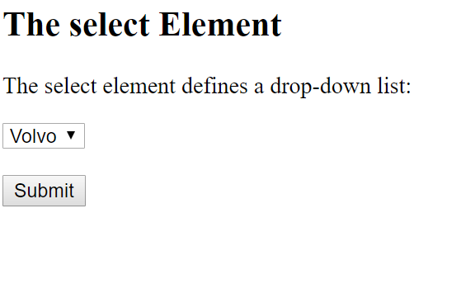

**//DROP DOWN WITH SIZE(SEEN 3 AT A TIME)**

**<form action="/action_page.php">**

**<select name="cars" size="3">**

**<option value="volvo">Volvo</option>**

**<option value="saab">Saab</option>**

**<option value="fiat">Fiat</option>**

**<option value="audi">Audi</option>**

**</select>**

**<br><br>**

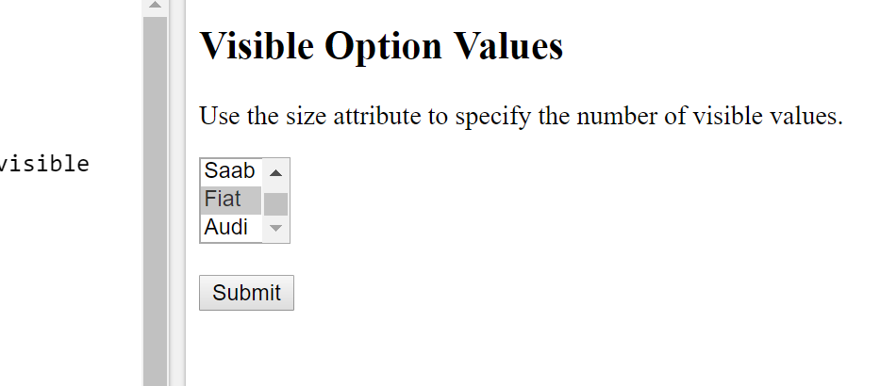

//To define a pre-selected option, add the selected attribute to the option:

<option value="fiat" selected>Fiat</option>