Solar Power Generation Forecasting using an End-to-End MLOps Pipeline on AWS

Student Names: _________________________________
Roll Numbers: _________________________________
Course Name: Essentials of MLOps
Faculty Name: _________________________________

Department of Artificial Intelligence and Machine Learning

Academic Year: 2025-2026

Abstract
This project implements an end-to-end MLOps pipeline for forecasting solar power generation using weather and time-based features. The pipeline covers data versioning with DVC and AWS S3, experiment tracking with MLflow, modular training and evaluation, CI/CD with GitHub Actions, monitoring and governance, Docker containerization, and deployment on AWS EC2. The final XGBoost regression model predicts AC_POWER and achieved RMSE 45.8368, MAE 16.9224, and R2 Score 0.9864. A Streamlit application was built for real-time inference, drift monitoring was implemented for governance, and the deployed Dockerized application was verified on an EC2 Ubuntu instance.

Introduction

Problem Statement
Solar power generation is highly dependent on environmental conditions such as solar irradiation, ambient temperature, module temperature, and time of day. In renewable energy systems, forecasting the generated power is important for grid planning, energy management, and operational monitoring. This project addresses the problem of forecasting AC power generation from a solar plant using a machine learning model and an end-to-end MLOps pipeline.

Objectives
- Develop a regression model to forecast solar AC power output.
- Build a modular and reproducible MLOps pipeline.
- Version raw data using DVC and store it in an AWS S3 remote.
- Track experiments, models, metrics, plots, and drift outputs using MLflow.
- Deploy the model as a real-time prediction application using Streamlit, Docker, and AWS EC2.
- Add CI/CD, monitoring, logging, and governance controls to improve reliability and maintainability.

Scope of the Project
The scope of this project includes raw data versioning, data preprocessing, model training, evaluation, monitoring, deployment, and governance documentation. The project focuses on a single plant dataset and a real-time prediction interface. It does not yet include HTTPS, automated production deployment, or advanced retraining orchestration.

Literature Review
Forecasting renewable energy output has become an important research area because energy generation from solar plants is inherently variable. Most practical solar forecasting systems rely on historical plant data, weather measurements, and temporal features. Supervised regression algorithms are widely applied because they can learn the relationship between environmental conditions and generated power.
Among tabular machine learning methods, gradient boosting models such as XGBoost are frequently used because they can capture nonlinear dependencies, interactions between features, and irregular patterns in operational data. At the same time, modern MLOps practices emphasize that a model alone is not sufficient. A full production-style workflow requires data versioning, experiment tracking, deployment readiness, monitoring, logging, and governance controls.
This project adopts that broader MLOps perspective by combining a forecasting model with DVC, MLflow, GitHub Actions, Docker, Streamlit, AWS S3, and AWS EC2. The result is not only a trained model but a complete pipeline that is reproducible, auditable, deployable, and easier to maintain.

System Architecture

Overall Architecture
- Raw generation and weather datasets are tracked by DVC and stored remotely on AWS S3.
- The ingestion layer loads both datasets and validates their shapes before processing.
- The preprocessing layer merges the datasets on DATE_TIME, creates time-based features, and writes the processed file used for modeling.
- The training layer builds an XGBoost regression model and logs parameters plus model artifacts to MLflow.
- The evaluation layer computes RMSE, MAE, and R2 Score, and generates evaluation visualizations.
- The monitoring layer measures feature drift and generates drift reports for governance.
- The deployment layer exposes the trained model through Streamlit and Docker, and the application is hosted on AWS EC2.
- The CI/CD layer validates the end-to-end workflow through GitHub Actions by pulling DVC data, running the pipeline, and checking the app.
The architecture separates responsibilities across data, modeling, experimentation, deployment, and governance. This separation makes the project easier to debug, extend, document, and evaluate against the Essentials of MLOps rubric.

Pipeline Flow
The end-to-end pipeline begins with DVC-managed raw CSV files. The generation dataset and weather dataset are ingested, cleaned, merged, and transformed into a processed modeling dataset. The processed dataset is then used to train an XGBoost model, evaluate prediction quality, generate plots, and run drift checks. After training, the model is exposed through a Streamlit application for real-time prediction. The same project is validated in CI and containerized for deployment.
- Data collection and versioning
- Data ingestion
- Preprocessing and feature engineering
- Model training
- Evaluation and report generation
- Drift monitoring
- Real-time prediction interface
- Containerization and cloud deployment
- CI/CD validation and governance

Tools and Technologies Used
Category | Tools / Platforms | Purpose
Programming | Python | Core implementation language
Data Processing | Pandas, NumPy | Data loading, cleaning, merge, and feature handling
Modeling | XGBoost, Scikit-learn | Regression and evaluation metrics
Experiment Tracking | MLflow | Runs, parameters, metrics, model artifacts, drift artifacts
Data Versioning | DVC, AWS S3 | Raw data versioning and remote storage
Visualization | Matplotlib, Seaborn | Exploratory and evaluation visualizations
Deployment | Streamlit, Docker, AWS EC2 | Real-time app, containerization, cloud hosting
Automation | GitHub Actions | CI/CD validation workflow
Governance and Logging | Python logging, governance.md, Git | Execution audit trail and process controls

Methodology

Data Handling
The project uses two raw datasets for Plant 1: generation data and weather sensor data. The generation data contains timestamped power and yield values, while the weather data contains irradiation and temperature measurements. During preprocessing, both datasets are aligned using DATE_TIME and merged into a single processed file.
The preprocessing stage converts timestamps, engineers HOUR, DAY, and MONTH features, removes null values, and writes the final dataset to data/processed/final_data.csv. Although the raw merged data contains other generation-related columns, the final forecasting model uses only weather and time features in order to avoid target leakage.

Model Development
The target variable is AC_POWER. The model input features are AMBIENT_TEMPERATURE, MODULE_TEMPERATURE, IRRADIATION, HOUR, DAY, and MONTH. An XGBoost Regressor was selected because it performs strongly on structured tabular data and handles nonlinear relationships well.
The train-test split uses 80 percent training data and 20 percent testing data with random_state 42. Hyperparameters were configured through params.yaml so that the experiment remains reproducible and centrally configurable.

Versioning and Experimentation Strategy
The project uses DVC to track raw data files and store them in an S3 remote. This ensures that raw data changes are reproducible and can be restored using dvc pull. MLflow is used to record experiment metadata, selected features, hyperparameters, train-test counts, model artifact, evaluation metrics, plots, and monitoring outputs.

Experiments and Results

Experimental Setup
Item | Value
Target Variable | AC_POWER
Features | AMBIENT_TEMPERATURE, MODULE_TEMPERATURE, IRRADIATION, HOUR, DAY, MONTH
Model | XGBoost Regressor
Test Size | 0.2
Random State | 42
n_estimators | 100
max_depth | 6
learning_rate | 0.1

Performance Metrics
Metric | Value | Meaning
RMSE | 45.8368 | Root mean squared error
MAE | 16.9224 | Mean absolute error
R2 Score | 0.9864 | Explained variance score
The final model achieved a high R2 score while still relying only on weather and time features. This makes the forecasting setup more realistic than a model that uses generation-derived variables such as DC_POWER. Residual analysis and actual-versus-predicted plots show that the model captures the target trend effectively.

Result Visualizations
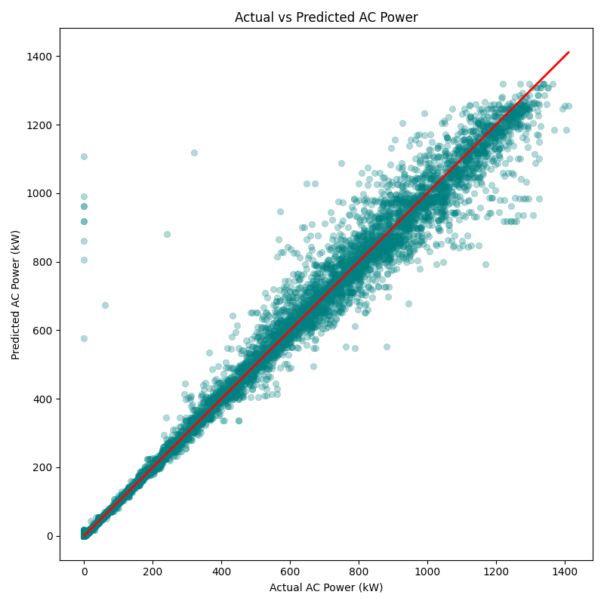
Figure 1. Actual vs Predicted AC Power
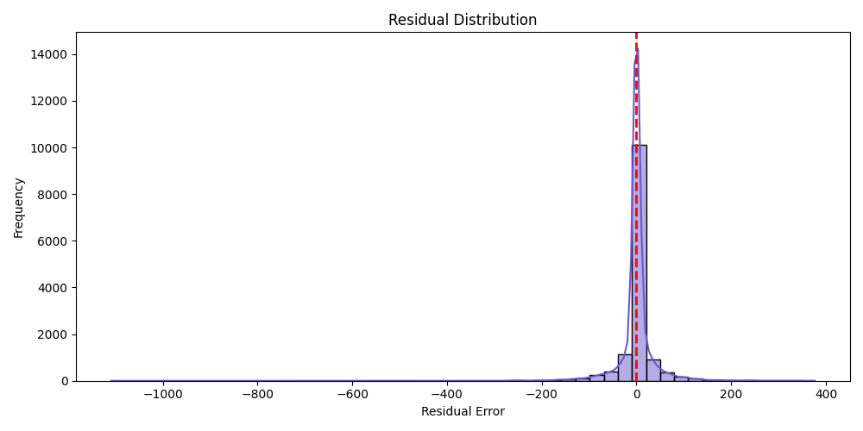
Figure 2. Residual Distribution
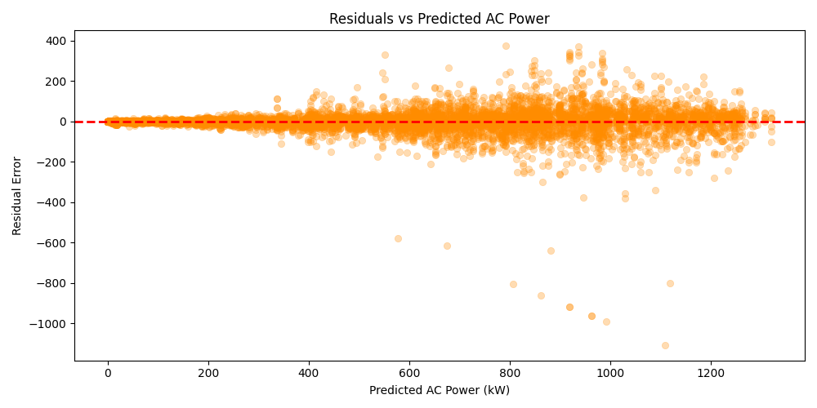
Figure 3. Residuals vs Predicted AC Power
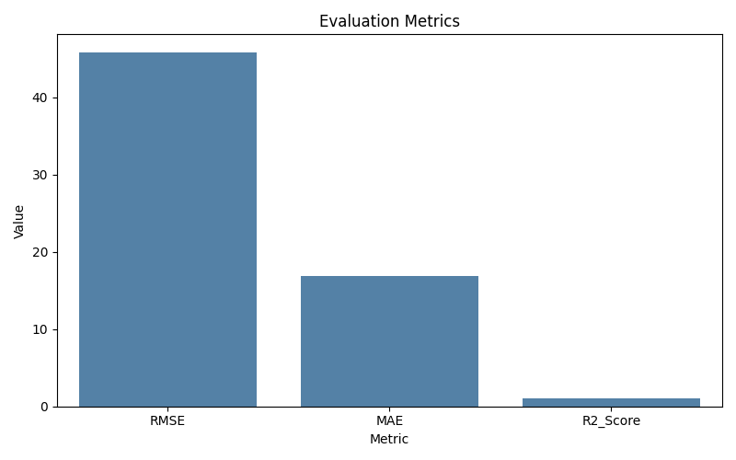
Figure 4. Evaluation Metrics
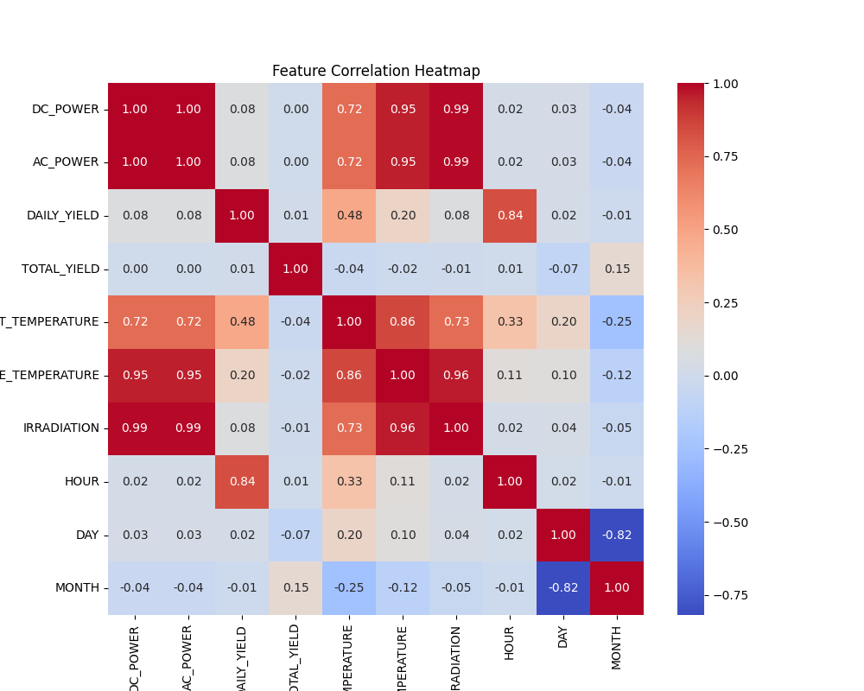
Figure 5. Feature Correlation Heatmap
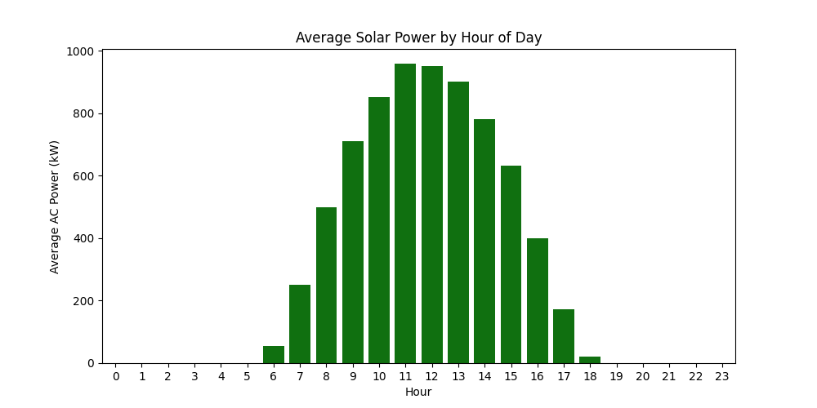
Figure 6. Average Solar Power by Hour

Comparative Study
An earlier intermediate version of the project used generation-related variables such as DC_POWER as inputs while predicting AC_POWER. Although that approach gave near-perfect results, it was not a strong forecasting design because those variables are too closely related to the target. The final model uses only weather and time-based features, which makes the prediction task more realistic, defensible, and suitable for demonstration in an MLOps context.
Approach | Advantages | Limitations
Leakage-prone feature set | Artificially high scores | Not suitable for realistic forecasting
Final weather/time feature set | Better reflects real deployment scenario | Slightly harder prediction problem
Implemented MLOps version | Tracks data, experiments, deployment, and monitoring | Future work can add automated retraining

Deployment

Deployment Strategy
A real-time deployment approach was selected for this project. The user provides current weather and time values through the Streamlit interface, and the model immediately returns the predicted AC power value. This approach is appropriate because the use case is interactive forecasting rather than offline batch scoring.

Deployment Implementation
The Streamlit application was containerized using Docker and deployed on an AWS EC2 Ubuntu instance. Docker provides environment consistency, while EC2 offers flexible cloud hosting for the containerized app. The EC2 security group was configured to allow inbound traffic on port 8501.
Deployment Item | Value
Platform | AWS EC2 (Ubuntu 22.04)
Instance Type | t3.micro
Container Runtime | Docker
Application Port | 8501
Public URL | http://65.1.133.227:8501

Monitoring and Maintenance
The monitoring stage compares reference and current feature distributions and writes a JSON drift report. The configured drift threshold is 20 percent. The latest run reported drift_detected = False. These monitoring outputs are also logged to MLflow, making them visible in the experiment history.
Feature | Reference Mean | Current Mean | Drift % | Drift Detected
AMBIENT_TEMPERATURE | 25.7902 | 24.6316 | 4.4924 | False
MODULE_TEMPERATURE | 31.7089 | 29.3893 | 7.3153 | False
IRRADIATION | 0.2388 | 0.2061 | 13.6904 | False
HOUR | 11.4649 | 11.9756 | 4.4546 | False
DAY | 16.1523 | 14.2052 | 12.0544 | False
MONTH | 5.3982 | 6.0 | 11.1487 | False
Maintenance strategy for the project includes checking logs in logs/pipeline.log, reviewing MLflow runs, observing drift behavior, and retraining the model if drift or performance degradation becomes significant.

Conclusion and Future Work
This project successfully demonstrates a complete MLOps workflow for solar power forecasting. It covers data versioning, modular pipeline design, experiment tracking, CI/CD, real-time deployment, monitoring, logging, governance, and cloud hosting. The final result is not just a machine learning model but a project that is reproducible, testable, deployable, and aligned with the Essentials of MLOps rubric.
Future work can include adding HTTPS and custom domain support for the deployed application, setting up automated deployment from GitHub Actions to AWS, introducing more advanced statistical drift detection, and implementing a retraining pipeline triggered by drift or performance decay.

References
[1] T. Chen and C. Guestrin, “XGBoost: A Scalable Tree Boosting System,” Proc. 22nd ACM SIGKDD Int. Conf. Knowledge Discovery and Data Mining, 2016, pp. 785-794.
[2] MLflow, “MLflow Documentation.” [Online]. Available: https://mlflow.org/docs/latest/index.html
[3] DVC, “Data Version Control Documentation.” [Online]. Available: https://dvc.org/doc
[4] Docker, “Docker Documentation.” [Online]. Available: https://docs.docker.com/
[5] Streamlit, “Streamlit Documentation.” [Online]. Available: https://docs.streamlit.io/
[6] GitHub, “GitHub Actions Documentation.” [Online]. Available: https://docs.github.com/actions
[7] Amazon Web Services, “Amazon EC2 Documentation.” [Online]. Available: https://docs.aws.amazon.com/ec2/

GitHub Repository
https://github.com/AbizerJesawada/solar-power-mlops
The repository contains the full project implementation, including source code, pipeline modules, configuration files, DVC pointers, MLflow tracking outputs, governance documentation, CI workflow, Docker files, and deployment instructions.

Appendix: Suggested Screenshots for Final Submission
- GitHub repository home page
- GitHub Actions successful workflow run
- MLflow experiment UI showing the latest unified run
- Streamlit prediction app screenshot
- AWS S3 bucket used as the DVC remote
- AWS EC2 instance details
- EC2 security group inbound rules for port 8501
- Docker container running on EC2 (`docker ps` output)
- Drift report JSON file
- Pipeline log file (`logs/pipeline.log`)

