Security Incident Detection and Response Management System
  - Sprint 1 Backend Implementation Report
Abdulrahman Kobeissi
Software Tools Lab
13 October 2026
This report describes a working backend with nine independently running services, role-based permissions, a relational SQLite database, documented APIs, and reproducible Postman tests. It explains the implementation and links each result to evidence captured from the local system.
Submission component | Included material
Source | Nine Flask services, SQL schema, launcher and backup utility
API documentation | 60 business operations, OpenAPI reference and Postman collection
Verification | 173 HTTP requests, 364 Newman assertions and 18 invariant tests
Evidence | Actual response captures, database records, diagrams and Git history
Solo project attribution: all nine services and this report are assigned to Abdulrahman Kobeissi. AI assistance is disclosed in References. No teammate activity or CREATES attendance is claimed.
Repository: https://github.com/Abkob/Abdulrahman-Kobeissi-430L

Table of Contents (Abdulrahman Kobeissi)
Every section is attributed to Abdulrahman Kobeissi. The evidence appendix is organized by the numbered Postman request, followed by database and GitHub captures.
Table of Contents (Abdulrahman Kobeissi) 2
Introduction (Abdulrahman Kobeissi) 3
System Architecture (Abdulrahman Kobeissi) 4
Service Communication (Abdulrahman Kobeissi) 5
Object Oriented Implementation (Abdulrahman Kobeissi) 6
Users and Identity Management (Abdulrahman Kobeissi) 7
Asset Management (Abdulrahman Kobeissi) 8
Incident Management (Abdulrahman Kobeissi) 9
Threat Intelligence (Abdulrahman Kobeissi) 10
Security Audit Logging (Abdulrahman Kobeissi) 11
Security Reports (Abdulrahman Kobeissi) 12
Vulnerability Management (Abdulrahman Kobeissi) 13
Notification Management (Abdulrahman Kobeissi) 14
Security Playbooks and Response Actions (Abdulrahman Kobeissi) 15
Database Design (Abdulrahman Kobeissi) 16
Response and History Relationships (Abdulrahman Kobeissi) 17
Database Dictionary 1 (Abdulrahman Kobeissi) 18
Database Dictionary 2 (Abdulrahman Kobeissi) 19
Database Dictionary 3 (Abdulrahman Kobeissi) 20
Database Dictionary 4 (Abdulrahman Kobeissi) 21
Database Dictionary 5 (Abdulrahman Kobeissi) 22
Database Dictionary 6 (Abdulrahman Kobeissi) 23
Database Dictionary 7 (Abdulrahman Kobeissi) 24
Error Handling and Validation (Abdulrahman Kobeissi) 25
API Documentation (Abdulrahman Kobeissi) 26
API Walkthroughs (Abdulrahman Kobeissi) 27
Authentication and Authorization (Abdulrahman Kobeissi) 28
Verification and Recovery (Abdulrahman Kobeissi) 29
GitHub and Version Control (Abdulrahman Kobeissi) 30
References and AI Disclosure (Abdulrahman Kobeissi) 31
Evidence Appendix (Abdulrahman Kobeissi) 32

Use the Word table of contents links to navigate. Page numbers are updated in the delivered document.

Introduction (Abdulrahman Kobeissi)

Problem and scope (Abdulrahman Kobeissi)
Security teams need to connect reported incidents with affected assets, analysts, evidence, known threats, and remediation work. Separate spreadsheets make it difficult to preserve ownership and status history. This backend centralizes those records while exposing a distinct HTTP service for each responsibility.
Sprint 1 covers account and role management, assets, incident investigation, threat intelligence, audit logs, reports, vulnerabilities, notifications, and response playbooks. A product frontend and public cloud deployment are outside this sprint. The read-only database evidence viewer is a development utility.

Objectives and results (Abdulrahman Kobeissi)
The implementation provides the 54 required operations and six supporting business operations for logout, role assignment and removal, account status, permissions, and asset history. Four roles are enforced before protected operations. Validation rejects malformed data, unauthorized access and invalid workflow changes. Real HTTP tests exercise all nine processes.
The 173-request collection completed with 364 assertions and no failures. A separate 18-test suite checks security and persistence invariants. Live database checks confirm referential integrity, report reconciliation, empty results and verified backups. These results establish the demonstrated local behavior; they are not load-test or production-readiness claims.

Solo scope and submission status (Abdulrahman Kobeissi)
The student requested a solo project. The handout normally specifies three students and three services each, so course staff must confirm solo eligibility. The required CREATES meeting and incorporation of its feedback remain personal course tasks. The project has not been uploaded to Moodle. The handout restricts complete AI-generated submissions; the disclosed assisted package requires student review, understanding and instructor-approved use.

System Architecture (Abdulrahman Kobeissi)
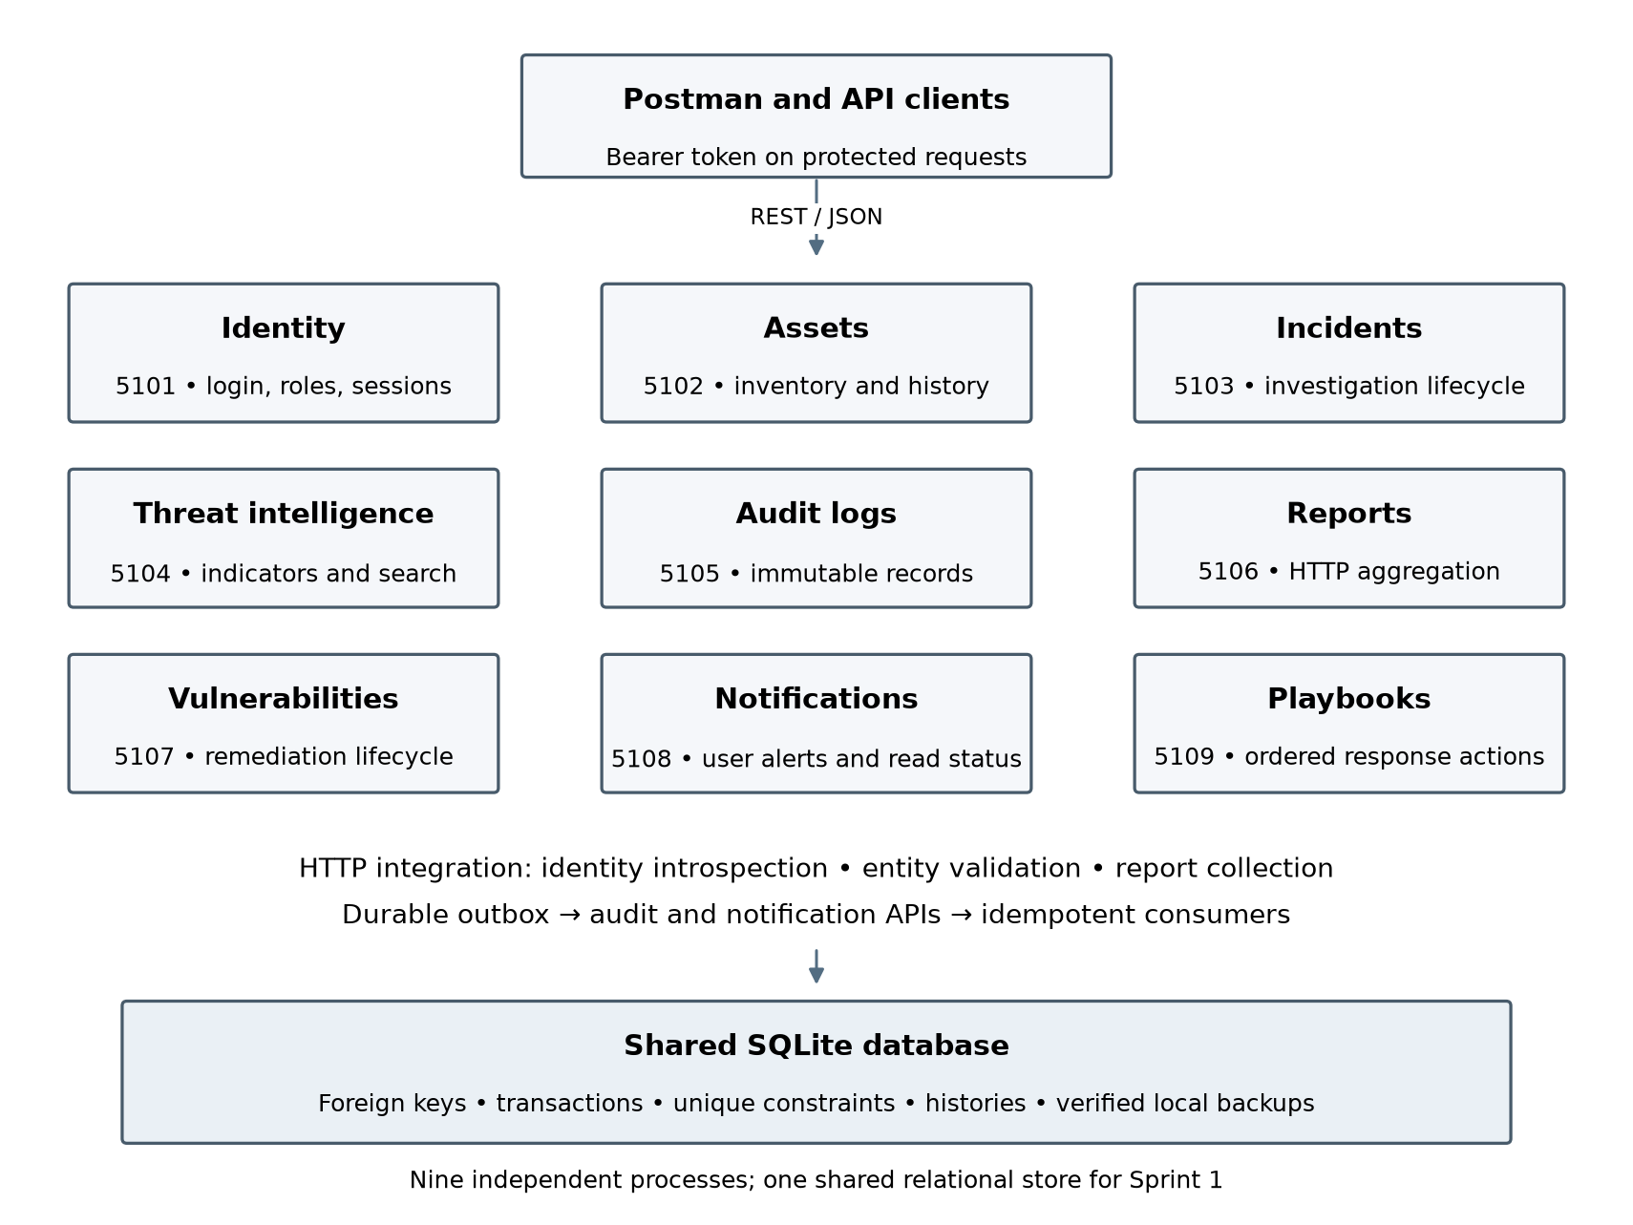
Abdulrahman Kobeissi — Nine service processes, HTTP integration and shared persistence.
Each service has its own Flask application and port. run.py supervises the nine processes. All public paths start with /Abdulrahman-Kobeissi. A shared SQLite database retains relational foreign keys across the sprint’s entities. This is process-level service separation with shared persistence, rather than nine isolated databases.

Service Communication (Abdulrahman Kobeissi)
Caller | HTTP dependency | Reason
Protected services | Identity introspection | Validate the bearer token and current user state
Assets, incidents, notifications, playbooks | Identity user lookup | Validate owners, assignees and recipients
Incidents and vulnerabilities | Assets lookup | Validate the affected asset before insertion
Reports | Users, assets, incidents, threats, vulnerabilities and logs | Aggregate actual service responses
Mutation event workers | Audit and notification internal APIs | Deliver durable activity records and alerts
The ServiceClient class makes HTTP calls with bounded timeouts. Internal endpoints require a local shared service key, which is generated into the private runtime folder. External requests use bearer sessions. If a required service is unavailable, the caller returns HTTP 503 instead of silently inventing a result.
A business transaction writes both its data and an outbox event. A worker in each service retries pending events through HTTP. Consumers identify events by a unique event_id, making retries idempotent. Pending and failed delivery counts are visible in health responses. This design preserves audit and notification intent when a downstream service is temporarily unavailable.
Example: assigning an incident validates the analyst through Identity, stores the assignment and event in one transaction, then creates an Incident Assignment notification through the Notifications service. Reports obtain source records through HTTP before grouping counts.

Operational boundary (Abdulrahman Kobeissi)
The local teaching setup binds to 127.0.0.1. A production deployment would require production WSGI hosting, TLS, service-specific credentials, secret management, pagination and operational monitoring. No existing production data or schema was changed.

Object Oriented Implementation (Abdulrahman Kobeissi)
Class | Responsibility | Use of the abstraction
Settings | Database location, key and service ports | One configuration object per app
Database | Connections and transactions | Commits successful operations and rolls back failures
Repository | Parameterized CRUD and approved filters | Shared persistence behavior without user-supplied SQL
Lifecycle | Allowed ordered status transitions | Reused for incidents, vulnerabilities and response actions
ServiceClient | HTTP communication | Encapsulates timeouts and service errors
EventBus | Durable audit and notification events | Queues and retries idempotent delivery
Context | Service dependencies and actor context | Composes persistence, client and events
CatalogService | Common catalog route and CRUD behavior | Base implementation for two catalogs
ThreatService and VulnerabilityService | Specialized field validation and update rules | Override base validation and lifecycle behavior
Encapsulation keeps SQL connection handling inside Database and common record operations inside Repository. Catalog inheritance removes duplicated route plumbing while preserving domain-specific validation. Lifecycle composition applies the same ordered-transition rule to three different workflows. Route functions coordinate these objects and return consistent JSON envelopes.
The source layout separates identity.py, assets.py, incidents.py, catalogs.py, audit_reports.py, notifications.py and playbooks.py. app.py creates the selected service and installs common error handling. The split keeps each service’s authorization and validation close to its business behavior.

Users and Identity Management (Abdulrahman Kobeissi)
Accounts, authentication, role assignment and account status. Usernames and email addresses are unique case-insensitively. Public registration creates active employees; only an authenticated administrator can create privileged accounts.
Method | Endpoint suffix | Required body fields
POST | /users/register | full_name, username, email, password, department, role
POST | /users/login | login, password
POST | /users/logout | None
GET | /users | None
GET | /users/{username} | Path or query only
PUT | /users/{user_id} | Optional update fields
DELETE | /users/{user_id} | Path or query only
DELETE | /users/{user_id}/role | Path or query only
PUT | /users/{user_id}/role | role
PUT | /users/{user_id}/status | account_status
GET | /users/permissions | None
All routes use the prefix /Abdulrahman-Kobeissi on port 5101.
Registration requires full_name, username, email, password, department and role. Login takes login and password. Responses omit hashes and expose only safe user fields. Profile updates accept full_name, email and department.
Persistence. users and sessions; login_attempts throttles repeated failures. Deleted users are hidden and suspended, while historical foreign keys remain valid.
Rules. A duplicate username returns 409. Invalid credentials return 401. Inactive and suspended accounts cannot authenticate. Role changes, deletion and account-status changes revoke sessions. The last active administrator cannot be removed.
Evidence: numbered collection requests 001–035. Screenshots appear in the evidence appendix; complete JSON responses and parameters are included in docs/API_REFERENCE.md and docs/openapi.json.

Asset Management (Abdulrahman Kobeissi)
Maintains inventory, ownership, location, criticality and current status. Administrators manage inventory; auditors read it. Analysts can inspect and search only assets related to their assigned incidents.
Method | Endpoint suffix | Required body fields
POST | /assets | name, asset_type, ip_address, department, owner_id, criticality
PUT | /assets/{asset_id} | Optional update fields
DELETE | /assets/{asset_id} | Path or query only
GET | /assets | None
GET | /assets/search | Path or query only
GET | /assets/{asset_id} | Path or query only
GET | /assets/{asset_id}/history | Path or query only
All routes use the prefix /Abdulrahman-Kobeissi on port 5102.
Creation requires name, asset_type, ip_address, department, owner_id and criticality. operating_system, location and status are optional. Single-asset responses also list related incident and vulnerability IDs.
Persistence. assets references its owner in users. asset_history stores before and after JSON and retains deletion history. Referenced assets cannot be deleted.
Rules. Criticality is a constrained text value: Low, Medium, High or Critical. Searches combine name, type, IP, department and criticality. SQL values are bound parameters. Invalid IPs and unknown owners are rejected.
Evidence: numbered collection requests 036–055; 069–071; 081. Screenshots appear in the evidence appendix; complete JSON responses and parameters are included in docs/API_REFERENCE.md and docs/openapi.json.

Incident Management (Abdulrahman Kobeissi)
Tracks reporting, assignment, notes and investigation status. Employees see their own reports; analysts see assigned incidents; administrators and auditors have broader read access.
Method | Endpoint suffix | Required body fields
POST | /incidents | title, description, category, severity, asset_id
GET | /incidents | None
GET | /incidents/{incident_id} | Path or query only
PUT | /incidents/{incident_id}/assign | analyst_id
PUT | /incidents/{incident_id}/status | status
POST | /incidents/{incident_id}/notes | content
All routes use the prefix /Abdulrahman-Kobeissi on port 5103.
Creation requires title, description, category, severity and asset_id; asset_id may be null. reporter_id is derived from authentication; an explicitly supplied reporter must match the caller. Notes take content.
Persistence. incidents references reporter, optional asset and assigned analyst. investigation_notes references incident and note author.
Rules. The sequence is Open → Under Investigation → Mitigated → Resolved → Closed. Assignment to an active analyst is required before advancing. Notes are visible to authorized investigators and auditors, but hidden from employee incident views. Resolution time is generated when resolved.
Evidence: numbered collection requests 056–080. Screenshots appear in the evidence appendix; complete JSON responses and parameters are included in docs/API_REFERENCE.md and docs/openapi.json.

Threat Intelligence (Abdulrahman Kobeissi)
Stores indicators and supports investigation searches. Administrators create, update and delete; analysts and auditors read and search.
Method | Endpoint suffix | Required body fields
POST | /threats | threat_type, value, description, severity, source
GET | /threats | None
GET | /threats/search | Path or query only
GET | /threats/{record_id} | Path or query only
PUT | /threats/{record_id} | Optional update fields
DELETE | /threats/{record_id} | Path or query only
All routes use the prefix /Abdulrahman-Kobeissi on port 5104.
Creation takes threat_type, value, description, severity and source. Updates accept description, severity and source. Responses include the record ID and creation timestamp.
Persistence. threats has a composite unique constraint on threat_type and value. High and Critical creations generate an alert to the acting administrator.
Rules. IP values are parsed, domains are normalized to lowercase and trailing-dot-free form, and hashes must be valid MD5, SHA1 or SHA256 hexadecimal strings. Duplicate normalized indicators return 409. Searches support type, value, severity and source. Test indicators use reserved laboratory addresses and example.test domains.
Evidence: numbered collection requests 082–099. Screenshots appear in the evidence appendix; complete JSON responses and parameters are included in docs/API_REFERENCE.md and docs/openapi.json.

Security Audit Logging (Abdulrahman Kobeissi)
Records security actions and permission violations. Administrators create and delete log records. Auditors inspect and search; analysts have the read permissions described in the service specification.
Method | Endpoint suffix | Required body fields
POST | /logs | user_id, action, description, severity, related_service
GET | /logs | None
GET | /logs/{record_id} | Path or query only
GET | /logs/search | Path or query only
GET | /logs/user/{user_id} | Path or query only
DELETE | /logs/{record_id} | Path or query only
All routes use the prefix /Abdulrahman-Kobeissi on port 5105.
Creation requires user_id, action, description, severity and related_service. A record includes a server UTC timestamp. Lists and searches return arrays; no matches return an empty array.
Persistence. logs references an optional user; unauthenticated denials may have no user. The database trigger rejects UPDATE operations. Unique event IDs deduplicate delivery.
Rules. Search filters cover user, date, action, severity and related service. Logs preserve the originally recorded values. The handout explicitly requires administrative deletion; a delete itself emits an audit event, while no modification endpoint exists.
Evidence: numbered collection requests 151–163. Screenshots appear in the evidence appendix; complete JSON responses and parameters are included in docs/API_REFERENCE.md and docs/openapi.json.

Security Reports (Abdulrahman Kobeissi)
Generates summary, incident, asset, threat, vulnerability and activity reports for administrators and auditors.
Method | Endpoint suffix | Required body fields
GET | /reports/summary | None
GET | /reports/incidents | None
GET | /reports/assets | None
GET | /reports/threats | None
GET | /reports/vulnerabilities | None
GET | /reports/activity | None
All routes use the prefix /Abdulrahman-Kobeissi on port 5106.
The six GET endpoints take no JSON body. Each returns a data object with generated_at, source and its report-specific totals or groups.
Persistence. The service does not create report tables. It reads source records over the other services’ HTTP APIs and computes counts and groupings.
Rules. Incident reports group severity and status; asset reports group type and criticality; threat reports group severity/type and show recent indicators; vulnerability reports group severity/status; activity reports count actions and login attempts. Summary combines the sources. HTTP 503 surfaces a missing dependency.
Evidence: numbered collection requests 164–171. Screenshots appear in the evidence appendix; complete JSON responses and parameters are included in docs/API_REFERENCE.md and docs/openapi.json.

Vulnerability Management (Abdulrahman Kobeissi)
Tracks asset vulnerabilities through investigation and remediation. Administrators create and delete; analysts may update; auditors read and search.
Method | Endpoint suffix | Required body fields
POST | /vulnerabilities | title, description, cve, cvss, severity, asset_id, discovery_source
GET | /vulnerabilities | None
GET | /vulnerabilities/search | Path or query only
GET | /vulnerabilities/{record_id} | Path or query only
PUT | /vulnerabilities/{record_id} | Optional update fields
DELETE | /vulnerabilities/{record_id} | Path or query only
All routes use the prefix /Abdulrahman-Kobeissi on port 5107.
Creation requires title, description, cve, cvss, severity, asset_id and discovery_source. Updates accept description, severity, status, cvss and resolution_date.
Persistence. vulnerabilities references an affected asset. Resolution time is retained when Closed. Critical or High creation emits a notification.
Rules. CVE syntax is validated, without claiming a lookup in an external CVE database. CVSS must be numeric from 0 to 10. Status follows Open → Under Investigation → In Progress → Resolved → Closed. A supplied resolution time must be timezone-aware, not future and not before creation.
Evidence: numbered collection requests 100–119. Screenshots appear in the evidence appendix; complete JSON responses and parameters are included in docs/API_REFERENCE.md and docs/openapi.json.

Notification Management (Abdulrahman Kobeissi)
Supports manual and automatic alerts, recipient scoping and read tracking. Administrators create and delete; employees and analysts can read their own alerts; auditors have read-only access.
Method | Endpoint suffix | Required body fields
POST | /notifications | user_id, title, message, notification_type, severity
GET | /notifications/user/{user_id} | Path or query only
GET | /notifications/{record_id} | Path or query only
PUT | /notifications/{record_id}/read | Path or query only
GET | /notifications/search | Path or query only
DELETE | /notifications/{record_id} | Path or query only
All routes use the prefix /Abdulrahman-Kobeissi on port 5108.
Creation requires user_id, title, message, notification_type and severity. Marking read uses PUT with no body. It changes Unread to Read and records the first read timestamp.
Persistence. notifications references its recipient and stores status, created_at, read_date and an optional unique event ID.
Rules. Repeated marking as read preserves the original read time. Analysts cannot search another user’s notifications. Searches combine recipient, notification type, severity and read status. A known user without notifications receives a successful empty array.
Evidence: numbered collection requests 120–135. Screenshots appear in the evidence appendix; complete JSON responses and parameters are included in docs/API_REFERENCE.md and docs/openapi.json.

Security Playbooks and Response Actions (Abdulrahman Kobeissi)
Organizes response procedures by incident category and severity, with ordered actions and execution history.
Method | Endpoint suffix | Required body fields
POST | /playbooks | name, description, incident_category, severity
GET | /playbooks | None
GET | /playbooks/{book_id} | Path or query only
POST | /playbooks/{book_id}/actions | description, step_number
PUT | /actions/{action_id}/status | status
DELETE | /playbooks/{book_id} | Path or query only
All routes use the prefix /Abdulrahman-Kobeissi on port 5109.
Create a playbook with name, description, incident_category and severity. Add actions with description and step_number; assigned_user_id is optional. Status updates require status and may include an assignee.
Persistence. playbooks references its creator. response_actions references its playbook and assignee. action_history retains every recorded progression. Soft deletion preserves execution history.
Rules. Steps must be consecutive within a playbook. Pending → In Progress → Completed is enforced, and earlier steps must be completed before later ones begin. Analysts may claim or update their own actions. Completion time is server-generated; completed actions cannot be reassigned.
Evidence: numbered collection requests 136–150. Screenshots appear in the evidence appendix; complete JSON responses and parameters are included in docs/API_REFERENCE.md and docs/openapi.json.

Database Design (Abdulrahman Kobeissi)
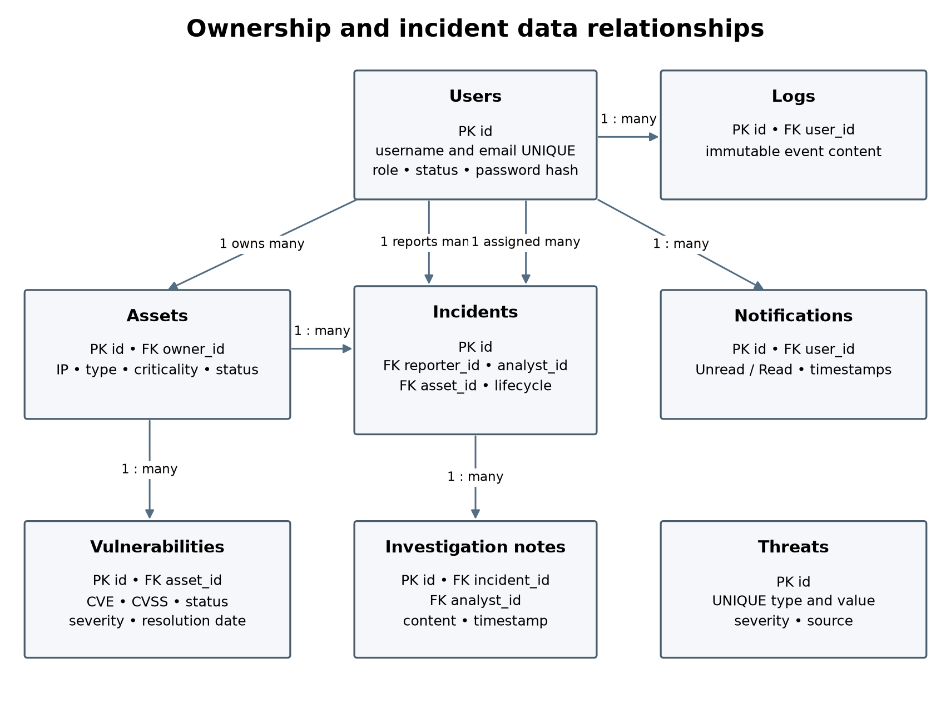
Abdulrahman Kobeissi — Core entity relationships and foreign-key direction.
SQLite enforces foreign keys on each connection. IDs are primary keys; session and outbox identifiers use text keys. Timestamps are stored in UTC ISO format. One user may own many assets, report many incidents and receive many notifications. Each note belongs to one incident. An asset may have many incidents and vulnerabilities.

Response and History Relationships (Abdulrahman Kobeissi)
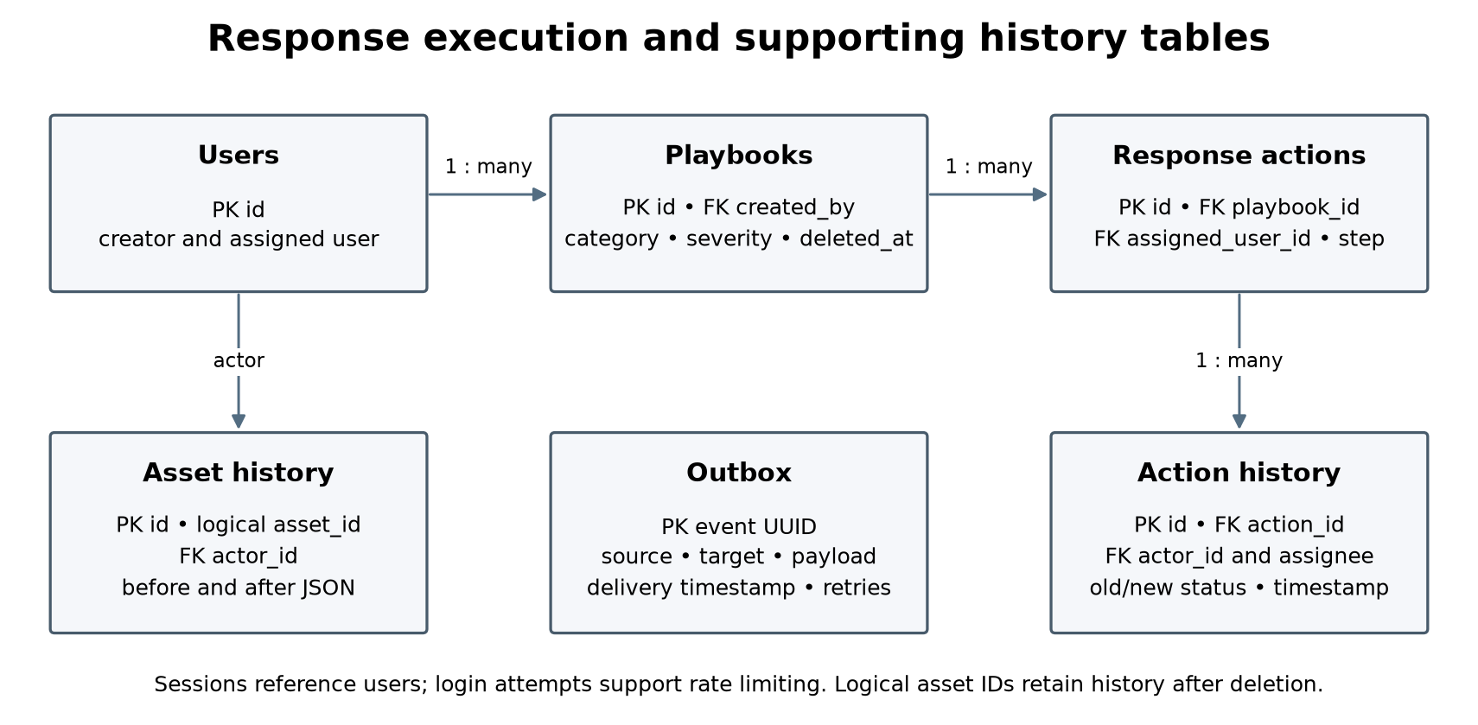
Abdulrahman Kobeissi — Playbook, action, notification and history relationships.
Playbooks contain ordered response actions. Users can be assigned many actions. Each action has many immutable historical status entries. Asset history retains a logical asset ID even after deletion, so asset_history.asset_id deliberately does not have a foreign key; actor_id remains linked to users.
User and playbook deletion is soft deletion to preserve relationships and evidence. Asset deletion is restricted if incidents or vulnerabilities reference it. Unique constraints protect usernames, emails, normalized indicator pairs, event IDs and step numbers within a playbook. Enum and range checks provide a second layer beneath API validation.

Database Dictionary 1 (Abdulrahman Kobeissi)

Users (Abdulrahman Kobeissi)
Accounts and hashed credentials.
Field | Type | Key or nullability
id | INTEGER | PK
full_name | TEXT | NOT NULL
username | TEXT | NOT NULL
email | TEXT | NOT NULL
password_hash | TEXT | NOT NULL
department | TEXT | NOT NULL
role | TEXT | NOT NULL
account_status | TEXT | NOT NULL; default 'Active'
created_at | TEXT | NOT NULL
last_login_at | TEXT | Nullable
deleted_at | TEXT | Nullable

Sessions (Abdulrahman Kobeissi)
Hashed bearer-token sessions.
Field | Type | Key or nullability
token_hash | TEXT | PK
user_id | INTEGER | NOT NULL; FK → users.id
expires_at | TEXT | NOT NULL
created_at | TEXT | NOT NULL

Login Attempts (Abdulrahman Kobeissi)
Failed-login throttling.
Field | Type | Key or nullability
id | INTEGER | PK
login | TEXT | NOT NULL
address | TEXT | NOT NULL
created_at | TEXT | NOT NULL

Database Dictionary 2 (Abdulrahman Kobeissi)

Assets (Abdulrahman Kobeissi)
Organizational inventory.
Field | Type | Key or nullability
id | INTEGER | PK
name | TEXT | NOT NULL
asset_type | TEXT | NOT NULL
ip_address | TEXT | NOT NULL
operating_system | TEXT | NOT NULL; default ''
department | TEXT | NOT NULL
owner_id | INTEGER | NOT NULL; FK → users.id
location | TEXT | NOT NULL; default ''
criticality | TEXT | NOT NULL
status | TEXT | NOT NULL
created_at | TEXT | NOT NULL

Asset History (Abdulrahman Kobeissi)
Inventory changes before and after mutation.
Field | Type | Key or nullability
id | INTEGER | PK
asset_id | INTEGER | NOT NULL
actor_id | INTEGER | Nullable; FK → users.id
operation | TEXT | NOT NULL
before_json | TEXT | Nullable
after_json | TEXT | Nullable
created_at | TEXT | NOT NULL

Database Dictionary 3 (Abdulrahman Kobeissi)

Incidents (Abdulrahman Kobeissi)
Reported security events.
Field | Type | Key or nullability
id | INTEGER | PK
title | TEXT | NOT NULL
description | TEXT | NOT NULL
category | TEXT | NOT NULL
severity | TEXT | NOT NULL
reporter_id | INTEGER | NOT NULL; FK → users.id
asset_id | INTEGER | Nullable; FK → assets.id
assigned_analyst_id | INTEGER | Nullable; FK → users.id
status | TEXT | NOT NULL
created_at | TEXT | NOT NULL
resolution_date | TEXT | Nullable

Investigation Notes (Abdulrahman Kobeissi)
Analyst evidence and notes.
Field | Type | Key or nullability
id | INTEGER | PK
incident_id | INTEGER | NOT NULL; FK → incidents.id
analyst_id | INTEGER | NOT NULL; FK → users.id
content | TEXT | NOT NULL
created_at | TEXT | NOT NULL

Database Dictionary 4 (Abdulrahman Kobeissi)

Threats (Abdulrahman Kobeissi)
Threat intelligence indicators.
Field | Type | Key or nullability
id | INTEGER | PK
threat_type | TEXT | NOT NULL
value | TEXT | NOT NULL
description | TEXT | NOT NULL
severity | TEXT | NOT NULL
source | TEXT | NOT NULL
created_at | TEXT | NOT NULL

Logs (Abdulrahman Kobeissi)
Audit records.
Field | Type | Key or nullability
id | INTEGER | PK
user_id | INTEGER | Nullable; FK → users.id
action | TEXT | NOT NULL
description | TEXT | NOT NULL
severity | TEXT | NOT NULL
related_service | TEXT | NOT NULL
created_at | TEXT | NOT NULL
event_id | TEXT | Nullable

Database Dictionary 5 (Abdulrahman Kobeissi)

Vulnerabilities (Abdulrahman Kobeissi)
Asset remediation records.
Field | Type | Key or nullability
id | INTEGER | PK
title | TEXT | NOT NULL
description | TEXT | NOT NULL
cve | TEXT | NOT NULL
cvss | REAL | NOT NULL
severity | TEXT | NOT NULL
asset_id | INTEGER | NOT NULL; FK → assets.id
discovery_source | TEXT | NOT NULL
status | TEXT | NOT NULL
created_at | TEXT | NOT NULL
resolution_date | TEXT | Nullable

Notifications (Abdulrahman Kobeissi)
Recipient alerts and read tracking.
Field | Type | Key or nullability
id | INTEGER | PK
user_id | INTEGER | NOT NULL; FK → users.id
title | TEXT | NOT NULL
message | TEXT | NOT NULL
notification_type | TEXT | NOT NULL
severity | TEXT | NOT NULL
status | TEXT | NOT NULL
created_at | TEXT | NOT NULL
read_date | TEXT | Nullable
event_id | TEXT | Nullable

Database Dictionary 6 (Abdulrahman Kobeissi)

Playbooks (Abdulrahman Kobeissi)
Response procedures.
Field | Type | Key or nullability
id | INTEGER | PK
name | TEXT | NOT NULL
description | TEXT | NOT NULL
incident_category | TEXT | NOT NULL
severity | TEXT | NOT NULL
created_by | INTEGER | NOT NULL; FK → users.id
created_at | TEXT | NOT NULL
deleted_at | TEXT | Nullable

Response Actions (Abdulrahman Kobeissi)
Ordered response steps.
Field | Type | Key or nullability
id | INTEGER | PK
playbook_id | INTEGER | NOT NULL; FK → playbooks.id
description | TEXT | NOT NULL
step_number | INTEGER | NOT NULL
status | TEXT | NOT NULL
assigned_user_id | INTEGER | Nullable; FK → users.id
completion_date | TEXT | Nullable

Database Dictionary 7 (Abdulrahman Kobeissi)

Action History (Abdulrahman Kobeissi)
Response execution history.
Field | Type | Key or nullability
id | INTEGER | PK
action_id | INTEGER | NOT NULL; FK → response_actions.id
actor_id | INTEGER | NOT NULL; FK → users.id
old_status | TEXT | Nullable
new_status | TEXT | NOT NULL
assigned_user_id | INTEGER | Nullable; FK → users.id
created_at | TEXT | NOT NULL

Outbox (Abdulrahman Kobeissi)
Durable HTTP delivery queue.
Field | Type | Key or nullability
id | TEXT | PK
source | TEXT | NOT NULL
target | TEXT | NOT NULL
payload | TEXT | NOT NULL
created_at | TEXT | NOT NULL
delivered_at | TEXT | Nullable
attempts | INTEGER | NOT NULL; default 0
last_error | TEXT | Nullable

Error Handling and Validation (Abdulrahman Kobeissi)
Every service uses a common JSON error envelope with status="error", a meaningful message and request_id. Error handlers map expected validation, authentication, authorization, lookup and relationship failures to consistent HTTP statuses. Unhandled failures return a generic server error rather than exposing internals.
HTTP | Meaning | Demonstrated case
400 | Invalid input | Invalid email, IP, severity, CVSS or unsupported field
401 | Authentication failure | Missing token, incorrect login or revoked session
403 | Permission or ownership failure | Employee changes incident status; analyst deletes a threat
404 | Missing record | Unknown user, asset, incident, catalog entry or playbook
409 | Conflict | Duplicate username/indicator or skipped workflow state
415 | Unsupported content type | JSON-required operation sent non-JSON content
429 | Rate limit | Repeated failed login attempts
503 | Dependency unavailable | A report source cannot be contacted
Input is parsed as JSON objects. Required fields, data types, length bounds, allowed values and unknown keys are checked before persistence. The API rejects empty or malformed requests. Search fields come from a fixed allowlist, and SQL values use placeholders; user input is never inserted into SQL syntax. HTML is not rendered by the backend, so data is stored as text rather than altered with lossy HTML stripping.
Negative requests are intentional test successes when the expected error is returned. Screenshots 013, 015, 025, 051, 065, 072, 085–087, 106, 117 and other appendix cases show these failures. The invariant suite also verifies that SQL-like text remains literal and that a direct log UPDATE fails at the database layer.

API Documentation (Abdulrahman Kobeissi)
docs/openapi.json describes all 60 business operations. docs/API_REFERENCE.md lists purpose, method, complete route, role requirements, path/query parameters, accepted request fields, response examples and possible errors. postman/Sprint1.postman_collection.json contains every numbered test with descriptions, scripts and real response examples.
Protected calls send Authorization: Bearer <token>. Successful reads and updates use HTTP 200; creation uses 201. Data objects and arrays are wrapped in {"status":"success","data":...}. Empty lists remain successful arrays. Errors use the common envelope described in the previous section. Passwords and token values in published examples are redacted.

Registration walkthrough (Abdulrahman Kobeissi)
POST /Abdulrahman-Kobeissi/users/register on port 5101 validates the six required fields and uniqueness, hashes the password, then inserts the account and durable events within a transaction. Public callers may register employees; privileged roles require an administrator token. A duplicate is a 409 conflict rather than a second row.
{
"full_name": "Demo Analyst",
"username": "r17918970950626932_analyst",
"email": "r17918970950626932_analyst@example.test",
"password": "[REDACTED]",
"department": "Security",
"role": "Security Analyst"
}
{
"data": {
"account_status": "Active",
"created_at": "2026-10-13T13:11:36.964620+00:00",
"department": "Security",
"email": "r17918970950626932_analyst@example.test",
"full_name": "Demo Analyst",
"id": 7,
"role": "Security Analyst",
"username": "r17918970950626932_analyst"
},
"status": "success"
}
Actual request 003 creates an analyst under administrator authorization. The displayed password is redacted. Figure 003 contains the original Postman view; the collection retains the full safe response.

API Walkthroughs (Abdulrahman Kobeissi)

Incident assignment (Abdulrahman Kobeissi)
PUT /Abdulrahman-Kobeissi/incidents/{incident_id}/assign on port 5103 accepts analyst_id. It requires an administrator, checks the incident, calls Identity to verify an active Security Analyst, and stores the assignment. The same transaction queues an audit event and an Incident Assignment notification. Missing incident returns 404, invalid assignee 400, and insufficient permission 403.
{
"analyst_id": 7
}
{
"status": "success",
"data": {
"id": 5,
"assigned_analyst_id": 7,
"status": "Open"
}
}
The response above is an explicitly shortened extract of request 067; the complete incident fields are in the saved response. Request 065 shows an unauthorized caller rejected from the same operation.

Incident report (Abdulrahman Kobeissi)
GET /Abdulrahman-Kobeissi/reports/incidents on port 5106 requires an administrator or auditor and has no body. Reports requests the incident list through HTTP, counts severity and status, and adds generated_at plus the source label. The live reconciliation utility compares those groups with SQLite, not merely with a hardcoded expectation.
{
"data": {
"by_severity": {
"Critical": 2,
"High": 2,
"Low": 2,
"Medium": 2
},
"by_status": {
"Closed": 2,
"Open": 6
},
"generated_at": "2026-10-13T13:12:21.991662+00:00",
"source": "Service HTTP APIs",
"total": 8
},
"status": "success"
}
This is the saved execution response for request 165. Counts reflect the database at that run. Later reruns create additional uniquely named test records, so current totals may increase without invalidating the dated evidence.

Authentication and Authorization (Abdulrahman Kobeissi)
Werkzeug scrypt hashes passwords with a salt. The database never stores plaintext passwords. Login verifies the hash and issues an opaque random token valid for one hour. Only a SHA-256 digest of that token is stored in sessions. Other services ask Identity to introspect the bearer token and check the current user role and active status.
Role | Allowed scope | Denied examples
Security Administrator | Manage users and records, assignments, reports and roles | Cannot bypass data validation or ordered lifecycle rules
Security Analyst | Assigned incidents, related assets, threat reads, vulnerability updates, own notifications and response work | User administration and destructive inventory/catalog operations
Regular Employee/User | Register, maintain own profile, submit and track own incidents, read own notifications | Organizational assets, threats, vulnerabilities, audit logs, reports and playbooks
Auditor | Read users, assets, incidents, catalogs, logs, reports, notifications and playbooks | Any creation, update, deletion or role modification
The protected decorator rejects missing/invalid authentication before calling the operation and then checks roles. Resource-specific checks constrain employee ownership and analyst assignments. Denials enqueue an audit record. Removing a privileged role demotes the account to Regular Employee/User. Role and account-status changes revoke existing sessions immediately.
Where the handout’s broad role list and endpoint list differ, the README records the choice: employee and analyst incident lists are scoped to their own/assigned records; analyst asset reads are limited to related incidents; auditor access stays read-only. Login and self-service registration are public entry points, not administrative permissions.
Evidence pairs include login success/failure (001–002), authorized/unauthorized assignment (067/065), deletion pairs across services, inactive/suspended account tests, and token revocation. The test suite checks token storage, session expiry, role changes and protection of the last active administrator.

Verification and Recovery (Abdulrahman Kobeissi)
Check | Observed result | Evidence file
Real HTTP scenarios | 173 requests; 364 checks; no failures | evidence/http-summary.json
Newman collection execution | 173 requests; 364 assertions; no failures | evidence/newman-results.json
Fresh GitHub checkout | 173 requests; 364 assertions; no failures on a separate database | evidence/clean-checkout.json
Security and persistence invariants | 18 tests pass | evidence/unit-tests.txt
SQLite integrity | ok; zero foreign-key violations | evidence/integration-checks.json
Report reconciliation | All six report types match stored data | evidence/integration-checks.json
Empty responses | Logs and notifications return [] | Supplemental-evidence collection
Durable event delivery | Zero pending events at verification | evidence/integration-checks.json
Backup validation | Integrity, foreign keys, counts and SHA-256 checked | Verified local backup manifest
The invariant suite uses disposable databases and in-process service clients for focused failure tests. The 173-request HTTP and Newman runs use the actual nine local processes. These are complementary checks; in-process tests are not presented as network evidence.
The supervisor creates a SQLite backup on startup and hourly. The backup utility refuses to overwrite an existing destination, uses the SQLite backup API, validates integrity and foreign keys, and records counts plus a SHA-256 manifest. runtime/backup-status.json makes success or failure visible. Recovery tests open the copied database and verify its data.
Runtime databases, passwords, tokens and backups stay outside Git and the submission archive. The package includes the schema and reproducible sample-data/test procedures. GitHub protects source and sanitized evidence; it does not provide a backup of live application data. These are verified private local recovery copies, not a claimed cloud backup.

GitHub and Version Control (Abdulrahman Kobeissi)
Repository: https://github.com/Abkob/Abdulrahman-Kobeissi-430L
The repository is private under Abkob. The project uses the requested 430L naming suffix from the brief. Commits record the implementation, tests, documentation and evidence in meaningful stages. No retroactive dates, fabricated contribution history or teammate authorship are used.
aba6755 2026-10-13 Abdulrahman Kobeissi
Document all APIs and add verified backups and report reconciliation
790d457 2026-10-13 Abdulrahman Kobeissi
Add 173 live API scenarios, Postman automation and security invariant tests
87c8d7c 2026-10-13 Abdulrahman Kobeissi
Implement nine security services with RBAC and durable event delivery
All nine service areas, SQL design, testing and report sections are assigned to Abdulrahman Kobeissi’s solo project. Codex generated and assisted this work as disclosed below. Commit attribution identifies the configured repository author; it does not claim independent human authorship of AI-generated material.
The GitHub evidence appendix shows the actual repository commit page. The final packaging commit may follow that dated screenshot. Reviewers need permission to the private repository; no unrequested collaborators or public access were added.

Reproduction (Abdulrahman Kobeissi)
Create a Python virtual environment, install requirements-lock.txt, and run python run.py. The first start creates runtime/bootstrap.json with a random administrator password. Import the collection and clean environment into Postman, select the local environment, set that password locally, and use a local Desktop Agent. Run all requests in order. The README includes exact commands and port assignments.
Reruns use unique names and do not reset an existing database. To start an isolated demonstration, use a separate SECURITY_RUNTIME and SECURITY_DB path. Keep the current database and verified backup before any restoration.

References and AI Disclosure (Abdulrahman Kobeissi)
Course specification. Final Project Fall 2026-2027-Sprint 1.docx, supplied course handout.
Prior course work. Local Lab 1, Lab 3, Lab 4 and Lab 5 project materials and earlier project chats for Flask, OOP, SQLite, Postman, Git workflow and report conventions.
Flask. Official Quickstart, https://flask.palletsprojects.com/en/stable/quickstart/
Python SQLite. Official sqlite3 documentation, https://docs.python.org/3/library/sqlite3.html
Werkzeug. Official security helper documentation, https://werkzeug.palletsprojects.com/en/stable/utils/
Postman. Official Collection Runner documentation, https://learning.postman.com/docs/tests-and-scripts/running-collections/intro-to-collection-runs/
Online documentation was consulted on 13 October 2026. Sample incident descriptions, indicators and account data are local test fixtures, not claims about real attacks or affected people. CVE-formatted sample values demonstrate validation and do not establish real vulnerability findings.

Assistance disclosure (Abdulrahman Kobeissi)
OpenAI Codex was used to interpret the handout and prior project context, design and generate the backend, write tests, run local verification, prepare Postman requests, capture actual response views, create diagrams, write API documentation, manage Git commits and assemble this report. This is substantial implementation and writing assistance, not merely proofreading. The screenshots and responses come from executing the resulting local implementation; they are not simulated outputs.
Abdulrahman Kobeissi must review, understand and be able to demonstrate the implementation. Because the handout prohibits copying an entire AI-generated solution, this assisted package must not be represented as independently authored student work. Course staff approval for the permitted use of the material and solo scope remains necessary.

CREATES status (Abdulrahman Kobeissi)
No coaching attendance or feedback is claimed. The brief requires a 30-minute CREATES session at least three days before the deadline and application of its feedback. Booking, attendance, questions discussed and any resulting revisions must be completed and recorded by the student.

Evidence Appendix (Abdulrahman Kobeissi)
The following screenshots show real response examples captured by Newman from the running local services and opened in Postman. The saved example name identifies the request number and observed status. This is recorded execution evidence, not a mock server or a claim that each screenshot was taken during a fresh Send action.
Crops retain the request title, method, full student-name route, request panel and response/status panel. Long JSON bodies extend beyond the visible editor; the collection and evidence/newman-results.json preserve their complete content. Secrets are redacted. Database captures are fresh read-only queries against runtime/security.db through the included evidence utility.
The request numbers follow the collection’s execution order. Each caption names Abdulrahman Kobeissi and explains the operation. Successful rejection tests are labeled with the actual error status. The table below indexes the groups; individual screenshot captions identify the exact test.
Request numbers | Evidence group
001–035 | Users and Identity Management
036–055; 069–071; 081 | Asset Management
056–080 | Incident Management
082–099 | Threat Intelligence
151–163 | Security Audit Logging
164–171 | Security Reports
100–119 | Vulnerability Management
120–135 | Notification Management
136–150 | Security Playbooks and Response Actions

Postman Evidence 1 (Abdulrahman Kobeissi)
Administrator login · POST · observed HTTP 200
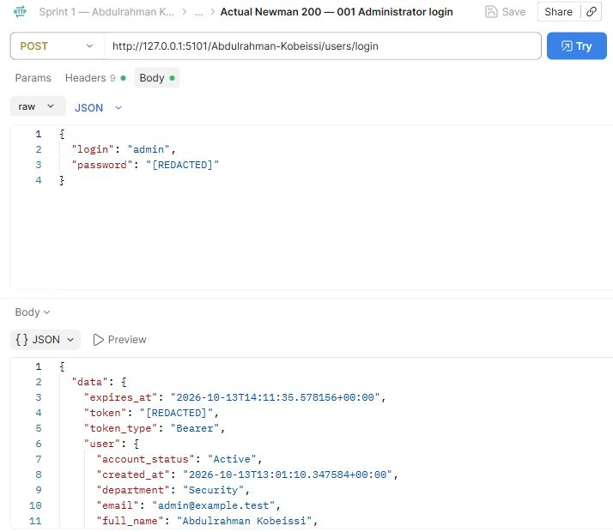
Abdulrahman Kobeissi — 001 Administrator login. The request and saved actual response demonstrate this operation.

Postman Evidence 2 (Abdulrahman Kobeissi)
Failed login · POST · observed HTTP 401
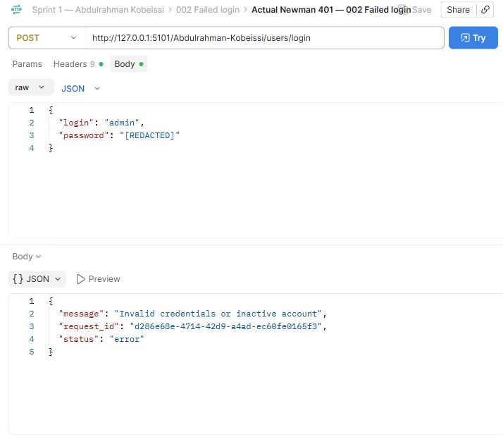
Abdulrahman Kobeissi — 002 Failed login. The request and saved actual response demonstrate this operation.

Postman Evidence 3 (Abdulrahman Kobeissi)
Register analyst · POST · observed HTTP 201
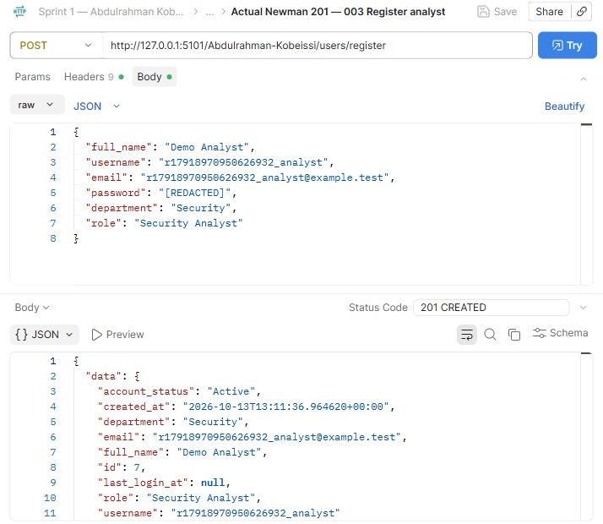
Abdulrahman Kobeissi — 003 Register analyst. The request and saved actual response demonstrate this operation.

Postman Evidence 13 (Abdulrahman Kobeissi)
Reject duplicate username · POST · observed HTTP 409
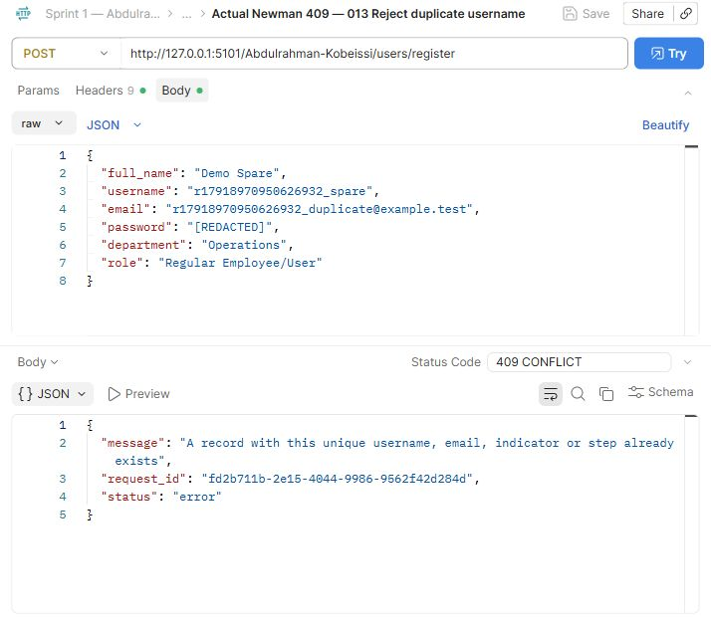
Abdulrahman Kobeissi — 013 Reject duplicate username. The request and saved actual response demonstrate this operation.

Postman Evidence 14 (Abdulrahman Kobeissi)
Reject public privilege escalation · POST · observed HTTP 403
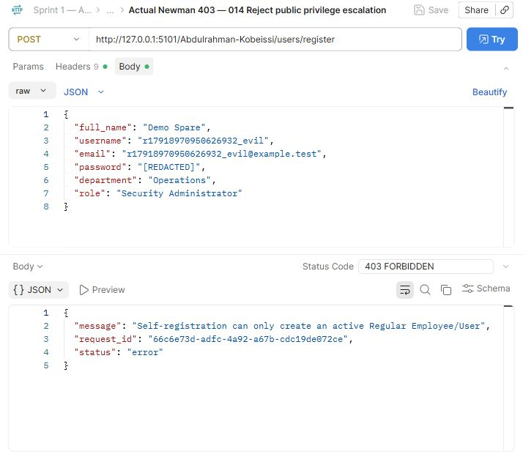
Abdulrahman Kobeissi — 014 Reject public privilege escalation. The request and saved actual response demonstrate this operation.

Postman Evidence 15 (Abdulrahman Kobeissi)
Reject invalid email · POST · observed HTTP 400
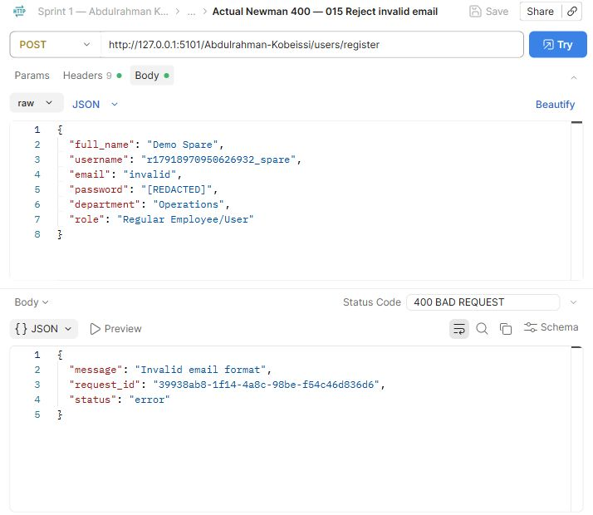
Abdulrahman Kobeissi — 015 Reject invalid email. The request and saved actual response demonstrate this operation.

Postman Evidence 16 (Abdulrahman Kobeissi)
Reject weak password · POST · observed HTTP 400
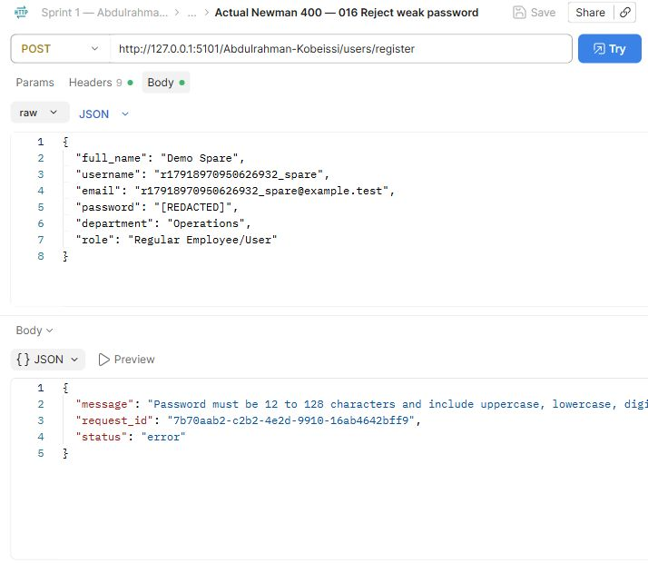
Abdulrahman Kobeissi — 016 Reject weak password. The request and saved actual response demonstrate this operation.

Postman Evidence 17 (Abdulrahman Kobeissi)
Reject missing required fields · POST · observed HTTP 400
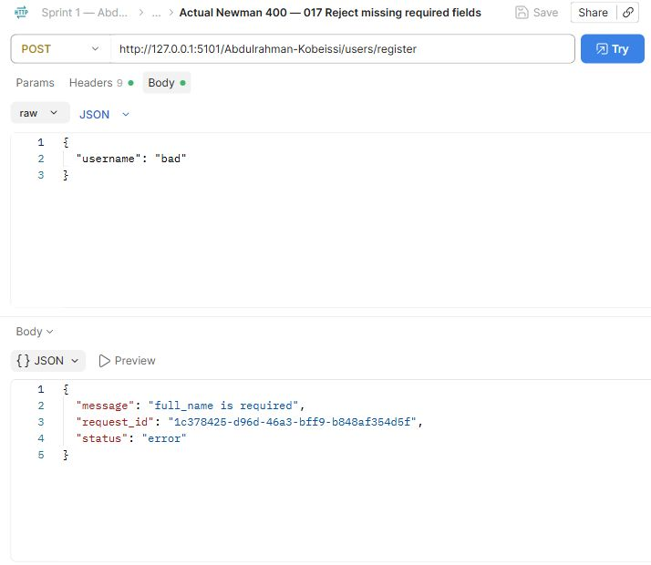
Abdulrahman Kobeissi — 017 Reject missing required fields. The request and saved actual response demonstrate this operation.

Postman Evidence 18 (Abdulrahman Kobeissi)
Update own profile · PUT · observed HTTP 200
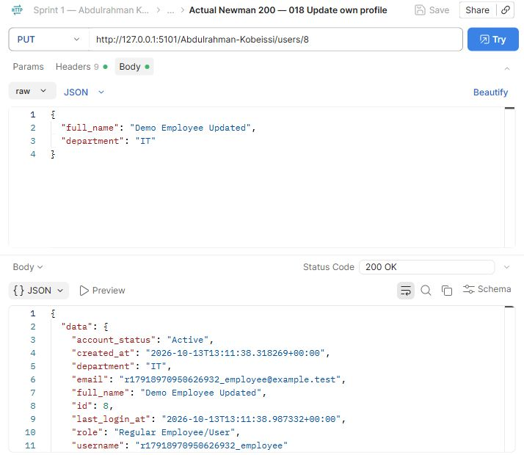
Abdulrahman Kobeissi — 018 Update own profile. The request and saved actual response demonstrate this operation.

Postman Evidence 19 (Abdulrahman Kobeissi)
Retrieve own profile · GET · observed HTTP 200
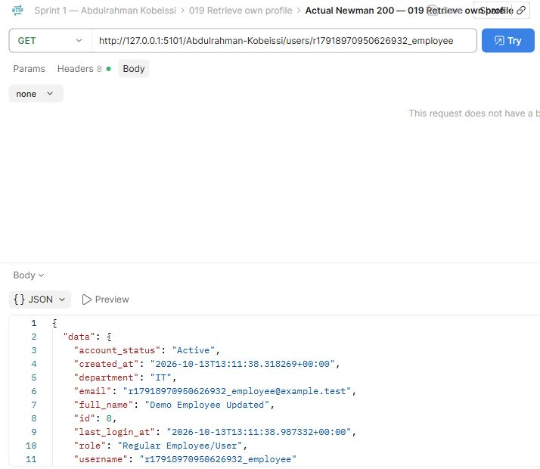
Abdulrahman Kobeissi — 019 Retrieve own profile. The request and saved actual response demonstrate this operation.

Postman Evidence 21 (Abdulrahman Kobeissi)
List users · GET · observed HTTP 200
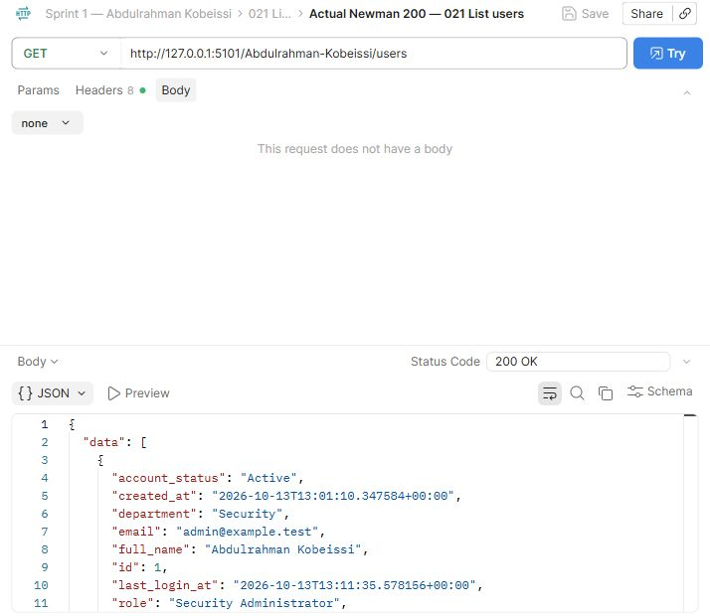
Abdulrahman Kobeissi — 021 List users. The request and saved actual response demonstrate this operation.

Postman Evidence 22 (Abdulrahman Kobeissi)
Find missing username · GET · observed HTTP 404
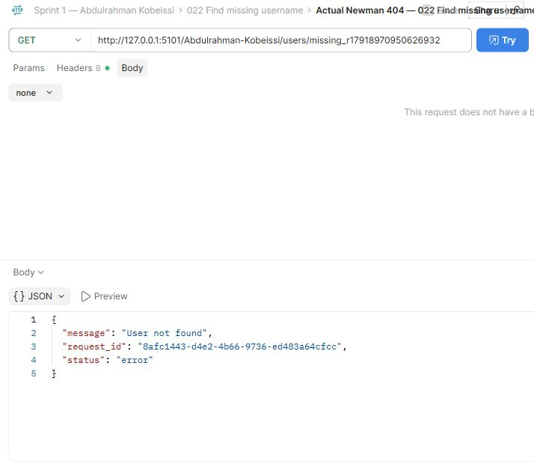
Abdulrahman Kobeissi — 022 Find missing username. The request and saved actual response demonstrate this operation.

Postman Evidence 24 (Abdulrahman Kobeissi)
Reject analyst user management · GET · observed HTTP 403
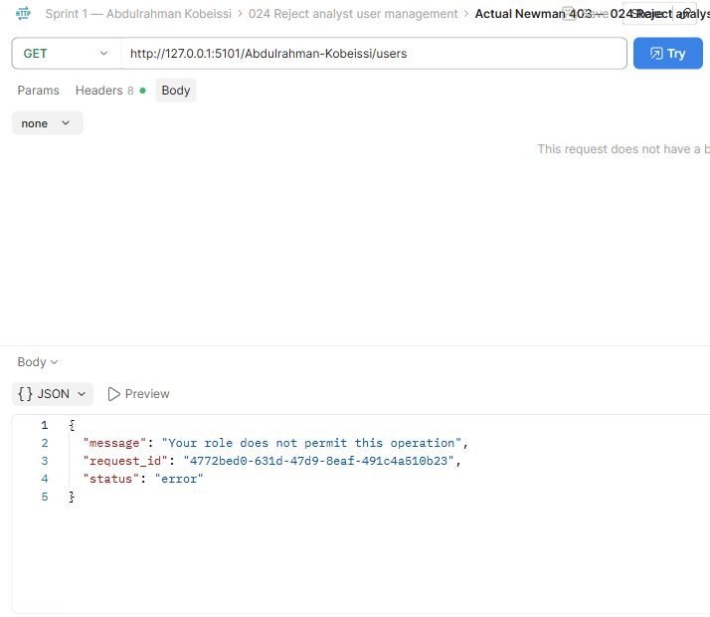
Abdulrahman Kobeissi — 024 Reject analyst user management. The request and saved actual response demonstrate this operation.

Postman Evidence 25 (Abdulrahman Kobeissi)
Reject missing authentication · GET · observed HTTP 401
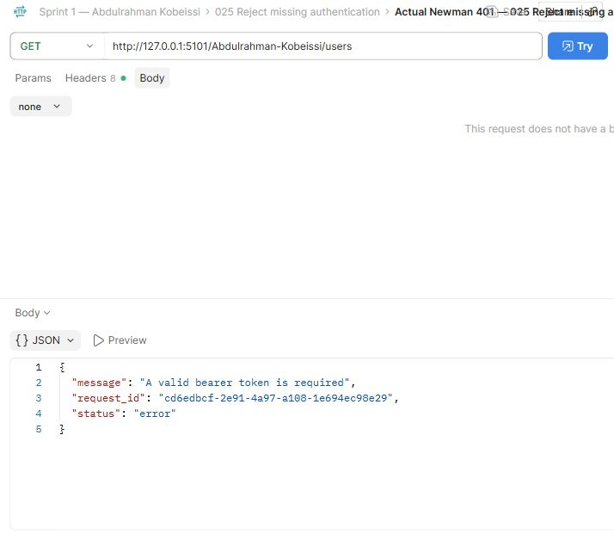
Abdulrahman Kobeissi — 025 Reject missing authentication. The request and saved actual response demonstrate this operation.

Postman Evidence 26 (Abdulrahman Kobeissi)
Assign Auditor role · PUT · observed HTTP 200
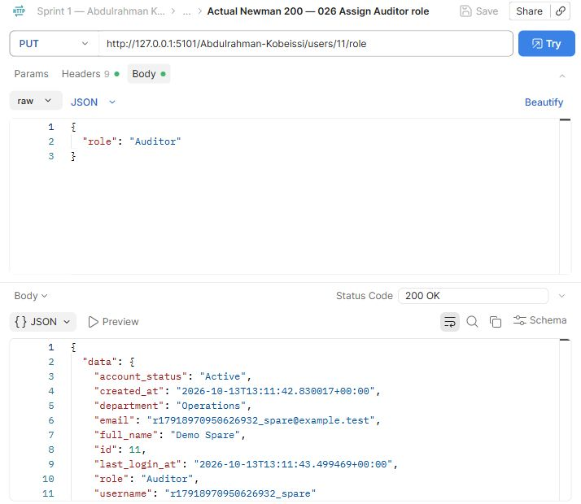
Abdulrahman Kobeissi — 026 Assign Auditor role. The request and saved actual response demonstrate this operation.

Postman Evidence 29 (Abdulrahman Kobeissi)
Suspend account · PUT · observed HTTP 200
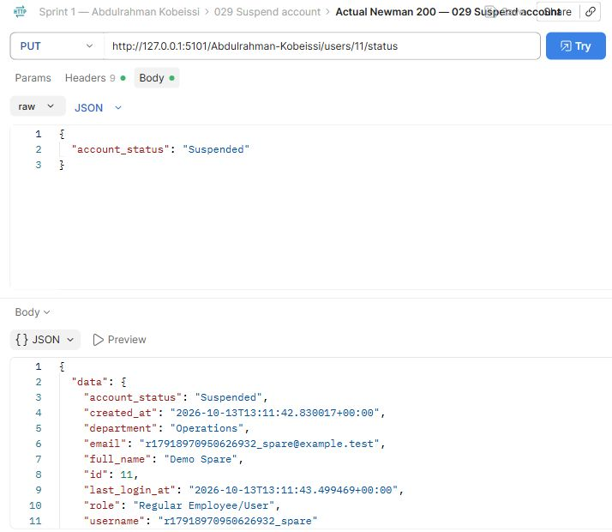
Abdulrahman Kobeissi — 029 Suspend account. The request and saved actual response demonstrate this operation.

Postman Evidence 30 (Abdulrahman Kobeissi)
Suspended login rejected · POST · observed HTTP 401
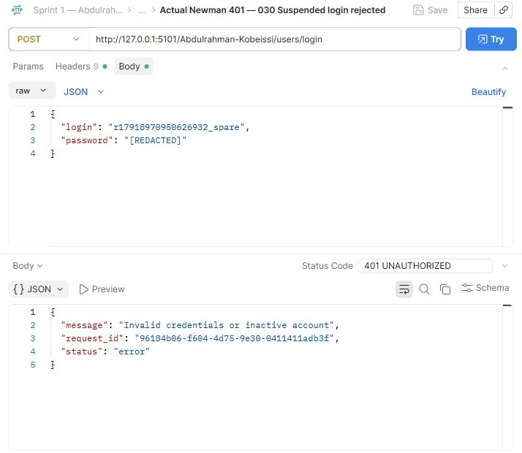
Abdulrahman Kobeissi — 030 Suspended login rejected. The request and saved actual response demonstrate this operation.

Postman Evidence 32 (Abdulrahman Kobeissi)
Inactive login rejected · POST · observed HTTP 401
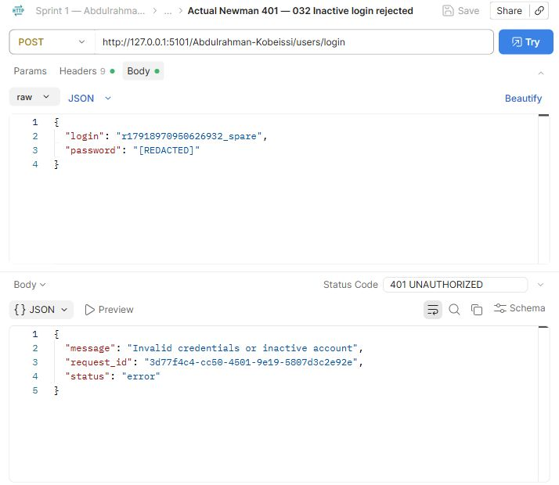
Abdulrahman Kobeissi — 032 Inactive login rejected. The request and saved actual response demonstrate this operation.

Postman Evidence 34 (Abdulrahman Kobeissi)
Unauthorized user deletion · DELETE · observed HTTP 403
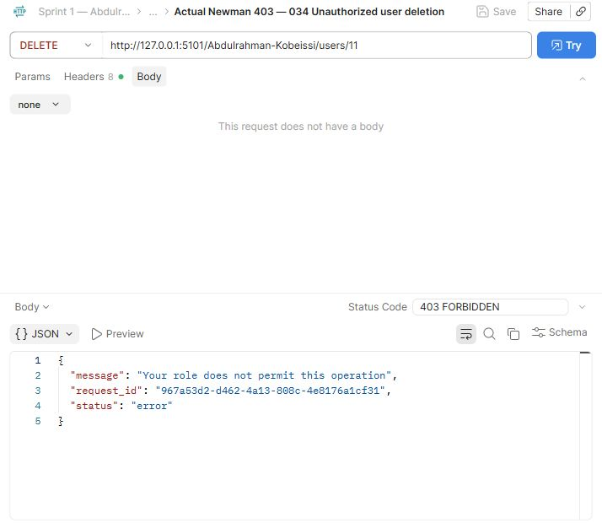
Abdulrahman Kobeissi — 034 Unauthorized user deletion. The request and saved actual response demonstrate this operation.

Postman Evidence 35 (Abdulrahman Kobeissi)
Delete spare account · DELETE · observed HTTP 200
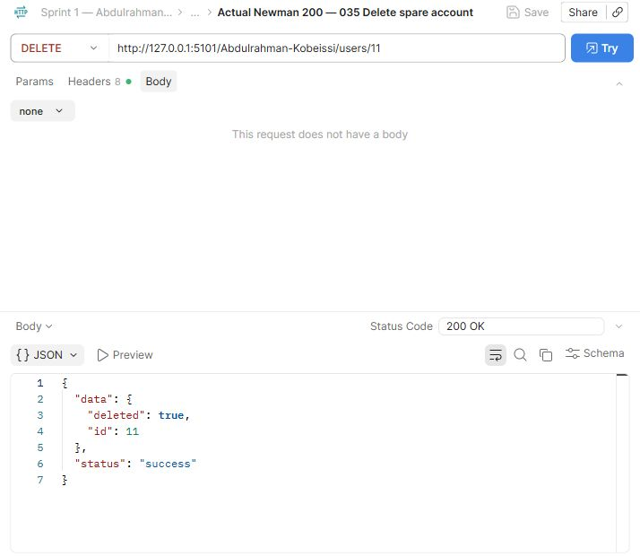
Abdulrahman Kobeissi — 035 Delete spare account. The request and saved actual response demonstrate this operation.

Postman Evidence 37 (Abdulrahman Kobeissi)
Create server · POST · observed HTTP 201
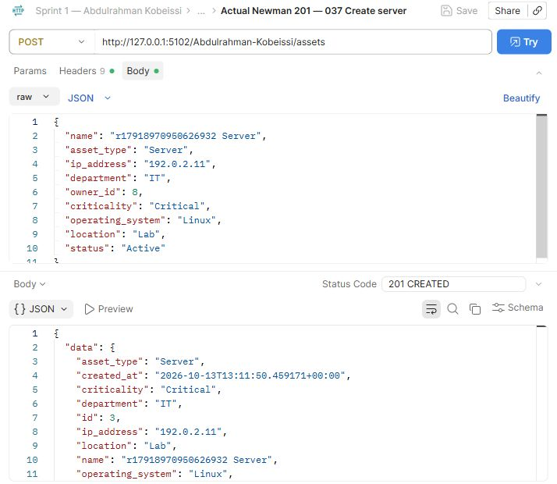
Abdulrahman Kobeissi — 037 Create server. The request and saved actual response demonstrate this operation.

Postman Evidence 38 (Abdulrahman Kobeissi)
Create workstation · POST · observed HTTP 201
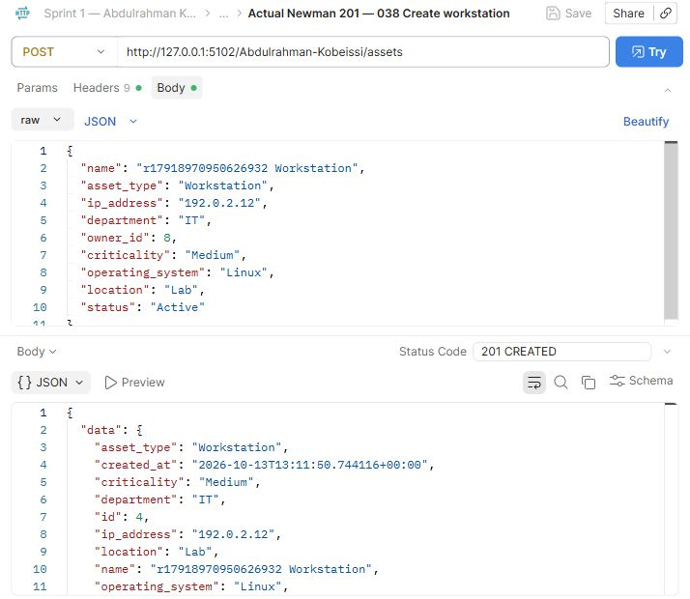
Abdulrahman Kobeissi — 038 Create workstation. The request and saved actual response demonstrate this operation.

Postman Evidence 40 (Abdulrahman Kobeissi)
Asset before update · GET · observed HTTP 200
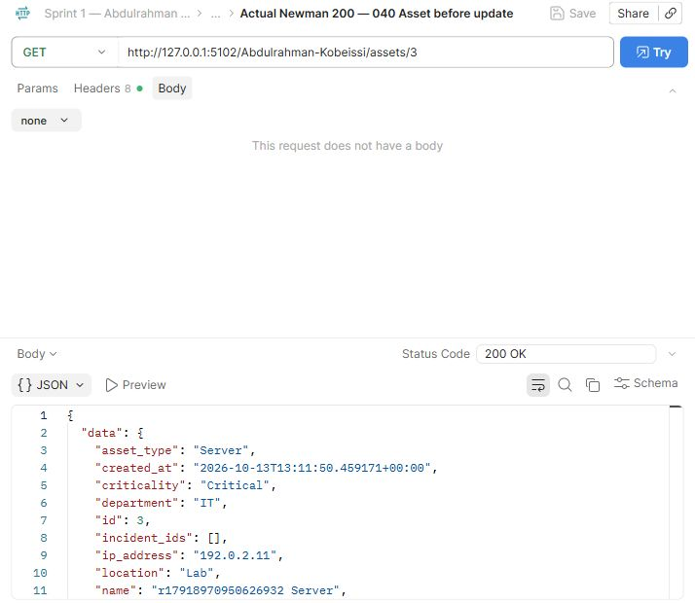
Abdulrahman Kobeissi — 040 Asset before update. The request and saved actual response demonstrate this operation.
Compare this view with the adjacent before/update/after requests. The full response remains available in the collection.

Postman Evidence 41 (Abdulrahman Kobeissi)
Update asset · PUT · observed HTTP 200
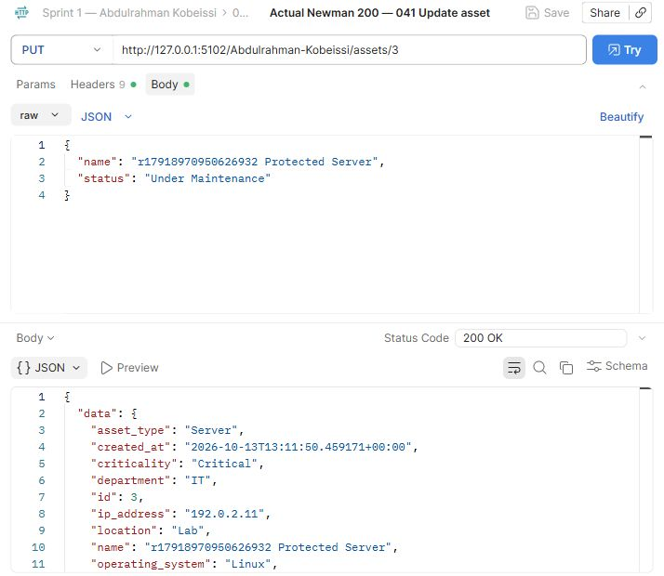
Abdulrahman Kobeissi — 041 Update asset. The request and saved actual response demonstrate this operation.

Postman Evidence 42 (Abdulrahman Kobeissi)
Asset after update · GET · observed HTTP 200
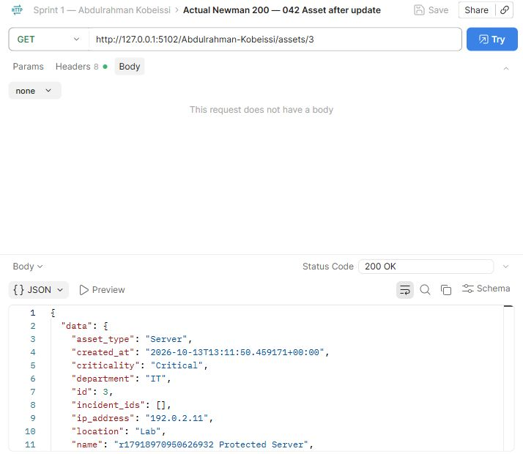
Abdulrahman Kobeissi — 042 Asset after update. The request and saved actual response demonstrate this operation.
Compare this view with the adjacent before/update/after requests. The full response remains available in the collection.

Postman Evidence 44 (Abdulrahman Kobeissi)
List assets · GET · observed HTTP 200
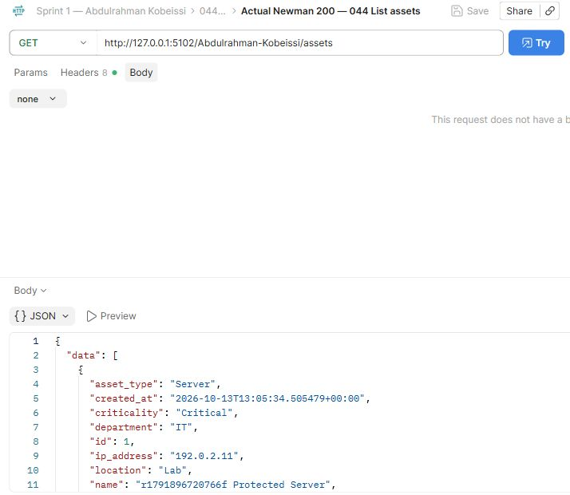
Abdulrahman Kobeissi — 044 List assets. The request and saved actual response demonstrate this operation.

Postman Evidence 45 (Abdulrahman Kobeissi)
Search assets by name · GET · observed HTTP 200
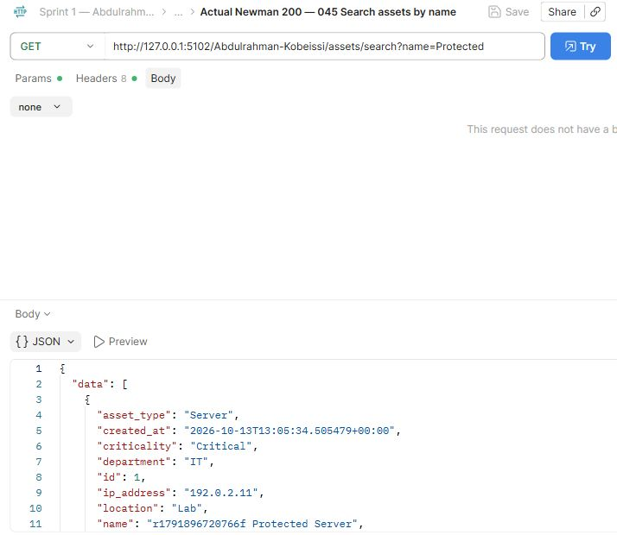
Abdulrahman Kobeissi — 045 Search assets by name. The request and saved actual response demonstrate this operation.

Postman Evidence 46 (Abdulrahman Kobeissi)
Search assets by asset_type · GET · observed HTTP 200
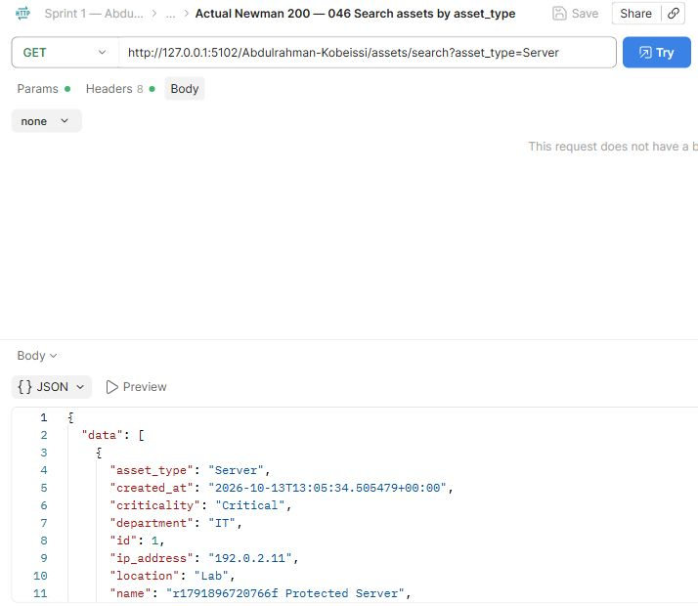
Abdulrahman Kobeissi — 046 Search assets by asset_type. The request and saved actual response demonstrate this operation.

Postman Evidence 47 (Abdulrahman Kobeissi)
Search assets by ip_address · GET · observed HTTP 200
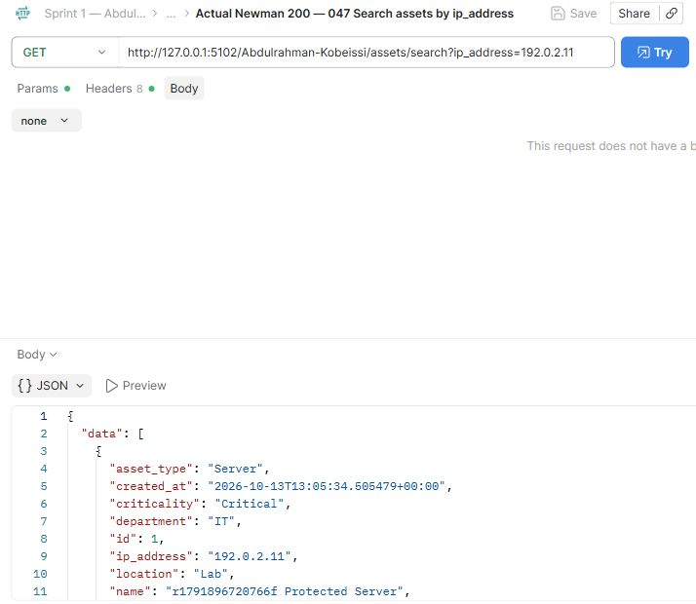
Abdulrahman Kobeissi — 047 Search assets by ip_address. The request and saved actual response demonstrate this operation.

Postman Evidence 48 (Abdulrahman Kobeissi)
Search assets by department · GET · observed HTTP 200
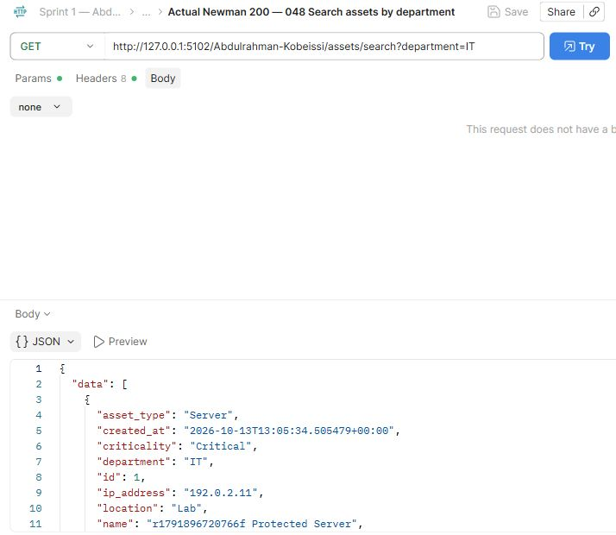
Abdulrahman Kobeissi — 048 Search assets by department. The request and saved actual response demonstrate this operation.

Postman Evidence 49 (Abdulrahman Kobeissi)
Search assets by criticality · GET · observed HTTP 200
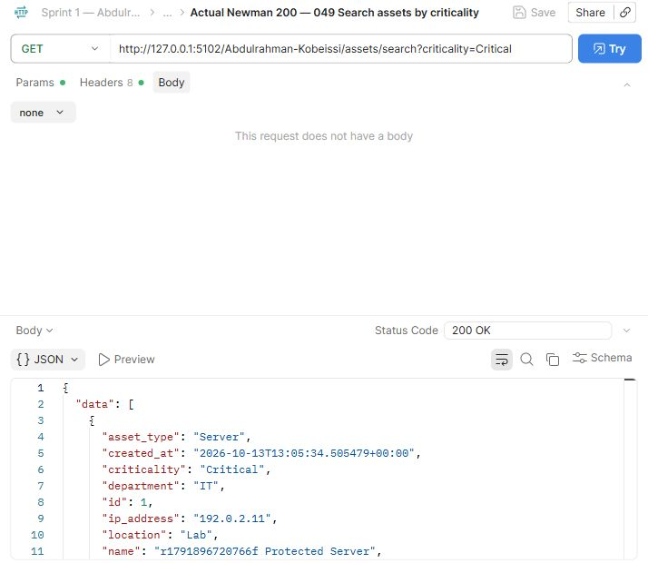
Abdulrahman Kobeissi — 049 Search assets by criticality. The request and saved actual response demonstrate this operation.

Postman Evidence 50 (Abdulrahman Kobeissi)
Missing asset · GET · observed HTTP 404
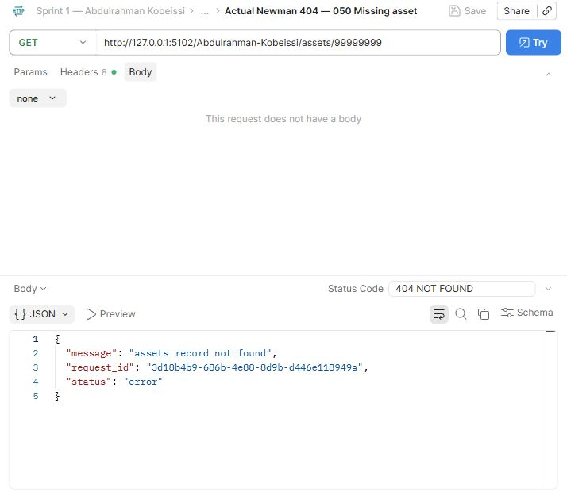
Abdulrahman Kobeissi — 050 Missing asset. The request and saved actual response demonstrate this operation.

Postman Evidence 51 (Abdulrahman Kobeissi)
Invalid IP address · PUT · observed HTTP 400
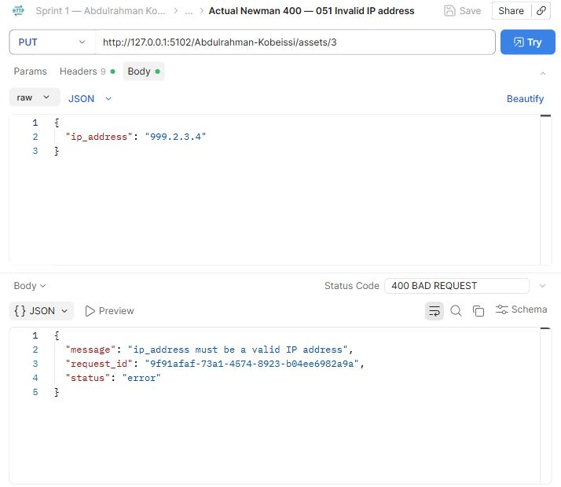
Abdulrahman Kobeissi — 051 Invalid IP address. The request and saved actual response demonstrate this operation.

Postman Evidence 53 (Abdulrahman Kobeissi)
Unauthorized asset delete · DELETE · observed HTTP 403
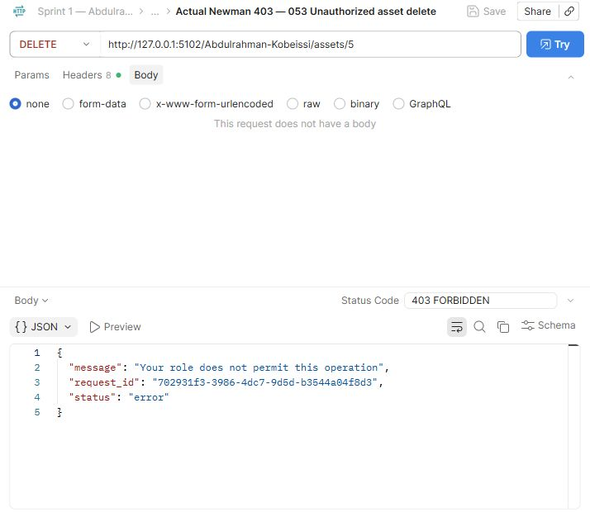
Abdulrahman Kobeissi — 053 Unauthorized asset delete. The request and saved actual response demonstrate this operation.

Postman Evidence 54 (Abdulrahman Kobeissi)
Delete unreferenced asset · DELETE · observed HTTP 200
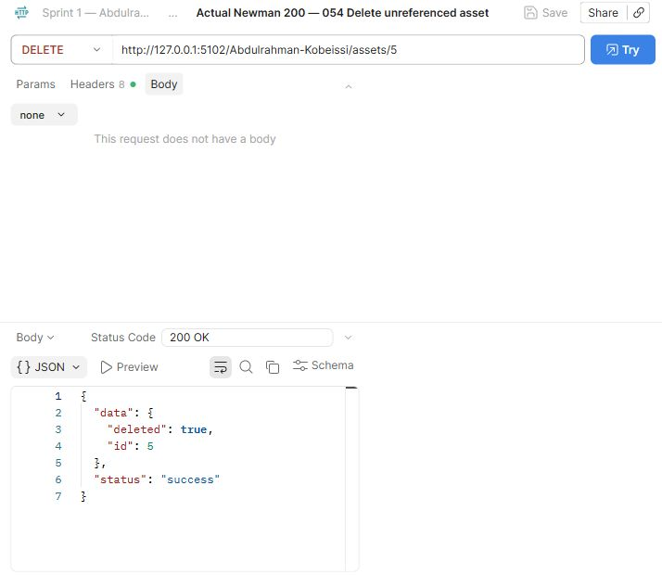
Abdulrahman Kobeissi — 054 Delete unreferenced asset. The request and saved actual response demonstrate this operation.

Postman Evidence 56 (Abdulrahman Kobeissi)
Report low incident · POST · observed HTTP 201
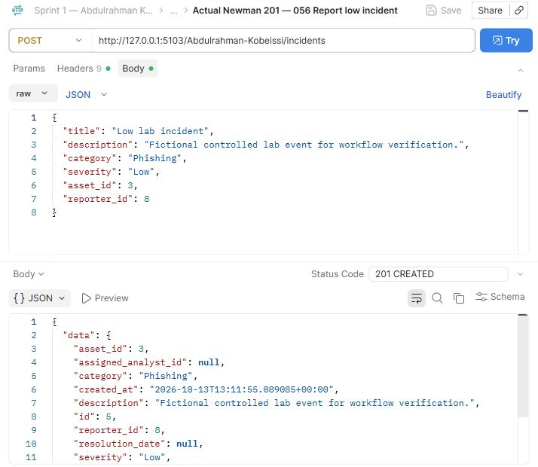
Abdulrahman Kobeissi — 056 Report low incident. The request and saved actual response demonstrate this operation.
Severity rationale: Low represents a limited-impact event. This fictional Phishing fixture verifies that the system stores that category correctly.

Postman Evidence 57 (Abdulrahman Kobeissi)
Report medium incident · POST · observed HTTP 201
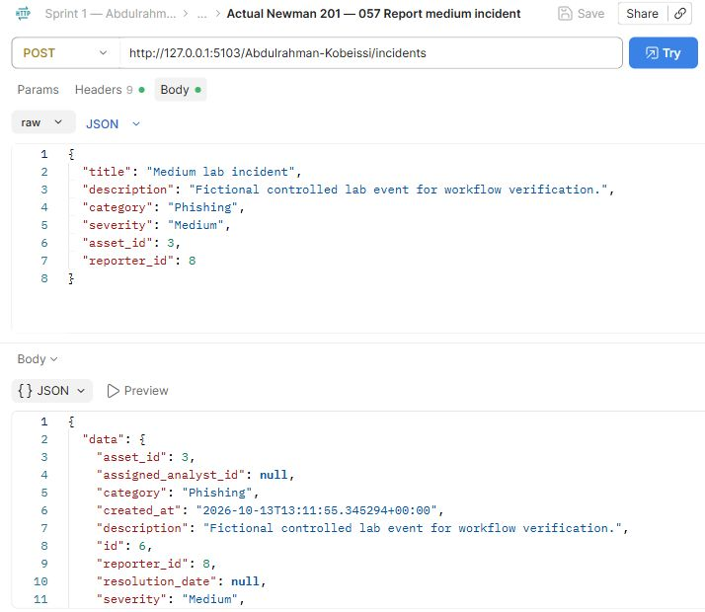
Abdulrahman Kobeissi — 057 Report medium incident. The request and saved actual response demonstrate this operation.
Severity rationale: Medium represents an event requiring investigation. This fictional Phishing fixture tests that level without asserting a real attack.

Postman Evidence 58 (Abdulrahman Kobeissi)
Report high incident · POST · observed HTTP 201
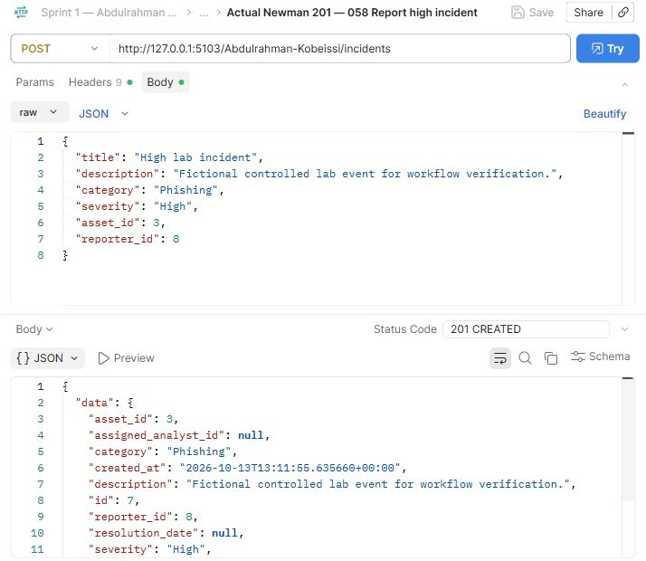
Abdulrahman Kobeissi — 058 Report high incident. The request and saved actual response demonstrate this operation.
Severity rationale: High represents an event affecting important systems or users. This fictional fixture exercises escalation data; no real compromise is claimed.

Postman Evidence 59 (Abdulrahman Kobeissi)
Report critical incident · POST · observed HTTP 201
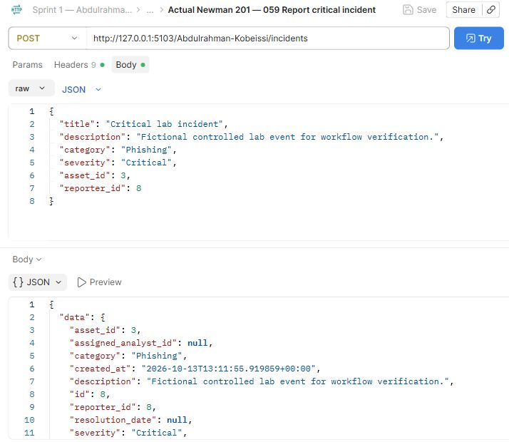
Abdulrahman Kobeissi — 059 Report critical incident. The request and saved actual response demonstrate this operation.
Severity rationale: Critical represents an event needing immediate response. This fictional fixture tests urgent classification; it is not a measured real-world impact assessment.

Postman Evidence 60 (Abdulrahman Kobeissi)
List all incidents · GET · observed HTTP 200
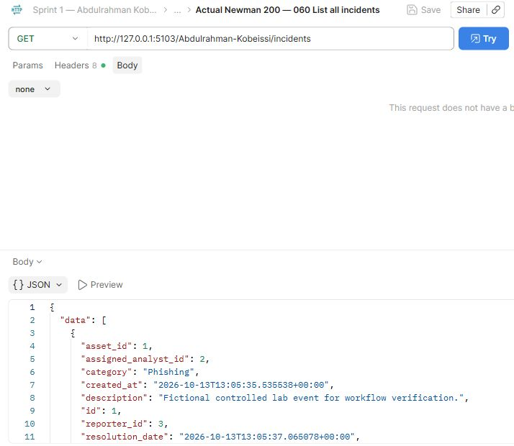
Abdulrahman Kobeissi — 060 List all incidents. The request and saved actual response demonstrate this operation.

Postman Evidence 64 (Abdulrahman Kobeissi)
Missing incident · GET · observed HTTP 404
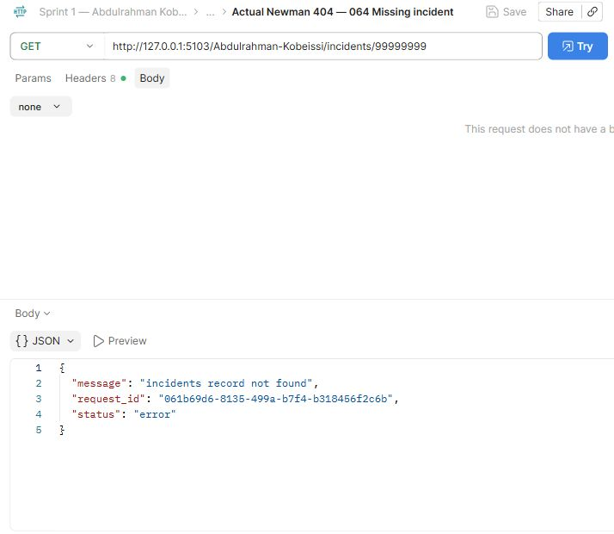
Abdulrahman Kobeissi — 064 Missing incident. The request and saved actual response demonstrate this operation.

Postman Evidence 65 (Abdulrahman Kobeissi)
Unauthorized assignment · PUT · observed HTTP 403
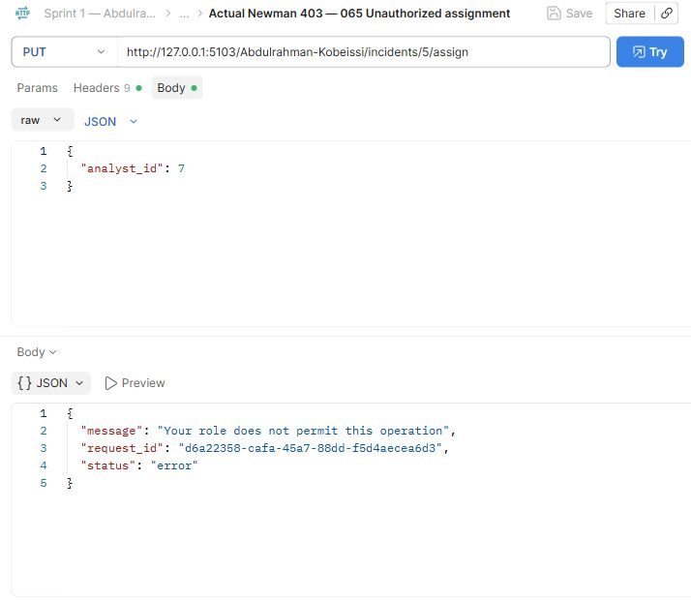
Abdulrahman Kobeissi — 065 Unauthorized assignment. The request and saved actual response demonstrate this operation.

Postman Evidence 66 (Abdulrahman Kobeissi)
Reject non-analyst assignee · PUT · observed HTTP 400
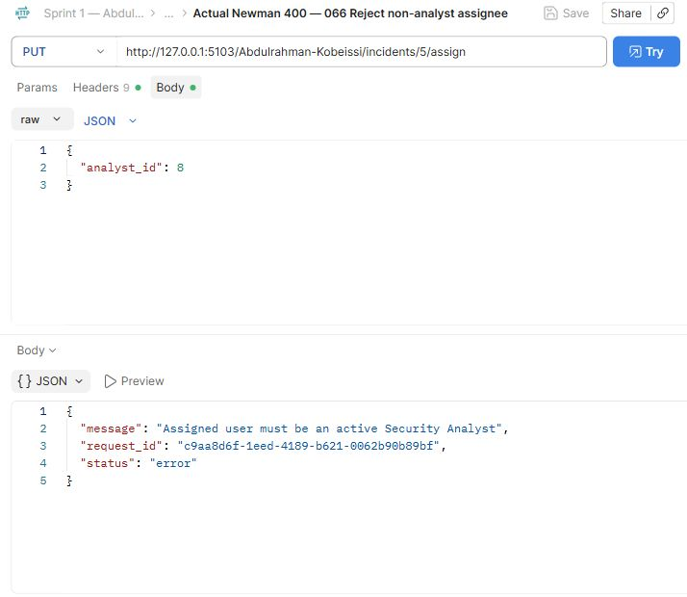
Abdulrahman Kobeissi — 066 Reject non-analyst assignee. The request and saved actual response demonstrate this operation.

Postman Evidence 67 (Abdulrahman Kobeissi)
Assign analyst · PUT · observed HTTP 200
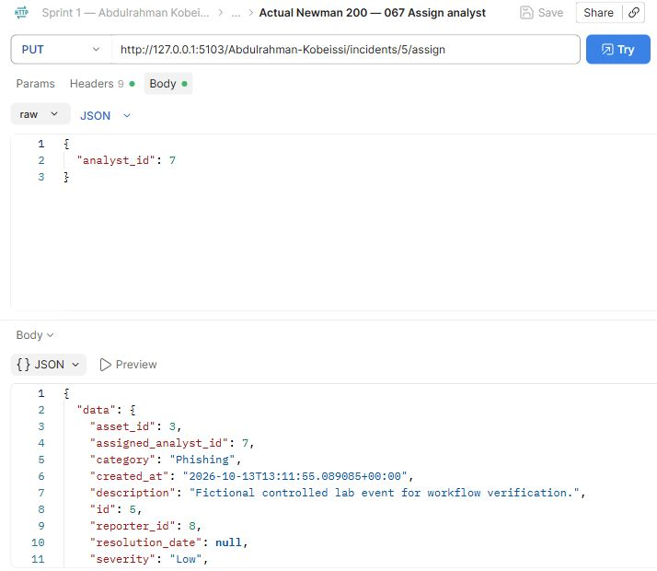
Abdulrahman Kobeissi — 067 Assign analyst. The request and saved actual response demonstrate this operation.

Postman Evidence 68 (Abdulrahman Kobeissi)
Analyst assigned incidents · GET · observed HTTP 200
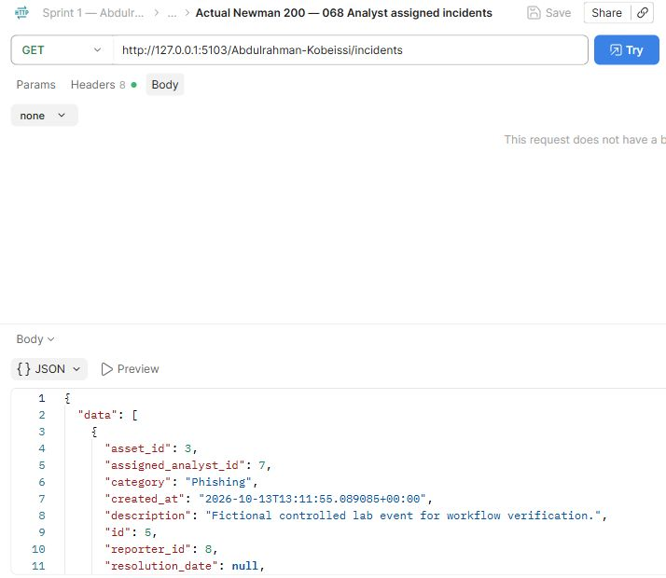
Abdulrahman Kobeissi — 068 Analyst assigned incidents. The request and saved actual response demonstrate this operation.

Postman Evidence 69 (Abdulrahman Kobeissi)
Analyst related asset · GET · observed HTTP 200
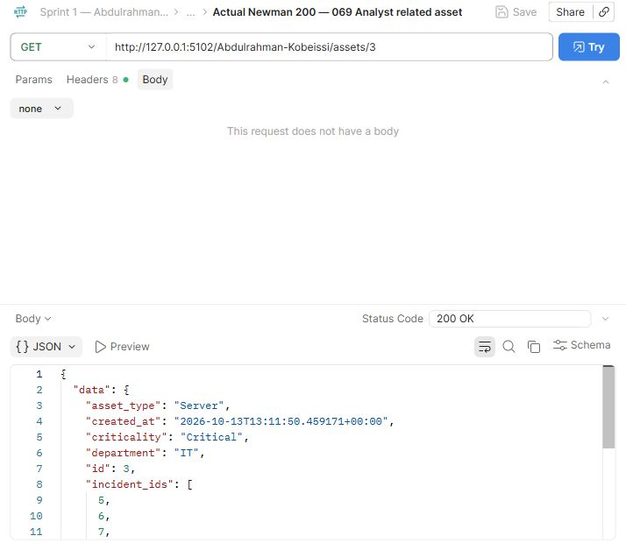
Abdulrahman Kobeissi — 069 Analyst related asset. The request and saved actual response demonstrate this operation.

Postman Evidence 72 (Abdulrahman Kobeissi)
Reject skipped incident lifecycle · PUT · observed HTTP 409
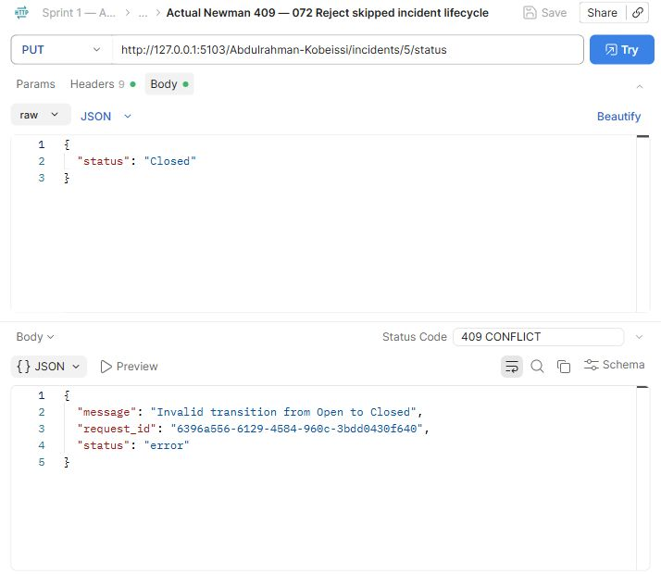
Abdulrahman Kobeissi — 072 Reject skipped incident lifecycle. The request and saved actual response demonstrate this operation.

Postman Evidence 73 (Abdulrahman Kobeissi)
Investigation note · POST · observed HTTP 201
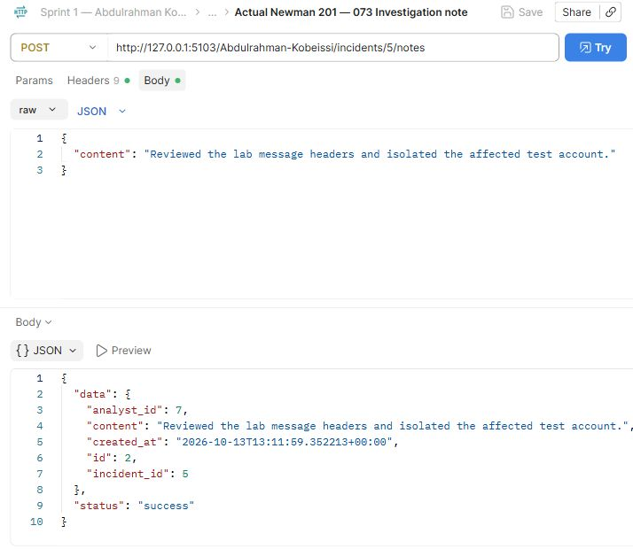
Abdulrahman Kobeissi — 073 Investigation note. The request and saved actual response demonstrate this operation.

Postman Evidence 74 (Abdulrahman Kobeissi)
Retrieve incident with notes · GET · observed HTTP 200
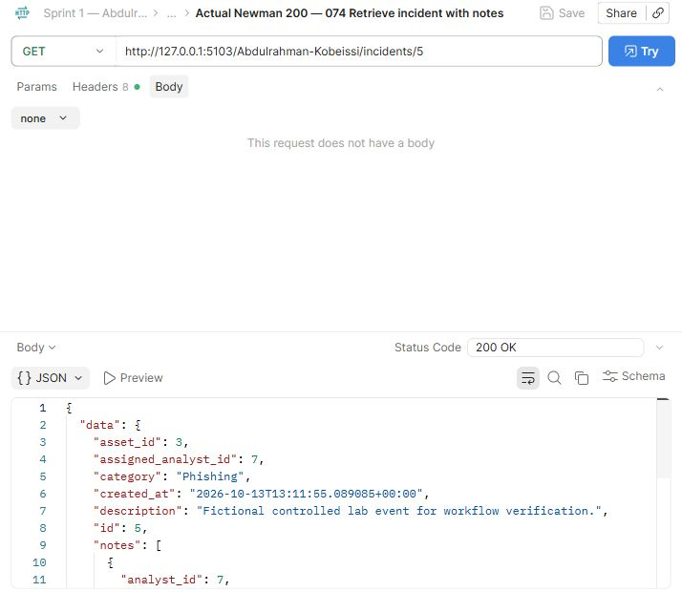
Abdulrahman Kobeissi — 074 Retrieve incident with notes. The request and saved actual response demonstrate this operation.

Postman Evidence 75 (Abdulrahman Kobeissi)
Incident becomes Under Investigation · PUT · observed HTTP 200
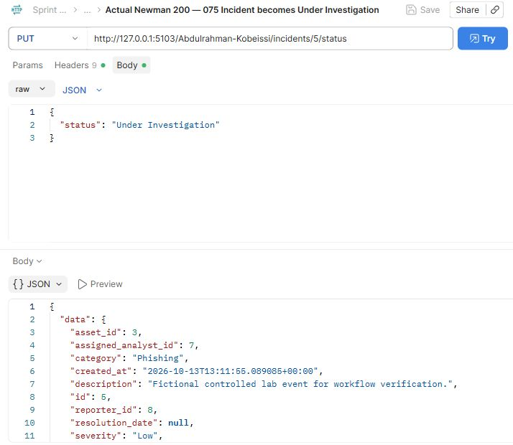
Abdulrahman Kobeissi — 075 Incident becomes Under Investigation. The request and saved actual response demonstrate this operation.

Postman Evidence 76 (Abdulrahman Kobeissi)
Incident becomes Mitigated · PUT · observed HTTP 200
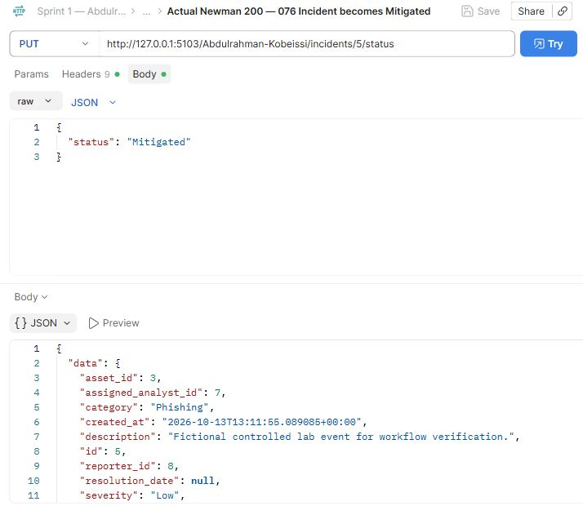
Abdulrahman Kobeissi — 076 Incident becomes Mitigated. The request and saved actual response demonstrate this operation.

Postman Evidence 77 (Abdulrahman Kobeissi)
Incident becomes Resolved · PUT · observed HTTP 200
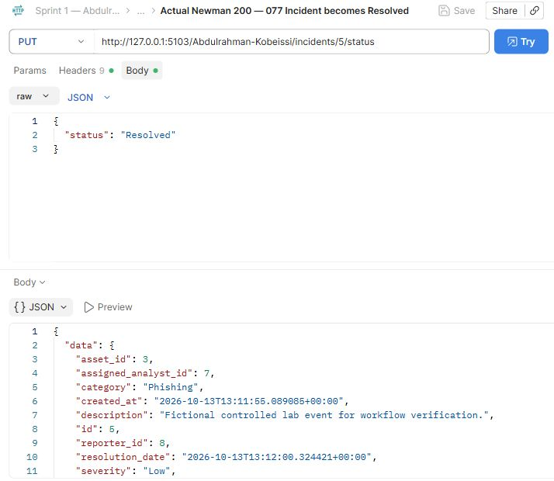
Abdulrahman Kobeissi — 077 Incident becomes Resolved. The request and saved actual response demonstrate this operation.

Postman Evidence 78 (Abdulrahman Kobeissi)
Incident becomes Closed · PUT · observed HTTP 200
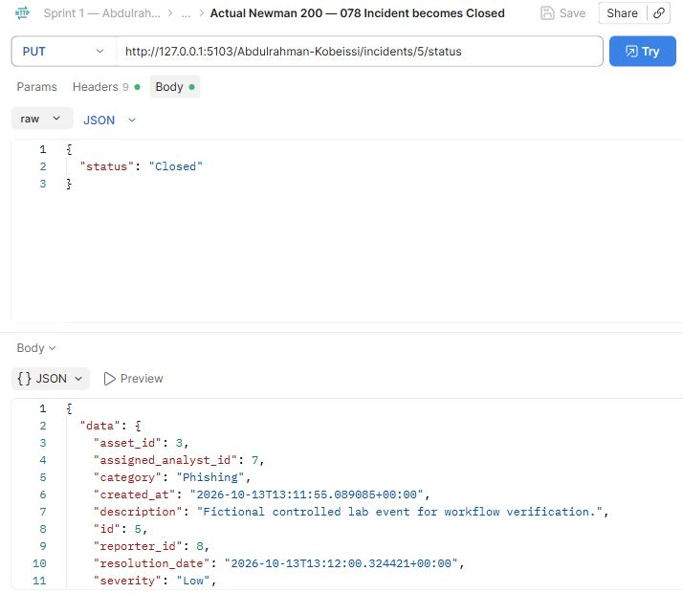
Abdulrahman Kobeissi — 078 Incident becomes Closed. The request and saved actual response demonstrate this operation.

Postman Evidence 79 (Abdulrahman Kobeissi)
Employee status modification rejected · PUT · observed HTTP 403
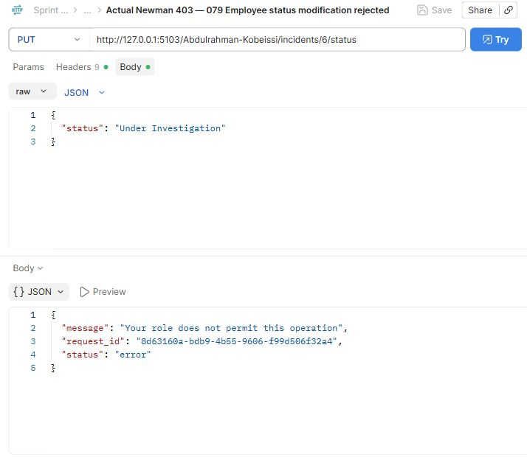
Abdulrahman Kobeissi — 079 Employee status modification rejected. The request and saved actual response demonstrate this operation.

Postman Evidence 80 (Abdulrahman Kobeissi)
Invalid incident severity · POST · observed HTTP 400
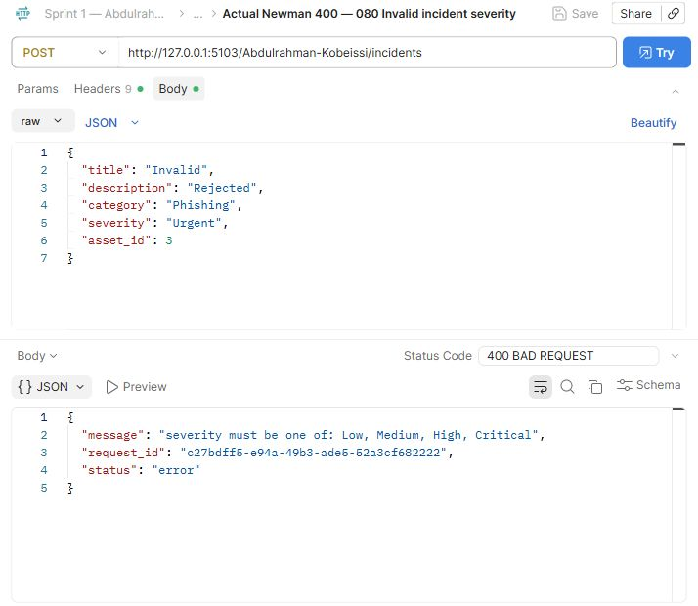
Abdulrahman Kobeissi — 080 Invalid incident severity. The request and saved actual response demonstrate this operation.

Postman Evidence 82 (Abdulrahman Kobeissi)
Create IP Address indicator · POST · observed HTTP 201
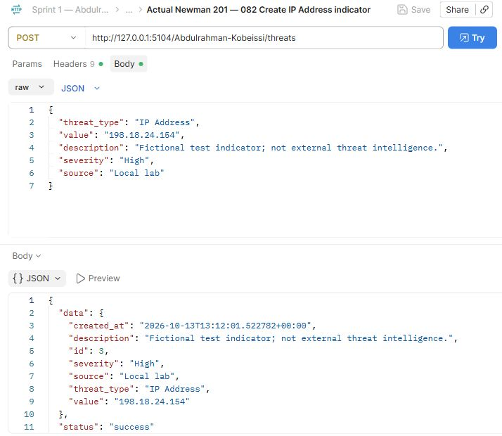
Abdulrahman Kobeissi — 082 Create IP Address indicator. The request and saved actual response demonstrate this operation.

Postman Evidence 83 (Abdulrahman Kobeissi)
Create Domain indicator · POST · observed HTTP 201
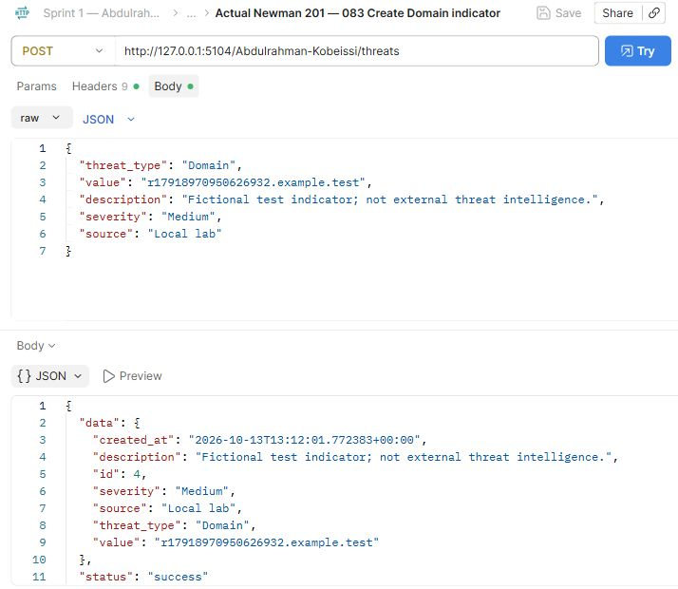
Abdulrahman Kobeissi — 083 Create Domain indicator. The request and saved actual response demonstrate this operation.

Postman Evidence 84 (Abdulrahman Kobeissi)
Create File Hash indicator · POST · observed HTTP 201
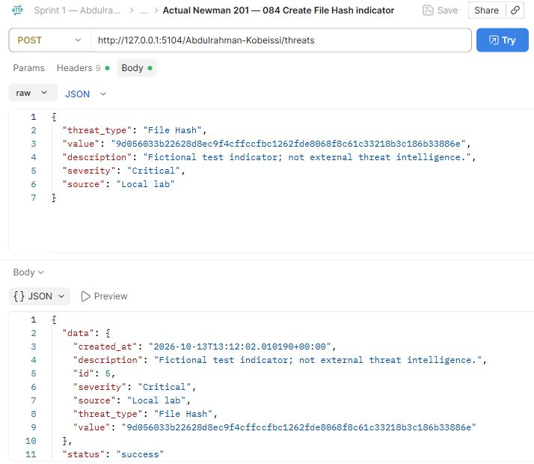
Abdulrahman Kobeissi — 084 Create File Hash indicator. The request and saved actual response demonstrate this operation.

Postman Evidence 85 (Abdulrahman Kobeissi)
Duplicate indicator rejected · POST · observed HTTP 409
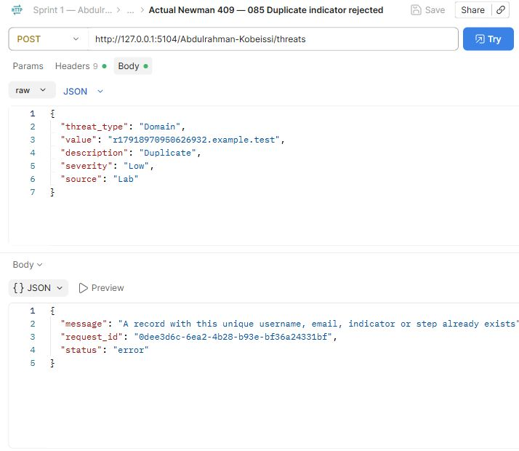
Abdulrahman Kobeissi — 085 Duplicate indicator rejected. The request and saved actual response demonstrate this operation.

Postman Evidence 86 (Abdulrahman Kobeissi)
Invalid domain rejected · POST · observed HTTP 400
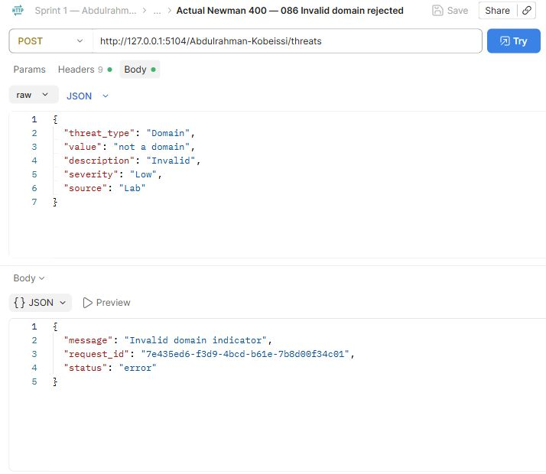
Abdulrahman Kobeissi — 086 Invalid domain rejected. The request and saved actual response demonstrate this operation.

Postman Evidence 87 (Abdulrahman Kobeissi)
Invalid hash rejected · POST · observed HTTP 400
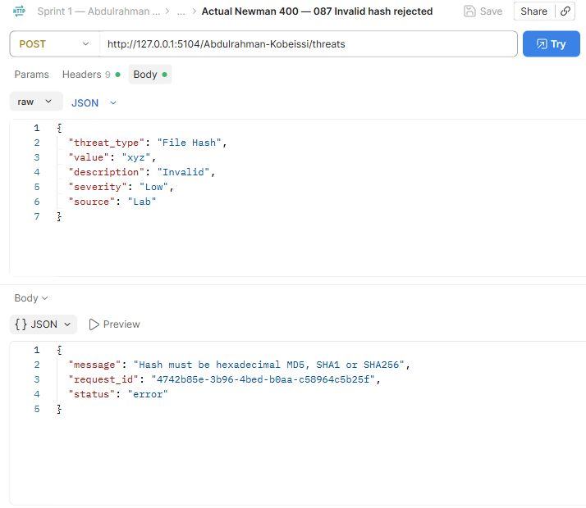
Abdulrahman Kobeissi — 087 Invalid hash rejected. The request and saved actual response demonstrate this operation.

Postman Evidence 88 (Abdulrahman Kobeissi)
List threat indicators · GET · observed HTTP 200
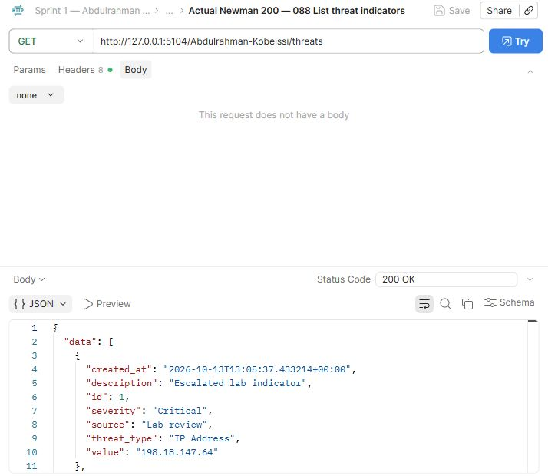
Abdulrahman Kobeissi — 088 List threat indicators. The request and saved actual response demonstrate this operation.

Postman Evidence 89 (Abdulrahman Kobeissi)
Threat before update · GET · observed HTTP 200
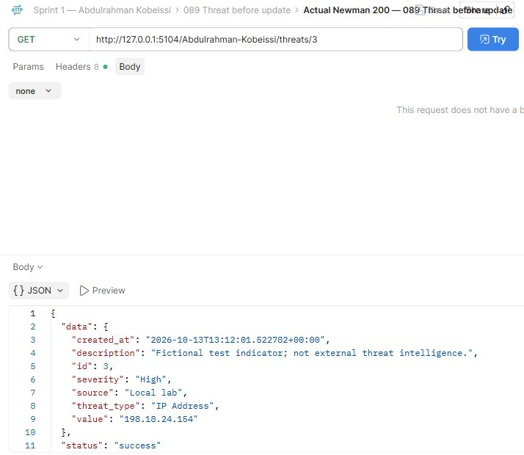
Abdulrahman Kobeissi — 089 Threat before update. The request and saved actual response demonstrate this operation.
Compare this view with the adjacent before/update/after requests. The full response remains available in the collection.

Postman Evidence 90 (Abdulrahman Kobeissi)
Update threat information · PUT · observed HTTP 200
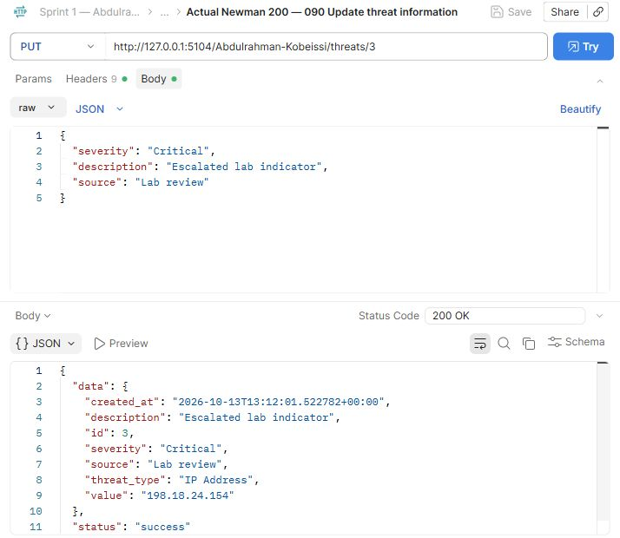
Abdulrahman Kobeissi — 090 Update threat information. The request and saved actual response demonstrate this operation.

Postman Evidence 91 (Abdulrahman Kobeissi)
Threat after update · GET · observed HTTP 200
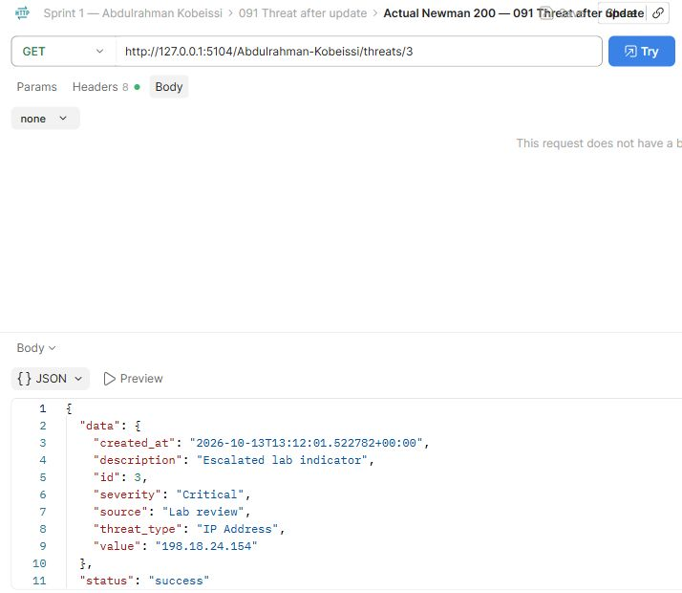
Abdulrahman Kobeissi — 091 Threat after update. The request and saved actual response demonstrate this operation.
Compare this view with the adjacent before/update/after requests. The full response remains available in the collection.

Postman Evidence 92 (Abdulrahman Kobeissi)
Search threats by threat_type · GET · observed HTTP 200
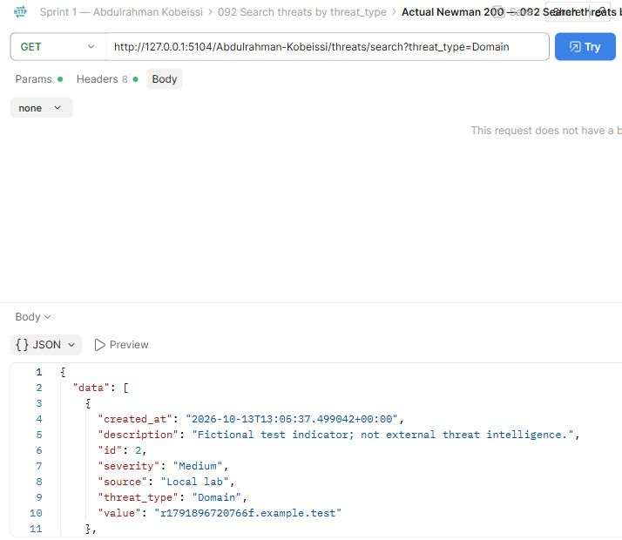
Abdulrahman Kobeissi — 092 Search threats by threat_type. The request and saved actual response demonstrate this operation.

Postman Evidence 93 (Abdulrahman Kobeissi)
Search threats by value · GET · observed HTTP 200
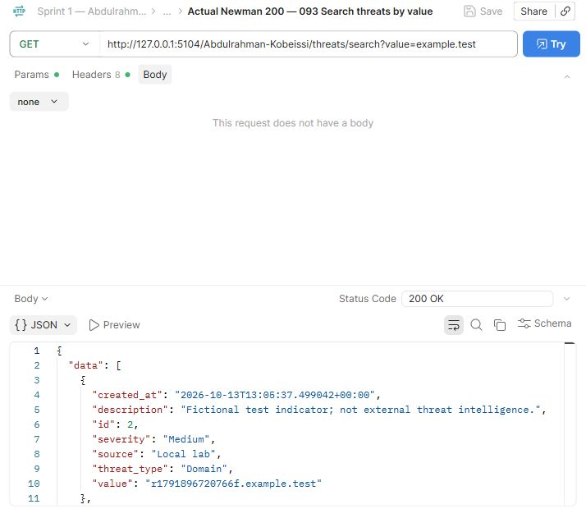
Abdulrahman Kobeissi — 093 Search threats by value. The request and saved actual response demonstrate this operation.

Postman Evidence 94 (Abdulrahman Kobeissi)
Search threats by severity · GET · observed HTTP 200
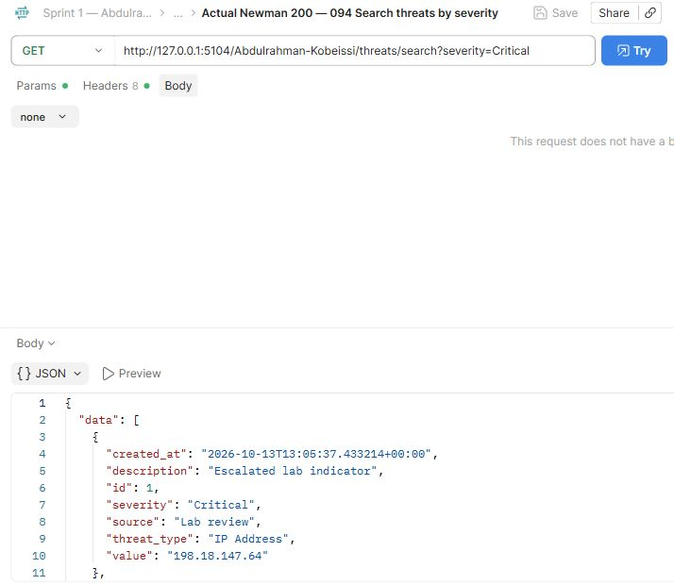
Abdulrahman Kobeissi — 094 Search threats by severity. The request and saved actual response demonstrate this operation.

Postman Evidence 95 (Abdulrahman Kobeissi)
Search threats by source · GET · observed HTTP 200
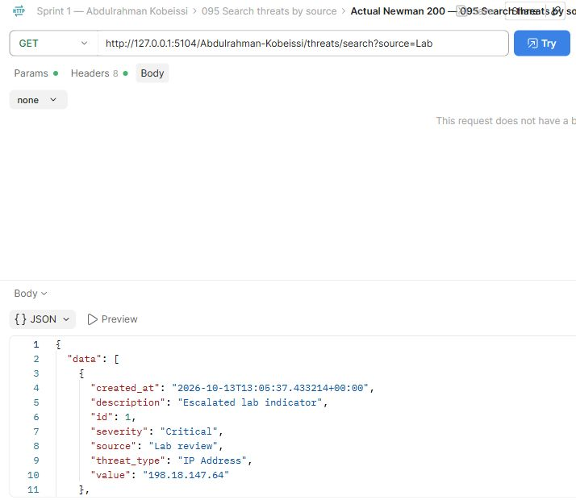
Abdulrahman Kobeissi — 095 Search threats by source. The request and saved actual response demonstrate this operation.

Postman Evidence 96 (Abdulrahman Kobeissi)
Missing threat · GET · observed HTTP 404
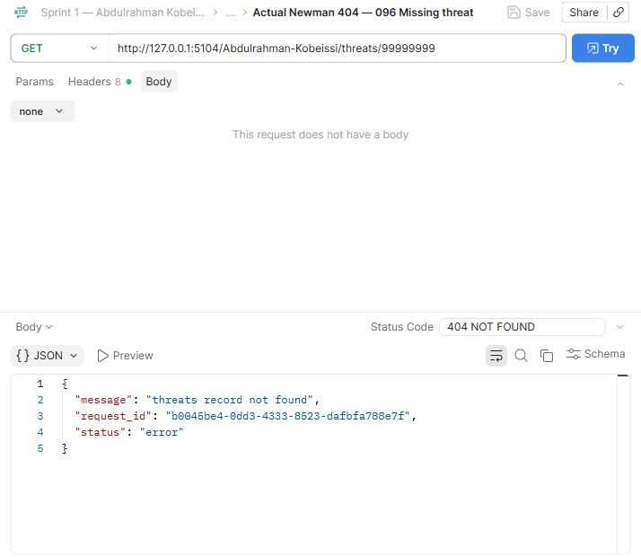
Abdulrahman Kobeissi — 096 Missing threat. The request and saved actual response demonstrate this operation.

Postman Evidence 97 (Abdulrahman Kobeissi)
Unauthorized threat deletion · DELETE · observed HTTP 403
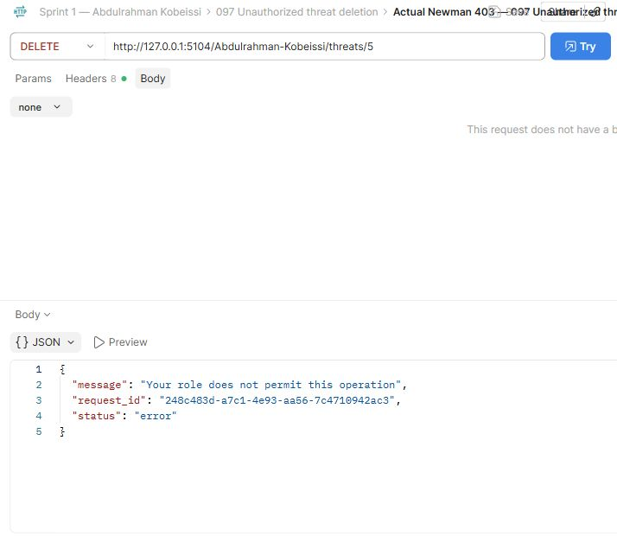
Abdulrahman Kobeissi — 097 Unauthorized threat deletion. The request and saved actual response demonstrate this operation.

Postman Evidence 98 (Abdulrahman Kobeissi)
Delete threat · DELETE · observed HTTP 200
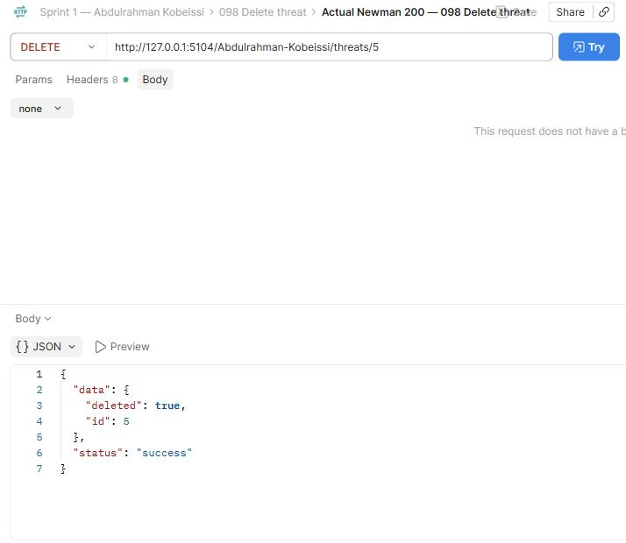
Abdulrahman Kobeissi — 098 Delete threat. The request and saved actual response demonstrate this operation.

Postman Evidence 100 (Abdulrahman Kobeissi)
Create critical vulnerability · POST · observed HTTP 201
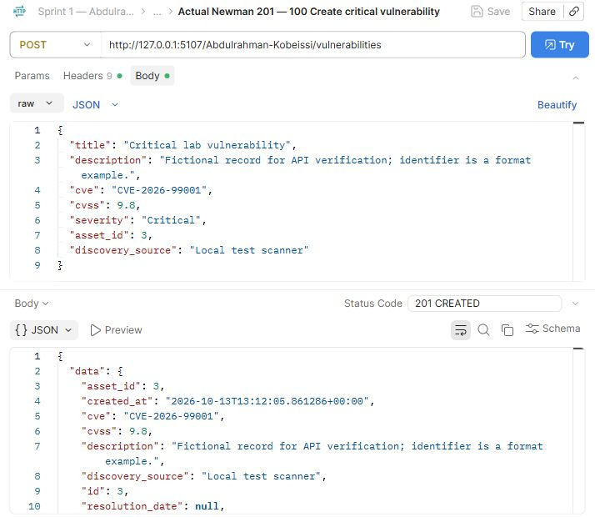
Abdulrahman Kobeissi — 100 Create critical vulnerability. The request and saved actual response demonstrate this operation.

Postman Evidence 101 (Abdulrahman Kobeissi)
Create high vulnerability · POST · observed HTTP 201
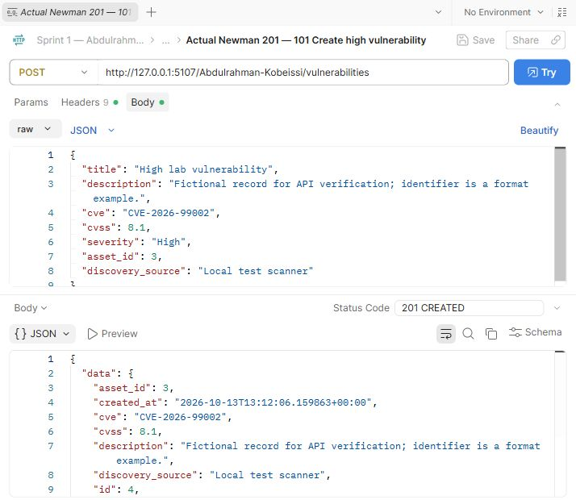
Abdulrahman Kobeissi — 101 Create high vulnerability. The request and saved actual response demonstrate this operation.

Postman Evidence 102 (Abdulrahman Kobeissi)
Create low vulnerability · POST · observed HTTP 201
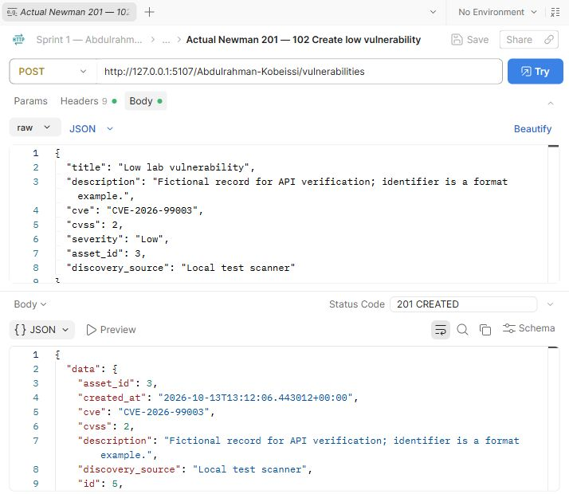
Abdulrahman Kobeissi — 102 Create low vulnerability. The request and saved actual response demonstrate this operation.

Postman Evidence 103 (Abdulrahman Kobeissi)
List vulnerabilities · GET · observed HTTP 200
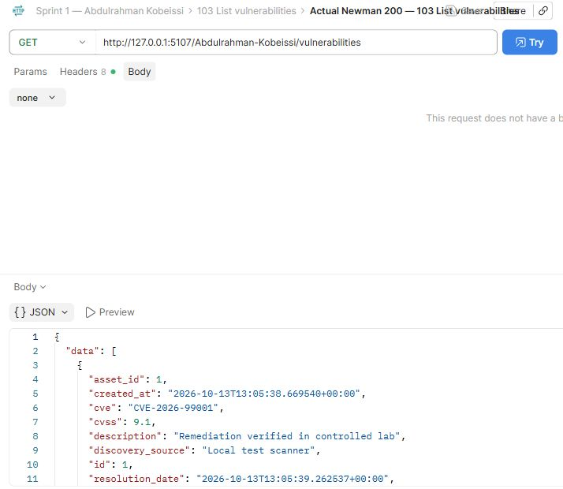
Abdulrahman Kobeissi — 103 List vulnerabilities. The request and saved actual response demonstrate this operation.

Postman Evidence 104 (Abdulrahman Kobeissi)
Vulnerability before update · GET · observed HTTP 200
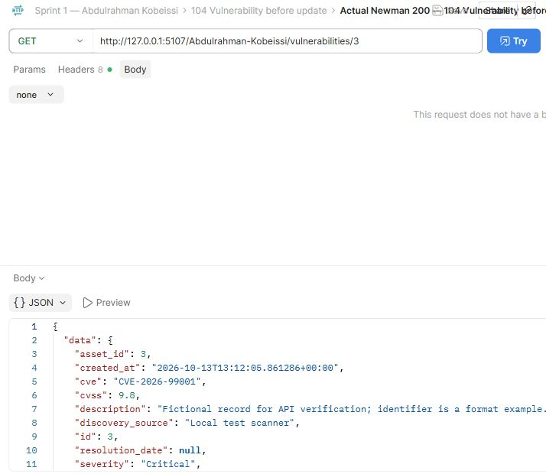
Abdulrahman Kobeissi — 104 Vulnerability before update. The request and saved actual response demonstrate this operation.
Compare this view with the adjacent before/update/after requests. The full response remains available in the collection.

Postman Evidence 105 (Abdulrahman Kobeissi)
Update vulnerability details · PUT · observed HTTP 200
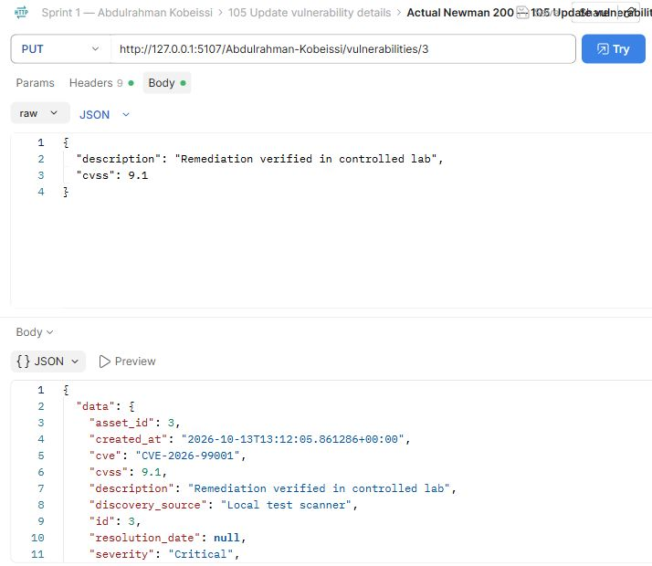
Abdulrahman Kobeissi — 105 Update vulnerability details. The request and saved actual response demonstrate this operation.

Postman Evidence 106 (Abdulrahman Kobeissi)
Reject skipped remediation lifecycle · PUT · observed HTTP 409
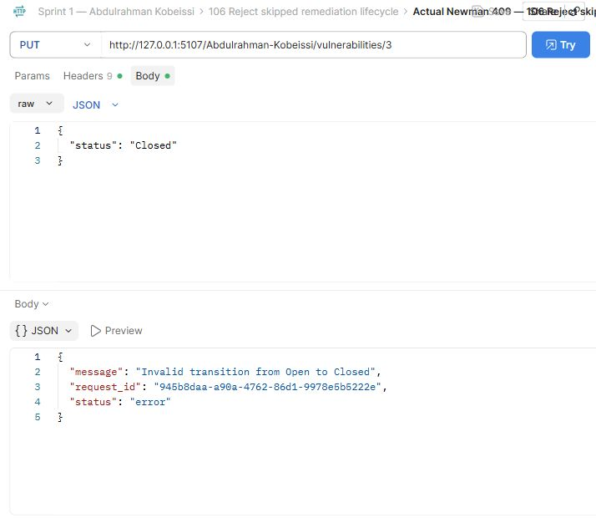
Abdulrahman Kobeissi — 106 Reject skipped remediation lifecycle. The request and saved actual response demonstrate this operation.

Postman Evidence 107 (Abdulrahman Kobeissi)
Vulnerability becomes Under Investigation · PUT · observed HTTP 200
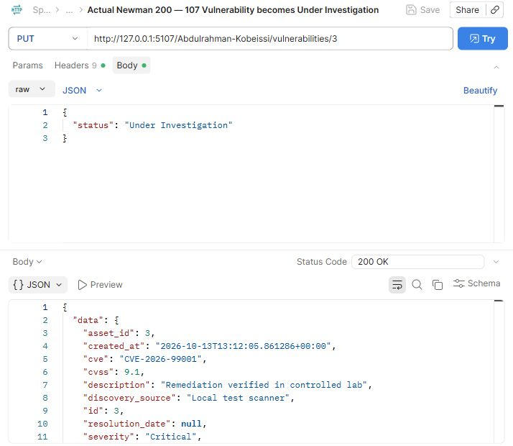
Abdulrahman Kobeissi — 107 Vulnerability becomes Under Investigation. The request and saved actual response demonstrate this operation.

Postman Evidence 108 (Abdulrahman Kobeissi)
Vulnerability becomes In Progress · PUT · observed HTTP 200
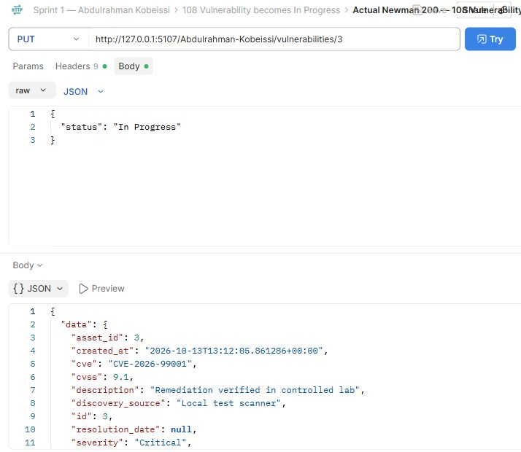
Abdulrahman Kobeissi — 108 Vulnerability becomes In Progress. The request and saved actual response demonstrate this operation.

Postman Evidence 109 (Abdulrahman Kobeissi)
Vulnerability becomes Resolved · PUT · observed HTTP 200
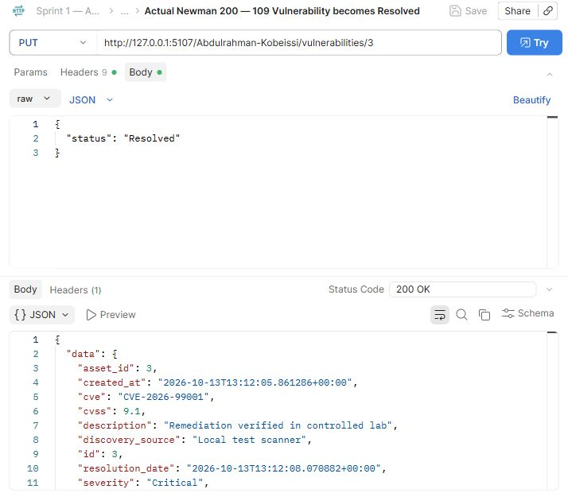
Abdulrahman Kobeissi — 109 Vulnerability becomes Resolved. The request and saved actual response demonstrate this operation.

Postman Evidence 110 (Abdulrahman Kobeissi)
Vulnerability becomes Closed · PUT · observed HTTP 200
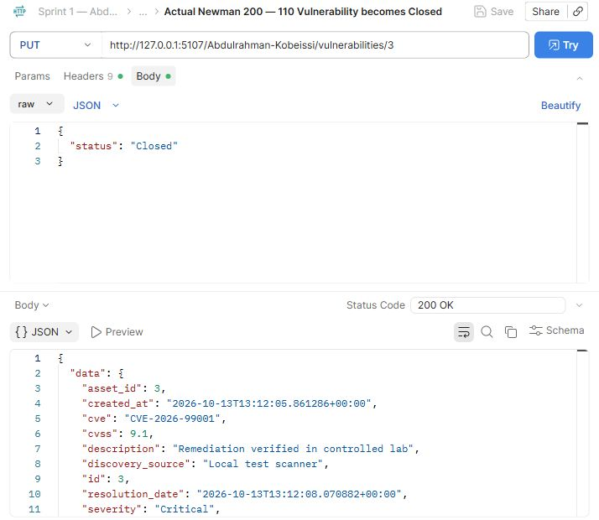
Abdulrahman Kobeissi — 110 Vulnerability becomes Closed. The request and saved actual response demonstrate this operation.

Postman Evidence 111 (Abdulrahman Kobeissi)
Vulnerability after update · GET · observed HTTP 200
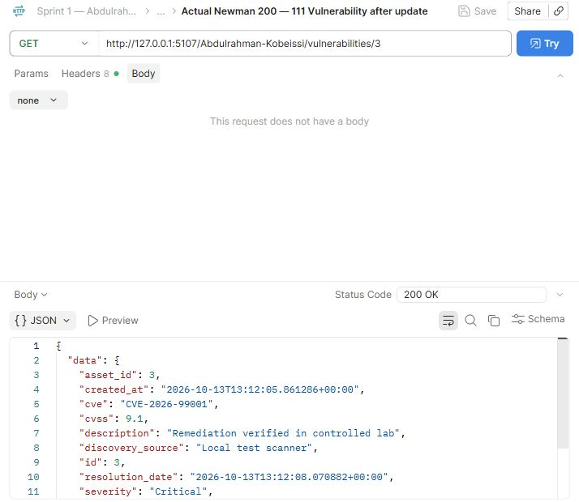
Abdulrahman Kobeissi — 111 Vulnerability after update. The request and saved actual response demonstrate this operation.
Compare this view with the adjacent before/update/after requests. The full response remains available in the collection.

Postman Evidence 112 (Abdulrahman Kobeissi)
Search vulnerabilities by cve · GET · observed HTTP 200
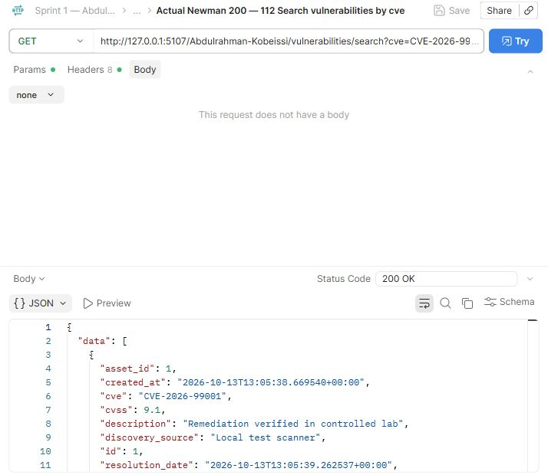
Abdulrahman Kobeissi — 112 Search vulnerabilities by cve. The request and saved actual response demonstrate this operation.

Postman Evidence 113 (Abdulrahman Kobeissi)
Search vulnerabilities by severity · GET · observed HTTP 200
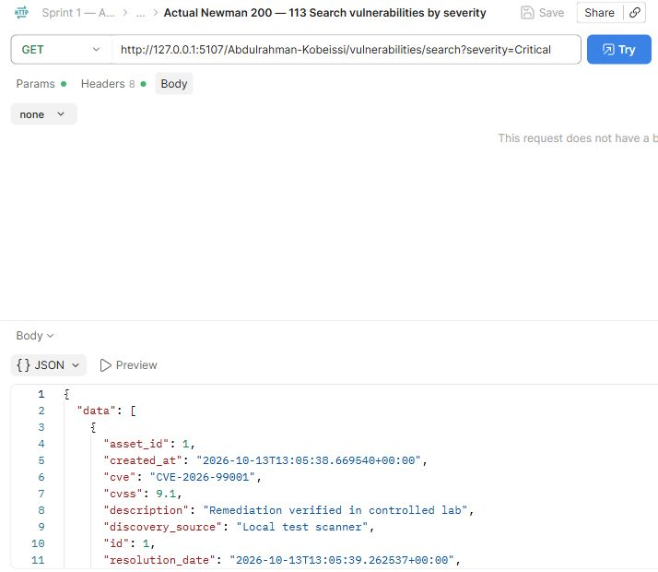
Abdulrahman Kobeissi — 113 Search vulnerabilities by severity. The request and saved actual response demonstrate this operation.

Postman Evidence 114 (Abdulrahman Kobeissi)
Search vulnerabilities by asset_id · GET · observed HTTP 200
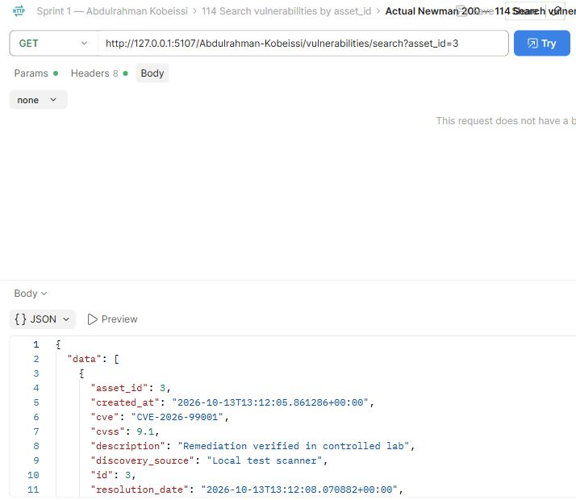
Abdulrahman Kobeissi — 114 Search vulnerabilities by asset_id. The request and saved actual response demonstrate this operation.

Postman Evidence 115 (Abdulrahman Kobeissi)
Search vulnerabilities by status · GET · observed HTTP 200
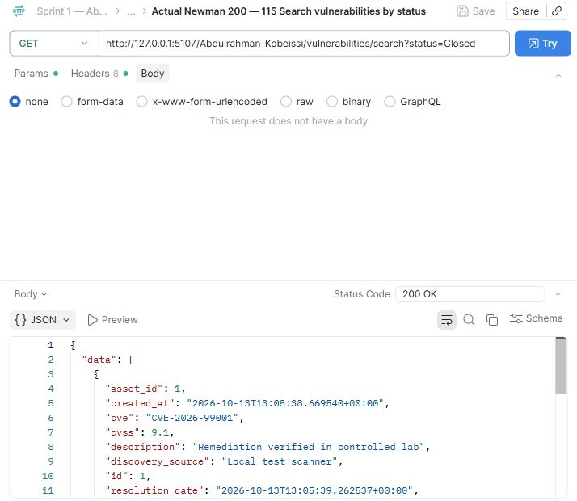
Abdulrahman Kobeissi — 115 Search vulnerabilities by status. The request and saved actual response demonstrate this operation.

Postman Evidence 116 (Abdulrahman Kobeissi)
Missing vulnerability · GET · observed HTTP 404
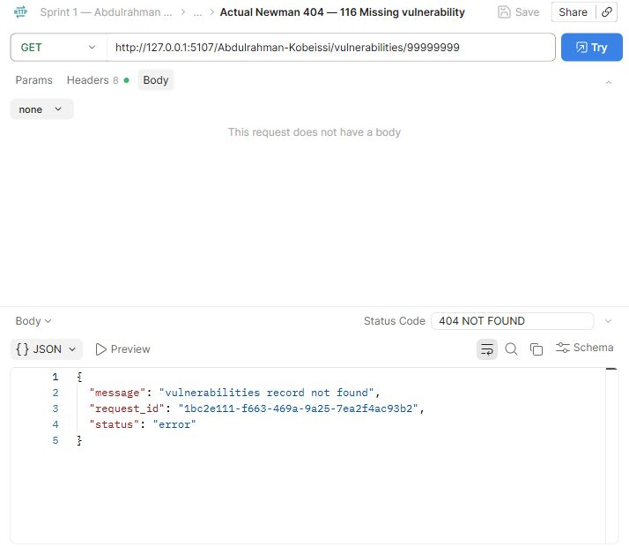
Abdulrahman Kobeissi — 116 Missing vulnerability. The request and saved actual response demonstrate this operation.

Postman Evidence 117 (Abdulrahman Kobeissi)
Invalid CVSS · PUT · observed HTTP 400
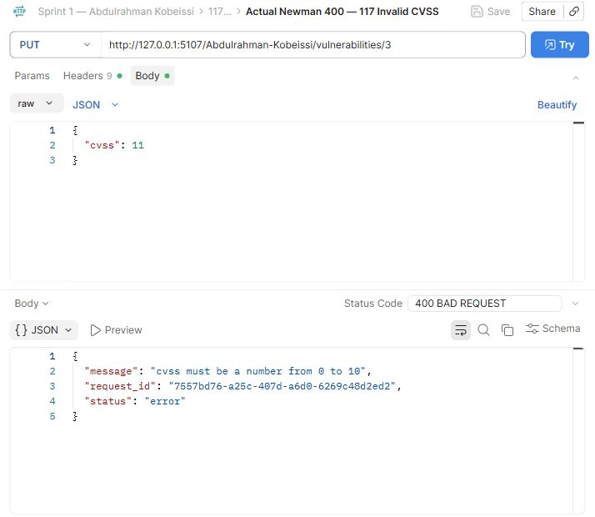
Abdulrahman Kobeissi — 117 Invalid CVSS. The request and saved actual response demonstrate this operation.

Postman Evidence 118 (Abdulrahman Kobeissi)
Unauthorized vulnerability delete · DELETE · observed HTTP 403
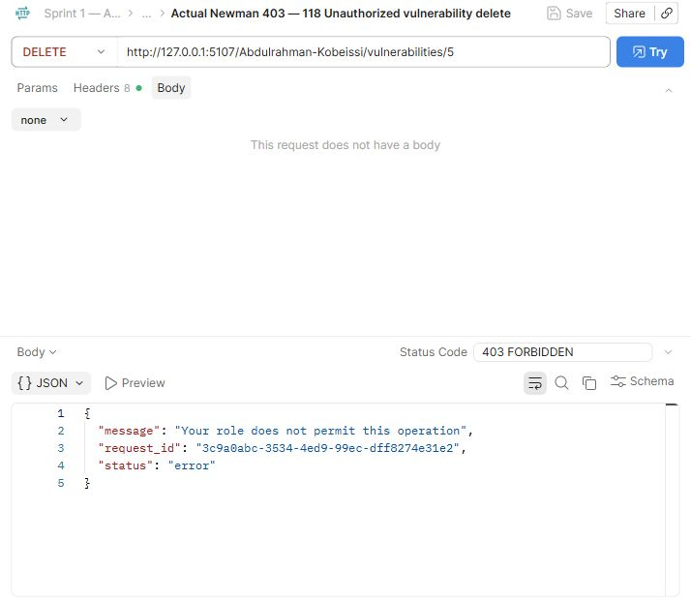
Abdulrahman Kobeissi — 118 Unauthorized vulnerability delete. The request and saved actual response demonstrate this operation.

Postman Evidence 119 (Abdulrahman Kobeissi)
Delete vulnerability · DELETE · observed HTTP 200
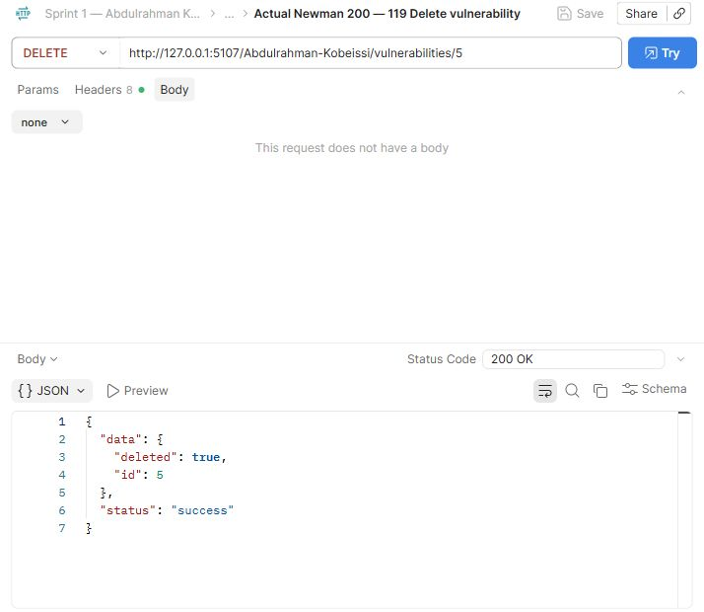
Abdulrahman Kobeissi — 119 Delete vulnerability. The request and saved actual response demonstrate this operation.

Postman Evidence 120 (Abdulrahman Kobeissi)
Create security alert · POST · observed HTTP 201
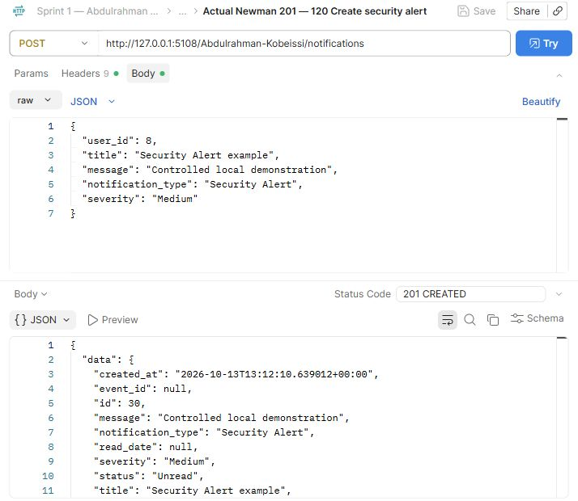
Abdulrahman Kobeissi — 120 Create security alert. The request and saved actual response demonstrate this operation.

Postman Evidence 121 (Abdulrahman Kobeissi)
Create system notification · POST · observed HTTP 201
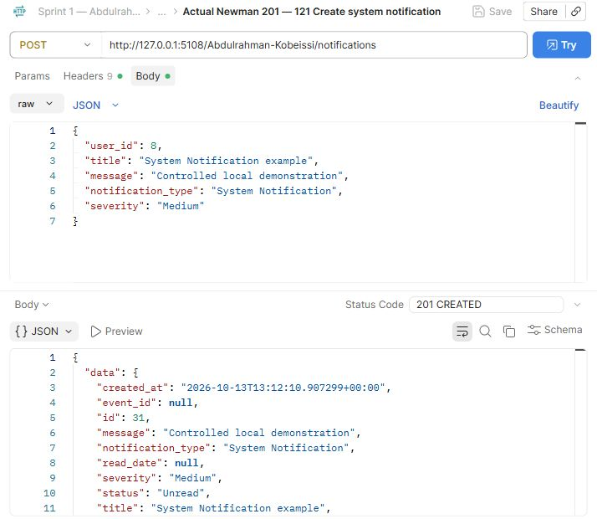
Abdulrahman Kobeissi — 121 Create system notification. The request and saved actual response demonstrate this operation.

Postman Evidence 122 (Abdulrahman Kobeissi)
Employee personal notifications · GET · observed HTTP 200
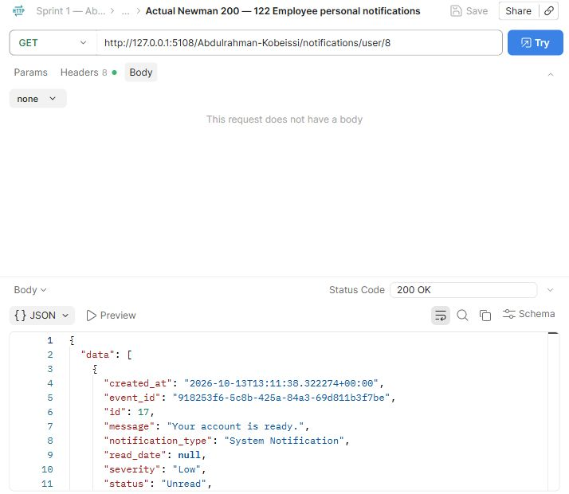
Abdulrahman Kobeissi — 122 Employee personal notifications. The request and saved actual response demonstrate this operation.

Postman Evidence 123 (Abdulrahman Kobeissi)
Analyst assignment notification · GET · observed HTTP 200
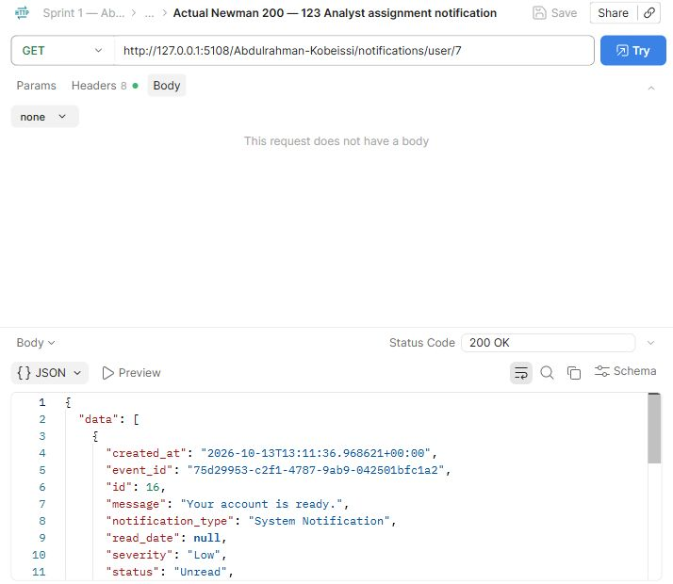
Abdulrahman Kobeissi — 123 Analyst assignment notification. The request and saved actual response demonstrate this operation.

Postman Evidence 124 (Abdulrahman Kobeissi)
Notification before read · GET · observed HTTP 200
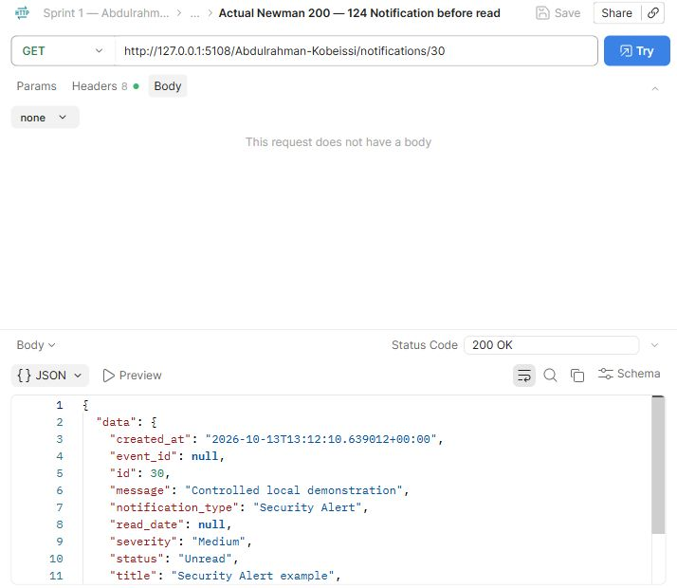
Abdulrahman Kobeissi — 124 Notification before read. The request and saved actual response demonstrate this operation.
Compare this view with the adjacent before/update/after requests. The full response remains available in the collection.

Postman Evidence 125 (Abdulrahman Kobeissi)
Mark notification read · PUT · observed HTTP 200
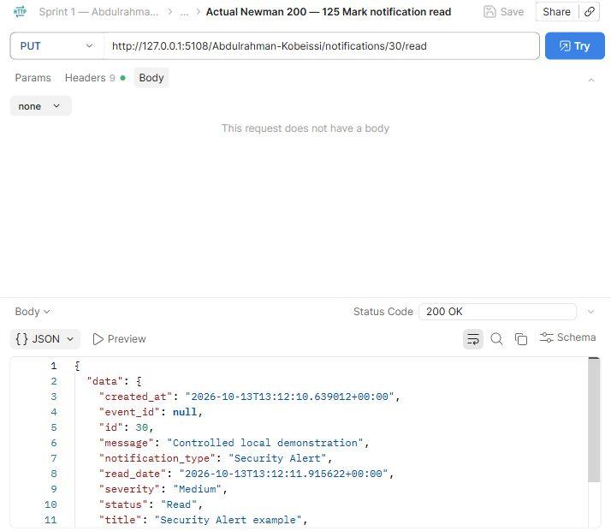
Abdulrahman Kobeissi — 125 Mark notification read. The request and saved actual response demonstrate this operation.

Postman Evidence 126 (Abdulrahman Kobeissi)
Notification after read · GET · observed HTTP 200
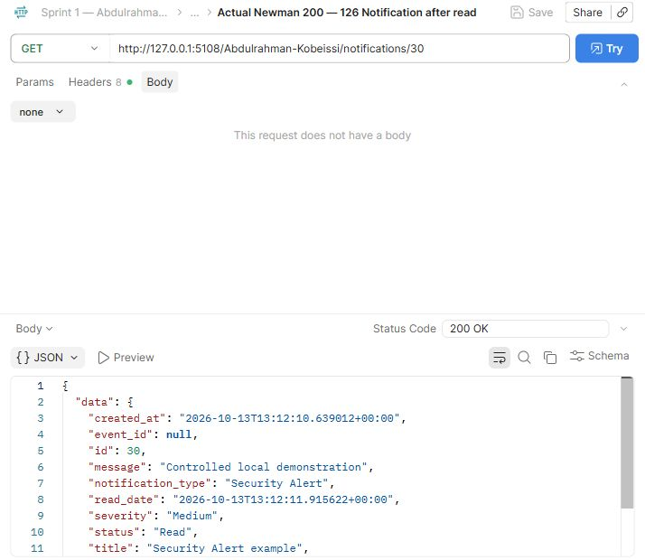
Abdulrahman Kobeissi — 126 Notification after read. The request and saved actual response demonstrate this operation.
Compare this view with the adjacent before/update/after requests. The full response remains available in the collection.

Postman Evidence 127 (Abdulrahman Kobeissi)
Reject other notification access · GET · observed HTTP 403
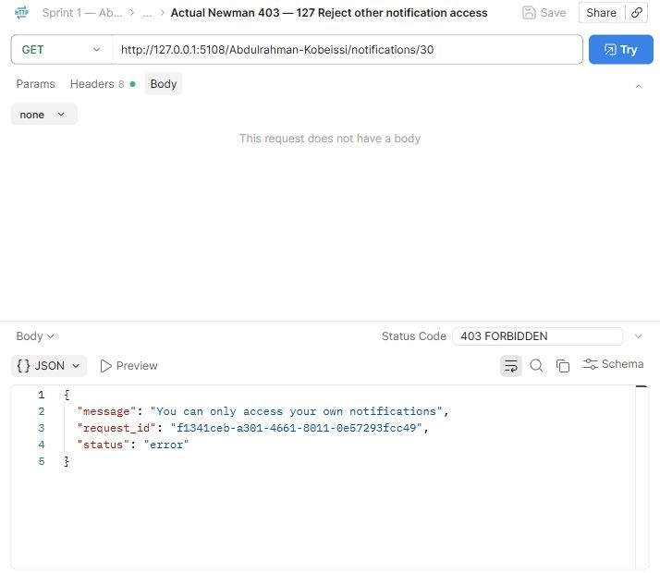
Abdulrahman Kobeissi — 127 Reject other notification access. The request and saved actual response demonstrate this operation.

Postman Evidence 128 (Abdulrahman Kobeissi)
Search notifications by user_id · GET · observed HTTP 200
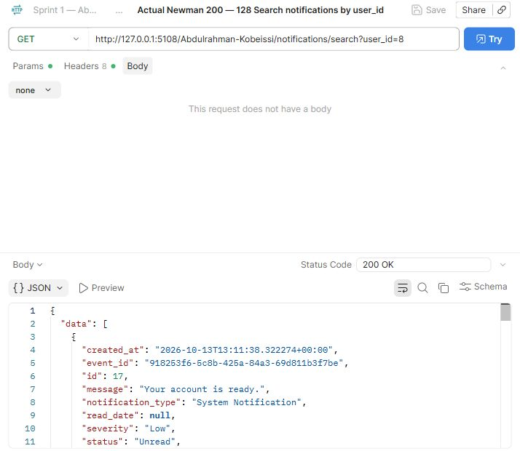
Abdulrahman Kobeissi — 128 Search notifications by user_id. The request and saved actual response demonstrate this operation.

Postman Evidence 129 (Abdulrahman Kobeissi)
Search notifications by notification_type · GET · observed HTTP 200
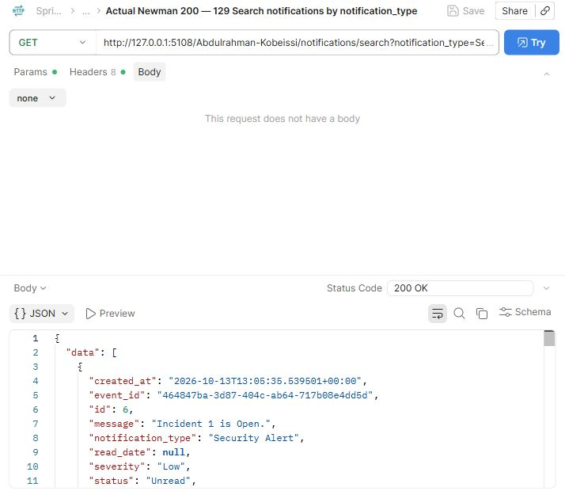
Abdulrahman Kobeissi — 129 Search notifications by notification_type. The request and saved actual response demonstrate this operation.

Postman Evidence 130 (Abdulrahman Kobeissi)
Search notifications by severity · GET · observed HTTP 200
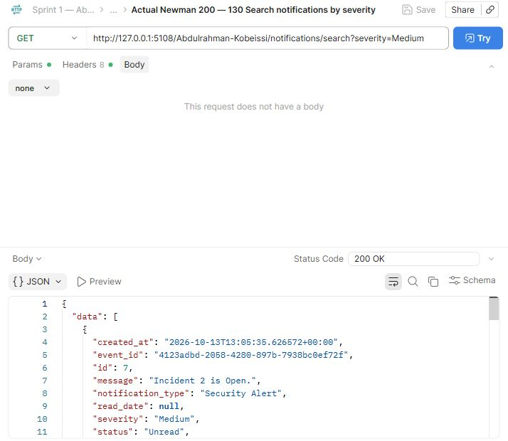
Abdulrahman Kobeissi — 130 Search notifications by severity. The request and saved actual response demonstrate this operation.

Postman Evidence 131 (Abdulrahman Kobeissi)
Search notifications by status · GET · observed HTTP 200
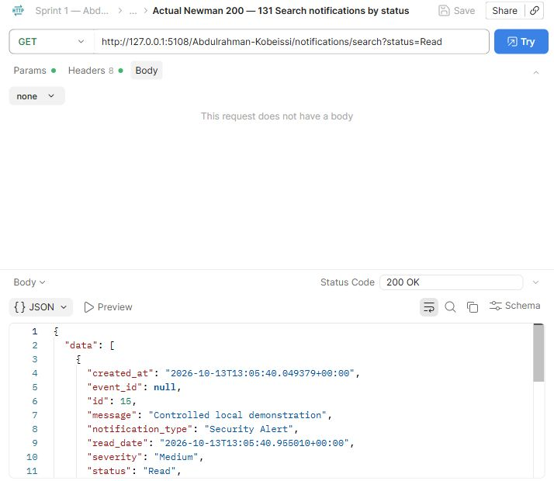
Abdulrahman Kobeissi — 131 Search notifications by status. The request and saved actual response demonstrate this operation.

Postman Evidence 132 (Abdulrahman Kobeissi)
Missing notification · GET · observed HTTP 404
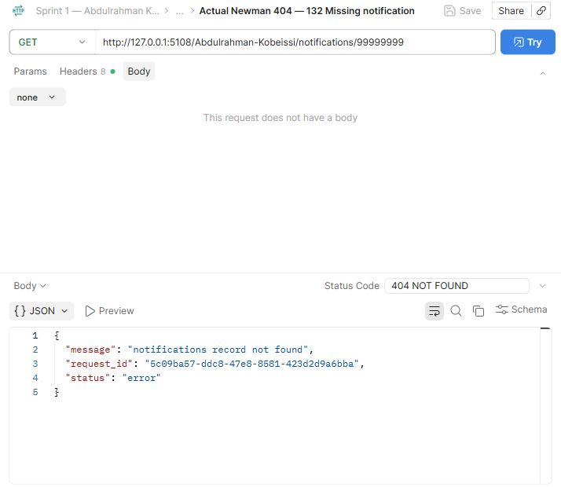
Abdulrahman Kobeissi — 132 Missing notification. The request and saved actual response demonstrate this operation.

Postman Evidence 133 (Abdulrahman Kobeissi)
Auditor cannot mark read · PUT · observed HTTP 403
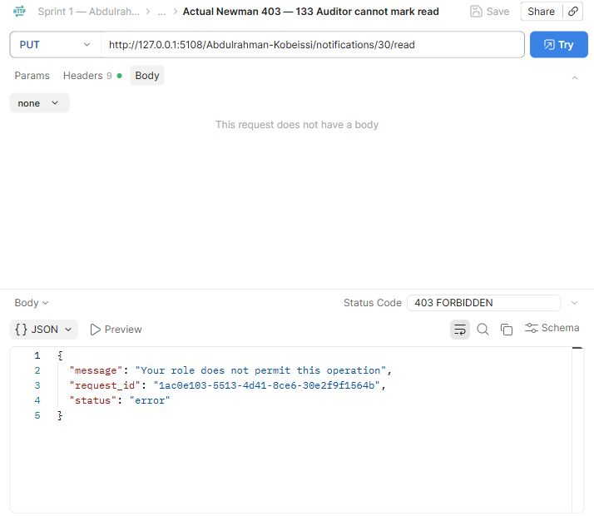
Abdulrahman Kobeissi — 133 Auditor cannot mark read. The request and saved actual response demonstrate this operation.

Postman Evidence 134 (Abdulrahman Kobeissi)
Unauthorized notification delete · DELETE · observed HTTP 403
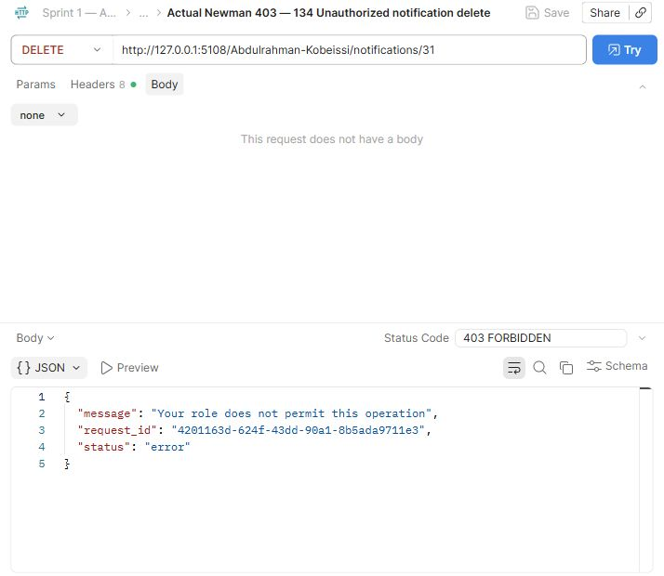
Abdulrahman Kobeissi — 134 Unauthorized notification delete. The request and saved actual response demonstrate this operation.

Postman Evidence 135 (Abdulrahman Kobeissi)
Delete notification · DELETE · observed HTTP 200
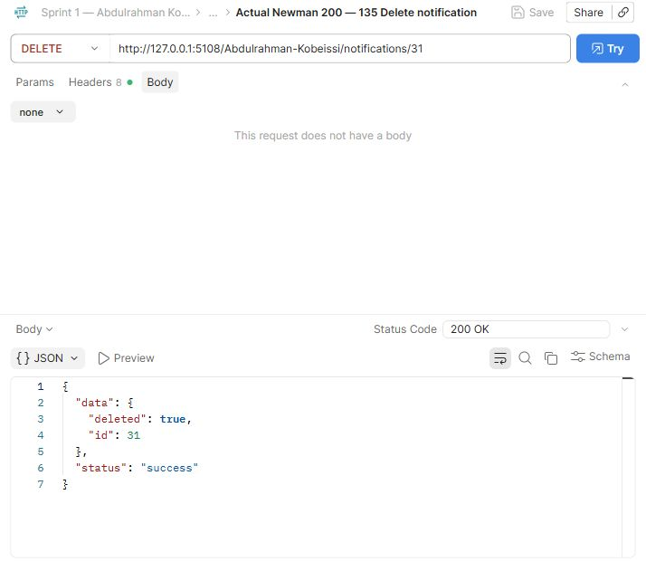
Abdulrahman Kobeissi — 135 Delete notification. The request and saved actual response demonstrate this operation.

Postman Evidence 136 (Abdulrahman Kobeissi)
Create response playbook 1 · POST · observed HTTP 201
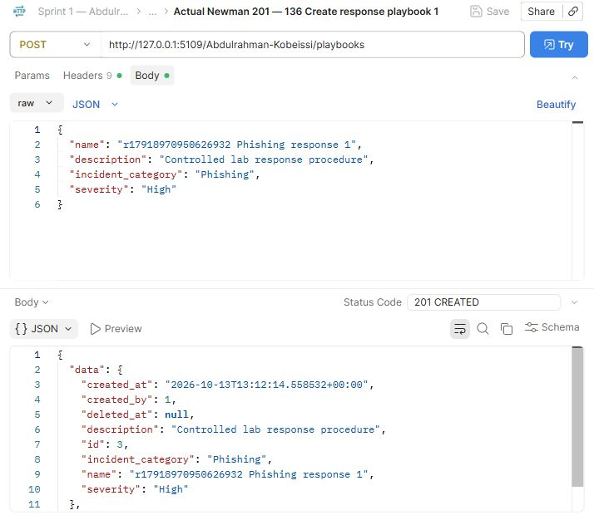
Abdulrahman Kobeissi — 136 Create response playbook 1. The request and saved actual response demonstrate this operation.

Postman Evidence 137 (Abdulrahman Kobeissi)
Create response playbook 2 · POST · observed HTTP 201
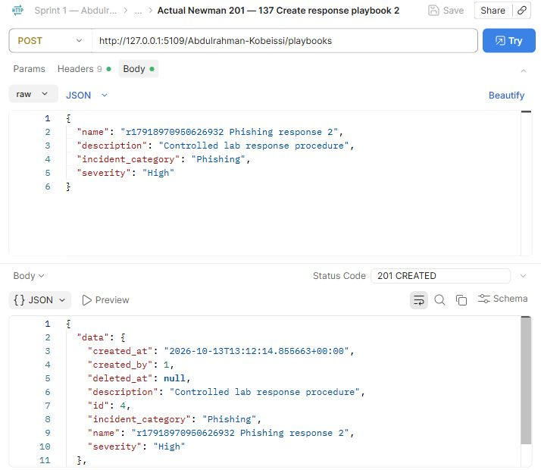
Abdulrahman Kobeissi — 137 Create response playbook 2. The request and saved actual response demonstrate this operation.

Postman Evidence 138 (Abdulrahman Kobeissi)
List playbooks · GET · observed HTTP 200
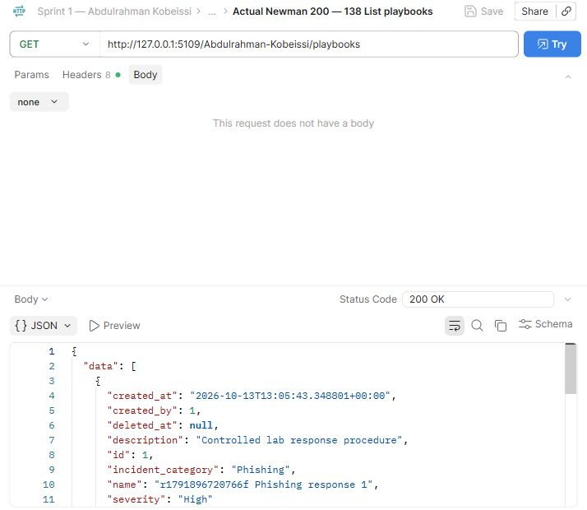
Abdulrahman Kobeissi — 138 List playbooks. The request and saved actual response demonstrate this operation.

Postman Evidence 139 (Abdulrahman Kobeissi)
Add ordered action 1 · POST · observed HTTP 201
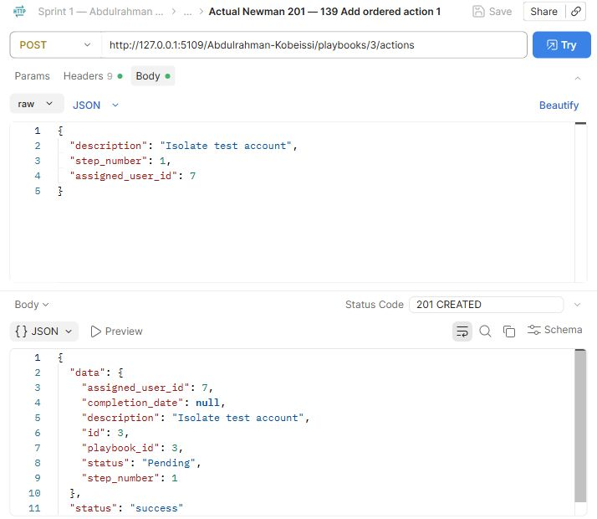
Abdulrahman Kobeissi — 139 Add ordered action 1. The request and saved actual response demonstrate this operation.

Postman Evidence 140 (Abdulrahman Kobeissi)
Add ordered action 2 · POST · observed HTTP 201
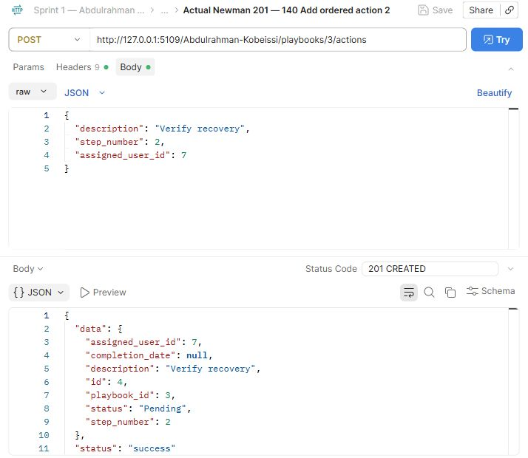
Abdulrahman Kobeissi — 140 Add ordered action 2. The request and saved actual response demonstrate this operation.

Postman Evidence 141 (Abdulrahman Kobeissi)
Reject out of order action · PUT · observed HTTP 409
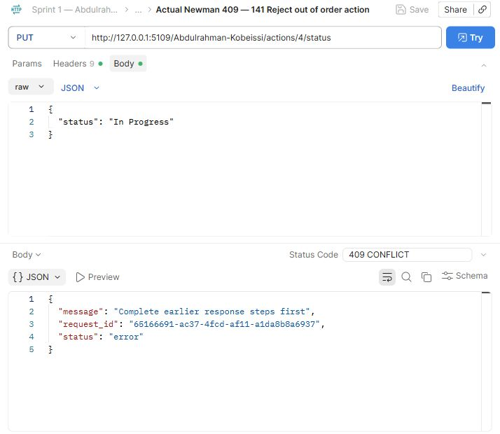
Abdulrahman Kobeissi — 141 Reject out of order action. The request and saved actual response demonstrate this operation.

Postman Evidence 142 (Abdulrahman Kobeissi)
Reject skipped action status · PUT · observed HTTP 409
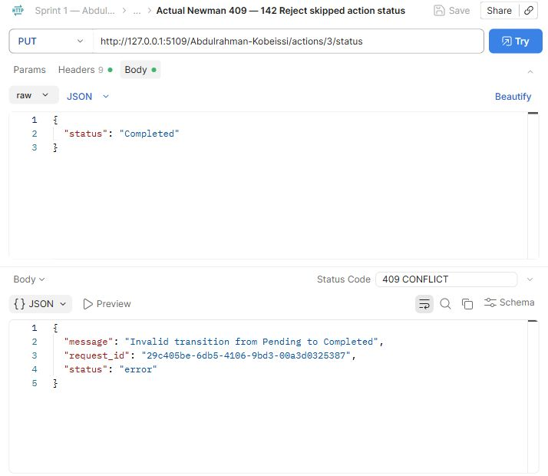
Abdulrahman Kobeissi — 142 Reject skipped action status. The request and saved actual response demonstrate this operation.

Postman Evidence 143 (Abdulrahman Kobeissi)
Action 1 becomes In Progress · PUT · observed HTTP 200
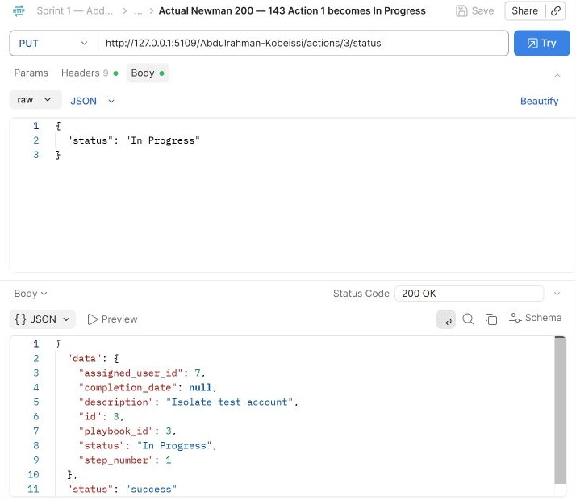
Abdulrahman Kobeissi — 143 Action 1 becomes In Progress. The request and saved actual response demonstrate this operation.

Postman Evidence 144 (Abdulrahman Kobeissi)
Action 1 becomes Completed · PUT · observed HTTP 200
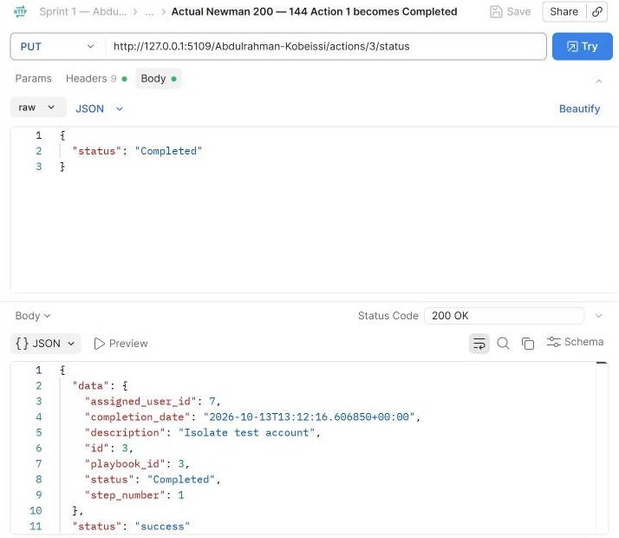
Abdulrahman Kobeissi — 144 Action 1 becomes Completed. The request and saved actual response demonstrate this operation.

Postman Evidence 145 (Abdulrahman Kobeissi)
Action 2 becomes In Progress · PUT · observed HTTP 200
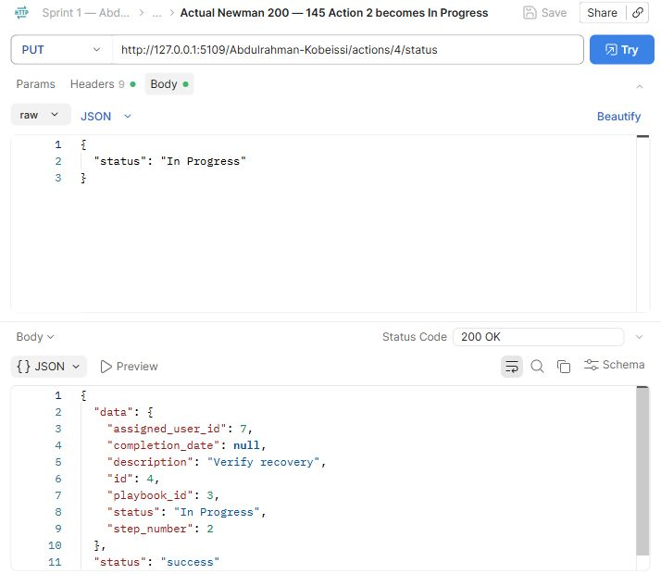
Abdulrahman Kobeissi — 145 Action 2 becomes In Progress. The request and saved actual response demonstrate this operation.

Postman Evidence 146 (Abdulrahman Kobeissi)
Action 2 becomes Completed · PUT · observed HTTP 200
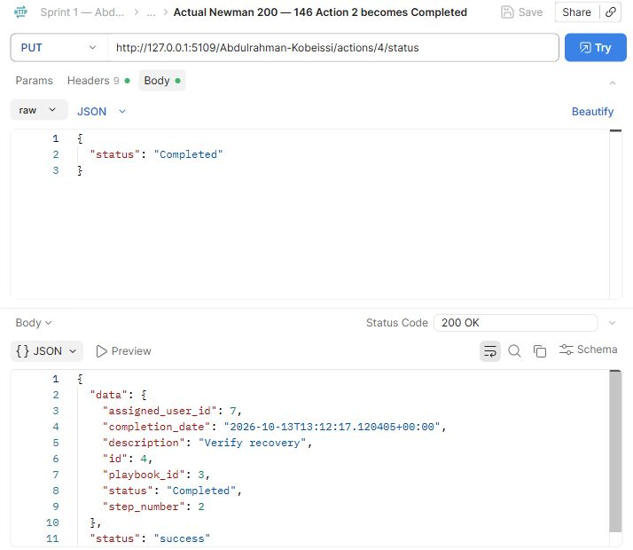
Abdulrahman Kobeissi — 146 Action 2 becomes Completed. The request and saved actual response demonstrate this operation.

Postman Evidence 147 (Abdulrahman Kobeissi)
Playbook with ordered actions and history · GET · observed HTTP 200
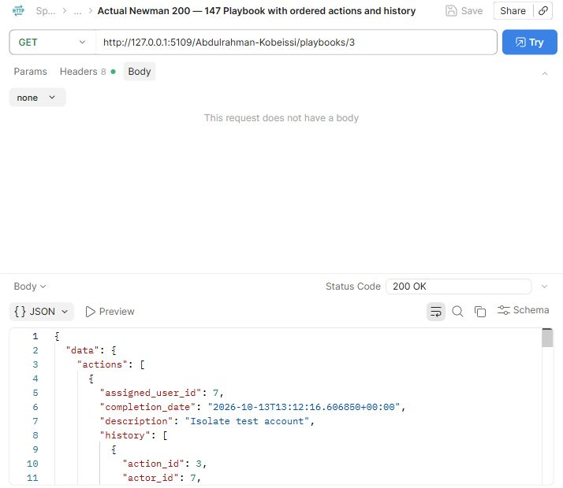
Abdulrahman Kobeissi — 147 Playbook with ordered actions and history. The request and saved actual response demonstrate this operation.

Postman Evidence 148 (Abdulrahman Kobeissi)
Missing playbook · GET · observed HTTP 404
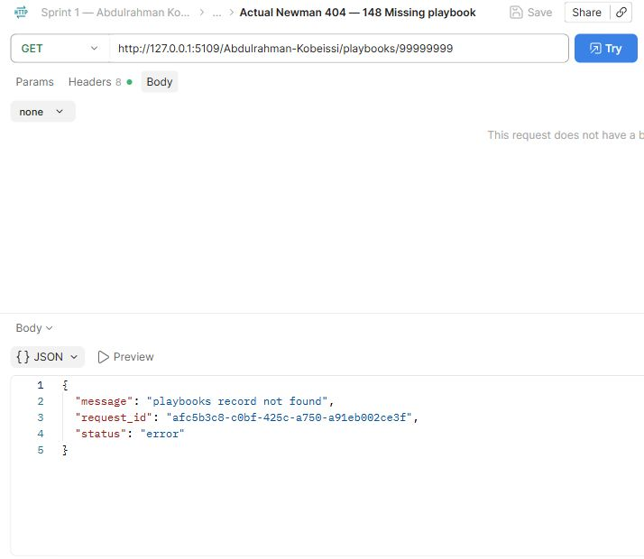
Abdulrahman Kobeissi — 148 Missing playbook. The request and saved actual response demonstrate this operation.

Postman Evidence 149 (Abdulrahman Kobeissi)
Unauthorized playbook deletion · DELETE · observed HTTP 403
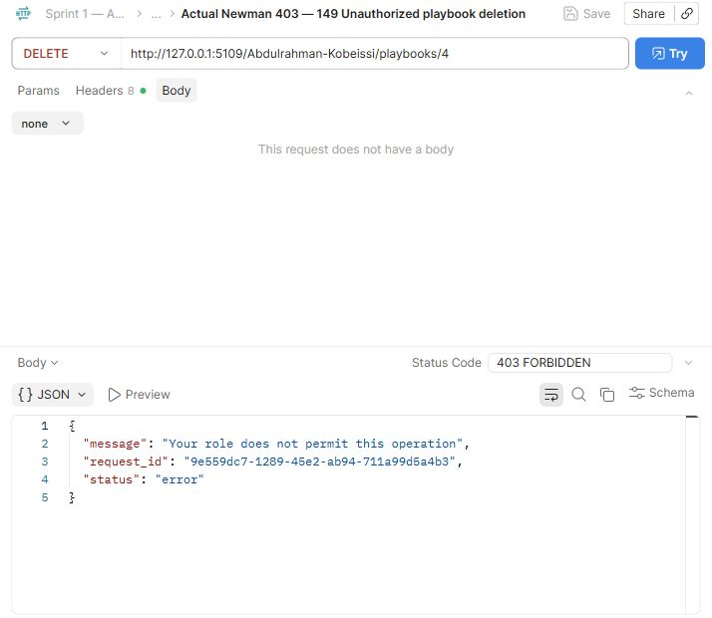
Abdulrahman Kobeissi — 149 Unauthorized playbook deletion. The request and saved actual response demonstrate this operation.

Postman Evidence 150 (Abdulrahman Kobeissi)
Delete unused playbook · DELETE · observed HTTP 200
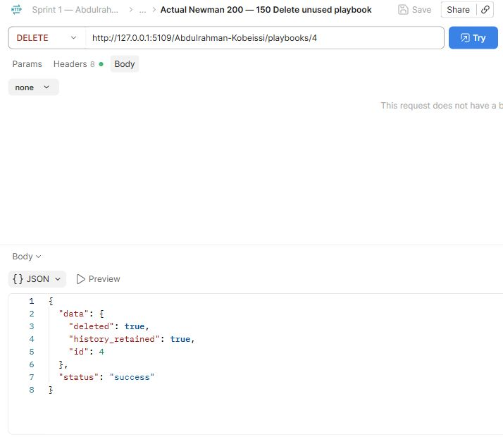
Abdulrahman Kobeissi — 150 Delete unused playbook. The request and saved actual response demonstrate this operation.

Postman Evidence 151 (Abdulrahman Kobeissi)
Create manual audit log 1 · POST · observed HTTP 201
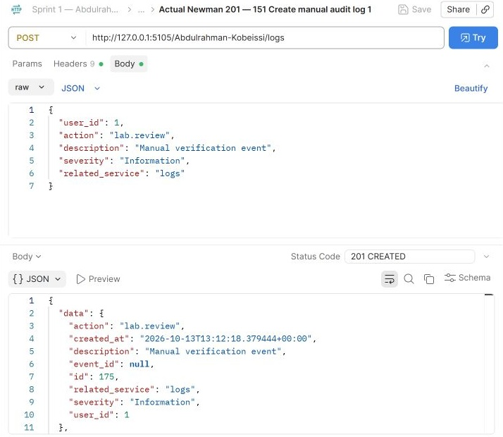
Abdulrahman Kobeissi — 151 Create manual audit log 1. The request and saved actual response demonstrate this operation.

Postman Evidence 152 (Abdulrahman Kobeissi)
Create manual audit log 2 · POST · observed HTTP 201
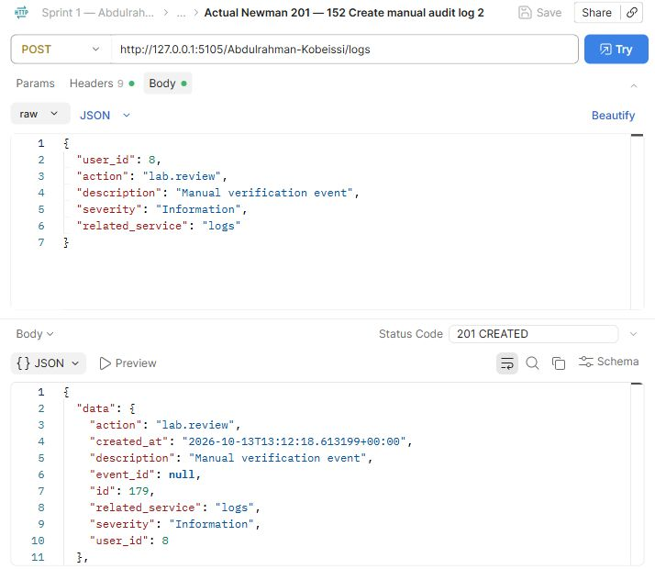
Abdulrahman Kobeissi — 152 Create manual audit log 2. The request and saved actual response demonstrate this operation.

Postman Evidence 153 (Abdulrahman Kobeissi)
List automatic and manual logs · GET · observed HTTP 200
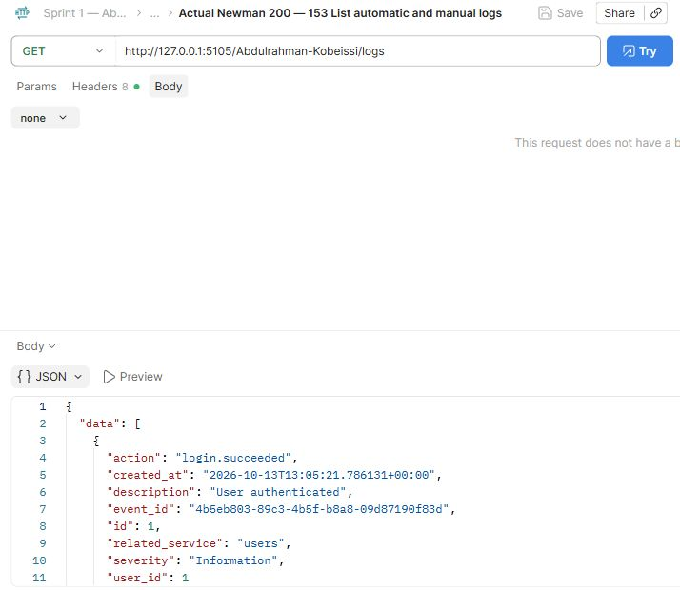
Abdulrahman Kobeissi — 153 List automatic and manual logs. The request and saved actual response demonstrate this operation.

Postman Evidence 154 (Abdulrahman Kobeissi)
Retrieve audit record · GET · observed HTTP 200
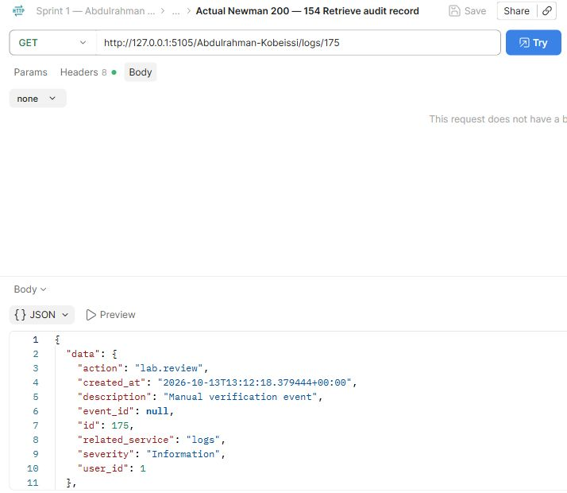
Abdulrahman Kobeissi — 154 Retrieve audit record. The request and saved actual response demonstrate this operation.

Postman Evidence 155 (Abdulrahman Kobeissi)
Missing audit record · GET · observed HTTP 404
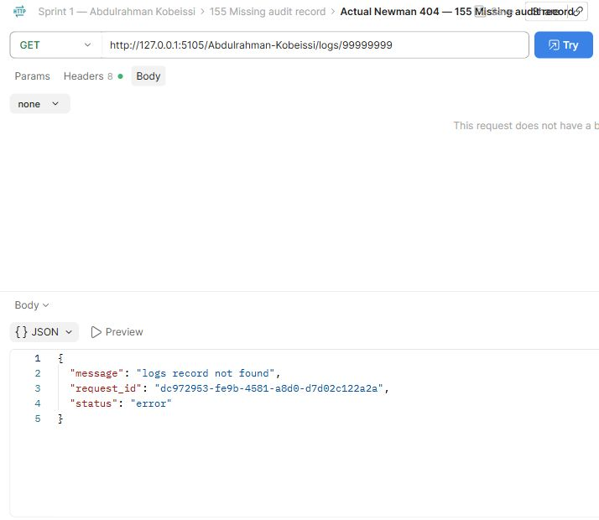
Abdulrahman Kobeissi — 155 Missing audit record. The request and saved actual response demonstrate this operation.

Postman Evidence 156 (Abdulrahman Kobeissi)
Search logs by user_id · GET · observed HTTP 200
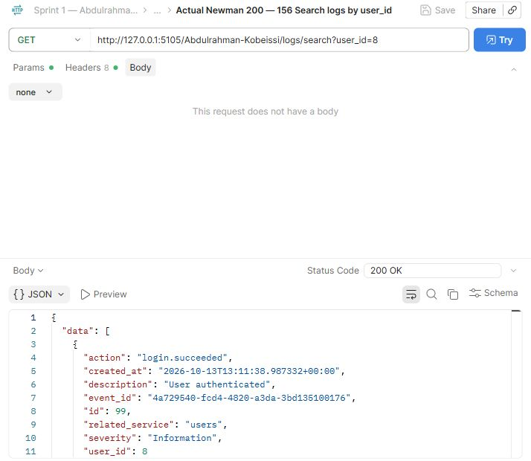
Abdulrahman Kobeissi — 156 Search logs by user_id. The request and saved actual response demonstrate this operation.

Postman Evidence 157 (Abdulrahman Kobeissi)
Search logs by date · GET · observed HTTP 200
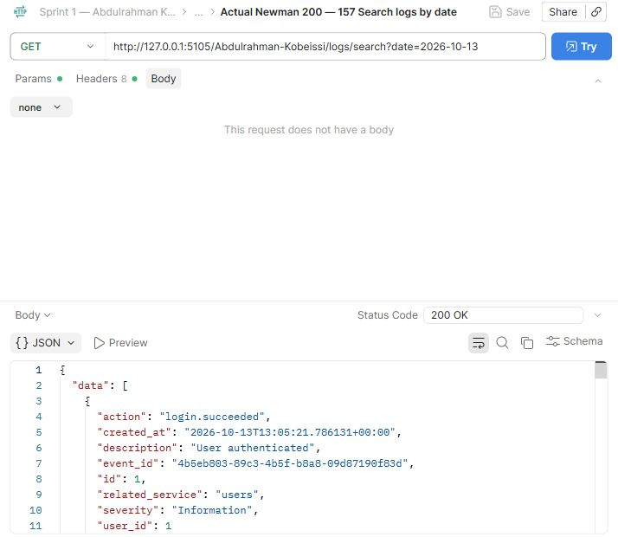
Abdulrahman Kobeissi — 157 Search logs by date. The request and saved actual response demonstrate this operation.

Postman Evidence 158 (Abdulrahman Kobeissi)
Search logs by action · GET · observed HTTP 200
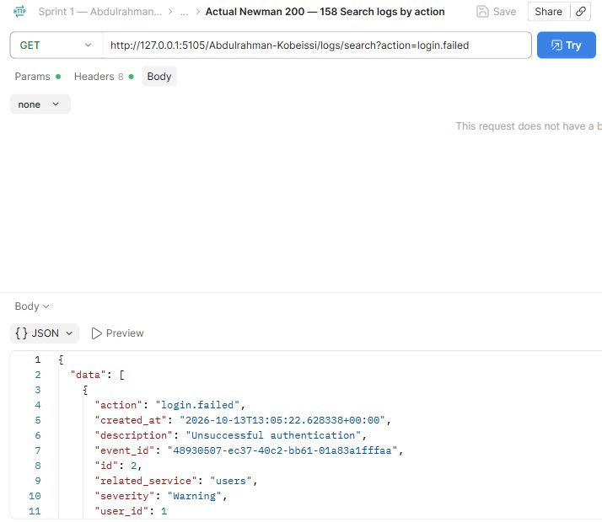
Abdulrahman Kobeissi — 158 Search logs by action. The request and saved actual response demonstrate this operation.

Postman Evidence 159 (Abdulrahman Kobeissi)
Search logs by severity · GET · observed HTTP 200
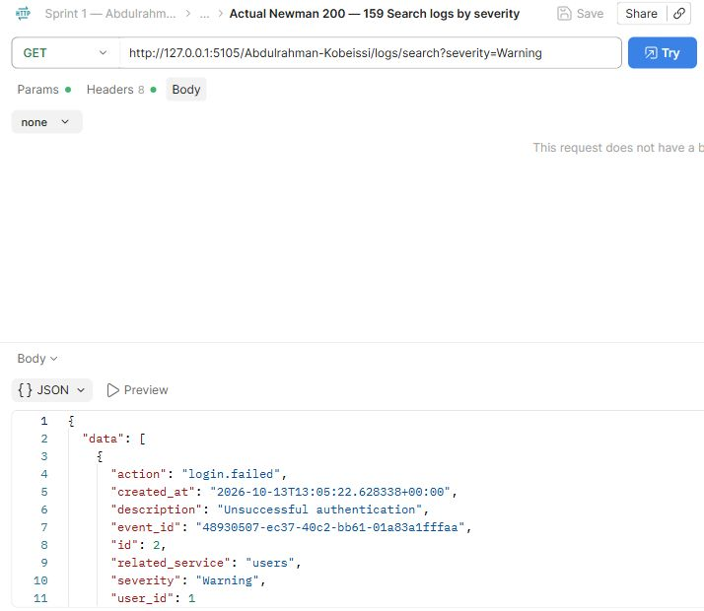
Abdulrahman Kobeissi — 159 Search logs by severity. The request and saved actual response demonstrate this operation.

Postman Evidence 160 (Abdulrahman Kobeissi)
Search logs by related_service · GET · observed HTTP 200
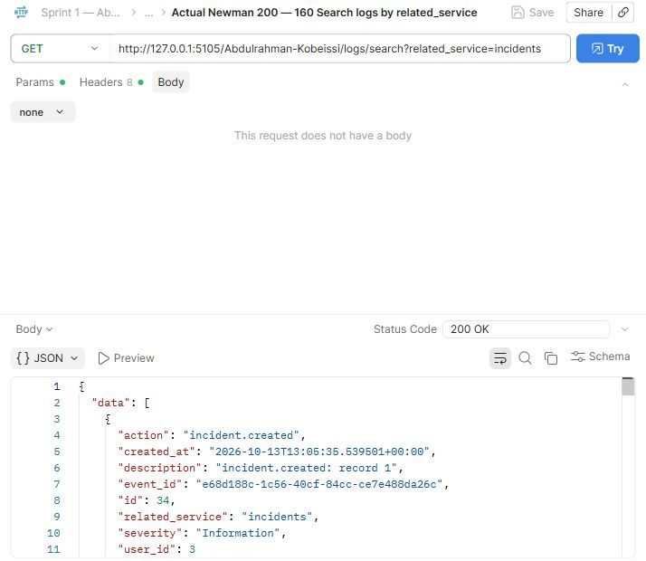
Abdulrahman Kobeissi — 160 Search logs by related_service. The request and saved actual response demonstrate this operation.

Postman Evidence 161 (Abdulrahman Kobeissi)
Logs by user · GET · observed HTTP 200
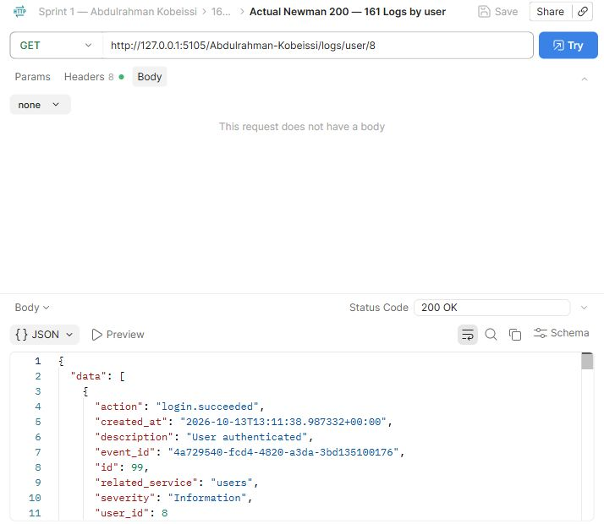
Abdulrahman Kobeissi — 161 Logs by user. The request and saved actual response demonstrate this operation.

Postman Evidence 162 (Abdulrahman Kobeissi)
Unauthorized audit deletion · DELETE · observed HTTP 403
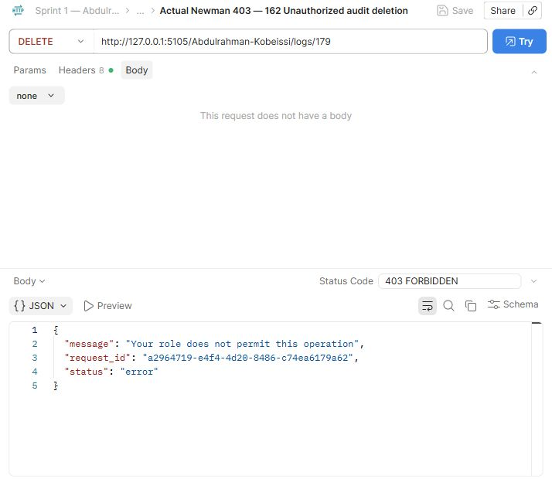
Abdulrahman Kobeissi — 162 Unauthorized audit deletion. The request and saved actual response demonstrate this operation.

Postman Evidence 163 (Abdulrahman Kobeissi)
Delete manual audit log · DELETE · observed HTTP 200
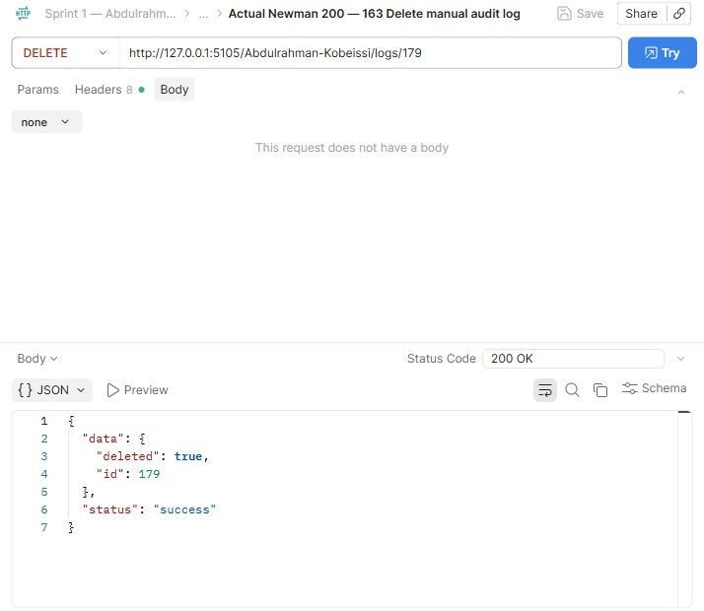
Abdulrahman Kobeissi — 163 Delete manual audit log. The request and saved actual response demonstrate this operation.

Postman Evidence 164 (Abdulrahman Kobeissi)
Generate summary report · GET · observed HTTP 200
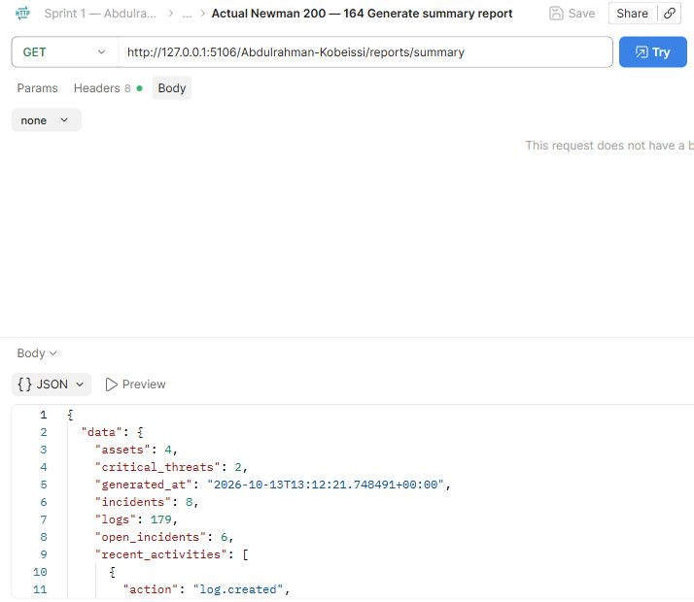
Abdulrahman Kobeissi — 164 Generate summary report. The request and saved actual response demonstrate this operation.

Postman Evidence 165 (Abdulrahman Kobeissi)
Generate incidents report · GET · observed HTTP 200
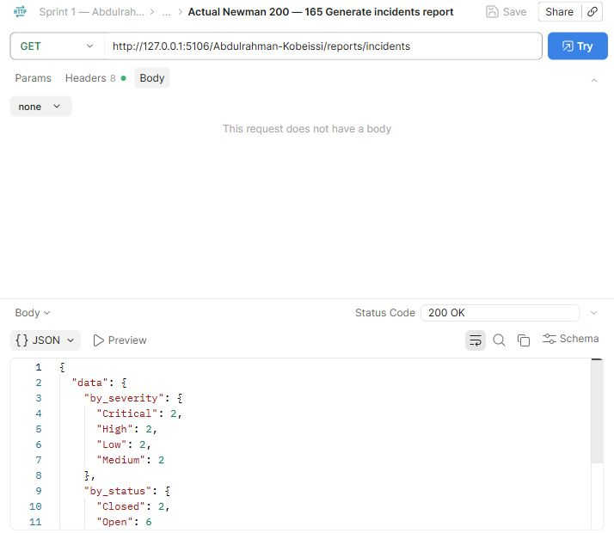
Abdulrahman Kobeissi — 165 Generate incidents report. The request and saved actual response demonstrate this operation.

Postman Evidence 166 (Abdulrahman Kobeissi)
Generate assets report · GET · observed HTTP 200
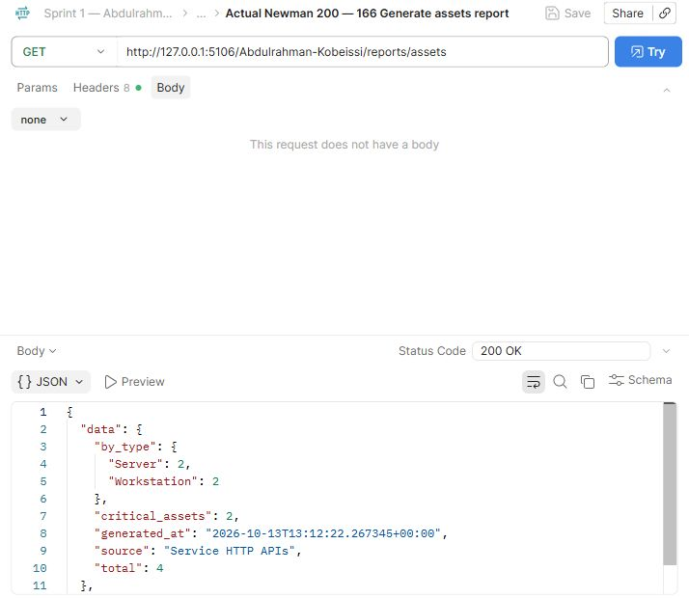
Abdulrahman Kobeissi — 166 Generate assets report. The request and saved actual response demonstrate this operation.

Postman Evidence 167 (Abdulrahman Kobeissi)
Generate threats report · GET · observed HTTP 200
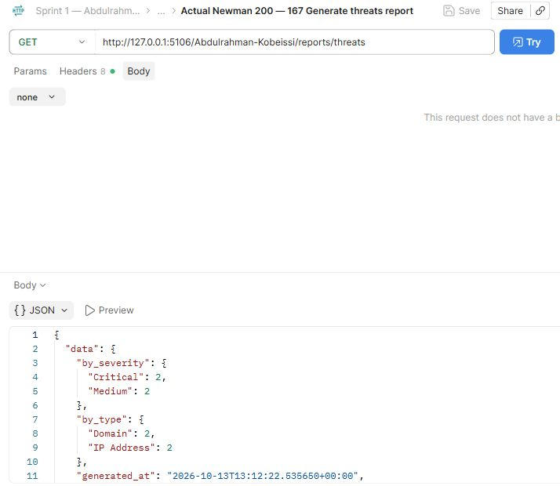
Abdulrahman Kobeissi — 167 Generate threats report. The request and saved actual response demonstrate this operation.

Postman Evidence 168 (Abdulrahman Kobeissi)
Generate vulnerabilities report · GET · observed HTTP 200
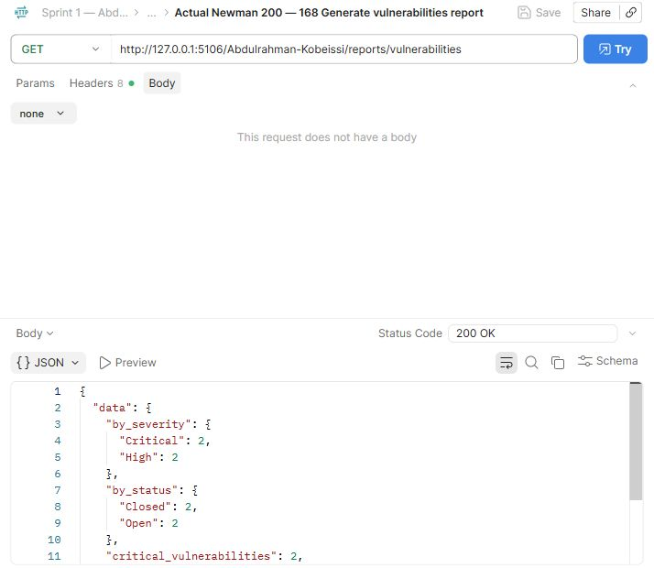
Abdulrahman Kobeissi — 168 Generate vulnerabilities report. The request and saved actual response demonstrate this operation.

Postman Evidence 169 (Abdulrahman Kobeissi)
Generate activity report · GET · observed HTTP 200
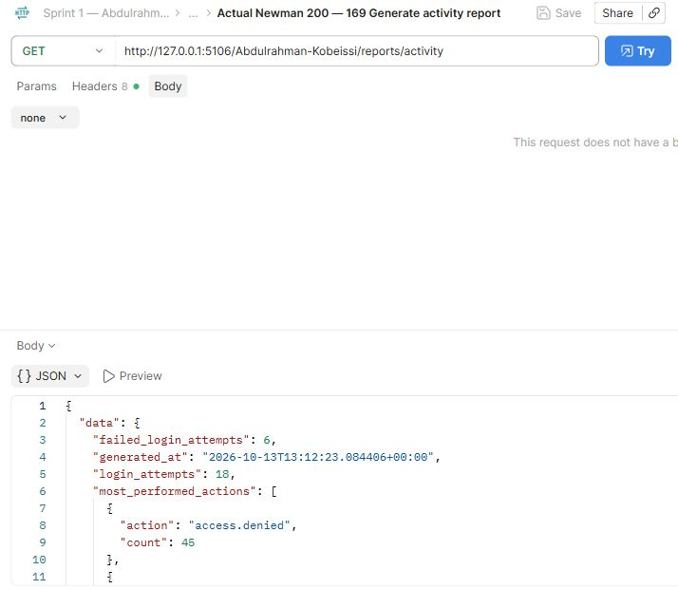
Abdulrahman Kobeissi — 169 Generate activity report. The request and saved actual response demonstrate this operation.

Postman Evidence 170 (Abdulrahman Kobeissi)
Analyst reports rejected · GET · observed HTTP 403
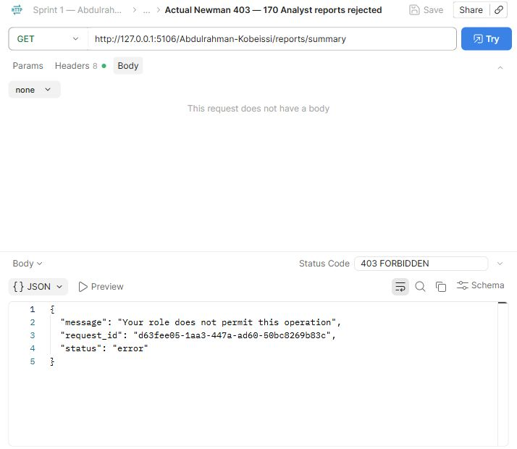
Abdulrahman Kobeissi — 170 Analyst reports rejected. The request and saved actual response demonstrate this operation.

Postman Evidence 171 (Abdulrahman Kobeissi)
Employee reports rejected · GET · observed HTTP 403
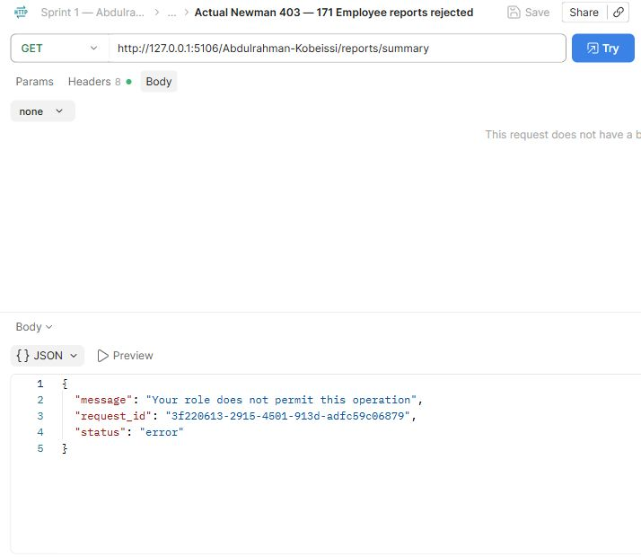
Abdulrahman Kobeissi — 171 Employee reports rejected. The request and saved actual response demonstrate this operation.

Live Database Schema (Abdulrahman Kobeissi)
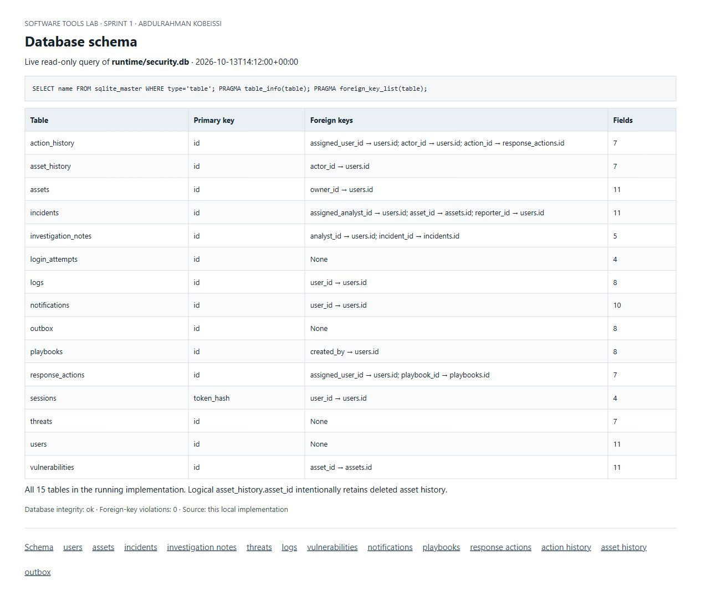
Abdulrahman Kobeissi — Actual SQLite schema query showing all tables, primary keys and foreign keys.

Stored users Records (Abdulrahman Kobeissi)
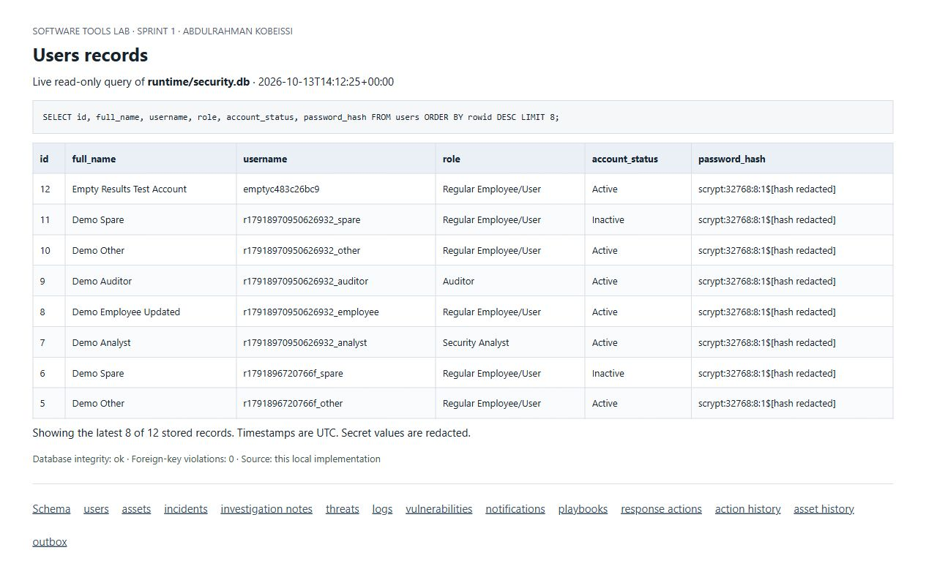
Abdulrahman Kobeissi — Actual read-only SQLite query showing stored users records. Credential hashes are redacted where present.

Stored assets Records (Abdulrahman Kobeissi)
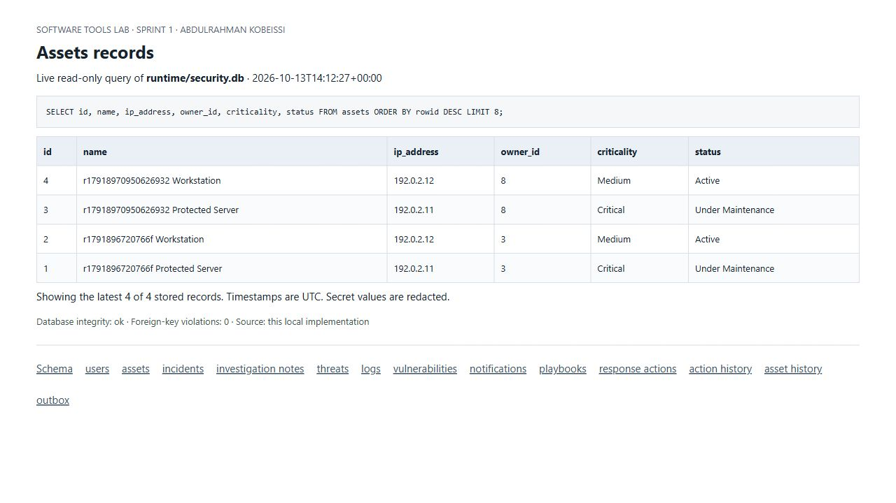
Abdulrahman Kobeissi — Actual read-only SQLite query showing stored assets records. Credential hashes are redacted where present.

Stored incidents Records (Abdulrahman Kobeissi)
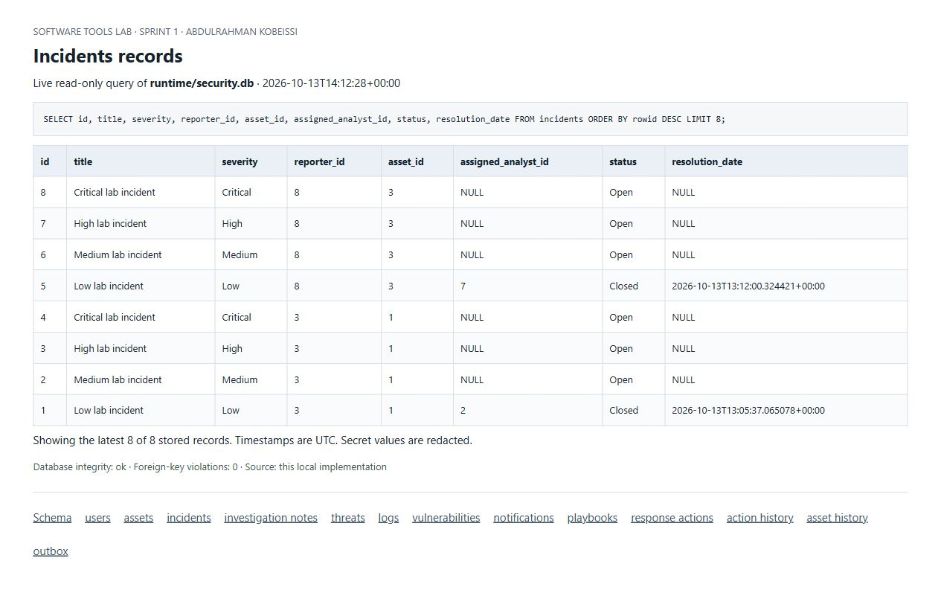
Abdulrahman Kobeissi — Actual read-only SQLite query showing stored incidents records. Credential hashes are redacted where present.

Stored investigation notes Records (Abdulrahman Kobeissi)
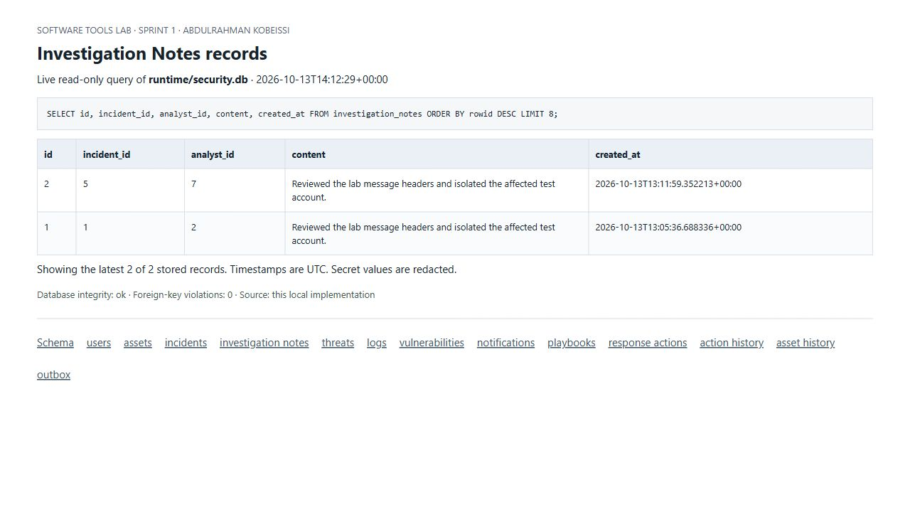
Abdulrahman Kobeissi — Actual read-only SQLite query showing stored investigation notes records. Credential hashes are redacted where present.

Stored threats Records (Abdulrahman Kobeissi)
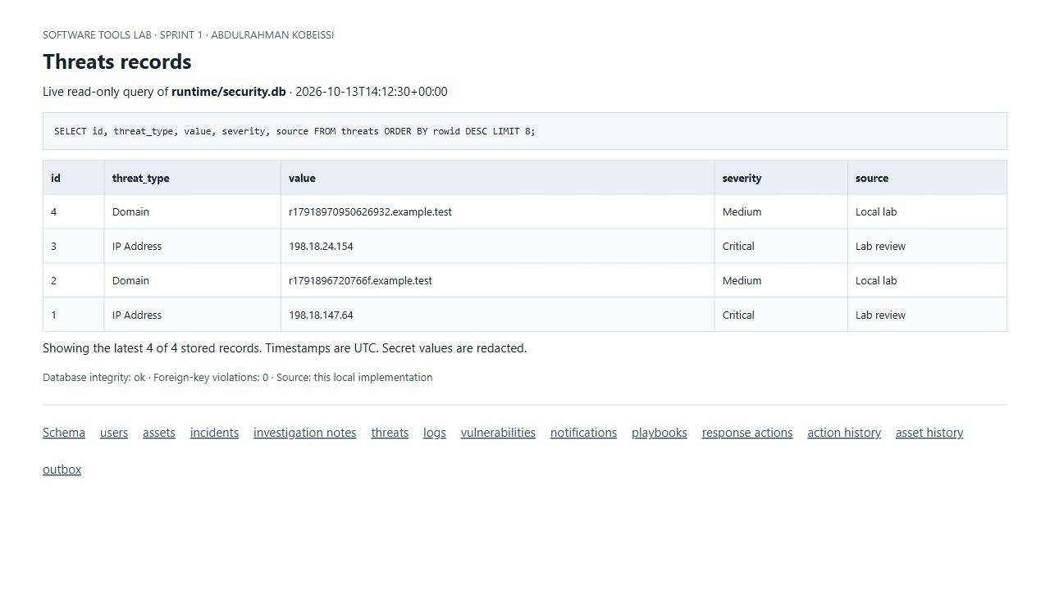
Abdulrahman Kobeissi — Actual read-only SQLite query showing stored threats records. Credential hashes are redacted where present.

Stored logs Records (Abdulrahman Kobeissi)
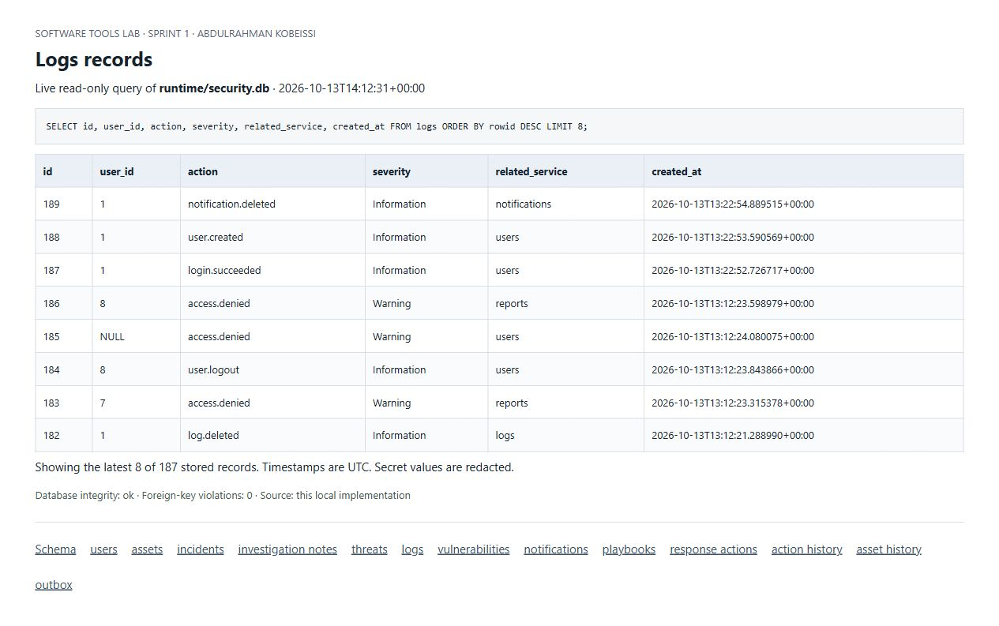
Abdulrahman Kobeissi — Actual read-only SQLite query showing stored logs records. Credential hashes are redacted where present.

Stored vulnerabilities Records (Abdulrahman Kobeissi)
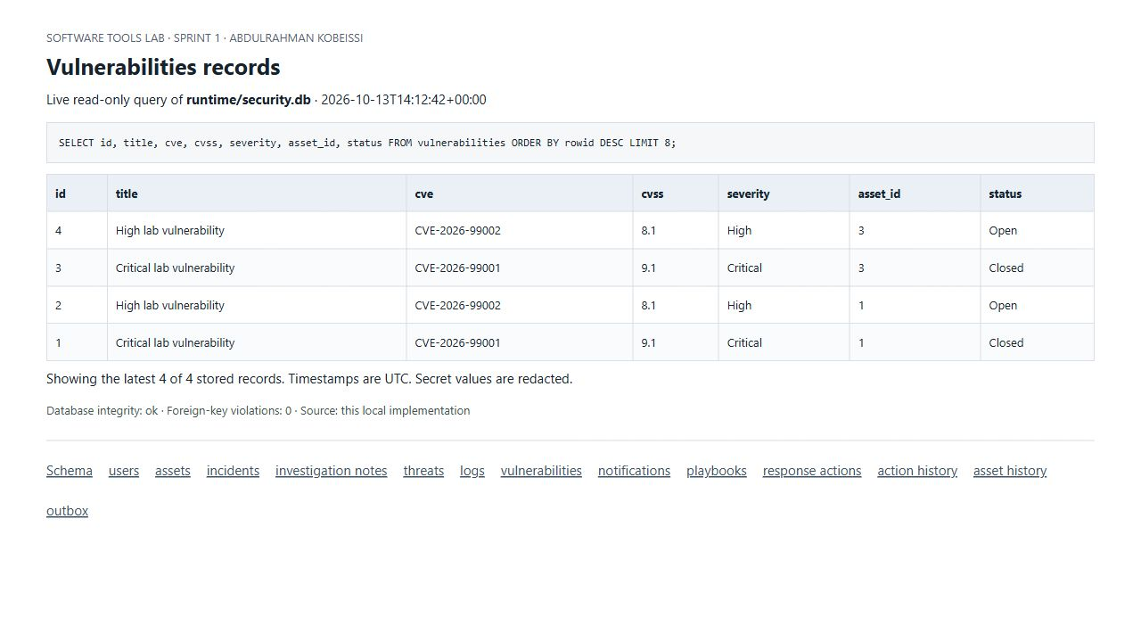
Abdulrahman Kobeissi — Actual read-only SQLite query showing stored vulnerabilities records.

Stored notifications Records (Abdulrahman Kobeissi)
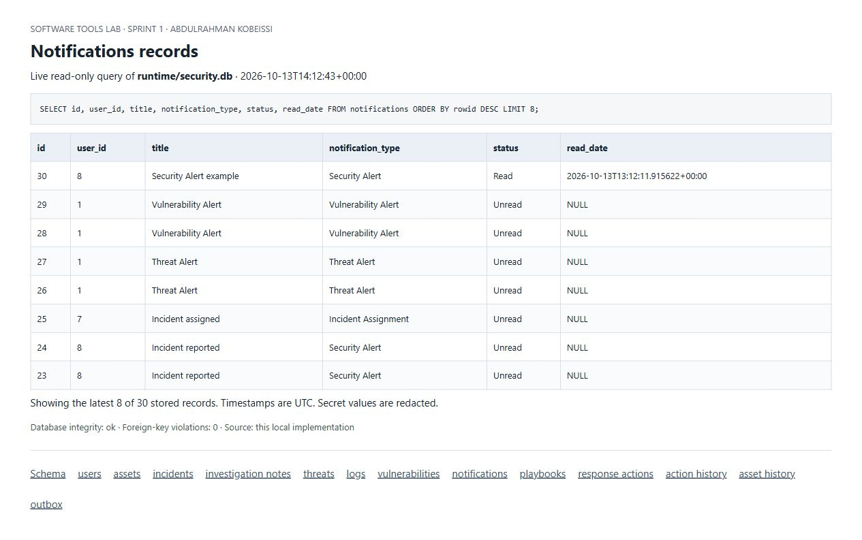
Abdulrahman Kobeissi — Actual read-only SQLite query showing stored notifications records.

Stored playbooks Records (Abdulrahman Kobeissi)
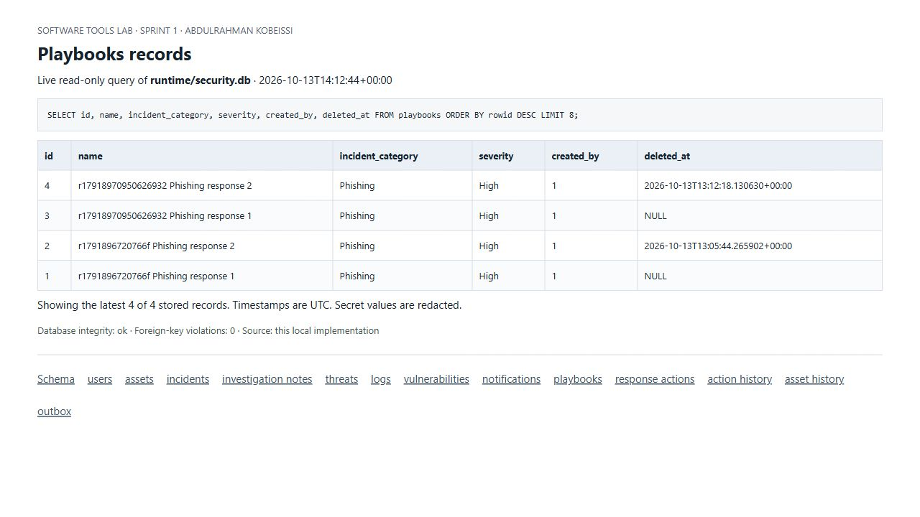
Abdulrahman Kobeissi — Actual read-only SQLite query showing stored playbooks records.

Stored response actions Records (Abdulrahman Kobeissi)
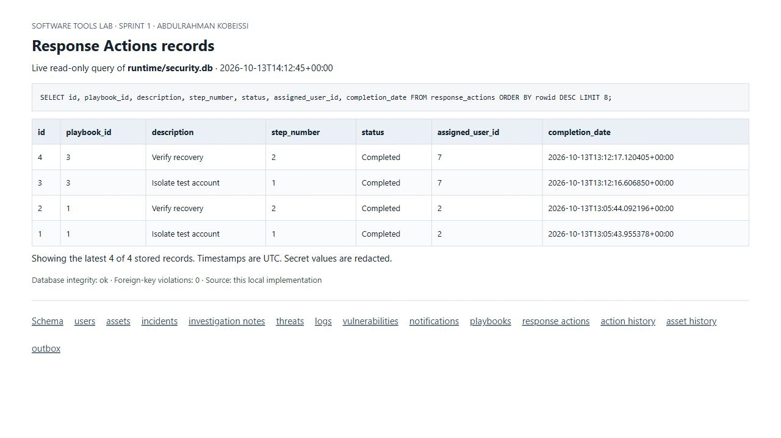
Abdulrahman Kobeissi — Actual read-only SQLite query showing stored response actions records.

Stored action history Records (Abdulrahman Kobeissi)
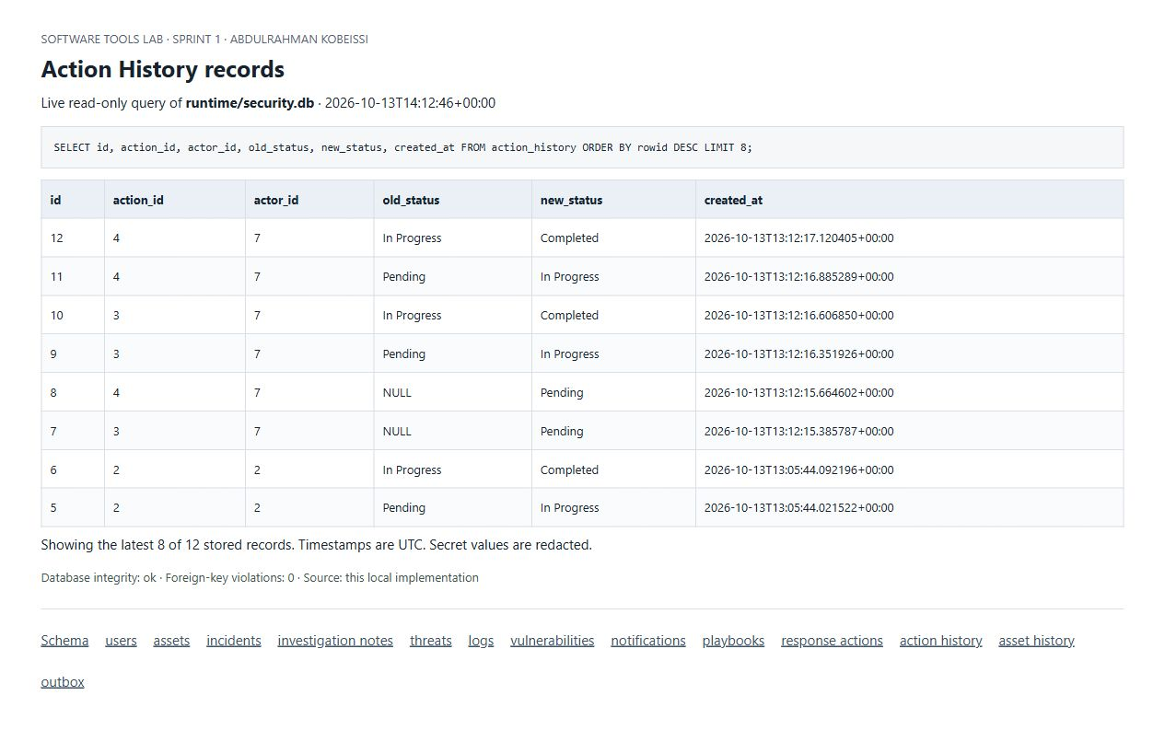
Abdulrahman Kobeissi — Actual read-only SQLite query showing stored action history records.

Stored asset history Records (Abdulrahman Kobeissi)
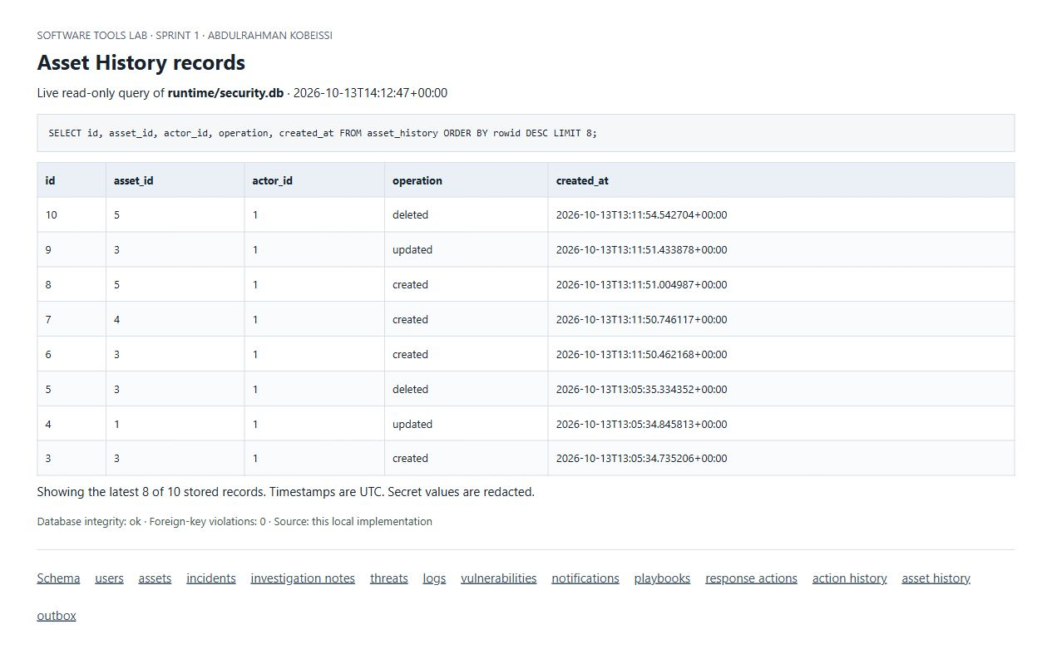
Abdulrahman Kobeissi — Actual read-only SQLite query showing stored asset history records.

Stored outbox Records (Abdulrahman Kobeissi)
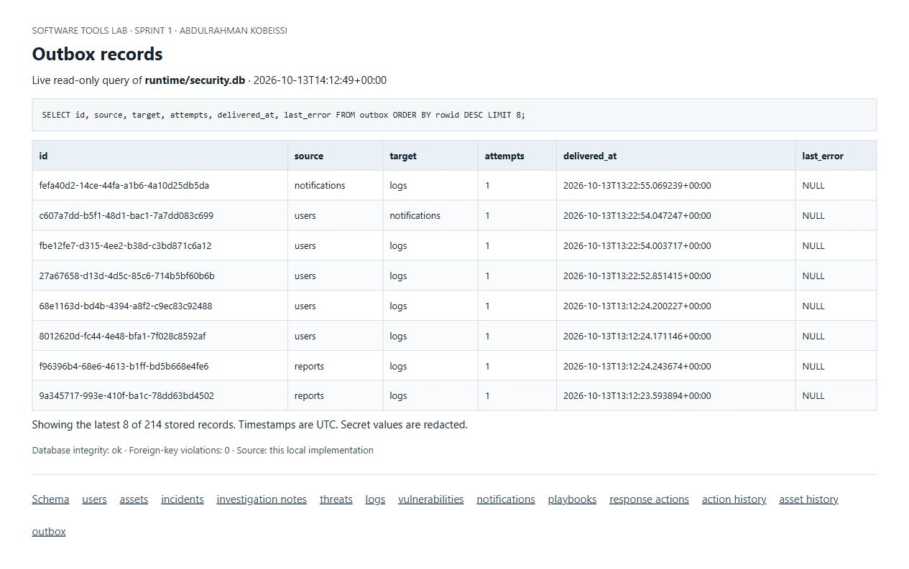
Abdulrahman Kobeissi — Actual read-only SQLite query showing stored outbox records.

GitHub Commit History (Abdulrahman Kobeissi)
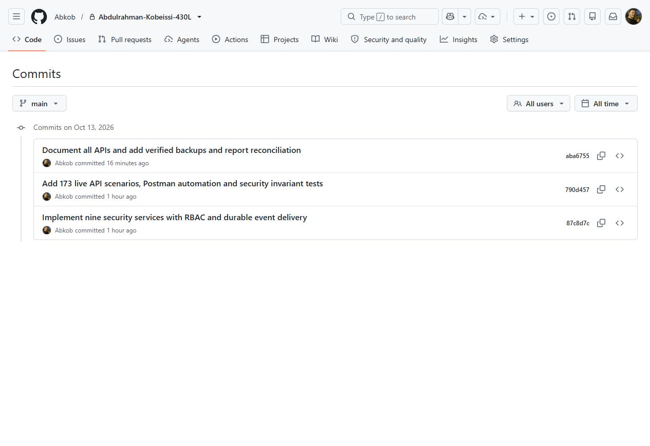
Abdulrahman Kobeissi — Actual private repository history showing the implementation, testing and documentation commits by Abkob on 13 October 2026.
Later report-packaging commits may follow this screenshot.

