**MACHINE LEARNING**

**Contents i**

**Machine learning ii**

1. Introduction to machine learning
2. Types of learning and modals
3. Machine learning in python

**Linear regression iii**

1. Mathematical definition
2. Gradient descent
3. Computer science way
4. Implementation in python
5. Compared to other modals and learning algorithms

**Artificial Neural Network iv**

1. Definition
2. Other

**Hidden Markov Model v**

1. Definition
2. Other

**References vi**

1. **Machine Learning**

**Introduction to machine learning**

In traditional programming, problems are solved using an algorithmic approach where a set of logical instruction are used to process inputs and produce an output. This approach is highly efficient in determined tasks like sorting, where algorithms such as Quick Sort or Merge Sort perform the tasks greatly and without rapidly increasing complexity as data increases. This method is a clear difference from the way our brain approaches problems. The brain natural approach does not really on strict low level instructions to create an output, instead it is founded on neural networks.

The limitations of traditional programming becomes apparent when faced with complex inputs like images or sounds. In this case machine learning comes into play. Inspired by our brain, machine learning, does what it sounds like, trains a machine to find patterns in complex and near chaotic inputs without being programmed for every scenario. If we look more in depth we can divide this concept into three phases : Initial model, learning algorithms, Final model.

**Model :**  
To find patterns and make decisions from images, sounds or any other inputs, we will first need a function to process the data using parameters that scale the inputs. Those variables are called **weight** and **biases**.

**Initial Model :**The model needs to be initialized with random values before entering the training phase.

**Final Model :**The model after the training phase. At this point it should have a maximally positive output and a performance approaching one to be trusted and usable.

**Learning Algorithm :**The method to update the initial model using a training dataset.

**Types of learning and modals**

Here are some commonly used types of learning :

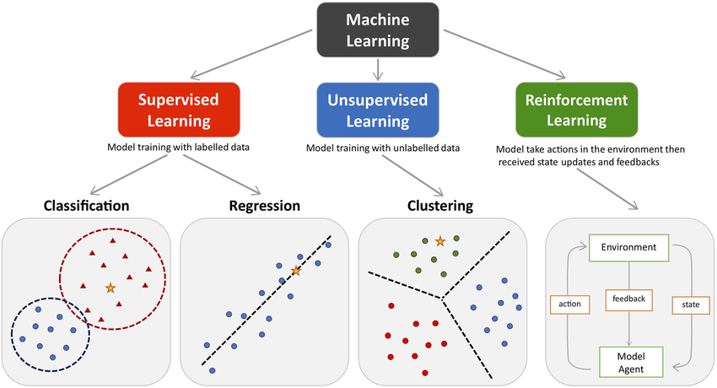

**Machine learning in python**

- using jupiter to visualize data  
- write another programme to execute called function from learning file  
- linux : use virtual environement to install packages using pip by executing this command   
 “here command” (venv)