RFVD Device Report
SENSOR-D envelope instrument • Design and engineering assessment • 8 September 2026
Purpose. Explain the complete measurement and recording system, its circuit and software behavior, the numerical results behind its design, and the tests needed before a prototype can support scientific measurements.
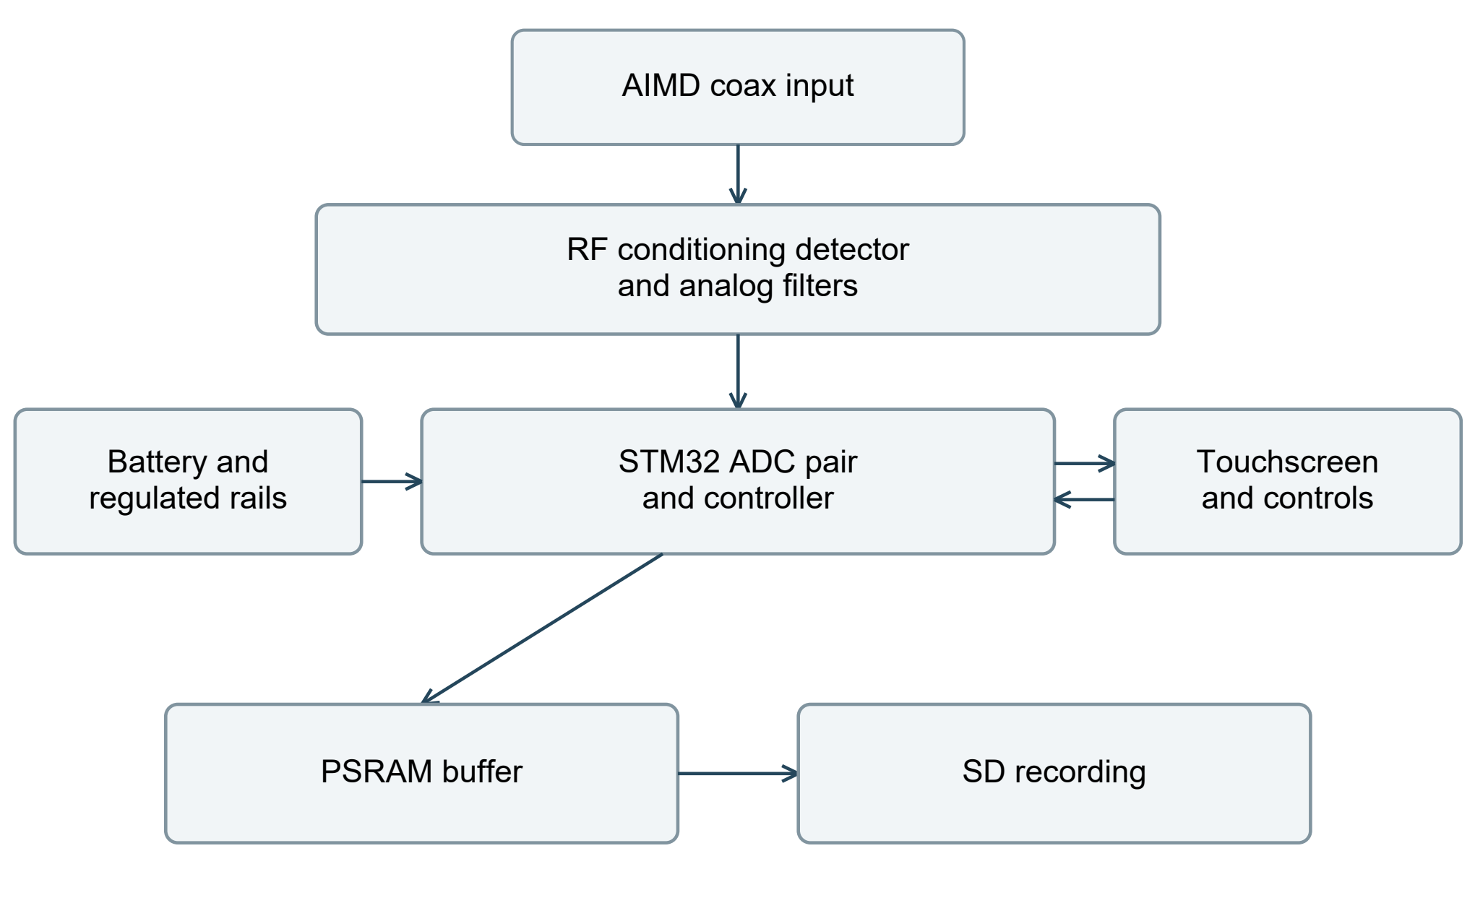
Figure 1. Intended instrument architecture. Analog circuitry converts the RF carrier to slower voltages. The controller records paired samples while managing storage and operator controls.
The design is a battery-powered RF-envelope recorder for a coax connection to an active implantable medical device. It combines an ADL5511 detector, two analog filter paths, paired STM32H743 ADCs, external RAM, a touchscreen and removable SD storage.
Principal finding. The instrument targets one million simultaneous envelope/reference pairs per second through an approximately 95 kHz envelope path. The 14-bit converter setting and revised recording pipeline pass their selected model criteria. The current board adds a close ground reference and two-ended RAM damping. Manufacturer-model checks support a conditional prototype choice, while retaining a small clock-voltage screen failure and very little modeled edge margin.
No assembled RFVD hardware was measured for this report. All plots identify their modeled conditions; software test fixtures are synthetic. A successful simulation is not an achieved accuracy, EMC or field-suitability result.

Scope and reading guide
This report describes the current SENSOR-D circuit and board: 194 schematic parts, 166 nets, 572 pin assignments and 198 PCB footprints. It explains the complete device without requiring calculation files or software folders. The companion RFVD_EMC_OPTIMIZATION_REPORT.docx and RFVD_PCB_LAYOUT_RATIONALE.docx provide additional field, supply and layout detail.
Evidence type | What it supports | What it does not establish
Native design export | Actual part identities and pin connectivity at the recorded export time. | That the populated board functions or meets a noise target.
Numerical simulation | Consequences of stated circuit parameters, waveforms and timing assumptions. | Unmodeled device behavior or hardware qualification.
Executed software tests | Behavior of exercised algorithms, record formats and modeled register events. | Worst-case timing on the STM32 or a real SD card.
Manufacturer data | Component characteristics under the cited conditions. | Complete-instrument accuracy or immunity.
Physical measurements | Required for final calibration, loading, noise and timing qualification. | None were generated in this work.

Package boundary. The design includes connected amplifier feedback, detector/reference grounds, ADC reservoirs, buck feedback and oscillator bypass. Eight 33 Ω RAM data resistors provide damping at both ends of the bidirectional bus. The CAD and explanation package supplies no firmware image or build environment; the implemented software behavior described here still requires a separately controlled programming image and bench qualification.
Topic | Technical detail | Pages
Experiment and signal path | Loading, detector theory, filter and pulse results. | 3–14
Power and measurement noise | Supply budgets, grounding and calibration. | 15–18
Recording and user operation | Buffers, card capacity, scheduler and integrity. | 19–24
Implementation and qualification | Circuit checks, equations, interface margins and sources. | 25–35

Values named “nominal” describe the model or configured target. Reported tolerance extrema are the sampled range of the stated population, not guaranteed production limits. MB and GB are decimal; MiB is 1,048,576 bytes.

The experiment being measured
The lab connection is a coax attached directly to selected terminals inside the AIMD. The center conductor and shield therefore define a real measurement port. The receiver observes voltage between those conductors; it does not directly measure tissue temperature, local electric field or an undisturbed internal node.
During RF excitation, the expected signal is a carrier near the selected MR frequency whose amplitude changes with the excitation pulse. A pulse train may contain many repeated bursts separated by quiet intervals. Continuous acquisition records both. Selecting 64 or 128 MHz is a declaration for interpretation and calibration; the present instrument does not generate or tune the laboratory stimulus.
Input characteristic | Evidence or design meaning
Carrier | Nominal study points are 64 and 128 MHz. A published MITS experiment used 63.8 and 127.7 MHz; record the actual frequency. [16]
Pulse shapes | The MITS product supports rectangular, sinc, Gaussian and arbitrary waveforms. The partner lab’s protocol is still needed. [17]
Pulse duration | This report stresses 1–42 µs rectangles and 0.512/2 ms sinc envelopes. They are test cases, not a declaration of the lab’s minimum pulse.
Measurement objective | Time history of the loaded terminal RF envelope, with waveform and setup metadata.
Unknown boundary conditions | AIMD center/shield nodes, source impedance, maximum voltage, cable assembly and permitted receiver location.

FDA transfer-function methods use a defined excitation and measurement procedure. A terminal-envelope record can support that work, but is not by itself a complete transfer-function measurement or an MR safety determination. The measurement plane and physical loading must accompany the data. [18]
For first-board testing, replace the AIMD with a calibrated bench source and characterize the whole coax path. Introduce the AIMD and field apparatus only after the bench behavior and allowed exposure configuration are established.

From coax voltage to stored samples
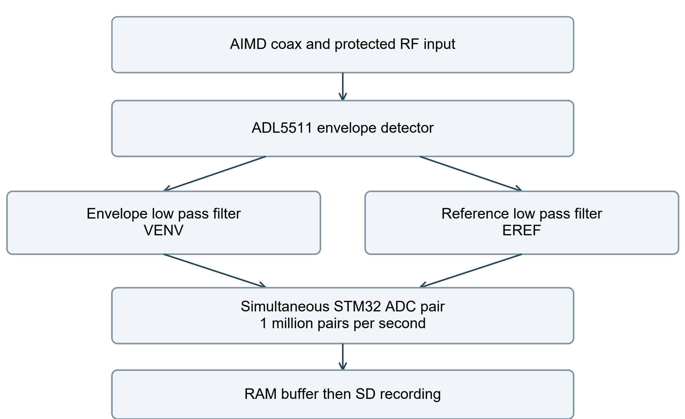
Figure 2. Functional signal path. EREF is the detector’s voltage reference, not a second RF pickup. Housekeeping measurements are separate from this recorded pair.
Stage | Why it is present
Input resistors, DC block and clamp | Reduce signal level and DC exposure while attempting to limit loading. The actual RF impedance and overload behavior need measurement.
ADL5511 | Convert the carrier amplitude to VENV, referred to EREF. Its separate RMS output is available for diagnosis. [1]
OPA2320 analog stages | Buffer and low-pass the envelope/reference signals before conversion. Their component network determines the instrument bandwidth. [2]
STM32H743 paired ADCs | Acquire the two voltages at the same nominal instant, then DMA packed pairs to memory.
RAM, SD and local display | Absorb temporary storage delays, retain indexed data and provide operator controls.

The circuit callouts are ADL5511 U2, envelope amplifiers U4, reference amplifiers U3, STM32 U8 and RAM U9. Each schematic module identifies its signal directions, local nodes and supplies. R60/R62/R64/R66 are the MCU-end RAM data resistors; R61/R63/R65/R67 are the RAM-end resistors.

Measurement planes and loading
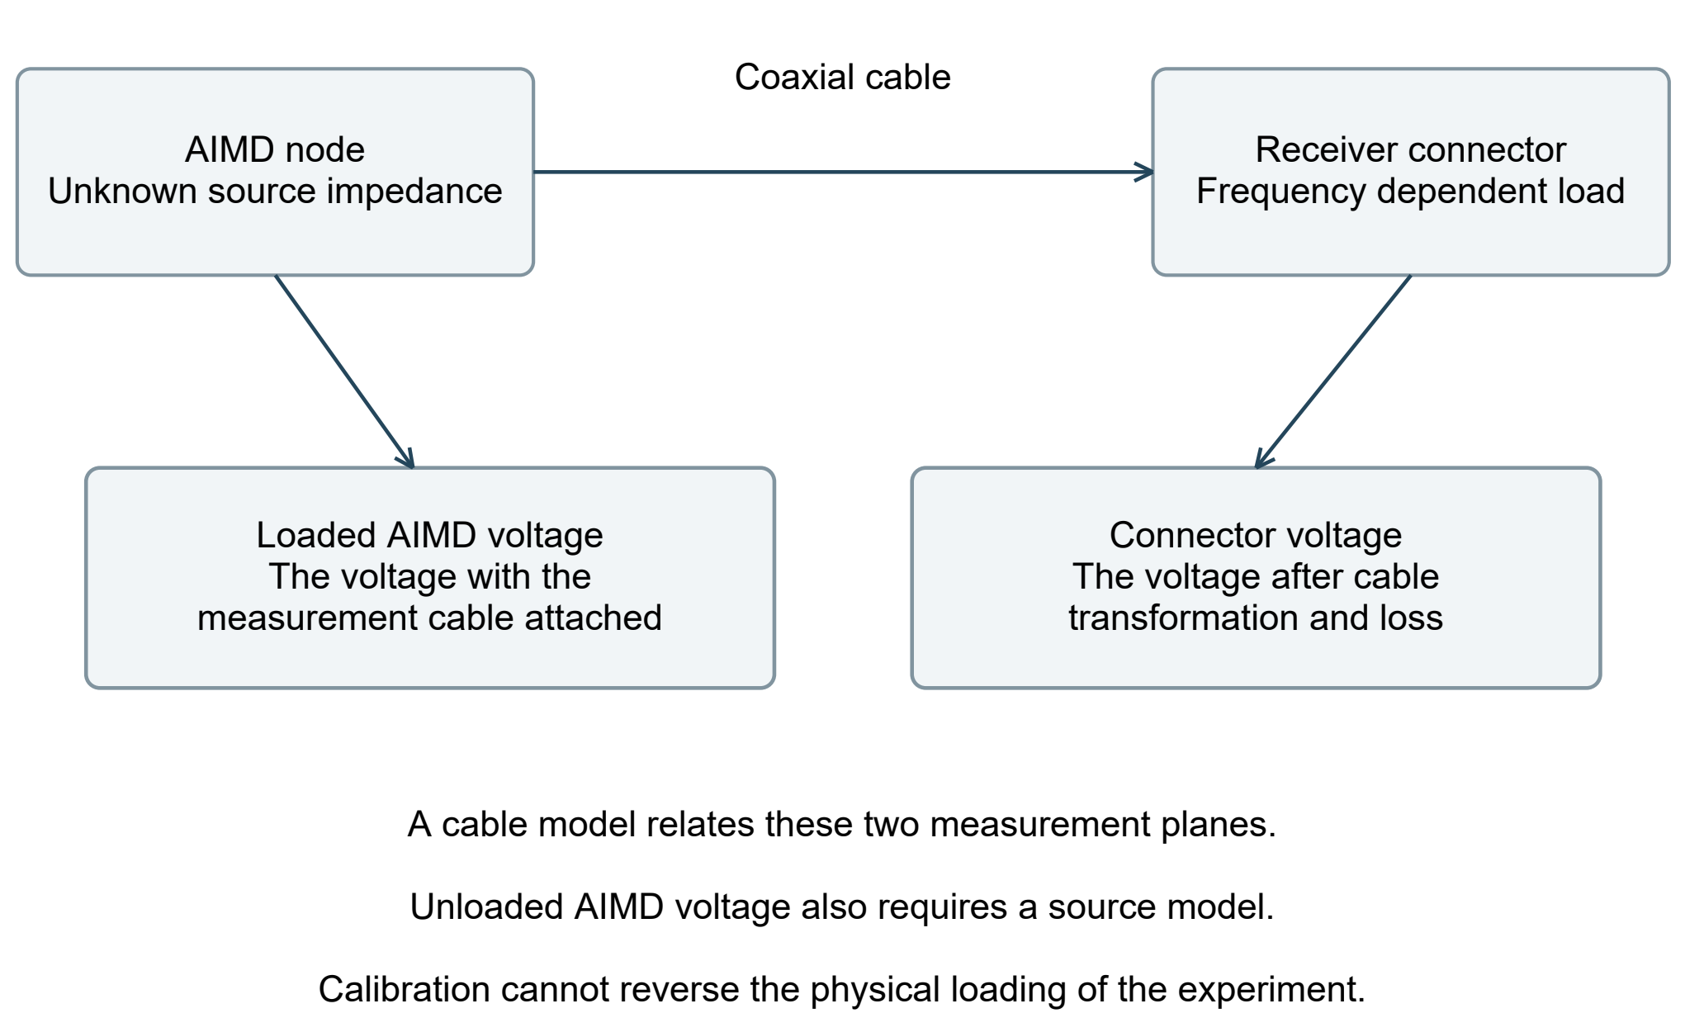
Figure 3. The AIMD terminal and receiver connector are different voltage planes. The coax is part of the measurement circuit.
$$Vloaded = Vopen × \frac{Zseen}{Zsource + Zseen}$$
The Thevenin relation shows why the measured voltage changes when a finite load is connected. The impedances are complex and frequency dependent; this expression applies at one carrier frequency.
A cable transforms the receiver load before the AIMD sees it. A receiver with a large input resistance can still place a much smaller reactive impedance across the AIMD through a finite-length cable. A matched 50 Ω termination would control reflections, but would impose its own substantial load. Neither choice is automatically correct without the source and allowable perturbation. [3]
A calibrated cable model can relate connector voltage to loaded-terminal voltage. Recovering the hypothetical unloaded voltage additionally requires a source model. Numerical correction cannot reverse the physical change in the experiment caused by the measurement connection.

The RF input network
The input uses two 1.5 kΩ thin-film resistors, a 470 pF DC-blocking capacitor, a low-capacitance clamp and the detector input. It is a voltage-sensing attenuator, not a matched 50 Ω pi network. The table includes the selected 3313 stack through an approximate trace and pad capacitance model. [1] [26]
$$Gideal = \frac{250 Ω}{3000 Ω + 250 Ω} = 0.0769$$
Ignoring RF reactance, the nominal 250 Ω detector input gives about 13:1 attenuation. At RF, the close plane loads intermediate high-impedance nodes. The following geometry-informed prediction uses 250 Ω in parallel with 1 pF at the detector, assumed component parasitics and approximate land capacitance; it is not a measured port impedance.
3313 model at connector plane | 64 MHz | 128 MHz
Board input impedance | 1539 − j1588 Ω | 636 − j1228 Ω
Detector / connector voltage magnitude | 0.07401 | 0.06687
Detector voltage for 14 V peak at connector | 1.036 V peak | 0.936 V peak
Largest resistor dissipation in that sinusoidal case | 14.98 mW | 17.67 mW

The 14 V case is a numerical screen, not an approved input rating. This model uses uniform-line parameters and a 0.5–2× pad-capacitance sensitivity; mask, coplanar copper, full package fields and overload are not extracted. Closer ground improves digital return geometry but also changes the RF load. Voltage sharing, heating, clamping and recovery must be measured. [26]
Two resistors divide dissipation and voltage stress without adding the many intermediate parasitic nodes of a ten-part chain. The comparative study holds assumed per-part parasitics constant, so it cannot prove that two physical packages outperform every alternative layout. The Panasonic part is specified as 1.5 kΩ, 0.1%, 25 ppm/K and 0.063 W; its exact mounted RF model is not established. [4]
The clamp’s 2.5 V standoff is not an ideal hard clipping level. Its modeled off-state capacitance does not simulate transient clamping, sustained RF overload or ESD return currents. [5]

Cable sensitivity is a system limit
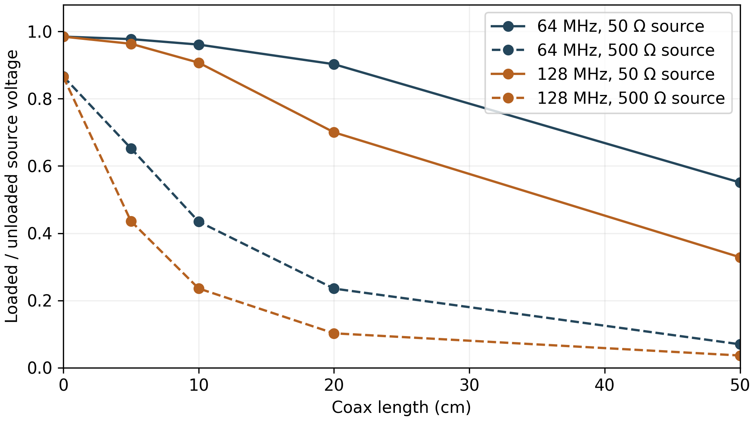
Figure 4. Earlier cable sensitivity fixture: 50 Ω line, velocity factor 0.7, loss 0.5 dB/m and a lumped receiver model before explicit 3313 pad loading. Source resistance is 50 or 500 Ω. The curves join five simulated lengths and are not measured behavior or a prediction for the final powered input.
In that illustrative fixture, a 20 cm cable leaves about 90.3% of unloaded terminal voltage at 64 MHz and 70.0% at 128 MHz for a 50 Ω source; at 5 cm, about 97.7% and 96.4%. The final stack changes receiver loading, so these percentages cannot calibrate the current device. Actual AIMD impedance and cable parameters must replace the assumed boundary conditions.
The full 5,400-case cable study spans line impedance, velocity factor, length, loss and complex source impedance. Some reactive-source cases show voltage magnification rather than simple attenuation. That is a circuit response, not power gain from the passive cable. It is another reason to avoid applying a single generic cable correction.
Practical decision | Evidence needed
Choose cable length and receiver position | Measure the actual cable and powered input; compare loading at both operating frequencies.
Report terminal voltage | Define the center/shield node pair and measurement plane in the session.
Claim low perturbation | Compare the loaded configuration with an agreed reference measurement or source model.

What the envelope detector measures
$$vRF(t) = A(t) cos(2πfct + φ(t))$$
A(t) is the carrier’s voltage amplitude at a stated plane. The ADL5511 produces a slower output related to its magnitude. The stored envelope does not retain the carrier’s sign or instantaneous oscillation.
$$VENV(t) ≈ EREF(t) + k(f,T,A) × |A(t)|$$
This is a local explanatory relation, not a calibrated transfer law. The scale k depends on frequency, amplitude and temperature; offsets, compression and bandwidth must be measured. [1]
Subtracting the digitized reference from the envelope channel is useful only after accounting for the two analog paths and their offsets. EREF provides a detector reference voltage. It does not automatically remove ADC-reference modulation, unequal pickup or dynamic mismatch.
Quantity | Meaning in this instrument
RF peak amplitude | Carrier amplitude inferred from the envelope after validated calibration.
RF RMS voltage | For a sinusoid with constant amplitude, peak divided by √2. For a pulse train, averaging interval and duty cycle also matter.
RMS diagnostic output | The ADL5511 has a separate RMS output, exposed for diagnosis. It is not a third continuously recorded RF channel.
Envelope integral or squared integral | Potential derived quantities only after bandwidth, baseline, calibration and the integration window are qualified.

Opposite-sign lobes in a sinc excitation produce positive magnitude lobes at an envelope detector. This is expected measurement behavior. An analyst must not reconstruct the sign from the recorded envelope unless an independently known waveform model supplies it.
The ADL5511’s advertised 130 MHz envelope capability describes the component under its stated conditions. The installed filter capacitors and subsequent active filters reduce the RFVD system response by orders of magnitude. [1]

Analog bandwidth and stored profiles
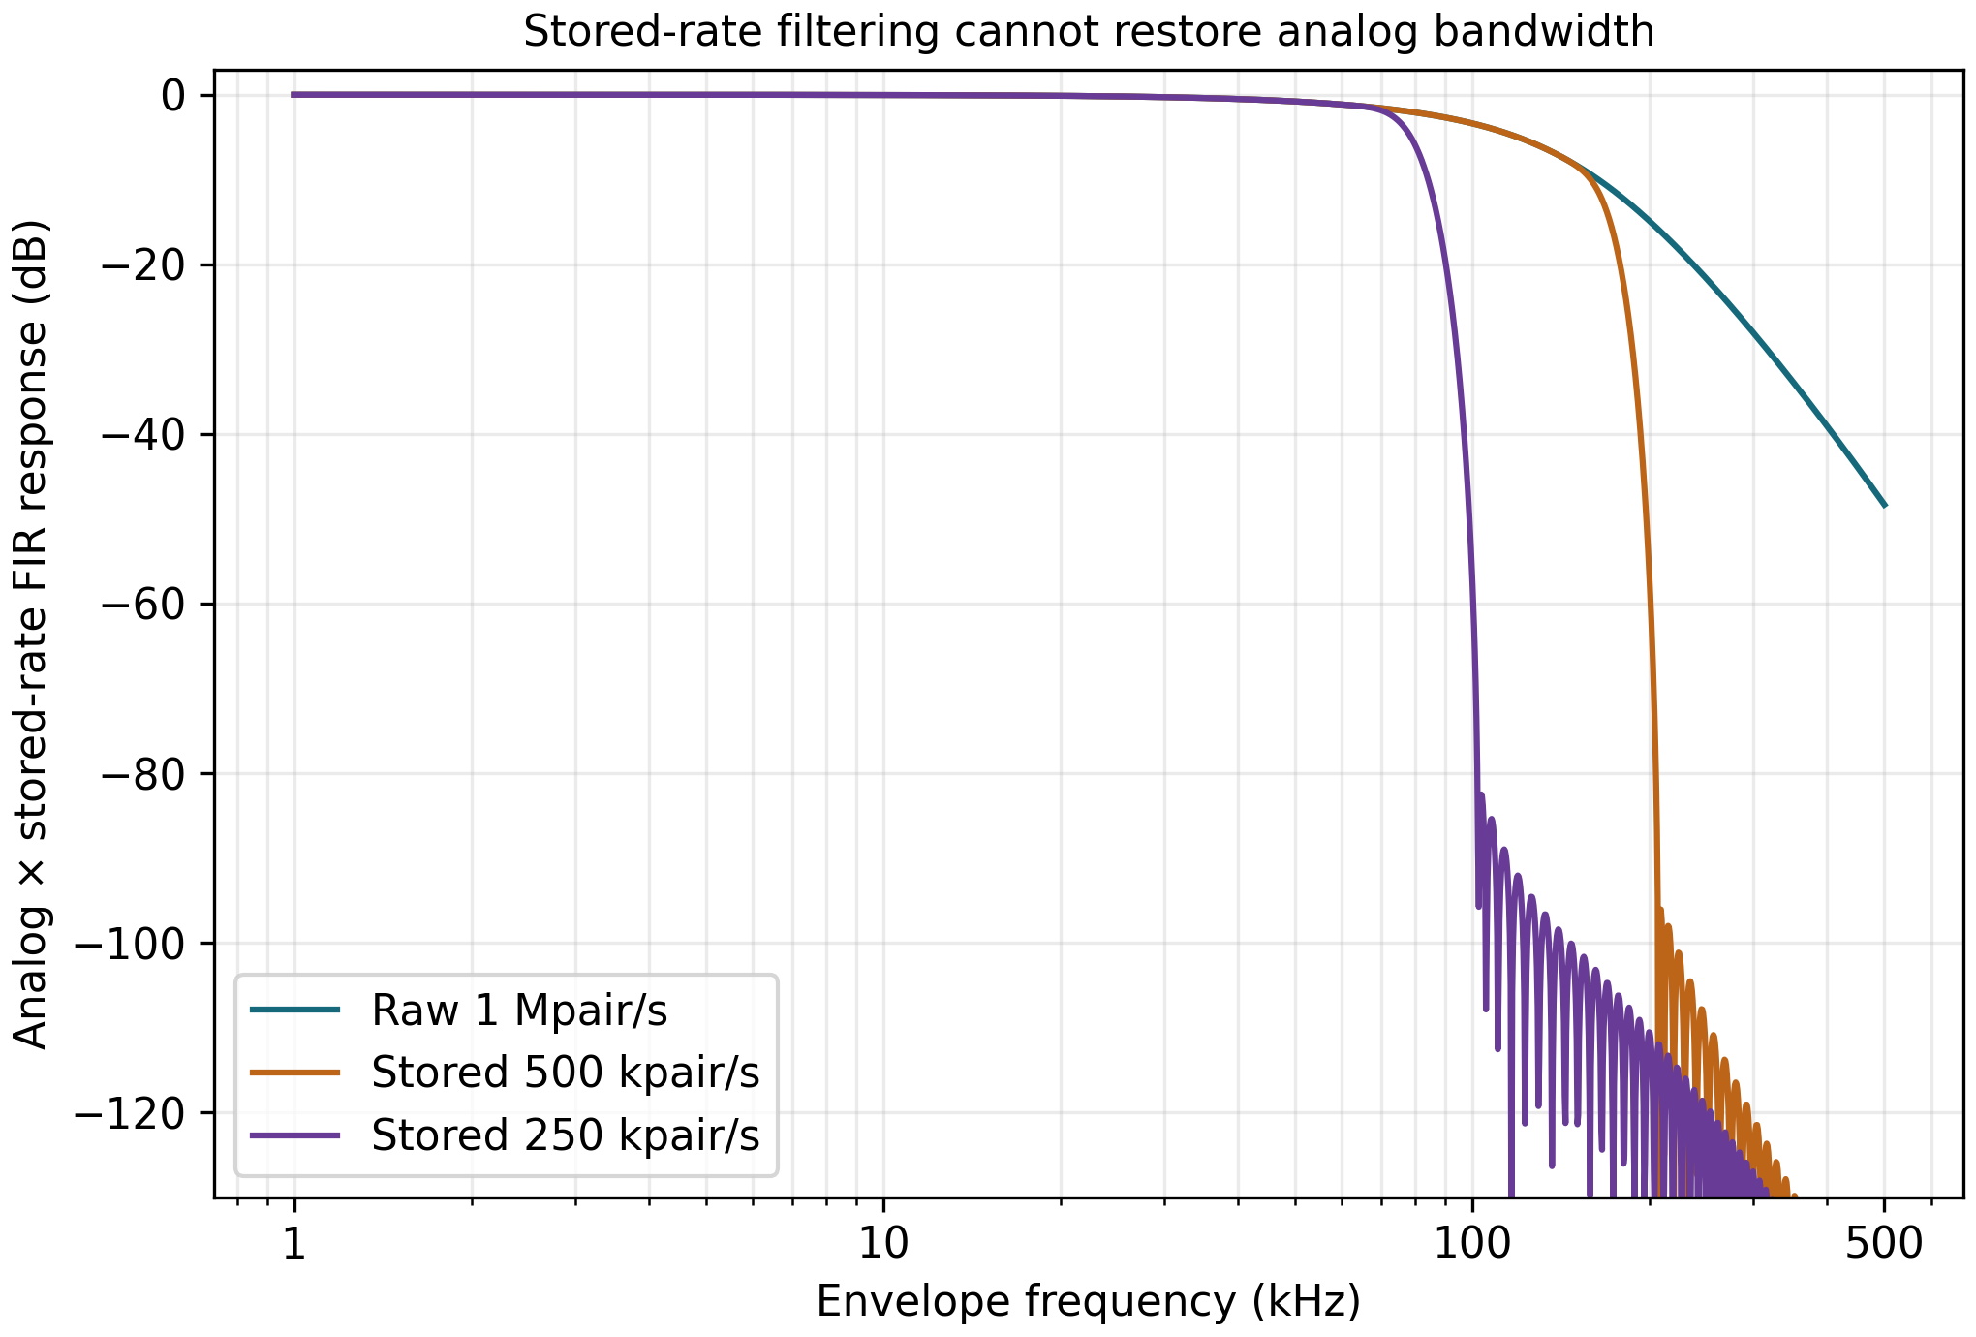
Figure 5. Nominal VENV response and the actual firmware FIR profiles, normalized to VENV DC gain. EREF is tabulated separately. The plot is a transfer calculation, not a measured noise spectrum.
Result | Numerical value | Interpretation
VENV nominal −3 dB corner | 94.75 kHz | Main envelope path bandwidth.
EREF nominal −3 dB corner | 100.14 kHz | Reference-path dynamics differ slightly.
512-trial VENV corner range | 92.3–96.2 kHz | Sampled tolerance population.
512-trial 10–90% rise time | 3.65–3.80 µs | Step response under model assumptions.
Nominal low-frequency delay | 4.056 µs VENV; 3.401 µs EREF | Approximately 0.655 µs mismatch.

The nominal path combines the detector’s external filtering, two Sallen-Key sections and the ADC isolation network. Bessel behavior favors time-domain shape and modest overshoot, at the expense of a slower stopband transition than sharper filters. The actual component network, not the filter name alone, determines the result. [6]

Short pulses through the complete path
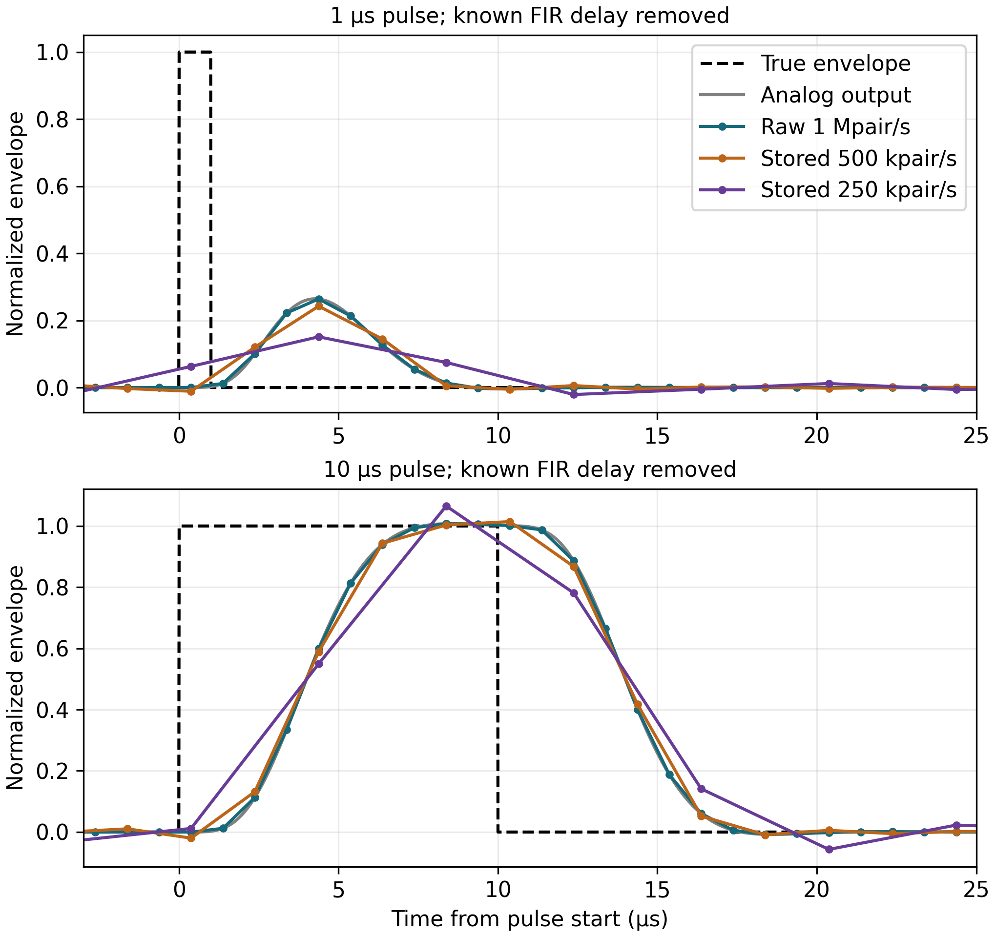
Figure 6. Synthetic short pulses through the nominal analog path and stored profiles. Known FIR delay is removed only for visual comparison. The firmware retains its documented timestamp convention.
A pulse shorter than the analog settling time is spread into a wider, lower waveform. More samples describe that filtered waveform more densely; they do not recover the original peak. Sampling phase adds a second effect because the pulse can fall between sample instants.
The campaign sweeps 32 native ADC phases over one microsecond. It also checks all two or four global decimation positions for the lower-rate profiles. Thus a 250 kpair/s result includes 128 phase/residue cases, rather than assuming a favorable alignment.
Test pulses begin after 200 µs of acquisition history. The 81- and 129-tap FIRs need full windows; with a run starting at index zero, their first outputs use native indices 80 and 128. The tables do not cover pulses arriving immediately at acquisition startup.

Pulse peaks and practical mode choice
Rectangle width | Raw 1 Mpair/s | 500 kpair/s | 250 kpair/s
1 µs | 25.2–26.5% | 21.1–24.3% | 12.7–15.1%
2 µs | 48.3–50.4% | 41.0–46.9% | 25.2–30.0%
5 µs | 91.1–93.3% | 84.8–93.1% | 59.4–69.6%
10 µs | 100.6–100.8% | 100.5–101.5% | 96.3–107.9%
42 µs | 100.6–100.8% | 100.8–102.1% | 103.6–106.1%

Table values are the minimum–maximum sampled peak as a percentage of the applied normalized envelope peak. They cover sample alignment, not the full component-tolerance or hardware-error population. Values above 100% are overshoot, not improved accuracy.
The synthetic ADC has a 0.3 V pedestal and 1 V envelope scale within a 3 V, 14-bit conversion span. Results are shifted into 16-bit storage words. This avoids clipping; it is not measured detector scaling. Noise, detector nonlinearity and ADC offset/gain error are excluded.
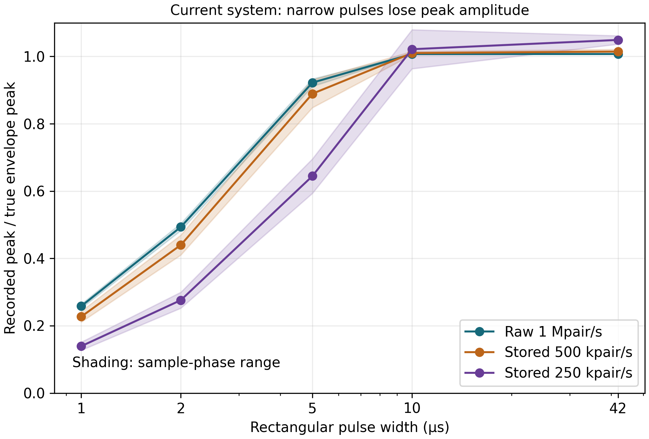
Figure 7. Peak retention across native sampling phase and decimation residue. The slower profiles trade storage for additional waveform modification.
Start qualification with the raw 1 Mpair/s profile. Use a filtered lower-rate profile only when its measured bandwidth and ringing are acceptable for the declared experiment. A 10 µs pulse can have a nearly correct raw peak while its edges are still distorted; one peak statistic does not qualify its area or detailed shape.

Shaped pulses and repeated experiments
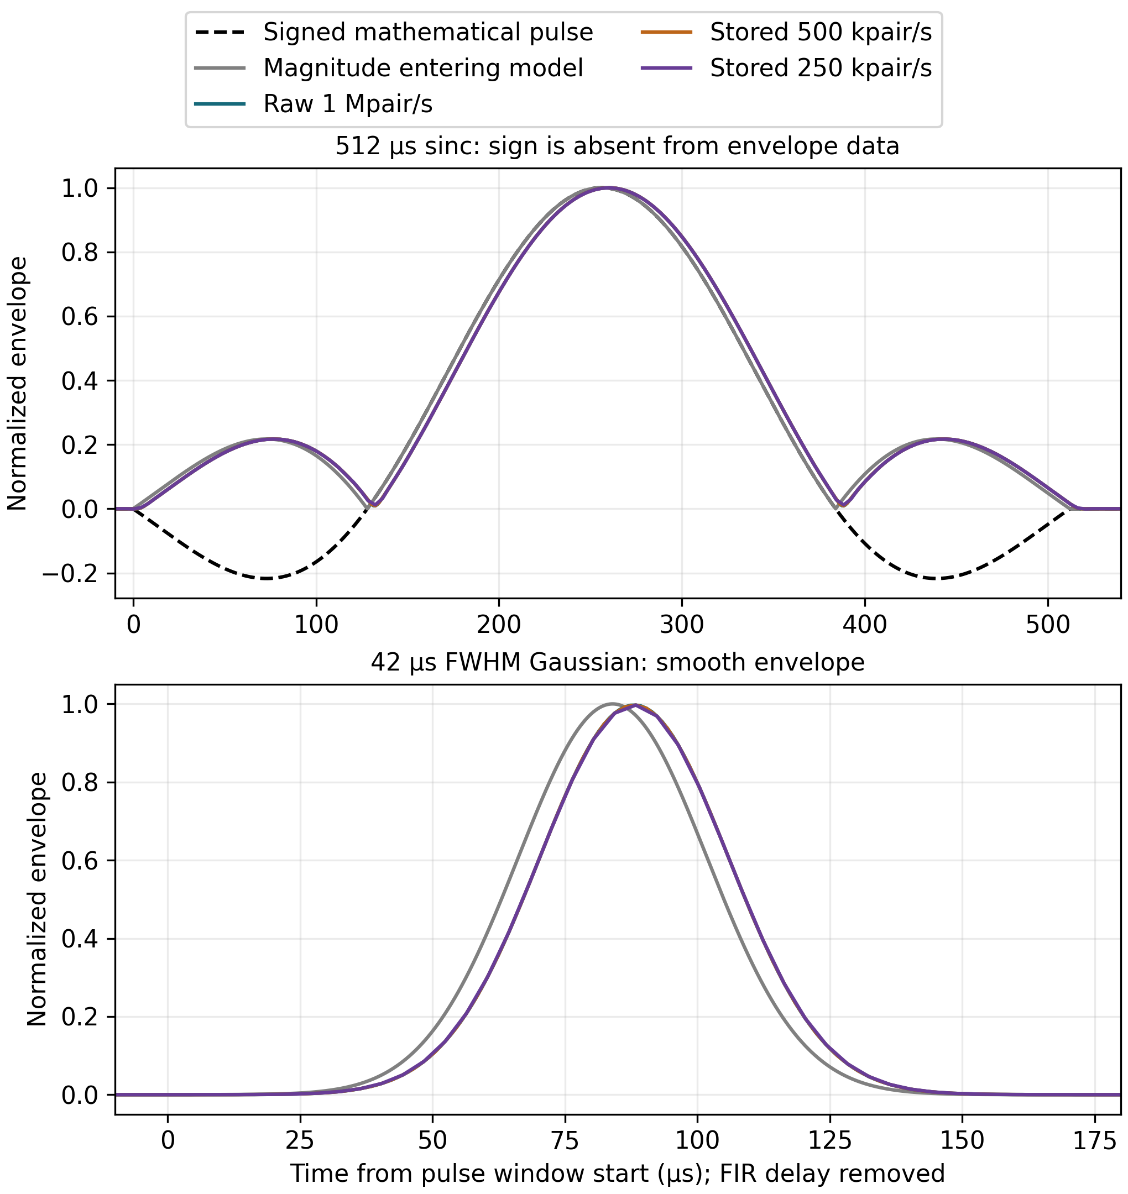
Figure 8. Synthetic sinc and Gaussian examples. The sinc test has an explicitly assumed time-bandwidth product of four. It is not a captured FDA laboratory waveform.
The 0.512 and 2 ms sinc cases are much slower than the nominal analog response. Their peak is retained far better than the 1–5 µs rectangles. That supports investigating the current design for conventional shaped-pulse measurements, but does not establish a universal MRI bandwidth requirement.
Published MITS work includes shaped RF excitation; one experiment used sinc 2π pulses at 40% duty and 1 kHz repetition. The model shapes are deliberate engineering stress cases, not a reproduction of that apparatus. Actual waveform files, rise time, amplitude and repetition must come from the lab. [16] [17]

Pulse trains and aliasing
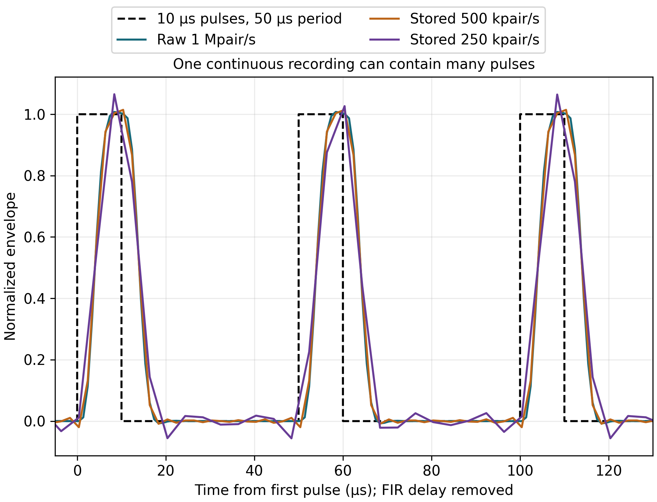
Figure 9. A synthetic pulse train recorded through the same continuous path. Recording a train does not require restarting acquisition for each pulse.
At 1 Mpair/s, the native Nyquist frequency is 500 kHz. The nominal VENV model gives about 48.3 dB attenuation there. A 600 kHz baseband disturbance folds to 400 kHz at the native ADC. The FIR can suppress some content before decimation, but cannot generally repair interference that has already folded into the wanted band.
$$falias = |finterference − n fs|$$
Choose integer n to place the result in the first Nyquist interval. Interference coupled after the analog filter does not receive that filter’s attenuation.
The configured buck is nominally 1 MHz. Its specified 0.9–1.1 MHz switching range can map into 0–100 kHz at a 1 MHz sample rate if switching energy couples into the conversion path. This identifies a frequency relationship to test; it does not claim that a spur was measured. [10]
The 81- and 129-tap firmware filters add 40 and 64 µs linear-phase delay. They use the existing Q31 coefficients and full-window startup rules. Data timestamps refer to the latest native input sample, with filter identity and delay available for interpretation.

ADC timing and settling evidence
The paired ADCs now use 14-bit conversion at 20 MHz. ADC1 reads PA6 and ADC2 reads PC4. The Rev V fixed division follows a 40 MHz PLL2 kernel. ST’s LQFP100 reference-settling guidance covers three overlapping ADCs at this setting; it is typical-condition guidance, not a guaranteed effective-resolution specification. [7] [8]
Timing term | Revised configuration | Reason
Acquisition | 8.5 cycles = 425 ns | More time for the external driver and sample capacitor.
Conversion after acquisition | 7.5 cycles = 375 ns | 14-bit setting.
Maximum asynchronous latency | 2.5 cycles = 125 ns | Included in the sample-timer period budget.
Total / margin at 1 Mpair/s | 925 ns / 75 ns | Calculated timing passes; measure actual cadence.

The former 25 MHz, 16-bit setting exceeded the package reference-settling guidance. Merely lowering it to 18 MHz would require 1.083 µs including maximum start latency, longer than the 1 µs period. The resolution change is a deliberate tradeoff that retains native sample rate. [7] [8]
Six vendor-amplifier transient cases at 425 ns pass half-LSB14 = 91.55 µV. They span 1.1, 2 and 3 V bias and assumed 4 pF/1.5 kΩ and 8 pF/3 kΩ sample loads. The largest residual is 37.57 µV. Older half-LSB16 failures remain recorded. The ADC switch/reset model is synthetic; this is not a complete converter simulation.
$$LSB = \frac{3 V}{16384} = 183.11 µV$$
One ideal 14-bit step. Each result is shifted left by two into a 16-bit word: raw codes run from 0 to 65,532 in steps of four. Two words still form a four-byte pair. Filtering can produce intermediate integer codes.
One ideal converter step is 183.1 µV at the ADC input. To express it as RF voltage at the connector, divide by the measured detector-and-filter slope in volts per RF volt. Neither the 14-bit label nor 16-bit storage establishes effective resolution or accuracy. The ADCs sample the envelope; they do not digitize the 128 MHz carrier.

Power architecture
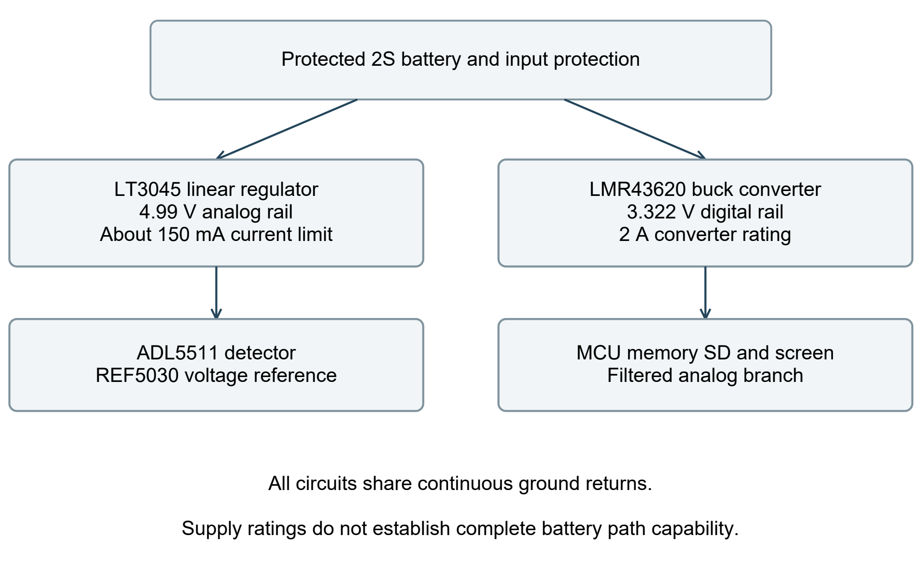
Figure 10. Intended supply tree. The precision analog rail and filtered 3.3 V branch share a continuous ground reference with the digital system.
Circuit | Reason for selection | Constraint
LT3045 | Low-noise supply for detector/reference circuits. | 4.99 V nominal; the fitted 1 kΩ limit resistor implies about 150 mA. [9]
LMR43620MB5RPER | 2 A buck for MCU, storage and display loads. | 1 MHz FPWM configuration; exact suffix has no spread spectrum. [10]
REF5030IDR | Stable nominal 3 V ADC reference. | Use the I-grade specifications and qualify local return/bypass behavior. [11]
Positive analog-supply filter | Separate some supply-current disturbances from the ADC/amplifier branch. | Actual loaded transfer and damping remain unmeasured. [14]

The digital divider is 33.2 kΩ over 14.3 kΩ, giving 1 V × (1 + 33.2/14.3) = 3.32168 V nominal. The repaired feedback node joins U6 pin 8, C41 and the divider midpoint; output bypass returns reach GND. Regulation and load transients still require powered tests.

Power margins and dissipation
Allocation | Current | Meaning
MCU / PSRAM / SD | 200 / 50 / 200 mA | Planning values; replace with measured worst-case activity.
Logic and analog 3.3 V support | 50 mA | Includes the amplifier branch and other support loads.
Screen, touch and backlight | 300 mA | UI branch has a separate load switch and current limit.
Total digital converter allocation | 800 mA | Approximately 2.66 W at the nominal rail.
5 V analog allocation | 50 mA | Below the approximately 150 mA programmed limit.

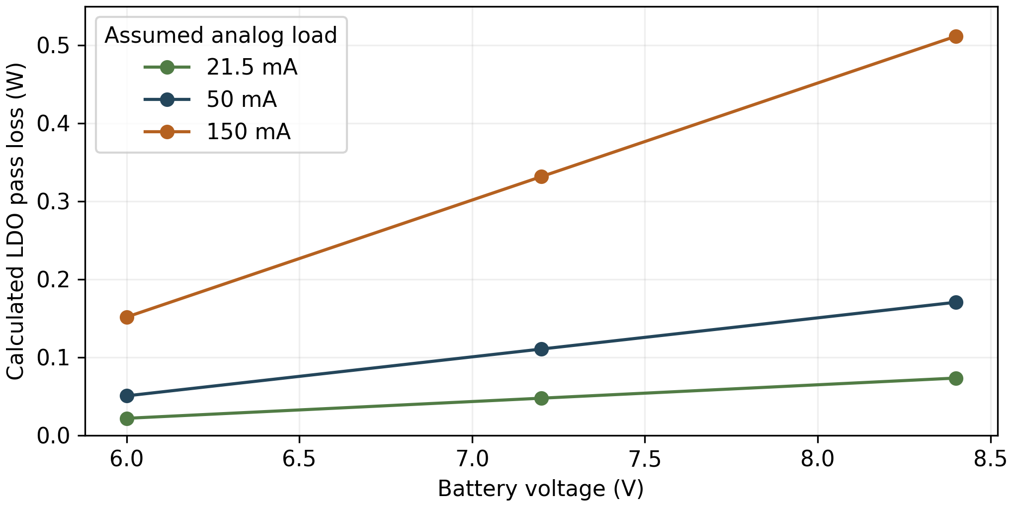
Figure 11. LDO pass-element loss versus battery voltage for three assumed currents. This deliberately ignores the input-diode drop and regulator quiescent power. It is not a junction-temperature prediction.
At 8.4 V and 50 mA, calculated pass loss is 0.171 W; at 150 mA it is 0.512 W. The digital 800 mA allocation gives 0.30–0.47 W buck conversion loss if efficiency is assumed to be 90–85%. The exact board, enclosure, ambient and load transients determine temperatures.
Battery voltage minus cable, PTC and diode drops must leave enough analog-regulator headroom. Firmware requires 300 ms of fresh acceptable rail observations before capture or recovery, using a nominal 4.90–5.10 V code window. This allows for supervisor startup; it is not calibrated rail metrology and cannot detect every fast dip. The protected pack and matched charger still need qualification.

Grounding and noise control
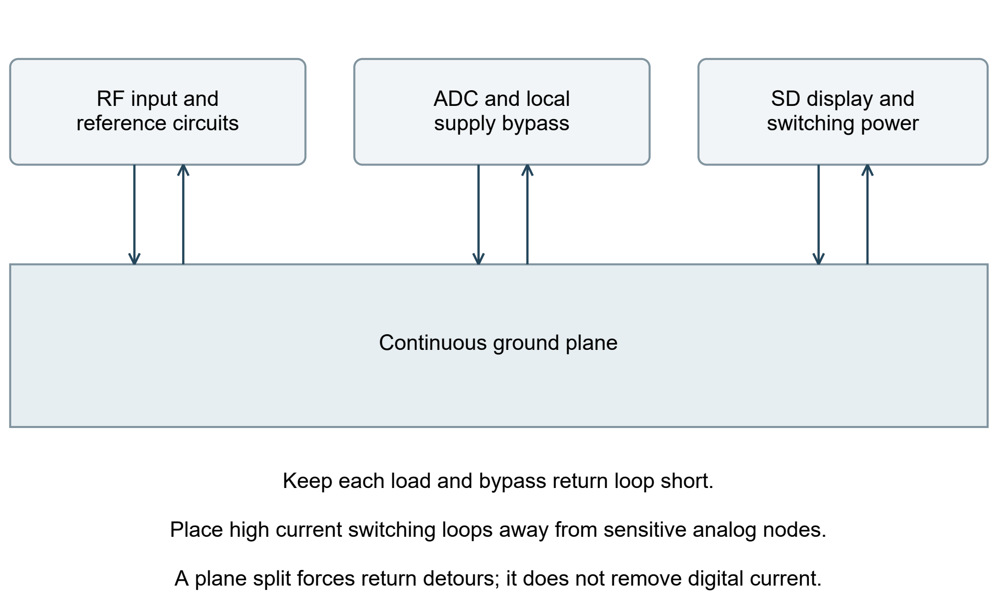
Figure 12. Placement controls where high-frequency return currents flow. This is a conceptual return-path diagram, not a field simulation of the routed PCB.
The board uses one common GND net and two continuous inner ground planes. Local bypass loops and placement separate noisy current paths from sensitive circuits. Analog and digital ground pins should not be separated by a ferrite, capacitor or narrow bridge that forces signal return current around a gap. STM32-specific supply requirements take precedence over generic mixed-signal rules. [7] [12] [13]
FB1 filters the positive 3.3 V analog branch; its 600 Ω at 100 MHz label does not establish 1 MHz rejection. An exact zero-bias bead model and biased capacitor models were evaluated, but the bead model is valid only from 1 MHz and does not represent operating DC bias. Low-frequency transients used a reduced, explicitly extrapolated model. Retain FB1 until powered rail transfer and damping are measured. [14] [26]
The ADC reservoirs, REF5030 return, LT3045 OUTS pin 10 and local bypass loops require short connections. The explicit 3313 stack places 99.4 µm dielectric between each outer signal layer and its inner GND plane. Both planes share one net. Fifteen targeted ground-return vias were added across the layout campaign; this improves available paths without proving a noise floor. [9] [15] [25] [27]
Measure quiet-input mean, RMS noise and spectra with SD writes, RAM, display, touch and backlight separately active. The 8 MHz oscillator has harmonic positions at 64 and 128 MHz; RAM runs at 66.667 MHz and the FPWM buck near 1 MHz. Frequency coincidence identifies a test, not an emission amplitude. Ideal duty-cycle cancellation must not be assumed for a real board.

Calibration and uncertainty
The present firmware collects raw CW plateaus and can review a calibration candidate. It does not activate coefficients or display qualified calibrated volts. The host tools fit per-carrier relationships and evaluate independent held-out points. Revised metadata declares the ADC resolution and left shift; raw calibration rejects saturation and invalid packing for this configuration. Synthetic tests verify those checks.
Step | Required evidence
Define the measurand | Loaded terminal or receiver-connector voltage; peak or RMS; carrier, cable and pulse conditions.
Establish the reference | Calibrated source and measurement instrument at the declared plane, with uncertainty and loading accounted for.
Collect calibration plateaus | Multiple amplitudes at each actual carrier; record temperature, supply state, firmware and setup identity.
Fit and validate separately | Fit selected points; evaluate new amplitudes and repeated setups without refitting them.
Qualify dynamic behavior | Pulse width/shape, overshoot, settling, baseline recovery and timing must be checked beyond CW gain.
Authorize and retain evidence | A reviewed fit is not an activation. Keep raw data and the evidence supporting its valid range.

The 0.1 V goal needs a stated amplitude range, plane and confidence convention. An error of 0.1 V is 10% at 1 V and 1% at 10 V. A single absolute target without those conditions is not yet a complete accuracy specification.
$$ucombined² = ureference² + ufit² + urepeatability² + uloading² + udrift² + udynamic²$$
This illustrative root-sum-square budget assumes independent standard uncertainties. Correlated terms require covariance; systematic loading and bandwidth errors must first be corrected or bounded. No numerical combined uncertainty is claimed here.
The REF5030IDR’s initial tolerance and drift contribute to the budget, but are not instrument accuracy. ADC-reference noise modulates conversion gain; subtracting EREF does not generally cancel it. Temperature reported by the board sensor is not tissue or gel temperature. [11]

Acquisition and buffering
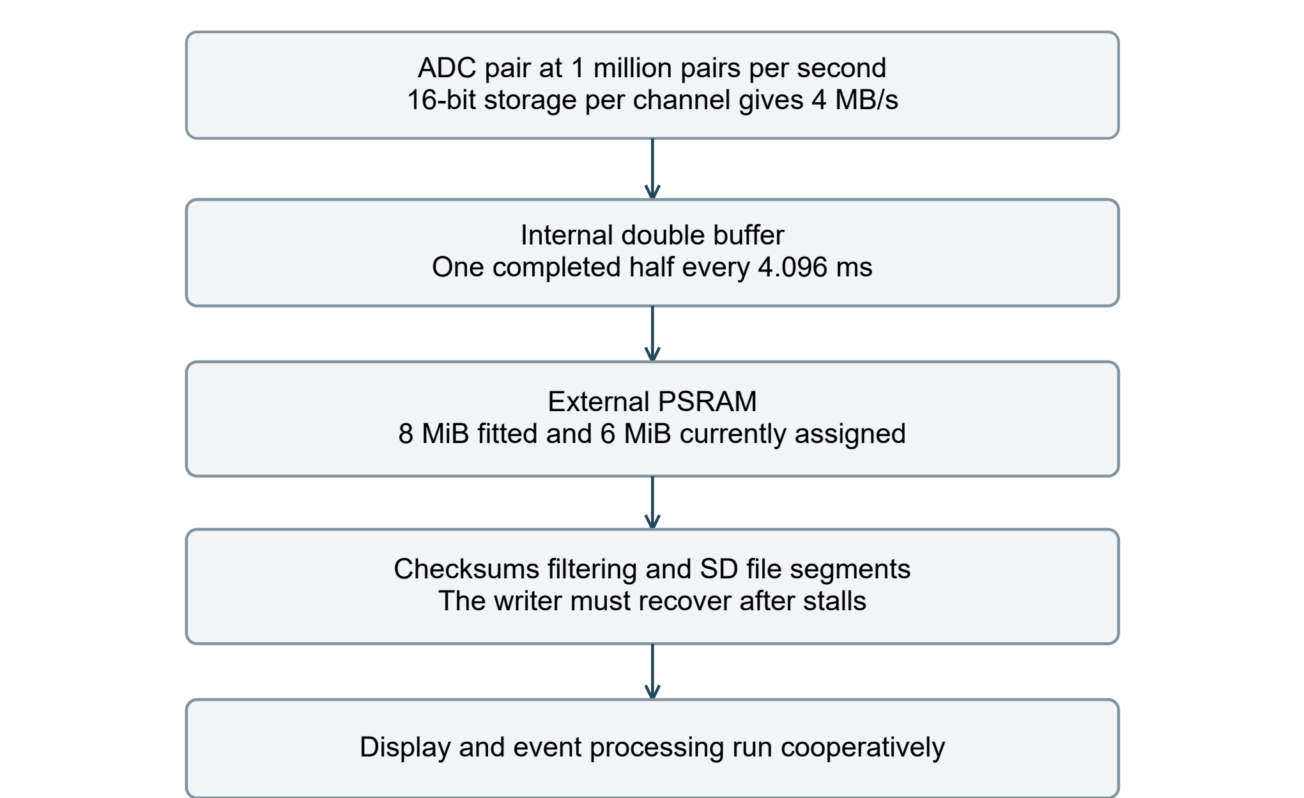
Figure 13. Native data flow and the short deadline that precedes the larger external buffer. Lower stored rates still move the same native data through RAM.
$$Data rate = 1,000,000 pairs/s × 2 channels × 2 bytes = 4 MB/s$$
The packed pair contains two 16-bit storage words carrying left-shifted 14-bit ADC results. Record headers, checksums and filesystem overhead are additional.
The internal DMA buffer has two halves of 4,096 pairs. One half becomes ready every 4.096 ms. Firmware must copy a completed half before DMA overwrites it. External RAM can absorb later storage delays only if that first copy deadline is met.
The board fits 8 MiB PSRAM, while the present firmware assigns 6 MiB to the recording ring. At 4 MB/s those are 2.097 and 1.573 seconds of gross capacity respectively. Only 6 MiB is currently implemented. Existing backlog, integrity holdback and chunk granularity reduce free capacity.

Continuous recording and card capacity
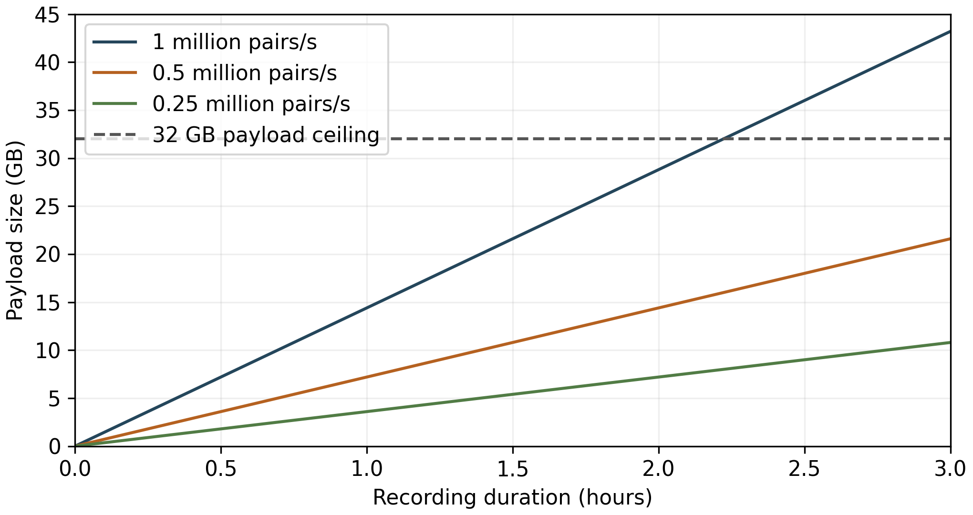
Figure 14. Payload-only storage growth. A nominal 32 GB card provides less usable session capacity after filesystem and record overhead; the dashed line is an upper-bound calculation.
Stored profile | Payload | Per hour | 32 GB upper bound
Raw 1 Mpair/s | 4 MB/s | 14.4 GB | 2.22 hours
Filtered 500 kpair/s | 2 MB/s | 7.2 GB | 4.44 hours
Filtered 250 kpair/s | 1 MB/s | 3.6 GB | 8.89 hours

Continuous recording writes every acquired interval until the operator stops, capacity is exhausted or a fault occurs. Firmware rotates linked file segments, using 256 MiB preallocated extents and approximately 240 MiB payload per segment. At raw rate that payload is about 62.9 seconds.
This resembles a dashcam only in its continuous capture and file rotation. The current firmware does not delete old experiments or overwrite the oldest files automatically. Recording duration is finite and depends on capacity, battery and qualified sustained operation.
The selected SD interface is four bits at 25 MHz, an ideal 12.5 MB/s bus ceiling before overhead. A card’s speed-class marking does not bound its worst individual write delay in this system. The exact card and firmware must be tested together. [19]

Storage stalls and real deadlines
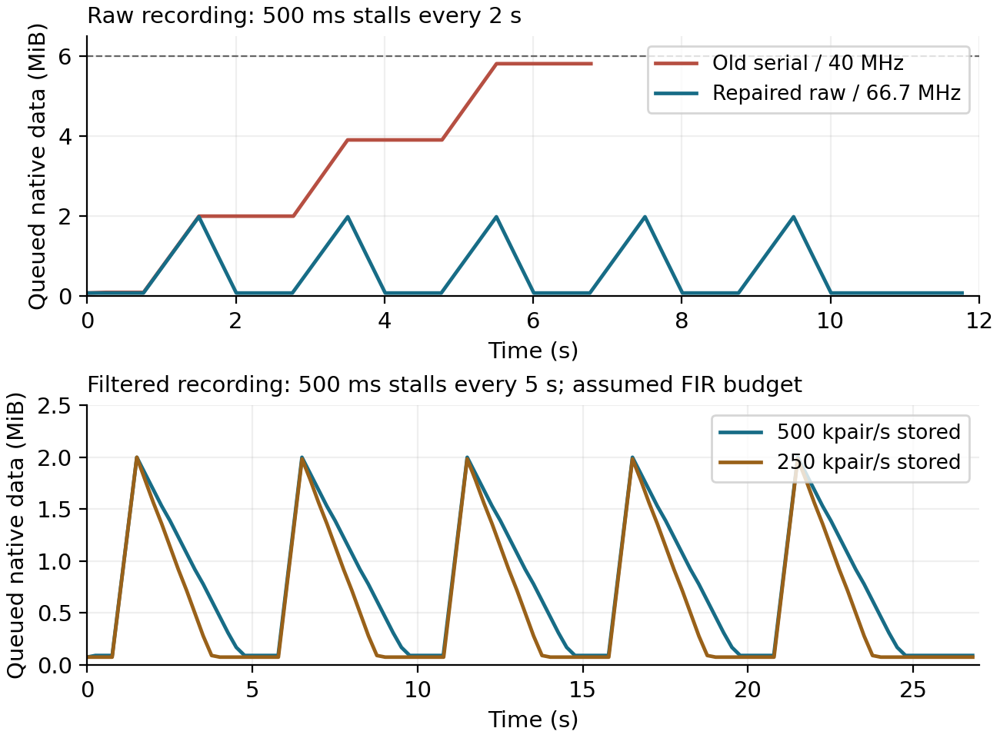
Figure 15. Executed recorder timing model. The revised pipeline recovers after repeated stalls under the declared service budgets. These are simulated timings, not board measurements.
The writer prefetches RAM during cooperative SD waits and retains each block until consumption completes. Normal transactions use 66.667 MHz and 128 bytes. PLL2R supplies 133.333 MHz and QUADSPI divides by two, correcting the former odd-divider asymmetry. Identification uses 22.222 MHz. A separately compiled 33.333 MHz / 64-byte diagnostic option remains unqualified for recording. [7] [22] [24]
Declared stress case | Result and qualification boundary
Raw 1 Mpair/s, 500 ms stall every 2 s | Queue recovers in the timing model and actual C recorder harness.
All profiles, 500 ms stall every 5 s | Passes the common bounded stress with the stated CPU costs and no pre-event history.
Lower-rate processing | 120 µs per 256 native pairs is a required complete-block budget that must be measured on target.
Beyond the service envelope | Slower polling, excessive FIR cost or prolonged no-yield work still fail; retain those bounds.

The model assumes 10 MB/s SD service outside stalls; native RAM read/write traffic occupies about 33% of modeled time. The 120 µs complete processing budget per 256 native pairs is conditional, not measured worst-case time. Painting pauses above the backlog threshold while controls continue. Lower clock rates, longer stalls or insufficient CPU service can fail even when a finite run initially appears healthy.
More RAM can absorb a longer isolated interruption. It cannot repair an average service deficit or a missed 4.096 ms internal DMA lease. Card choice, stall duty, filter profile and CPU cost all belong in the operating specification.

Firmware and data integrity
The target uses a 400 MHz CPU and 200 MHz HCLK, with revision and clock checks. PLL2 runs at 400 MHz: P10 preserves the 40 MHz ADC kernel and R3 supplies the RAM peripheral. CSI and SYSCFG clocks precede automatic I/O compensation; READY is required within a bounded 20 ms wait before fast pins are configured. HSLV stays off at 3.3 V. The final build passes eight native test suites, including 278 clock and 93 compensation assertions. [7] [21] [22]
Mechanism | Purpose and executed evidence
DMA ownership and sequence checks | Detect overwritten or missed halves instead of silently accepting stale samples.
Indexed record frames and checksums | Preserve sample order and reject damaged frames. Independent tests rejected 2,364 truncated prefixes and 2,364 one-bit corruption cases.
Session identity and file chains | Bind configuration, source identity, sample indices and segment relationships.
FIR agreement | Exact fixed-point outputs crosschecked between target-style C and independent host code.
Timer snapshots | 173 modeled register interleavings exercise rollover and late-capture behavior.
Fault handling | Stop when integrity is uncertain; do not invent replacement zeros or claim an exact unknown loss count.

The recorder keeps a 20 ms integrity holdback before certifying data, and distinguishes safe card removal from an active filesystem operation. A clean close, crash recovery and a physically removed card are different states. Preserve the raw files and inspect fault/identity fields during analysis.
Host tests verify software semantics in the paths exercised. They do not emulate the complete SD controller, card flash-translation layer, bus contention or physical interruption of power. The first-board campaign must measure those interactions while recording.

Operator workflow and service access
Stage | Current behavior or required action
Prepare | Use a qualified battery and card. Confirm firmware identity, available space and the exact signal cable.
Configure | Choose raw or filtered storage and declared carrier/pulse metadata. Detailed test, DUT and cable tags can be entered through the service interface before the run.
Connect | Attach the characterized coax to the agreed AIMD center/shield nodes. Use the approved receiver position and field setup.
Record | Start continuous acquisition, then run one or more experiments. Acquisition and storage take priority over display work.
Review | The display currently reports raw codes and session status. It is not an independently qualified calibrated-voltage display.
Finish | Stop, wait for the explicit safe-removal state, remove the card and verify records with the host tools.

The Waveshare 2.8-inch capacitive panel uses SPI for display and I2C for touch. Firmware uses portrait 240 × 320 at 12.5 MHz: one RGB565 frame takes at least 98.3 ms of wire time, with composition capped at 5 Hz. Match the touch controller to the driver. The documented 180 ± 10 mm harness and active TXS0108E translator need actual loading/edge tests; 30–50 mm harnesses are integration candidates, not a qualified replacement. [20] [26]
Service feature | How it supports bring-up
SWD and reset access | SWD header J6 and reset provide primary flashing, halt/debug and recovery. Obtain the controlled firmware image separately; this CAD/document package contains no image. Verify target voltage, pinout and probe ground before powering.
UART and boot access | UART J7 provides diagnostics and metadata entry; boot controls support recovery. This is not a USB data port. Recovery may require disconnecting display J4 and isolating PA6 at R12 with power off, following verified boot-entry conditions.
Analog and supply testpoints | Test points expose detector, ADC, reference and rail nodes. Use a low-capacitance probe and short ground contact; probing can itself alter RF loading or high-speed edges.

Disconnect programming and service cables during the controlled noise baseline. A grounded service cable can change the measurement return path. The repaired service and display pin groups are checked by native netlist comparison. Hardware tests must still establish electrical operation and responsiveness.

Physical board and model availability
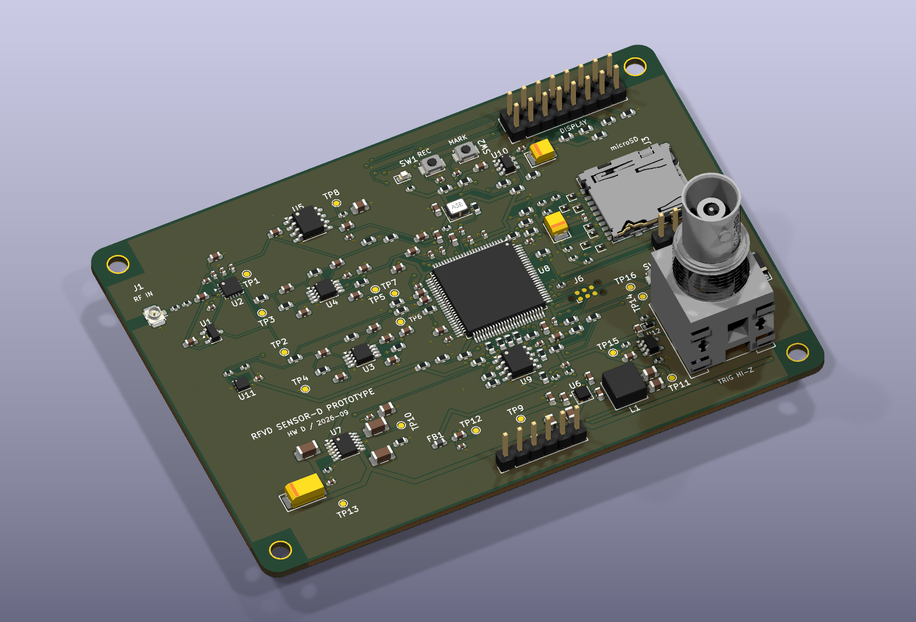
Figure 16. Native rendering of the current saved SENSOR-D PCB, including eight RAM data damping resistors and revised return paths. It represents CAD geometry, not assembled hardware.
The 100 × 70 mm board has four copper layers. Native export resolves 177 model associations for the fitted population; 17 bare schematic features and four board-only holes have no component body. The 3313 construction has two continuous inner GND planes and about 1.5642 mm nominal layer sum. Supplier construction, seating, enclosure and harness fit still require confirmation. [25] [27]
The saved design has 198 footprints and matches all 194 schematic parts, 572 pin assignments and 166 nets. Filled-board checks report zero enabled DRC errors, zero unconnected items and zero schematic-parity items. Twenty-six library warnings and one silkscreen-over-copper warning retain explicit review limits. Fifteen added GND stitching vias support the revised routes; these checks establish CAD consistency, not physical timing or EMC performance.
Enclosure bonds, display opening, card access, cable strain relief and the actual battery are part of the instrument. A conductive enclosure can alter both EMI coupling and the applied field; its performance cannot be inferred from the bare PCB image.

Repaired circuit connectivity
The current circuit is checked by part identity and complete pin groups, so reference renumbering cannot conceal a missing connection. The relationships below are essential to the intended measurement path. The data damping addition splits each RAM data connection into MCU-side, inter-resistor and RAM-side sections while preserving the functional bus.
Repair | Verified intended relationship
Buck feedback and bypass | U6 FB, C41 and the R16/R17 midpoint join. Output bypass capacitors return to GND.
Detector and protection ground | U2 COMM and exposed pad, clamp return and local bypasses join the common GND.
Precision reference ground | U5 ground and its capacitor returns join GND.
Amplifier feedback | Both stages of U3 and U4 have output-to-inverting-input feedback.
ADC interface | C21/TP6 and C22/TP7 reach the intended ADC nets.
Clock supply bypass | C93 adds the dedicated 10 nF bypass at Y1.

The analog values remain the basis of the filter models. R39 is 33 Ω, and each RAM data line has two 33 Ω resistors, one near each device. Resistive damping addresses a bidirectional line; a resistor near only the MCU cannot source-terminate a RAM-driven read. The final choice remains conditional on the actual pin, load, supply and routing behavior. [23] [24] [26]
Electrical-rule checks and intended pin-group checks answer different questions: the first checks pin rules, the second checks the actual connections. Neither proves amplifier stability, ADC accuracy or high-speed bus timing on a populated board.

Module interfaces and grounding
Each sheet has a module interface table. IN and OUT are relative to the module on that sheet. I/O marks a bidirectional bus or shared reset/debug line; LOCAL names an internal node; PWR identifies a supply or return. Global labels connect sheets. Local labels identify nodes only within their sheet.
Module | External signal relationship | Internal function
RF input | AIMD coax in; VENV and EREF out. | Attenuation, DC block, clamp and detector filters.
Analog acquisition | Raw pair in; ADC_VENV and ADC_EREF out. | Two filter stages per channel and ADC reservoirs.
MCU | ADC inputs; SD/RAM/UI buses; service interface. | Clock, reset, boot defaults and supply monitoring.
Storage and display | Module bus directions match MCU ownership. | Card detect, chip-select defaults and UI power control.
Power and temperature | Positive rails, common return and I2C readings. | Regulation, filtering, bypass and address selection.

Analog and digital grounds are one electrical net. There is no intentional ground bridge, ferrite or split plane between them. Geometric separation means placing switching loops, RAM, SD and display traffic away from the RF detector, reference and ADC paths while preserving short continuous return paths. [12] [13]
FB1 filters the positive 3.3 V analog branch. It does not join two grounds. Both the analog and digital supply bypass capacitors return to the common plane near the load they serve. The RF coax shield also joins this reference, so external cable grounding changes the complete experiment. [14]
The printed sheets use US Letter landscape, 1.778 mm titles and 1.27 mm comments and interface text. Label shapes express direction without changing the nets. Component Function properties describe purpose and placement; reference designators follow the active main project.

Filter equations and model assumptions
Each intended analog path uses two unity-gain Sallen-Key low-pass stages. In the ideal follower approximation, a stage with feedback capacitor Cf and grounded capacitor Cg has the transfer below. Series source resistance adds to the first input resistor. The simulation also includes finite amplifier bandwidth. [6]
$$Hstage(s) = \frac{1}{R1 R2 Cf Cg s² + Cg(R1 + R2)s + 1}$$
Here s is the Laplace variable in inverse seconds; resistances are in ohms and capacitances in farads. This expression is an explanatory ideal stage, not the complete vendor amplifier model.
Network | R1 / R2 | Cf / Cg | Additional condition
VENV stage 1 | 2.26 / 2.26 kΩ | 510 / 470 pF | Nominal source resistance 0 Ω.
EREF stage 1 | 2.15 / 2.26 kΩ | 510 / 470 pF | Nominal source resistance 100 Ω.
Both stage 2 | 1.33 / 1.33 kΩ | 1.2 nF / 470 pF | Second unity-gain section.
ADC interface | 47 Ω series | 330 pF to GND | Local reservoir, separate from the filter-stage capacitors.
VENV detector filters | 400 / 250 Ω model terms | 1 nF on each FLT node | Approximately 398 / 636 kHz poles from data-sheet equations.

$$Htotal(s) = Hdetector(s) × Hstage1(s) × Hstage2(s) × Hadc(s)$$
The normalized waveform model uses the complete intended path. EREF does not receive the same pair of envelope-detector poles, which contributes to its dynamic difference.
The 512-trial sensitivity study uses 0.1% resistor and 1% filter-capacitor tolerances, 5% detector-capacitor variation, amplifier bandwidth from 16 to 24 MHz, and stated source-resistance cases. Uniform sampling describes an assumed population; it is not a statistically established manufacturing distribution.
The earlier lumped RF sweep assumes 0.04 pF resistor bypass, 0.1 pF pad capacitance, 0.2 nH series inductance, 1 pF detector capacitance and 0.25 pF clamp capacitance. The updated 3313 comparison adds approximate geometry-based line and land loading. Its 0.5–2× pad factor is a sensitivity, not an extracted bound. Neither model includes measured AIMD impedance or a full three-dimensional RF input. [26]

What the simulations establish
Campaign | Executed scope | Main limit
RF network | 16,200 parameter cases; six independent RF AC checks. | Detector and mounted-part parasitics include assumed values.
Cable loading | 5,400 lossy line / complex-source cases; four SPICE line checks. | No measured AIMD impedance or common-mode field coupling.
Analog filtering | 512 tolerance trials; two ngspice filter models. | Sampled population, not production worst-case proof.
ADC interface | Historical 405 cases plus 243 revised RC cases and 25 completed vendor cases. | Six selected 425 ns cases pass half-LSB14; assumed switch/reset load.
Cross-engine filter | 181 frequency points in LTspice and ngspice. | Same finite-gain amplifier abstraction in both.
Waveforms and actual FIR | 11 waveforms, 32 native phases and all decimation residues. | Normalized synthetic envelopes; no calibrated RF volts.
Digital and records | Revised recorder harness, timing sweeps, native suites and corruption/recovery checks. | CPU timing and peripherals are modeled; measure on target.

The independent filter engines agree to a maximum relative complex difference of 1.23e-08. This checks numerical implementation consistency. It cannot validate a shared modeling assumption or predict the assembled noise floor.
The waveform study’s 10 ns versus 5 ns integration refinement changes peak by less than 0.000003 in normalized units and sampled output by less than 0.000085. Twelve focused model tests passed, including packing and the exact streaming FIR comparison. Vendor settling changes by at most 6.43 nV when the maximum step is halved. Two tighter-tolerance solver runs timed out; that refinement remains unclosed. Numerical stability does not establish physical accuracy.
Additional analysis now includes cross-section field models, a limited FDTD coupon check, exact component supply models and nonlinear ST IBIS driver/package models. These do not constitute a full-board radiation simulation, loaded-bead measurement, complete STM32 analog model, real SD-latency trace or hardware calibration. Read the model assumptions alongside each result. [26]

First-board qualification sequence
Order | Test | Evidence required before moving on
1 | Freeze the verified build | Retain the final native pin comparison, ERC, PCB checks and exact firmware/BOM identity.
2 | Unpowered inspection | Assembly orientation, shorts, connector polarity and access; preserve exact fitted BOM.
3 | Current-limited power bring-up | Rail voltage, inrush, shutdown and analog headroom at low/high battery and load.
4 | Digital subsystem | SWD flash, clocks/revision, RAM patterns, card writes and UI operation. Measure DMA leases and PSRAM CE timing.
5 | Quiet baseband | ADC code histograms, reference/rail noise, stepped input settling and channel interaction.
6 | Known RF source | Powered input impedance, actual cable transfer, CW gain and pulse response at each frequency.
7 | Concurrent operation | Long captures with card stalls, segment rollover, full UI activity, low battery and fault recovery.
8 | Calibration validation | Independent held-out points, temperature/setup repeats and uncertainty budget.
9 | Laboratory field setup | Compare receiver error, setup perturbation and cable/grounding effects in the approved apparatus.

Qualification should specify acceptance limits before measuring. Derive permitted baseband error from the calibrated input-to-code slope. Record both systematic shift and additional noise under each aggressor; a device that keeps running can still produce invalid measurements.
Ordinary laboratory EMC and accurate operation inside the RF test field are distinct questions. Establish the intended environment and port configurations before choosing emissions/immunity tests. MR bore placement adds material, force, gradient and heating questions that this circuit simulation does not answer.

Digital interfaces and remaining margins
The selected implementation uses 33 Ω clock damping and two 33 Ω resistors per RAM data line. Nonlinear driver tables and actual MCU pin packages replace the earlier 1 nH package assumption: PB2 clock package inductance is about 5.272 nH. The normal 3.3 V high-speed family is inferred for several incomplete pin selectors, not confirmed by the vendor for those pins. [21] [23] [26]
Current engineering check | Result and condition
Clock edge at RAM | 128/128 selected 33 Ω ±1% cases meet 1.5 ns; worst 1.4911 ns leaves only about 9 ps modeled margin.
Clock voltage stress | 127/128 meet the conservative ±0.4 V screen. One reaches −0.400677 V; all meet ±0.5 V for less than 20 ns.
Data bus and sampling | 96 write and 128 assumed-source read cases pass their voltage screen. Conditional minimum setup: 1.412 ns write, 4.723 ns read with SSHIFT enabled.
Read hold | The 0.25 ns remaining hold budget includes an assumed reserve; it is not a guaranteed measured margin.
Clock and load coverage | Only two repeated-clock cases were run. Six pF is the RAM pin specification; 8 pF allocates land/stray load and 12 pF is additional stress.
Physical unknowns | RAM output model, complete PVT, selector mapping, simultaneous switching, load capacitance and actual return inductance remain qualification inputs.

The worst corners include 2.7 V at 140 °C and 3.6 V at −40 °C; the MCU timing table has its own voltage and load conditions. These are not a measured fixed-3.3 V population. Package-pad timing avoids counting the arbitrary model stimulus delay twice. The 2–3 nH aggregate transition term is a sensitivity, not a field-extracted loop value.
Thirty-three ohms is therefore a prototype starting value, not a claim of robust closure. Preserve the failed conservative voltage screen and tiny edge margin. Measure the loaded RAM clock, source and receiver thresholds, read/write setup and hold, and error rate under simultaneous recording and display activity before qualifying the rate.
A good digital waveform is necessary but insufficient for measurement quality. Check ADC mean shift, noise and spurs while each interface operates. The RF detector is broadband; choosing 64 or 128 MHz in the user interface does not add an RF band-pass filter or remove interference.

Component and measurement sources
Manufacturer references support the component explanations. Their limits retain the cited operating, load and temperature conditions.
1. Analog Devices, ADL5511 data sheet, Rev E. Detector operation, electrical characteristics and FLT1–4 behavior; pp. 3, 5, 8 and 17–20. Open source
2. Texas Instruments, OPAx320-Q1 data sheet, Rev B. Unity-gain stability, supply range and amplifier characteristics; pp. 1, 5–6 and applications sections. Open source
3. Keysight, Reflection Measurements. Impedance mismatch and reflected-wave interpretation for transmission lines. Open source
4. Panasonic, ERA2AEB152X exact component listing. Resistance, tolerance, temperature coefficient and package power rating. Open source
5. Nexperia, PESD2V5Y1BSF data sheet. Standoff, capacitance test conditions and transient clamping characteristics; Tables 1 and 6. Open source
6. Texas Instruments, FilterPro MFB and Sallen-Key Low-Pass Filter Design Program User Guide, SBFA001C. Filter response and topology background. Open source
7. STMicroelectronics, STM32H742/H743 data sheet, DS12110 Rev 11. Package, ADC and supply requirements. Open source
8. STMicroelectronics, AN5354 Rev 2. Getting started with the STM32H7 16-bit ADC; typical package/reference-settling guidance, Table 12; use actual resolution and number of overlapping ADCs. Open source

Power and EMC sources
These sources explain supply and return-path mechanisms; none certifies this assembled instrument.
9. Analog Devices, LT3045 data sheet, Rev D. Programmable current limit, output sense, bypassing and layout; pp. 12 and 16–20. Open source
10. Texas Instruments, LMR436x0 data sheet, Rev B. Exact suffix comparison and adjustable output configuration; p. 3, §8.3.2 and Table 9-6. Open source
11. Texas Instruments, REF50xx data sheet, Rev O. REF5030IDR I-grade characteristics and bypass recommendations; Tables 4-1/4-2 and §9.4. Open source
12. Analog Devices, MT-031 Grounding Data Converters; pp. 11–15. Ground-current architecture and converter grounding context. Open source
13. Texas Instruments, Grounding in mixed-signal systems demystified, Part 1, SLYT499. Return paths, placement and plane slots. Open source
14. Analog Devices, AN-1368 Ferrite Bead Demystified. LC resonance, DC bias and damping. Open source
15. Analog Devices, MT-101 Decoupling Techniques; pp. 5–7. Connection inductance and complete bypass loops. Open source
16. ISMRM 2019, abstract 4183. Comparison of Simulated and Robotically Mapped RF Fields in 64 and 128 MHz Medical Implant Test Systems; Methods. Published example, not the partner lab protocol. Open source

Laboratory and interface sources
Laboratory examples establish context, not the partner laboratory’s exact waveform, port or approved setup.
17. ZMT, MITS 1.5 system. Supported pulse-generator waveforms and operating capabilities. Open source
18. FDA Regulatory Science Tool, Transfer Function Measurement System for MRI Safety Assessment of Implantable Medical Devices in Curved Trajectories. Purpose, method and limitations. Open source
19. SD Association, Speed Class and Bus Speed overviews. Sequential-write classification differs from a system-specific worst-case latency guarantee. Open source
20. Waveshare, 2.8inch Capacitive Touch LCD wiki. Display/touch interfaces and controller-version distinction. Open source
The first laboratory waveform comparison is illustrative. It does not identify the voltage at the partner lab’s AIMD port, its source impedance or its approved receiver location. Those remain explicit setup inputs.

Interface sources and prototype cost
The following sources support the current clock, package and board construction. The two companion reports are in the same document folder; the device explanation and principal results are included here.
21. STMicroelectronics, AN4803. GPIO speed configuration: OSPEEDR 11 selects the high-speed family. Open source
22. STMicroelectronics, RM0433. STM32H743 clock tree, QUADSPI division and sample-shift operation, and I/O compensation. Open source
23. STMicroelectronics, STM32H7 IBIS models. Nonlinear driver tables, waveform fixtures and per-pin package RLC; model-selection caveats remain. Open source
24. AP Memory, APS6404L documentation. SPI/quad commands, timing, pin capacitance and transient limits; Rev 2.7 conditions apply to the modeled device. Open source
25. JLCPCB, published impedance stackups. The selected 3313 construction requires supplier confirmation of the finished board. Open source
26. RFVD_EMC_OPTIMIZATION_REPORT.docx. Detailed field, RF-loading, supply and nonlinear digital comparisons and their retained limitations. Open companion
27. RFVD_PCB_LAYOUT_RATIONALE.docx. Placement, ground planes, supply routing and targeted return-via choices. Open companion
28. SD Association, Bus Speed. Interface classes and their distinction from actual sustained throughput or worst-case card latency. Open source
The current BOM contains 177 fitted parts across 75 MPNs. A historical complete-instrument estimate was $382.82 against a target below $400. The dated component-price index increases by $0.048 for the EMC changes; this is not a new supplier quotation and excludes any new assembly or setup fees.
Requote the actual board, assembly, display, card, battery and matched charger, coax, enclosure and shipping before ordering. Bare test points and mounting holes are not fitted components. A stocked package model or a low quoted unit price does not establish physical fit, availability or assembly acceptance.
The nominal 3.3 V load allocation is 800 mA, not a measured operating current. Battery runtime requires measured average power, usable pack energy, regulator efficiency and the permitted low-battery cutoff; no runtime guarantee follows from the part count or cost estimate.

Optional trigger explanation
The main recording system operates continuously without a trigger cable. The existing external input is an optional timing aid: it can identify when another laboratory instrument started an event or align a saved window to a selected edge. It does not improve RF bandwidth, restore a short pulse’s lost peak or create additional storage capacity.
The BNC input is optional and accepts the intended 3.3 V or 5 V laboratory pulse through protection, high-impedance conditioning and a buffer. It shares instrument ground; do not attach an unknown voltage or an earth-referenced source before checking its amplitude, polarity and return path. It must not be exposed to the RF input’s voltage assumptions.
Operating choice | Behavior
Continuous recording | Save the complete time history while the run is active. External timing input is unnecessary.
Event marker | Associate a timing event with a continuous stream for later experiment alignment.
Triggered window | Use configured history and a post-event window. The current window mode is one-shot; automatic rearming is not implemented.
Removing the option | Retention is a system decision involving the circuit, connector, software and qualification. It is present in the documented board.

Pre-event history consumes the same native 4 MB/s ring. One second occupies 4 MB, leaving about 0.573 seconds of gross zero-drain capacity in the 6 MiB ring before holdback and granularity. An 800 ms initial no-drain stall can therefore overflow it; an earlier model failed near 0.578 seconds. This capacity limit persists even when steady recording later recovers backlog.
For the current project priority, qualify autonomous RF acquisition and SD recording first. Keep this optional interface outside the core measurement claim until the team decides whether to retain it and tests the complete electrical connection.

