RFVD EMC optimization engineering report
SENSOR D | 2026-09-08 | RFVD Senior Design Team
This addendum explains how the RFVD board can reduce interference generated by its own clocks, power conversion and storage activity while preserving the measurement made through the AIMD coax connection. It supports layout and bench decisions for the standalone envelope instrument, which records locally to SD and uses a local display.
Keep one electrical GND net with two continuous inner reference planes. Separate the RF, reference and ADC region from switching and digital activity by placement and routing. Use the published 3313 physical stack as the four-layer target, retain the existing analog ferrite filter, and judge digital damping against the actual devices and cable assembly. The thinner 1080 alternative offers somewhat closer returns but also changes RF loading more.
Table 1. Selected direction and supporting reasons
Decision | Engineering reason
Four layers retained | Adjacent ground references support both outer routing layers; six layers are not required by the present evidence.
Continuous ground retained | Avoid forcing signal returns around slots or through a single remote connection.
3313 physical stack targeted | Resolve the generic saved dielectric assumptions and improve proximity of signal returns.
FB1 and bypass values retained | Available models show damping tradeoffs, but low-frequency biased bead behavior is not established.
No generic damping increase | LCD translation and bidirectional PSRAM timing constrain resistor choices.

The analysis combines native design geometry, two-dimensional electrostatics, small transmission-line circuits, RF loading models and manufacturer passive-component models. Numerical agreement checks support the calculations within their assumptions. They do not establish radiated emissions, immunity, MR suitability, achieved voltage accuracy or effective ADC resolution.
The applied design, numerical methods, reported results and remaining physical tests are described in this report. RFVD_DEVICE_REPORT.docx explains the complete instrument and its operating workflow; RFVD_PCB_LAYOUT_RATIONALE.docx illustrates component placement and routing.

Ground and power regions
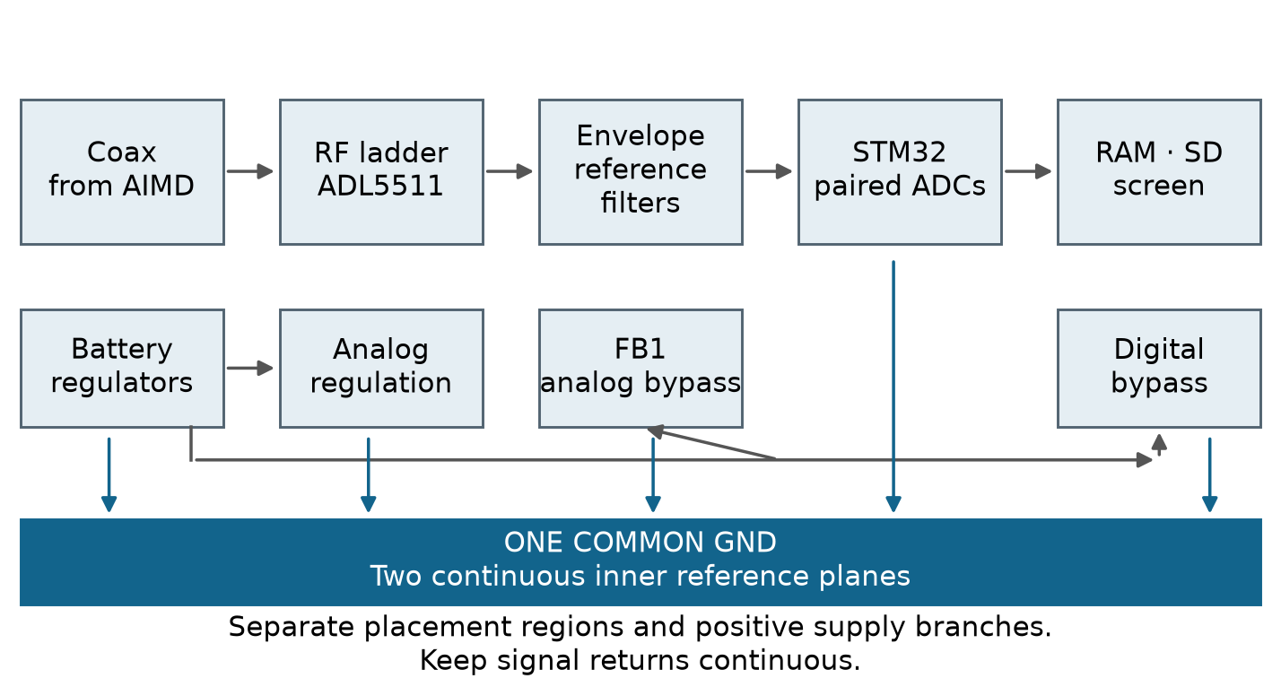
Figure 1. Functional signal and supply regions share one electrical ground. This overview is not a wiring diagram; +5V_A and +3V3_A use different supply branches.
The RF signal enters J1 from the coax attached to the AIMD. The attenuator and ADL5511 U2 produce the envelope/reference signals; U3/U4 filter and buffer them before the paired ADCs in U8. Keep those signal and return paths compact. Place U6 switching loops, memory activity and display connections away from this region. Positive analog supplies may be separately regulated or filtered while GND remains continuous. [1, 2]
The current board has all 198 footprints on the top face, with signal and power tracks on the outer layers. Each inner layer has a connected ground region with normal pad and via clearances. Moving digital components to the bottom can help placement in some designs, but it does not isolate supply impedance, connector returns or the MCU substrate. Analog and digital placement regions should extend through both faces, rather than place a clock directly under a sensitive analog node.
A local bypass capacitor closes fast supply current near its load. Its ground connection must be short and tied to the same reference used by the signal. A capacitor between artificially divided ground regions creates a frequency-dependent connection; it does not provide galvanic isolation. Ground cuts are not proposed for this board. [1, 2]
The coax shield and any connected trigger, service or programming cable can create external return paths. Battery power and SD logging remove some external connections, but do not isolate a grounded coax or laboratory trigger. Cable common-mode current and field pickup remain part of the experiment and must be measured in the intended arrangement.

Physical stack and return proximity
Table 2. Physical comparison using the published JLC stack choices [3]
Parameter | Generic saved default | 3313 target | 1080 alternative
Outer dielectric gap | 0.480 mm | 0.0994 mm | 0.0764 mm
Outer nominal Dk | 4.5 | 4.1 | 3.91
Copper thickness | 35/35/35/35 µm | 35/15.2/15.2/35 µm | 35/15.2/15.2/35 µm
Central core | 0.480 mm | 1.265 mm | 1.265 mm
Copper and dielectric sum | 1.5800 mm | 1.5642 mm | 1.5182 mm

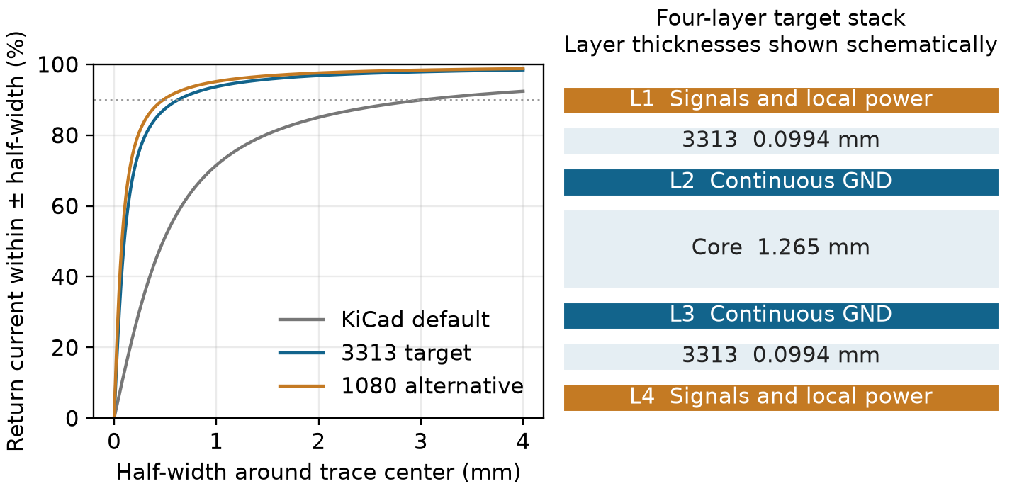
Figure 2. Ideal return-current concentration for a wire over an infinite plane, beside the 3313 layer arrangement. The drawing is not a full-board current solution.
For a thin wire at height h above an ideal plane, the fraction of return current within lateral distance ±w is F = (2/π) arctan(w/h). This illustration explains why a closer reference reduces lateral spreading. Finite trace width, holes, connections, losses and neighboring conductors change the actual distribution.
The original board omitted an explicit stack table; KiCad generated the generic values above. They are software defaults, not measurements. The published copper/dielectric sum differs from the nominal 1.6 mm finished-board label. Confirm finished thickness, mask profile and tolerances with the fabricator; a uniform KiCad mask setting is not the actual coating profile. [3]

Electrostatic model and numerical checks
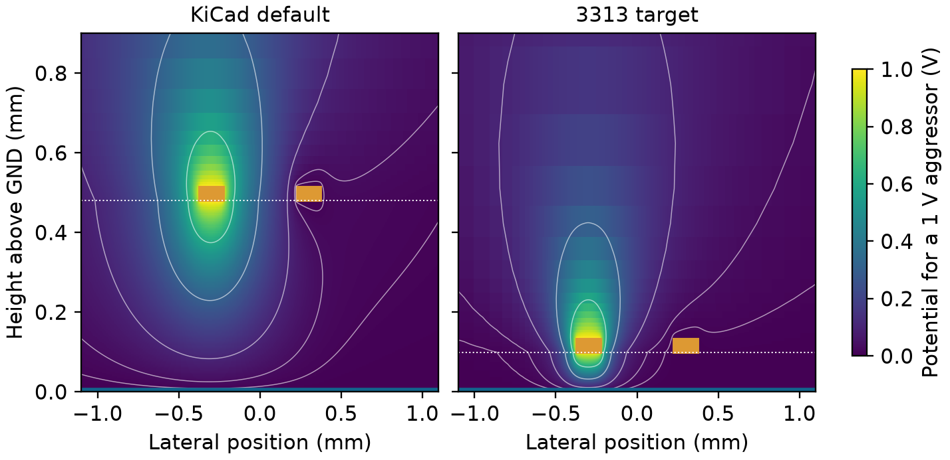
Figure 3. Two-dimensional potential around an excited trace and a grounded neighboring trace. Orange rectangles identify metal rather than voltage. A closer ground plane confines more of the field near the signal and its return.
The finite-volume model solves the dielectric electrostatic equation on a cross-section. Unit-voltage excitations produce a capacitance matrix. A corresponding vacuum calculation supplies the quasi-static inductance relation. These are uniform-line parameters; they do not model the enclosure, cables, radiation or every structure on the board.
$∇ · (ε ∇V) = 0$
Table 3. Uniform microstrip comparison with finite copper thickness [3, 4]
0.15 mm trace | Finite-volume Z0 | Independent formula Z0
Generic saved default | 103.109 Ω | 103.887 Ω
3313 target | 54.014 Ω | 54.099 Ω
1080 alternative | 47.331 Ω | 47.342 Ω

Four independent analytical benchmarks have a maximum characteristic-impedance difference of 0.748%. The coupled-line mesh comparison reaches 1.106%; final domain expansion changes the checked quantities by at most 1.917%. Initial domains were too small and were enlarged before accepting the calculation. These checks support this solver setup, not arbitrary geometries or dielectric properties.
Independent openEMS thin-strip coupons check the real characteristic impedance. At 128 MHz, the 3313 coupon gives 58.859 Ω versus 59.197 Ω analytically, a 0.571% difference. Across the checked frequencies the largest difference is 0.733%; the final temporal change is 0.390% and last spatial change 1.777%. These zero-thickness coupons differ from the finite-copper table above. The residual imaginary impedance is −0.606 Ω at 128 MHz, so a fully converged complex S-matrix is not established. Modal power residual is not measured copper loss or board emissions. [13]

Trace spacing and coupling
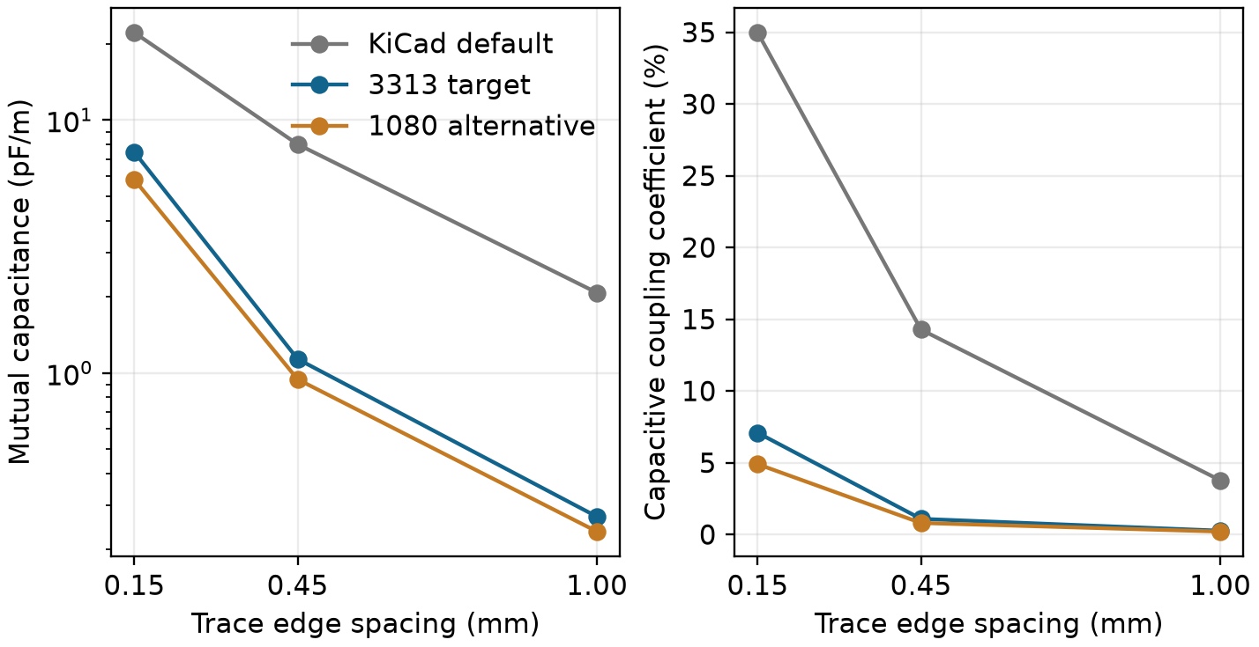
Figure 4. Mutual capacitance and a capacitance-matrix coupling ratio versus trace edge spacing. The ratio is not directly a voltage-crosstalk percentage at a receiver.
For two parallel traces, bringing the reference plane closer or increasing separation reduces their mutual capacitance in the modeled cross-section. The chart keeps the trace width and other stated geometry fixed. It supports short parallel runs and sensible spacing between clocks and analog traces; it does not establish a universal clearance rule for every route.
Receiver disturbance depends on line length, edge rate, source impedance, termination, mutual inductance and return geometry. A small capacitive ratio can still matter at a high-impedance analog node. Conversely, the plotted percentage should not be multiplied by 3.3 V and reported as an exact victim waveform without solving the connected circuit.
Table 4. How to use the coupling study in layout review
Mechanism | Layout response | Remaining evidence
Shared reference discontinuity | Route over continuous adjacent GND; connect returns near layer transitions. | Inspect actual fill and return barrels after routing.
Parallel clock and analog routing | Start with 0.45 mm edge spacing for fast 0.15 mm traces; aim for 1 mm near sensitive analog routes where practical. | These are layout targets; use actual geometry and load/driver conditions.
External cable loop | Control cable routing and ground connections. | Measure common-mode current and pickup in the lab fixture.

Six layers could provide more routing space or dedicated power distribution if routing density demands it. Layer count alone is not a noise metric. The present choice retains four layers and concentrates on the material stack, source placement, local return continuity and cable behavior.

RF input loading tradeoff
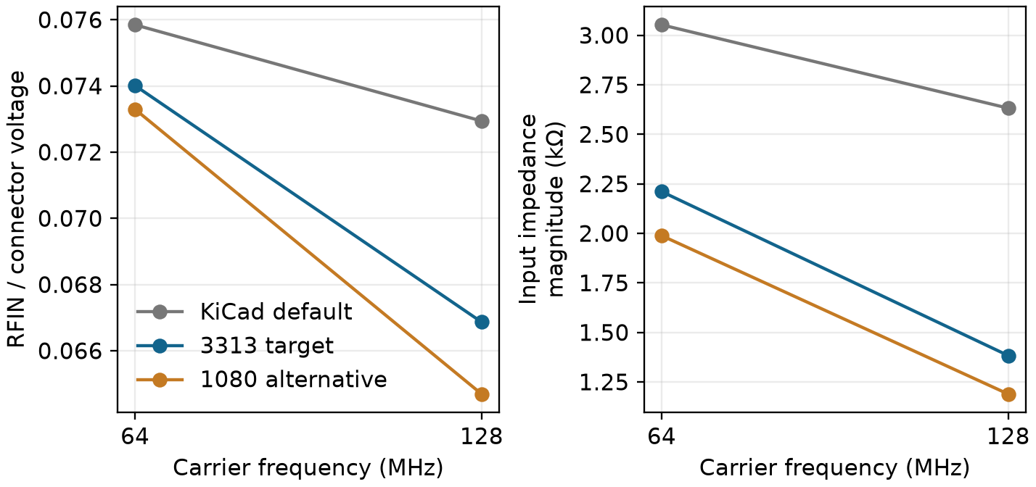
Figure 5. Illustrative loading of the present two-resistor input as the outer dielectric gap changes. The source is the voltage at the board connector; detector and parasitic values are assumptions.
R1 and R2 provide 3.0 kΩ of series resistance ahead of the 470 pF coupling capacitor and ADL5511 input. This is not a matched 50 Ω attenuator. The coax characteristic impedance does not establish the impedance of the opened AIMD node. Loading and cable transformation must be considered when relating the board reading to the original implant voltage. [5]
The 486-case comparison combines native 0.15 mm route lengths, approximate pad-to-plane capacitance, and detector/resistor uncertainties. The nominal detector is 250 Ω in parallel with 1 pF. Resistor bypass capacitance, detector impedance and pad factors are varied; they are not measured limits. Full pad areas and centerline traces overlap in the approximation, biasing geometric capacitance upward without guaranteeing conservative gain or heating.
Table 5. Connector-to-RFIN voltage ratio and input impedance in the nominal model
Nominal fixture | Gain at 64 MHz | Gain at 128 MHz | |Zin| at 128 MHz
Generic default | 0.07585 | 0.07294 | 2.632 kΩ
3313 | 0.07401 | 0.06687 | 1.383 kΩ
1080 | 0.07330 | 0.06469 | 1.189 kΩ

3313 provides much closer returns than the default while changing the modeled RF loading less than 1080. Six independent ngspice checks agree with the matrix solution. Voltage calibration still requires the actual board, carrier frequency, cable and source configuration. The modeled gain is not a calibrated voltage reading.
The ADL5511 is broadband; the 64/128 MHz setting does not add hardware RF selectivity. Clock-field or cable pickup can reach the detector through paths absent from the passive supply model. A future carrier-band filter needs a loading, pulse-bandwidth and calibration study. [5]

Digital interfaces and cable limits
The HSE source launch at R26 is shortened from 9.398 to 2.223 mm, and the PSRAM clock launch at R39 from 9.310 to 2.007 mm. The new data resistor launches are about 1.3–2.9 mm at the MCU and 1.6–2.4 mm at RAM, with small final pad-overlap adjustments. These are routed geometry, not a universal 2 mm compliance rule. SD and LCD clock interfaces still require loaded-waveform checks.
Firmware now starts CSI and automatic I/O compensation, requires READY before fast pins are configured, and checks the memory clock setup. PLL2 produces a 40 MHz ADC kernel and a 133.333 MHz QSPI kernel; an even divider gives the same 66.667 MHz data clock with corrected duty. The former divide-by-three clock was about 5 ns high and 10 ns low. Read-ID now uses 22.222 MHz. Eight host suites pass, including 93 compensation and 278 clock checks; receiver waveforms and hardware timing remain unmeasured. [2, 12]
Table 6. Interface-specific constraints [6–9]
Interface | Constraint | Design implication
PSRAM clock | 33 Ω ±1% selected for the prototype | 128/128 modeled edges meet 1.5 ns; 127/128 meet the conservative voltage screen. Physical margin remains to be measured.
PSRAM data | 33 Ω at both ends of each line | 96 write and 128 read isolated-edge cases meet the modeled voltage screen; the RAM driver remains an assumption.
LCD module | TXS0108E translator plus cable | Retain 33 Ω and current slew; shorter harnesses remain alternatives for physical testing.
HSE oscillator | Source placement and return | R26 launch shortened; the C93 local bypass is preserved.

The supplied ST model replaces the old generic 1 nH package assumption: PB2 has 5.272 nH. With 33 Ω ±1%, the worst modeled edge is 1.491 ns, only 9 ps below the 1.5 ns limit. One case reaches −0.400677 V and fails the conservative −0.4 V screen; all 128 tolerance cases meet the separate −0.5 V/VDD+0.5 V, 20 ns transient screen. This supports a conditional prototype choice, not robust physical closure. Larger 36/39 Ω parts slow some weak-load edges beyond the limit. [8]
The published Waveshare module schematic places a TXS0108EPWR between the connector and the display controller. Its one-shot-assisted translator is active circuitry, not simply the controller input capacitance. TI timing assumes an external driver below 50 Ω; a larger resistor that looks good in a passive cable model cannot be selected on that result alone. Confirm the physical module revision and test the actual harness. [6, 7]
The initial passive simulations do not include TXS active behavior or a verified AP Memory driver model. The bare display-controller timing specification also does not qualify the complete cable/module assembly. Linear and nonlinear studies are identified separately; neither an unclamped waveform nor a clean design-rule result establishes radiated emissions. [6–9]

Vendor I/O model and remaining uncertainty
ST’s LQFP100 IBIS model describes nonlinear pullup, pulldown and protection-clamp currents, switching waveforms and per-pin package parameters. Its stated origin is ST ELDO simulation. This gives a better device basis than a generic output resistance, but does not make the result a measured model of this assembled instrument.
The package inductance belongs between the silicon die and the board pin. It is separate from routed-line inductance and the aggregate signal/return transition element. Using the old 1 nH package assumption would underrepresent the listed memory-pin inductances. The table below records the supplied values; it is not a tolerance distribution.
Table 7. STM32 LQFP100 package data and selector caveats
U8 pin / signal | Package L | Normal 3.3 V model mapping
36 / PB2 clock | 5.272 nH | Family inference; selector omits normal 3.3 V
58 / PD11 IO0 | 5.471 nH | Family inference; selector omits normal 3.3 V
59 / PD12 IO1 | 5.354 nH | Model appears in the supplied selector
1 / PE2 IO2 | 7.034 nH | Family inference; selector omits normal 3.3 V
60 / PD13 IO3 | 5.276 nH | Model appears in the supplied selector

Some supplied pin selectors omit the normal-voltage high-speed model even though the pin family supports the required normal-voltage operation. For those pins, applying io8_ft_hs_3v3 is an explicit family-based inference, not vendor-confirmed pin selection. HSLV stays disabled at the board supply voltage. Resolve this mapping with ST or corroborate it through hardware waveforms before treating it as a validated device model. [2, 9]
Two 50 Ω fixture waveforms determine time-varying pullup and pulldown weights through Kirchhoff’s current law without clipping coefficients. All 12 reconstructed waveforms pass, with at most 4.281 mV error. Two ngspice/LTspice controls differ by at most 4.02 µV; timestep refinement changes at most 46.2 µV. Increasing die capacitance tenfold while holding the original switching weights produces the expected failed reconstruction. These checks verify conversion, not an unseen load.
IBIS specifies die capacitance separately from package capacitance. C_comp is an independent parameter: weak-drive and high-capacitance combinations, and strong-drive and low-capacitance combinations, must be considered. The supplied minimum and maximum waveform columns also change supply voltage and temperature; they are not resistance limits at a fixed 3.3 V. [14]
The weak model column is 2.7 V/140 °C and the strong column 3.6 V/−40 °C. Clock sensitivity includes 45/60 Ω lines, 6/8 pF receiver allocation and an assumed 2/3 nH aggregate transition return. Read tests use typical MCU clamp curves, maximum die capacitance and an assumed RAM source of 8–80 Ω with a 1 ns edge. Two repeated-clock checks retain transition tails; they are not a full bus eye. No midpoint recrossings occurred in 880 isolated source-pad waveforms. Physical supply and timing tests remain necessary.

Analog supply filter results
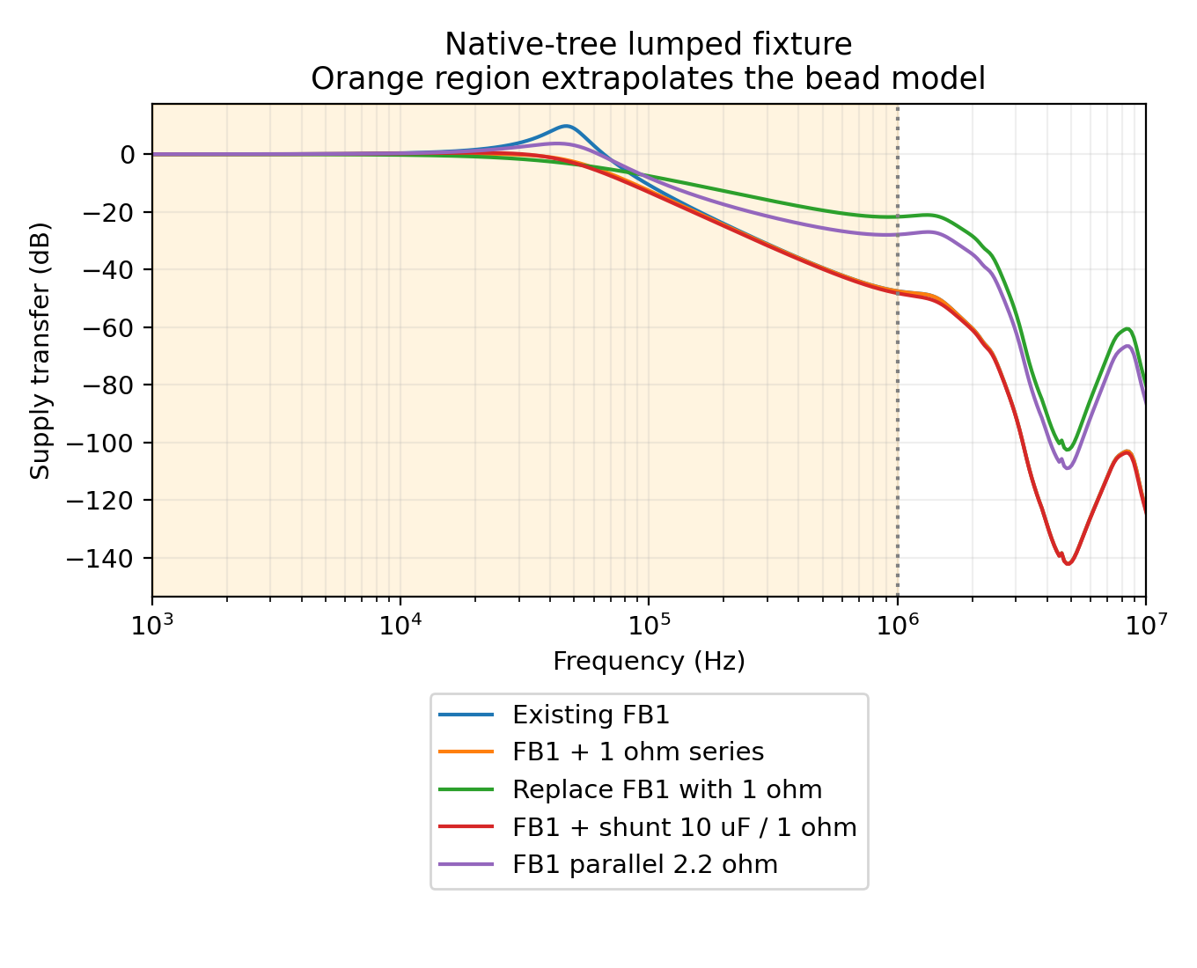
Figure 6. Supply transfer through the native-tree lumped fixture. Orange shading is below the bead model frequency range. The shunt 10 µF means effective analytical capacitance, not a selected part.
The filtered +3V3_A rail supplies U3/U4 and U8 VDDA. All three loads share 23.447 mm of supply trace; U4 and VDDA share 37.936 mm before separating. The study preserves that routed tree rather than assuming separate star branches. Seven of eight bypass capacitors have exact manufacturer models at 3.3 V and 25 °C. Trace parasitics remain lumped assumptions and common-plane impedance is excluded; unchanged branch geometry does not validate the new stack’s physical impedance.
The bottom +3V3_D feed upstream of FB1 grows from 17.700 to 20.276 mm at 0.5 mm width and adds two logical vias. At assumed 35 µm copper, 20 µm barrel plating and 20 °C, its isolated series-path increase is 5.282 mΩ. A shared center/bottom barrel creates an upstream supply mesh; these branch estimates are not its total impedance. The local +3V3_A tree is retained. Probe both FB1 terminals under recording loads.
The 284 AC runs compare filter choices while varying source resistance from 0.02 to 0.5 Ω and explicitly changing load, capacitance and route parasitics. The Murata BLM18AG601SN1 model and a 401-point two-port conversion agree within 6.68 parts per million over their checked range, beginning at 1 MHz at zero DC bias and small signal. Available DC-bias curves conflict. Therefore the predicted 46.81 kHz peak is extrapolation, not a measured resonance. [10, 11]

Damping decisions and voltage headroom
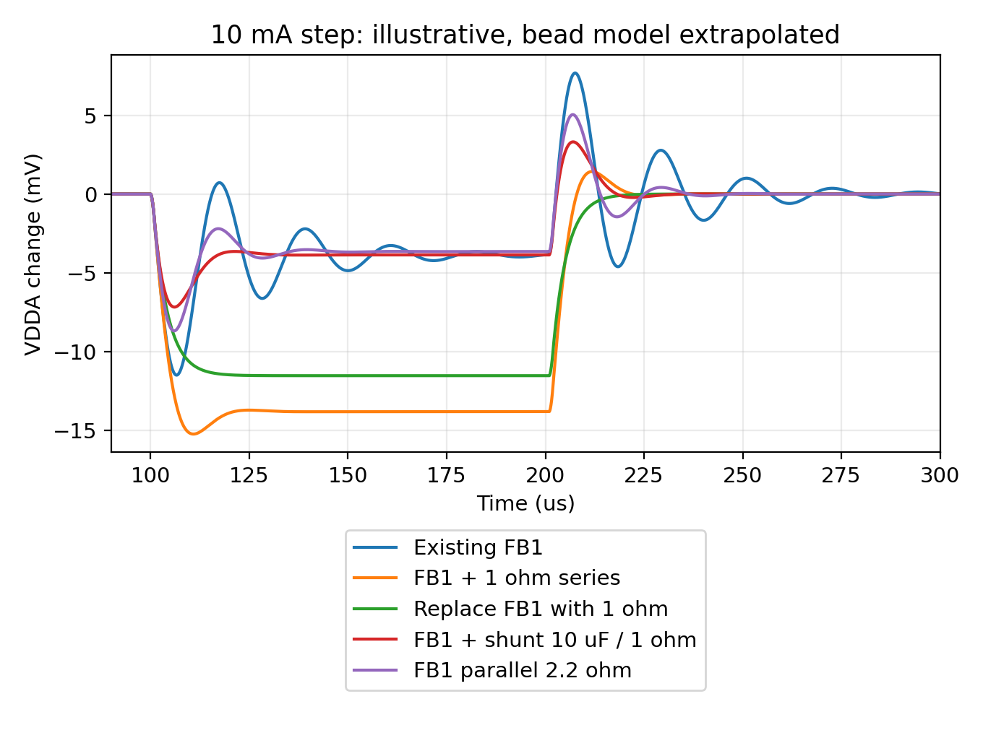
Figure 7. Illustrative 10 mA VDDA load step using a reduced low-frequency network. The distributed transient model did not converge, so it supplies no accepted transient result. This plot is not regulator startup or stability validation.
In the reduced fixture, 1 Ω reduces ringing but raises the maximum drop from 11.50 to 15.24 mV. A 2.2 Ω series resistor suppresses extrapolated peaking in the sweeps, but adds 110 mV at 50 mA and increases low-frequency impedance. VDDA must stay above VREF+, and the opamp needs output headroom. [2]
A shunt series-RC branch avoids added DC series drop, but capacitance under bias matters. The existing 22 µF, 10 V, 0805 Samsung part models as 8.933 µF at 3.3 V; it cannot stand in for an ideal 22 µF effective result. Startup charging, temperature, tolerance and placement would also need validation. Retain FB1 and the current capacitors; no extra damping footprint is required by this study. [10, 11]
The reduced fixture applies a 10 mA pulse for 100 µs with 1 µs edges. Halving its timestep changes maximum drop by 0.895 µV. That establishes numerical consistency only for this fixture; low-frequency biased bead behavior, source control-loop dynamics and shared ground impedance remain unmodeled.

Applied layout and verification
The saved SENSOR D board includes the 3313 stack, shortened clock launches, eight memory data resistors and local GND stitches. Native checks report zero errors, zero unconnected items and 27 warnings. The schematic has zero ERC errors. These checks bind the saved design; physical EMC, timing margin and voltage accuracy remain to be measured.
Table 8. Applied changes distinguished from modeled alternatives
Area | Final action | Evidence status
Physical stack | 3313 dielectric and copper table | Applied; both inner GND planes retained.
Clock and data damping | R39 = 33 Ω; R60–R67 = 33 Ω | Applied; conditional vendor-model choice.
Ground returns | 12 new local stitches in the memory region | Applied, in addition to three earlier display/control stitches.
Analog supply | FB1 and local +3V3_A branches retained | Upstream +3V3_D routes change; physical PDN check remains open.

Table 9. Native design and preservation checks
Check | Scope | Result
Schematic | 194 parts; 572 pins; 166 nets | ERC: 0 errors
Saved PCB | 198 footprints; 1700 segments; 289 vias | DRC: 0 errors; 0 unconnected; 27 warnings
3D and ground | 177 model instances; two inner GND regions | Models resolve; one connected fill on each inner layer
Physical instrument | EMC, calibration, timing and accuracy | Bench validation open

The layout retains U7 OUTS pin 10 and C36, the U8 ADC reservoirs, C93 oscillator bypass, connector clearance areas and existing models. Final data-pad connection stubs add 0.100 mm on IO0/IO1 and 0.250 mm on IO3, at most 1.414 ps of calculated line flight. The clock and limiting IO2 paths are unchanged. This small extension is an applicability bound, not a new complete bus simulation. Ground contact is assessed below.
KiCad reports 22 library-copy mismatches, four library footprint issues and one U8 silkscreen outline clipped by the R64 mask opening. Checks for missing courtyards, off-center track/via endpoints, tuning profiles, footprint filters and footprint type are disabled. Zero reported errors therefore applies to the enabled checks; it does not establish low noise, reliable SD timing or EMC qualification.
RF and analog filter studies describe the original local circuit and their stated parasitics. Final digital routing is assessed using the actual line sections and the small connection-stub limit above. The changed upstream analog supply mesh is not a complete broadband PDN extraction. Confirm finished stack thickness, materials and mask profile with the fabricator before treating the numerical coupon as the manufactured board.

Local return paths on the saved board
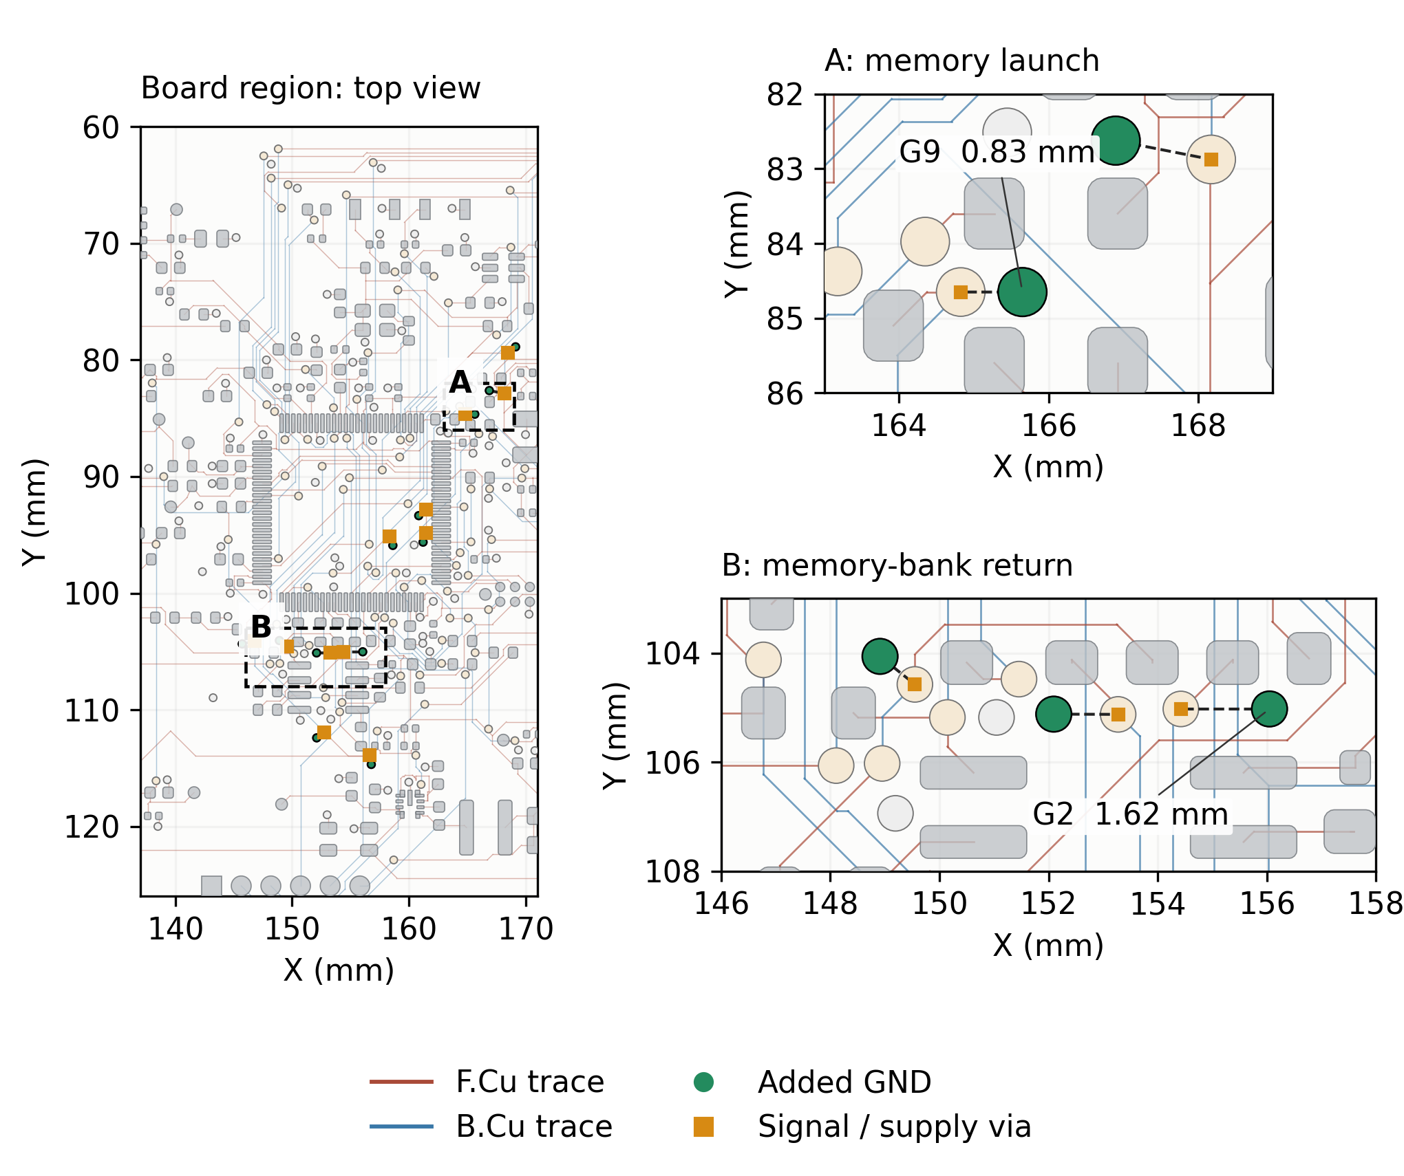
Figure 8. Actual saved routing: top copper is brown, bottom copper blue, and the 12 added GND stitches green. Inner planes are omitted for visibility and checked separately. Dashed distances join barrel centers; they are not current-path lengths.
All 12 new GND barrels connect to both final inner fills; each land has at least 98.59% plane contact. The 16 changed fast-route jobs have no unrelated reference-plane centerline gaps in this scoped screen; local signal-via antipads account for the detected gaps. The lower IO2 transition still has a 3.037 mm nearest-GND spacing. Its return inductance and receiver waveform remain bench questions.
Table 10. Saved geometry of the selected local returns
Return stitch | Signal transition | Barrel spacing
G9, memory launch | IO2 source transition | 0.826 mm
G2, memory bank | IO3 upper transition | 1.625 mm
Existing return, lower IO2 | No closer legal stitch demonstrated | 3.037 mm

Measurement targets and bench plan
Use measurement error and interface margin as the outcomes. Do not optimize a single simulated capacitance, via count or field plot in isolation. Record raw ADC codes, workload state, supply traces and the actual cable arrangement so noise sources can be traced to the instrument behavior.
Table 11. Practical outcomes and missing acceptance inputs
Metric | How to obtain it | What is still needed
Input-referred noise and spurs | Compare quiet capture with SD, PSRAM and display activity under a stable RF stimulus. | Calibrated transfer and an allowed measurement-error allocation.
Rail disturbance and impedance | Probe FB1 input/output and local U3/U4/VDDA bypasses during known current steps. | Worst current step, edge duration and allowable rail variation.
Receiver waveform and timing | Measure both PSRAM directions and the actual LCD module/harness. | Driver behavior, thresholds, setup/hold and clamp-safe probing.
Cable common-mode current | Probe the coax and attached laboratory leads in the intended arrangement. | Representative field, fixture and operating states.
Emissions and immunity | Run an agreed laboratory test plan with representative cables and enclosure. | Applicable standards, limits, test configuration and physical hardware.

$Ztarget = allowable rail variation / current step$
A converter code width is not the allowable supply ripple. Derive the supply-to-output sensitivity and its contribution to the calibrated input error before assigning a numerical impedance target.
For +3V3_A, probe FB1 pins 1/2; C44/C45 at the entry; C15/C20 for U3; C13/C14 for U4; and C48/C51 for U8 VDDA. Use the nearby capacitor ground or ground via with a short spring or suitable differential probe. Long probe-ground leads can turn pickup into an apparent rail problem. Observe the separate U5 reference supply when correlating ADC noise.
Y1 is an 8 MHz oscillator: 64 and 128 MHz coincide with its nominal eighth and sixteenth harmonics. An ideal 50% duty square wave suppresses even harmonics; real duty, nonlinear behavior and coupling determine their strength. Inspect those frequencies and workload-dependent spurs in the actual instrument. The broadband ADL5511 is not made frequency-selective by the carrier setting. Interference converted into DC or a slow envelope can pass the later measurement filters. [5]
First confirm DC rails and safe startup. Then collect quiet and workload-stressed records with one variable changed at a time. Characterize the input transfer at 64 and 128 MHz with the intended cable. Use these results to allocate tolerances and choose any damping change. Finally test representative pulse sequences and external-field conditions with the laboratory; desktop models cannot establish MR suitability.

Methods and primary sources
The field study uses finite-volume electrostatics and openEMS time-domain coupons. The RF study solves a lumped complex-admittance network, checked against ngspice. Digital studies use distributed line sections and nonlinear ST IBIS output currents. The supply study uses SPICE passive networks with measured-model frequency and bias limits. The results are simulated sensitivities and design checks, not measured emissions or an EMC certificate.
1 Analog Devices MT031 Grounding Data Converters
2 ST STM32H743 datasheet DS12110 Rev 11
3 JLCPCB published impedance and material stack table
4 Qucs microstrip equations and Hammerstad Jensen model
5 Analog Devices ADL5511 datasheet
6 Waveshare 2.8 inch capacitive display module schematic
7 Texas Instruments TXS0108E datasheet SCES642
8 AP Memory SPI and QSPI PSRAM product documentation
9 ST AN4899 GPIO hardware settings
10 Analog Devices AN1368 Ferrite bead demystified
11 Murata SimSurfing and exact BLM18AG601SN1 model
12 ST RM0433 QSPI clock divider and I/O compensation
13 openEMS microstrip port definitions and calculations
14 IBIS Open Forum specification version 4.2
Passive-model conditions are part of the result: seven of eight analog bypass capacitors use manufacturer models at 3.3 V and 25 °C. The 22 µF Samsung capacitor falls to 8.933 µF at that bias. The Murata bead is characterized only from 1 MHz at zero DC current. Neither result establishes its behavior under a different voltage, temperature or current.
For the supply comparison, AC transfer is output ripple divided by injected source ripple; load impedance is output ripple divided by injected load current. Capacitance and source impedance sweeps expose sensitivity, not a measured tolerance distribution. For digital timing, delay starts at the actual source-package pad midpoint, adds datasheet pad delay once, and includes receiver settling. No result here replaces the physical tests in Table 11.

