RFVD PCB layout rationale
SENSOR D | 2026-09-08 | RFVD Senior Design Team
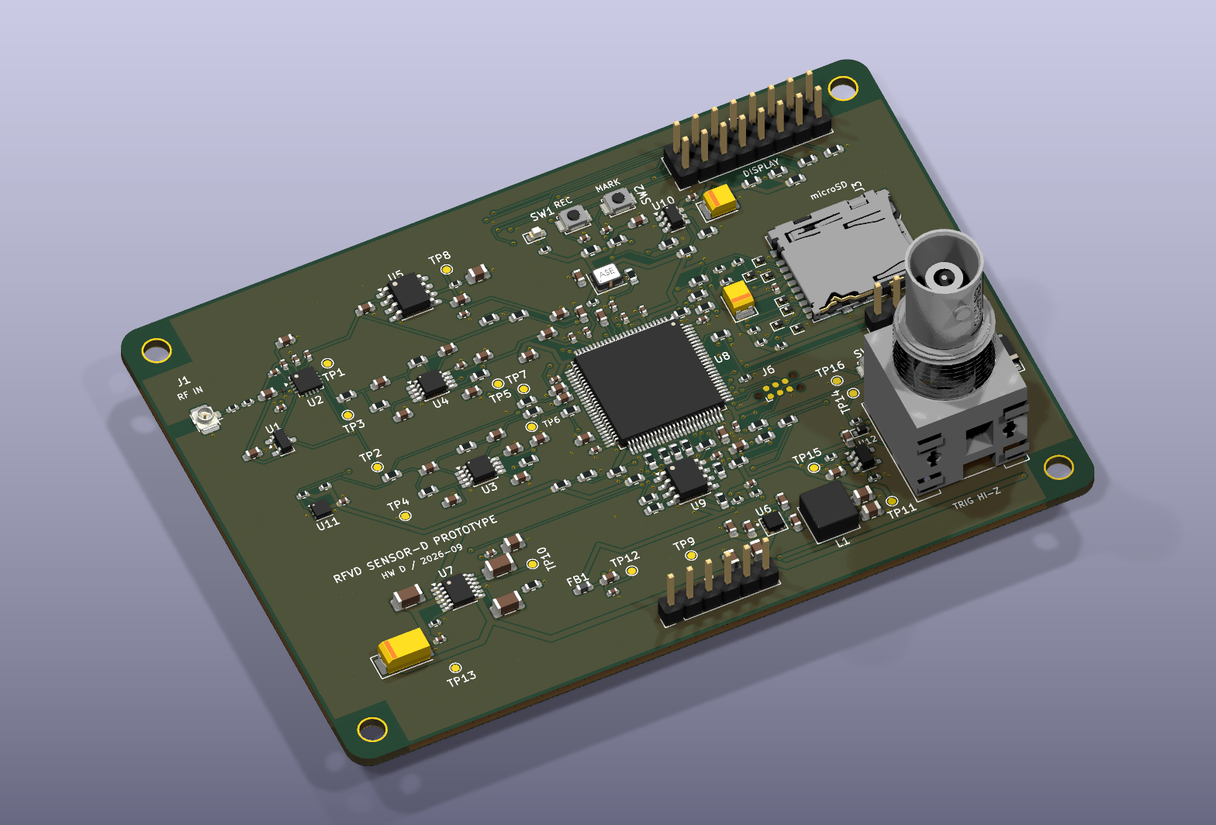
Figure 1. Native rendering of the final saved board. RF input and analog circuits occupy the left region; MCU, memory and display/storage connections sit toward the right. The regulator sections are below. The BNC at the right edge is the optional trigger input.
The layout follows the measurement: coax input, attenuation and protection, ADL5511 detection, envelope filtering, reference and ADC acquisition, then memory and SD storage. Keep the small detector and converter signals local while clocks, storage traffic and the switching regulator occupy their own physical regions. The aim is to keep unwanted current out of voltage-measurement paths. RFVD_DEVICE_REPORT.docx explains instrument operation. [1, 2]
The positive rails have different jobs. The low-noise +5V_A branch supplies the detector and reference. FB1 filters +3V3_D into +3V3_A for the opamps and MCU analog supply. The ground beneath these blocks remains connected. Supply filtering and geometric separation manage coupling without making every signal cross a ground split.

Why the four-layer stack is arranged this way
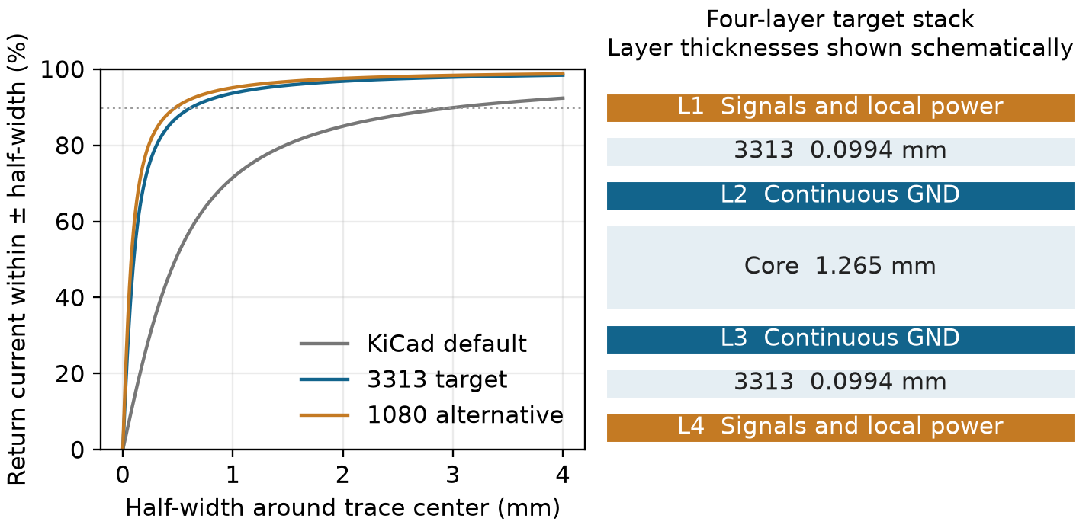
Figure 2. Signals on each outer layer have an adjacent inner ground plane. The return-current illustration assumes an infinite plane; it is not a full-board field solution.
Table 1. One ground net on two inner reference planes
Layer | Role | Placement consequence
F.Cu | Components and local signal/supply routes | Reference fast and sensitive routes to In1.Cu.
In1.Cu | GND reference | Keep useful copper beneath top-layer paths.
In2.Cu | GND reference | Provide the adjacent reference for bottom routes.
B.Cu | Crossings and selected longer routes | Pair layer changes with nearby GND connections.

For a 0.15 mm trace with 35 µm copper, two-dimensional electrostatic coupons give 54.0 Ω with the 3313 stack (0.0994 mm outer dielectric, Dk 4.1), versus 103.1 Ω with the generic 0.48 mm gap and Dk 4.5. The 1080 alternative uses 0.0764 mm and Dk 3.91, giving 47.3 Ω. These uniform-line calculations omit actual mask and manufacturing variation; closer ground also changes RF parasitic loading. [3]
Putting all analog parts on top and all digital parts on the bottom would not by itself establish isolation. The useful distinction is where each current flows and which nearby plane supports it. Preserve local analog placement, keep digital routes out of sensitive input/reference areas, and use the lower surface where it shortens a crossing without creating a remote return. A six-layer board remains an option if future interfaces outgrow these routing regions.

Component placement and local return paths
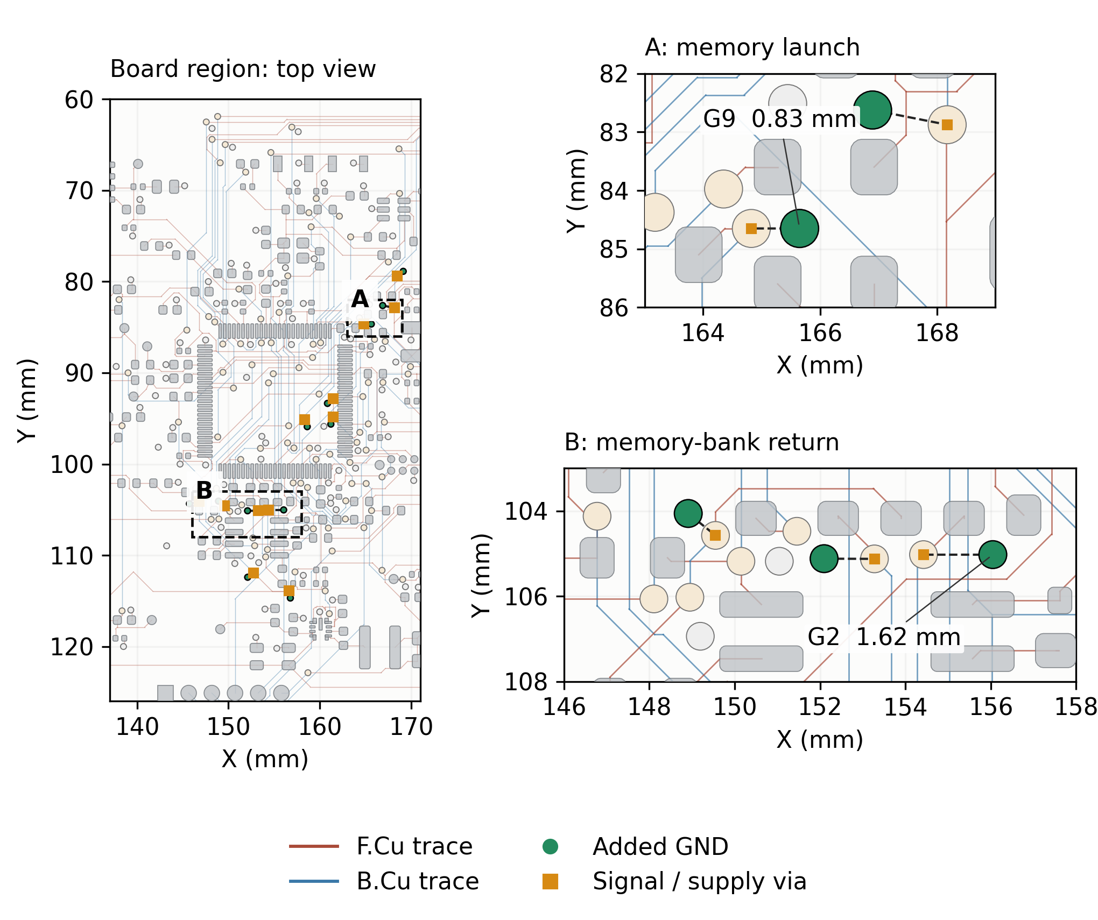
Figure 3. Actual saved routing: top copper is brown, bottom copper blue, and the 12 added GND stitches green. Inner planes are omitted for visibility and checked separately. Dashed distances join barrel centers; they are not current-path lengths.
All 12 new GND barrels connect to both final inner fills; each land has at least 98.59% plane contact. The 16 changed fast-route jobs have no unrelated reference-plane centerline gaps in this scoped screen; local signal-via antipads account for the detected gaps. The lower IO2 transition still has a 3.037 mm nearest-GND spacing. Its return inductance and receiver waveform remain bench questions.
Place each source resistor before the longer clock trace, keep oscillator bypass C93 at Y1, and keep the ADC reservoir capacitors at the converter pins. Preserve the LT3045 OUTS pin 10 sense connection and the local output-capacitor return. The new data resistors put damping at both possible driving ends of each bidirectional memory line. GND stitches accompany specific signal or supply transitions; their barrel spacing is a geometric check, not a measured loop inductance.

Memory clocks and why damping is a compromise
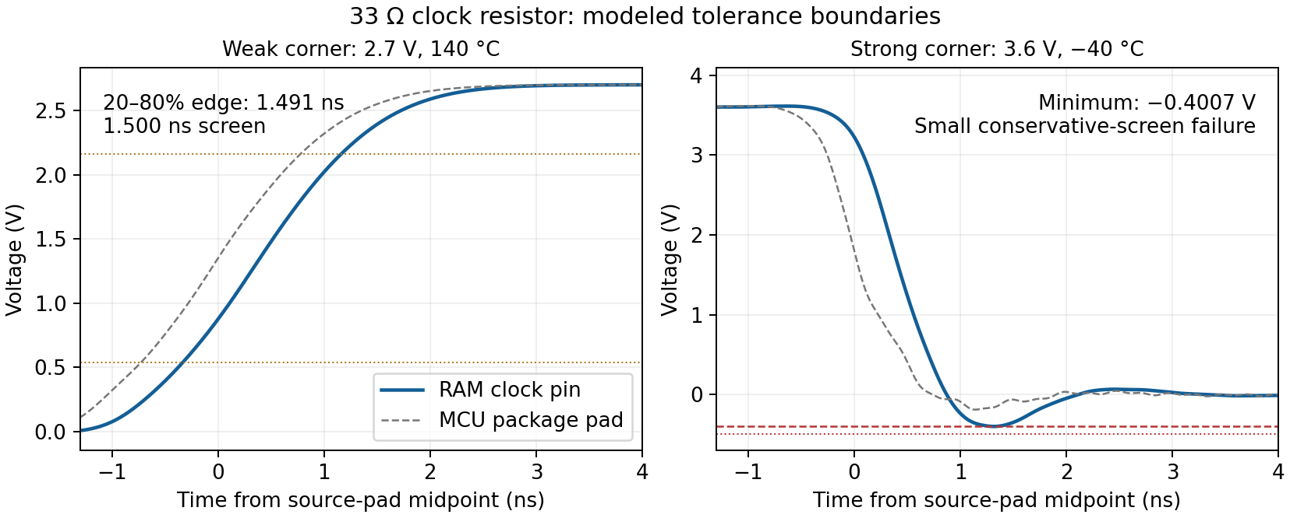
Figure 4. The declared 33 Ω ±1% clock sensitivity retains the conservative voltage-screen failure. Numerical edge margin is small; the first board must be measured.
The supplied ST model replaces the old generic 1 nH package assumption: PB2 has 5.272 nH. With 33 Ω ±1%, the worst modeled edge is 1.491 ns, only 9 ps below the 1.5 ns limit. One case reaches −0.400677 V and fails the conservative −0.4 V screen; all 128 tolerance cases meet the separate −0.5 V/VDD+0.5 V, 20 ns transient screen. This supports a conditional prototype choice, not robust physical closure. Larger 36/39 Ω parts slow some weak-load edges beyond the limit. [5]
ST’s model gives 5.272 nH at the memory-clock package pin, separate from trace inductance and the assumed aggregate 2/3 nH transition return. Clock sweeps use 45/60 Ω lines and 6/8 pF receiver allocation. Weak/strong columns change supply and temperature to 2.7 V/140 °C and 3.6 V/−40 °C. Some normal 3.3 V pin-model choices require a family inference. RAM read drivers are assumed because a vendor model is unavailable. These conditions limit the result. [2, 4]
Firmware uses a 133.333 MHz QSPI kernel divided by two for 66.667 MHz, and waits for I/O compensation before enabling fast pins. A 33.333 MHz, 64-byte-burst setting is available for diagnosis; sustained throughput at that setting is not established. The LCD contains an active TXS0108E translator. Its cable and one-shot behavior require physical testing; passive cable damping alone cannot qualify the assembly. [5, 6]

RF loading and the cost of supply detours
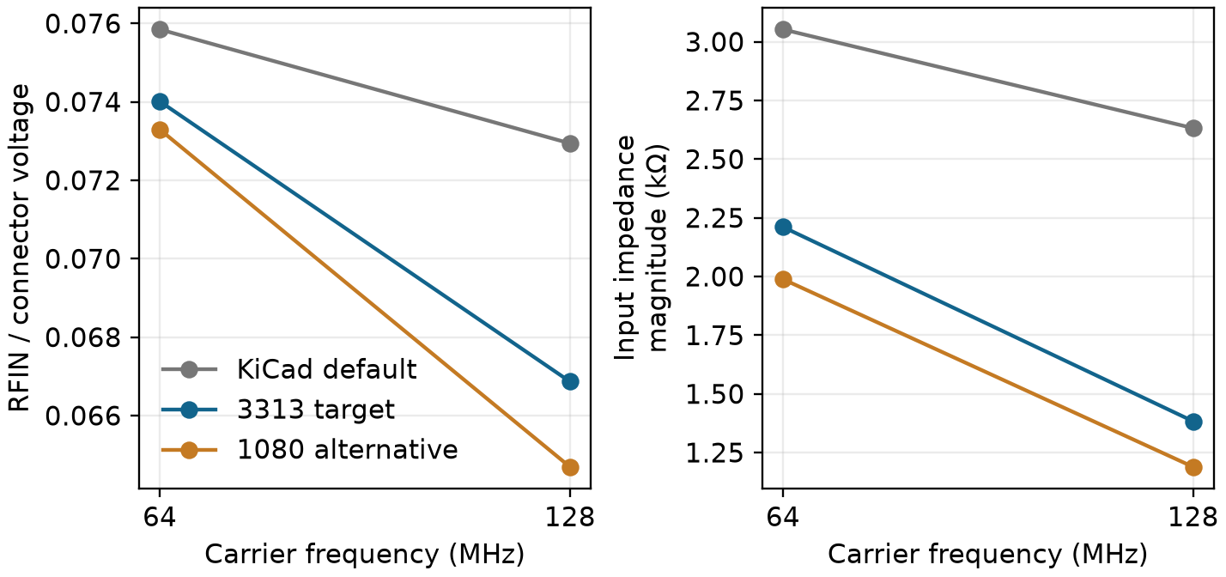
Figure 5. A closer ground reference increases modeled parasitic loading in the present high-impedance RF input. The excitation is the voltage at the board connector, not an assumed 50 Ω AIMD source.
R1 and R2 total 3.0 kΩ and divide the series network voltage and dissipation between two parts. Their input does not become a 50 Ω measurement just because the cable is coaxial. A 50 Ω termination would change the loading on the opened AIMD port. Preserve the connector reference plane and calibrate the complete chosen cable, input network and frequency setting. The ADL5511 is broadband; selecting 64 or 128 MHz in the interface does not insert an RF bandpass filter. [1]
The bottom +3V3_D feed upstream of FB1 grows from 17.700 to 20.276 mm at 0.5 mm width and adds two logical vias. At assumed 35 µm copper, 20 µm barrel plating and 20 °C, its isolated series-path increase is 5.282 mΩ. A shared center/bottom barrel creates an upstream supply mesh; these branch estimates are not its total impedance. The local +3V3_A tree is retained. Probe both FB1 terminals under recording loads.
Retain FB1 and the analog bypass capacitors. In a reduced SPICE fixture, a 1 Ω series resistor lowers ringing but increases a 10 mA step’s maximum drop from 11.50 to 15.24 mV. Its 100 µs pulse has 1 µs edges. The bead model starts at 1 MHz at zero bias, so the predicted 46.81 kHz peak is extrapolation. Bias, source dynamics and common ground impedance remain unqualified. RFVD_EMC_OPTIMIZATION_REPORT.docx gives the broader tradeoffs. [7]

What is verified and what the first board must show
The saved SENSOR D board includes the 3313 stack, shortened clock launches, eight memory data resistors and local GND stitches. Native checks report zero errors, zero unconnected items and 27 warnings. The schematic has zero ERC errors. These checks bind the saved design; physical EMC, timing margin and voltage accuracy remain to be measured.
Table 2. Current source and native verification
Check | Scope | Result
Schematic | 194 parts; 572 pins; 166 nets | ERC: 0 errors
Saved PCB | 198 footprints; 1700 segments; 289 vias | DRC: 0 errors; 0 unconnected; 27 warnings
3D and ground | 177 model instances; two inner GND regions | Models resolve; one connected fill on each inner layer
Physical instrument | EMC, calibration, timing and accuracy | Bench validation open

Table 3. Tests that convert the layout rationale into instrument evidence
Bench measurement | Reason
Input off and known 64/128 MHz CW | Separate self-generated offsets/spurs from signal response.
SD busy, memory traffic, LCD/backlight changes | Measure coupling during the actual recording workload.
Clock at the receiver and memory test patterns | Check overshoot, edge time, duty and receive-window margin.
Both FB1 terminals and ADC/reference nodes | Measure supply impedance effects and input-referred disturbance.
Cable placement and enclosure changes | Identify common-mode pickup and configuration-dependent calibration.

The 27 warnings comprise 22 library-copy mismatches, four library footprint issues and U8 silkscreen clipped by the R64 mask opening. Five check categories are disabled: missing courtyard, off-center via entry, tuning profile, footprint filter and footprint type. Physical EMC, timing, calibration, enclosure and laboratory waveform validation remain open.
1. Analog Devices ADL5511
2. ST STM32H743 datasheet
3. JLCPCB published stackups
4. IBIS specification 4.2
5. AP Memory PSRAM documentation
6. TI TXS0108E
7. ADI AN1368 ferrite-bead behavior

