Efficient Graph-Based Image Segmentation Algorithm

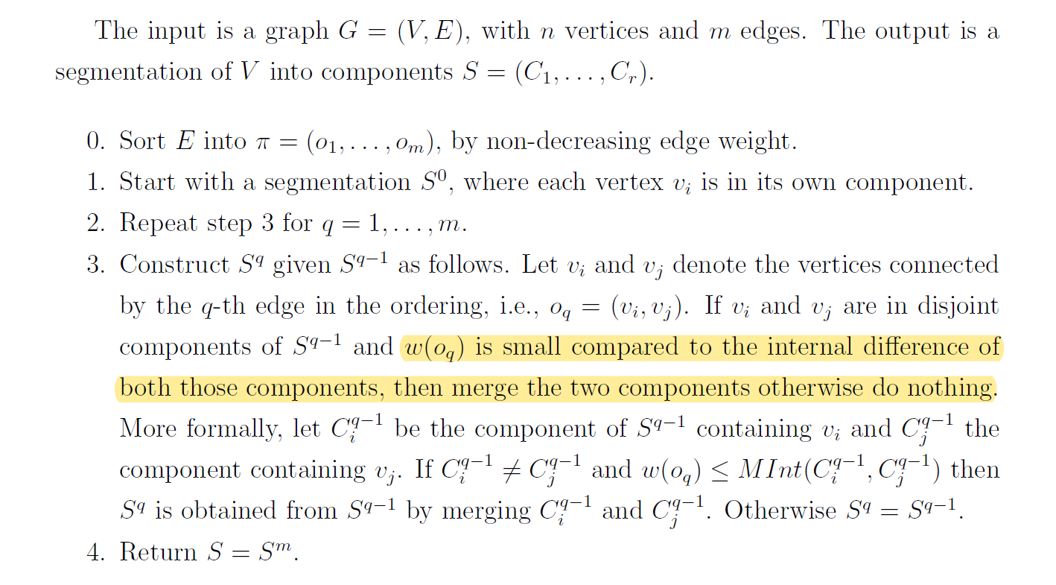

Selective Search Algorithm:

