OMEN
Open Movement & Exercise Nomenclature
A Generative, Computable Naming Standard for Resistance-Training Movements
Carlos Abel Vivanco
Independent Researcher
Correspondence: research@ablevlabs.com · ORCID: 0009-0001-0178-7752
This manuscript is a preprint and has NOT been peer reviewed.
Preprint · Standard version 0.1 · September 2026

Abstract
Resistance-training movements are named inconsistently across research, coaching, and software, and the cost of that inconsistency is now concrete: the same exercise appears under many names in the scientific literature, every exercise database invents its own schema, and no shared identifier lets a training log, a research dataset, and a coaching app refer to the same movement without ambiguity. Practitioner surveys confirm the problem is real and that professionals want it fixed, but the reforms proposed so far are style guidelines (recommended word orders) rather than computable standards. This paper proposes OMEN (Open Movement & Exercise Nomenclature): a generative naming standard that describes a movement as a bundle of orthogonal facets, derives its target musculature from its movement pattern rather than treating muscle as an input, and produces two deterministic outputs: a human-readable canonical string and a short, stable, language-neutral identifier suitable as a database primary key. OMEN separates three layers that existing systems conflate (the structured facet record, the canonical identifier, and the curated display name), the same separation that let systematic naming succeed in chemistry (SMILES, InChI) and clinical terminology (SNOMED CT). We give the facet schema and its controlled vocabularies, a fixed serialization order, a defaults mechanism that keeps everyday names short, a governance and versioning model, and an evaluation protocol centered on inter-annotator agreement. A working reference encoder and test suite accompany the standard; every canonical string and identifier in this paper is produced by that implementation. We also report an initial evaluation. Of 678 resistance-training records in an independent public database, 75.4% are expressible in version 0.1 without inventing a term (81.4% of those whose own fields disclose enough to encode at all); the residual gaps cluster into six enumerable concepts that constitute the version 0.2 agenda; 511 distinct source names collapse to 253 keys, exposing synonymy directly; 79% of those names never state posture; and no key collision occurs across 2,498,496 generated records. The inter-annotator study on which a naming standard ultimately rests is specified but not yet run.
Keywords: resistance training; exercise nomenclature; controlled vocabulary; faceted classification; ontology; data interoperability; movement patterns

Contents
1. Introduction
2. Background and Related Work
3. Design Principles
4. The OMEN Model
5. Canonical Forms and Identifiers
6. Worked Examples
7. Reference Implementation
8. Evaluation Protocol
9. Results
10. Governance and Versioning
11. Limitations and Future Work
12. Conclusion
Data and Code Availability
References

1. Introduction
Ask ten trainers to name a common movement and you will get several answers: arm curl, bicep curl, biceps curl; one-arm row, single-arm row, 1-arm dumbbell row. This is not a matter of taste with no consequences. A survey of 205 exercise professionals found that terminology for resistance-training exercises is used inconsistently, that most respondents use multiple names for the same exercise, and that a majority support standardization (Jackson et al., 2013). A later text analysis of the exercise names in a standard technique manual found 35 distinct naming patterns among just 57 exercises (Nuzzo, 2017). The inconsistency reaches into the literature itself: across research articles, the same movement is written many different ways, so that anyone assembling or comparing datasets must first reconcile names by hand (Nuzzo, 2021).
The problem is worth solving because exercise data is increasingly computed on, not just read. Training logs are analyzed for volume and balance; wearable and app ecosystems exchange workout records; sports-science studies pool across sources; recommendation systems reason over exercise catalogs. Every one of these tasks needs a stable, unambiguous way to say which movement: a shared key. Today there is none. Each exercise database defines its own fields and its own names, and the identifiers they do expose are typically derived from the display name itself, so they break the moment the name is written differently.
Two families of prior work bear on this, and neither closes the gap. On the practitioner side, standardization has been proposed as a naming pattern, for example specification, then equipment, then exercise, yielding names like “1-arm dumbbell row” (Jackson et al., 2013). This is a valuable style guideline, but it is not computable: it fixes word order without fixing a vocabulary, an identifier, or a way for software to tell whether two names denote the same movement. On the biomedical side, rigorous ontologies exist for physical activity and exercise (PACO, the exercise-medicine and prescription ontologies, and a recent kinetic human-movement ontology), but they are built for epidemiology, clinical prescription, and anatomical modeling, not to serve as the interoperable naming key that training logs and strength-science datasets share.
This paper proposes a standard aimed squarely at that unfilled middle. OMEN treats a movement as a structured record of orthogonal facets, generates a canonical form and a stable identifier from that record deterministically, and keeps human names as a curated presentation layer rather than as the identity itself. The contribution is fourfold: (i) a facet schema and controlled vocabularies for resistance-training movements; (ii) a canonical serialization and a versioned, language-neutral identifier scheme; (iii) a governance and evaluation model designed for global adoption; and (iv) an open reference implementation that produces every canonical string in this paper.

2. Background and Related Work
Existing efforts fall into three layers. Each is useful and none is a computable naming standard for resistance-training movements; OMEN is designed to unify their strengths.

2.1 Practitioner naming guidelines
The closest direct precedent is the proposal to standardize resistance-exercise names around a fixed pattern of specification, equipment, and exercise (Jackson et al., 2013). The follow-up text analysis quantified the underlying chaos and, usefully for our purposes, categorized the words people actually use in exercise names (Nuzzo, 2017). Table 1 reproduces that breakdown, because it is essentially an empirical inventory of the facets a standard must cover.
Word category | Share | Example
Action | 30.3% | row
Equipment | 23.4% | barbell
Body part | 19.1% | shoulder
Equipment position | 8.0% | incline
Body position | 7.0% | seated
Action direction | 5.9% | lateral
Miscellaneous | 4.3% | power
Body-part adjective | 1.1% | stiff
Body-position direction | 1.1% | over
Table 1. Word categories in resistance-exercise names, after Nuzzo (2017). Read as facets, action dominates: evidence that the movement itself, not the muscle, is the natural primitive.
Two things stand out. First, action (the movement) is the single largest category, which supports treating the movement pattern, rather than the muscle, as the classificatory primitive. Second, a later analysis argued that eccentric and other muscle-action distinctions add yet another axis the existing conventions do not handle (Sports Medicine – Open, 2023). A durable standard must therefore make contraction type a first-class, optional facet. What this layer lacks is everything that makes a standard computable: a closed vocabulary, a canonical form, and a stable identifier.

2.2 Open exercise databases
Community databases such as Free Exercise DB and wger already decompose exercises into fields, and their choices independently validate two OMEN design decisions. Free Exercise DB stores force (push/pull/static), mechanic (compound/isolation), equipment, and, crucially, primaryMuscles and secondaryMuscles as separate lists rather than a single “muscle” slot. That is exactly the treatment OMEN gives musculature. However, these schemas bury posture, grip, laterality, and bench angle inside the free-text name; they carry only a coarse push/pull axis rather than a true movement-pattern taxonomy; and their record identifiers are slugs derived from the display name (for example, Alternate_Incline_Dumbbell_Curl), which are neither stable nor canonical and cannot be mapped across databases. There is no shared key that lets two of these datasets refer to the same movement.

2.3 Biomedical and activity ontologies
A parallel body of rigorous work models physical activity and exercise as formal ontologies: the Physical Activity Concept Ontology (PACO) standardizes activity descriptions drawn from questionnaires; exercise-medicine and prescription ontologies support individualized clinical exercise programs; and a recent kinetic human-movement ontology represents the anatomy and physiology of movement in a description-logic model. These are valuable and OMEN aligns with their methods: controlled terms, defining relationships, open publication. But their purpose is epidemiology, clinical prescription, or anatomical reasoning, not the naming of gym movements for interoperable logging. They answer “what is physical activity, clinically?” rather than “what is the shared identifier for a single-arm cable row?” OMEN occupies that unclaimed niche and is designed to reference the anatomical ontologies for its muscle terms rather than to duplicate them.

3. Design Principles
A standard intended for worldwide adoption succeeds on properties that have little to do with the elegance of its taxonomy; chemistry and clinical terminology adopted their systems for governance, stable identifiers, and tooling as much as for content. OMEN is built to the following principles.
- Unambiguous. One movement has exactly one canonical form. Two encoders, given the same movement, must produce the same identifier.
- Complete but bounded. Every everyday resistance movement is expressible, using closed controlled vocabularies rather than free text, so that validity is checkable.
- Generative, not enumerative. The standard is a grammar, not a list. It can name a movement invented next year by composing existing facets, as systematic chemical naming can name a novel compound.
- Human and machine readable. The same record renders as a short human name and as a precise machine key, without either compromising the other.
- Stable, versioned identifiers. Identifiers are language-neutral, permanent, and carry the standard's version, so a citation resolves to the same movement forever and changes to the standard never silently reinterpret old data.
- Backward-compatible. Existing colloquial names map onto canonical records as curated aliases, so the standard augments rather than discards the vocabulary people already use.
- Governed and open. An open specification, an open reference implementation, and a defined process for proposing and ratifying new terms: the machinery by which a standard actually spreads.

4. The OMEN Model

4.1 Three layers
OMEN keeps three representations of a movement distinct. Conflating them is the single most common failure of existing schemes, and separating them is what every durable naming system does.
- The facet record is the source of truth: a movement is a bundle of orthogonal facets (Section 4.2). It is the only thing a human authors.
- The canonical form and key are derived deterministically from the record (Section 5). The canonical string is human-inspectable; the key is a short, stable identifier suitable as a primary key.
- The display name is a curated label, “Bench Press,” attached to the record as an alias (Section 4.4). It is never generated and never the identity, so it is free to be localized.
A consequence worth stating plainly: in OMEN the exercise name is an output, not an input. You describe a movement by its facets, and “bench press” is the label those facets resolve to, not one of the coordinates you supply. This is what removes the redundancy and the contradictions (a record whose name says one thing and whose fields say another) that fixed-word-order schemes permit.
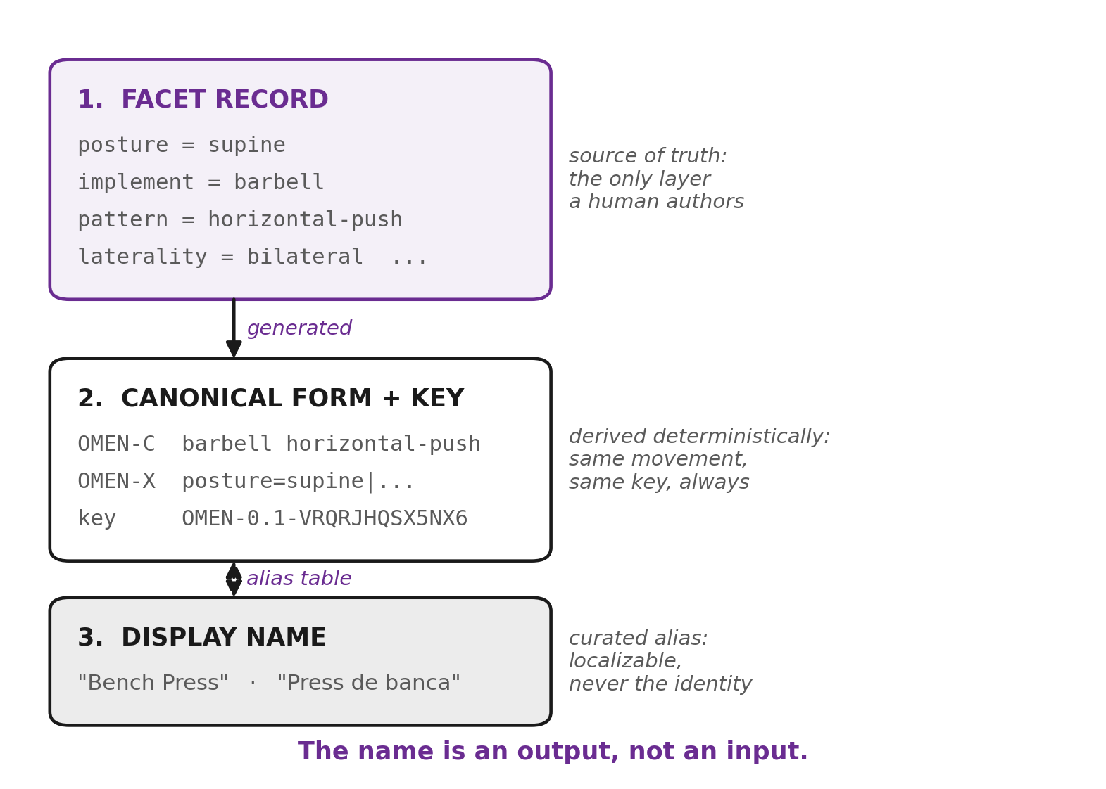
Figure 1. The three layers OMEN keeps distinct. The facet record is authored; the canonical form and key are generated from it; the display name is a curated alias attached to the record. Conflating these layers is the characteristic failure of existing schemes.

4.2 The facets
A movement is described by three required facets (posture, implement, and movement pattern) together with laterality, which has a default, and a set of optional modifiers. Table 2 lists the facets and a representative slice of each controlled vocabulary; the reference implementation holds the complete lists.
Facet | Role | Representative controlled terms
posture | required | standing, seated, supine, prone, kneeling, bent-over, hanging
implement | required | barbell, dumbbell, ez-bar, cable, machine, kettlebell, bodyweight, band
pattern | required | horizontal-push, vertical-pull, hip-hinge, squat, elbow-flexion, …
laterality | default | bilateral (default), unilateral, alternating
attachment | optional | rope, straight-bar, single-handle, lat-bar (cable/machine only)
grip | optional | pronated, supinated, neutral, mixed; wide / standard / narrow
angle | optional | flat (default), incline, decline
contraction | optional | dynamic (default), eccentric-only, isometric, plyometric
range | optional | full (default), partial, deficit, paused
Table 2. The OMEN facets. Required facets must be supplied; defaulted and optional facets fall to defaults when unstated (Section 4.3).

4.3 Muscle and mechanic are derived, not entered
The muscle worked is a consequence of the movement, not an independent choice, so OMEN does not store it as a facet. Instead each movement pattern maps to its primary and secondary musculature, and to whether it is compound or isolation, through a fixed table. Encoding horizontal-push therefore yields pectoralis major, anterior deltoid, and triceps, and the mechanic “compound,” with no further input. This removes the ambiguity of a free “muscle” field, handles multi-muscle movements correctly, and matches the primary/secondary treatment that exercise databases already found necessary. Muscle terms are intended to reference an external anatomical ontology rather than to be redefined by OMEN.
The defaults mechanism keeps everyday names short. Optional facets that equal their default are omitted from the human form and restored in the canonical form, so a flat, bilateral, full-range, dynamic barbell press is written simply as a press, while an incline, unilateral variant states only what it changes. Grip, when unstated, is filled by the pattern's natural grip (a curl is supinated, a pulldown pronated).

4.4 Named exercises as aliases
Because the name is not the identity, established names are stored as a curated alias table mapping a display name to the facet overrides that define it; the remaining facets fall to defaults. “Bench press” is the bundle {posture: supine, implement: barbell, pattern: horizontal-push}; “chin-up” and “pull-up” differ only in grip. This preserves the real-world vocabulary and, read in reverse, lets any record that matches a known bundle render under its accepted name, while records with no accepted name fall back to their compact canonical string.

5. Canonical Forms and Identifiers
From the facet record OMEN produces three renderings under a single fixed field order (the citation order) that runs from general context to specific execution: posture, implement, attachment, grip, laterality, pattern, angle, contraction, range.
- OMEN-C (compact), the human form: only non-default facets, in citation order. Example: incline dumbbell horizontal-push.
- OMEN-X (canonical), every facet explicit, in citation order, grip resolved. This is the lossless form the key is hashed from.
- OMEN key, a short, language-neutral identifier: a version prefix plus a base-32 hash of OMEN-X. The database primary key, analogous to an InChIKey.
For the bench press, the reference implementation produces the following (verbatim):
OMEN-C: barbell horizontal-push
OMEN-X: posture=supine|implement=barbell|attachment=none|grip_orientation=pronated|
grip_width=standard|laterality=bilateral|pattern=horizontal-push|angle=flat|
contraction=dynamic|range=full
key: OMEN-0.1-VRQRJHQSX5NX6
Because the key is a function of the canonical string, the same movement always yields the same key regardless of how it was authored, and any change to a facet (grip, laterality, angle, contraction) yields a different key. The version prefix (OMEN-0.1-) guarantees that identifiers minted under one edition of the standard are never silently reinterpreted by another.
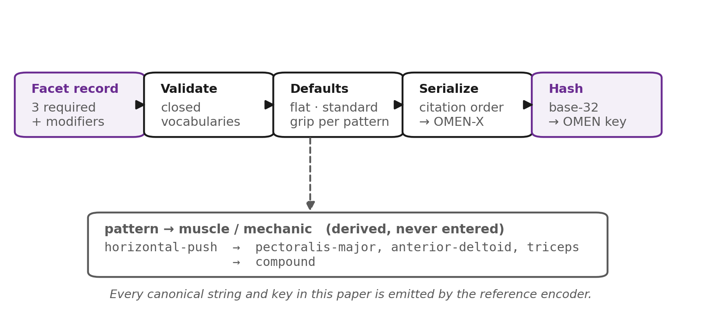
Figure 2. The encoding pipeline. A validated facet record is expanded against its defaults, serialized in the fixed citation order to OMEN-X, and hashed with a version prefix to yield the key. Musculature and mechanic are read from the movement pattern and are never entered by hand.

6. Worked Examples
Table 3 shows a representative set of movements as encoded by the reference implementation: the human form, the derived primary muscles (never entered), and the stable key. Two pairs are instructive. Pull-up versus chin-up differ only in grip yet receive distinct keys, capturing a distinction colloquial names often blur. The last row is a movement with no accepted name; its compact canonical string simply becomes its label, demonstrating generativity: the standard names movements it was never explicitly taught.
Movement | OMEN-C | Primary muscles (derived) | OMEN key
Back squat | barbell squat | quadriceps, gluteus-maximus | OMEN-0.1-HWYDOFIMW3MXQ
Bench press | barbell horizontal-push | pectoralis-major, ant.-deltoid, triceps | OMEN-0.1-VRQRJHQSX5NX6
Incline DB press | incline dumbbell horizontal-push | pectoralis-major, ant.-deltoid, triceps | OMEN-0.1-CRBWWU6C4RMIK
Pull-up | vertical-pull | latissimus-dorsi, teres-major | OMEN-0.1-L2SHL5OD62KEW
Chin-up | supinated vertical-pull | latissimus-dorsi, teres-major | OMEN-0.1-NJJ6HLRNNFORY
Triceps pushdown | rope cable elbow-extension | triceps | OMEN-0.1-LX2LC34DVHM4I
Romanian deadlift | barbell hip-hinge | glute-max, hamstrings, erectors | OMEN-0.1-K5R5GCRCMTPDE
Plank | anti-extension isometric | rectus-abdominis | OMEN-0.1-R77DG3ING3F7U
(unnamed) 1-arm cable row | single-handle cable unilateral horizontal-pull | lat-dorsi, rhomboids, mid-trap, post-delt | OMEN-0.1-6PY6ZOH7GNUNG
Table 3. Worked examples, produced verbatim by the OMEN reference encoder. Muscles are derived from the movement pattern, not supplied.

7. Reference Implementation
The standard ships with an open reference encoder (Python, no dependencies) that is the executable definition of the controlled vocabularies and the canonical algorithms. It exposes a movement record, validates it against the vocabularies, expands defaults, emits OMEN-C, OMEN-X, and the key, derives musculature and mechanic from the pattern, and resolves names both ways through the alias table. A standard with running code is adopted; a specification alone is not.
Correctness is enforced by a test suite that doubles as the standard's guarantees made executable: determinism (the same movement always yields the same key), non-collision (distinct movements never share a key across the alias table), predictable default expansion, first-class contraction (an eccentric-only variant is a distinct identity), and round-tripping (a colloquial name resolves to its record and back to its name). All tests pass in the accompanying release.
$ python omen.py --name "chin-up"
CHIN-UP
OMEN-C supinated vertical-pull
OMEN key OMEN-0.1-NJJ6HLRNNFORY
primary muscles latissimus-dorsi, teres-major

8. Evaluation Protocol
A naming standard is validated less by argument than by whether people apply it the same way. This section specifies the protocol; Section 9 reports results for the four measures that can be computed without human subjects, and Section 11 states plainly which measure remains outstanding.
- Inter-annotator agreement. Several trained annotators independently encode the same set of movements; the primary metric is the proportion producing identical canonical keys, with per-facet agreement (Cohen's / Fleiss' κ) to locate any facet whose vocabulary is ambiguous. High agreement is the central claim a standard must earn.
- Coverage. Encode a random sample drawn from existing databases (Free Exercise DB, wger) and report the fraction expressible without inventing new terms, along with every gap, which is a direct measure of completeness and a queue for the extension process.
- Round-trip fidelity. For every named exercise, confirm name → record → key → name returns the original name, and that OMEN-C re-parses to the same record.
- Collision resistance. Over a large generated cross-product of facets, confirm no two distinct records share a key, a property the hash makes overwhelmingly likely but which should be measured, not assumed.
- Backward-compatibility. Map a corpus of colloquial and literature names onto OMEN records and report how much ambiguity is resolved: how often several source names collapse to one key (synonymy captured) and how often one source name must split into several (ambiguity exposed).

9. Results
The protocol of Section 8 has been executed in part. Coverage, backward-compatibility and collision resistance were measured against an independent database and a generated cross-product of the vocabularies. The inter-annotator study was not run and remains the principal item of future work. Every number below is produced by the reference encoder and the audit scripts released with it.

9.1 Coverage against an independent database
We attempted to express every record of the Free Exercise DB, a public-domain database of 876 exercises, in OMEN v0.1. Of these, 198 lie outside the declared scope of version 0.1 (stretching, cardiovascular and plyometric entries), leaving 678 resistance-training records as the denominator. Each record was mapped onto OMEN facets by a deterministic script that reads the database's structured fields (equipment, mechanic, primary musculature) together with the tokens of its display name, and draws only on the v0.1 controlled vocabularies. Failures were separated into two kinds, because they license different conclusions: records that require a term OMEN does not define, and records whose own fields do not disclose enough to encode them at all.
Outcome | Records | Share
Encodable in OMEN v0.1 | 511 | 75.4%
Requires a term OMEN does not define | 117 | 17.3%
Source record underspecified (not an OMEN limitation) | 50 | 7.4%
Total resistance-training records | 678 | 100%
Table 4. Coverage of an independent exercise database by OMEN v0.1.
Coverage is therefore 75.4% of all resistance-training records, or 81.4% of the 628 records that carry enough information to be encoded at all. The distinction is worth preserving: the second figure measures the standard, the first measures the standard and the source data together.

9.2 The extension queue
The 117 vocabulary gaps are not scattered across the corpus; they collapse into a small number of recurring concepts. That is the result a facet standard should hope for, because it means the grammar is close to complete and what is missing is enumerable rather than open-ended. Table 5 is, in effect, the agenda for version 0.2.
Missing concept | Records | Representative examples
Olympic and other multi-phase lifts | 48 | Clean, Snatch, Hang Clean
Scapular elevation (shrug, upright row) | 16 | Barbell Shrug, Upright Row
Shoulder horizontal adduction (fly) | 13 | Cable Rear Delt Fly, Bodyweight Flyes
Cervical movement | 9 | Isometric Neck Exercise
Shoulder extension (pullover) | 5 | Bent-Arm Barbell Pullover
Complex multi-pattern movements | 3 | Turkish Get-Up, Thruster
Grip and finger flexion | 1 | Finger Curls
Implements not in v0.1 | 22 | sled, atlas stone, stability ball, chains, ab wheel, tire
Table 5. Every gap found, grouped by the concept that would close it. Together these define the v0.2 extension queue.

9.3 Synonymy captured and underspecification exposed
Two by-products of the audit bear directly on the argument of Section 1. First, the 511 encodable records, written by their authors as 511 distinct names, resolved to 253 distinct keys, forming 93 clusters in which two or more names denote one movement: Barbell Full Squat, Barbell Hack Squat and Barbell Squat To A Bench, for instance, share a key. Synonymy is captured by construction rather than asserted. Second, 404 of the 511 names (79%) did not state posture anywhere in the name or the record, so posture had to be supplied by the pattern default. The claim that existing exercise names are underspecified is therefore not rhetorical; it is measurable, and it is the majority case.

9.4 Collision resistance and determinism
Collision resistance was measured over a generated cross-product of the controlled vocabularies rather than argued from the properties of the hash. Two sweeps were run: one of 2,402,400 records spanning every combination of posture, implement, pattern, laterality, angle, contraction and range, and a second of 96,096 spanning grip orientation and width. Across 2,498,496 distinct canonical forms no two produced the same key. Determinism and independence from field order were confirmed over 20,000 randomly generated records.
Property tested | Records | Result
Distinct canonical forms encoded | 2,498,496 | 0 collisions
Determinism (repeated encoding) | 20,000 | identical keys
Independence from field order | 20,000 | identical keys
Table 6. Collision and determinism sweep over the generated facet space.

10. Governance and Versioning
The property most often fatal to a proposed standard is the absence of a body to steward it. OMEN therefore specifies its governance as part of the standard, not as an afterthought.
- Maintaining authority. An open registry owns the controlled vocabularies and the alias table, publishes the specification and reference implementation under open licenses, and adjudicates change.
- Versioning. The standard follows semantic versioning, and the major version is embedded in every key's prefix, so identifiers are self-dating and a consumer always knows which edition minted a code.
- Extension. New patterns, implements, or terms are proposed to the registry with a rationale and worked examples, reviewed for overlap with existing terms, and ratified into a numbered release: the mechanism by which the grammar grows without fragmenting.
- Deprecation and merging. Terms are never silently removed; they are deprecated with a mapping to their replacement, and identifiers remain permanently resolvable, so published citations never rot.
- Internationalization. Because identity is language-neutral, display names are a localizable layer: the registry can carry language reference sets so a single key renders in many languages without changing identity.

11. Limitations and Future Work
OMEN, as drafted, scopes itself deliberately to the identity of a resistance-training movement. Several boundaries and extensions follow.
- Dosage is a separate layer. How a movement is performed in a session (load, sets, repetitions, rest, tempo prescription) is a distinct standardization problem. OMEN names the movement; a companion dosage notation should reference OMEN keys rather than fold into them.
- Beyond resistance training. Cardiovascular, mobility, sport-specific, and rehabilitation movements are out of scope for version 0.1. The facet approach should extend to them, but each brings axes (duration, intensity zones, sport context) that need their own vocabularies.
- Granularity of muscle and pattern. The pattern-to-muscle table is intentionally coarse; linking it to a formal anatomical ontology and allowing finer variants (for example, a curl biased to the brachialis) is future work.
- Inter-annotator agreement is not yet measured. Section 9 reports coverage, synonymy, collision resistance and determinism, all of which a machine can measure. The central claim of any naming standard, that independent trained humans encode the same movement identically, requires annotators and has not been run. Until it is, OMEN's reproducibility is demonstrated for the encoder and not yet for its users.
- The coverage audit is automated. Records were mapped to facets by script rather than by expert annotators, which is a proxy for manual encoding and not a substitute for it. The mapping heuristics are released with the audit so the figure can be reproduced, checked and contested.
- A single database was audited. Coverage is reported against one public corpus. Repeating the audit on wger and on a sample of research-article exercise names would test whether 75% generalizes.

12. Conclusion
Exercise naming is inconsistent, the inconsistency has a measurable cost, and the professionals affected want it fixed, all of which is established, not conjectured. What has been missing is a standard that is computable rather than merely recommended: one that fixes a vocabulary and an identifier, not just a word order. OMEN supplies that by describing a movement as orthogonal facets, deriving its musculature from its movement pattern, and generating a canonical form and a stable, versioned key while keeping human names as a curated layer. It unifies the strengths of the three prior camps (the practitioner call for standardization, the database instinct to decompose into fields, and the ontological commitment to controlled terms and open publication) into the interoperable key the field currently lacks. The reference implementation makes the standard executable today; the coverage audit and the collision sweep reported in Section 9 make it measurable; the governance model makes it able to grow. Three quarters of an independent database encodes without invention, the gaps are enumerable rather than open-ended, and the identifier survives two and a half million records without a collision. The step that remains is the one only people can supply: the inter-annotator study that will show whether trained humans, and not merely the encoder, apply the standard the same way.

Data and Code Availability
The OMEN reference encoder, its test suite (18 tests, all passing), the coverage-audit and collision-sweep scripts, and the machine-readable controlled vocabularies are released under an open licence at the project repository. The exercise corpus audited in Section 9 is the public-domain Free Exercise DB. All figures reported here regenerate from the released scripts.
Repository: https://github.com/AbleVLabs/omen

Author Contributions
C.A.V. is the sole author. He conceived and directed the project, specified and approved the design of the standard, verified the results reported in Section 9 by independently re-running the released audit scripts, and reviewed and approved the final manuscript.

Use of Generative AI
The author used Anthropic's Claude, a generative AI assistant, throughout this project. AI assistance was used to survey prior work, draft and revise the manuscript, implement the reference encoder and its test suite, generate Figures 1 and 2, and execute the coverage audit and collision sweep reported in Section 9. The author directed the project, reviewed and approved all design decisions, independently reproduced the reported results using the released scripts, and takes full responsibility for the content of this manuscript.

Funding
This work received no external funding.

Conflicts of Interest
The author declares no competing interests.

References
Jackson, M. C., Brown, L. E., Coburn, J. W., Judelson, D. A., & Cullen-Carroll, N. (2013). Towards standardization of the nomenclature of resistance training exercises. Journal of Strength and Conditioning Research, 27(5), 1441-1449. doi:10.1519/JSC.0b013e318289168d
Nuzzo, J. L. (2017). Words and patterns that comprise resistance training exercise names. Journal of Strength and Conditioning Research, 31(3), 826-830. doi:10.1519/JSC.0000000000000965
Nuzzo, J. L. (2021). Inconsistent use of resistance exercise names in research articles: a brief note. Journal of Strength and Conditioning Research, 35(12), 3518-3520. doi:10.1519/JSC.0000000000004083
Nuzzo, J. L., & Nosaka, K. (2023). Eccentric muscle actions add complexity to an already inconsistent resistance exercise nomenclature. Sports Medicine - Open, 9, 118. doi:10.1186/s40798-023-00667-4
Kim, H., Mentzer, J., & Taira, R. (2019). Developing a physical activity ontology to support the interoperability of physical activity data. Journal of Medical Internet Research, 21(4), e12776. doi:10.2196/12776
Liu, X., Yang, Y., Zong, H., et al. (2024). Core reference ontology for individualized exercise prescription. Scientific Data, 11. doi:10.1038/s41597-024-04217-9
Kinetic human movement ontology: a semantic terminology model to symbolically represent physiological movement. (2026). Scientific Data. doi:10.1038/s41597-026-06984-z
Weininger, D. (1988). SMILES, a chemical language and information system. Journal of Chemical Information and Computer Sciences, 28(1), 31-36. doi:10.1021/ci00057a005
Heller, S. R., McNaught, A., Pletnev, I., Stein, S., & Tchekhovskoi, D. (2015). InChI, the IUPAC International Chemical Identifier. Journal of Cheminformatics, 7, 23. doi:10.1186/s13321-015-0068-4
Free Exercise DB. Open public-domain exercise dataset (JSON). https://github.com/yuhonas/free-exercise-db
wger Workout Manager. Open-source fitness and exercise database. https://github.com/wger-project/wger

