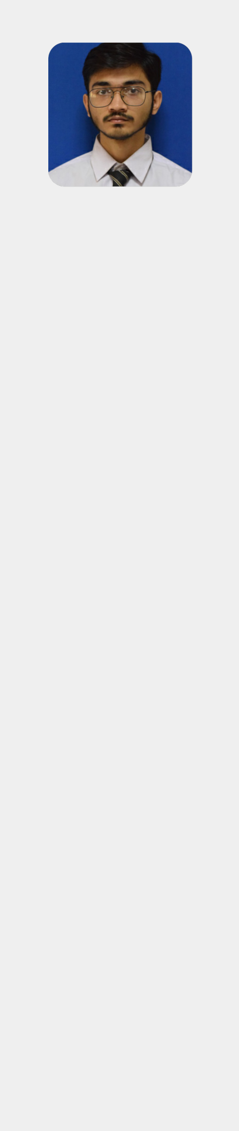

Profile

* student, looking for part-time job to help the organization grow and work on personal skills.

Contact

Karachi

03208398159

abledtaha@gmail.com

***SYED TAHA REZWAN***

Education

**Matriculation**



The Educators, Karachi | 2021 - 2022

**Intermediate (Computer Science)**



NCR-CET, Karachi | 2022 - Present

**Computer Course**



SMJ, Karachi | 2018 - 2019

Practicing on MS Office Suite

Skills

**IT Skills** **Social Skills**

Typing Speed  Dealing with



MS Office Suite  People