**Laboratory work 5 Abylaikhan**

**We continue to work with the database from the previous laboratory works.**

**Take a full-page screenshot that covers the code and results of each task.**

**Tasks**:

1. Add a CHECK constraint to passenger table to provide that passengers must be at least 10 years old.
2. 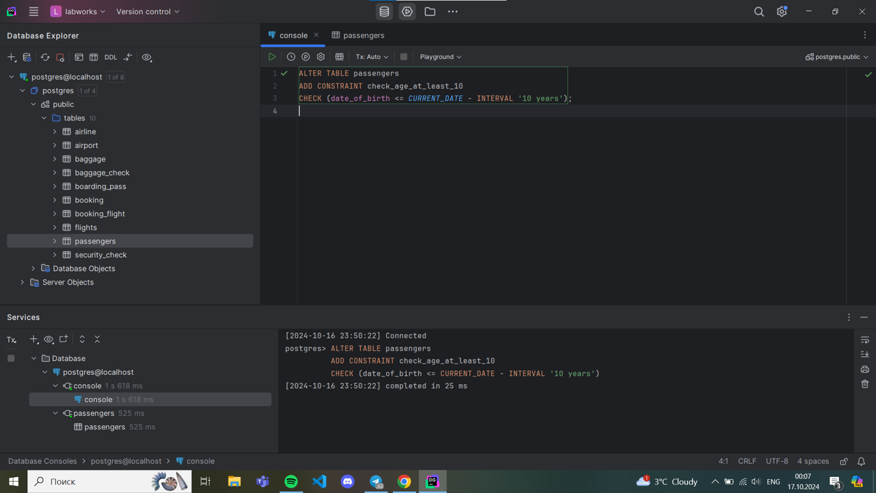
3. Add a CHECK constraint to accept values in booking price not more than 50000tg and less than 0tg.
4. 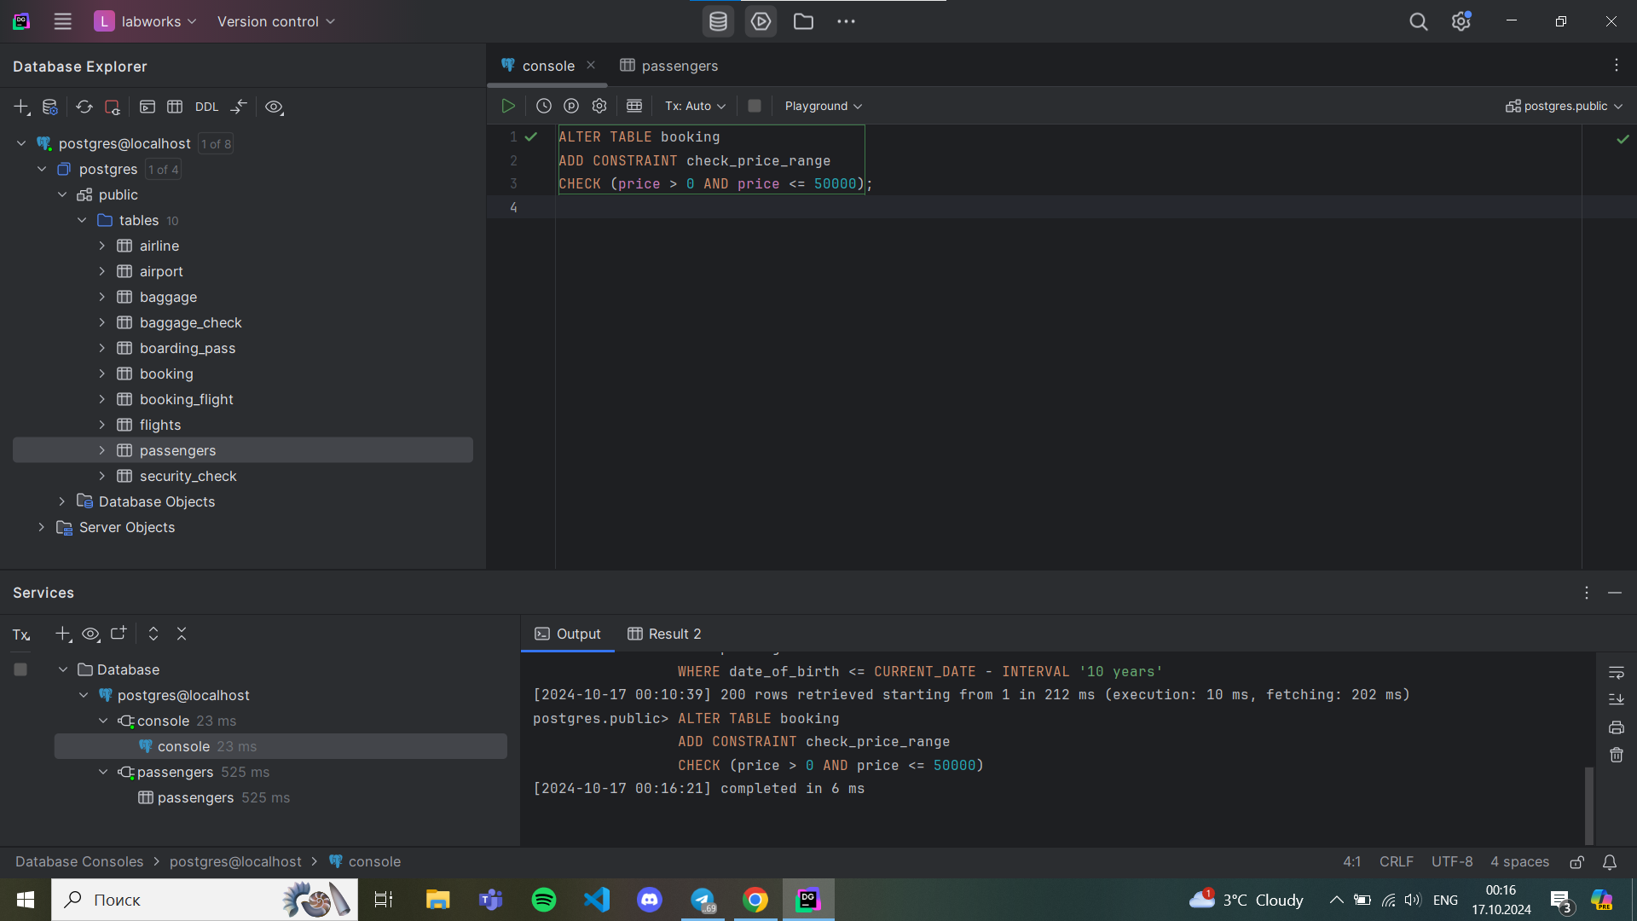
5. Add a CHECK constraint to accept the luggage weight between 1 and 23 kg.
6. 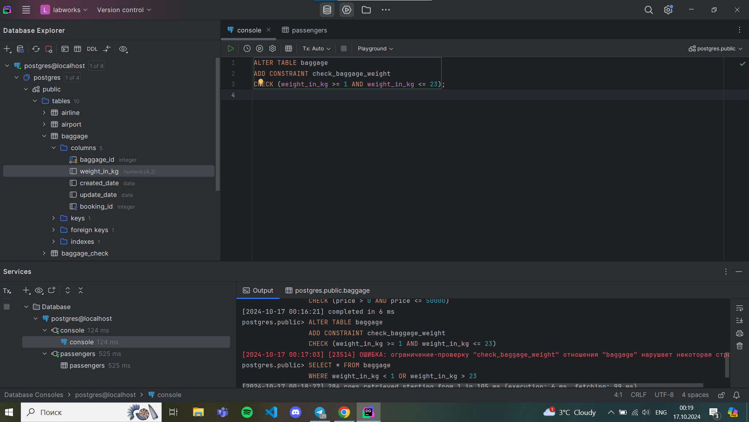
7. Add a CHECK constraint to ensure that all values in airport_name must have at least 10 characters.
8. 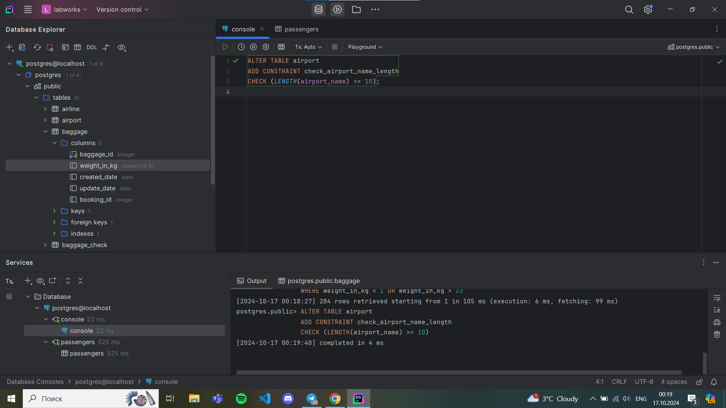
9. Add UNIQUE constraint to some columns in each table in database.
10. 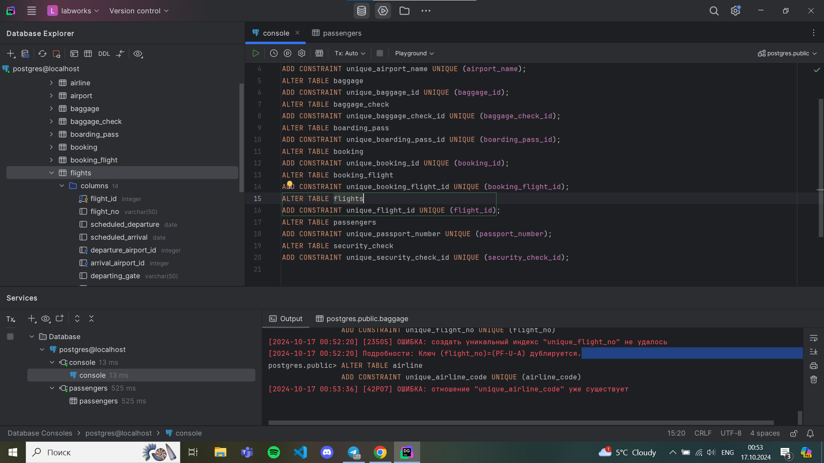
11. Add a CHECK constraint to ensure that male passengers must be at least 18 years old and female passengers must be 19 years old.
12. 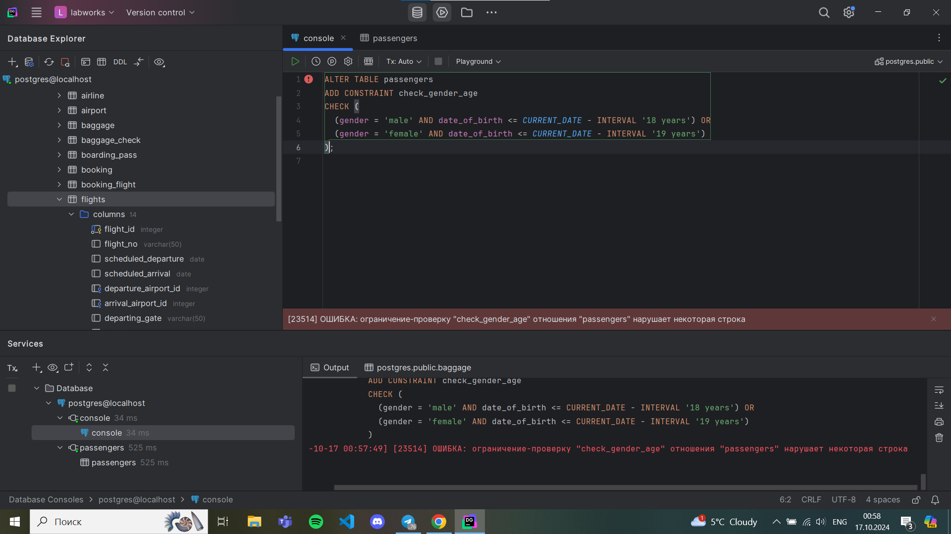
13. Add a CHECK constraint to add rule as follow (use column country_of_citizenship):

* Passengers from Kazakhstan must be at least 18 years old.
* Passengers from France must be at least 17 years old.
* Passengers from other countries must be at least 19 years old.
* 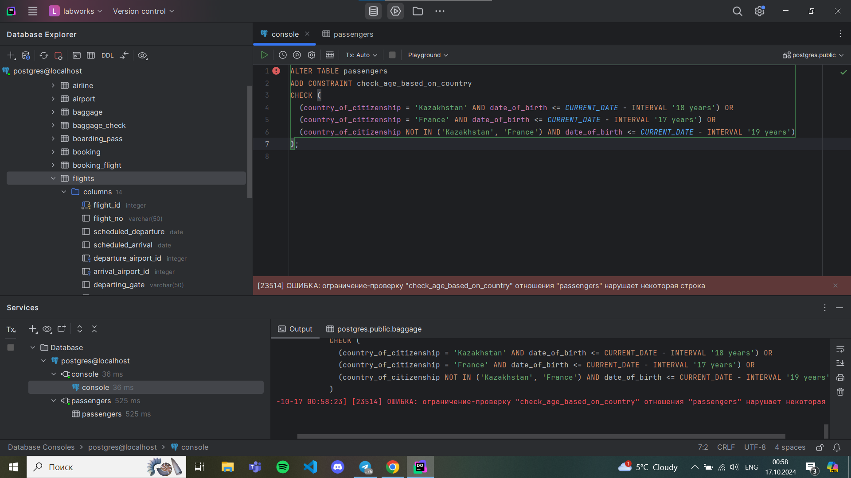

1. Add a ticket_discount column to table booking and a CHECK constraint to apply some discount based on ticket price and created time:

* the constraint applies a 5% discount for tickets created after 2024-01-01,

and 10% discount for tickets created before 2024-01-01.

