Mastering Embedded System Online Diploma

<https://www.learn-in-depth.com/>

First Term (Final Project 1)

Eng. Mohamed Abd El-Naby Mohamed

My Profile:

<https://www.learn-in-depth.com/online-diploma/mahameda.naby@gmail.com>

Table of Contents

LIST OF FIGURES 4

Description 5

System Specifications 5

System Assumptions: 5

System Architecture 5

1- Case study 5

2- Method 5

3- Requirement 6

4- Space exploration/partitioning 6

5- System Analysis 7

i- Use Case Diagram 7

ii- Activity Diagram 8

iii- Sequence Diagram (UML) 9

6- System Design 9

System Design in Details 10

1- Pressure Sensor Logic 10

2- Main Algo 11

3- Memory Driver Logic 11

4- Alarm Manger Logic 12

5- Alarm Driver 13

Blocks Implementation in C 14

1- Pressure Sensor 14

2- Main Algo 14

3- Alarm Manger 15

4- Alarm 16

Boot Sequence 17

Linker script file 18

Startup 19

Make 20

Map File 21

Memory dump 22

Symbols 24

ELF image details 25

Hardware Simulation 26

# LIST OF FIGURES

Figure 1:System Architecture 5

Figure 2:System Requirement 6

Figure 3:System Partitioning 6

Figure 4:Use Case Diagram 7

Figure 5:Activity Diagram 8

Figure 6:UML Diagram 9

Figure 7:System Design 9

Figure 8:Pressure Sensor Logic 10

Figure 9:Main Computational Logic 11

Figure 10:Memory Storing Logic 11

Figure 11:Alarm Manger Logic 12

Figure 12:Alarm Logic 13

Figure 13:Pressure C code 14

Figure 14:MainAlgo C code 14

Figure 15:Alarm Manger C code 15

Figure 16:Alarm C code 16

Figure 17:Sequence 17

Figure 18:Memory Areas in Linker Script 18

Figure 19:Memory Section in Linker script 18

Figure 20:Reset Handler in startup code 19

Figure 21:Vector Section in startup code 19

Figure 22: vector functions 19

Figure 23:Default Handler 20

Figure 24: Memory configuration in Linkerscript and map file. 21

Figure 25:Vector table position in map file 21

Figure 26:Disassemble of elf image 22

Figure 27:Memory Dump with debug section 22

Figure 28:position of .data section in flash and sram 23

Figure 29:Memory dump without dung sections 23

Figure 30:Symbols of ELF image 24

Figure 31:ELF image details 25

Figure 32:ELF image attributes 25

Figure 33:simulation test case 1 26

Figure 34:simulation test case 2 27

Pressure Detection System

# Description

This System deliver software that detect high pressure and alarm if pressure is high.

# System Specifications

1. Pressure detection at 60 bar inform with alarm.
2. Alarm duration 60 second
3. Optional Keeps track the measured values.

# System Assumptions:

1. Controller setup and shutdown procedure are not modeled.
2. Controller maintenance is not modeled.
3. Pressure sensor never fails.
4. Alarm never fails.
5. All components never face power cut.

# System Architecture

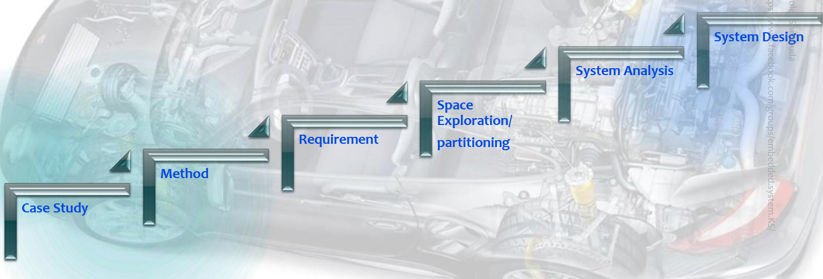

Figure :System Architecture

## Case study

software that detects high pressure and alarm for info.

## Method

Using V-Model

## Requirement

Figure :System Requirement

## Space exploration/partitioning

Figure :System Partitioning

STM 32-BIT MCU

ADC

LED info.

Storage

Compute Pressure

Main Algo

Air Pressure

Pressure Value

PressureVal > threshold

LED State

Pressure Sensor

Alarm

Memory

Optional

I used STM32F103C6 MCU which based on ARM Cortex m3 microprocessor its specification

1. ARM 32-bit Cortex™-M3 CPU Core
2. 72 MHz maximum frequency
3. Single-cycle multiplication and hardware division.
4. Memories
5. 32 Kbytes of Flash memory
6. 10 Kbytes of SRAM
7. Clock, reset and supply management
8. 2.0 to 3.6 V application supply and I/Os.
9. 4-to-16 MHz crystal oscillator.
10. 32 kHz oscillator for RTC with calibration

## System Analysis

### Use Case Diagram

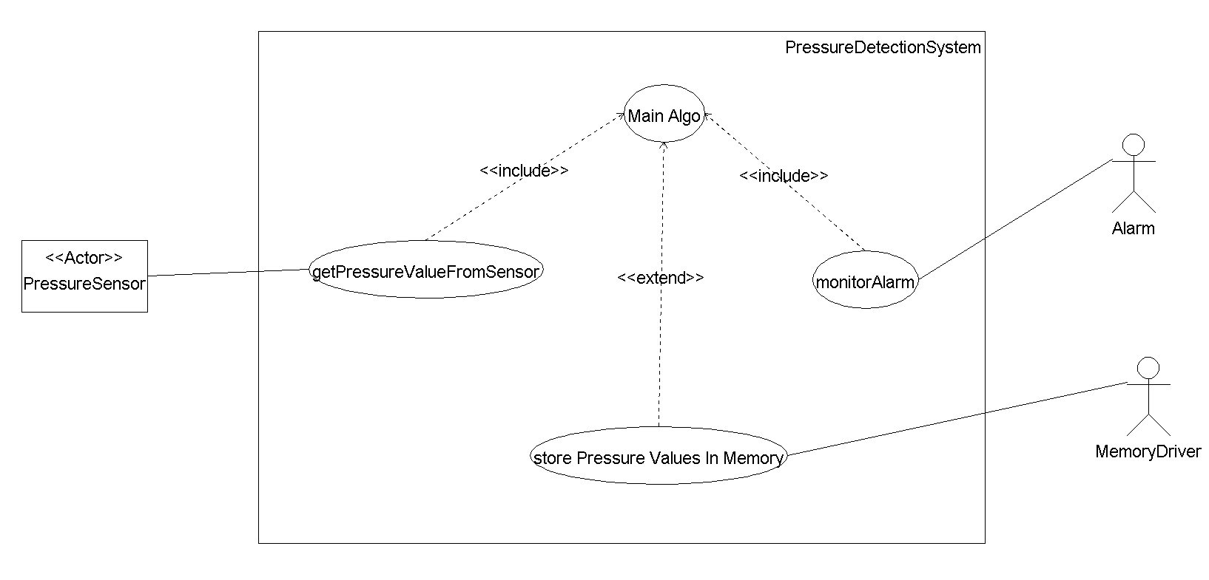

Figure :Use Case Diagram

### Activity Diagram

Figure :Activity Diagram

### Sequence Diagram (UML)

Figure :UML Diagram

## System Design

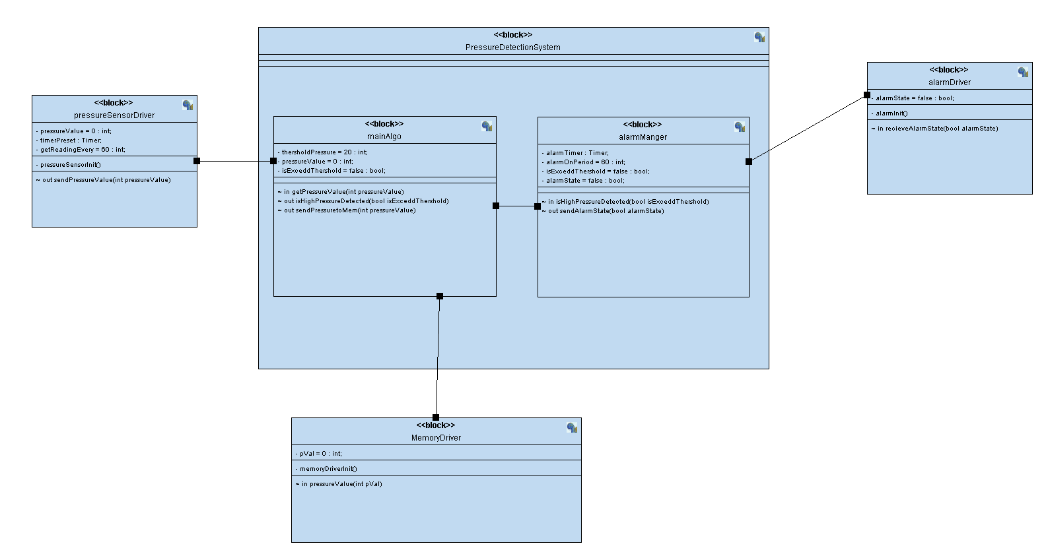

Figure :System Design

# System Design in Details

## Pressure Sensor Logic

It emulates sensor value

Figure :Pressure Sensor Logic

## Main Algo

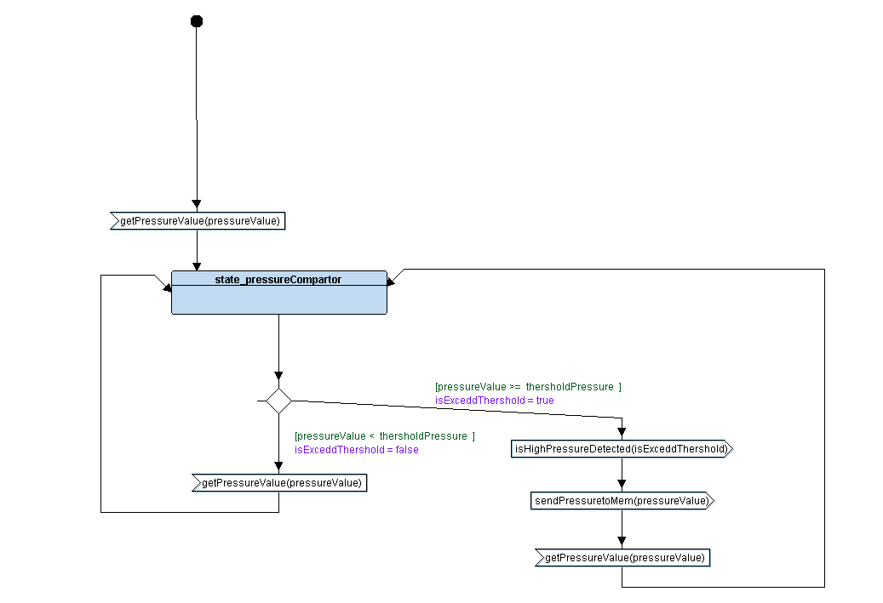

Figure :Main Computational Logic

## Memory Driver Logic

Figure :Memory Storing Logic

## Alarm Manger Logic

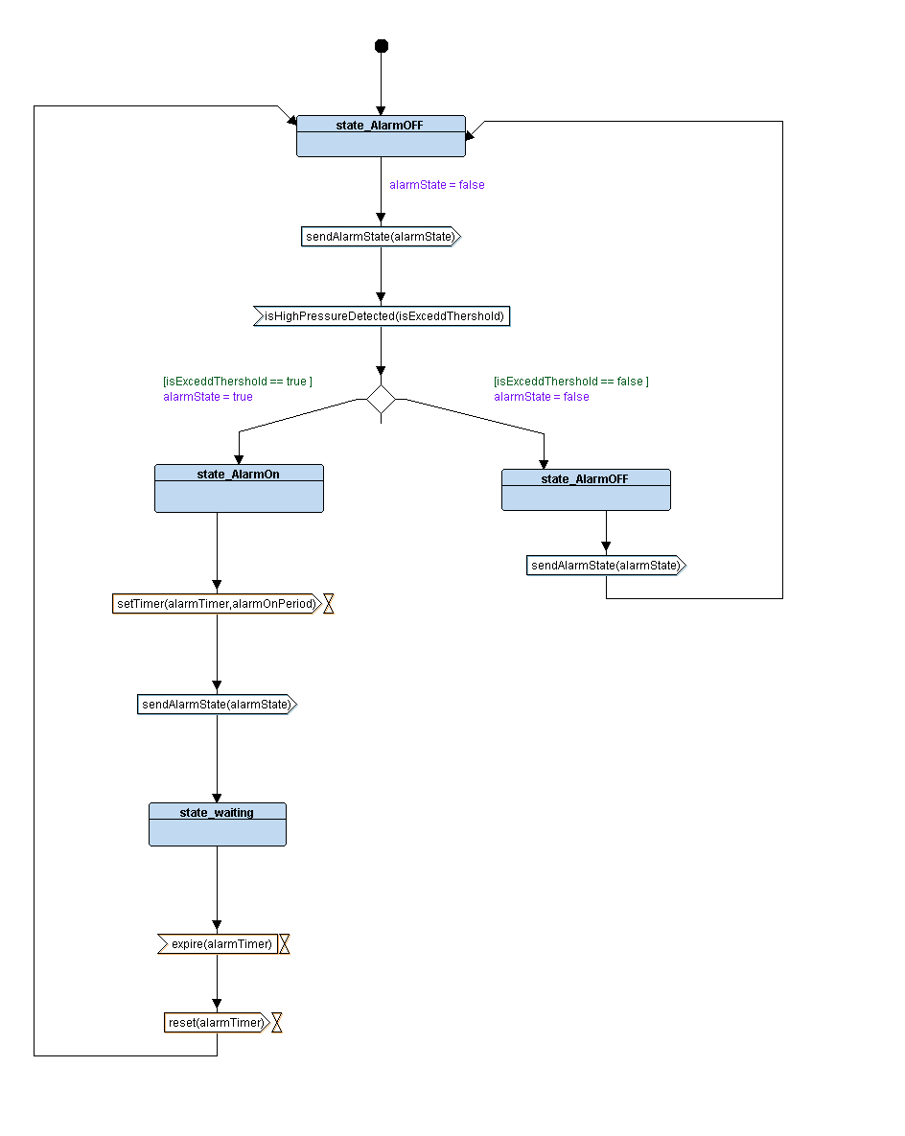

Figure :Alarm Manger Logic

## Alarm Driver

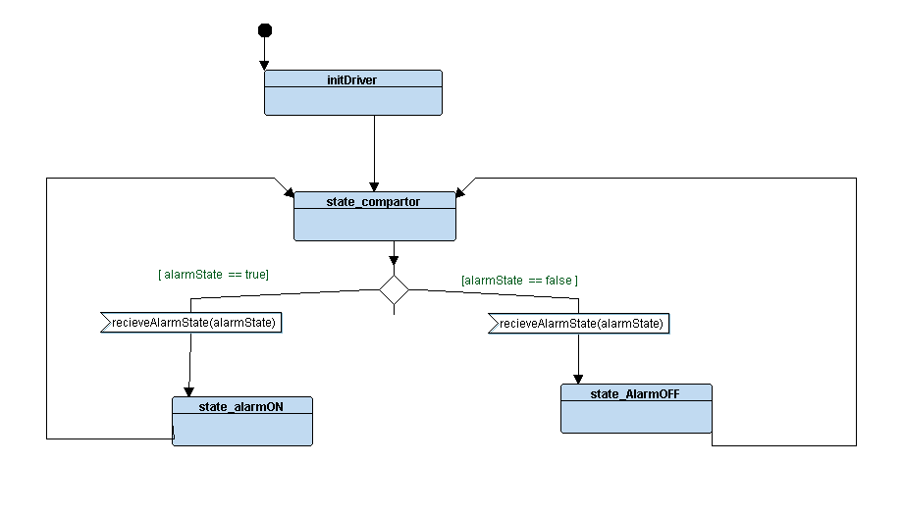

Figure :Alarm Logic

# Blocks Implementation in C

## Pressure Sensor

Figure :Pressure C code

## Main Algo

Figure :MainAlgo C code

## Alarm Manger

Figure :Alarm Manger C code

## Alarm

Figure :Alarm C code

For Source Code

# Boot Sequence

Entry Point (Reset Section)

Reset section

FLASH MEM

BareMetal SW

Figure :Sequence

Our entry point is reset handler that move .data from FLASH to SRAM and reserve .bss section in SRAM.

# Linker script file

Memory Areas and stack size

Figure :Memory Areas in Linker Script

Sections

Figure :Memory Section in Linker script

# Startup

resetHandler()

Figure :Reset Handler in startup code

Vector section

Figure :Vector Section in startup code

Vector table functions

Figure : vector functions

Weak --> to be overwritten, alias to make declaration emitted to be alias for another function.

Default handler

Figure :Default Handler

# Make

# Map File

* Memory Configuration

In LinkerScript.ld

In map file

Figure : Memory configuration in Linkerscript and map file.

* Memory map



Start address of flash memory



Figure :Vector table position in map file

Disassemble elf image

Figure :Disassemble of elf image

# Memory dump

Debug info

Figure :Memory Dump with debug section

Figure :position of .data section in flash and sram

Sections without debug

Figure :Memory dump without dung sections

# Symbols

Figure :Symbols of ELF image

All symbols successfully resolved

For each symbol check [link](https://sourceware.org/binutils/docs/binutils/nm.html)

# ELF image details

Figure :ELF image details

Figure :ELF image attributes

# Hardware Simulation

Figure :simulation test case 1

I/P Pressure = 12 bar < 20 BAR

O/P Alarm = OFF

Figure :simulation test case 2

I/P Pressure = 32 bar > 20 BAR

O/P Alarm = ON FOR 60 SEC