* Good toturial: <https://www.geeksforgeeks.org/flutter-tutorial/>
* major differences between dart and c++ is optional typing, asynchronous programming , first-class function and built-in garbage
* What's the difference between AABs and APKs? App bundles are only for publishing and cannot be installed on Android devices
* Naming Convention
  + file names in small letters and separated with underscore
  + everything starts in a capital letter is a widget
  + everytihng starts in a small letter is an argument
* VS code extensions:
  + Awesome Flutter Snippets
  + Material Icon Theme
  + Dart
  + Flutter
* Environment System Variable
  + ANDROID_SDK_ROOT = C:\Users\compu gate\AppData\Local\Android\Sdk
* Commands to start flutter app
  + flutter create counter_app
  + cd counter_app && flutter pub get
  + flutter run
* Commands to build flutter app
  + fultter clean
  + flutter build apk
* app starts from

void main(){

runApp(const MyApp());

}

* Flutter App Structure

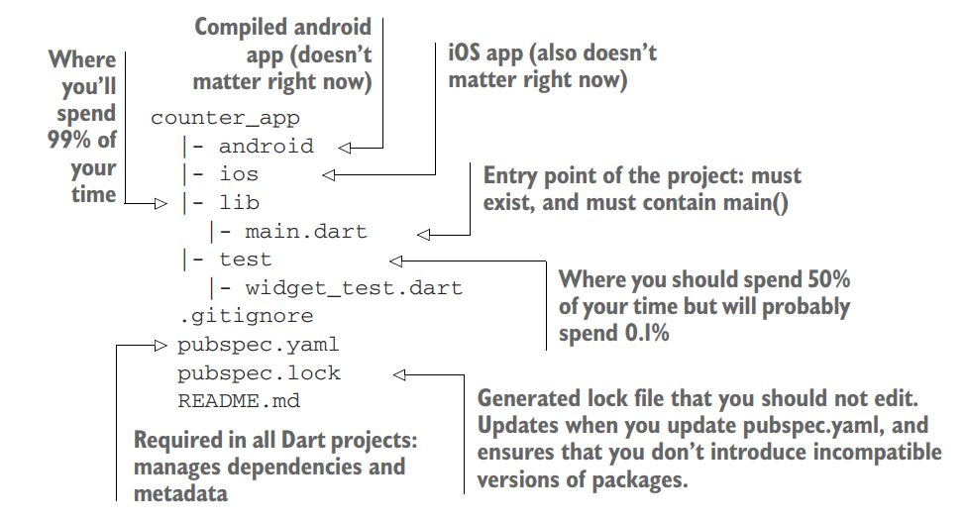

* Every widget that you create must have a build method, and that method must return another widget. In most cases, it can be any widget

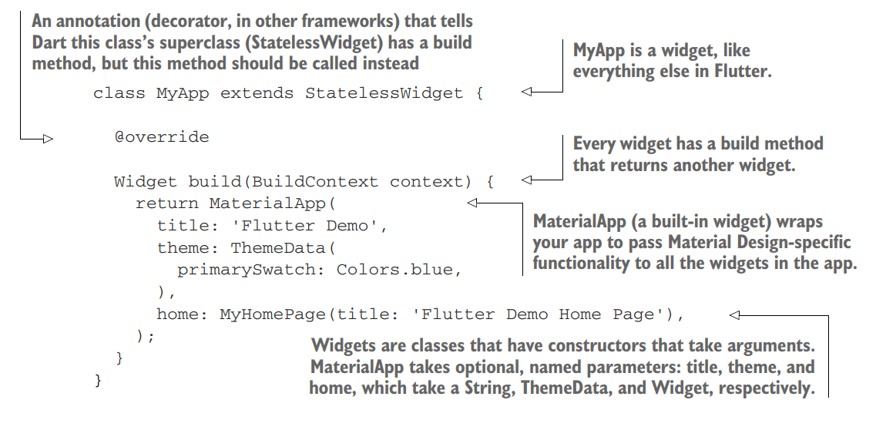

* The difference between StatefulWidget and a StatelessWidget is right in the name. A StatefulWidget tracks its own internal state. A StatelessWidget doesn’t have any internal state that changes during the lifetime of the widget. It doesn’t care about its configuration or what data it’s displaying
* setState is the third important Flutter method you have to know, after build and createState. It exists only for the state object. It more or less says, “Hey Flutter, execute the code in this callback (in this case, increase the counter variable by one), and then repaint all the widgets that rely on this state for configuration (in this case, the number on the screen in the middle of the app)
* Flexible layout most used flutter layout

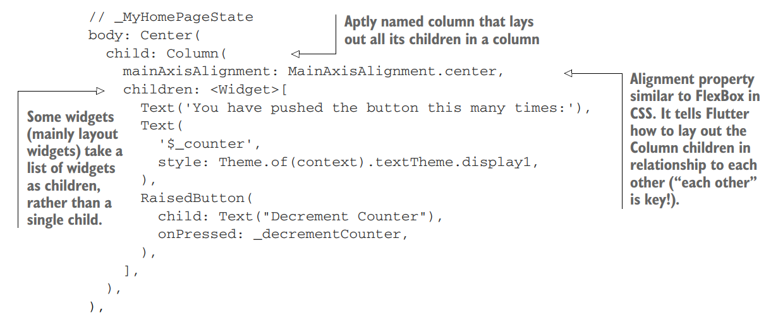

* Multi-child widgets

