Python is an interpreted high-level general-purpose programming language. Python's design philosophy emphasizes code readability with its notable use of significant indentation.

• Python is open-source and has a great support community,

• Plus, extensive support libraries.

• Its data structures are user-friendly.

Table of Contents

* Main Python Data Types
* How to Create a String in Python
* Math Operators
* How to Store Strings in Variables
* Built-in Functions in Python
* How to Define a Function
* List
* List Comprehensions
* Tuples
* Dictionaries
* If Statements (Conditional Statements) in Python
* Python Loops
* Class
* Dealing with Python Exceptions (Errors)

Python Basics: Getting Started

Most Windows and Mac computers come with Python pre-installed.

You can check that via a Command Line search.

The particular appeal of Python is that you can write a program in any text editor, save it in .py format and then run via a Command Line.

But as you learn to write more complex code or venture into data science, you might want to switch to an IDE or IDLE.

What is IDLE (Integrated Development and Learning) IDLE (Integrated Development and Learning Environment) comes with every Python installation.

Its advantage over other text editors is that it highlights important keywords (e.g. string functions), making it easier for you to interpret code.

Shell is the default mode of operation for Python IDLE. In essence, it’s a simple loop that performs that following four steps:

• Reads the Python statement

• Evaluates the results of it

• Prints the result on the screen

• And then loops back to read the next statement.

Python shell is a great place to test various small code snippets.

* Opening file modes:

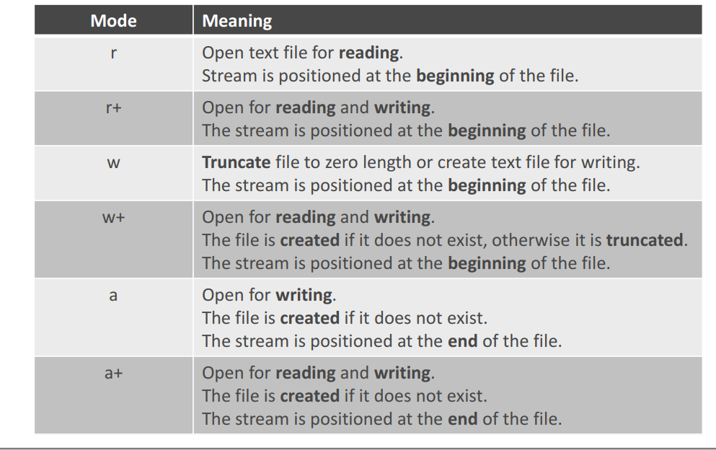

Good

1. Tuples. A tuple is simply a grouping of elements that can be of the same or different types For example, a 3-element tuple describing a book could be (title, author, number_of_pages).
2. Returning multiple values. In Python, a function or a method can return multiple values easily be returning a tuple. Combining this with tuple unpacking, you can write code like this:

max, min, avg = summarize(source)

This is also very natural and useful. In Java, I sometimes created simple result classes and returned those when I needed to return multiple values. But it took some effort, which meant that I didn’t use it as much as I would have liked.

1. Functions as arguments. In Python, functions and methods are first class objects. This means for example that they can be passed in as arguments to other functions and methods. In my opinion, this is much cleaner and easier than the Java way with interfaces (often combined with ugly anonymous implementations).
2. Stand-alone functions. In Python, you can define functions that stand by themselves, unlike in Java, where they always have to belong to a class. In Java I frequently used static methods for “functional” tasks (functions that didn’t require any state, but instead only depended on the arguments passed in).
3. Odds and ends. There are a few other features that were pleasant surprises, for example named arguments and default arguments, the built-in function enumerates, flexible string quoting (double quote or single quote, which makes it very easy to write a string containing quotation marks). I also found out that you can use the import-statement within a function, to make the dependency local to the function.

Bad

1. No Static Types. The biggest drawback for me is that there is no type information when reading code. In Java, when I saw a new function and tried to understand what it did, I almost always looked at the types of the arguments and return value to get a sense of what it did. In Python, it is much harder. It takes a lot more digging to find out what a function does in Python.
2. No Static Types. The other consequence of the dynamic typing in Python is that the “find usage” feature in the IDE is not as useful. I am using PyCharm for Python, and used IntelliJ IDEA for Java. In Java, I used “find usage” a lot to find out where a method is called from, where a class is used etc. In PyCharm the accuracy is (naturally) worse – often there are many false positives for usage, unless the name of the function is unique. So it is basically back to grep:ing the code base for a given string (like in my C++ days).