Lab 01
Getting Started
- Start MATLAB
- On the HOME tab, in the ENVIRONMENT section, click Layout, then Default.
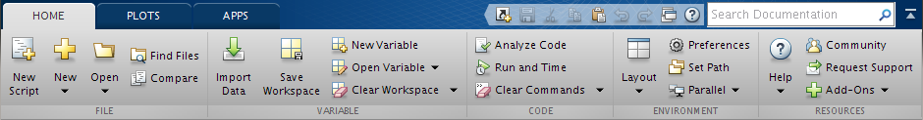
- Consider the Command Window.
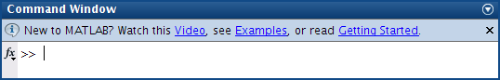
Arithmetic
- In the Command Window, type the following commands and write down the output:
  - 2+3 ↵
ans =

5
  - 2*3 ↵

  - 2/3 ↵

  - 2^3 ↵

- Write the intended operation of the following operators:
+ Addition
-
*
/
\
^
Variables
- In the Command Window, type the following commands and write down the output:
  - a=2 ↵
a =

2
  - b=3 ↵

  - c=a/b ↵

- Consider the Workspace.
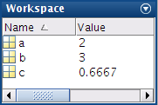
- In the Command Window, type the following commands:
  - a=4; ↵
  - b=5; ↵
- From the Workspace, write the values of the variables a, b, and c.
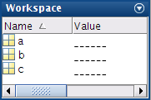
- In the Command Window, type the following commands and write down the output:
  - a=4;b=5; ↵
  - a=4,b=5, ↵

- Notice that both (,) and (;) can be used to separate commands, but (;) suppresses the output.

- In the Command Window, type the following commands, write down the output, and monitor the Workspace:
  - clc ↵
  - clear ↵
  - a=4; ↵
  - whos ↵

  - b=5; ↵
  - whos ↵

  - clear a ↵
  - whos ↵

  - help clc ↵

- Write the purpose of using the following functions:
clc to clear command window
clear
whos
help
Mathematical Functions
- In the Command Window, type the following commands and write down the output:
  - sin(pi/2); ↵

  - tan(0); ↵

- Write the purpose of the following functions:
sin to calculate sine of argument in radians
cos
tan
sqrt
Vectors
- In the Command Window, type the following commands and write down the output:
  - a=0:10 ↵

  - b=0:2:20 ↵

  - c=a+b ↵

Plot
- In the Command Window, type the following commands and write draw the output:
  - x=0:0.1:4*pi; ↵
  - y=sin(x); ↵
  - plot(x,y,'-+r'),grid ↵
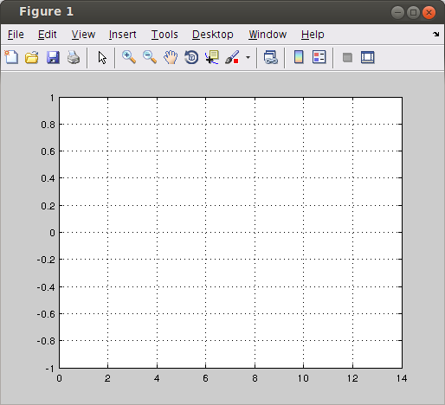
- Try different plot styles.

You may like to try other Layout options.

