Lab 02
Getting Started
- Start MATLAB
- On the HOME tab, in the ENVIRONMENT section, click Layout, then Default.
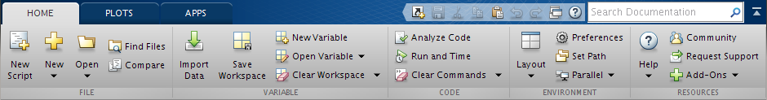
- Consider the Command Window.
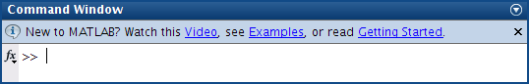
Numbers
- Which of the following numbers are/not acceptable in MATLAB? If not, state why.
9,87 not acceptable because of the comma
–356231
3.57*e2
3.57e2.1
3.57e+2
3,57e–2
Variable
- Which of the following are/not valid variable names in MATLAB? If not, state why.
What valid
min*2
Inf
pay day
miXedUp
’a’one
a.2

Arithmetic
- Translate the following expressions into MATLAB:
A+B/C

- Write the equivalent MATLAB statement for the following:
Add 1 to the value of x and store the result in x. x = x + 1;
Cube x, add y to this, and store the result in x.
Set g equal to the larger of the two variables e and f.
If d is greater than 0, set x equal to −b.
Divide the sum of a and b by the product of c and d, and store the result in x.
Syntax
- What’s wrong with the following MATLAB statements?
n + 1 = n; it is invalid to assign to an expression
Fahrenheit temp = 9*C/5 + 32;
x = sqrt(4,2);
x.1 = 2;
n = 1,345;
Applications
- There are eight pints in a gallon and 1.76 pints in a liter. The volume of a tank is given as 2 gallons and 4 pints. Write a script that inputs this volume in gallons and pints and converts it to liters.

- Write some statements in MATLAB that exchange the contents of two variables 'x' and 'y', using only one additional variable 'z'. Is it possible without using any additional variables? If yes, how; otherwise, why?

- Write a program to calculate , where and .

Vectors
- Generate a table of conversions from degrees (first column) to radians (second column). Degrees should go from 0◦ to 360◦ in steps of 60◦. Recall that π radians = 180◦.

- Write some statements that display a list of integers from 10 to 20 inclusive, each with its square root next to it.

You may like to try other Layout options.

