Lab 03
Getting Started
- Start MATLAB
- On the HOME tab, in the ENVIRONMENT section, click Layout, then Default.
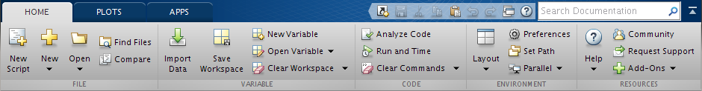
- Consider the Command Window.
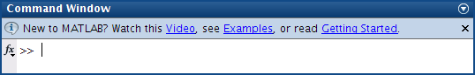
Vectors
- Ten students in a class take a test. The marks are out of 10. All the marks are entered in a MATLAB vector, marks. Write a statement to find and display the average mark.
Try it on the following: 5 8 0 10 3 8 5 7 9 4

- What are the values of x and a after the following statements have been executed?
a = 0; i = 1; x = 0; a = 0 x = 0
a = a + i; a = x =
x = x + i / a; a = x =
a = a + i; a = x =
x = x + i / a; a = x =
a = a + i; a = x =
x = x + i / a; a = x =
a = a + i; a = x =
x = x + i / a; a = x =
Loops
- Rewrite the statements in the previous exercise more economically by using a for loop. Can you do even better by vectorizing the code?

- Work out by hand the output of the following script for n = 4:
n = input( 'Number of terms? ' );
s = 0;
for k = 1:n
s = s + 1 / (k ^ 2);
end;
disp(sqrt(6 * s))
k = 1, s = 0+1/1²=1
k = 2, s =
k = 3, s =
k = 4, s =

- If you run this script for larger and larger values of n, you will find that the output approaches a well-known limit. Can you figure out what it is? Now rewrite the script using vectors and array operations.

Applications
- The steady-state current I flowing in a circuit that contains a resistance , capacitance , and inductance in series is given by

where and are the input voltage and angular frequency, respectively. Compute the value of .

- The electricity accounts of residents in a very small town are calculated as follows:
- If 500 units or fewer are used, the cost is 2 cents per unit.
- If more than 500 but not more than 1000 units are used, the cost is $10 for the first 500 units and 5 cents for every unit in excess of 500.
- If more than 1000 units are used, the cost is $35 for the first 1000 units plus 10 cents for every unit in excess of 1000.
- A basic service fee of $5 is charged, no matter how much electricity is used.
Write a program that enters the following five consumptions into a vector and uses a for loop to calculate and display the total charge for each one: 200, 500, 700, 1000, 1500.

- A mortgage bond (loan) of amount L is obtained to buy a house. The interest rate r is15%.The fixed monthly payment P that will pay off the bond loan over N years is given by the formula

- Write a program to compute and print P if N = 20 and the bond is for $50,000.You should get $658.39.
- See how P changes with N by running the program for different values of N (use input). Can you find a value for which the payment is less than $625?
- Go back to N = 20 and examine the effect of different interest rates. You should see that raising the interest rate by 1% (0.01) increases the monthly payment by about $37.

You may like to try other Layout options.

