Lab 04
Getting Started
- Start MATLAB
- On the HOME tab, in the ENVIRONMENT section, click Layout, then Default.
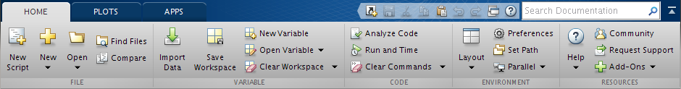
- Consider the Current Folder window, right click, New File, Function.
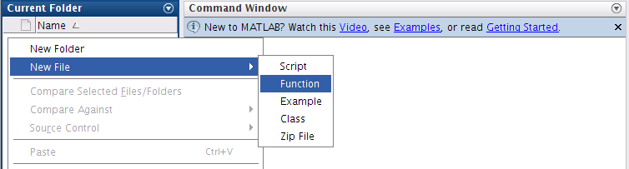
User Defined Functions
- Define a function average in a file named average.m that accepts an input vector, calculates the average of the values, and returns a single result. Call the function from the command line to calculate the average of
z = [1,2,3,4,……,99].
function [ ave ] = average( X )

end

- Define a function min_max in a file named min_max.m that returns the minimum and the maximum values of an input vector. Call the function from the command line to find the minimum and maximum of
values = [12.7, 45.4, 98.9, 26.6, 53.1]
function

end

- There are 39.37 inches in a meter, 12 inches in a foot, and 3 feet in a yard. Write a function meter2yard to input a length in meters (which may have a decimal part) and convert it to yards, feet, and inches.
(Check: 3.51 m converts to 3 yds, 2 ft, 6.19 in.)
function [ ave ] = average( X )

end

Plot
- Try the following code snippets:

  - clear; clc; close;
  - x = -pi:0.01:pi;
  - y = cos(x);
  - plot(x,y)

  - clear; clc; close;
  - x = 1:0.1:2*pi;
  - y = sin(x);
  - plot(x,y)

  - clear; clc; close;
  - x = -pi:0.01:pi;
  - y = cos(x);
  - plot(x,y)
  - xlabel('x');
  - ylabel('cos(x)');
  - title('Graph of cosine fron -\pi to \pi')

  - clear; clc; close;
  - x=-pi:pi/100:pi;
  - y=sin(x);
  - plot(x,y)
  - axis([-pi pi -1 1])
  - xlabel('x')
  - ylabel('sin(x)')
  - title('Graph the sine function')
  - text(1,-1/3,' Note the odd symmetry ')

You may like to try other Layout options.

