PHP is a general-purpose scripting language geared towards web development.

PHP code is usually processed on a [web server](https://en.wikipedia.org/wiki/Web_server) by a PHP [interpreter](https://en.wikipedia.org/wiki/Interpreter_(computing)) implemented as a [module](https://en.wikipedia.org/wiki/Plugin_(computing)), a [daemon](https://en.wikipedia.org/wiki/Daemon_(computing)) or as a [Common Gateway Interface](https://en.wikipedia.org/wiki/Common_Gateway_Interface) (CGI) executable. On a web server, the result of the [interpreted](https://en.wikipedia.org/wiki/Interpreter_(computing)) and executed PHP code – which may be any type of data, such as generated [HTML](https://en.wikipedia.org/wiki/HTML) or [binary](https://en.wikipedia.org/wiki/Binary_number) image data – would form the whole or part of an [HTTP](https://en.wikipedia.org/wiki/Hypertext_Transfer_Protocol) response.

PHP is a widely-used, free, and efficient alternative to competitors such as Microsoft's ASP.

HP is an acronym for "PHP: Hypertext Preprocessor"

Table of Contents

Variables and Constants

PHP Arrays - Grouped Values

PHP Strings

PHP Operators

Loops in PHP

Conditional Statements

Working with Forms in PHP

Regular Expressions

PHP Functions

PHP Filters

HTTP Functions in PHP

Working with MySQL

Date and Time

PHP Errors

Types of Data

Integers

Floats

Strings

Boolean 🡪 values Meaning true/false statements.

Arrays

Objects

Resources 🡪 These are references to functions and resources outside of PHP.

Set Up PHP on Your Own PC

However, if your server does not support PHP, you must:

* install a web server
* install PHP
* install a database, such as MySQL

In PHP, keywords (e.g. if, else, while, echo, etc.), classes, functions, and user-defined functions are not case-sensitive.

Look at the example below; only the first statement will display the value of the $color variable! This is because $color, $COLOR, and $coLOR are treated as three different variables:

PHP ARRAYS – GROUPED VALUES

Indexed arrays 🡪 Arrays that have a numeric index

Associative arrays 🡪 Arrays where the keys are named

Multidimensional arrays 🡪 Arrays that contain one or more other arrays

Difference between echo and print

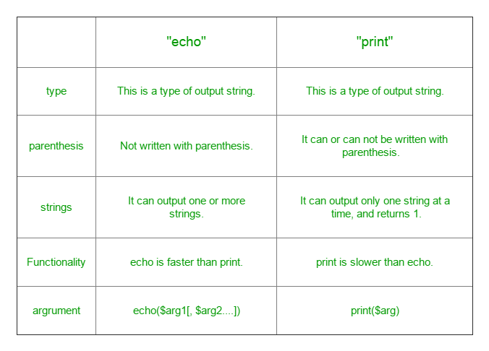

Defining Strings

Single quotes 🡪 This is the simplest way. Just wrap your text in ' markers and PHP will handle it as a string.

Double quotes🡪 As an alternative you can use ". When you do, it’s possible to use the escape characters below to display special characters.

Heredoc 🡪 Begin a string with <<< and an identifier, then put the string in a new line. Close it in another line by repeating the identifier. heredoc behaves like double-quoted strings.

Nowdoc 🡪 Is what heredoc is for double-quoted strings but for single quotes. It works the same way and eliminates the need for escape characters.

Escape Characters

\n — Line feed

\r — Carriage return

\t — Horizontal tab

\v — Vertical tab

\e — Escape

\f — Form feed

\\ — Backslash

\$ — Dollar sign

\’ — Single quote

\" — Double quote

\[0-7]{1,3} — Character in octal notation

\x[0-9A-Fa-f]{1,2} — Character in hexadecimal notation

\u{[0-9A-Fa-f]+} — String as UTF-8 representation

WORKING WITH FORMS IN PHP

Using GET vs POST

GET collects data via URL parameters. That means all variable names and their values are contained in the page address.

The advantage of this is that you’re able to bookmark the information. Keep in mind that it also means that the information is visible to everyone. For that reason, GET is not suitable for sensitive information such as passwords. It also limits the amount of data that can be sent in ca 2000 characters.

POST, on the other hand, uses the HTTP POST method to pass on variables. This makes the data invisible to third parties, as it is sent in the HTTP body. You are not able to bookmark it.

With POST, there are no limits to the amount of information you can send. Aside from that, it also has advanced functionality and is therefore preferred by developers.

Form Security

PHP offers tools to thwart those attacks, namely:

htmlspecialchars() trim() stripslashes()

Required Fields, Error Messages and Data Validation

Aside from that, PHP is able to define required fields (you can’t submit the form without filling them out), display error messages if some information is missing and to validate data. We have already talked about the necessary tools to do so.

For example, you can simply define variables for your form fields and use the empty() function to check if they have values. After that, create a simple if/else statement to either send the submitted data or output an error message.

The next step is to check submitted data for validity. For that, PHP offers a number of filters such as FILTER_VALIDATE_EMAIL to make sure a submitted email address has the right format.

|  |  |
| --- | --- |
| Javascript | Php |
| Does job for Both Front-end and Back-end. | Php is used mostly for Back-end Purposes only. |
| Javascript is synchronous but it has a lot of features like callbacks, promises, async/await which allows to implement asynchronous event handling | Php is synchronous, It waits for IO operations to execute. |
| Can be run in browsers and after Node, we can also run it in Command line3. | Php requires a Server to Run. Cannot run without a server. |
| Js can be combined with HTMl, AJAX and XML. | Can be combined with HTML only. |
| It is a single threaded language that is event-driven which means it never blocks and everything runs concurrently. | It is multi-threaded which means it blocks I/O to carry out multiple tasks concurrently. |