Postprocessing Stage Results
SAREdgeNet | Water manuscript water-4645099
The example below shows boundary support, seed growth, boundary refinement and internal-gap filling. The figure illustrates one lake; Table 1 summarizes the same fixed Kokoxili region of interest across the measured stages.
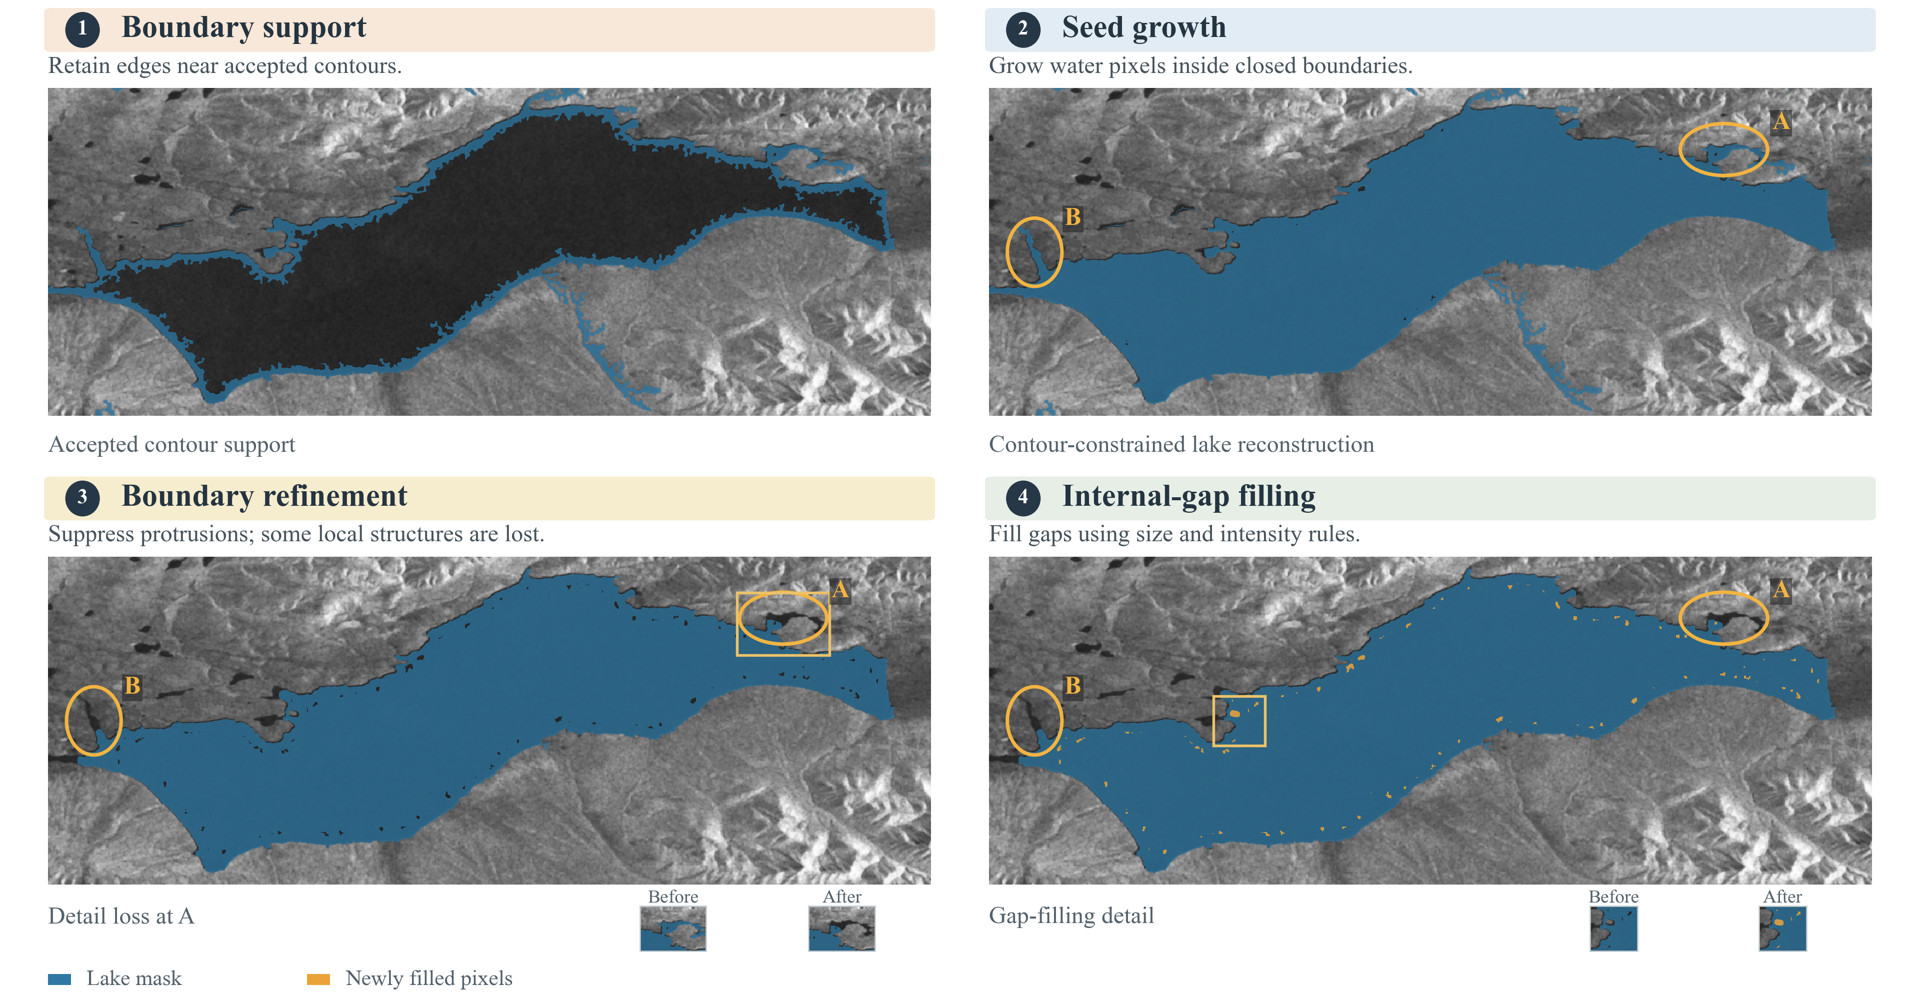
Figure 1. Stage-by-stage example. Blue denotes the lake mask; orange denotes newly filled pixels. Markers A and B identify local shoreline structures reduced or removed during boundary refinement. The insets show detail loss and gap filling.
Table 1. Pixelwise stage comparison in the Kokoxili ROI (%).
Stage | Precision | Recall | F1 | Lake IoU
Initial mask after seed growth | 74.94 | 92.85 | 82.94 | 70.85
After boundary refinement | 94.58 | 88.97 | 91.69 | 84.65
After internal-gap filling | 94.42 | 89.89 | 92.10 | 85.36

What changes between stages
Boundary refinement removes many false-positive pixels, increasing precision and F1, but also removes some reference-water pixels and lowers recall. Internal-gap filling recovers some interior omissions and raises recall and F1. It does not restore all shoreline detail removed by refinement.

Evaluation conditions
All three rows use the same ROI, reference and valid grid, with one frozen existing 43-control-point registration and no per-stage registration fitting. All lake sizes are included, and no largest-component filter is applied. The initial mask already includes seed growth; this is not a comparison with every postprocessing operation disabled. These local supplementary results are separate from the external regional evaluation.
Supporting files in the archived source version: stage image | stage metrics | pixel changes | evaluation code

