<http://www.robots.ox.ac.uk/~vgg/data/data-mview.html> (书中网址已失效)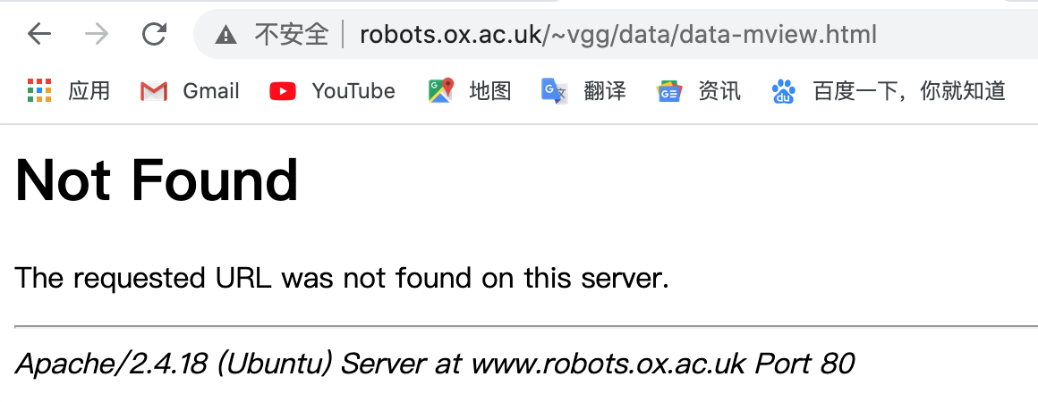

<http://www.robots.ox.ac.uk/~vgg/data/>

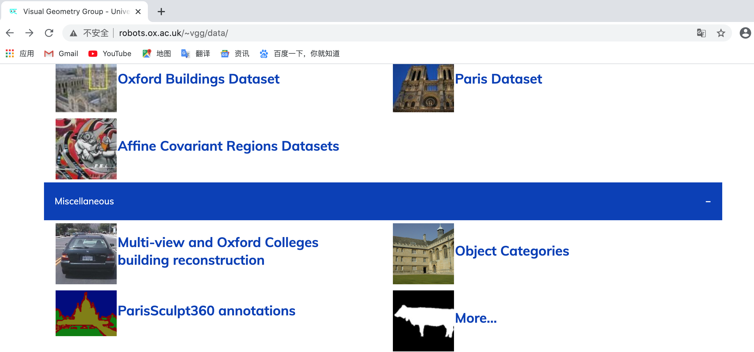

点击[Multi-view and Oxford Colleges building reconstruction](http://www.robots.ox.ac.uk/~vgg/data/mview/)进入牛津多视数据集网站

<http://www.robots.ox.ac.uk/~vgg/data/mview/>

[Multi-view and Oxford Colleges building reconstruction](http://www.robots.ox.ac.uk/~vgg/data/mview/)

点击

点击[Images - 11 frames](http://www.robots.ox.ac.uk/~vgg/data/corridor/images.tar.gz)下载牛津corridor序列

http://www.robots.ox.ac.uk/~vgg/data/corridor/images.tar.gz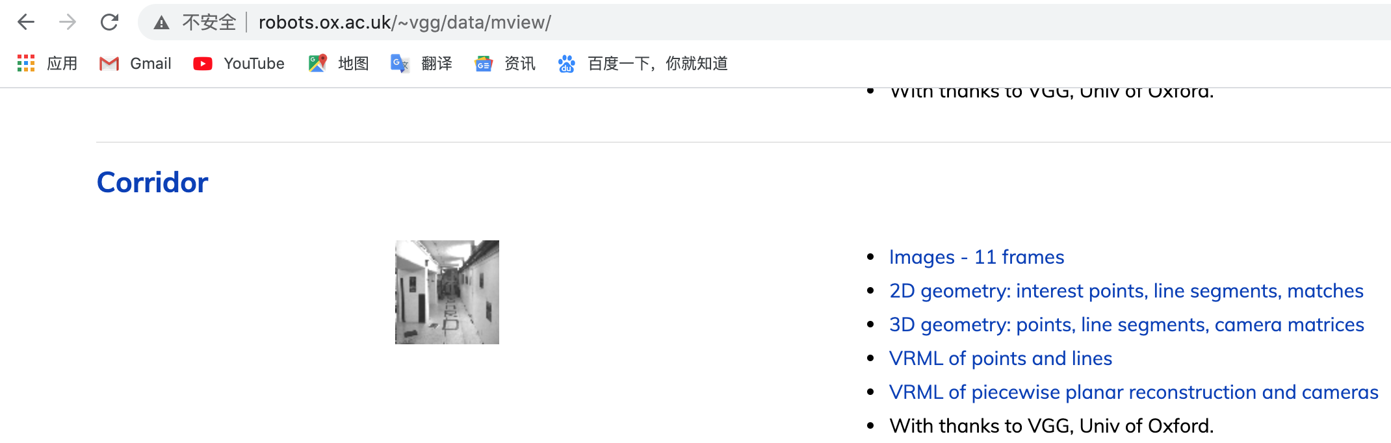

点击[Images - 10 frames](http://www.robots.ox.ac.uk/~vgg/data/dunster/images.tar.gz)下载牛津dinosaur序列

<http://www.robots.ox.ac.uk/~vgg/data/dino/images.tar.gz>