TECHNICAL FINDINGS REPORT

Project 1 Feature Research
  - What has been achieved, the essential findings, and a review of the notebook's scripts and safeguards
Primary source: notebooks/exploration/feature_research_1.ipynb
Notebook scope: 67 cells; 24 executed code cells; four unexecuted Section 6 result cells
Repository state: Branch AMM; base commit e75cab144f9f2096d51262c5da478166e116c9c5
Report date: 26 July 2026
Current decision: PREDICTIVE_ONLY_NOT_DIRECTIONAL - stop before Section 7
Bottom line: The single locked retrospective Validation batch is complete. Four predeclared base features advance, but zero interactions, zero continuous models, and zero expansion classifiers advance. The headline verdict is PREDICTIVE_ONLY_NOT_DIRECTIONAL: FROZEN_NO_POLICY remains in force, GC economics are not applicable, and Section 7 MGC transfer is not permitted.

Executive summary
• Completed scope. Sections 1-6 are artifact-complete: contract/provenance, features, profiles, Development evidence, nested model freezing, and one locked Validation batch. Historical Final remains unread.
• Trial accounting. 148 of 150 predeclared trials are complete. Only the two Section 7 MGC-transfer trials remain planned, and the Section 6 verdict explicitly states that MGC work is not permitted.
• Feature evidence. All four Development-supported base features pass their frozen Validation gates and advance. The other 16 confirmatory features and all eight interactions do not advance.
• Model evidence. Validation directional ICs are positive, but every selected continuous model fails the full gate. London's M8 models underperform their anchors in Validation, and the 378-date Development sample remains below the frozen 400-date minimum. Range/expansion prediction stays strongest.
• Policy status. The fitted p90 directional and p80 expansion thresholds remain inactive. No trades were executed, so expectancy, Sharpe, drawdown, and cost sensitivity are correctly marked not applicable.
• Most important audit caveat. Section 6 artifacts exist and hash-verify, but the notebook's four Section 6 code cells are unexecuted and show no saved outputs. The notebook, FES modules, runner, and focused tests are also untracked, so the recorded base commit does not capture the executed source state.

Achievement snapshot
Section | Status | Research job | Delivered | Evidence boundary
1 | Complete | Frozen contract and trusted data | 150-trial ledger; provenance and access rules | No outcomes used
2 | Complete | Scalar features and interactions | F01-F10, H01, I01-I04; sealed Validation features | Development diagnostics only
3 | Complete | Profile representations | P0 raw profiles; P1-P3 transforms and fold-local interfaces | Outcome-free
4 | Complete | Feature evidence | 20 confirmatory, 40 exploratory, 8 interaction trials | Development outcomes only
5 | Complete | Nested models and policy freeze | 54 continuous, 12 classifier, 2 policy trials | Development OOF only
6 | Complete | Locked Validation / GC gate | 12 complete-not-applicable trials; 26 hashed artifacts | Validation read once; Historical Final unread
7 | Not run | MGC structural transfer | 2 planned trials | Not permitted by Section 6 verdict

1. Scope, evidence boundary, and review method
This report treats the notebook's saved execution as the primary research record and cross-checks it against the v1 checkpoint files, CSV evidence tables, figures, manifests, and implementation modules. The current notebook has 67 cells and 28 code cells. Its first 24 code cells are executed sequentially from 1 to 24 with no saved error output; the four appended Section 6 code cells are unexecuted and have no saved outputs.
The code flow was traced through GitNexus and then checked in source. The principal chains are build_scalar_feature_matrix -> _legal_continuity -> build_continuity_run_id; build_profile_matrix -> _legal_continuity -> build_continuity_run_id; build_section4_evidence -> partial/univariate/interaction evidence; and build_section5_development -> exact date folds -> nested models -> frozen thresholds and policy. The newer Section 6 chain was source-traced as hash authorization -> locked comparator preparation -> one-time Validation load -> frozen scoring/gates -> not-applicable economics -> immutable save.
As an independent current check, the five focused suites for features, profiles, Development evidence, nested modeling, and locked Validation evaluation were rerun together: 90 tests passed in 78.33 seconds. The earlier executed notebook record reports a full-repository result of 309 passed plus three subtests; a new full suite after Section 6 was not rerun for this report.
Interpretation rule: Development evidence is not Validation evidence. DEV_SUPPORT, model selection, and fitted thresholds are research-stage outputs only. The report does not treat them as final advancement, live-strategy approval, or economic proof.

Frozen market and data contract
• GC is the signal instrument. MGC is coverage context only until a GC policy is frozen.
• Decisions use information through completed GC bar t; earliest entry is the true t+1 open.
• Entry windows are London [03:00, 06:00) and New York [07:00, 12:00), America/New_York, with a [06:00, 07:00) no-entry gap.
• Positions must be flat by 15:30 New York time; overnight positions are prohibited.
• Continuity may not cross date, product, instrument, selected contract, continuous segment, roll/liquidity boundary, or one-minute timestamp gaps.
• Development is through 2023; retrospective Validation is calendar 2024; Historical Final is 2025 through 22 May 2026 and remains unread.

2. What has been achieved

Section 1 - Contract, provenance, and trusted data
The notebook froze a deterministic v1 specification, configuration, and trial ledger before outcome-driven work. The specification SHA-256 is c7c87fe613788ecb4cbde8bb7973def9014b7572ebb9d5351d714f004342eb3a; the frozen config SHA-256 is efb7ee9a79a81b96023fd20ae747a99129809ba4307a314d482b0370b648401f; and the original 150-row ledger SHA-256 is 60eadc61477430b3fb6e4ba7719db983270c4d8ea5a49c747d1827d1009cbb5a.
Partition | London | New York | Total rows | NY dates
Development | 114,834 | 191,396 | 306,230 | 638
Validation | 44,276 | 73,800 | 118,076 | 246
Historical Final | 60,828 | 101,396 | 162,224 | 338
All eligible decisions | 219,938 | 366,592 | 586,530 | 1,222 partition-dates

The trusted one-minute bar store contains 3,487,656 rows: 1,759,671 GC rows and 1,727,985 MGC rows over 1,556 dates. There are 1,721,888 synchronized minutes, covering 97.8528% of GC minutes and 99.6472% of MGC minutes. The existing GC feature matrix and labels each contain 586,530 aligned observation IDs; the existing registry contains 85 unique features, including six marked experimental.
The frozen 15-feature O1 content matches the prompt exactly as a set, although its stored row order differs from the prompt listing. Nine untracked MLAT scratch files were inventoried and explicitly excluded from evidence and models. Historical research context also records: zero advancing directional features, strong unsigned/expansion predictability, four rejected standalone sequential variants under base costs, an archived True-POI policy that turned negative at the 2.6-tick base cost, and no approved live strategy.

Section 2 - Scalar path features and interactions
The notebook implemented ten frozen scalar features (F01-F10), one hierarchy-support transform (H01), and four predeclared interactions (I01-I04). Calculations use float64 working arrays, are saved as float32, map decision IDs and timestamps to the same source row, and apply the production continuity identity plus an outer New York trade-date reset.
Coverage is exceptionally high. Across 306,230 Development observations, complete rows range from 305,659 for the longest lagged-volume feature to 306,114 for clipped relative volume. Every feature covers all 638 Development dates in both sessions. The integrity audit found zero infinite values, zero integrity failures, zero observed degenerate rows, and zero formula-defined-zero rows.
Redundancy finding: Several attractive raw constructions are close substitutes for existing features. F01 correlates 0.914 with 30-minute return and 0.825 with normalized slope; F02 correlates 0.887 with realized volatility and 0.859 with ATR20; F05 correlates 0.876 with momentum acceleration; and F06 correlates 0.777 with rolling range position. By contrast, F07-F09 are largely orthogonal to their named comparators.
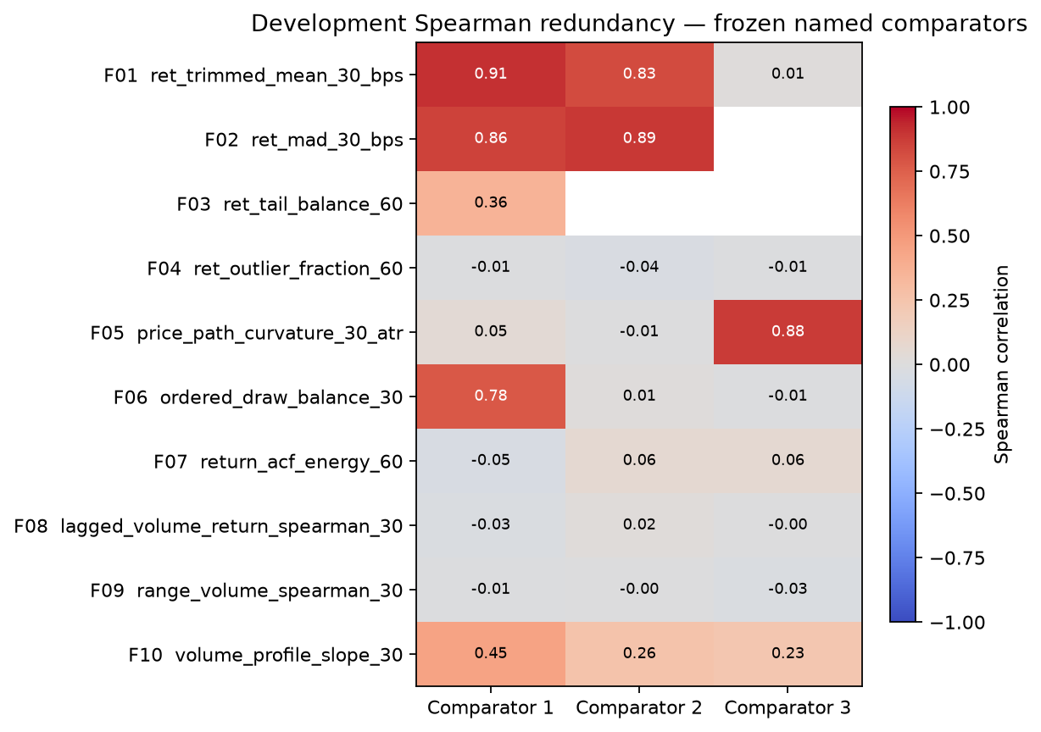
Figure 1. Development-only redundancy against the frozen named comparators.
Source: reports/statistical_research/fes_project1/v1/section2_named_comparator_heatmap_development.png

Section 3 - Multichannel profile representations
The exact P0 profile stores 30 ordered positions for each of three channels: one-bar log return in basis points (R), true range divided by ATR20 (G), and trailing-60 log-volume z-score (Q). The stored order is R_0..R_29, G_0..G_29, Q_0..Q_29. No padding, shortening, carry-forward, boundary crossing, or centered smoothing is allowed.
Development P0 completeness is 114,525 rows (99.7309%) for London and 191,142 rows (99.8673%) for New York, for 305,667 complete profiles in total. Every incomplete profile is explained by a timestamp gap: 309 London and 254 New York rows. There are no source-null, nonpositive-ATR, zero-scale, or degeneracy failures.
Rep. | Columns | Num. rank | Effective rank | Condition no. | PCA 80% | PCA 90% | PCA 95%
P0 | 90 | 90 | 65.0 | 6.16 | 51 | 61 | 72
P1 | 90 | 90 | 71.0 | 8.82 | 51 | 62 | 74
P2 | 87 | 87 | 60.6 | 23.97 | 40 | 52 | 61
P3 | 84 | 84 | 44.2 | 9.03 | 29 | 45 | 60

P0 and P1 retain full 90-dimensional numerical rank. P2 is the most ill-conditioned representation (condition number 23.97), while P3 is the most compressible: 45 PCA components explain 90% of variance and its entropy effective rank is 44.2. The transformer interfaces enforce training-fold-only standardization; PCA signs are deterministic; and PLS is locked to P2 and requires training-fold targets. No learned full-Development PCA/PLS object was persisted in Section 3.

3. Essential empirical findings

Section 4 - Development-only feature evidence
Section 4 opened exactly 306,230 Development label rows and zero Validation or Historical Final outcome rows. It completed the frozen families of 20 confirmatory base-feature tests, 40 separately corrected exploratory tests, and eight hierarchical incremental interaction tests. Multiplicity correction used a global Benjamini-Hochberg procedure within each declared family.
Session | Supported feature | Target | Mean daily IC | 95% CI | BH q | Partial retention
London | return_acf_energy_60 | range_60_atr | 0.0306 | [0.0059, 0.0555] | 0.0206 | 0.846
London | range_volume_spearman_30 | range_60_atr | -0.1019 | [-0.1258, -0.0777] | 1.83e-15 | 0.727
New York | lagged_volume_return_spearman_30 | return_60_atr | 0.0183 | [-0.0013, 0.0376] | 0.0742 | 1.125
New York | volume_profile_slope_30 | range_60_atr | 0.0437 | [0.0321, 0.0562] | 2.97e-11 | 0.273

• London support is opportunity-oriented: return_acf_energy_60 and range_volume_spearman_30 pass all frozen gates.
• New York support splits across direction and opportunity: lagged_volume_return_spearman_30 supports 60-minute direction, while volume_profile_slope_30 supports future range.
• Sixteen confirmatory tests fail at least one gate. This is not because every raw association is weak; it is because the research contract requires distinctiveness, shape, and economically interpretable directional spread in addition to statistical significance.
Why strong raw results were rejected: Return MAD is the clearest example. Its raw mean daily IC with 60-minute future range is -0.290 in London and -0.451 in New York, with extremely small q-values, but only 1.3% and 14.8% of the absolute IC remains after jointly controlling for tracked comparators. It therefore fails the overlap gate. Several path-direction features show large negative raw ICs but fail monotonicity, partial-overlap, or the required two-tick directional top-minus-bottom spread.
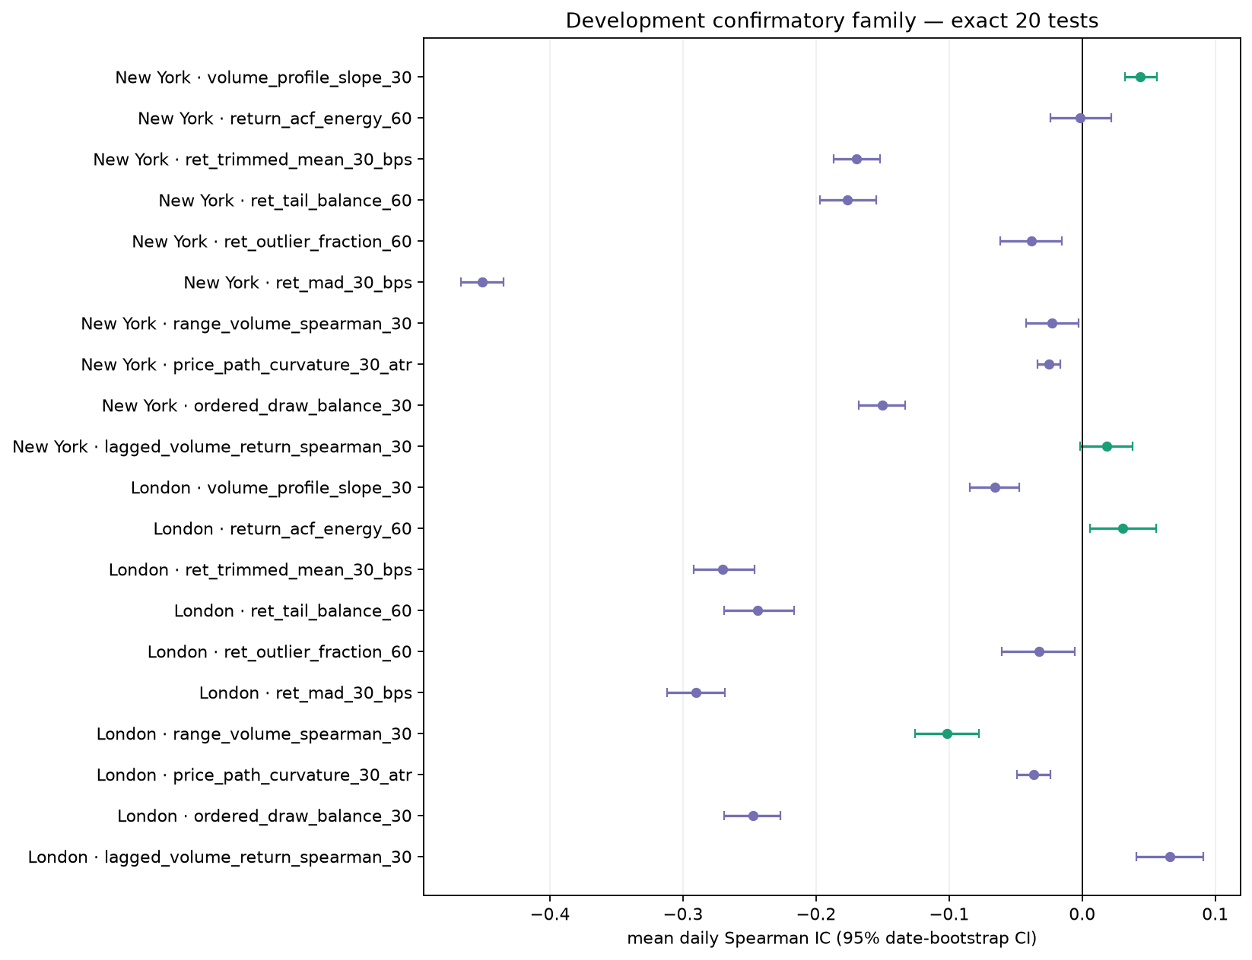
Figure 2. Mean daily IC and 95% date-bootstrap intervals for the exact 20-test confirmatory family.
Green markers are DEV_SUPPORT; purple markers are DEV_NO_SUPPORT. Source: section4_confirmatory_ic_development.png
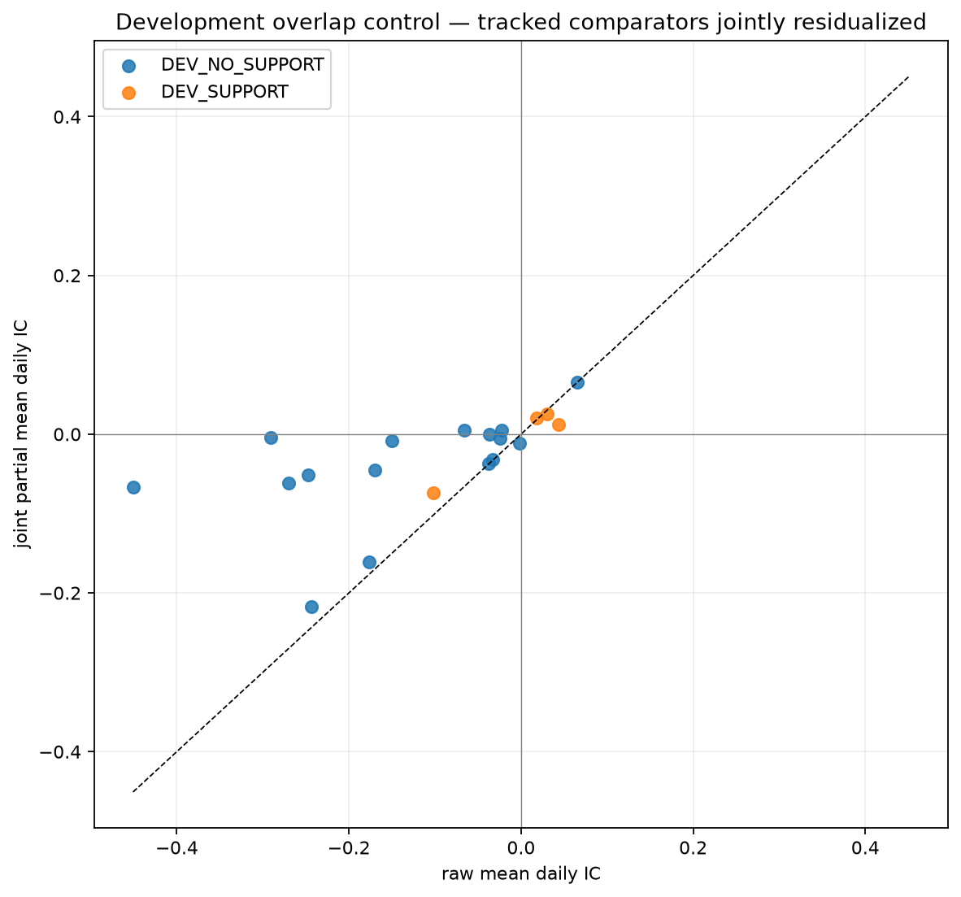
Figure 3. Raw daily IC versus jointly controlled partial daily IC.
Source: reports/statistical_research/fes_project1/v1/section4_partial_ic_development.png

Interactions did not add incremental value
All eight I01-I04 session-level comparisons are DEV_NO_INCREMENTAL_SUPPORT. Every test evaluates six exact outer folds and 378 paired dates. Mean daily-IC deltas range from -0.00676 to +0.00104, far below the frozen +0.01 minimum; all confidence intervals fail to clear both zero and the required delta, and all BH-adjusted q-values exceed 0.10.
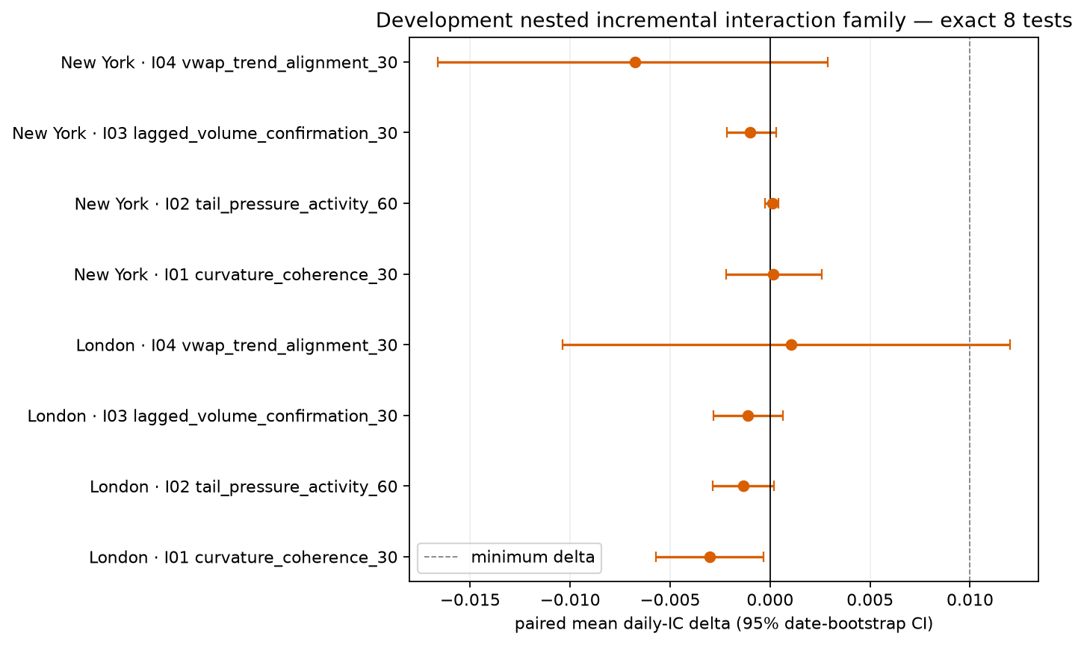
Figure 4. Nested paired daily-IC deltas for the eight predeclared interactions.
The dashed vertical line is the +0.01 Development minimum. Source: section4_interaction_incremental_development.png
The correct conclusion is not that every interaction is useless in all settings; it is that the exact predeclared interaction slate provides no reliable incremental value over the frozen hierarchy-respecting base designs on Development.

Section 5 - Nested models and full policy freeze
Section 5 uses exact chronological date blocks: 252 training dates, one embargo date, and 63 assessment dates, stepping 64 dates. Six complete outer folds yield 378 OOF dates per session/target. Inner tuning uses 126 training dates, one embargo date, and 21 assessment dates, with purging at target exits that reach the first assessment timestamp.
Session | Target | Model | Daily IC | 95% IC CI | Delta vs anchor | 95% delta CI | Gate
London | return_30_atr | M8 | 0.0356 | [0.0146, 0.0555] | 0.0092 | [-0.0020, 0.0204] | FAIL (378 < 400)
London | return_60_atr | M8 | 0.0094 | [-0.0213, 0.0404] | 0.0487 | [0.0168, 0.0810] | FAIL (378 < 400)
London | range_60_atr | M1 | 0.4471 | [0.4226, 0.4713] | 0.0000 | [0.0000, 0.0000] | FAIL (378 < 400)
New York | return_30_atr | M1 | 0.1176 | [0.0937, 0.1426] | 0.0000 | [0.0000, 0.0000] | FAIL (378 < 400)
New York | return_60_atr | M1 | 0.1729 | [0.1490, 0.1969] | 0.0000 | [0.0000, 0.0000] | FAIL (378 < 400)
New York | range_60_atr | M3 | 0.6349 | [0.6153, 0.6551] | 0.0012 | [-0.0011, 0.0035] | FAIL (378 < 400)

Directional results
• London 60-minute direction. M8 combines scalar inputs with a two-component P2-PLS profile. Its paired daily-IC improvement over D1 is +0.0487 with a 95% CI of [0.0168, 0.0810], the clearest incremental model result in the notebook. Its absolute daily IC is only +0.0094 and its own CI crosses zero.
• London 30-minute direction. M8 achieves daily IC +0.0356 with a positive 95% CI, but its +0.0092 incremental delta is below the +0.01 minimum and its delta CI crosses zero.
• New York direction. The existing D1/M1 anchor remains selected at both 30 and 60 minutes, with daily IC +0.1176 and +0.1729 respectively. Because the selected model is the anchor, incremental delta is zero.

Opportunity and expansion results
Opportunity/range prediction is substantially stronger than directional prediction. London retains M1 with daily IC +0.4471. New York selects M3 with daily IC +0.6349, but its improvement over the M1 anchor is only +0.00115 and the delta CI crosses zero. These results reinforce the project's earlier conclusion that the feature set is better at forecasting movement opportunity than sign.
Session | Model | ROC AUC | PR AUC | Brier | Cal. slope | p80 lift | p80 precision | p80 recall
London | M1_O1 | 0.634 | 0.259 | 0.141 | 0.913 | 1.636 | 0.287 | 0.327
New York | M1_O1 | 0.805 | 0.501 | 0.133 | 0.947 | 2.414 | 0.512 | 0.483

The selected expansion family is M1_O1 in both sessions. New York is notably stronger (ROC AUC 0.805, PR AUC 0.501, and p80 lift 2.414) than London (ROC AUC 0.634, PR AUC 0.259, and p80 lift 1.636). However, each selected classifier is exactly the O1 baseline, so its paired log-loss delta versus O1 is zero. This is useful probability ranking, not incremental evidence for a new classifier family.
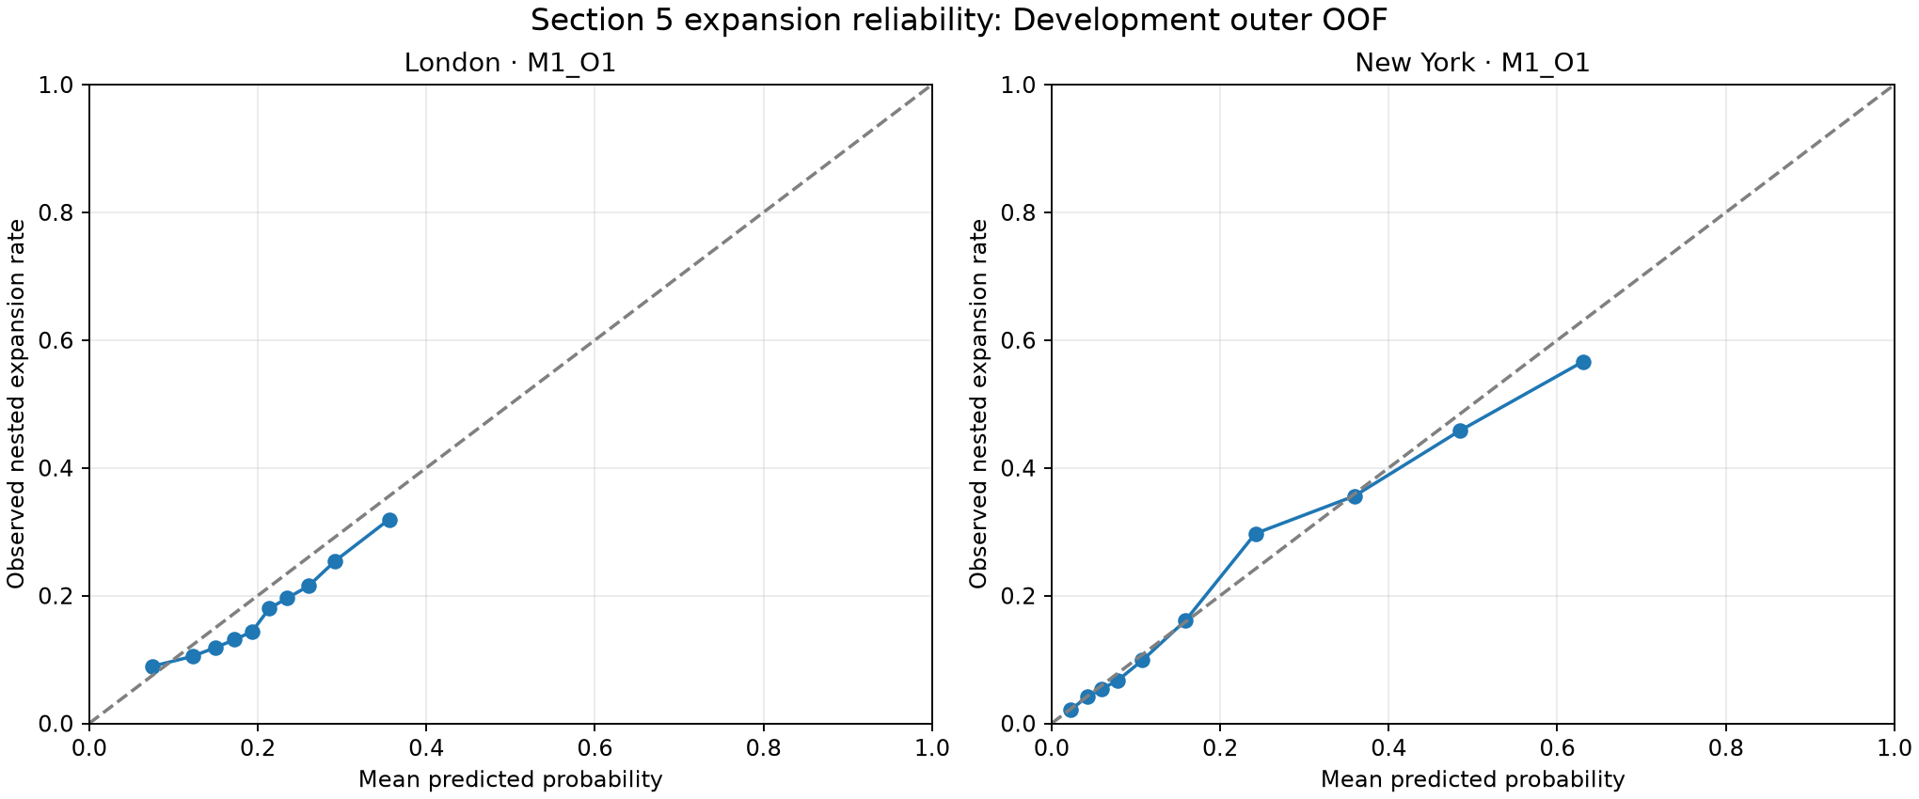
Figure 5. Development outer-OOF reliability of the selected expansion classifiers.
Source: reports/statistical_research/fes_project1/v1/section5_expansion_reliability.png

Why the result is FROZEN_NO_POLICY
Mechanical stop: The frozen model gate requires at least 400 Development OOF dates. The exact complete-block design yields 378. Therefore development_model_gate_pass is false for all six selected continuous models, regardless of point estimates. The two pre-validation policy trials were completed as FROZEN_NO_POLICY.
Four numerical thresholds were fitted for reproducible accounting but remain inactive: London directional |prediction| p90 = 0.439427, London expansion probability p80 = 0.274541, New York directional |prediction| p90 = 0.320785, and New York expansion probability p80 = 0.422523. Eight all-Development model objects (six continuous, two expansion classifiers) were serialized and reloaded successfully.
This was the correct conservative Development outcome. Section 6 subsequently opened retrospective Validation exactly once under the locked hashes, but the no-policy state prevented trade execution. Consequently no realized P&L, daily-net-R Sharpe, drawdown, cost sensitivity, or MGC execution result exists.

Section 6 - Single locked Validation batch and GC gate
Section 6 is complete in the immutable artifact namespace. The authorized runner verified the frozen Section 5 manifest and policy hashes, prepared locked comparators before reading Validation, opened all 118,076 retrospective Validation rows in one batch, and did not read Historical Final. The checkpoint records COMPLETED_STOP_BEFORE_SECTION_7, while the current notebook's four Section 6 display cells remain unexecuted.
The Section 6 manifest contains 26 data/report artifacts; every entry was independently re-hashed for this review with zero failures. Trial accounting is now 148 complete of 150, with only the two Section 7 MGC transfer trials still planned.

Four base features advance
Session | Feature | Target | Dev IC | Validation IC | Validation partial IC | Final
London | return_acf_energy_60 | range_60_atr | 0.0306 | 0.0345 | 0.0256 | ADVANCES
London | range_volume_spearman_30 | range_60_atr | -0.1019 | -0.0725 | -0.0390 | ADVANCES
New York | lagged_volume_return_spearman_30 | return_60_atr | 0.0183 | 0.0314 | 0.0329 | ADVANCES
New York | volume_profile_slope_30 | range_60_atr | 0.0437 | 0.0398 | 0.0205 | ADVANCES

The advancing slate exactly matches the four Development-supported features: London return_acf_energy_60 and range_volume_spearman_30; New York lagged_volume_return_spearman_30 and volume_profile_slope_30. Validation signs are retained and all frozen integrity, sample-size, overlap, and direction/spread gates pass. The remaining 16 confirmatory features do not advance.

No interaction, continuous model, or classifier advances
Session | Target | Model | Validation IC | Validation delta | 95% delta CI | Verdict
London | return_30_atr | M8 | 0.1988 | -0.0270 | [-0.0329, -0.0207] | DOES NOT ADVANCE
London | return_60_atr | M8 | 0.0726 | -0.0398 | [-0.0686, -0.0112] | DOES NOT ADVANCE
London | range_60_atr | M1 | 0.4298 | 0.0000 | [0.0000, 0.0000] | DOES NOT ADVANCE
New York | return_30_atr | M1 | 0.0681 | 0.0000 | [0.0000, 0.0000] | DOES NOT ADVANCE
New York | return_60_atr | M1 | 0.1338 | 0.0000 | [0.0000, 0.0000] | DOES NOT ADVANCE
New York | range_60_atr | M3 | 0.6273 | 0.0012 | [-0.0012, 0.0035] | DOES NOT ADVANCE

All six selected continuous models have positive Validation IC, but none passes the full frozen gate. London M8 underperforms its anchor in Validation: the 30-minute paired delta is -0.0270 (95% CI [-0.0329, -0.0207]) and the 60-minute delta is -0.0398 (95% CI [-0.0686, -0.0112]). New York's M1 anchors have zero incremental delta by construction. Every model also retains the Development date-count failure (378 < 400).
All eight interactions remain INTERACTION_DOES_NOT_ADVANCE. The selected M1_O1 expansion classifiers also do not advance: they are equal to the O1 baseline (paired log-loss delta zero), and their authoritative range-threshold contract does not match the model-training threshold.
Session | ROC AUC | PR AUC | p80 lift | p80 precision | p80 recall | Verdict
London | 0.660 | 0.274 | 1.975 | 0.324 | 0.192 | NO ADVANCE
New York | 0.799 | 0.534 | 2.763 | 0.636 | 0.249 | NO ADVANCE

Expansion discrimination nevertheless validates as a descriptive result: London ROC AUC is 0.660 with p80 lift 1.975, while New York ROC AUC is 0.799 with p80 lift 2.763. This confirms that opportunity prediction is useful, but it does not create an incremental or trade-authorized classifier.
Final Section 6 verdict: PREDICTIVE_ONLY_NOT_DIRECTIONAL. Zero directional models pass, zero policies are sequenced, zero trades are executed, GC economics and Sharpe are NOT_APPLICABLE, FROZEN_NO_POLICY remains active, and MGC work is not permitted. Historical Final remains unread.

4. Notebook scripts and implementation review

What the notebook actually executes
The 24 executed code cells do not launch a single end-to-end research script for Sections 1-5. They import the research modules and call public functions directly. The four appended Section 6 cells only read and display already-created artifacts, and they are currently unexecuted. Explicit subprocess calls in the executed notebook record are limited to environment, repository, provenance, and focused-test checks:
• git branch --show-current; git rev-parse HEAD; git status --short --branch
• nvidia-smi --query-gpu=name,driver_version,memory.total --format=csv,noheader
• git grep ... sharpe to verify that no reusable tracked Sharpe implementation exists
• git ls-files over the MLAT scratch namespaces to verify they are untracked and excluded
• pytest tests/test_fes_project1_features.py (26 passed in the notebook)
• pytest tests/test_fes_project1_profiles.py (24 passed in the notebook)
• pytest tests/test_fes_project1_modeling.py (16 passed in the notebook)

Core modules used by the notebook
fes_project1_config.py - Freezes the specification, deterministic seeds, feature/model gates, trial ledger, paths, hashes, and market/evidence boundaries. It refuses to overwrite conflicting v1 contract artifacts.
fes_project1_features.py - Builds F01-F10, H01, and I01-I04 using the shared production continuity ID. It rejects outcome columns, enforces one-to-one observation joins, records missing causes, and provides coverage/integrity/redundancy audits.
fes_project1_profiles.py - Builds exact 90-column P0 profiles and fold-local P0-P3/PCA/PLS interfaces. It shares the same legal continuity path as scalar features and stores complete raw P0 rows only.
fes_project1_modeling.py - Loads Development labels through a physical parquet filter with no caller-selectable partition. It computes daily IC, BH correction, quintiles, joint partial IC, matched nested interactions, stability, and the Section 4 ledger.
fes_project1_nested.py - Loads only Development model inputs, builds exact purged date folds, tunes M0-M8 and classifiers inside training folds, performs stability/random-subset diagnostics, fits frozen all-Development objects, and produces the no-policy freeze.
fes_project1_evaluation.py - Verifies the Section 5 manifest/policy/model hashes, prepares comparators before the one-time Validation read, scores frozen continuous and expansion models, applies feature/interaction/model gates, builds candidate counts and not-applicable economics, and saves the immutable Section 6 batch.

Review of scripts/run_fes_project1_research.py
The notebook prints the following Section 6 command as an exact locked capability:
.\.venv\Scripts\python.exe scripts\run_fes_project1_research.py --section 6 --non-interactive --section5-manifest-sha256 5a5513722f49a552fa17793cc0a71fb831ea6897d29b9252a3839dc6db6e67c3 --policy-sha256 5ba74d5f44100be957254857f9b0aea51a95ab68f1260395667c991abc82c4fc
Script finding: The runner is now operational for Sections 5 and 6. Section 6 refuses to run without --non-interactive plus both frozen hashes, calls assert_section5_freeze, runs the single locked batch, and saves outputs through a conflict-refusing writer. The existing Section 6 checkpoint proves the command completed once; rerunning it against the same output namespace is intentionally blocked.
The runner imports LockedValidationAuthorization, assert_section5_freeze, run_locked_section6_batch, and save_section6_outputs from src/statistical_research/fes_project1_evaluation.py. The source-level sequence is well guarded: comparator preparation precedes load_locked_validation_inputs; Historical Final is explicitly kept false; and Section 7 is outside the runner's allowed section choices.

Caching, immutability, and artifact verification
The visible Section 5 run loaded four continuous-group caches (London 30/60 and New York 30/60) instead of recomputing them. The code accepts a cache only when its frozen numerical contract hash matches. Final Section 5 outputs were then saved, model objects were reloaded, and manifest/policy hashes were checked. A no-cache recomputation was not performed for this report.
Section | Manifest artifacts checked now | Hash failures | Notebook focused tests
2 | 17 | 0 | 26 passed
3 | 17 | 0 | 24 passed
4 | 25 | 0 | 16 passed
5 | 33 | 0 | Section 5 checkpoint: 54 focused modeling tests
6 | 26 | 0 | 10 evaluation tests passed independently

All 118 Section 2-6 manifest entries currently match their saved SHA-256 values. The independent combined focused run performed for this review reports 90 passed tests. These checks support internal consistency, but they do not replace a clean-source, no-cache, end-to-end rerun.

5. Quality findings, limitations, and risks

Strengths
• Strong leakage control: Validation is opened once under hash authorization; Historical Final remains unread.
• Predeclared trial families and gates reduce outcome-driven model/feature selection.
• Chronological date-block resampling, embargoes, target-exit purges, fold hashes, and common support are explicit.
• Feature and profile continuity rules reuse the production continuity identity, reducing research/production drift.
• Artifact writes are additive and conflict-refusing; outputs are reloaded and hash-verified.
• The no-policy result remains enforced after Validation even when descriptive predictive metrics look attractive.

Limitations and open risks
• Untracked implementation state. The notebook, runner, FES modules, prompt, and focused tests are not captured by the recorded Git commit. This is the largest reproducibility risk.
• Section 5 cache reuse. The saved run reused caches; the final artifacts are internally verified, but a clean no-cache reproduction has not been demonstrated in this report.
• Code-intelligence freshness. The GitNexus index predates the final Section 6 runner/notebook additions. Sections 1-5 were graph-traced; the updated Section 6 path was checked directly in source. Reindex before future impact analysis.
• Notebook execution gap. Section 6 artifacts are complete, but the notebook's four Section 6 result cells have no execution counts or saved outputs. The notebook is therefore not yet a self-contained display of the completed batch.
• External evidence remains narrow. Retrospective Validation is now complete, but Historical Final, new forward data, live simulation, and MGC transfer remain unopened. The feature advancements are predictive research findings, not a trading-strategy approval.
• Directional calibration is weak. Directional daily ICs are much smaller than range/expansion ICs, and selected directional models still fail the complete Development gate.
• Metadata compatibility workaround. Narrow parquet reads use ignore_metadata=True because stored pandas dictionary metadata is incompatible with the current pandas/Arrow combination; physical Arrow schemas remain authoritative.
• O1 order mismatch. The 15-feature content is exact, but stored artifact order differs from the prompt. Downstream code should continue to rely on named columns and input-schema hashes.

6. Current project status and next gates
Current status: COMPLETED_STOP_BEFORE_SECTION_7 / PREDICTIVE_ONLY_NOT_DIRECTIONAL / FROZEN_NO_POLICY. No approved live strategy exists, all numerical thresholds remain inactive, and MGC work is not permitted.

Essential conclusions
- The project has a functioning, well-tested research pipeline through one locked Validation batch. Sections 1-6 form a coherent, hashed chain from contract and data to features, models, final gates, and a mechanically enforced no-policy verdict.
- Opportunity prediction is the strongest recurring result. Future-range ICs and expansion-classifier discrimination are materially stronger than directional performance, consistent with prior Project 1 findings.
- Four scalar features survive both Development and Validation. The same four Development-supported features advance; the other 16 confirmatory features and all eight interactions do not.
- London's 60-minute M8 Development improvement does not validate incrementally. Its Validation delta versus the anchor is -0.0398 with a fully negative confidence interval, while the model also retains the 378-versus-400 Development date-count failure.
- The correct operational outcome is no policy. With zero models advancing, there is no basis to activate thresholds, execute trades, calculate strategy economics, or begin MGC transfer.

Required controls before any future work
- Freeze the full source state: commit the notebook, modules, runner, evaluation code, prompt, tests, and requirement files, or create a source manifest with SHA-256 hashes.
- Execute and save the four Section 6 notebook result cells without rerunning the locked batch, so the notebook displays the existing immutable outputs and checkpoint.
- Run the full repository test suite against the exact Section 6 source state; the focused five-suite check currently passes 90 tests.
- If strict reproducibility is required, perform a clean no-cache Section 5 reconstruction in a separate versioned namespace and compare hashes without altering v1.
- Preserve FROZEN_NO_POLICY and keep all thresholds inactive. Any change to the 400-date gate would be a new specification, not a continuation of v1.
- Do not start Section 7, MGC transfer, Historical Final, or live-strategy work unless a new explicit authorization and specification override the current stop verdict.

Appendix A - Evidence and source inventory
Primary evidence was taken from the notebook and its immutable v1 namespace. Representative sources reviewed are listed below; hashes for all Section 2-6 artifacts were rechecked against the saved manifests.
• notebooks/exploration/feature_research_1.ipynb
• reports/statistical_research/fes_project1/v1/section1_checkpoint.json
• reports/statistical_research/fes_project1/v1/section2_checkpoint.json
• reports/statistical_research/fes_project1/v1/section3_checkpoint.json
• reports/statistical_research/fes_project1/v1/section4_checkpoint.json
• reports/statistical_research/fes_project1/v1/section5_checkpoint.json
• reports/statistical_research/fes_project1/v1/section6_checkpoint.json
• reports/statistical_research/fes_project1/v1/section2_hash_manifest.json
• reports/statistical_research/fes_project1/v1/section3_hash_manifest.json
• reports/statistical_research/fes_project1/v1/section4_hash_manifest.json
• reports/statistical_research/fes_project1/v1/section5_hash_manifest.json
• reports/statistical_research/fes_project1/v1/section6_hash_manifest.json
• reports/statistical_research/fes_project1/v1/section6_final_feature_gates.csv
• reports/statistical_research/fes_project1/v1/section6_final_interaction_gates.csv
• reports/statistical_research/fes_project1/v1/section6_final_model_gates.csv
• reports/statistical_research/fes_project1/v1/section6_gc_gate_verdict.csv
• src/statistical_research/fes_project1_config.py
• src/statistical_research/fes_project1_features.py
• src/statistical_research/fes_project1_profiles.py
• src/statistical_research/fes_project1_modeling.py
• src/statistical_research/fes_project1_nested.py
• src/statistical_research/fes_project1_evaluation.py
• scripts/run_fes_project1_research.py
• tests/test_fes_project1_features.py
• tests/test_fes_project1_profiles.py
• tests/test_fes_project1_modeling.py
• tests/test_fes_project1_nested.py
• tests/test_fes_project1_evaluation.py

Appendix B - Status vocabulary
Term | Meaning in this report
DEV_SUPPORT | A Section 4 Development feature label that passed the frozen feature-evidence gates; not final advancement.
DEV_NO_SUPPORT | A Section 4 Development feature label that failed one or more frozen gates.
DEV_NO_INCREMENTAL_SUPPORT | A predeclared interaction failed to improve its matched hierarchical base design.
FEATURE_ADVANCES | A Development-supported feature also passed the frozen Section 6 Validation gates.
MODEL_DOES_NOT_ADVANCE | A selected continuous model failed at least one frozen Development/Validation advancement gate.
FROZEN_NO_POLICY | No directional model passed the complete Development policy gate; thresholds are inactive.
PREDICTIVE_ONLY_NOT_DIRECTIONAL | Predictive structure survives, but no directional model or executable policy advances.
COMPLETED_STOP_BEFORE_SECTION_7 | The single locked Validation batch is complete; MGC transfer and Historical Final remain unopened.

