- Project Overview

Field Report App
Field Report App is an offline-first mobile application built with React Native CLI and TypeScript.
It allows users to create, edit, and manage field reports with image attachments while working completely offline.
All reports and images are stored locally on the device using SQLite and local file storage, ensuring that the application remains functional even in environments without internet connectivity.
This application demonstrates mobile engineering practices such as:
- Offline data persistence
- Local image storage
- Clean architecture separation
- Utility-based UI styling with NativeWind
- ORM-based database access with TypeORM
- Tech Stack
- React Native CLI
Used to build a native mobile application for Android with direct access to device features.
- TypeScript
Provides static typing and improves maintainability and developer experience.
- NativeWind (Tailwind utility styling)
Used for consistent utility-based styling instead of inline JSX styles.
- SQLite
Lightweight local database used to store reports and metadata.
- TypeORM
Object-Relational Mapping layer that provides structured data access to SQLite.
- react-native-file-access
Handles local file storage for attached report images.
- react-native-image-picker
Allows users to select or capture images to attach to reports.
- App Features
- Create Reports
Users can create reports with title, description, status, and images.
- Edit Reports
Existing reports can be modified and updated.
- Delete Reports
Reports can be removed from the local database.
- Image Attachments
Each report supports multiple images stored locally on the device.
- Offline Data Persistence
Reports and images remain accessible even after closing and reopening the application.
- Search Reports
Users can search reports by title.
- About Screen
Provides a description of the application and how it works.
- Architecture Overview
The application follows a layered architecture that separates user interface logic from data persistence and domain logic.
This separation improves maintainability, testability, and scalability.
The architecture consists of four primary layers:
- UI Layer
Responsible for rendering the interface and handling user interactions.
- Service Layer
Contains application logic and coordinates data flow between the UI and repositories.
- Repository Layer
Provides structured database operations and isolates database logic from the rest of the application.
- Persistence Layer
Handles data storage using SQLite and manages local file storage for images.
- Architecture Diagram
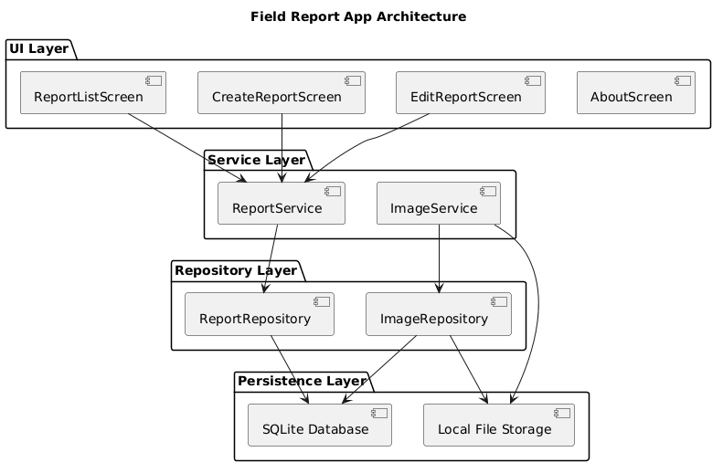
Explanation:
- UI interacts only with services
- Services interact with repositories
- Repositories communicate with SQLite
- Images are stored separately in device file storage
- Project Structure
Folder Layout is represented as shown below;
src
- components
Reusable UI components such as report cards and buttons.
- screens
Application screens including ReportList, CreateReport, EditReport, and About.
- navigation
Application navigation configuration.
- database
Database connection and entity definitions for TypeORM.
- services
Business logic that manages report creation, updates, and retrieval.
- repositories
Database access layer that interacts with SQLite through TypeORM.
- utils
Helper functions such as file storage management.
- Data Model

Report Entity: Id, title, description, status, createdAt, updatedAt
ReportImage Entity: Id, reportId, filePath, createdAt
Relationship: Report (1) ─────── (Many) ReportImage
- Offline-First Strategy
The application is designed to operate without an internet connection.
All report data is stored locally using SQLite through TypeORM.
Attached images are copied to the device’s local storage using react-native-file-access.
The file path of each stored image is saved in the SQLite database.
When the application starts, the database is loaded locally and all reports and associated images are retrieved without requiring network access.
- Setup Instructions
Clone the repository: git clone https://github.com/your-username/field-report-app
Install dependencies: npm install
Run the application: npx react-native run-android

