PhotoVault
AI-Powered Photo Search
Service Integration - Google Cloud
Cloud Storage, Firestore, Cloud run, Cloud Vision API

Author
János Abonyi – KXQ5GL
May 2026

1. Introduction 3
1.1 Goal 3
1.2 Key Functionalities 3
1.3 Why This Application Benefits from Cloud Technologies 3
1.4 Task Distribution and the usage of AI 3
2. Design and Architecture 4
2.1 High-Level Architecture 4
2.2 Cloud Services and Their Roles 4
2.3 Execution Flow 4
Upload an image (POST /api/upload) 4
Search (GET /api/search?q=...) 5
Delete (DELETE /api/photos/<id>) 5
2.4 Modules Developed by me 5
3. Implementation 6
3.1 Lazy, Per-Process GCP Client Initialisation 6
3.2 Letting Vision Read Directly from GCS (No Double Upload) 6
3.3 Designing the Firestore Schema for Content Search 6
3.4 Safe Blob Naming 6
3.5 Containerisation for Cloud Run 7
3.6 Configuration via Environment Variables 7
4. The Deployment and Configuration journey 8
4.1 Storage Configuration 8
4.2 Firestore Configuration 8
4.3 Continuous Deployment (Cloud Run and Github) 9
4.3 Environment and Variable Injection 10
5. Results 11
5.1 Working Features 11
5.2 Logs and Readiness 11
5.3 LLM generated frontend 12

1. Introduction

1.1 Goal
PhotoVault is a web application that lets users upload photos and later search them by content rather than by filename. For example, a user can upload a holiday photo and later find it by searching for “mountain”, “dog”, or “beach”. The system auto-tags each image at upload time using Google’s pretrained vision model (Google Vision API).

1.2 Key Functionalities
- Web UI for drag-and-drop photo upload (JPG / PNG / WebP, up to 10 MB).
- Automatic content tagging via Google Cloud Vision (label detection) at upload time.
- A gallery view that lists all uploaded photos with their AI-generated labels.
- Full-text search over labels (e.g. dog returns every photo tagged Dog).
- Photo deletion that removes both the binary in Cloud Storage and its metadata document in Firestore.

1.3 Why This Application Benefits from Cloud Technologies
AI Vision models are computation heavy. Label detection on an image would normally require maintaining a CNN (convolutional neural network) model, GPU hardware, and a serving stack. The Cloud Vision API provides this as a managed REST call, so the app only has to do the calling of this API. This is a common case of consuming AI as a service.

Flexible storage that can grow with demand. Photos space can grow without bound. Cloud Storage offers unlimited durable object storage with a flat pricing model, completely separated from the stateless Flask backend.

Serverless data store. Firestore lets the app store and query photo metadata (variable label arrays per photo) without managing a database server, and its array_contains field enables easy label search.

Pay-per-use deployment. Running the Flask app on Cloud Run means there is zero cost when nobody is using the app, and instant scale if many users upload at once. It is a classic example and benefit of the FaaS (Function-as-a-Service).

1.4 Task Distribution and the usage of AI
This is a single person project. The architecture design, deployment and the integration of the cloud services were carried out by me. The Python Flask backend was also implemented by me. Every task related to the Cloud Programming Course was my work including writing the documentation of the project. However, it is important to note that AI were used to enhance the quality of the project. The tasks executed by LLMs include: Frontend design (app.js, style.css, index.html), Formatting the documentation.

2. Design and Architecture

2.1 High-Level Architecture
The application follows a layered architecture with the browser communicating over HTTPS with a stateless Flask App on Cloud Run, which communicates with the three GCP services:

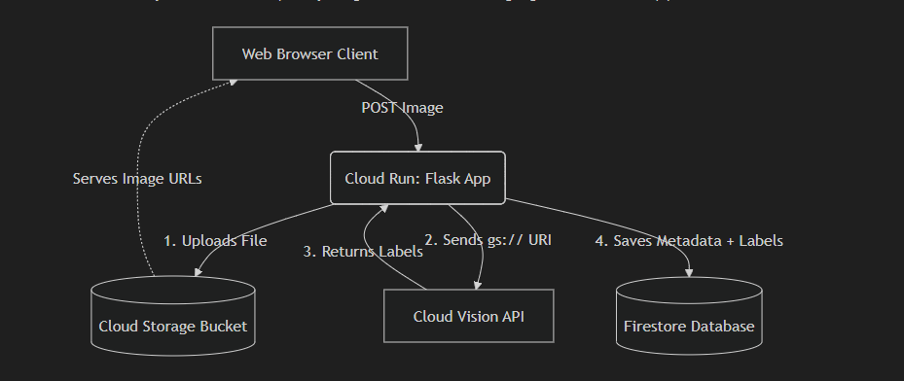

2.2 Cloud Services and Their Roles
Service | Role in PhotoVault
Cloud Run | Hosts the containerised Flask app. It has the ability to scale up when traffic spikes and scales to zero when idle, ensuring maximum cost efficiency.
Cloud Storage | Durable and flexible store for the uploaded photo files. Blobs are named photos with uuid for collision-free storage. Acts as the source for the image bytes. Vision and the public URL both reference the same object.
Cloud Vision API | Runs label detection over a gs:// URI (reference to the image in a bucket) and returns a ranked list of (label, confidence) pairs. The app does not download/upload bytes a second time. Vision reads directly from the bucket.
Cloud Firestore | Document database holding one document per photo with imageUrl, storagePath, fileName, labels, labelsLower, scores, and createdAt. Search uses array_contains on labelsLower.

2.3 Execution Flow

Upload an image (POST /api/upload)
- Browser submits a form with the photo file.
- Flask validates extension and size, generates a UUID-based blob name, and uploads the file to Cloud Storage via blob.upload_from_file function.
- Flask backend builds the gs://bucket/photos/<uuid>.<ext> URI and calls Vision API’s label_detection with that URI.
- Vision API returns label annotations and the backend turns them into labels, labelsLower (for case insensitive queries, every character in lowercase) and scores.
- Then the backend creates a Firestore document under photos/ with the metadata and the public storage URL.
- The new document (with id) is returned to the browser, which inserts it into the gallery grid.

Search (GET /api/search?q=...)
- Flask backend lower cases the query term (becomes case insensitive).
- Returns photos based on the firestore labelsLower and array_contains where the query term could be matched.
- Sorts result photos in descending upload time order and returns them as JSON.

Delete (DELETE /api/photos/<id>)
- Read the document from firestore, locate storagePath.
- Delete the blob from Cloud Storage first, then delete the Firestore document, trying to keep the two stores consistent.

2.4 Modules Developed by me
Module | Responsibility
main.py | Flask backend application, route handlers, Cloud service connecting and the upload pipeline (storage → vision → firestore).
Dockerfile | Container image (Python 3.11-slim + gunicorn) for Cloud Run.
requirements.txt | Pinned dependency versions for the DockerFile.

3. Implementation
This section discusses the non-trivial design and implementation decisions. And the Integration of the Google cloud services.

3.1 Lazy, Per-Process GCP Client Initialisation
GCP client objects (storage.Client, vision.ImageAnnotatorClient, firestore.Client) are expensive to construct as they require credential check. Cloud Run cold-starts a new container occasionally, so it is best practice to use lazy loading.
The app uses a tiny lazy-singleton pattern (main.py:39–59):
_storage_client = None
def get_storage_client():
global _storage_client
if _storage_client is None:
_storage_client = gcs.Client(project=GCP_PROJECT_ID)
return _storage_client
The same pattern is repeated for the Vision and Firestore clients. Construction happens on the first request after a cold start, not at module import.

3.2 Letting Vision Read Directly from GCS (No Double Upload)
A simple implementation would first upload the photo to GCS, then re-read the bytes and send them to Vision API. That doubles bandwidth, doubles memory, and slows the request.
Instead, the upload function gives Vision API the GCS URI of the object that was just stored (main.py:120–121):
gcs_uri = f"gs://{GCS_BUCKET_NAME}/{blob_name}"
labels_data = analyze_image_labels(gcs_uri)

3.3 Designing the Firestore Schema for Content Search
Firestore is a document store, not a search engine, so the schema has to be chosen with the query in mind.
The schema stores two label representations per photo:
"labels": label_names, # original-case, for display
"labelsLower": labels_lower, # lower-case, for queries
"scores": {desc: score, ...}, # confidence map for the UI
Search then uses Firestore’s native array_contains operator on the lower-case field (main.py:180):
photos_ref.where("labelsLower", "array_contains", query_term)

3.4 Safe Blob Naming
werkzeug.secure_filename strips path separators but can still return an empty string for filenames consisting only of special characters. Two safeguards are in place (main.py:105–110):
original_name = secure_filename(file.filename)
if not original_name or "." not in original_name:
original_name = "upload.png"
ext = original_name.rsplit(".", 1)[1].lower()
blob_name = f"photos/{uuid.uuid4().hex}.{ext}"
The actual blob name is a UUID, so two users uploading photo.jpg cannot overwrite each other, and the original filename is preserved only as metadata in Firestore.

3.5 Containerisation for Cloud Run
The application is powered by a custom docker container image running gunicorn with 2 workers. The reason for this custom docker image is that Flask’s built in server is designed to handle only one request at a time, which would cause the app to freeze during simultaneous image uploads. Gunicorn provides a production model to handle traffic spikes gracefully.

3.6 Configuration via Environment Variables
Project ID, bucket name, and Firestore database ID are all read from environment variables (main.py:31–36). This ensures that the secrets are handled in a safe manner. The required variables are:
- GCP_PROJECT_ID - the GCP project identifier.
- GCS_BUCKET_NAME - the Cloud Storage bucket for photo blobs.
- FIRESTORE_DATABASE_ID - storage for labels and metadata

4. The Deployment and Configuration journey
Building this project required a series of configurations within the Google Cloud Console. This chapter discusses the step by step record of the actions taken.

4.1 Storage Configuration
To allow all users to view the images without authentication (not in the scope of the project), the cloud storage needed a specific permission setup:
- Created a standard storage bucket in eu-west3 (kxq5gl-cloud-proj).
- Crucial Step: Unchecked "Enforce public access prevention" during creation.
- Navigated to the bucket's Permissions tab and granted the principal allUsers the role of Legacy Storage Object Viewer.
The following guides were used: https://docs.cloud.google.com/storage/docs/access-control/making-data-public, https://docs.cloud.google.com/storage/docs/creating-buckets
Screenshot of the created bucket as proof:
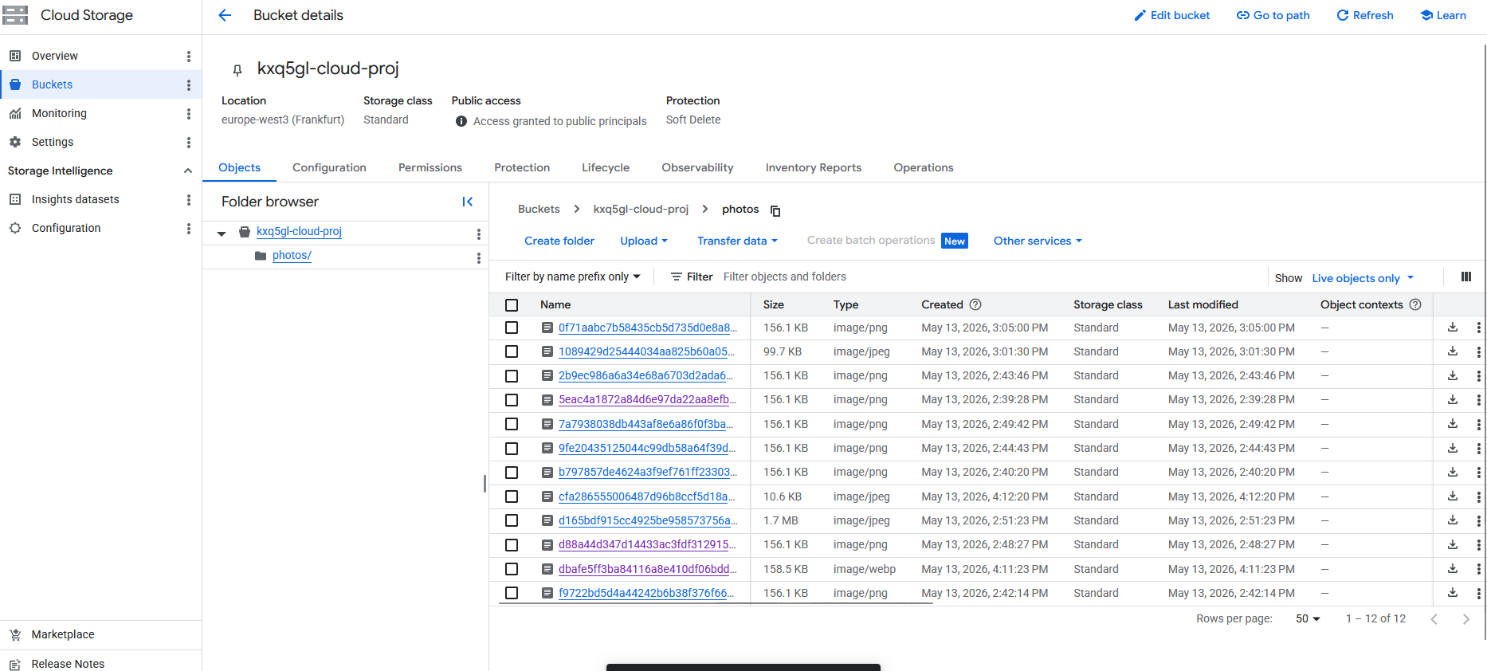

4.2 Firestore Configuration
To allow all users to query the labels, the database had to initialized correctly.
- Navigated to Datastore/Firestore in the GCP Console.
- Crucial Step: Selected Firestore Native Mode. (Selecting Datastore mode by accident triggers a "Firestore API data access is disabled") Unfortunately I ran into this issue.
- Created the database with a custom ID (kxq5gl-proj-cloud) to keep resources organized.
Screenshot of the created database as proof: 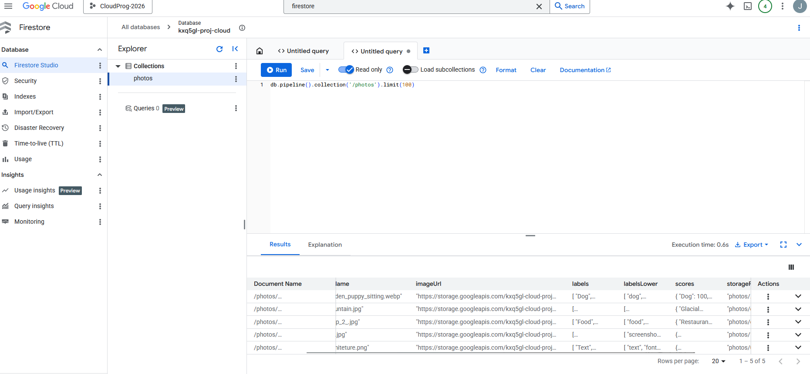

4.3 Continuous Deployment (Cloud Run and Github)
The application is deployed using CI/CD practices.
- Pushed the entire local codebase (including the Dockerfile) to a GitHub repository.
- In the Cloud Run console, created a new service (kxq5gl-cloud-proj) and selected Continuously deploy new revisions from a source repository.
- Linked the GitHub repository via Cloud Build.
- Built the project using Cloud Build
The following guides were used: https://docs.cloud.google.com/run/docs/quickstarts/deploy-continuously, https://docs.cloud.google.com/run/docs/continuous-deployment, https://gunicorn.org/guides/docker/#environment-variables
Screenshots of the Cloud Run and the Github repo:
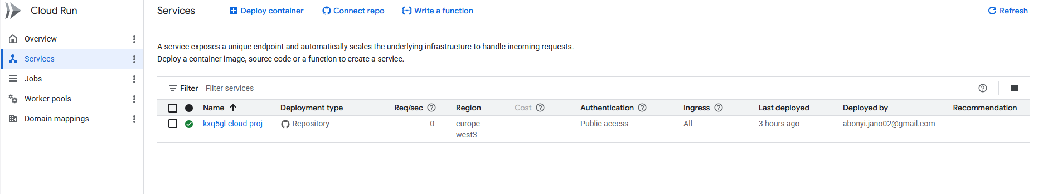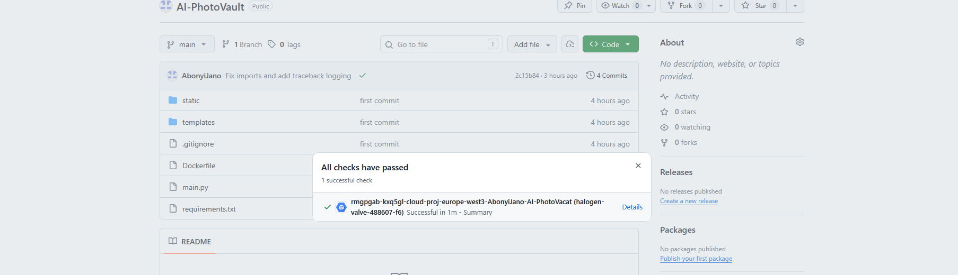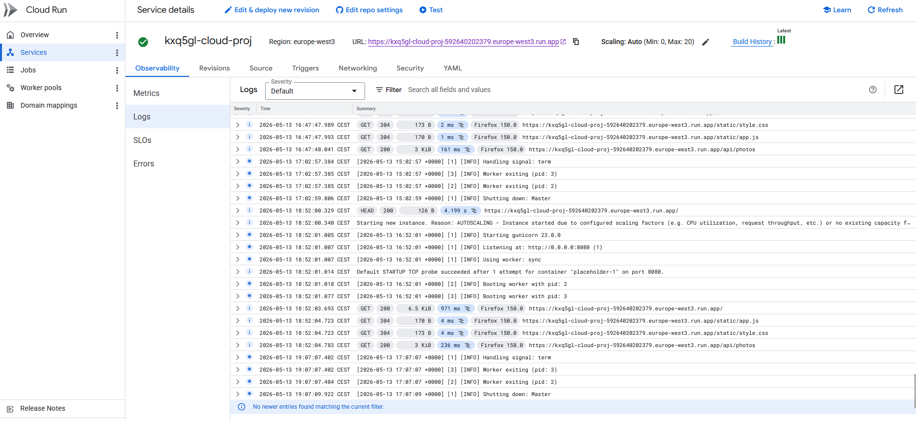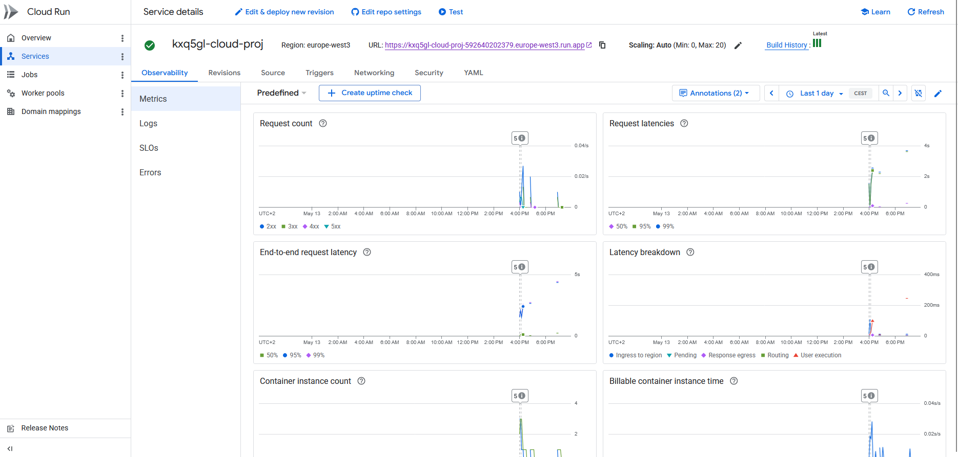
Link to a successful build: https://github.com/AbonyiJano/AI-PhotoVault/runs/75802082508

4.3 Environment and Variable Injection
Cloud Run containers are isolated environments that do not read local .env files. The final step was mapping the cloud resources to the code:

- In the Cloud Run service settings, navigated to the Variables & Secrets tab.
- Injected the critical routing variables so the backend knew where to send data:
  - GCP_PROJECT_ID = halogen-valve-488607-f6
  - GCS_BUCKET_NAME = kxq5gl-cloud-proj
  - FIRESTORE_DATABASE_ID = kxq5gl-proj-cloud
- Triggered a redeployment, binding the Python backend to the GCP infrastructure.
The following guides were used: https://docs.cloud.google.com/run/docs/configuring/services/environment-variables
Screenshot of the configuration: 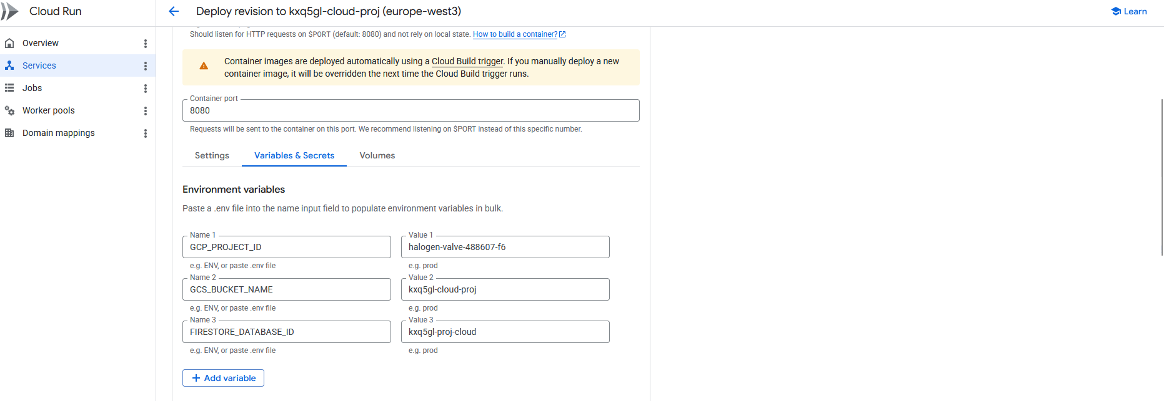

5. Results
The application is fully working end-to-end. All core user-facing features have been validated. The application can be tested at: https://kxq5gl-cloud-proj-592640202379.europe-west3.run.app, the source code can be found on GitHub: https://github.com/AbonyiJano/AI-PhotoVault

5.1 Working Features
- Upload pipeline. A photo dropped into the UI lands in GCS, is labelled by Vision within 1–2 s, and appears in the gallery with its labels visible.
- Content search. Searching for dog, mountain, or car returns the correct subset of uploaded photos. Search is case-insensitive due to the labelsLower field.
- Deletion. Removing a photo removes it from both stores, and the gallery refreshes without the deleted entry.

5.2 Logs and Readiness
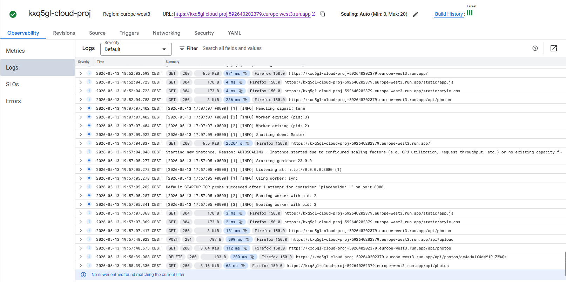
18:52:03: Initial page load. GET / returns 200 in 971 ms (cold start of the gunicorn workers + first-byte rendering of index.html). The next two lines show the static assets app.js and style.css served as 304 Not Modified from the browser cache, and an immediate GET /api/photos hydrating the gallery in 236 ms.
19:07:07: Scale-to-zero. With no traffic for around 15 minutes, Cloud Run terminates the instance: the logs show Handling signal: term, then both gunicorn workers exit (Worker exiting (pid: 3), pid: 2), and finally Shutting down: Master. This is a great evidence that the pay-per-use, scale-to-zero benefit described in the Introduction is actually happening and the container stops consuming resources between sessions.
19:57:04: Cold start on next request. A new GET / arrives and takes 2.204 s because Cloud Run has to spin up a fresh instance and the next logs show both workers booting. It also confirms that it uses port 8080 which is defined in the dockerfile.
19:57:48: Full upload pipeline in one request. POST /api/upload returns Created in 599 ms. That single half-second covers the entire chain: streaming the file into Cloud Storage, calling the Vision API on the resulting gs:// URI, receiving the label annotations, and writing the metadata document to Firestore. The fact that the next GET /api/photos returns in only 112 ms confirms that the gunicorn worker has now cached the three GCP client objects (the lazy-singleton pattern described in Chapter 3.1).
19:58:39: Delete works end-to-end. DELETE /api/photos/qe… returns 200 in 200 ms, and the following GET /api/photos (63 ms) no longer includes that document
From this screenshot of the log, it can be confirmed that the system works as intended. Hovewer, the application has not been tested under heavy load and traffic spikes have not been simulated.

5.3 LLM generated frontend
Since the frontend was completely generated by LLMs, the documentation of the frontend is not part of the documentation nor can be considered part of the project. On the other hand, detailed prompting was required to ensure best results. Since the goal was to create a deployed web application, including screenshots of the final application feels essential. 