1-
Open PGadmin :
make DB
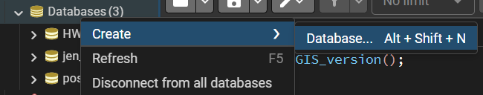

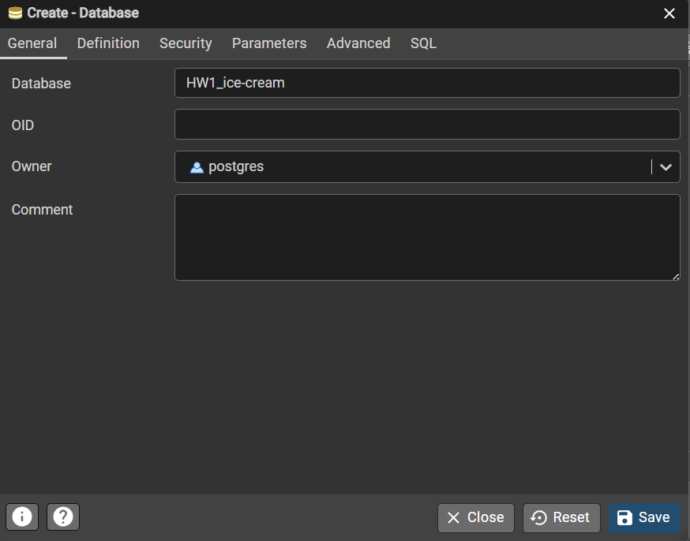

2- Open QGIS.
In QGIS main window, open the Browser panel (View → Panels → Browser Panel).
Right-click PostgreSQL → New Connection.
- Name: jen_barry_db ( whatever you want )
- Host: localhost (or the DB host)
- Port: 5432 (or your port)
- Database: HW1_ice-cream ( or whatever you already names it in step 1 )
- Username / Password: fill in → click Test Connection → OK.
3-
Create a new schema jen_barry (recommended)
You can do it from QGIS DB Manager or psql.
In QGIS main window, open the Browser panel (View → Panels → Browser Panel).
Choose your DB and right click then Execute SQL
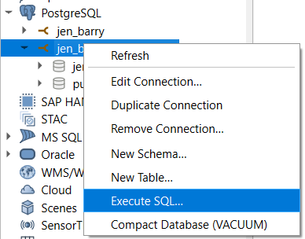

And run : CREATE SCHEMA IF NOT EXISTS jen_barry;

4-
Import shapefiles into PostGIS using QGIS (DB Manager method)
Repeat these steps for each shapefile (Counties, Cities, Interstates, RecreationAreas).
- In QGIS: Database → DB Manager
- Select your connection → expand it → click the target database.
- Click Import Layer/File (or use the “Import” button).
- In the dialog:
  - Input: choose the shapefile layer (e.g. Counties.shp) , you can choose from the QGIS layer list or browse file.
  - Schema: jen_barry
  - Table: counties (use lowercase and underscores) , set names exactly:
    - jen_barry.counties
    - jen_barry.cities
    - jen_barry.interstates
    - jen_barry.recreationareas
  - SRID / Source CRS: set to 4267 (NAD27) , choose from drop down.
  - Check Create spatial index.
  - Optionally check Overwrite if rerunning.
- Click OK / Import.
- Wait until import completes. You’ll see the new table in the DB Manager tree.

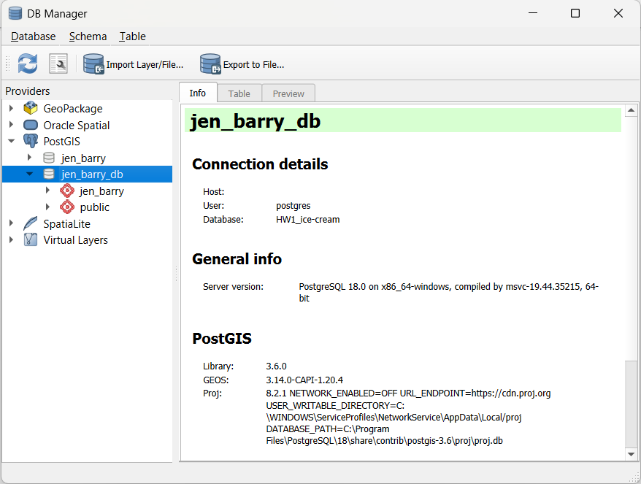

To check :
In QGIS main window, open the Browser panel (View → Panels → Browser Panel).
Choose your DB and right click then Execute SQL

And run :
SELECT table_name
FROM information_schema.tables
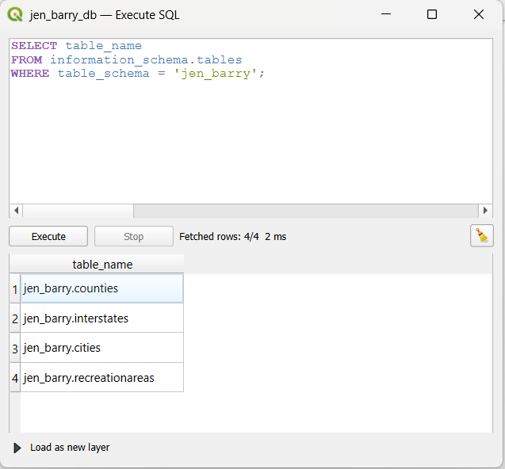
WHERE table_schema = 'jen_barry';

To check all the names : run this
-- Check columns for ALL tables
SELECT table_name, column_name, data_type
FROM information_schema.columns
WHERE table_schema = 'jen_barry'
AND table_name IN ('jen_barry.cities', 'jen_barry.counties', 'jen_barry.interstates', 'jen_barry.recreationareas')
ORDER BY table_name, ordinal_position;

table_name | column_name | data_type
jen_barry.cities | id | integer
jen_barry.cities | geom | USER-DEFINED
jen_barry.cities | ID | integer
jen_barry.cities | NAME | character varying
jen_barry.cities | POPULATION | numeric
jen_barry.cities | TOTAL_CRIM | numeric
jen_barry.cities | CRIME_INDE | numeric
jen_barry.cities | UNIVERSITY | numeric
jen_barry.cities | geom_2271 | USER-DEFINED
jen_barry.counties | id | integer
jen_barry.counties | geom | USER-DEFINED
jen_barry.counties | AREA | numeric
jen_barry.counties | PERIMETER | numeric
jen_barry.counties | NAME | character varying
jen_barry.counties | POP1990 | numeric
jen_barry.counties | AGE_18_64 | numeric
jen_barry.counties | NO_FARMS87 | numeric
jen_barry.counties | POP_SQMILE | bigint
jen_barry.counties | SQ_MILES | numeric
jen_barry.counties | GAVPRIMARY | bigint
jen_barry.counties | X | double precision
jen_barry.counties | Y | double precision
jen_barry.counties | geom_2271 | USER-DEFINED
jen_barry.interstates | id | integer
jen_barry.interstates | geom | USER-DEFINED
jen_barry.interstates | FNODE_ | bigint
jen_barry.interstates | TNODE_ | bigint
jen_barry.interstates | LPOLY_ | bigint
jen_barry.interstates | RPOLY_ | bigint
jen_barry.interstates | LENGTH | numeric
jen_barry.interstates | INTERSTATE | bigint
jen_barry.interstates | INTERSTATE_1 | bigint
jen_barry.interstates | NAME | character varying
jen_barry.interstates | TYPE | character varying
jen_barry.interstates | geom_2271 | USER-DEFINED
jen_barry.recreationareas | id | integer
jen_barry.recreationareas | geom | USER-DEFINED
jen_barry.recreationareas | AREA | double precision
jen_barry.recreationareas | PERIMETER | double precision
jen_barry.recreationareas | NCREC_ | bigint
jen_barry.recreationareas | NCREC_ID | bigint
jen_barry.recreationareas | geom_2271 | USER-DEFINED

Solution :

-- ============================================================================
-- Jen and Barry's Ice Cream Site Selection Project
-- PostGIS Spatial Analysis
-- ============================================================================

-- STEP 0: Enable PostGIS Extensions
-- ============================================================================
CREATE EXTENSION IF NOT EXISTS postgis;
CREATE EXTENSION IF NOT EXISTS postgis_topology;

-- ============================================================================
-- STEP 1: Create Transformed Geometry Columns (EPSG:2271 - PA State Plane South)
-- ============================================================================
-- Why EPSG:2271? Pennsylvania State Plane South (NAD83) uses feet as units,
-- which allows us to measure distances accurately in feet.
-- Distance conversions: 10 miles = 52,800 feet | 20 miles = 105,600 feet

-- Add new geometry columns in EPSG:2271 (PA State Plane South, feet)
ALTER TABLE jen_barry."jen_barry.counties"
ADD COLUMN geom_2271 geometry(MultiPolygon, 2271);

ALTER TABLE jen_barry."jen_barry.cities"
ADD COLUMN geom_2271 geometry(Point, 2271);

ALTER TABLE jen_barry."jen_barry.interstates"
ADD COLUMN geom_2271 geometry(MultiLineString, 2271);

ALTER TABLE jen_barry."jen_barry.recreationareas"
ADD COLUMN geom_2271 geometry(MultiPolygon, 2271);

-- ============================================================================
-- STEP 2: Transform Geometries from EPSG:4267 (NAD27) to EPSG:2271
-- ============================================================================

UPDATE jen_barry."jen_barry.counties"
SET geom_2271 = ST_Transform(geom, 2271);

UPDATE jen_barry."jen_barry.cities"
SET geom_2271 = ST_Transform(geom, 2271);

UPDATE jen_barry."jen_barry.interstates"
SET geom_2271 = ST_Transform(geom, 2271);

UPDATE jen_barry."jen_barry.recreationareas"
SET geom_2271 = ST_Transform(geom, 2271);

-- ============================================================================
-- STEP 3: Create Spatial Indexes on Transformed Geometries
-- ============================================================================
-- Spatial indexes significantly improve query performance for spatial operations

CREATE INDEX idx_counties_geom2271
ON jen_barry."jen_barry.counties" USING GIST(geom_2271);

CREATE INDEX idx_cities_geom2271
ON jen_barry."jen_barry.cities" USING GIST(geom_2271);

CREATE INDEX idx_interstates_geom2271
ON jen_barry."jen_barry.interstates" USING GIST(geom_2271);

CREATE INDEX idx_recreationareas_geom2271
ON jen_barry."jen_barry.recreationareas" USING GIST(geom_2271);

-- ============================================================================
-- STEP 4: Verify Transformed Geometries
-- ============================================================================
-- Check that all geometries were transformed correctly

SELECT
'counties' AS tbl,
GeometryType(geom_2271) AS geom_type,
ST_SRID(geom_2271) AS srid,
COUNT(*) AS count
FROM jen_barry."jen_barry.counties"
GROUP BY GeometryType(geom_2271), ST_SRID(geom_2271)

UNION ALL

SELECT
'cities' AS tbl,
GeometryType(geom_2271),
ST_SRID(geom_2271),
COUNT(*)
FROM jen_barry."jen_barry.cities"
GROUP BY GeometryType(geom_2271), ST_SRID(geom_2271)

UNION ALL

SELECT
'interstates' AS tbl,
GeometryType(geom_2271),
ST_SRID(geom_2271),
COUNT(*)
FROM jen_barry."jen_barry.interstates"
GROUP BY GeometryType(geom_2271), ST_SRID(geom_2271)

UNION ALL

SELECT
'recreationareas' AS tbl,
GeometryType(geom_2271),
ST_SRID(geom_2271),
COUNT(*)
FROM jen_barry."jen_barry.recreationareas"
GROUP BY GeometryType(geom_2271), ST_SRID(geom_2271);

-- ============================================================================
-- VIEW 1: Suitable Counties (County-Level Criteria)
-- ============================================================================
-- Criteria:
-- - Greater than 500 farms (NO_FARMS87 > 500)
-- - Labor pool of at least 25,000 (AGE_18_64 >= 25000)
-- - Population density less than 150 per square mile (POP_SQMILE < 150)

CREATE OR REPLACE VIEW jen_barry.suitable_counties AS
SELECT
id,
"NAME",
"NO_FARMS87",
"AGE_18_64",
"POP_SQMILE",
"SQ_MILES",
geom,
geom_2271
FROM jen_barry."jen_barry.counties"
WHERE
"NO_FARMS87" > 500
AND "AGE_18_64" >= 25000
AND "POP_SQMILE" < 150;

-- Test Query 1: View suitable counties
SELECT COUNT(*) AS count_of_suitable_counties
FROM jen_barry.suitable_counties;

SELECT "NAME", "NO_FARMS87", "AGE_18_64", "POP_SQMILE"
FROM jen_barry.suitable_counties
ORDER BY "NAME";

-- ============================================================================
-- VIEW 2: Suitable Cities (City-Level Criteria within Suitable Counties)
-- ============================================================================
-- Criteria:
-- - Located within a suitable county (spatial join)
-- - Low crime index (CRIME_INDE <= 0.02)
-- - Has a university or college (UNIVERSITY = 1)
-- Expected Result: 9 cities

CREATE OR REPLACE VIEW jen_barry.suitable_cities AS
SELECT
c.id AS city_id,
c."NAME" AS city_name,
c."POPULATION",
c."CRIME_INDE",
c."UNIVERSITY",
s."NAME" AS county_name,
s."NO_FARMS87",
s."AGE_18_64",
s."POP_SQMILE" AS county_pop_sqmile,
c.geom,
c.geom_2271
FROM jen_barry."jen_barry.cities" AS c
JOIN jen_barry.suitable_counties AS s
ON ST_Within(c.geom_2271, s.geom_2271)
WHERE
c."CRIME_INDE" <= 0.02
AND c."UNIVERSITY" = 1;

-- Test Query 2: View suitable cities (should return 9 cities)
SELECT COUNT(*) AS count_of_suitable_cities
FROM jen_barry.suitable_cities;

SELECT city_name, county_name, "POPULATION", "CRIME_INDE", "UNIVERSITY"
FROM jen_barry.suitable_cities
ORDER BY city_name;

-- ============================================================================
-- VIEW 3: Cities Near Interstate (Within 20 Miles)
-- ============================================================================
-- Criteria:
-- - Within 20 miles (105,600 feet) of an interstate
-- Uses ST_DWithin for efficient distance-based spatial join

CREATE OR REPLACE VIEW jen_barry.cities_near_interstate AS
SELECT DISTINCT
c.city_id,
c.city_name,
c."POPULATION",
c."CRIME_INDE",
c."UNIVERSITY",
c.county_name,
c."NO_FARMS87",
c."AGE_18_64",
c.county_pop_sqmile,
c.geom,
c.geom_2271
FROM jen_barry.suitable_cities AS c
JOIN jen_barry."jen_barry.interstates" AS i
ON ST_DWithin(c.geom_2271, i.geom_2271, 105600); -- 20 miles in feet

-- Test Query 3: View cities near interstates
SELECT COUNT(*) AS count_cities_near_interstate
FROM jen_barry.cities_near_interstate;

SELECT city_name, county_name
FROM jen_barry.cities_near_interstate
ORDER BY city_name;

-- ============================================================================
-- VIEW 4: Final Candidate Cities (All Criteria Met)
-- ============================================================================
-- Final Criteria:
-- - Within 10 miles (52,800 feet) of a recreation area
-- Expected Result: 4 cities

CREATE OR REPLACE VIEW jen_barry.final_candidate_cities AS
SELECT DISTINCT
c.city_id,
c.city_name,
c."POPULATION",
c."CRIME_INDE",
c."UNIVERSITY",
c.county_name,
c."NO_FARMS87",
c."AGE_18_64",
c.county_pop_sqmile,
c.geom,
c.geom_2271
FROM jen_barry.cities_near_interstate AS c
JOIN jen_barry."jen_barry.recreationareas" AS r
ON ST_DWithin(c.geom_2271, r.geom_2271, 52800); -- 10 miles in feet

-- Test Query 4: View final candidate cities (should return 4 cities)
SELECT COUNT(*) AS count_final_candidates
FROM jen_barry.final_candidate_cities;

SELECT city_name, county_name
FROM jen_barry.final_candidate_cities
ORDER BY city_name;

-- ============================================================================
-- BONUS: Comprehensive Summary Report
-- ============================================================================
-- Detailed view of final candidates with all criteria verification

SELECT
city_name,
county_name,
"POPULATION" AS city_population,
"CRIME_INDE" AS city_crime_index,
"UNIVERSITY" AS has_university,
"NO_FARMS87" AS county_farms,
"AGE_18_64" AS county_labor_force,
county_pop_sqmile AS county_pop_density,
-- Verify all criteria are met
CASE WHEN "NO_FARMS87" > 500 THEN '✓' ELSE '✗' END AS "Farms>500",
CASE WHEN "AGE_18_64" >= 25000 THEN '✓' ELSE '✗' END AS "Labor≥25K",
CASE WHEN county_pop_sqmile < 150 THEN '✓' ELSE '✗' END AS "Density<150",
CASE WHEN "CRIME_INDE" <= 0.02 THEN '✓' ELSE '✗' END AS "Crime≤0.02",
CASE WHEN "UNIVERSITY" = 1 THEN '✓' ELSE '✗' END AS "Has_Univ"
FROM jen_barry.final_candidate_cities
ORDER BY city_name;

-- ============================================================================
-- END OF SQL SCRIPT
-- ============================================================================

Add Layers to Map Canvas
Add Base Layers First
In Browser Panel, expand:
  - PostgreSQL → jen_barry_db → jen_barry schema
Drag these to your map canvas:
- ✅ jen_barry.counties.geom - All counties (gray background)
- ✅ suitable_counties.geom - Suitable counties (light blue)
2. Feature Layers (Middle)
- ✅ jen_barry.recreationareas.geom - Recreation areas (light green)
- ✅ jen_barry.interstates.geom - Highways (red lines)
3. City Layers (Top - Most Important)
- ✅ suitable_cities.geom - 9 cities (orange circles)
- ✅ cities_near_interstate.geom - Cities near highways (yellow circles)
- ✅ final_candidate_cities.geom - 4 FINAL CITIES (red stars ⭐)
Layers You Should NOT Add:
❌ jen_barry.cities.geom - (This shows ALL cities, not just suitable ones) ❌ Any geom_2271 layers - (These are for calculations only)
Now Style Each Layer:
Follow the styling guide I gave you earlier with these colors:
Layer | Color | Type
jen_barry.counties.geom | Gray #E0E0E0 | Polygon
suitable_counties.geom | Light Blue #B3D9FF | Polygon
jen_barry.recreationareas.geom | Light Green #90EE90 | Polygon
jen_barry.interstates.geom | Purple/Violet #9933FF | Line (1mm)
suitable_cities.geom | Orange #FFA500 | Circle (3mm)
cities_near_interstate.geom | Yellow #FFFF00 | Circle (4mm)
final_candidate_cities.geom | Red #FF0000 | Star ⭐ (7mm)

