Machine Learning Reflective e Portfolio
  - End of Module Assignment
Alya Nasser Mohammed Ahmad Abdulla
Module ML_PCOM7E
Machine Learning July 2026
19 October 2026
Critical reflection on virtual teamwork and the individual MovieLens 100K presentation
Evidence sources: the updated peer evaluation, the supplied individual presentation and the tutor feedback reproduced in the assignment information.

Contents and scope
1 Learning from the group project
2 Developing technical judgement
3 Evaluation and explainability
4 Ethics and professional practice
5 Development plan
6 Evidence coverage
References
Evidence appendix
This portfolio reflects on the Airbnb team assessment and my individual presentation comparing matrix factorisation with neural collaborative filtering. My central learning is that credible machine learning work depends on both technical reasoning and timely, verifiable participation. Independent effort cannot replace the collaboration required by a team assessment.
I separate what the available artefacts demonstrate from what still requires execution records. The presentation establishes a proposed comparison and its limitations. It contains pending results, so I do not claim a measured improvement, a completed fairness audit or a verified deployment outcome. The weekly activities listed in the module schedule are mapped in Section 6 without claiming completion where records are absent.
The full Unit 12 marking rubric and word limit were not supplied. This reflection follows the assessment information available here and should be checked against that rubric before submission.

1 Learning from the group project
The Unit 6 Airbnb assessment required a shared analytical report and individual peer assessment. Work commitments and group differences affected my participation. My updated peer evaluation records my account that messages to the group received no response, that I sought tutor guidance and that I completed the work independently. These statements describe my perspective; the supplied evidence does not include dated messages or the analytical report itself (Alya, 2026a).
The tutor awarded 0% and stated that I had not engaged within the required timeframe and that separately submitted individual evidence could not be accepted. The feedback appears in the information supplied for both 11 September and 18 October 2026. I cannot resolve the difference between my account and the assessment decision from the peer form alone. I need to recognise that the timing and visibility of engagement were central to the assessed outcome (University of Essex Online, 2026).
My response emphasised completing a product when communication appeared ineffective. That approach may have protected my sense of progress, but it did not establish a functioning team process. A stronger response would have created an early written agreement on responsibilities, interim deadlines and escalation routes. I should have sought explicit guidance on an approved alternative before relying on independent work.
The peer form also gives me the highest rating on every completed self-evaluation item. This now requires more critical judgement. Initiative and persistence may be strengths, but effective cooperation and meeting participation need dated supporting evidence. I would reassess these criteria individually rather than treating a completed personal contribution as proof of successful collaboration. My improvement is to make engagement visible early, acknowledge constraints promptly and evaluate my contribution against the actual assessment criteria.

2 Developing technical judgement
The individual presentation shifts the application from Airbnb business analysis to movie recommendation. It compares biased matrix factorisation with a neural model using the same MovieLens 100K dataset. This provides evidence of my ability to structure a comparison, while the slides alone cannot verify that the associated notebook was executed (Alya, 2026b, slides 3–8).
The official documentation describes 100,000 ratings from 943 users on 1,682 films, with at least 20 ratings per included user. These inclusion rules help explain why the benchmark cannot establish performance for genuinely new users. Its historical observations also limit claims about contemporary audiences (GroupLens Research, 1998). I now place greater weight on the population represented by a dataset before discussing model suitability.
A useful distinction in the presentation is that an unrated film represents an unknown preference. Coding every missing rating as dislike would introduce an unsupported assumption. Similarly, user and film identifiers serve as lookup labels, so their numerical distance should not be interpreted as meaningful. These choices connect preprocessing directly to the validity of later conclusions.
The classical model combines a global mean, user and film biases and a latent dot product. The neural design uses two 24-dimensional embeddings followed by hidden layers of 64 and 32 units. The presentation adapts the neural collaborative filtering idea to explicit rating regression; it does not reproduce the original implicit-feedback experiment of He et al. (2017). Recognising that distinction improves the precision of my technical communication.
My model-selection reasoning has become more conditional. Architectural flexibility creates an opportunity to represent complex interactions, but does not demonstrate better generalisation. I would need comparable tuning budgets, repeated runs and measured inference costs before recommending the neural model. The current artefact supports a reasoned comparison of designs, with empirical conclusions still outstanding.

3 Evaluation and explainability
The validation slide is especially useful evidence of critical reasoning. It reserves each user’s latest rating for testing and second latest for validation. This preserves within-user order, but another user’s training interaction can still occur after a test event. I therefore need a global time-based evaluation before claiming realistic prospective performance (Alya, 2026b, slide 5).
The presentation also identifies a limitation in the three development folds. If a held-out fold guides early stopping, its score has influenced model selection. I would reserve an inner validation set for stopping and evaluate the outer fold once. This distinction helps me separate development feedback from an unbiased assessment of generalisation.
RMSE addresses rating error, while NDCG at ten addresses the order of relevant recommendations. A gain on one metric may accompany a loss on the other. The presentation defines relevance as a held-out rating of at least four and describes sampled unrated candidates. Those candidates are unlabelled, so the resulting ranking score needs a stated sampling rule, seed and eligible-user count. It cannot be treated as a full-catalogue evaluation.
The proposed explanation for matrix factorisation decomposes a score into its components. This explains the arithmetic without assigning reliable everyday meanings to latent dimensions. The proposed neural diagnostic permutes user or film identifiers and measures the effect on RMSE. I would interpret this as sensitivity to a perturbation, with repeated shuffles, rather than as causal evidence about preferences.
The most important evidence limit is visible in slide 10: the result cells await executed outputs. The notes also contain unfinished demonstration and diagnostic prompts. I therefore cannot claim that either model achieved a particular score or that explainability was successfully demonstrated. My next step is to retain actual outputs, uncertainty estimates and examples that can be traced to an executed notebook.

4 Ethics and professional practice
The presentation connects recommendation errors with practical harms. An unsuitable recommendation can waste attention, while a missed relevant film can restrict discovery. Repeated popularity-driven exposure may disadvantage niche content. These considerations make catalogue coverage and exposure concentration relevant alongside predictive accuracy (Alya, 2026b, slide 13).
MovieLens contains demographic fields, and public research availability does not establish unrestricted permission for reuse. Its documentation requires separate permission for redistribution and commercial use (GroupLens Research, 1998). My learning is to examine provenance and permitted use before proposing deployment. Pseudonymous identifiers should also not be mistaken for a complete privacy guarantee.
Slide 12 proposes comparisons across users with different activity levels, but supplies no measured subgroup outcomes. I would define the bands using training history, report group sizes and examine uncertainty. Even similar RMSE values would leave unresolved questions about exposure and discovery. I should describe such checks as diagnostic evidence rather than as certification that a system is fair.
The deployment discussion proposes an authenticated service, candidate retrieval, ranking and policy checks. This is a design proposal, not evidence of a deployed application. Model versions would need matching identifier mappings and preprocessing, a fallback for unseen users, monitoring and rollback. NIST’s AI RMF 1.0 provides a basis for considering risks across the system lifecycle (Tabassi, 2023).
Professional accountability links this work to the team-project experience. In both cases, a strong explanation needs an auditable record: timely contributions for teamwork and reproducible outputs for experiments. I will distinguish plans, self-reported activity and independently checkable results in future portfolios. This also means acknowledging assistance used in preparing an assessment in accordance with the module’s AI guidance.

5 Development plan
My immediate priority is to turn the strongest parts of the reflection into observable improvements. The following actions are future commitments; they do not imply that missing activities or experiments have already been completed.
Priority | Action and timing | Evidence of improvement
Team participation | Within 48 hours of the next group allocation, agree tasks, availability and interim deadlines. | Written agreement and acknowledgement from members.
Escalation | Agree a response window at the outset. Raise missed checkpoints through the module route as soon as that window expires. | Dated messages and a recorded response or follow-up.
Reproducibility | Before making a model-performance claim, execute the complete notebook from a clean session. | Saved environment, data source, split indices, settings and outputs.
Validation | During the next experiment, separate tuning from final testing and add a global chronological check. | Split audit and comparison of development and final test results.
Interpretation | Before recommending deployment, complete repeated explanations and subgroup diagnostics. | Worked score decomposition, permutation variation, group sizes and uncertainty.
Portfolio practice | At the end of each future unit, save the activity, feedback and a short reflection. | Dated artefact plus a note explaining what changed in my understanding.
For the current portfolio, I will check the Unit 12 rubric, add genuine weekly records that already exist and verify the presentation’s remaining outputs. I will handle the GitHub upload myself. The actions above will let me assess progress through evidence rather than through confidence alone.

6 Evidence coverage
E1 is the supplied updated peer evaluation. E2 is the supplied 17-slide MovieLens presentation and its notes. E3 is the tutor feedback copied into the assignment information. E3 has not been supplied as an original screenshot. The appendix reproduces rendered extracts from E1 and E2 only.
Module activity | Available evidence and limit
Units 1–3 Collaborative Discussion 1 | No posts or peer replies supplied.
Units 2 4 6 8 10 12 Seminar preparation | No preparation records or attendance evidence supplied.
Unit 3 Correlation and regression | No completed activity supplied.
Unit 5 Wiki and Jaccard coefficient | No wiki contribution or calculations supplied.
Unit 6 Airbnb team project | E1 and E3 support reflection on teamwork. The report, code and dated communication records were not supplied.
Unit 7 Perceptron activities | No completed activity supplied; E2 neural architecture is a separate artefact.
Unit 8 Gradient cost function | No completed exercise supplied.
Units 8–10 Collaborative Discussion 2 | No posts or peer replies supplied.
Unit 9 CNN model activity | No completed CNN artefact supplied. The recommender presentation does not substitute for it.
Unit 11 Model performance measurement | E2 slides 9–12 describe evaluation and diagnostics. Numerical outputs remain pending.
Unit 11 Individual presentation | E2 supports technical reflection. No executed notebook, recorded presentation or submission receipt was supplied.
This mapping records the limits of the supplied evidence. Absence from this document does not establish that an activity was never completed. Existing records should be added under their original dates, without recreating earlier participation retrospectively.

References
Alya (2026a) Updated peer evaluation. Unpublished student document. Name recorded in the document: Alya Nasser Mohammed Ahmad Abdulla. Supplied file: Updated Peer evaluation template(20261019-184522).docx.
Alya (2026b) Comparative intelligence and ethics MovieLens 100K. Unpublished student presentation, ML_PCOM7E July 2026. Supplied file: Comparative Intelligence and Ethics_ MovieLens 100K(1).pptx.
GroupLens Research (1998) MovieLens 100K dataset README. Available at: https://files.grouplens.org/datasets/movielens/ml-100k-README.txt (Accessed: 19 October 2026).
He, X., Liao, L., Zhang, H., Nie, L., Hu, X. and Chua, T.-S. (2017) ‘Neural collaborative filtering’, Proceedings of the 26th International Conference on World Wide Web, pp. 173–182. doi: 10.1145/3038912.3052569.
Tabassi, E. (2023) Artificial Intelligence Risk Management Framework AI RMF 1.0. NIST AI 100-1. Gaithersburg, MD: National Institute of Standards and Technology. doi: 10.6028/NIST.AI.100-1.
University of Essex Online (2026) Machine Learning July 2026 assessment instructions and team project feedback. ML_PCOM7E. Feedback attributed to Noah (Nouh) Elmitwally, 11 September and 18 October. Text supplied by the student.

Evidence appendix 1 Peer evaluation
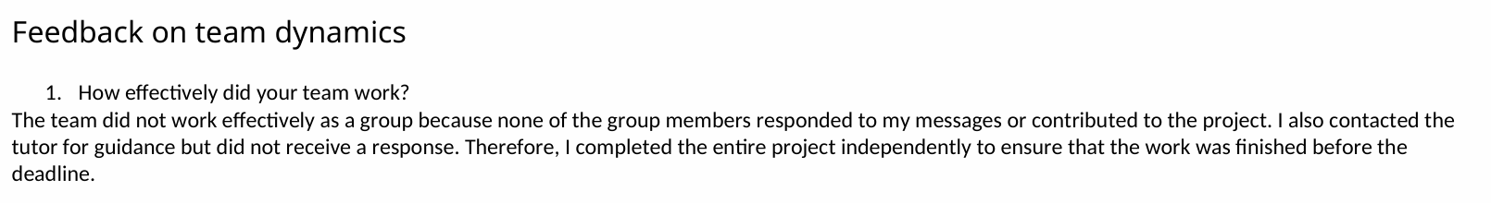
Figure 1 E1 page 2 extract. My account of communication problems and independent completion. This is self-report, not a dated communication log.

Figure 2 E1 page 3 extract. My stated learning about roles, deadlines and early escalation.
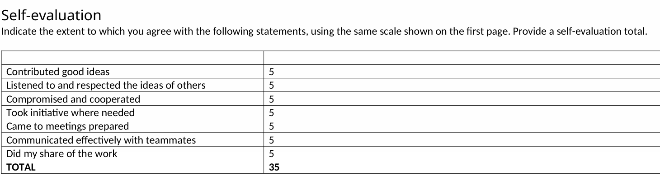
Figure 3 E1 page 3 extract. Self-evaluation ratings total 35. These require critical interpretation alongside the tutor feedback.

Evidence appendix 2 Model designs
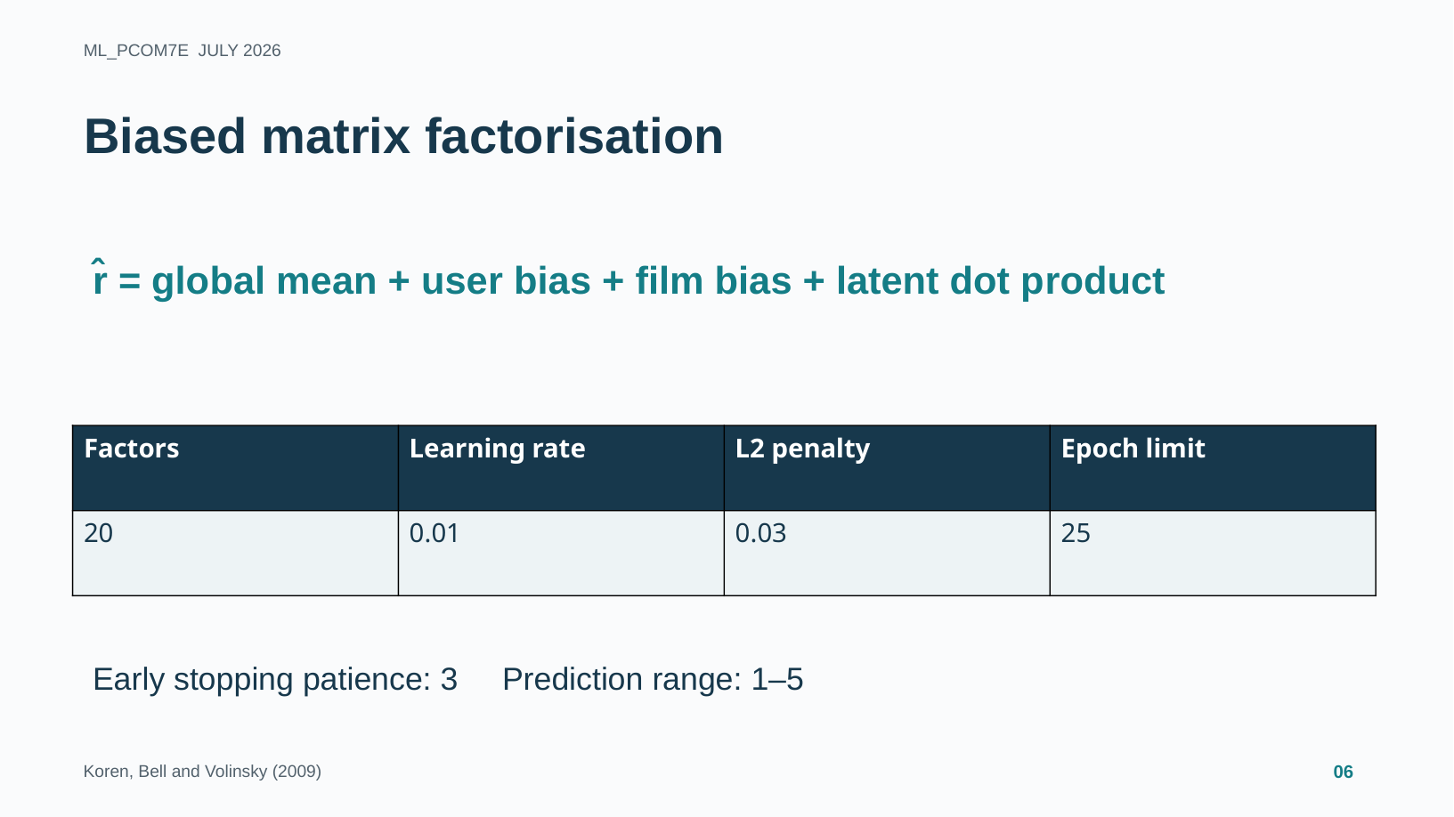
Figure 4 E2 slide 6. Matrix factorisation design and proposed settings. The screenshot documents the presentation content, not a verified training run.
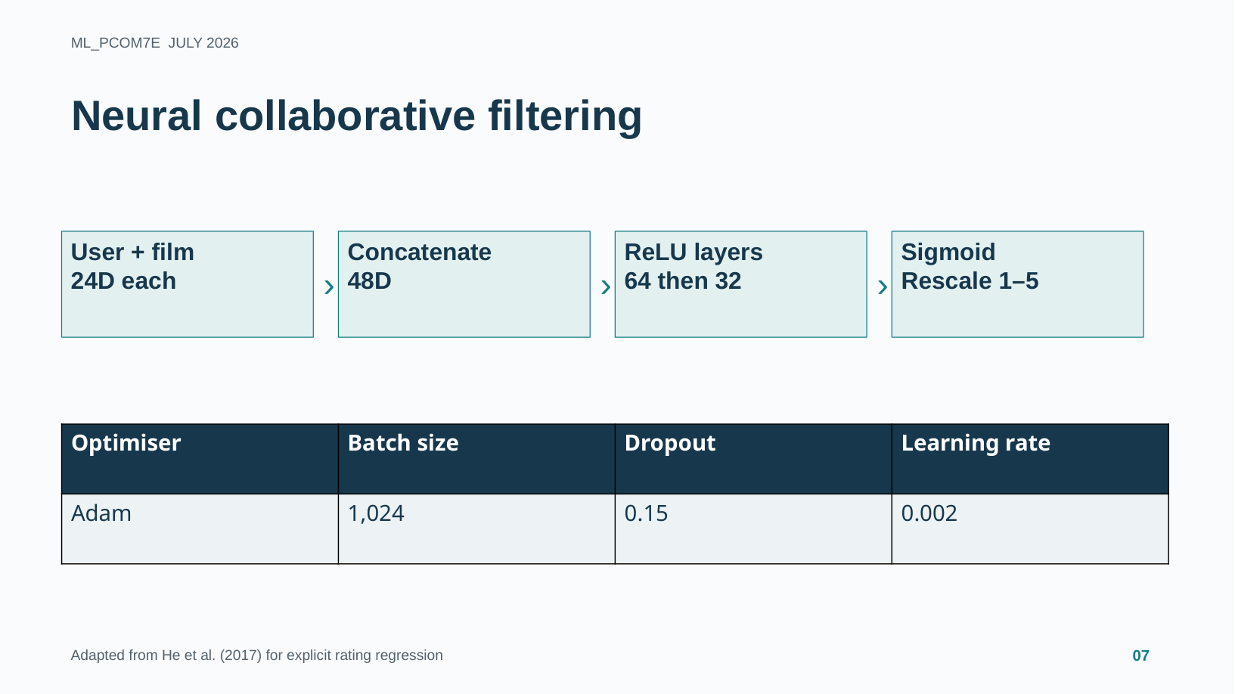
Figure 5 E2 slide 7. Neural architecture and proposed training settings. These settings alone do not establish performance.

Evidence appendix 3 Evaluation limits
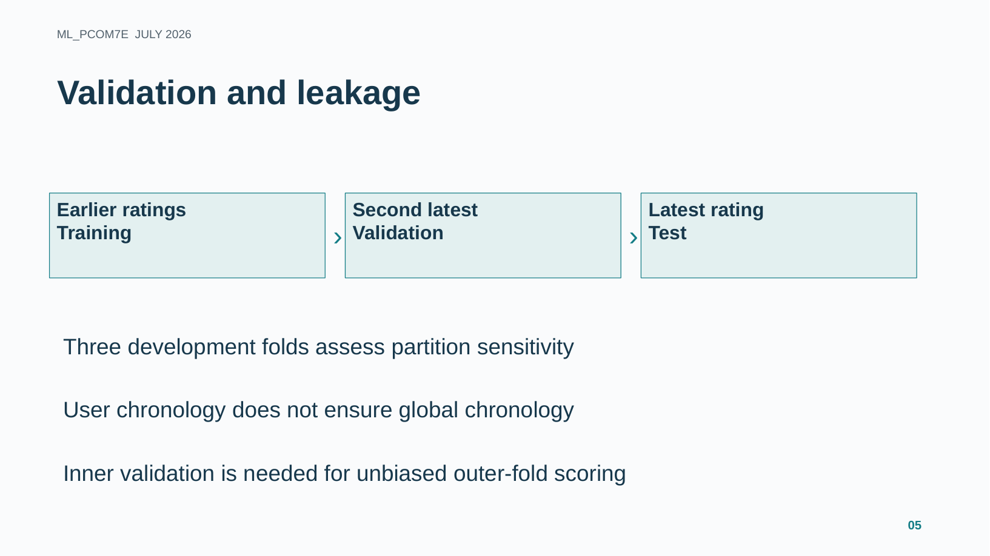
Figure 6 E2 slide 5. Proposed validation and explicit recognition of chronology and fold-selection limitations.
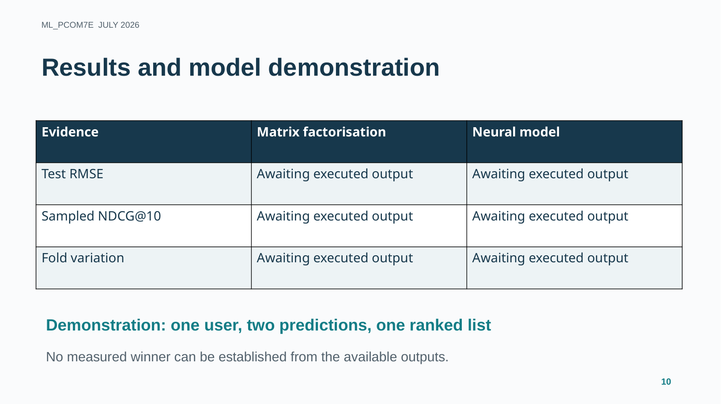
Figure 7 E2 slide 10. Results visibly await executed output. No numerical comparison or measured winner is claimed in this reflection.

Evidence appendix 4 Responsible use
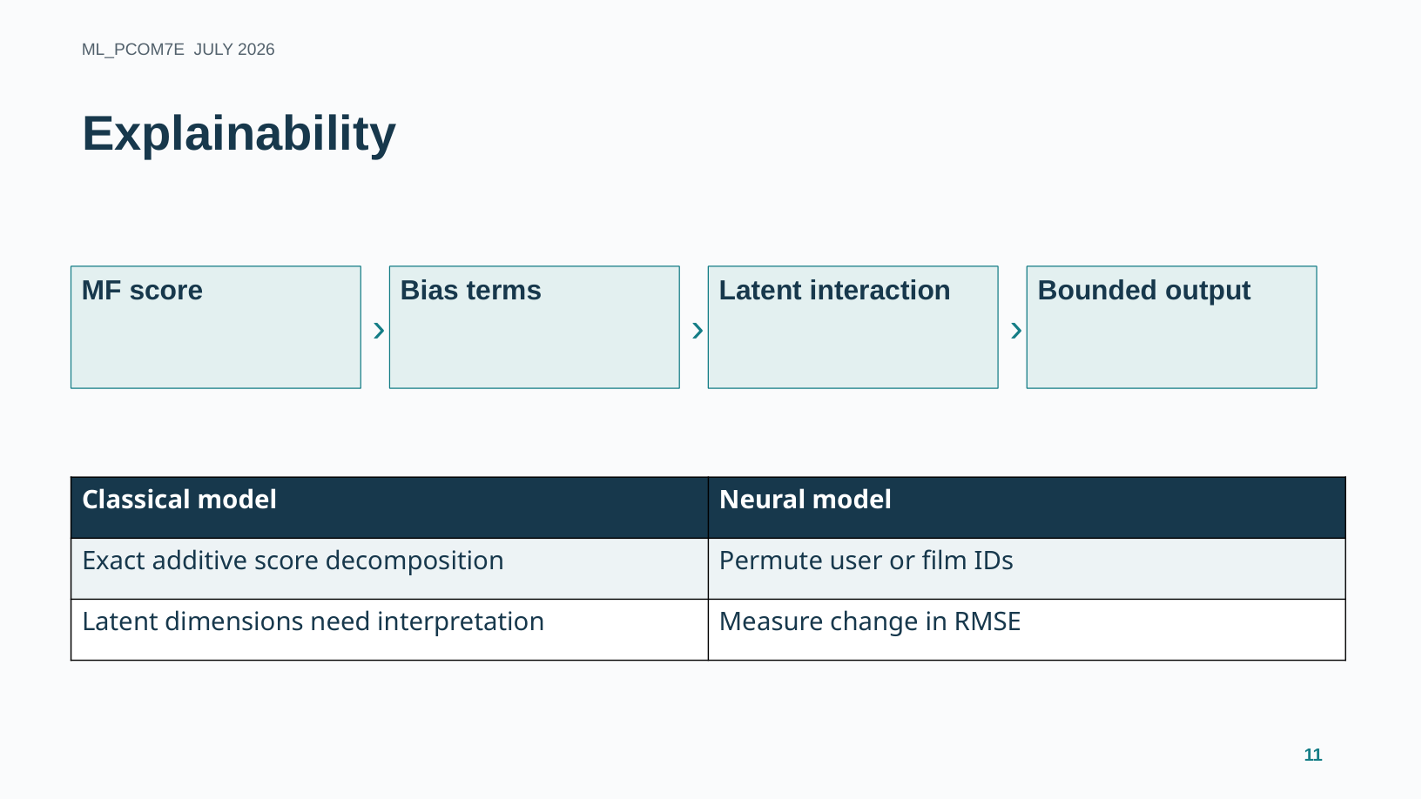
Figure 8 E2 slide 11. Proposed explanation methods. Verified examples and repeated diagnostic outputs remain necessary.
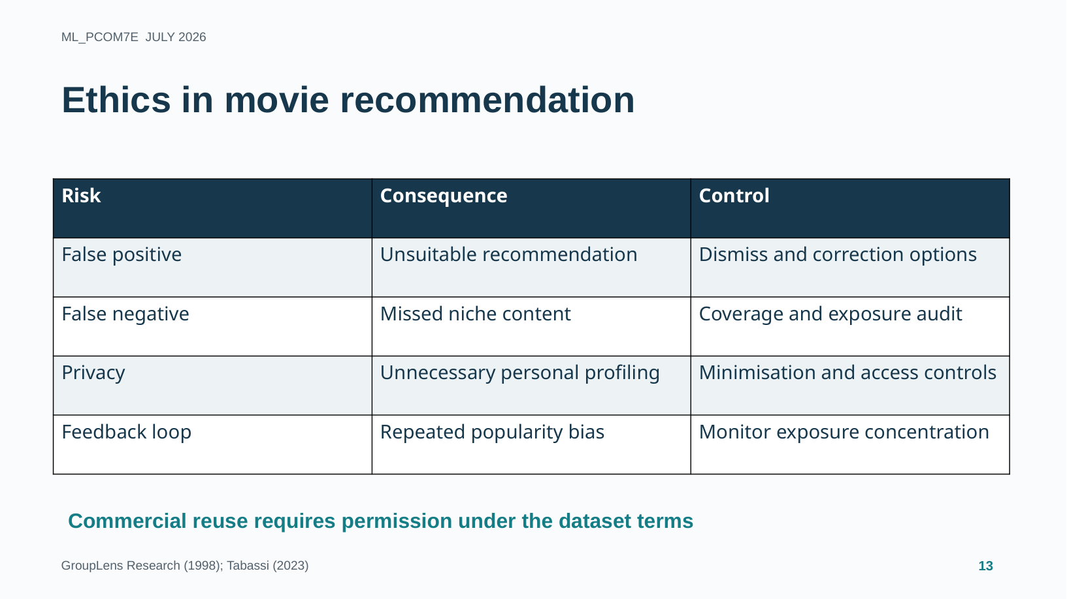
Figure 9 E2 slide 13. Application-specific ethical risks and proposed controls. This evidences risk analysis rather than completed mitigation testing.

