18th Jun 2026

Relieving & Experience Letter

This is to confirm that Mr. Aaditya Shahapurkar (ASIPL3875) was employed with Aditi Tech Consulting Pvt Ltd (Formerly known as Aditi staffing India Pvt Ltd) from 05 May 2025 to 14 Jul 2025 as a Technical Recruiter.

We wish you the best in your future endeavors.

Yours Sincerely,
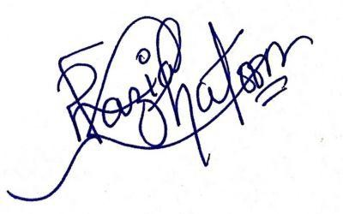

Razia Khatoon
Associate Director - People & Culture

