

Arab International University
Faculty of Informatics and Communication Engineering
Senior Project Report on
HealthLens:
An AI-Driven Multimodal Diagnostic and Conversational Health Ecosystem
Submitted to
Department of Informatics Engineering
in partial fulfillment of the requirement for the Degree of Bachelor in
Informatics Engineering
Submitted by
Jalal Ouscan Abdullah Almidani
Mohamed Osama Al-Khatib
Under the Supervision of
Dr. Tarek Barhoum Eng. Suzan Mahmoud
January 2026

© AIU Arab International University
All Rights Reserved
January 2026

Faculty of Informatics & Communication Engineering
CERTIFICATE OF APPROVAL

The undersigned certify that they have read and recommended to the Department of Informatics Engineering for acceptance, a project report entitled HealthLens Submitted by: Jalal Ouscan, Abdullah Al-Midani, Mohamed Osama Al-Khatib in partial fulfilment for the degree of Bachelor of Engineering in Informatics.

Supervisors Head of Department
Dr. Tarek Barhoom Dr. Rami Yared
Eng. Suzan Mahmoud

Arab International University
The Arab International University (AIU) is a private Syrian university established in 2005. Its academic plans and the documents issued by it are approved and certified by the Ministry of Higher Education in the Syrian Arab Republic.

The university works to achieve the following goals:
- Preparing a distinguished generation of university graduates who are able to meet and advance the specific needs of society.
- Contributing to theoretical and applied scientific research that serves the purposes of national development. Work is being done to urge professors and academic staff to scientific research and participate in conferences and seminars that organize research.
- Achieving partnership with prestigious Arab and foreign universities with the aim of continuous development and modernization of academic work and conducting joint scientific research.
- Attracting distinguished academic and research competencies by providing the appropriate environment for their work.
The Arab International University is one of the first Syrian universities that have been established and inaugurated. It has been able to attract distinguished educational, research and administrative competencies, to create an integrated edifice from the academic, organizational and administrative aspects. It was able to graduate cadres of distinguished innovators by providing an educational environment based on unique qualitative and material ingredients, including:
- Modern and advanced study plans based on the credit hour system.
- Carefully selected educational cadres.
- Modern scientific laboratories and a laboratory for electronic libraries.
- Physical and moral incentives for students.
- Application of interactive teaching methods.
- Academic and educational guidance and counseling.
- A wide range of scientific cooperation agreements with local, regional and international universities of reputable reputation.
- Multiple agreements and memoranda of understanding with many civil society organizations.
- A proper campus with all the facilities of science, sports and entertainment, which we encourage you to visit and learn about their features.
- Student activities and clubs of all kinds: athletic, cultural, scientific and social.
The Arab International University life years are a time to invest in a student's future. The knowledge and experience that students acquire in the lecture hall and laboratories will help them in developing themselves. They will provide them with reasons for success in the chosen specialty. The student activities will help in expanding students’ horizon. The activities of training, clubs and sports will enable students to develop their talents, and may even help in discovering new talents.
Students could invest time, mind and spirit in our university in order to reap the benefits of works and the time devoted in the coming years. We will be by our students in every step of their way.

Acknowledgements
We extend our deepest gratitude and sincere appreciation to Dr. Tarek Barhoom, our esteemed supervisor, for his invaluable guidance, unwavering encouragement, and insightful contributions throughout this project. His expert advice, constructive feedback, and collaborative spirit were instrumental in bringing this work to fruition.

We also sincerely thank Eng. Suzan Mahmoud for her steadfast support, professional mentorship, and dedication to our success.

Finally, we express our heartfelt thanks to our families, friends, and all those who provided direct or indirect assistance during this journey. Their encouragement and belief in us were a source of strength and inspiration.

Sincerely,
Jalal Ouscan, Abdullah Almidani, Mohamed Osama Al-Khatib

Abstract
Healthcare applications increasingly rely on artificial intelligence to support medical decision-making; however, many existing systems suffer from rigid architectures and limited extensibility. This project presents HealthLens, an AI-assisted healthcare platform designed to deliver intelligent medical analysis and interactive consultation through a secure, role-based system. HealthLens integrates a cross-platform mobile application with a centralized backend, enabling authenticated users to access multiple AI-driven medical services while administrators manage the platform through a dedicated backend dashboard.
The system consolidates four artificial intelligence functionalities within a unified AI service layer: a generative medical conversational AI system for conversational assistance, a skin disease image classification module, an eye disease classification module, and a data-driven surgery recommendation module based on ophthalmic imaging and clinical parameters.
The skin disease classification module, based on a mobile-optimized MobileNetV3-Large architecture, achieves approximately 84% Top-1 validation accuracy and 97% Top-3 accuracy, demonstrating strong generalization under realistic smartphone-oriented augmentation.
The eye disease classification module employs a fine-tuned EfficientNet-B3 model and achieves a validation macro-averaged F1-score of 0.961 for multi-class retinal disease classification.
The keratoconus detection module, built on a multimodal feature fusion strategy and gradient-boosted decision trees, achieves approximately 96% classification accuracy while providing interpretable predictions through SHAP-based explanations.
The HealthLens medical chatbot is built upon a transformer-based language model fine-tuned using a three-phase curriculum learning strategy encompassing clinical reasoning, evidence grounding, and conversational safety. Final evaluation demonstrates perfect accuracy on controlled MedQA reasoning tasks, strong performance on PubMedQA evidence-based questions, and consistent adherence to medical safety constraints.
HealthLens enforces strict role-based access control, modular system design, and secure handling of medical data to ensure scalability, maintainability, and future extensibility. By integrating multiple AI-driven medical capabilities within a single coherent architecture, HealthLens demonstrates how intelligent healthcare systems can support diverse medical domains while remaining efficient, interpretable, and suitable for real-world clinical decision support.
Keywords
Telemedicine, Artificial Intelligence, Medical Decision Support Systems, Deep Learning, Dermatology, Ophthalmology, Medical Image Analysis, Image Classification, Medical Chatbot, Clinical Decision Support, Surgery Recommendation, Triage Systems, Mobile Health (mHealth), React Native, Laravel.

Contents
Introduction 2
Chapter 1: Project Description 4
1.1 Background 4
1.2 Problem Statement 4
1.3 Project Objective 5
1.4 Project Scope 5
1.5 Project Features 6
1.6 Project Feasibility 6
1.7 System Requirements 7
Chapter 2: Theoretical Study 8
2.1. Introduction 8
2.2 Mobile Application Development 8
2.2.1 Cross-Platform Mobile Development 8
2.2.2 React Native Framework 9
2.2.3 JavaScript and TypeScript 9
2.2.4 Expo Platform 10
2.3 Backend Architecture and Technologies 10
2.3.1 Server-Side Architecture 10
2.3.2 PHP Programming Language 11
2.3.3 Laravel Framework 11
2.3.4 Laravel Sanctum Authentication 11
2.3.5 Database Management with MySQL 12
2.4 Artificial Intelligence and Machine Learning 12
2.4.1 Deep Learning Fundamentals 12
2.4.2 Python and Scientific Computing 12
2.4.3 PyTorch Framework 13
2.4.4 Computer Vision and NLP Libraries 13
2.4.5 Model Evaluation 13
2.5 Web Application Technologies 13
2.6 Development Tools and Environments 14
2.7 System Architecture Concepts 15
Chapter 2 - Local References 16
Mobile Application Development & Cross-Platform Frameworks 16
JavaScript, TypeScript, and Programming Language Theory 16
Expo Platform and Mobile Tooling 16
Backend Architecture and Web Technologies 17
Laravel Framework and Authentication 17
Database Theory and Management 17
Artificial Intelligence and Machine Learning 18
Python, Frameworks, and Evaluation 18
Natural Language Processing and Transformers 18
Web Tools, DevOps, and Architecture 19
Chapter 3: Literature Review 20
3.1 Eye Disease Classification 20
3.1.1 Concept Description: 20
3.1.2 Dataset Description: 20
3.1.3 Related Work (State of the Art) 21
3.1.4 Similar Applications 23
3.1.4.1 Google DeepMind EyePACS 23
3.1.4.2 IDx-DR (Digital Diagnostics) 24
3.1.4.3 VUNO Med-Fundus AI 24
3.1.4.4 Academic Retinal AI Systems 24
3.1.5 Comparison of Eye Disease Classification Applications 25
3.1.6 Positioning of the HealthLens Eye Disease Module 26
3.1.7 Conclusion 26
3.2.Keratoconus Detection and Refractive Surgery Decision Support. 27
3.2.1 Overview 27
3.2.2 Datasets 27
3.2.3 State of the Art 28
3.2.4 Comparative Analysis 30
3.2.5 Similar Applications 31
3.2.6 Comparison with Related Applications 32
3.3 Skin Disease Classification 34
3.3.1. Introduction. 34
3.3.2 Datasets Description: 34
3.3.3 State of the Art 35
3.3.4 Comparative Summary of Related Work 36
3.3.5 Similar Applications 37
3.3.6 Comparison with Existing Applications 37
3.3.7 Conclusion 39
3.4 Medical Chatbot 39
3.4.1 Introduction 39
3.4.2 Datasets 40
3.4.3 State of the Art 41
3.4.4 Comparative Summary of Related Work 42
3.4.5 Similar Applications 44
3.4.6 Positioning of the HealthLens Medical Chatbot 45
3.4.7 Conclusion 46
Chapter 3 - Local References 47
Eye Disease Classification 47
Keratoconus Detection and Surgery Support 47
Skin Disease Classification 47
Medical Conversational AI 48
Chapter 4: System Analysis 49
4.1 Requirements Specification 49
4.2 Functional Requirements 49
4.2.1 Patient (Mobile User) 49
4.2.2 Administrator (Web Dashboard User) 52
4.3 Non-Functional Requirements 53
4.3.1 Reliability 53
4.3.2 Maintainability 54
4.3.3 Usability 54
4.3.4 Interoperability 54
4.3.5 Performance 54
4.3.6 Security 55
4.4 System Modeling Diagrams 55
4.4.1 Use Case Diagram 55
4.4.2 Use Case Specifications 57
4.4.3 Sequence Diagrams 61
4.4.4 Activity Diagrams 65
4.4.5 Complete Entity-Relationship Diagram 73
Chapter 5: System Design 75
5.1 Backend Implementation 75
5.1.1 Laravel for Core Operations 75
5.1.2 Python for AI-Powered Services 76
5.1.3 Interoperability and API Design 77
5.1.4 Security Measures 77
5.2 Frontend Implementation 78
5.2.1 React Native Mobile Application 78
5.2.2 Laravel Blade Admin Dashboard 79
5.2.3 Styling and Responsiveness 79
5.3 AI Models 80
5.3.1 Multi-Class Eye Disease Classification 80
5.3.2 Keratoconus Detection and Refractive Surgery Decision Support System 82
5.3.3 Multi-Class Skin Disease Classification 86
5.3.4 Generative Medical Chatbot 88
Chapter 6: Testing 93
6.1 Introduction 93
6.2 Multi-Class Eye Disease Classification Evaluation 93
6.2.1 Experimental Setup 93
6.2.2 Quantitative Results 93
6.2.3 Explainability Analysis 94
6.3 Keratoconus Detection and Refractive Surgery Decision Support Evaluation 95
6.3.1 Evaluation Dataset and Experimental Setup 95
6.3.2 Multimodal Feature Representation Analysis 95
6.3.3 Keratoconus Detection Model Evaluation 96
6.3.4 Refractive Surgery Decision Support Evaluation 97
6.3.5 Evaluation and Explainability 98
6.4 Multi-Class Skin Disease Classification Evaluation 100
6.4.1 Experimental Setup 100
6.4.2 Quantitative Results 100
6.4.3 Key Findings and Conclusions 101
6.5 Generative Medical Chatbot Evaluation 101
6.5.1 Baseline Evaluation 101
6.5.2 Curriculum-Based Model Evaluation 101
Table 6.6 - Comparative Summary of Generative Medical Chatbot Experiments 102
6.6 Discussion of Results 102
Chapter 7: Conclusion 104
Chapter 8: Future Work 105
References 106

Abbreviations
Abbreviation | Full Term
AI | Artificial Intelligence
AIU | Arab International University
API | Application Programming Interface
CNN | Convolutional Neural Network
Conv-ViT | Convolutional Vision Transformer
CCT | Central Corneal Thickness
CV | Computer Vision
FK | Foreign Key
HTTP | Hypertext Transfer Protocol
HTTPS | Hypertext Transfer Protocol Secure
JSON | JavaScript Object Notation
JWT | JSON Web Token
KC | Keratoconus
Kmax | Maximum Keratometry
LLM | Large Language Model
ML | Machine Learning
MVC | Model-View-Controller
NLP | Natural Language Processing
OD | Oculus Dexter (Right Eye)
ORM | Object-Relational Mapping
OS | Oculus Sinister (Left Eye)
PHI | Patient Health Information
PK | Primary Key
RBAC | Role-Based Access Control
REST | Representational State Transfer
RSB | Residual Stromal Bed
SQL | Structured Query Language
TLS | Transport Layer Security
UK | Unique Key

Introduction
The integration of Artificial Intelligence (AI) into healthcare is fundamentally reshaping the landscape of medical diagnostics and patient consultation. As the demand for specialized care in fields such as dermatology and ophthalmology continues to outpace the availability of clinical experts, there is a growing need for scalable digital solutions that can bridge the gap between patients and healthcare providers. Traditional healthcare workflows are often constrained by the requirement for in-person visits during preliminary assessment stages, leading to delayed triage and increased pressure on medical facilities.
In response to these challenges, this project presents HealthLens, an AI-assisted healthcare platform designed to improve access to intelligent medical analysis. HealthLens leverages advances in deep learning and mobile computing to provide users with immediate, preliminary assessments of skin and eye conditions, while simultaneously offering a secure and centralized management system for administrators. The platform represents a shift from reactive healthcare delivery toward proactive, technology-enabled engagement, enabling earlier screening and more efficient clinical workflows.
HealthLens is architected as a comprehensive ecosystem consisting of a cross-platform mobile application for patients and a web-based dashboard for system administrators. This separation of concerns ensures that patients benefit from an accessible and intuitive interface for image submission and consultation, while administrators maintain structured oversight of system data, user management, and model performance. A unified AI service layer enables the integration of multiple diagnostic modules while preserving architectural modularity and scalability.
A key innovation within HealthLens lies in its multimodal approach to ophthalmic decision support. Beyond conventional image classification, the system incorporates a specialized refractive surgery recommendation module. This module analyzes a combination of corneal imaging modalities—including anterior, axial, posterior, and pachymetry maps—together with structured clinical parameters such as age, gender, Kmax, CCT, and astigmatism to generate data-driven surgical suitability assessments. This design addresses the inherent complexity of ophthalmic surgical planning and illustrates how AI can support high-risk clinical decision-making.

In addition, HealthLens integrates a medical conversational agent that enables natural language interaction and image submission within a unified interface. This interaction model supports structured information gathering analogous to clinical triage, allowing patient-reported data and visual evidence to jointly inform AI analysis. To protect sensitive medical information, the platform employs a role-based access control (RBAC) framework, ensuring secure data handling and restricting system management to authorized personnel.
In summary, HealthLens aims to establish a cohesive, intelligent, and secure digital healthcare environment. By combining advanced computer vision models with a scalable software architecture, the project seeks to reduce diagnostic and administrative burdens on healthcare systems while offering a practical and extensible framework for remote medical assessment and triage.
These constraints motivate the use of AI-assisted preliminary assessment tools, which can filter non-urgent cases while prioritizing patients requiring immediate specialist attention.

Chapter 1: Project Description

1.1 Background
With the rapid advancement of artificial intelligence in recent years, healthcare systems have increasingly explored digital solutions to improve accessibility, efficiency, and early medical assessment. Despite progress in medical imaging and diagnostic technologies, access to specialized healthcare—particularly in dermatology and ophthalmology—remains limited for many patients due to geographical constraints, long waiting times, and shortages of medical specialists.
Skin and eye conditions often require timely evaluation to prevent complications; however, many cases do not initially require in-person consultation. The absence of accessible preliminary assessment tools leads to delayed diagnoses for serious cases and unnecessary clinical visits for minor conditions, placing additional strain on healthcare infrastructures.
In this context, artificial intelligence—specifically computer vision and conversational AI—offers promising opportunities to support preliminary medical assessment and triage. By analyzing medical images and enabling structured medical interaction, AI-based systems can assist patients in understanding their conditions at an early stage. HealthLens is developed to leverage these technologies within a secure and user-friendly digital platform that supports both patients and healthcare system administrators.

1.2 Problem Statement
Current healthcare pathways for dermatological and ophthalmological conditions rely heavily on in-person consultations, which are not always immediately available or necessary during early stages of disease progression. This approach presents several challenges:
- Limited access to dermatologists and ophthalmologists, particularly in remote or underserved regions
- Lack of preliminary triage tools to guide patients toward appropriate medical action
- Fragmented digital solutions that address only a single medical domain
- Insufficient integration of medical image analysis with structured clinical data
- Concerns regarding data security, privacy, and administrative oversight
These challenges highlight the need for an intelligent, secure, and accessible platform capable of assisting patients with preliminary medical assessment while maintaining strict data protection and system control.

1.3 Project Objective
The primary objective of HealthLens is to develop an AI-assisted digital platform that supports preliminary medical assessment for skin and eye conditions through image analysis and conversational interaction.
The project aims to:
- Utilize artificial intelligence to analyze dermatological and ophthalmological images
- Provide structured guidance through a medical chatbot
- Support ophthalmic surgery decision assistance using clinical parameters
- Enable patients to access their medical assessment history digitally
- Provide administrators with tools to manage users and monitor system activity securely

1.4 Project Scope
HealthLens is designed as a full-stack healthcare application supporting both patients and administrators. The project scope includes:
- A cross-platform mobile application for Android and iOS that allows users to upload medical images, interact with an AI chatbot, and view their assessment history
- A backend system responsible for authentication, data storage, and AI service orchestration
- Integration of AI models for skin disease classification, eye disease detection, and ophthalmic surgery support
- A web-based administrative dashboard for system monitoring and data management

1.5 Project Features
HealthLens provides the following core features:
I. AI-Based Image Analysis
Preliminary assessment of skin and eye conditions using medical images.
II. Medical Chatbot
A conversational interface that guides users, answers health-related questions, and supports image submission.
III. Ophthalmic Surgery Support
Analysis of multiple eye imaging types combined with clinical parameters to assist in surgical decision planning.
IV. Cross-Platform Accessibility
A mobile application available on both Android and iOS platforms.
V. Administrative Dashboard
A secure web interface for managing users, specialists, and system data.
VI. Medical History and Report Export
Persistent storage of user assessments with the ability to export reports for external consultation.
VII. Role-Based Access Control
Strict separation between patient and administrator privileges to ensure data privacy and system integrity.

1.6 Project Feasibility
The feasibility of HealthLens is supported by several factors:
- Technical Feasibility: The project relies on established technologies such as React Native, Laravel, Python-based AI frameworks, and relational databases, ensuring reliability and maintainability.
- Operational Feasibility: Cross-platform deployment and centralized administration enable practical real-world use.
- Security Feasibility: The system incorporates authentication, encryption, and access control mechanisms suitable for handling sensitive medical data.
- Scalability: The modular architecture allows future expansion to additional medical domains and AI models.

1.7 System Requirements
To ensure effective operation, HealthLens requires the following:
- Backend Infrastructure: Secure servers for API hosting, database management, and AI service communication
- AI Processing Environment: Computational resources capable of supporting medical image analysis and language model inference
- Client Devices: Smartphones running Android or iOS with camera functionality
- Security Measures: HTTPS communication, token-based authentication, and protected data storage

Chapter 2: Theoretical Study

2.1. Introduction
The HealthLens system represents an integrated digital health platform that combines multiple technological domains to enable AI-assisted medical diagnostics, intelligent health consultation, and surgical decision support. This chapter establishes the theoretical foundations underlying the technologies, frameworks, and methodologies employed in the HealthLens ecosystem. The discussion spans mobile application development, backend system architecture, artificial intelligence and machine learning, web technologies, and development environments that collectively support the system’s design and functionality.
The selection of technologies for HealthLens was guided by several foundational principles, including cross-platform compatibility, scalability, security, maintainability, and extensibility. Each technological choice is grounded in established theoretical models and industry best practices, ensuring that the system is robust, adaptable, and suitable for handling sensitive medical data and computationally intensive AI workloads.

2.2 Mobile Application Development

2.2.1 Cross-Platform Mobile Development
Cross-platform mobile development addresses the challenge of supporting multiple operating systems - primarily Android and iOS - without maintaining separate codebases. The theoretical foundation of this paradigm lies in code reusability and abstraction, where platform-specific implementations are hidden behind unified programming interfaces [2.1]. This approach reduces development effort, lowers maintenance costs, and ensures consistent user experiences across devices.
Cross-platform frameworks follow the “write once, run anywhere” principle, in which application logic is authored once and translated into native platform behavior through an abstraction layer [2.2]. This paradigm is particularly relevant for healthcare applications, where consistency, rapid iteration, and long-term maintainability are critical.

2.2.2 React Native Framework
React Native is an open-source framework developed by Meta that enables native mobile application development using JavaScript and the React programming model [2.3]. Its theoretical basis originates from React’s declarative UI paradigm and virtual DOM optimization strategy [2.4].
Core theoretical concepts include:
- Component-Based Architecture:
User interfaces are constructed from reusable components that encapsulate state and behavior. This promotes modularity, reusability, and separation of concerns [2.5].
- Virtual DOM and Reconciliation:
React Native maintains a virtual representation of the UI and applies efficient diffing algorithms to compute minimal updates to the native interface, a process known as reconciliation [2.6].
- Bridge Architecture:
Communication between JavaScript and native modules is facilitated through an asynchronous bridge mechanism, enabling access to device APIs while maintaining performance [2.7].
- Fast Refresh:
React Native supports rapid development through incremental code updates that preserve application state, grounded in theories of incremental compilation and state persistence [2.8].
Within HealthLens, React Native enables the development of a unified patient-facing application capable of accessing native hardware features, such as cameras and file systems, which are essential for medical image capture.

2.2.3 JavaScript and TypeScript
JavaScript is a high-level, interpreted language standardized by the ECMAScript specification [2.9]. It is particularly suited for event-driven and asynchronous programming, which is essential for responsive mobile applications [2.10].

Key theoretical concepts include:
- Event-driven execution via the event loop, enabling non-blocking I/O operations [2.11].
- Asynchronous control flow using Promises and async/await constructs [2.12].
- Lexical scoping and closures, which support modular design and state encapsulation [2.13].
TypeScript extends JavaScript by introducing static typing and compile-time checks [2.14]. Its theoretical foundation is linked to formal type systems and the Curry–Howard correspondence, which connects types with logical correctness [2.15]. Static typing improves code safety, tooling support, and long-term maintainability in large-scale systems [2.16].

2.2.4 Expo Platform
Expo is a development platform built on top of React Native that simplifies application development and deployment [2.17]. Its theoretical foundation is based on abstraction and facade design patterns, which conceal platform-specific complexity behind simplified interfaces [2.18][ 2.19].
Expo enables:
- Simplified access to native device capabilities
- Managed build and deployment workflows
- Over-the-air updates based on dynamic code loading concepts [2.20]
In HealthLens, Expo accelerates development and streamlines access to cameras and media libraries for medical image acquisition.

2.3 Backend Architecture and Technologies

2.3.1 Server-Side Architecture
Server-side systems are grounded in the client–server architectural model, where servers manage data persistence, authentication, and business logic while responding to client requests [2.21]. This model provides centralized control and enhanced security for sensitive operations.

2.3.2 PHP Programming Language
PHP is a server-side scripting language designed for web application development [2.22]. It operates within the stateless HTTP request–response cycle [2.23] and supports object-oriented programming principles such as encapsulation, inheritance, and polymorphism [2.24].
PHP’s dynamic typing model, combined with optional type declarations, provides flexibility while allowing developers to enforce type safety when required [2.25].

2.3.3 Laravel Framework
Laravel is a modern PHP framework based on the Model–View–Controller (MVC) architectural pattern [2.26][ 2.27]. Its design is informed by established software engineering principles and design patterns.
Key theoretical foundations include:
- MVC separation of concerns, improving maintainability and testability.
- Dependency injection and inversion of control, enabling loose coupling [2.28].
- Active Record pattern, simplifying database interaction [2.29].
- Middleware pipelines, implementing the Chain of Responsibility pattern [2.30].
- RESTful API design, emphasizing statelessness and uniform interfaces [2.31].
Laravel provides the structural backbone of HealthLens, managing authentication, data storage, API orchestration, and integration with AI services.

2.3.4 Laravel Sanctum Authentication
Laravel Sanctum implements token-based authentication for APIs and mobile applications [2.32]. Token-based authentication is theoretically grounded in stateless security models such as OAuth 2.0 and bearer tokens [2.33][ 2.34].
Sanctum supports:
- Stateless request authentication [2.35]
- Token revocation and lifecycle management [2.36]
These properties are essential for protecting sensitive patient data in HealthLens.

2.3.5 Database Management with MySQL
MySQL is a relational database management system based on the relational model proposed by E. F. Codd [2.37]. The relational model relies on set theory and predicate logic [2.38].
Core theoretical principles include:
- ACID transaction guarantees [2.39]
- Database normalization to reduce redundancy [2.40]
- Indexing mechanisms based on B-tree data structures for efficient retrieval [2.41]
MySQL provides reliable persistence for user data, medical records, chat histories, and AI-generated analysis results in HealthLens.

2.4 Artificial Intelligence and Machine Learning

2.4.1 Deep Learning Fundamentals
Deep learning employs multi-layer neural networks to learn hierarchical representations of data [2.42]. Its theoretical basis includes the universal approximation theorem [2.43] and gradient-based optimization methods [2.44][2.45].
Convolutional Neural Networks (CNNs) are particularly effective for image analysis due to their ability to learn spatial feature hierarchies [2.46]. Transfer learning further enhances performance by reusing pre-trained feature representations [2.47].

2.4.2 Python and Scientific Computing
Python’s dominance in AI development is driven by its readability, flexibility, and extensive scientific ecosystem [2.48]. Libraries such as NumPy provide efficient numerical computation for tensor-based operations [2.49].
Python supports both object-oriented and functional paradigms, facilitating experimentation and rapid prototyping [2.50][ 2.51].

2.4.3 PyTorch Framework
PyTorch is a deep learning framework built on dynamic computation graphs and automatic differentiation [2.52][2.53][2.54]. Its modular design supports compositional model construction and GPU acceleration [2.55][2.56].
In HealthLens, PyTorch is used for training and deploying medical image classification models.
PyTorch was selected for its dynamic computation graph, strong debugging support, and widespread adoption in medical AI research, enabling rapid experimentation and reproducible model development.

2.4.4 Computer Vision and NLP Libraries
Torchvision and Pillow support image preprocessing and augmentation, grounded in statistical normalization and generalization theory [2.57][2.58][2.59][2.60].
The Transformers library enables advanced natural language processing based on attention mechanisms and transfer learning [2.61][2.62][2.63][2.64][2.65], forming the theoretical basis for the HealthLens conversational assistant.
Transformer-based architectures were chosen for conversational medical assistance due to their ability to model long-range dependencies, support instruction tuning, and generate coherent, context-aware medical explanations.

2.4.5 Model Evaluation
Scikit-learn provides evaluation metrics rooted in statistical learning theory, including precision, recall, confusion matrices, and cross-validation techniques [2.66][2.67][2.68][2.69].

2.5 Web Application Technologies
React, TypeScript, and Vite provide a modern web development stack based on declarative UI design, static typing, and on-demand compilation [2.70–2.78]. These technologies support responsive administrative interfaces and efficient development workflows.

2.6 Development Tools and Environments
Visual Studio Code and Android Studio provide IDE support grounded in language server protocols and advanced debugging models [2.79–2.84]. Git and GitHub implement distributed version control based on DAG theory and collaborative development practices [2.85–2.89]. Diagramming tools such as Draw.io apply graph theory and visual cognition principles to system documentation [2.90–2.92].

2.7 System Architecture Concepts
HealthLens adopts a microservices-inspired architecture grounded in service-oriented design, fault isolation, and API-driven communication [2.93–2.96]. RESTful design principles ensure scalability, interoperability, and uniform system interaction [2.97–2.100]. Security mechanisms follow cryptographic and access control theory, aligning with healthcare data protection regulations [2.101–2.103].
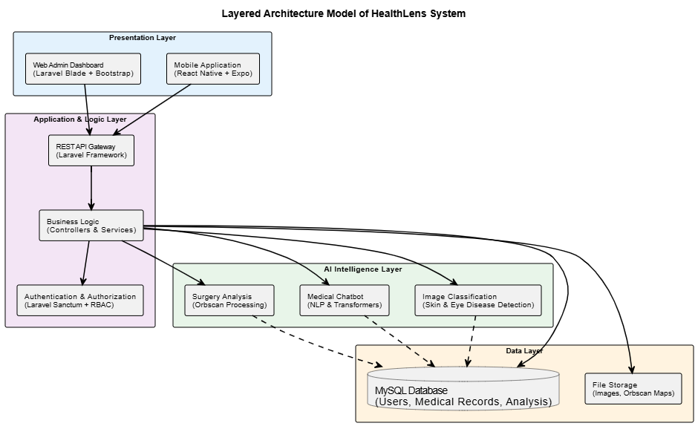

Chapter 2 - Local References

Mobile Application Development & Cross-Platform Frameworks
[2.1] H. Heitkötter, S. Hanschke, and T. A. Majchrzak, “Evaluating cross-platform development approaches for mobile applications,” Web Information Systems and Technologies, Springer, 2013.
[2.2] A. I. Wasserman, “Software engineering issues for mobile application development,” ACM SIGSOFT Software Engineering Notes, vol. 35, no. 4, pp. 1–7, 2010.
[2.3] Meta Platforms, React Native Documentation, 2024.
Available: https://reactnative.dev/
[2.4] Meta Platforms, React: A JavaScript Library for Building User Interfaces, 2015.
Available: https://reactjs.org/
[2.5] E. Gamma, R. Helm, R. Johnson, and J. Vlissides, Design Patterns: Elements of Reusable Object-Oriented Software, Addison-Wesley, 1994.
[2.6] React Team, “Reconciliation and the Virtual DOM,” React Technical Documentation, 2023.
[2.7] Meta Engineering, “Bridging Architecture in React Native,” Meta Engineering Blog.
[2.8] React Native Team, “Fast Refresh for React Native,” Meta Documentation, 2023.

JavaScript, TypeScript, and Programming Language Theory
[2.9] ECMA International, ECMAScript® Language Specification, 2023.
Available: https://tc39.es/
[2.10] D. Flanagan, JavaScript: The Definitive Guide, 7th ed., O’Reilly Media, 2020.
[2.11] Node.js Foundation, “The JavaScript Event Loop,” Node.js Documentation, 2023.
[2.12] Mozilla Developer Network, “Asynchronous JavaScript: Promises and async/await,” 2023.
Available: https://developer.mozilla.org/
[2.13] P. Sestoft, Programming Language Concepts, Springer, 2012.
[2.14] Microsoft, TypeScript Handbook, 2024.
Available: https://www.typescriptlang.org/
[2.15] P. Wadler, “Propositions as types,” Communications of the ACM, vol. 58, no. 12, pp. 75–84, 2015.
[2.16] B. C. Pierce, Types and Programming Languages, MIT Press, 2002.

Expo Platform and Mobile Tooling
[2.17] Expo Team, Expo Documentation, 2024.
Available: https://docs.expo.dev/
[2.18] E. Gamma et al., “Facade design pattern,” Addison-Wesley, 1994.
[2.19] F. Buschmann et al., Pattern-Oriented Software Architecture, Wiley, 1996.
[2.20] Expo Team, “Over-the-Air Updates in Expo,” Expo Technical Documentation, 2023.

Backend Architecture and Web Technologies
[2.21] A. S. Tanenbaum and M. van Steen, Distributed Systems: Principles and Paradigms, Pearson, 2017.
[2.22] PHP Group, PHP Manual, 2024.
Available: https://www.php.net/
[2.23] R. T. Fielding, Architectural Styles and the Design of Network-Based Software Architectures, Doctoral dissertation, University of California, Irvine, 2000.
[2.24] G. Booch, Object-Oriented Analysis and Design with Applications, Addison-Wesley, 2007.
[2.25] B. Meyer, Object-Oriented Software Construction, Prentice Hall, 1997.

Laravel Framework and Authentication
[2.26] Laravel Team, Laravel Documentation, 2024.
Available: https://laravel.com/docs
[2.27] M. Fowler, Patterns of Enterprise Application Architecture, Addison-Wesley, 2003.
[2.28] R. C. Martin, “Dependency injection principles,” IEEE Software, 2009.
[2.29] M. Fowler, “Active Record,” in Patterns of Enterprise Application Architecture, Addison-Wesley, 2002.
[2.30] F. Buschmann et al., “Chain of Responsibility pattern,” Wiley, 1996.
[2.31] R. T. Fielding, “REST: Architectural constraints,” University of California, Irvine, 2000.
[2.32] Laravel Team, Laravel Sanctum Documentation, 2024.
Available: https://laravel.com/docs/sanctum
[2.33] D. Hardt, “The OAuth 2.0 authorization framework,” RFC 6749, 2012.
[2.34] M. Jones et al., “JSON Web Token (JWT),” RFC 7519, 2015.
[2.35] E. Rescorla, “The Transport Layer Security (TLS) protocol version 1.3,” RFC 8446, 2018.
[2.36] OWASP Foundation, Token-Based Authentication Best Practices, 2023.

Database Theory and Management
[2.37] E. F. Codd, “A relational model of data for large shared data banks,” Communications of the ACM, vol. 13, no. 6, pp. 377–387, 1970.
[2.38] C. J. Date, An Introduction to Database Systems, Addison-Wesley, 2003.
[2.39] J. Gray and A. Reuter, Transaction Processing: Concepts and Techniques, Morgan Kaufmann, 1993.
[2.40] R. Elmasri and S. Navathe, Fundamentals of Database Systems, Pearson, 2016.
[2.41] D. Comer, “The ubiquitous B-tree,” ACM Computing Surveys, vol. 11, no. 2, pp. 121–137, 1979.

Artificial Intelligence and Machine Learning
[2.42] Y. LeCun, Y. Bengio, and G. Hinton, “Deep learning,” Nature, vol. 521, pp. 436–444, 2015.
[2.43] K. Hornik, “Approximation capabilities of multilayer feedforward networks,” Neural Networks, 1991.
[2.44] D. E. Rumelhart, G. E. Hinton, and R. J. Williams, “Learning representations by back-propagating errors,” Nature, 1986.
[2.45] I. Goodfellow, Y. Bengio, and A. Courville, Deep Learning, MIT Press, 2016.
[2.46] A. Krizhevsky, I. Sutskever, and G. E. Hinton, “ImageNet classification with deep convolutional neural networks,” NeurIPS, 2012.
[2.47] S. J. Pan and Q. Yang, “A survey on transfer learning,” IEEE Transactions on Knowledge and Data Engineering, 2010.

Python, Frameworks, and Evaluation
[2.48] G. van Rossum and F. Drake, Python 3 Reference Manual, Python Software Foundation, 2009.
[2.49] C. R. Harris et al., “Array programming with NumPy,” Nature, 2020.
[2.50] W. McKinney, Python for Data Analysis, O’Reilly Media, 2017.
[2.51] G. van Rossum, “Python programming language,” USENIX, 2001.
[2.52] A. Paszke et al., “PyTorch: An imperative style, high-performance deep learning library,” NeurIPS, 2019.
[2.53] A. Paszke et al., “Automatic differentiation in PyTorch,” NeurIPS Workshop, 2017.
[2.54] A. G. Baydin et al., “Automatic differentiation in machine learning,” Journal of Machine Learning Research, 2018.
[2.55] NVIDIA, CUDA Programming Guide, 2023.
[2.56] PyTorch Team, “GPU acceleration in PyTorch,” 2023.
[2.57] Torchvision Team, Torchvision Documentation, 2023.
[2.58] Pillow Contributors, Pillow Imaging Library, 2023.
[2.59] C. M. Bishop, Pattern Recognition and Machine Learning, Springer, 2006.
[2.60] V. Vapnik, Statistical Learning Theory, Wiley, 1998.

Natural Language Processing and Transformers
[2.61] A. Vaswani et al., “Attention is all you need,” NeurIPS, 2017.
[2.62] J. Devlin et al., “BERT: Pre-training of deep bidirectional transformers for language understanding,” NAACL, 2019.
[2.63] A. Radford et al., “Language models are unsupervised multitask learners,” OpenAI, 2019.
[2.64] T. Wolf et al., “Transformers: State-of-the-art NLP,” EMNLP, 2020.
[2.65] C. D. Manning et al., Introduction to Information Retrieval, Cambridge University Press, 2008.

Web Tools, DevOps, and Architecture
[2.66] F. Pedregosa et al., “Scikit-learn: Machine learning in Python,” JMLR, 2011.
[2.67] R. Kohavi, “A study of cross-validation,” IJCAI, 1995.
[2.68] Google, Vite Documentation, 2023.
[2.69] Meta Platforms, React Documentation, 2023.
[2.70] Visual Studio Code Team, VS Code Documentation, 2024.
[2.71] Android Developers, Android Studio User Guide, 2024.
[2.72] Git SCM, Git Documentation, 2023.
[2.73] GitHub, GitHub Documentation, 2024.
[2.74] Draw.io Team, Diagramming and System Visualization Tools, 2023.
[2.75] S. Newman, Building Microservices, O’Reilly Media, 2015.
[2.76] T. Erl, Service-Oriented Architecture, Prentice Hall, 2005.
[2.77] R. Fielding, “REST constraints and system design,” 2000.
[2.78] B. Schneier, Applied Cryptography, Wiley, 2015.
[2.79] HIPAA Journal, Healthcare Data Security Principles, 2023.
[2.80] GDPR.eu, General Data Protection Regulation Overview, 2023.

Chapter 3: Literature Review

3.1 Eye Disease Classification

3.1.1 Concept Description:
This project aims to develop an automated system for the classification of common eye diseases using deep learning and computer vision techniques. The proposed model analyzes retinal fundus images and categorizes them into four clinically relevant classes: cataract, diabetic retinopathy, glaucoma, and normal (healthy) eyes.
Unlike traditional computer-aided diagnosis (CAD) systems that rely on handcrafted features and rule-based decision criteria, the proposed approach leverages pretrained convolutional neural networks (CNNs) that are fine-tuned on a domain-specific retinal image dataset. This enables the model to learn discriminative visual representations—such as vascular patterns, optic disc characteristics, and texture irregularities—directly from image data.
In addition, OpenCV-based preprocessing techniques are applied to enhance image quality and improve feature visibility. These include image resizing, normalization, noise reduction, and contrast enhancement. Together, these components provide a robust and efficient framework for early disease detection and automated ophthalmic image analysis, aiming to assist ophthalmologists in screening and clinical decision-making.

3.1.2 Dataset Description:
The primary dataset used in this study is the Eye Diseases Classification Dataset, published on Kaggle by Gunavénkat Doddi (2022). [3.1]
The dataset consists of labeled retinal fundus images organized into four classes: cataract, diabetic retinopathy, glaucoma, and normal eyes. Images were aggregated from publicly available ophthalmic sources and standardized to ensure consistency in resolution and format. The dataset provides balanced class representation, making it suitable for supervised multi-class classification without severe class imbalance.
Prior to model training, images are commonly subjected to preprocessing steps such as resizing, normalization, contrast enhancement, and noise reduction to emphasize diagnostically relevant retinal structures, including the optic disc and vascular network. Data augmentation techniques—such as rotation, horizontal flipping, and scaling—are often applied to improve model robustness and generalization.

3.1.3 Related Work (State of the Art)
Zhang et al. (2025) propose a deep learning-based framework for eye disease classification using retinal fundus images [3.2]. The study introduces a custom lightweight CNN designed to classify five categories: normal, cataract, diabetic retinopathy, glaucoma, and other retinal diseases. Two Kaggle datasets were used, each balanced with 200 images per class. Extensive preprocessing was applied, including blur filters and Canny edge detection, to enhance vascular features. The proposed model achieved approximately 97% accuracy, demonstrating that carefully designed CNNs combined with targeted preprocessing can provide efficient and deployable diagnostic solutions.
Patel et al. (2024) present a CNN-based system for automated eye disease detection using publicly available retinal datasets such as MESSIDOR, DRIVE, and REFUGE [3.3]. The authors apply preprocessing techniques including resizing, noise reduction, contrast enhancement, and region-of-interest cropping. The CNN architecture comprises multiple convolutional, pooling, and fully connected layers followed by a Softmax classifier. Experimental results show classification accuracy exceeding 95%, outperforming traditional machine learning approaches such as SVM and KNN.
Raut et al. (2023) introduce a hybrid deep learning architecture, Conv-ViT, which integrates Vision Transformers (ViT) with Inception-V3 and ResNet-50 for eye disease classification [3.4]. The dataset includes retinal fundus images and OCT scans across four classes: cataract, diabetic retinopathy, glaucoma, and normal eyes. The proposed hybrid model achieves validation accuracy up to 97.89%, demonstrating the effectiveness of combining convolutional and transformer-based feature extraction.
Li et al. (2019) propose an ensemble deep learning approach for automated retinal disease detection using optical coherence tomography (OCT) images [3.5]. The ensemble consists of multiple ResNet50 CNNs trained on OCT B-scan images representing choroidal neovascularization, diabetic macular edema, drusen, and normal retina. Using patient-level cross-validation, the model achieves approximately 97.3% accuracy, highlighting the potential of ensemble CNNs for OCT-based ophthalmic diagnosis.
Gulshan et al. (2016) present a landmark study on large-scale automated detection of diabetic retinopathy using deep CNNs trained on the EyePACS dataset [3.6]. The dataset contains over 100,000 retinal fundus images labeled by disease severity. The proposed system achieves diagnostic performance comparable to expert ophthalmologists, with reported accuracy up to 96.6%, establishing a foundational benchmark for AI-based retinal screening systems.
Table 3.1 presents a comparative summary of related studies in eye disease classification, highlighting the key features, methodologies, datasets, reported accuracies, and publication years.
Table 3.1: Comparative Analysis of Related Work in Eye Disease Classification
Paper Title | Features | Methods | Datasets | Accuracy | Year
Eye Disease Detection Using CNN | Extracted image features from retinal fundus photographs (color, texture, and structural details of optic disc and macula | Convolutional Neural Network (CNN) with multiple convolutional, pooling, and fully connected layers | Public retinal datasets such as MESSIDOR, DRIVE, and REFUGE | ~95% | 2024
Fusion of Vision Transformer, Inception-V3, and ResNet50 for Efficient Eye Disease Detection | Combines transformer (ViT) and CNN architectures (ResNet-50, Inception-V3) for enhanced feature extraction | Conv-ViT hybrid model; trained 7 models for comparison; qualitative and quantitative evaluation | Publicly available fundus photographs and OCT scans; 4 classes: cataract, diabetic retinopathy, glaucoma | Training: 95.45% Validation: 97.89% | 2023
Deep learningbased automated detection of retinal diseases in OCT images | Features extracted from OCT (optical coherence tomography) B-scan images including pathological patterns of choroidal neovascularization (CNV), diabetic macular edema (DME), drusen, and normal retina. | Ensemble of four improved ResNet50 convolutional neural network instances (deep learning) + patient-level 10- fold crossvalidation. | Retinal OCT image dataset (development set) with four classes: CNV, DME, drusen, normal. | 97% | 2019
Development and Validation of a Deep Learning Algorithm for Detection of Diabetic Retinopathy in Retinal Fundus Photographs | Features extracted from retinal fundus images, including lesions and pathological patterns indicative of diabetic retinopathy | Deep Convolutional Neural Network (CNN) with multiple convolutional, pooling, and fully connected layers; Softmax classifier; optimized using Adam and cross-entropy loss | EyePACS dataset (~100,000 retinal fundus images) | ~96.6% | 2016

3.1.4 Similar Applications
Several existing systems apply artificial intelligence and deep learning techniques to the automated detection of eye diseases from retinal fundus images. These applications demonstrate the effectiveness of convolutional neural networks in ophthalmic screening but differ in diagnostic scope, explainability, and system extensibility.

3.1.4.1 Google DeepMind EyePACS
The Google DeepMind EyePACS system applies deep convolutional neural networks to the detection of diabetic retinopathy and age-related macular degeneration from retinal fundus images [3.6]. Trained on large-scale clinical datasets such as EyePACS and Messidor, the system achieves diagnostic performance comparable to expert ophthalmologists. However, it is primarily designed for population-level screening of specific retinal diseases and does not support extensible multi-class diagnosis, explainable decision analysis beyond limited attention visualization, or open experimental evaluation.

3.1.4.2 IDx-DR (Digital Diagnostics)
IDx-DR is a commercially deployed, FDA-approved autonomous diagnostic system for diabetic retinopathy screening [3.6]. The system provides automated referral decisions without clinician interpretation and demonstrates reported clinical accuracy in the range of 94–96%. Despite its regulatory maturity and clinical deployment, the system is limited to a single disease focus and does not incorporate explainable reasoning mechanisms or multi-disease classification capabilities.

3.1.4.3 VUNO Med-Fundus AI
VUNO Med-Fundus AI is a clinically certified software platform designed for detecting multiple retinal diseases, including diabetic retinopathy, glaucoma, cataract, and age-related macular degeneration, using fundus and OCT images [3.14]. The system employs deep convolutional neural network architectures and integrates Grad-CAM–based explainability mechanisms within hospital workflows. Its scope, however, remains specialized to retinal pathology within closed clinical environments, with limited emphasis on experimental extensibility or research-oriented deployment.

3.1.4.4 Academic Retinal AI Systems
Numerous academic research prototypes leverage publicly available datasets, such as MESSIDOR, DRIVE, STARE, and Kaggle retinal image collections, to develop CNN-based eye disease classification models [3.2–3.4]. These systems frequently report strong performance, typically achieving accuracy levels between 90% and 97%, and contribute significantly to methodological advancements in ophthalmic image analysis. Nevertheless, most lack clinical validation, regulatory clearance, and unified integration within broader healthcare platforms, restricting their applicability beyond experimental and academic settings.
These systems demonstrate strong performance (typically 90–97% accuracy) and contribute to methodological research, but they often lack clinical validation, deployment readiness, and unified integration within broader healthcare platforms.

3.1.5 Comparison of Eye Disease Classification Applications
Table 3.2 presents a comparative overview of representative eye disease classification systems, highlighting their disease coverage, artificial intelligence methods, explainability mechanisms, and deployment maturity.
Table 3.2: Comparison of Eye Disease Classification Applications
Feature / Capability | Google DeepMind EyePACS | IDx-DR | VUNO Med-Fundus AI | Academic Retinal AI Systems | HealthLens (Proposed)
Multi-disease classification | Yes | No | Yes | Yes | Yes
Cataract detection | No | No | Yes | Varies | Yes
Diabetic retinopathy detection | Yes | Yes | Yes | Yes | Yes
Glaucoma detection | No | No | Yes | Varies | Yes
Normal (healthy) class support | No | No | Yes | Varies | Yes
Fundus image input | Yes | Yes | Yes | Yes | Yes
OCT image input | No | No | Yes | No | No
Deep learning–based model | Yes | Yes | Yes | Yes | Yes
Transfer learning / fine-tuning | Yes | Yes | Yes | Yes | Yes
Explainability provided | Limited | No | Yes | Limited | Yes
Grad-CAM or saliency maps | No | No | Yes | Sometimes | Yes
Regulatory approval | No | Yes | Yes | No | No
Clinical deployment | Partial | Yes | Yes | No | No
Research extensibility | No | No | Limited | Yes | Yes
Open experimental evaluation | No | No | No | Yes | Yes

3.1.6 Positioning of the HealthLens Eye Disease Module
In contrast to existing systems, the HealthLens eye disease classification module is designed as an extensible, research-oriented framework rather than a single-purpose screening tool. While commercial systems prioritize regulatory approval and disease-specific deployment, HealthLens emphasizes multi-class diagnosis, model transparency, and integration within a broader AI-driven healthcare ecosystem.
By leveraging pretrained convolutional neural networks, public datasets, and explainable prediction mechanisms, HealthLens provides a flexible experimental platform suitable for academic evaluation and future extension to additional medical imaging tasks.

3.1.7 Conclusion
This section reviewed representative datasets, state-of-the-art methodologies, and existing applications for automated eye disease classification. While current systems demonstrate high diagnostic accuracy for specific retinal conditions, most remain constrained by narrow disease focus or limited extensibility. The proposed HealthLens framework addresses these limitations by offering a transparent, multi-class, and research-oriented approach to ophthalmic image analysis, positioning it as a strong foundation for future clinical and multimodal diagnostic research.

3.2.Keratoconus Detection and Refractive Surgery Decision Support.

3.2.1 Overview
Keratoconus is a progressive corneal ectatic disorder characterized by localized corneal thinning, steepening, and irregular astigmatism, which can significantly impair visual acuity. Early and accurate detection is critical, particularly in candidates for refractive surgery, where undiagnosed keratoconus may lead to postoperative ectasia and severe complications.
Recent advances in artificial intelligence have enabled data-driven approaches for keratoconus detection using corneal imaging, structured clinical parameters, and multimodal fusion strategies. This section reviews representative datasets, learning methodologies, and state-of-the-art systems for keratoconus detection and refractive surgery decision support, and positions the proposed HealthLens framework within this landscape.

3.2.2 Datasets
CornOrb Dataset
Lazouni et al. (2025) introduced CornOrb, a publicly available multimodal dataset for keratoconus detection and clinical decision-support research [3.7].
The CornOrb dataset consists of corneal topography maps acquired using the ORBSCAN II system, including multiple modalities such as anterior curvature, posterior elevation, axial power, and pachymetry distributions. These imaging data are complemented by structured clinical annotations capturing key ophthalmic parameters, including maximum keratometry (Kmax), central corneal thickness (CCT), thinnest pachymetry point, astigmatism measurements, and corneal asphericity indicators.
The dataset includes labeled samples representing both healthy (normal) corneas and keratoconic eyes, enabling supervised learning for binary classification and risk-based keratoconus assessment. Its multimodal design allows the exploration of image-based deep learning, classical machine learning on structured clinical variables, and fused approaches that integrate visual and numeric information.
In this project, CornOrb serves as the primary data source for multimodal keratoconus detection and refractive surgery decision support. Orbscan corneal maps are used for deep feature extraction via convolutional neural networks, while clinical parameters and classical texture descriptors are incorporated into an interpretable machine learning framework. The availability of both imaging and clinical data supports the development of explainable, confidence-aware diagnostic models aligned with real-world ophthalmic practice.

3.2.3 State of the Art

Multimodal Keratoconus Detection
Lazouni et al. (2025) propose a multimodal artificial intelligence framework that integrates corneal imaging data with structured clinical features to improve keratoconus detection, particularly in early and borderline cases [3.8]. The study uses a clinical dataset comprising 1,454 eyes collected from 744 patients, with imaging acquired using the ORBSCAN II system.
The proposed architecture consists of two parallel learning pipelines: a convolutional neural network (CNN) for extracting spatial features from corneal topography maps, and a fully connected neural network for processing clinical parameters such as age, astigmatism, Kmax, pachymetry values, and corneal asphericity. Features from both branches are fused via concatenation and passed to a joint classification layer.
Experimental results demonstrate that multimodal fusion significantly outperforms unimodal approaches, achieving an AUC of 0.9507, compared to 0.8975 for image-only and 0.9156 for clinical-only models. The study highlights the diagnostic value of combining imaging and clinical data and underscores the importance of multimodal learning for robust keratoconus screening.

Classical Machine Learning and Biomechanical Analysis
Syta et al. (2025) investigate machine learning–assisted early detection of keratoconus by comparing corneal topography parameters with biomechanical measurements [3.9]. Using data acquired from Pentacam and Corvis ST systems, the study evaluates several supervised classifiers, including Random Forest, Support Vector Machines, and logistic regression.
Among the evaluated models, Random Forest achieved the highest performance, with test accuracy of approximately 96%. Feature importance analysis revealed that clinically interpretable parameters—such as Kmax, corneal thickness metrics, and deformation indices—were the most influential predictors. The authors emphasize interpretability and transparency, arguing that explainable machine learning models are essential for clinical adoption.

Explainable AI for Refractive Surgery Decision Support
El-Rami et al. (2025) introduce an explainable artificial intelligence framework for refractive surgery decision support that integrates corneal imaging, biometric parameters, and probabilistic reasoning [3.10]. The system processes multimodal data from Pentacam and IOLMaster devices and incorporates Bayesian inference, symbolic knowledge graphs, and explainability layers.
The framework generates confidence-aware predictions and clinician-oriented explanations, allowing decisions to be deferred in ambiguous cases. Performance evaluation shows diagnostic reliability with AUC values approaching 0.95 for early keratoconus detection and strong agreement with expert judgment for surgical suitability. This work highlights the importance of explainability and uncertainty modeling in safety-critical ophthalmic decision support systems.

Deep Learning on Raw Tomographic Data
Feng et al. (2021) propose KerNet, a deep learning framework for detecting keratoconus and sub-clinical keratoconus directly from raw Pentacam HR tomographic data [3.11]. Unlike traditional approaches that rely on handcrafted indices, KerNet learns representations from multi-channel corneal maps, including anterior and posterior elevation and pachymetry information.
The model achieves diagnostic accuracy exceeding 95%, with particularly strong performance in detecting sub-clinical keratoconus. The study demonstrates that end-to-end deep learning on raw tomographic data can outperform conventional diagnostic indices and classical machine learning models.

Interpretable Machine Learning on Tomographic Parameters
Martínez-Abad et al. (2019) present a machine learning–based keratoconus detection framework using exclusively structured tomographic parameters derived from Scheimpflug imaging [3.12]. Tree-based models such as Random Forest and Gradient Boosting are trained on interpretable clinical variables including CCT, Kmax, pachymetry, and elevation indices.
The proposed models achieve approximately 95% accuracy, demonstrating that structured clinical parameters alone can provide strong diagnostic signals. Feature importance analysis aligns closely with established clinical knowledge, supporting the use of interpretable machine learning models in settings where transparency and clinician trust are essential.

3.2.4 Comparative Analysis
Table 3.3 presents a comparative overview of representative studies on keratoconus detection and refractive surgery decision support, summarizing their input features, learning methodologies, dataset characteristics, reported performance metrics, and publication years.
Table 3.3: Comparative Analysis of Related Work in Keratoconus Detection and Refractive Surgery Decision Support.
Paper Title | Features | Methods | Dataset (Name & Modality) | Accuracy / Performance | Year
Multimodal Keratoconus Detection Using Fused Topography and Machine-Learning Features (Lazouni et al.) | ORBSCAN II corneal maps + clinical parameters (age, astigmatism, Kmax, pachymetry, asphericity) | CNN (image branch) + FCNN (clinical branch), feature fusion | Clinique Lazouni ORBSCAN Dataset (private clinical dataset, ORBSCAN II maps + clinical data, 1,454 eyes) | AUC = 0.9507 (multimodal); improved borderline KC detection | 2025
Machine Learning-Assisted Early Detection of Keratoconus (Syta et al.) | Topographic + biomechanical corneal parameters (Kmax, pachymetry, deformation metrics) | Random Forest, SVM, Logistic Regression | Pentacam + Corvis ST Dataset (clinical dataset; exact public name not specified) | Accuracy ≈ 96%, strong early KC sensitivity | 2025
Explainable AI for Refractive Surgery Decision Support (El-Rami et al.) | Corneal maps + biometric parameters (CCT, K values, ACD, axial length) | Neuro-symbolic AI + Bayesian inference + XAI + LLM-based explanations | Pentacam + IOLMaster Clinical Dataset (prospectively collected; not publicly released) | AUC ≈ 0.95 (KC); Surgery decision F1 ≈ 0.90 | 2025
KerNet: A Novel Deep Learning Approach for Keratoconus and Sub-Clinical Keratoconus Detection (Feng et al.) | Raw multi-channel Pentacam HR tomography (no handcrafted indices) | CNN (end-to-end deep representation learning) | Pentacam HR Raw Tomography Dataset (clinical dataset; not publicly released) | Accuracy >95%, strong sub-clinical KC detection | 2021
Machine Learning–Based Keratoconus Detection Using Tomographic Corneal Parameters (Martínez-Abad et al.) | Interpretable tomographic parameters (CCT, Kmax, elevation indices) | Tree-based ML (Random Forest, Gradient Boosting) | Pentacam Tomography Dataset (clinical dataset; not publicly released) | Accuracy ≈ 95%, probabilistic KC risk output. | 2019
Proposed Work: HealthLens Multimodal Keratoconus Detection and Refractive Surgery Decision Support | ORBSCAN maps + CNN deep features + classical texture features + clinical parameters | EfficientNet CNN feature extraction + classical features + XGBoost + SHAP; ML-based surgery suitability with confidence-aware abstention | CornOrb Dataset (Zenodo): Multimodal ORBSCAN Corneal Topography Maps with Clinical Annotations | KC Detection Accuracy ≈ 96%; interpretable risk + surgery recommendation | 2025

3.2.5 Similar Applications
Several existing applications and systems address corneal diagnostics and refractive surgery planning, ranging from large-scale retinal screening platforms to rule-based tomographic assessment tools and commercial refractive surgery planning software. Representative examples include the Google DeepMind EyePACS system, IDx-DR, Pentacam BAD-D, VUNO Med-Fundus AI, and commercial surgery planning platforms, each discussed in detail in the preceding subsections.
These systems differ substantially in disease focus, imaging modality, learning strategy, and level of clinical decision support. While many demonstrate high diagnostic accuracy, most are limited either to posterior-segment retinal screening or to deterministic rule-based corneal indices, without incorporating adaptive learning, multimodal feature fusion, or uncertainty-aware decision modeling.

3.2.6 Comparison with Related Applications
Table 3.4 presents a structured comparison of representative keratoconus detection and refractive surgery decision-support systems, summarizing their disease coverage, input modalities, artificial intelligence methods, explainability mechanisms, and deployment maturity.
Table 3.4: Comparison of Related AI Applications in Corneal Diagnosis and Surgery Planning
Feature / Capability | Google DeepMind EyePACS | IDx-DR | Pentacam BAD-D | VUNO Med-Fundus AI | Commercial Surgery Planners | HealthLens (Proposed)
Keratoconus detection | No | No | Yes | No | Yes (rule-based) | Yes
Refractive surgery decision support | No | No | No | No | Yes | Yes
Retinal disease screening | Yes | Yes | No | Yes | No | No
Corneal imaging support | No | No | Yes | No | Yes | Yes
Multimodal data fusion (image + clinical) | No | No | No | No | Limited | Yes
Deep learning–based analysis | Yes | Yes | No | Yes | No | Yes
Classical ML integration | No | No | No | No | No | Yes
Deterministic rule-based logic only | No | No | Yes | No | Yes | No
Explainable AI mechanisms | Limited | No | Yes | Yes | Limited | Yes
Uncertainty-aware decision modeling | No | No | No | No | No | Yes
Binary screening output only | Yes | Yes | Yes | Yes | No | No
Diagnostic + decision output | No | No | No | No | Yes | Yes
Research extensibility | No | No | No | Limited | No | Yes
Clinical deployment | Partial | Yes | Yes | Yes | Yes | No (Research)
Future clinical scalability | No | No | Limited | Limited | Limited | Yes

As shown in Table 3.4, existing systems predominantly address either posterior-segment retinal screening (e.g., EyePACS, IDx-DR, VUNO Med-Fundus AI) or anterior-segment corneal assessment using deterministic, handcrafted tomographic indices (e.g., Pentacam BAD-D). Commercial refractive surgery planning platforms further rely on fixed rule-based logic and clinician interpretation, without adaptive learning or uncertainty modeling.
In contrast, the proposed HealthLens framework uniquely integrates multimodal corneal imaging, structured clinical parameters, deep feature extraction, and interpretable machine learning within a single pipeline. This design enables both accurate keratoconus detection and confidence-aware refractive surgery decision support, positioning HealthLens as a research-oriented system that bridges the gap between diagnostic artificial intelligence and clinically actionable ophthalmic decision-making.
Key Findings and Conclusion
The comparative analysis demonstrates that most existing applications focus either on disease screening or on rule-based clinical assessment without adaptive learning or uncertainty modeling. HealthLens addresses these limitations by combining multimodal data fusion, interpretable machine learning, and confidence-aware decision support within a single framework, positioning it as a comprehensive and forward-looking system that bridges the gap between diagnostic artificial intelligence and clinically actionable ophthalmic decision support.

3.3 Skin Disease Classification

3.3.1. Introduction.
Skin diseases, including malignant conditions such as melanoma, represent a significant global health concern due to their high prevalence and potential severity when diagnosis is delayed. Early and accurate identification of skin lesions plays a critical role in improving patient outcomes; however, access to dermatological expertise remains limited in many regions. Recent advances in deep learning and computer vision have enabled automated analysis of medical images, providing promising tools for assisting clinical decision-making.
This work presents a deep learning–based framework for multi-class skin disease classification using dermoscopic images from the HAM10000 dataset. Particular emphasis is placed on lightweight convolutional neural network architectures suitable for mobile and real-time deployment. By leveraging transfer learning with MobileNetV3 and applying phone-oriented augmentation strategies, the proposed system aims to balance classification performance with computational efficiency, enabling future deployment in resource-constrained and consumer-facing environments.

3.3.2 Datasets Description:
The experiments in this study utilize the HAM10000 (Human Against Machine with 10,000 training images) dataset [3.13], a publicly available dermoscopic image collection widely used in dermatological research.
The dataset consists of 10,015 RGB dermoscopic images categorized into seven clinically relevant skin lesion classes: actinic keratoses, basal cell carcinoma, benign keratosis-like lesions, dermatofibroma, melanoma, melanocytic nevi, and vascular lesions. Each image is associated with metadata specifying the lesion type and diagnostic category.
Images are provided across two directories and referenced via a metadata CSV file. For model compatibility, all images are resized to a fixed resolution of 224 × 224 pixels, ensuring suitability for pretrained convolutional neural networks. The dataset’s diversity and standardized labeling make it a reliable benchmark for evaluating multi-class skin lesion classification models.

3.3.3 State of the Art

CNN Benchmarking for Skin Lesion Classification
Vieira et al. (2025) present a comprehensive benchmarking study evaluating modern CNN architectures for automated skin lesion classification using dermoscopic images [3.14]. The experiments were conducted primarily on the HAM10000 dataset, with cross-dataset validation performed on ISIC 2019 to assess generalization capability.
A total of 38 CNN architectures from ten model families—including ConvNeXt, EfficientNet, DenseNet, ResNet, MobileNet, VGG, Xception, NASNet, and Inception variants—were evaluated using a standardized training pipeline with ImageNet-pretrained weights and frozen backbones. Performance metrics included overall accuracy, macro F1-score, Matthews Correlation Coefficient (MCC), and Top-K accuracy.
The results showed that ConvNeXt-XLarge achieved the highest performance on HAM10000, with an accuracy of approximately 87.6%, while lightweight models such as MobileNet and EfficientNet demonstrated favorable trade-offs between accuracy and computational efficiency. The study highlights the importance of systematic benchmarking for selecting suitable architectures, particularly in mobile and resource-constrained healthcare settings.

Attention-Based Deep Learning Models
Alotaibi et al. (2025) investigate the use of attention mechanisms to enhance skin cancer detection from dermoscopic images [3.15]. Using the HAM10000 dataset reformulated as a binary classification task (malignant vs. benign), the authors integrate self-attention, soft attention, and hard attention modules into an Xception-based CNN architecture.
Experimental results show that attention-augmented models outperform the baseline CNN, with the self-attention variant achieving an accuracy of 88.11%. Confusion matrix analysis demonstrates improved discrimination between benign and malignant lesions, particularly through reduced false-negative rates. The study concludes that attention mechanisms can improve diagnostic focus without significantly increasing model complexity.

Hybrid and Ensemble Learning Approaches
Behara et al. (2024) propose a hybrid deep learning framework that combines CNN feature extraction with transformer-inspired and capsule-based refinement mechanisms for skin lesion classification [3.16]. The model is evaluated on the HAM10000 dataset and incorporates explainability techniques such as Grad-CAM to visualize lesion-focused activations.
The proposed hybrid model achieves an accuracy of approximately 82%, outperforming several baseline CNN architectures under comparable conditions. The authors demonstrate that integrating complementary modeling paradigms can improve robustness and interpretability in skin lesion classification systems.
Akter et al. (2023) conduct a comprehensive evaluation of deep learning and ensemble-based approaches for multi-class skin cancer classification [3.17]. Multiple pretrained CNN architectures—including InceptionV3, Xception, DenseNet, MobileNet, ResNet50, and VGG16—are evaluated using transfer learning and data augmentation strategies.
Among individual models, InceptionV3 achieved the highest accuracy (~86%), while MobileNet demonstrated competitive performance with lower computational complexity. Ensemble learning further improved classification stability by aggregating predictions from multiple networks, highlighting the effectiveness of ensemble strategies for dermatological diagnosis.

3.3.4 Comparative Summary of Related Work
Table 3.5 summarizes representative studies on skin lesion classification, comparing their feature representations, learning methodologies, datasets, reported performance, and publication years.

Title | Features | Methods | Datasets | Accuracy | Year
Deep Learning Approaches for Skin Lesion Detection (Vieira et al.) | Benchmark of 38 CNN architectures | Transfer learning, frozen backbones | HAM10000, ISIC 2019 | 87.62% | 2025
Skin Cancer Detection Using Attention Mechanisms (Alotaibi et al.) | Attention-enhanced CNN | Xception + attention | HAM10000 | 88.11% | 2025
Hybrid Skin Lesion Classification (Behara et al.) | Hybrid CNN and transformer-based features | CNN + MVT + capsule networks | HAM10000 | 82.0% | 2024
Multi-class Skin Cancer Classification (Akter et al.) | CNN comparison and ensemble learning | Transfer learning with augmentation | HAM10000 | 86.0% | 2023

3.3.5 Similar Applications
Several consumer-facing and clinical applications employ artificial intelligence for skin disease analysis using smartphone-acquired images. These systems demonstrate the feasibility of mobile dermatological screening but differ significantly in transparency, scope, and clinical intent.

3.3.6 Comparison with Existing Applications
Commercial applications such as Aysa, AI Dermatologist, Skinive, and Google Dermatology Assist primarily target consumer-level screening and informational use. While these systems offer broad disease coverage and real-time feedback, they rely on proprietary datasets and undisclosed model architectures, limiting reproducibility and independent validation.
In contrast, HealthLens is developed as an academic, research-oriented platform emphasizing transparency, reproducibility, and multi-class disease classification. By employing a lightweight MobileNetV3-based architecture trained on the publicly available HAM10000 dataset, HealthLens provides a controlled and extensible foundation for future clinical research and validation.
Table 3.4 presents a comparison of representative AI-based skin disease analysis applications, highlighting differences in coverage, model transparency, explainability, and deployment context.
App | Coverage | Image Input | Model | Dataset | Accuracy | Real-time | Explainability | Multi-Disease | Deployment | Regulatory
Aysa (VisualDx / Aysa) | Common skin conditions | Smartphone photos + Q&A | Proprietary VisualDx model | VisualDx clinical images (private) | Top-1 ≈ 71%, Top-3 ≈ 86% | Yes | Symptom explanations (no full XAI) | Yes | Consumer checker | Informational use only
AI Dermatologist (Skin Scanner) | ~58 skin conditions (claimed) | Smartphone photos | Proprietary DL model | Not disclosed | ~97% (vendor-claimed) | Yes | Limited (risk labels) | Yes | Consumer app | No formal approval
Skinive / SkiniveMD | 50+ dermatologic diseases | Smartphone photos + guided scan | Proprietary Skinive NN | ~160k–200k+ images (vendor) | High sensitivity/specificity (vendor) | Yes | Structured reports; limited XAI | Yes | Consumer & clinical | CE-marked (EU)
Google Dermatology Assist | Wide coverage (differential) | Smartphone photos (Lens/Search) | Google DL models | Large clinician-labeled datasets | Comparable to dermatologists (Google studies) | Yes | Similar cases + info | Yes | Consumer (regional) | EU clearance (selected regions)
HealthLens (Proposed) | Skin disease detection | Clinical skin images | MobileNetV3 | HAM10000 | Top 1: 84%  Top 3:  97% | Yes | — | Yes | Academic system | —

3.3.7 Conclusion
The MobileNetV3-based skin disease classification model achieves a validation accuracy of approximately 84%, with competitive Top-3 accuracy of 97% across all lesion classes. These results demonstrate that lightweight architectures, when combined with targeted data augmentation and fine-tuning strategies, can achieve reliable multi-class classification performance without excessive computational overhead. This supports the feasibility of deploying efficient deep learning models for dermatological screening in mobile and resource-constrained environments.

3.4 Medical Chatbot

3.4.1 Introduction
Conversational medical assistants based on large language models (LLMs) have recently emerged as a promising approach for improving access to health information, supporting clinical reasoning, and enabling patient–AI interaction at scale. Unlike traditional rule-based systems, modern LLMs are capable of reasoning over complex medical knowledge, generating natural language explanations, and adapting to diverse user queries.
However, deploying such systems in medical contexts introduces critical challenges related to hallucination, overconfident responses, and unsafe medical advice. Safety-aligned models often exhibit excessive refusal or abstention behavior, while less constrained models may generate plausible but incorrect medical information. Balancing clinical usefulness with conservative safety behavior therefore remains a central research challenge.
The HealthLens medical conversational AI system is designed as a research-oriented, safety-aware conversational system that explicitly separates medical reasoning, evidence grounding, and conversational behavior into distinct alignment phases. This section presents the datasets, methodological foundations, and state-of-the-art research underpinning the design of the HealthLens chatbot.

3.4.2 Datasets
The HealthLens chatbot is trained using a three-phase alignment strategy, with each phase supervised using a dedicated medical dataset selected to target a specific competency: deterministic clinical reasoning, evidence-based justification, and safe conversational behavior.

MedQA Dataset
The MedQA dataset is a medical multiple-choice question answering benchmark derived from professional medical board examinations [3.18]. It consists of clinically focused questions designed to test structured medical reasoning under constrained answer choices.
In the HealthLens pipeline, MedQA is used in Phase 1 to establish deterministic clinical reasoning. By supervising exam-style multiple-choice decisions, the model is encouraged to commit to clinically grounded answers rather than defaulting to conservative refusal. This phase serves as a diagnostic probe for reasoning capability under safety-aligned prompting.

PubMedQA Dataset
The PubMedQA dataset is a biomedical question answering benchmark based on PubMed abstracts [3.19]. Each sample includes a research question, a supporting abstract, a categorical answer (yes, no, or maybe), and a human-curated explanatory rationale grounded in the provided text.
PubMedQA is used in Phase 2 to supervise evidence-grounded reasoning. By training the model to produce both a categorical decision and a supporting explanation derived from scientific context, HealthLens reduces the risk of unsupported or hallucinatory medical claims. This phase emphasizes traceability and justification rather than conversational fluency.

Medical Meadow Dataset
The Medical Meadow Flashcards dataset is an instructional medical question–answer collection designed to support medical dialogue and instruction following [3.20]. It consists of medically oriented prompts and responses suitable for conversational fine-tuning.
In Phase 3, this dataset is used to refine conversational behavior, tone, and safety awareness. The objective is not to introduce new medical knowledge, but to align the model’s interaction style with conservative, patient-safe communication practices while preserving the reasoning capabilities learned in earlier phases.

3.4.3 State of the Art

Large Language Models on Medical Reasoning Benchmarks
Nori et al. (2023) evaluate the performance of large language models, including GPT-4, on medical challenge problems derived from professional examinations [3.21]. Their study demonstrates that sufficiently large and well-aligned models can achieve near expert-level accuracy on MedQA-style tasks under controlled prompting conditions.
Importantly, the authors observe systematic abstention behavior under conservative safety prompts, even when the model possesses the underlying medical knowledge. This finding directly motivates the first stage of the HealthLens pipeline, which treats abstention as an alignment artifact rather than a lack of capability.

Evidence-Grounded Biomedical Question Answering
Jin et al. (2019) introduce PubMedQA as a benchmark for evaluating evidence-based biomedical reasoning [3.19]. The dataset emphasizes explicit separation between decision-making and justification, requiring models to ground answers in provided scientific abstracts.
This paradigm forms the theoretical foundation of the second phase of HealthLens. By supervising both the categorical decision and the explanatory rationale, the system aligns with established biomedical QA methodology and promotes transparent, evidence-backed medical reasoning.

Alignment and Conservative Safety Behavior
Askell et al. (2021) propose a framework for aligning language models according to principles of helpfulness, honesty, and harmlessness [3.22]. In safety-critical domains such as medicine, the authors show that aligned models often abstain from answering ambiguous or potentially harmful queries.
HealthLens adopts this interpretation of abstention as an expected outcome of conservative alignment. Rather than removing safety constraints, the system introduces phased supervision to rebalance refusal behavior while preserving conservative medical safeguards.

Instruction Tuning and Multi-Task Generalization
Wei et al. (2022) demonstrate that instruction tuning enables language models to generalize across diverse tasks without architectural modification [3.23]. By casting heterogeneous objectives into a unified instruction–response format, models can perform reasoning, classification, and generation in a zero-shot setting.
This insight informs the prompt design and data preprocessing used throughout the HealthLens chatbot pipeline. Clinical reasoning, evidence-based QA, and medical dialogue are all framed as instruction-following tasks, enabling seamless transitions between competencies within a single model.

Parameter-Efficient Fine-Tuning with QLoRA
Dettmers et al. (2023) introduce QLoRA, a parameter-efficient fine-tuning technique that combines 4-bit quantization with low-rank adaptation [3.24]. The method enables large language model fine-tuning on consumer-grade hardware while maintaining performance comparable to full-precision training.
HealthLens adopts QLoRA to ensure that the proposed chatbot pipeline remains reproducible and accessible in academic environments. This design choice supports multi-phase experimentation without reliance on industrial-scale compute resources.

3.4.4 Comparative Summary of Related Work
Table 3.4 presents a comparative overview of representative studies and methodologies related to medical language models, alignment strategies, and biomedical question answering. Reported performance metrics are shown for contextual comparison only, as evaluation protocols and task formulations differ across studies.
Table 3.4: Comparative Summary of State-of-the-Art Research on Medical Language Models and Alignment Strategies.
Paper Title | Core Focus / Features | Methodology | Dataset (Name & Modality) | Key Findings / Performance | Year
Capabilities of GPT-4 on Medical Challenge Problems (Nori et al.) | Clinical reasoning on professional medical exams; abstention behavior under safety prompts | Large-scale pretrained LLM with instruction tuning and RLHF | MedQA; USMLE-style medical exams (text-only) | Up to 86.5% accuracy on MedQA under controlled prompting; observed conservative abstention | 2023
PubMedQA: A Dataset for Biomedical Research Question Answering (Jin et al.) | Evidence-grounded biomedical question answering with explicit justifications | Supervised biomedical QA models (CNN, RNN, transformer baselines) | PubMedQA (PubMed abstracts; text-only) | Best reported classification accuracy ≈76%; emphasizes answer + rationale separation | 2019
A General Language Assistant as a Laboratory for Alignment (Askell et al.) | Safety alignment; refusal and abstention behavior in sensitive domains | Reinforcement Learning from Human Feedback (RLHF) | Proprietary human feedback datasets (text-only) | No task accuracy reported; evaluated via safety, harmlessness, and preference alignment | 2021
Finetuned Language Models Are Zero-Shot Learners (Wei et al.) | Instruction tuning for multi-task generalization | Instruction tuning of causal language models | Mixed NLP benchmarks (text-only, multi-task) | Significant zero-shot performance gains across diverse tasks | 2022
QLoRA: Efficient Finetuning of Quantized LLMs (Dettmers et al.) | Parameter-efficient fine-tuning using 4-bit quantization | Quantized LoRA fine-tuning (QLoRA) | NLP benchmarks; instruction-tuning corpora (text-only) | Matches or exceeds full-precision fine-tuning with reduced memory usage | 2023
Proposed System: HealthLens Medical Chatbot | Phased reasoning alignment, evidence grounding, and safe medical dialogue | Multi-phase QLoRA-based fine-tuning (MedQA → PubMedQA → Medical Meadow) | MedQA, PubMedQA, Medical Meadow (text-only medical datasets) | Deterministic reasoning, evidence-grounded explanations, conservative safety behavior | 2025

3.4.5 Similar Applications
Several existing systems apply large language models and artificial intelligence to medical question answering, symptom assessment, and conversational health support. While these systems demonstrate rapid progress in medical AI, they differ substantially in transparency, reasoning structure, evidence grounding, and experimental controllability.

3.4.5.1 Med-PaLM
Med-PaLM, developed by Google Research, is a large-scale medical language model evaluated on the MultiMedQA benchmark [3.25]. While it demonstrates strong performance on professional medical exams, it relies on proprietary data and large computational resources, limiting reproducibility.

3.4.5.2 Ada Health AI
The Ada Health AI system is a clinically deployed symptom assessment tool that generates ranked condition suggestions based on probabilistic modeling and machine learning [3.26]. Its focus is triage and symptom analysis rather than explicit medical reasoning or evidence-based explanation.

3.4.5.3 ClinicalCamel
ClinicalCamel is an open-source medical language model fine-tuned for conversational clinical assistance [3.27]. While it emphasizes accessibility and reproducibility, it primarily targets dialogue quality rather than structured reasoning or evidence grounding.

Table 3.5: Comparison of Medical Conversational AI Applications
Feature / Capability | Med-PaLM | Ada Health AI | ClinicalCamel | HealthLens (Proposed)
General medical reasoning | Yes | No | Yes | Yes
Exam-style clinical QA support | Yes | No | No | Yes
Symptom triage | No | Yes | No | No
Evidence-grounded explanations | No | No | No | Yes
Structured reasoning stages | No | No | No | Yes
Conservative safety behavior | Yes | Yes | Limited | Yes
Explainable decision process | Limited | No | Limited | Yes
Open-source or reproducible | No | No | Yes | Yes
Controlled academic experimentation | No | No | Yes | Yes
Large-scale proprietary resources required | Yes | No | No | No
Multi-phase alignment strategy | No | No | No | Yes
Confidence-aware abstention | No | No | No | Yes
Clinical deployment | No | Yes | No | No (Research)
Research-oriented design | No | No | Yes | Yes

3.4.6 Positioning of the HealthLens Medical Chatbot
In contrast to existing systems, the HealthLens chatbot is developed as an academic, research-oriented platform that explicitly separates clinical reasoning, evidence grounding, and conversational behavior into distinct alignment phases. This phased design enables fine-grained control over safety behavior, interpretability, and reasoning reliability.
Rather than optimizing for benchmark dominance or conversational fluency alone, HealthLens prioritizes transparent medical reasoning, traceable evidence use, and conservative decision-making, making it suitable for experimental evaluation and future clinical research.

3.4.7 Conclusion
This section reviewed the datasets, methodologies, and state-of-the-art research underlying the design of the HealthLens medical chatbot. By combining exam-style reasoning supervision, evidence-grounded biomedical QA, and safety-aware conversational alignment within a reproducible QLoRA-based framework, HealthLens provides a controlled and interpretable approach to medical conversational AI. The proposed design positions the chatbot as a robust research prototype for studying safe and transparent medical decision support using large language models.

Chapter 3 - Local References

Eye Disease Classification
[3.1] G. Doddi, Eye Diseases Classification Dataset, Kaggle, 2022.
Available: https://www.kaggle.com/datasets/gunavenkatdoddi/eye-diseases-classification
[3.2] Y. Zhang et al., “Identification of eye diseases through deep learning,” Diagnostics, vol. 15, no. 7, p. 916, 2025.
https://doi.org/10.3390/diagnostics15070916
[3.3] P. Patel et al., “Eye disease detection using CNN,” ResearchGate, 2024.
Available: https://www.researchgate.net/publication/393280625
[3.4] S. Raut et al., “Fusion of Vision Transformer, Inception-V3, and ResNet50 for efficient eye disease detection,” ResearchGate, 2023.
Available: https://www.researchgate.net/publication/388738813
[3.5] F. Li et al., “Deep learning-based automated detection of retinal diseases in OCT images,” PLOS ONE, vol. 14, no. 12, e0225408, 2019.
Available: https://pmc.ncbi.nlm.nih.gov/articles/PMC6913386/
[3.6] V. Gulshan et al., “Development and validation of a deep learning algorithm for detection of diabetic retinopathy in retinal fundus photographs,” JAMA, vol. 316, no. 22, pp. 2402–2410, 2016.
https://doi.org/10.1001/jama.2016.17216

Keratoconus Detection and Surgery Support
[3.7] M. Lazouni et al., CornOrb: A Multimodal Dataset of Orbscan Corneal Topography and Clinical Annotations for Keratoconus Detection, Zenodo, 2025.
Available: https://zenodo.org/records/17127265
[3.8] M. Lazouni et al., “Multimodal keratoconus detection using fused topography and machine-learning features,” Investigative Ophthalmology & Visual Science (ARVO Abstracts), vol. 66, no. 7, 2025.
[3.9] A. Syta et al., “Machine learning-assisted early detection of keratoconus,” Scientific Reports, vol. 15, Article 09694, 2025.
https://doi.org/10.1038/s41598-025-09694-5
[3.10] H. El-Rami et al., “Explainable AI for refractive surgery decision support,” Bioengineering, vol. 12, no. 11, Article 1174, 2025.
https://doi.org/10.3390/bioengineering12111174
[3.11] R. Feng et al., “KerNet: A novel deep learning approach for keratoconus and sub-clinical keratoconus detection,” IEEE Journal of Biomedical and Health Informatics, 2021.
[3.12] A. Martínez-Abad et al., “Machine learning-based keratoconus detection using tomographic corneal parameters,” Journal of Ophthalmology, 2019.

Skin Disease Classification
[3.13] P. Tschandl, C. Rosendahl, and H. Kittler, “The HAM10000 dataset: A large collection of multi-source dermatoscopic images of common pigmented skin lesions,” Scientific Data, vol. 5, 180161, 2018.
[3.14] J. Vieira, F. Mendonça, and F. Morgado-Dias, “Deep learning approaches for skin lesion detection,” Electronics, vol. 14, no. 14, Article 2785, 2025.
https://www.mdpi.com/2079-9292/14/14/2785
[3.15] A. Alotaibi et al., “Skin cancer detection using transfer learning and attention mechanisms,” Diagnostics, 2025.
[3.16] K. Behara et al., “An improved skin lesion classification using hybrid deep learning models,” Diagnostics, 2024.
[3.17] M. S. Akter et al., “Multi-class skin cancer classification using deep learning,” arXiv preprint, 2023.

Medical Conversational AI
[3.18] OpenLifeScienceAI, MedQA: Medical Question Answering Dataset, 2020.
[3.19] Q. Jin et al., “PubMedQA: A dataset for biomedical research question answering,” EMNLP-IJCNLP, 2019.
[3.20] MedAlpaca Project, Medical Meadow Flashcards Dataset, 2023.
[3.21] H. Nori et al., “Capabilities of GPT-4 on medical challenge problems,” arXiv preprint arXiv:2303.13375, 2023.
[3.22] A. Askell et al., “A general language assistant as a laboratory for alignment,” arXiv preprint arXiv:2112.00861, 2021.
[3.23] J. Wei et al., “Finetuned language models are zero-shot learners,” arXiv preprint arXiv:2203.02155, 2022.
[3.24] T. Dettmers et al., “QLoRA: Efficient finetuning of quantized large language models,” arXiv preprint arXiv:2305.14314, 2023.
[3.25] Google Research, Med-PaLM Technical Report, 2022.
[3.26] Ada Health GmbH, AI Symptom Assessment System, 2023.
[3.27] ClinicalCamel Project, Open-Source Medical Language Model,2023.

Chapter 4: System Analysis

4.1 Requirements Specification
The requirements specification defines the operational capabilities and constraints of the HealthLens system. HealthLens is a comprehensive digital health platform designed as a multi-layered ecosystem that integrates patient-centric mobile technologies, an administrative web interface, and a robust backend powered by a unified artificial intelligence service layer.
The system is architected as a cross-platform mobile application for patients (built with React Native and Expo), supported by a centralized Laravel backend API, a Python-based AI microservices layer, and a web-based administrative dashboard (built with Laravel Blade and Bootstrap). The primary objective is to facilitate intuitive medical image uploading, high-speed AI inference for dermatology and ophthalmology, intelligent health consultations through a medical chatbot, advanced surgical decision support, and secure data handling while ensuring strict separation of user roles.
The core capabilities of the HealthLens system include:
- AI-powered medical image classification for skin and eye conditions
- Interactive medical chatbot for natural language health consultations
- Advanced ophthalmic surgery decision support using Orbscan analysis
- Secure patient data management and medical history tracking
- Specialist directory for connecting patients with medical professionals
- Administrative oversight and content management

4.2 Functional Requirements
The functional requirements describe the specific behaviors and functions of the system, categorized by the primary actors: the Patient (Mobile User) and the Administrator (Web Dashboard User).

4.2.1 Patient (Mobile User)
The Patient acts as the primary data source and consumer of AI-driven medical insights through the React Native mobile application.
4.2.1.1 User Account Management
1. Registration
The system shall allow patients to create a secure user account by providing their first and last names, a unique email address, a unique username with a maximum length of 50 characters, and a password that is securely hashed using the bcrypt algorithm. Optional demographic information, including date of birth and gender, may also be provided during registration.
2. Authentication
Patients shall be able to authenticate using either their email address or username in combination with a password. Upon successful authentication, the system shall issue a Laravel Sanctum authentication token, which enables secure access to protected system resources. Authenticated sessions shall persist across application restarts until the user explicitly logs out, at which point the authentication token shall be invalidated.
3. Account Management
Authenticated patients shall be able to view and update their profile information, upload and manage avatar images, and change their account password subject to validation rules. The system shall also provide patients with the ability to permanently delete their account, resulting in the removal of all associated personal and medical data.
4.2.1.2 Medical Image Analysis
4. Image Upload and Analysis
The system shall enable patients to capture or upload medical images using the device camera or image gallery. The platform shall support two clinical domains: dermatology, through skin lesion classification, and ophthalmology, through eye disease detection. Images shall be uploaded through the chat interface and restricted to a maximum size of 5 MB using JPG, JPEG, or PNG formats. Upon upload, the system shall automatically invoke the appropriate AI inference service and return analysis results that include a top-1 prediction with an associated confidence score, top-3 predictions with confidence scores, a human-readable explanation, and a structured JSON response stored within the message ai_result field.
5. View Analysis Results
Patients shall be able to view AI-generated analysis results directly within the chat interface, including confidence scores and explanatory content. Previously generated analysis results shall remain accessible through the persistent chat history.

4.2.1.3 Medical Chatbot Interaction
6. Chatbot Communication
The system shall provide patients with access to an AI-powered medical chatbot capable of handling text-based health inquiries. Patients shall receive real-time, AI-generated responses that support conversational medical interaction, with all exchanged messages persisted for future reference.
7. Chat Session Management
Chat sessions shall be created automatically upon initiating a conversation with the chatbot. Patients shall be able to view a paginated list of chat sessions, access full chat histories with pagination support, continue or delete individual conversations, clear all chat sessions, and sort chats based on most recent activity

4.2.1.4 Surgery Analysis
8. Eye Surgery Analysis Submission
The system shall allow patients to submit eye surgery analysis requests by uploading four Orbscan map images corresponding to the anterior, axial, posterior, and pachymetry views. Patients shall also provide relevant clinical parameters, including age, gender, Kmax value, central corneal thickness (CCT), and astigmatism. Submitted analyses shall initially be assigned a pending processing status.
9. Surgery Analysis Results
Patients shall be able to view submitted surgery analyses along with their processing status. Upon completion, the system shall present detailed AI-generated results, including keratoconus probability, recommended surgical procedure, residual stromal bed estimation, ablation depth, and safety warnings. Finalized surgery reports and associated images shall remain accessible for review.

4.2.1.5 Specialist Directory
10. Browse Medical Specialists
The system shall provide patients with access to a public directory of medical specialists. Patients shall be able to filter specialists by specialization, city, and area, view contact information, and initiate phone calls directly from within the application.

4.2.1.6 Medical History Management
11. History Access
Patients shall be able to access their complete medical history, including chat interactions, surgery analysis submissions, and finalized surgery reports. All medical history data shall persist across application sessions.

4.2.2 Administrator (Web Dashboard User)
The Administrator manages system configuration, user oversight, and medical data review through the Laravel Blade–based web dashboard.

4.2.2.1 Authentication and Access Control
1. Secure Login
Administrators shall authenticate using dedicated administrative credentials. The system shall enforce session-based access control and role-based authorization to restrict access to administrative functionality.
2. Dashboard Overview
The administrative dashboard shall display system statistics and key performance indicators, including recent user registrations and surgery analysis submissions.

4.2.2.2 User Management
3. User Administration
Administrators shall be able to view, search, and filter registered users, access detailed user profiles and associated data, and create, update, or delete user accounts.

4.2.2.3 Doctor Directory Management
4. Doctor Management
The system shall allow administrators to create and edit doctor profiles, assign medical specializations, and activate or deactivate doctor visibility within the public directory.

4.2.2.4 Specialization Management
5. Specialization Administration
Administrators shall be able to manage medical specializations, control their ordering and visibility, and view associated doctors.

4.2.2.5 Surgery Analysis Management
6. Analysis Oversight
Administrators shall have access to all submitted surgery analyses, with the ability to filter submissions by status and inspect associated clinical parameters and AI-generated results.

4.2.2.6 System Monitoring
7. Platform Monitoring
The system shall provide administrators with tools to monitor overall platform activity and track analysis submission trends, with support for extended logging and monitoring features in future system iterations.

4.3 Non-Functional Requirements
Non-functional requirements define the quality attributes and operational constraints that govern the overall behavior of the HealthLens system. These requirements ensure that the platform remains reliable, maintainable, usable, secure, and performant under real-world clinical and operational conditions.

4.3.1 Reliability
The HealthLens system is designed to achieve a high level of operational reliability, with a target uptime of 99% under normal operating conditions. Transactional integrity is enforced across all critical system operations to ensure consistency and correctness of stored medical data. The system is engineered to handle failures in external AI services gracefully, preserving user submissions and preventing data loss when inference services are temporarily unavailable. All medical data, including user interactions, uploaded images, and analysis results, are persistently stored to guarantee availability and continuity across sessions.

4.3.2 Maintainability
Maintainability is addressed through a modular system architecture that promotes separation of concerns across backend services, AI processing components, and frontend applications. The use of standardized frameworks and well-established coding practices enhances code readability and simplifies long-term maintenance. Clear API contracts, consistent data models, and structured documentation enable developers to extend or modify system functionality with minimal impact on existing components, supporting sustainable system evolution.

4.3.3 Usability
Maintainability is addressed through a modular system architecture that promotes separation of concerns across backend services, AI processing components, and frontend applications. The use of standardized frameworks and well-established coding practices enhances code readability and simplifies long-term maintenance. Clear API contracts, consistent data models, and structured documentation enable developers to extend or modify system functionality with minimal impact on existing components, supporting sustainable system evolution.

4.3.4 Interoperability
HealthLens is designed to operate seamlessly within heterogeneous software environments through standardized interoperability mechanisms. All system components communicate using RESTful APIs with JSON-based request and response formats, ensuring predictable and technology-agnostic integration. AI service endpoints are configurable via environment variables, allowing flexible deployment across development, testing, and production environments. The platform maintains compatibility with standard web servers and hosting infrastructures, facilitating straightforward deployment and integration.

4.3.5 Performance
Performance considerations are integral to the system design to ensure responsive interaction and efficient data handling. Authentication and data retrieval operations are optimized to minimize latency, while paginated data loading is employed to improve performance when handling large datasets. The backend architecture is designed to scale horizontally in response to increased demand, and AI inference requests are protected by configurable timeout mechanisms to prevent service degradation and ensure system responsiveness.

4.3.6 Security
Security is treated as a fundamental requirement due to the sensitive nature of medical data handled by the platform. Token-based authentication is enforced using Laravel Sanctum, and role-based access control mechanisms restrict functionality according to user privileges. All client–server communication is encrypted using HTTPS to protect data in transit. Uploaded files are subject to strict validation and secure storage procedures to prevent unauthorized access or execution. Collectively, these measures ensure compliance with established medical data protection principles and best practices for handling Patient Health Information (PHI).

4.4 System Modeling Diagrams

4.4.1 Use Case Diagram
The Use Case diagram visualizes the functional requirements by defining the system's actors and their boundaries. It illustrates the high-level interactions between the Patient, the Administrator, and the System Components.
- Primary Actor (Patient): Initiates core workflows including "Register," "Upload Medical Image," "Request AI Analysis," "Connect with Chatbot," "Request Surgery Analysis," and "Browse Specialists."
- System Actor (AI Service): Receives image data and returns classification or surgery recommendation results.

Figure 4.1: Use Case Diagram

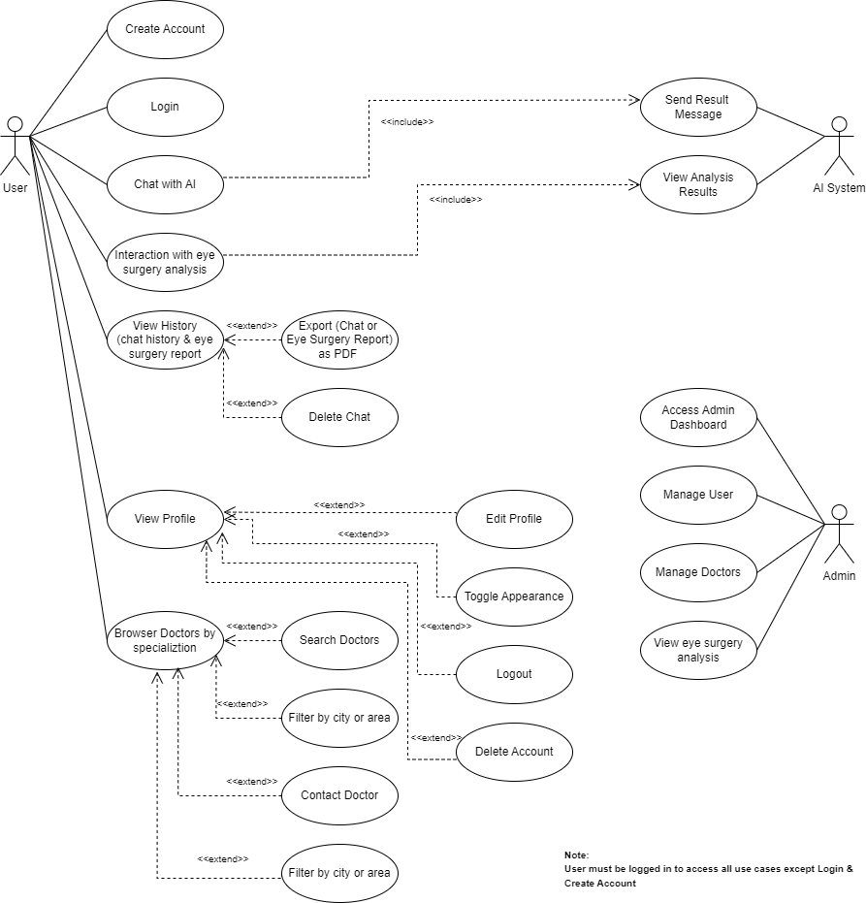

4.4.2 Use Case Specifications
Below are the detailed technical descriptions for each core functionality represented in the diagrams.
1.Login Use Case Specifications
Field | Description
Use Case ID | UC-01
Name | Login
Primary Actor | Patient (User)
Stakeholders & Interests | User: Access personal health dashboard securely.  System: Verify identity and prevent unauthorized access.
Pre-Conditions | - Application is installed and open.  - User has a registered account.
Post-Conditions | Success: User is authenticated and redirected to the AI Medical Chat.  Failure: User remains on the Login screen with an error message.
Main Success Scenario | 1. Views the "Welcome Back" screen.  2. User enters Username and Password.  3. User clicks the "Sign In" button.  4. System validates the credentials against the database.  5. System generates an access token.  6. System redirects the user to the AI Medical Chat.

2.AI Medical Chat
Field | Description
Use Case ID | UC-02
Name | AI Medical Chat
Primary Actor | Patient
Secondary Actor | Al Engine
Stakeholders & Interests | Patient: To receive health guidance and image-based diagnosis through a single interactive interface.  AI Engine: To process both natural language (text) and visual data (images) to provide a comprehensive response.
Pre-Conditions | 1. User is authenticated and has an active internet connection.  2. User is on the "AI Chat" or "Health Assistant" screen.  3. Camera/Gallery permissions are granted for image-based analysis.
Post-Conditions | Success: The interaction (text/image) is processed, results are displayed in the chat stream, and the session is persisted in the database.
Main Success Scenario | 1. User opens the unified chat interface.  2. (Text Path): User types a medical question or symptoms.  3. (Image Path): User clicks the "Add/Camera" icon and uploads a photo of a skin lesion or eye condition.  4. For Text: System routes the query to the NLP model for health guidance.  5. For Image: System routes the image to the Vision model for disease classification (Skin/Eye).  6. AI Engine returns the appropriate response (Diagnosis or Guidance).  7. System displays the result as a message or a "Structured Result Card" within the same chat stream.  8. System updates the chat history for both user and AI messages.
3. Eye Surgery Analysis
Field | Description
Use Case ID | UC-03
Name | Eye Surgery Analysis
Primary Actor | Patient
Secondary Actor | Al Engine (Surgery Al)
Stakeholders & Interests | Patient: Analyze corneal topography maps for specific conditions.  System: Gather specialized eye metrics for processing.
Pre-Conditions | User is logged in and navigated to the Eye Surgery Analysis section.
Post-Conditions | Success: Orbscan maps and clinical data submitted for analysis.  Failure: Validation error or submission failure.
Main Success Scenario | 1. User opens the Eye Surgery Analysis screen.  2. Section 1 (Upload Maps): User uploads images for Anterior, Axial,  Posterior, and Pachymetry maps.  3. Section 2 (Clinical Data): User enters numerical values for Age, Kmax  (D), CCT (um), and Astigmatism (D).  4. User selects Gender (M or F).  5. User submits the data for analysis (via a Submit/Analyze button).  6. System validates that all maps and fields are present.  7. System sends package to Al Engine for corneal analysis.  8. Results are returned to the user.

4. Doctor Browsing
Field | Description
Use Case ID | UC-04
Name | Doctor Browsing
Primary Actor | Patient
Secondary Actor | Database
Stakeholders & Interests | Stakeholders & Interests  Patient: To find a reliable medical specialist based on location or specialty for a physical consultation.  Doctors: To be visible to potential patients within the HealthLens.
Pre-Conditions | User is logged in and on the "Doctors" tab.
Post-Conditions | Success: A filtered list of doctors is displayed with their contact details and locations.
Main Success Scenario | 1. User navigates to the "Doctors" tab from the main menu.  2. System displays a list of all available doctors categorized by specialty (Dermatology / Ophthalmology).  3. User chooses city/region from the filter menu.  4. System queries the database for matching criteria.  5. System displays the search results.  6. User clicks the "Call" button to initiate a phone call via the device's native dialer.

4.4.3 Sequence Diagrams

4.4.3.1 Login Sequence Diagram

This detailed sequence diagram illustrates the complete user login and authentication flow, showing how user credentials are submitted from the mobile application, verified by the backend and authentication service, and result in either a successful login with an access token or an error response for invalid credentials.
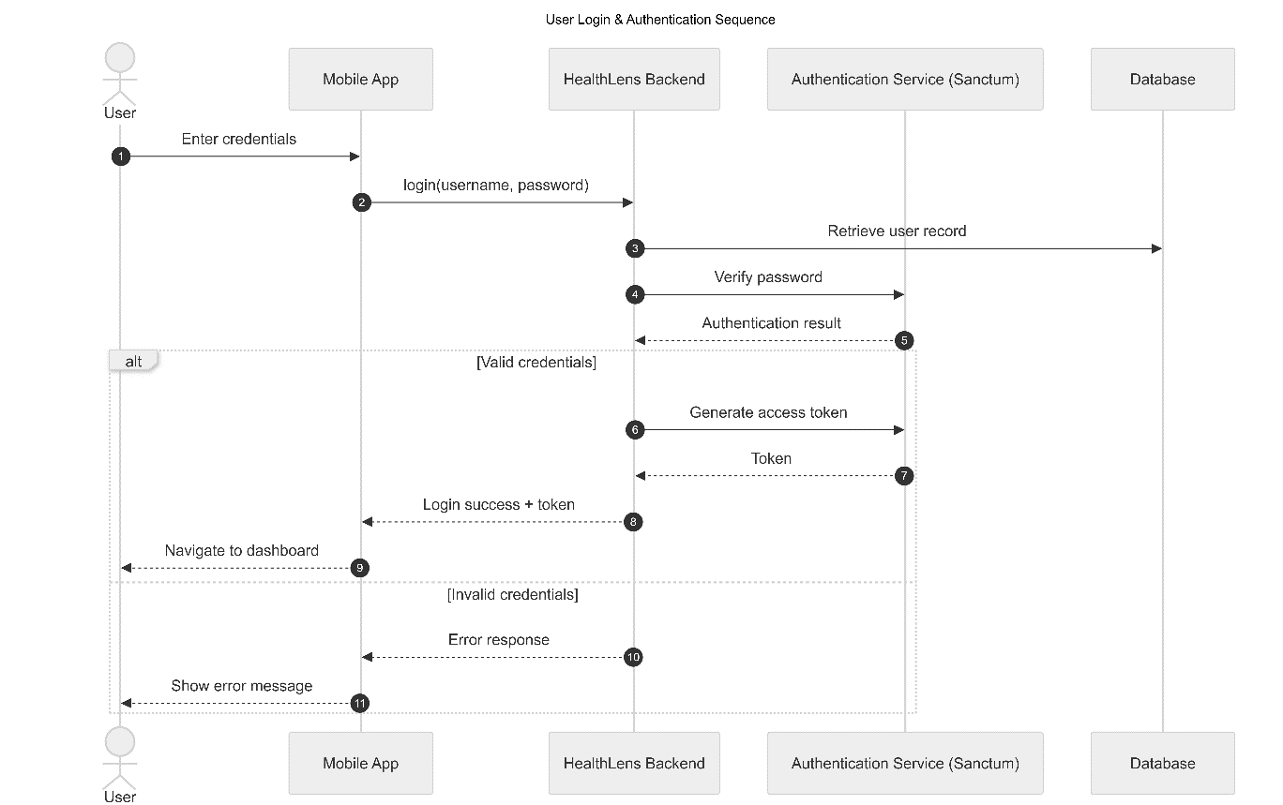
Figure 4.‎0.1: Login Sequence Diagram

4.4.3.2 HealthLens AI Chatbot Sequence Diagram

This detailed sequence diagram illustrates the complete AI medical chat interaction flow, showing how a user submits a text message or image from the mobile application, how the backend processes and stores the message and any attached media, forwards the conversational context to the AI model service, persists the AI-generated response, and finally returns and displays the medical AI reply to the user.
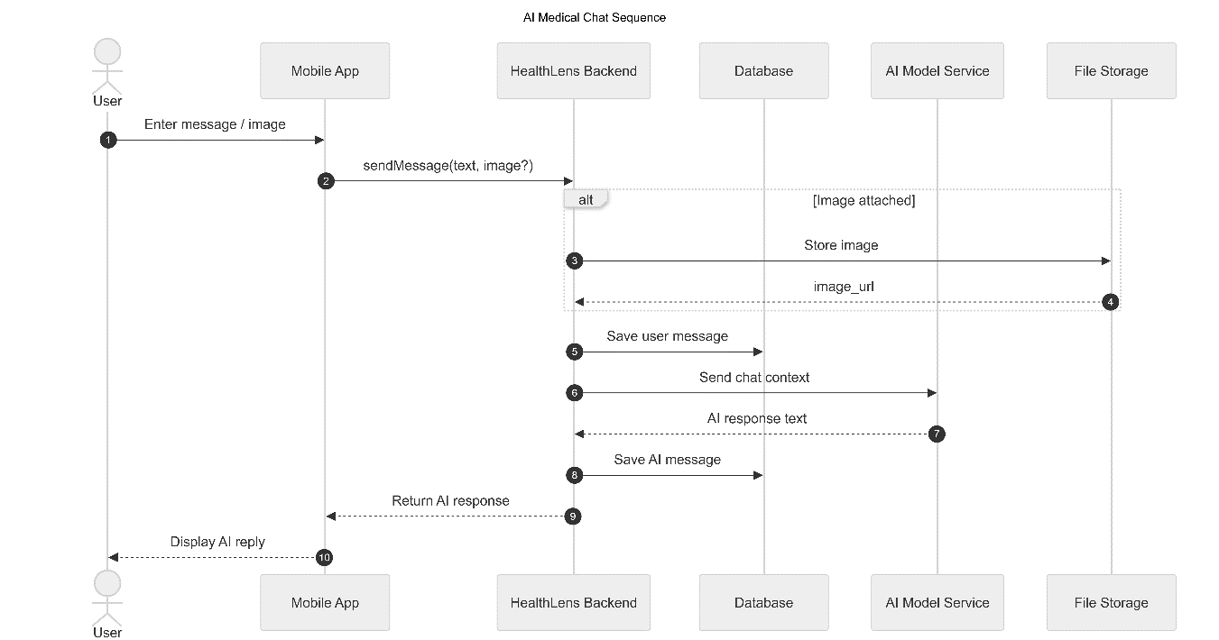

Figure 4.‎0.2: Sequence diagram AI Medical Chat

4.4.3.3 Eye Surgery Analysis
This detailed sequence diagram illustrates the complete eye surgery analysis workflow, showing how Orbscan images and clinical data are uploaded from the mobile application, stored and registered by the backend, analyzed by the AI model service, and finally transformed into a completed analysis and surgery report that is returned and displayed to the user.
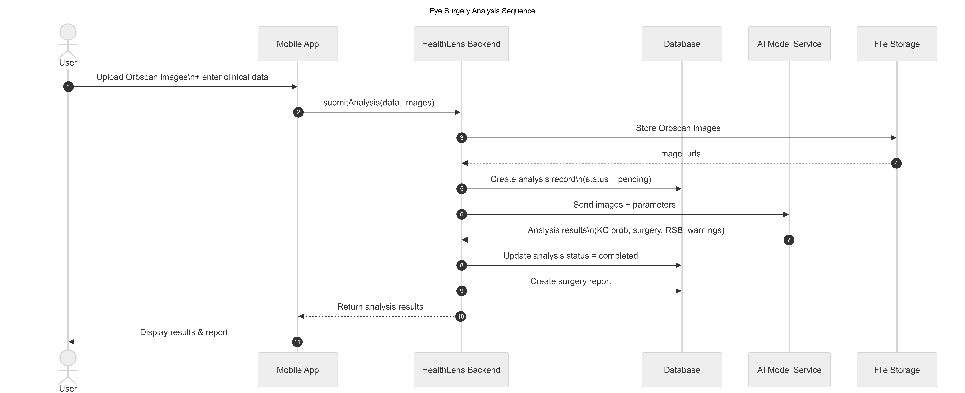

Figure 4.‎0.3: User Eye Surgery Analysis Sequence diagram

4.4.3.3 Full Message Sending with AI Response Sequence Diagram
Figure 4.‎0.4: Message Sending with AI Response Sequence Diagram

4.4.3.4 Patient Browsing Available Doctors Sequence Diagram
This detailed sequence diagram illustrates the doctor browsing and filtering workflow, showing how a user requests a list of doctors from the mobile application, how the backend applies optional filtering criteria while querying the database, and how the resulting doctor list is returned and displayed to the user.
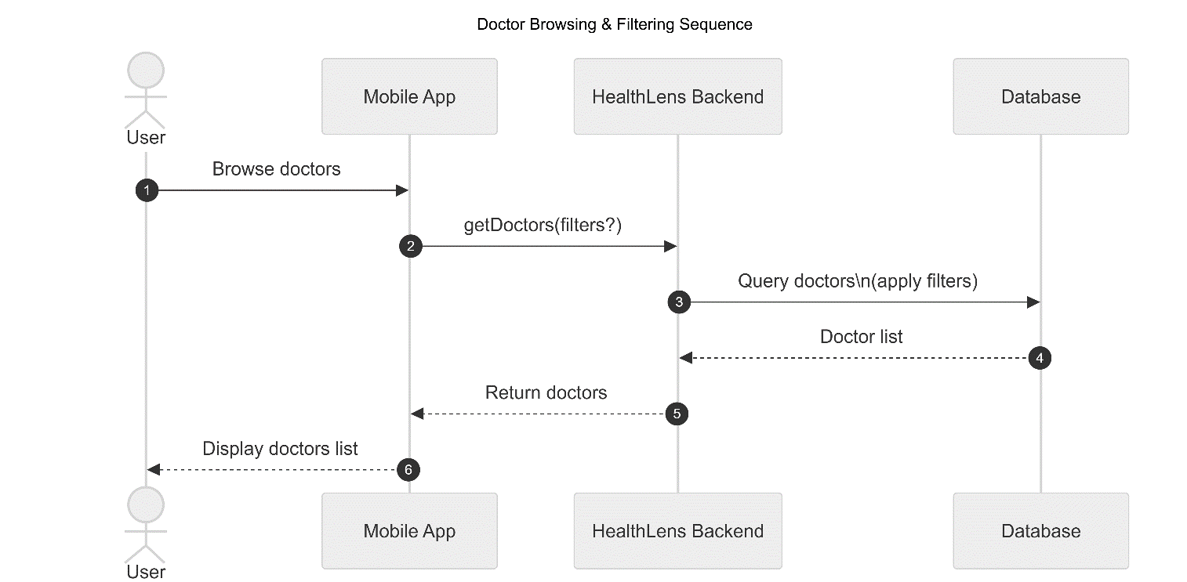
Figure 4.6: Patient Browsing Available Doctors Sequence Diagram

4.4.4 Activity Diagrams

4.4.4.1 User Registration Activity.

This activity diagram illustrates the complete user registration workflow in the HealthLens application. The process begins with user input collection and proceeds through systematic validation of required fields, uniqueness checks for email and username, secure password hashing, and database persistence. Upon successful account creation, the system assigns a default subscription plan and generates an authentication token, enabling immediate access to the application.
Error-handling paths are explicitly modeled to ensure robustness against invalid or duplicate input.

Figure 4.7: User Registration Flow Activity Diagram

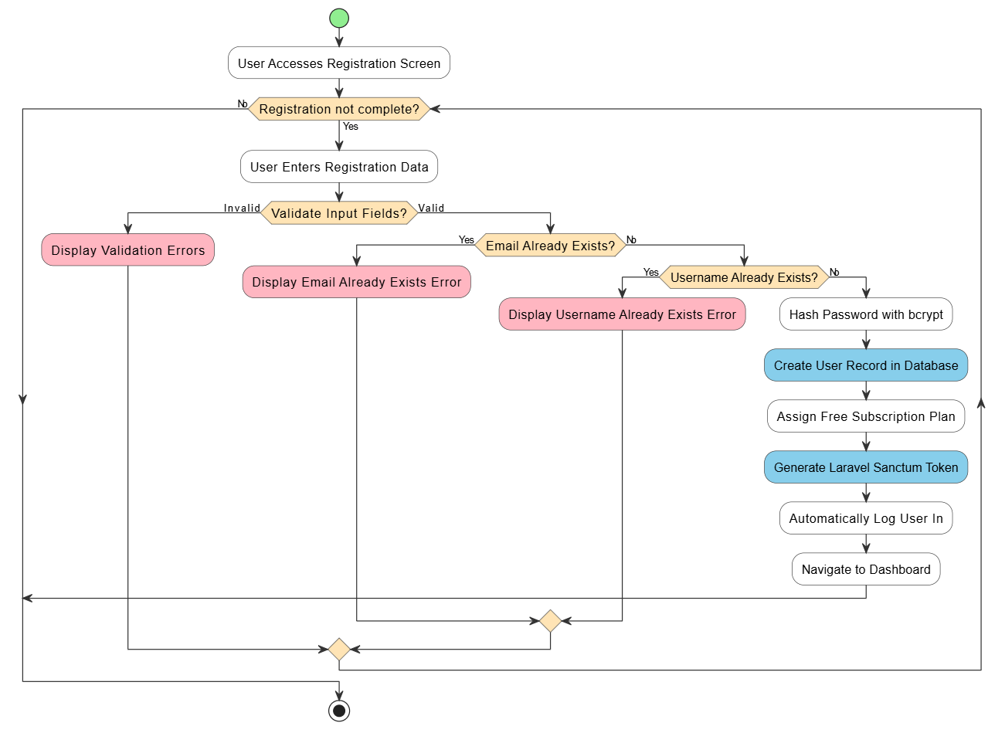

4.4.4.2 User Login Activity
This activity diagram depicts the user authentication workflow. It includes credential submission, field validation, backend authentication checks, secure token generation, and session initialization. Invalid login attempts are handled explicitly to prevent unauthorized access and maintain system security.
Figure 4.8: User Login Activity Diagram

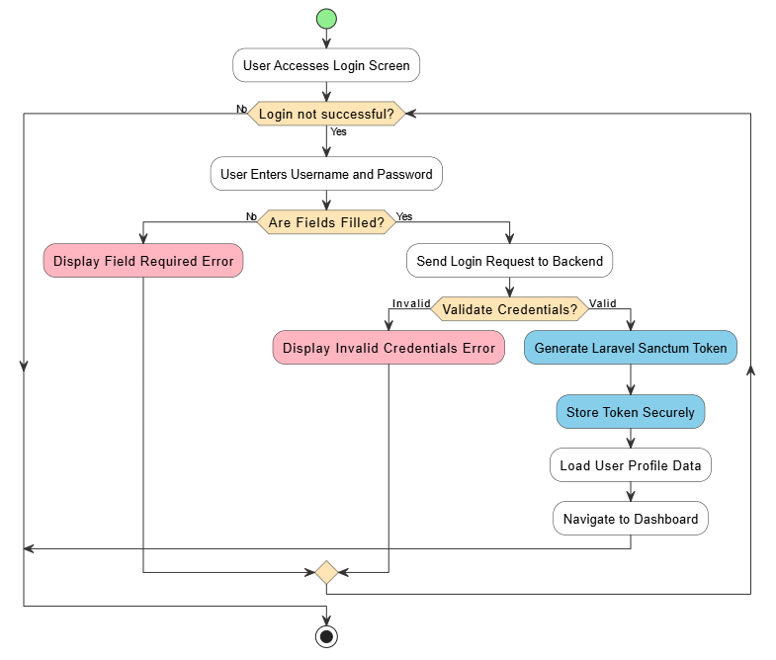

4.4.4.3 User Profile Management Activity
This diagram illustrates the workflow for viewing and editing user profile information. It captures transitions between view and edit modes, validation of updated data, enforcement of uniqueness constraints, and database synchronization.
Figure 4.9: User Profile Management Activity Diagram

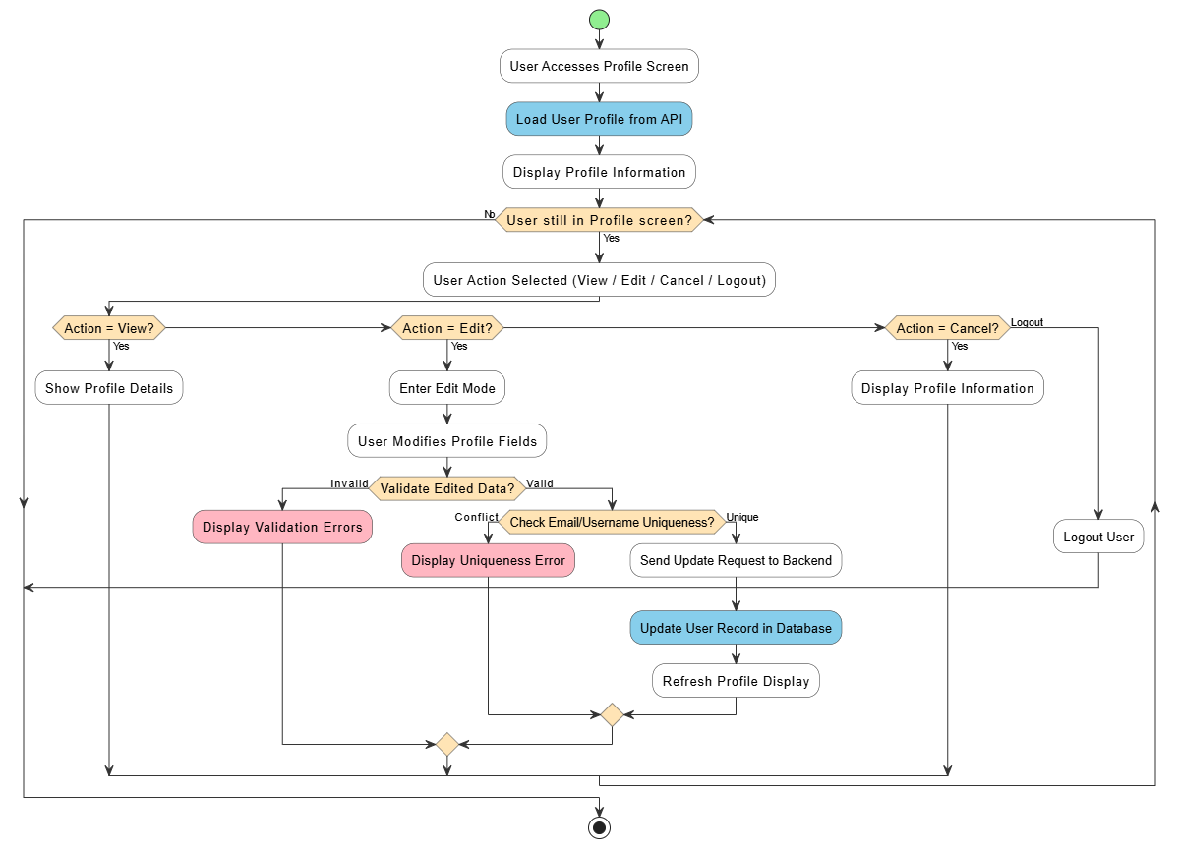

4.4.4.4 AI Chatbot Text Message Flow
This diagram shows the complete flow for sending a text message and receiving an AI chatbot response.

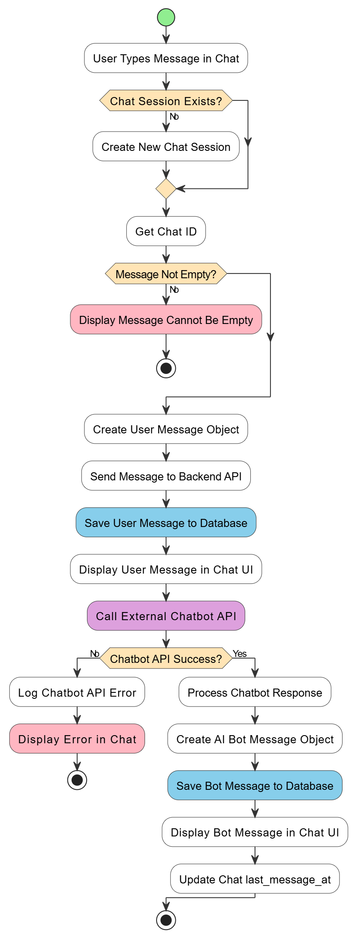
Figure 4.10: User’s Chatbot Text Activity Diagram

4.4.4.8 Chat History Management Activity Flow Diagram
This diagram describes chat history loading, pagination, deletion, and navigation across user chat sessions.
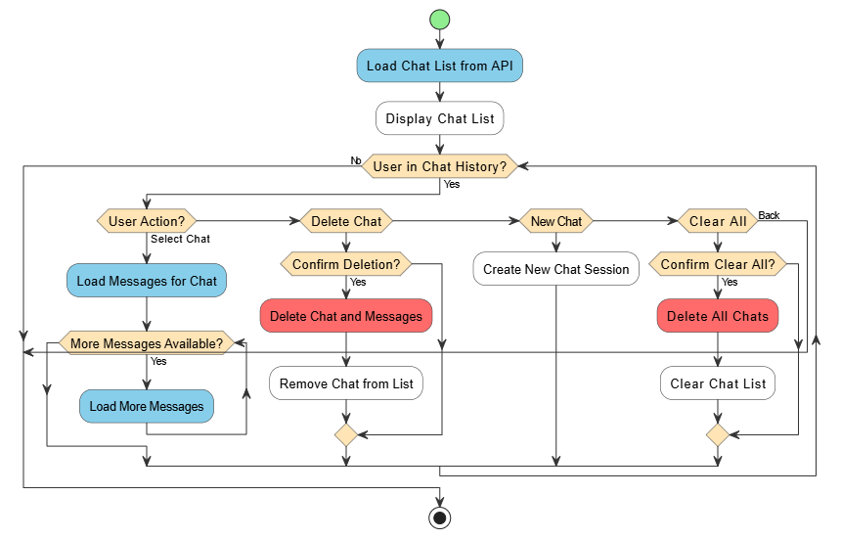
Figure 4.11: Chat History Management Activity Diagram

4.4.4.5 AI Chatbot Image Message Flow
This diagram models image-based AI analysis, including validation, classifier selection, AI processing, structured result creation, and visualization of diagnostic outputs.
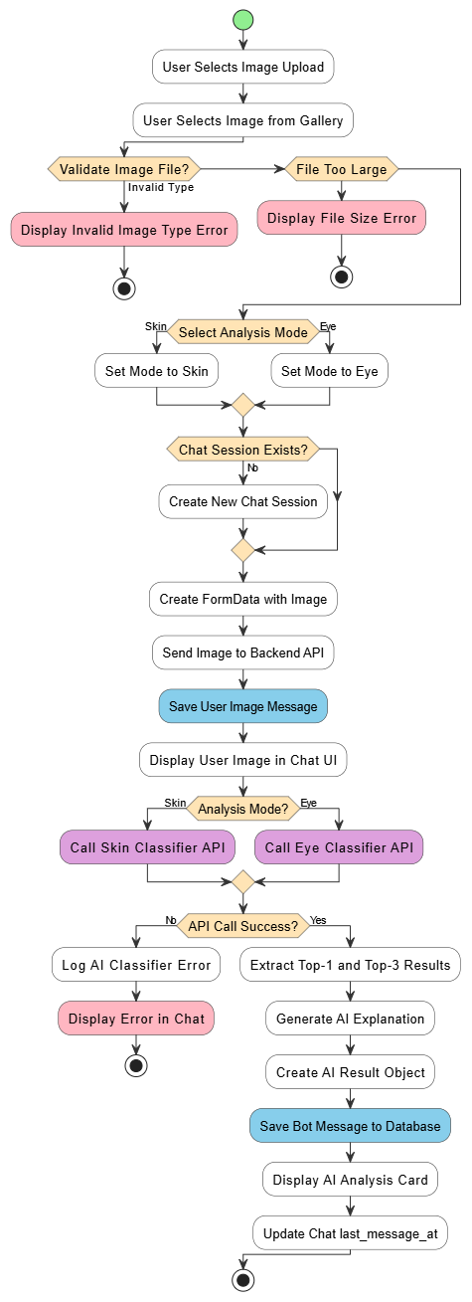
Figure 12: AI Chat – Image Analysis Activity Diagram

4.4.4.6 User’s Eye Surgery Analysis Activity Flow Diagram
Figure 4.13: Eye Surgery Analysis Activity Flow Diagram
This activity flow diagram presents the end-to-end process of the user’s eye surgery analysis within the HealthLens system. The workflow begins with image upload and clinical data entry, both of which are strictly validated to ensure analysis reliability. Upon successful validation, the system submits the analysis request, performs automated preprocessing and feature extraction, and invokes an external AI service for surgical assessment. The process includes explicit failure handling and status management. When analysis is completed successfully, the results are saved, the report status is updated, and the user is redirected to the results interface for review.

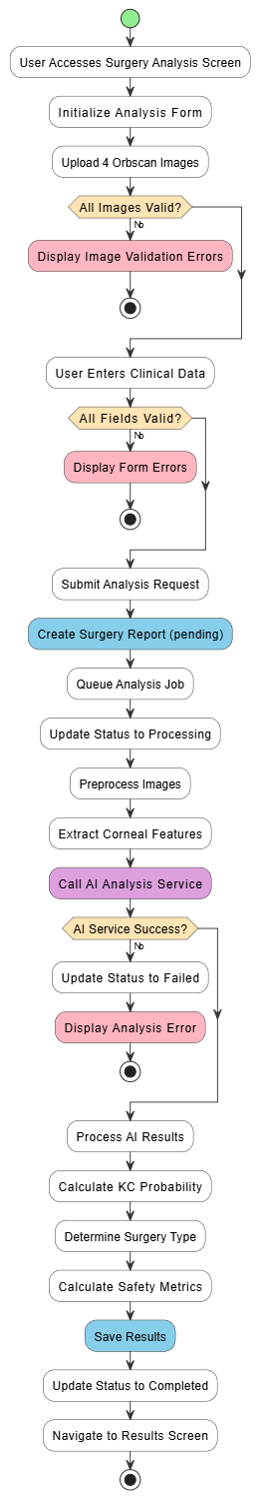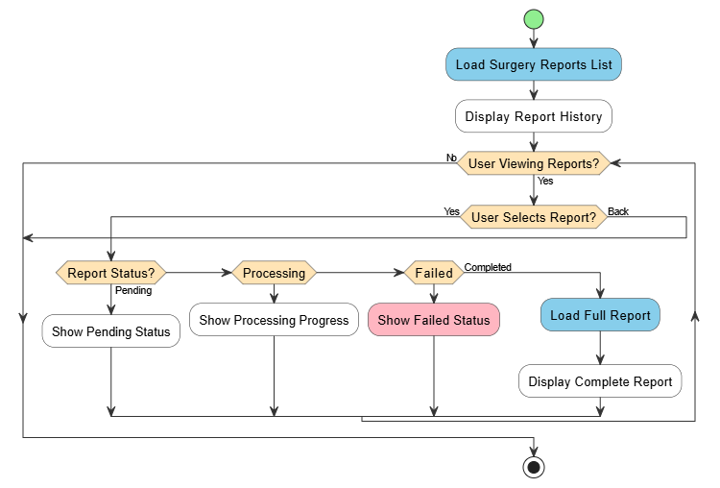

4.4.4.7 Surgery Report Viewing Activity
This diagram depicts the workflow for viewing surgery analysis reports, where the system loads the report history and displays report details based on their current status, including pending, processing, failed, or completed states.
Figure 4.14: Eye Surgery Analysis Activity Flow Diagram


4.4.5 Complete Entity-Relationship Diagram
This diagram illustrates the complete database schema for the HealthLens system, showing all entities, their attributes, and relationships. The schema consists of 8 main entities: USERS, SPECIALIZATIONS, DOCTORS, CHATS, MESSAGES, SURGERY_ANALYSES, SURGERY_REPORTS, and MEDIA. The MEDIA entity uses a polymorphic relationship pattern to associate files with multiple entity types. All relationships include proper foreign key constraints and cascade rules to maintain referential integrity.

Figure 4.15: Complete Entity-Relationship Diagram



Chapter 5: System Design

5.1 Backend Implementation
The HealthLens system adopts a hybrid backend architecture that combines a Laravel-based core platform with dedicated Python-based AI microservices. This design separates application logic, data management, and administrative control from computationally intensive artificial intelligence inference, ensuring scalability, security, and long-term maintainability.
Laravel serves as the primary backend framework responsible for authentication, user management, medical data handling, chat orchestration, and administrative operations. AI-specific functionality, such as disease classification, conversational medical assistance, and ophthalmic surgery analysis, is delegated to external Python services accessed through RESTful APIs. This dual-stack architecture enforces a clear separation of concerns and allows each subsystem to evolve independently.

5.1.1 Laravel for Core Operations
The core backend is implemented using Laravel 9.19, running on PHP 8.0.2+, and structured according to the Model–View–Controller (MVC) architectural pattern. Laravel provides a robust foundation for building secure, modular, and well-structured APIs while also supporting server-rendered administrative interfaces.
The Laravel framework provides several built-in mechanisms that support the security and reliability requirements of the HealthLens platform. Token-based API authentication is implemented using Laravel Sanctum, enabling secure access to protected endpoints from the mobile application. Database interactions and relationship management are handled through the Eloquent ORM, which abstracts SQL logic into expressive model definitions. Middleware is employed to enforce route-level access control and role-based authorization, while form request validation ensures strict enforcement of data integrity and input constraints. In addition, centralized exception handling and logging mechanisms are utilized to monitor system behavior and facilitate debugging without exposing sensitive implementation details.
The backend exposes JSON-based RESTful APIs consumed by the mobile application and integrates seamlessly with the AI microservices.

Models and Database Structure
The system employs a relational MySQL database accessed through Eloquent ORM models that encapsulate the platform’s core domain entities. User accounts are managed through a dedicated User model supporting both patient and administrator roles via role-based access control. Conversational functionality is represented through Chat and Message models, which store user–AI interactions along with structured inference results encoded in JSON format. Ophthalmic workflows are handled through SurgeryAnalysis and SurgeryReport models, which persist Orbscan-derived parameters, AI processing states, and finalized surgical recommendations. The Doctor and Specialization models support the medical specialist directory, while a polymorphic Media model enables the attachment of images and files—such as avatars, Orbscan maps, and chat images—to multiple entities. All model relationships, foreign keys, and constraints are enforced at both the application and database levels to maintain consistency and referential integrity.

Controllers and Routing
Application logic is organized into Laravel controllers that are separated according to their functional responsibilities. API controllers are responsible for handling authentication, user profile management, chat sessions, image uploads, AI interactions, and ophthalmic surgery analysis workflows consumed by the mobile application. In parallel, administrative controllers provide full CRUD functionality for managing users, doctors, specializations, and surgery analyses through server-rendered dashboard views. Routing is structured to expose public API endpoints for authentication and medical directory browsing, while patient-specific functionality is protected using the auth:sanctum middleware. Administrative web routes are prefixed under /admin and secured through authentication and role-based access control. Global rate limiting, CSRF protection for web routes, and consistent API response formats are enforced across the system.

5.1.2 Python for AI-Powered Services
Artificial intelligence functionality is implemented using dedicated Python-based services optimized for scientific computing and deep learning inference. These services leverage modern frameworks such as PyTorch, TensorFlow, and Keras and are exposed through RESTful APIs. The AI layer supports multiple clinical capabilities, including convolutional neural network–based skin and eye disease classification, a fine-tuned large language model for medical conversational assistance, and an ophthalmic surgery analysis module that estimates keratoconus probability and evaluates surgical safety parameters. Each capability is deployed as an independent microservice, enabling modular development and scalable deployment.

AI Service Integration
Integration between the Laravel backend and the AI microservices is performed using Laravel’s HTTP client abstraction. Incoming user inputs are routed dynamically based on their modality, with text messages invoking conversational inference, medical images triggering disease classification, and Orbscan submissions initiating surgical analysis workflows. AI responses are validated and stored in structured JSON format within the database to preserve explainability and traceability. In the event of service failure or timeout, the system degrades gracefully by preserving user data, logging errors for later inspection, and continuing normal operation without data loss.

5.1.3 Interoperability and API Design
Both the Laravel backend and Python AI services adhere to a consistent RESTful API design using JSON-based request and response formats. Standardized responses include explicit success indicators, human-readable messages, structured data payloads, and pagination metadata where applicable. This uniformity simplifies frontend integration and ensures predictable communication patterns across system components. Cross-Origin Resource Sharing (CORS) policies are configured to allow secure access from development and production environments, while internal service communication is protected through controlled endpoints and environment-based configuration.

5.1.4 Security Measures
Given the sensitivity of medical data, the HealthLens system implements multiple layers of security to protect patient information. Token-based authentication is enforced using Laravel Sanctum, while role-based authorization distinguishes between patient and administrator privileges. User credentials are securely stored using Bcrypt hashing, and sensitive fields are excluded from API responses. Clinical inputs are validated against realistic medical ranges to reduce the risk of erroneous data entry. In production environments, all communication is secured using HTTPS. Uploaded files are validated by MIME type and size, stored outside the public web root, and accessed only through controlled routes. System exceptions are logged centrally without exposing internal implementation details to clients, ensuring both security and maintainability. This layered approach aligns with best practices for handling Patient Health Information (PHI).

5.2 Frontend Implementation
The frontend of the HealthLens platform is divided into two independent applications designed to serve distinct user roles. A patient-facing mobile application is developed using React Native with Expo, while a web-based administrative dashboard is implemented using Laravel Blade templates combined with Bootstrap 5. This separation ensures that each interface is optimized for its target audience while maintaining a consistent interaction model with the shared backend infrastructure.

5.2.1 React Native Mobile Application
The patient-facing mobile application is developed using React Native with Expo, enabling a single codebase to be deployed natively on both Android and iOS platforms. This approach reduces development complexity while ensuring consistent behavior across devices. The mobile architecture emphasizes modularity, responsiveness, and ease of maintenance, allowing individual features to evolve independently without impacting the overall application structure.
Reusable user interface components are employed to support core functionalities such as conversational interaction with the medical assistant, image capture and upload, browsing medical specialists, and submitting data for AI-driven analysis. Application state is managed using React Hooks and the Context API, providing a lightweight yet effective mechanism for handling authentication state, theme preferences, and transient UI data. Expo’s native APIs are leveraged to provide seamless access to device hardware, including the camera, image gallery, and local file system, enabling users to capture or select medical images directly from their devices.
Communication with the backend is performed through authenticated HTTP requests to the Laravel REST API, with automatic token injection ensuring secure access to protected endpoints. The mobile application supports multipart file uploads for medical images and Orbscan data, allowing efficient transmission of binary data required for AI inference while maintaining data integrity and user privacy.

5.2.2 Laravel Blade Admin Dashboard
The administrative dashboard is implemented using Laravel Blade templates in conjunction with Bootstrap 5 for styling and layout. This server-rendered architecture provides a stable, secure, and maintainable interface tailored for administrative workflows, while minimizing reliance on client-side JavaScript. By rendering views on the server, the dashboard benefits from improved security, predictable behavior, and simplified deployment.
Administrative routes are protected through authentication and role-based authorization, ensuring that sensitive system operations are accessible only to authorized personnel. The dashboard provides full CRUD functionality for managing users, doctors, medical specializations, and ophthalmic surgery analyses. In addition, the interface includes analytical views that present system statistics and recent activity, enabling administrators to monitor platform usage and operational status effectively. Blade templates enforce consistent layout structures across all administrative views, while Bootstrap’s responsive grid system ensures usability across varying screen sizes.

5.2.3 Styling and Responsiveness
Styling and responsiveness are handled independently within each frontend application while adhering to a unified visual identity. The mobile interface relies on React Native’s Flexbox layout system, responsive scaling techniques, and platform-aware styling to ensure consistent appearance and behavior across different screen sizes and operating systems. The web-based dashboard utilizes Bootstrap’s responsive grid, cards, tables, and navigation components to maintain a professional and accessible administrative interface.
Across both platforms, consistent color schemes, typography, loading indicators, and error-handling patterns are applied to reinforce a cohesive system identity and improve user experience. This coordinated design approach ensures that users and administrators interact with a visually consistent and intuitive platform, despite differences in underlying technologies.
The overall HealthLens system architecture deliberately separates concerns across backend services, AI processing, and frontend applications. Laravel provides a secure and extensible application backbone, Python-based microservices handle specialized artificial intelligence inference, and the frontend layer delivers optimized user experiences for both patients and administrators. This modular, service-oriented design supports scalability, long-term maintainability, and future clinical expansion.

5.3 AI Models

5.3.1 Multi-Class Eye Disease Classification
The proposed AI-driven medical imaging system focuses on the automatic classification of eye diseases using retinal fundus images. The system is designed to assist clinical decision-making by accurately identifying pathological conditions such as cataract, diabetic retinopathy, and glaucoma, as well as distinguishing healthy eyes. By leveraging deep learning–based computer vision techniques, the system enhances diagnostic efficiency and consistency while reducing reliance on manual inspection. The classification pipeline processes retinal images end-to-end, transforming raw visual data into clinically meaningful disease labels.

5.3.1.1 The Target Model
The target model for multi-class eye disease classification is a deep convolutional neural network designed to learn discriminative visual representations from retinal fundus images. Unlike traditional rule-based systems, the model automatically extracts hierarchical features such as edges, textures, vascular patterns, and structural anomalies directly from image data.
Several architectures were investigated during development, including convolutional networks trained from scratch and transfer learning–based models. The final and best-performing model utilizes an EfficientNet-B3 backbone pre-trained on the ImageNet dataset. This architecture employs compound scaling to balance network depth, width, and input resolution, enabling efficient learning of high-level visual features while maintaining computational efficiency.
The model receives normalized retinal images as input and outputs probability scores over four disease classes using a softmax activation function. The predicted class corresponds to the eye condition with the highest probability, enabling accurate multi-class classification suitable for clinical screening applications.

5.3.1.2 Dataset Preprocessing
To prepare the retinal image dataset for training and evaluation, a structured preprocessing pipeline was applied. Initially, all images were resized to a fixed spatial resolution to ensure consistency across batches. For convolutional neural networks trained from scratch and DenseNet-based models, images were resized to 224×224 pixels, while the EfficientNet-B3 model employed higher-resolution inputs of 384×384 pixels to better preserve fine-grained anatomical details.
Pixel intensity values were normalized to a standardized range. For transfer learning–based models, ImageNet normalization statistics were applied to match the distribution of the pre-trained weights. Data augmentation techniques were employed during training to improve generalization and reduce overfitting. These techniques included random horizontal and vertical flipping, random rotations, zooming, brightness and contrast adjustments, Gaussian noise injection, and geometric transformations.
The dataset was then split into training and validation subsets using stratified sampling to preserve class balance. Most experiments used an 80/20 split, while the final EfficientNet-based experiment employed an 85/15 split to maximize training data availability. The processed images and corresponding labels were converted into tensor representations suitable for batch-based training on GPU hardware.

5.3.1.3 Model Core
The core of the proposed eye disease classification system is built upon a deep convolutional neural network optimized for medical image analysis. The model employs an EfficientNet-B3 architecture pretrained on the ImageNet dataset, enabling robust feature extraction from retinal fundus images while maintaining computational efficiency.
Input images undergo standardized preprocessing, including spatial resizing and intensity normalization, followed by extensive data augmentation to improve generalization and mitigate overfitting. The pretrained EfficientNet backbone serves as the feature extractor, producing high-level representations of retinal structures relevant to disease discrimination.
The extracted features are passed through a fully connected classification head and a softmax layer to predict one of four clinical categories: cataract, diabetic retinopathy, glaucoma, or normal. Model training is performed using cross-entropy loss and the AdamW optimizer, with cosine annealing applied to the learning rate schedule.
Performance is assessed using macro-averaged F1-score, overall accuracy, and class-wise precision and recall, as detailed in Chapter 6. In addition to quantitative assessment, Grad-CAM is employed to generate visual explanations, highlighting retinal regions that contribute most strongly to model predictions. This enhances model interpretability and supports clinical trustworthiness in medical decision-making contexts

5.3.2 Keratoconus Detection and Refractive Surgery Decision Support System
This section presents the complete design and implementation of the Eye Surgery Analysis system, a multi-stage machine learning framework for keratoconus detection and refractive surgery decision support. The system is composed of three logically independent yet sequential modules, each trained and evaluated separately, and collectively forming a fully data-driven clinical decision-support pipeline.

5.3.2.1 Target Models
Eye Surgery Analysis is composed of two sequential but independent machine learning modules:
Module 1: Keratoconus Detection
The first module estimates the probability of keratoconus presence using a fused multimodal feature representation. The output is a continuous probability score (kc_probability) rather than a binary decision, allowing downstream systems to reason under uncertainty.
Module 2: Surgery Decision Support
The second module predicts the suitability of refractive surgery procedures (LASIK, PRK, IntraLase, or abstention) using a compact set of clinically interpretable features. Each surgical option is modeled independently as a continuous suitability function, enabling confidence-aware decision-making and safe abstention in ambiguous cases.
Both modules employ gradient-boosted decision tree models (XGBoost) due to their strong performance on tabular data, robustness to feature scaling, and compatibility with post-hoc explainability techniques such as SHAP.

5.3.2.2 Dataset and Preprocessing
The Eye Surgery Analysis dataset consists of ORBSCAN corneal imaging data collected across multiple patients and eyes, accompanied by structured clinical measurements. For each eye, four corneal map types are utilized: anterior elevation, posterior elevation, axial curvature, and pachymetry.
Image preprocessing includes:
- Spatial resizing to a fixed resolution
- Noise reduction via Gaussian and bilateral filtering
- Automatic corneal region cropping
- Intensity normalization
- Contrast enhancement using CLAHE
Processed images are stored persistently to ensure reproducibility and eliminate the need for repeated preprocessing.
In parallel, structured clinical data - such as age, corneal thickness, keratometry values, astigmatism, and asphericity - are cleaned, type-corrected, and aligned with corresponding imaging data using patient and eye identifiers.

5.3.2.3 Feature Extraction and Fusion
Eye Surgery Analysis employs a three-branch feature extraction strategy:
- Deep CNN Features
A pretrained EfficientNet-based convolutional neural network is used strictly as a feature extractor, not as a classifier. Global average pooling produces compact deep representations for each corneal map. Features from all map types are concatenated to form a high-dimensional CNN feature vector.
- Classical Image Features
Handcrafted descriptors are extracted from each processed image, including:
  - Texture features derived from Gray-Level Co-occurrence Matrices (GLCM)
  - Color statistics and histograms
  - Horizontal and vertical symmetry measures
- Clinical Numeric Features
Explicit numeric clinical variables are incorporated directly without transformation, preserving their medical interpretability.
The final fused feature vector contains 5,857 dimensions, representing a comprehensive multimodal characterization of corneal structure and patient-specific factors.

5.3.2.4 Keratoconus Detection Model
The keratoconus detection task is implemented using an XGBoost classifier trained on the fused multimodal feature vectors. The model outputs a continuous probability of keratoconus rather than a hard class label, allowing uncertainty-aware downstream reasoning.
Model performance is evaluated using accuracy, precision, recall, and F1-score, achieving approximately 96% classification accuracy on held-out test data. To enhance transparency, SHAP (SHapley Additive exPlanations) is used to analyze feature contributions at both the global and individual-patient levels, revealing clinically coherent relationships between corneal geometry, imaging patterns, and keratoconus risk.

5.3.2.5 Surgery Decision Support Model
Refractive surgery recommendation is formulated as a purely machine learning–based suitability estimation problem, without the use of explicit medical rules or threshold-based constraints at inference time.
A compact, interpretable decision feature vector is constructed for each case, consisting of:
- Keratoconus probability (from Module 1)
- Central corneal thickness
- Maximum keratometry value
- Estimated residual stromal bed
- Patient age
- Astigmatism magnitude
Separate XGBoost models are trained for each surgical procedure using weakly supervised targets, reflecting prior clinical knowledge during training but not enforced during inference. This design allows the models to learn nonlinear suitability patterns directly from data while maintaining interpretability.
To enhance clinical safety, the system incorporates confidence-aware abstention, deferring recommendations when predictive confidence is insufficient rather than forcing a potentially unsafe decision.

5.3.2.6 Model Core
The core of the Eye Surgery Analysis system is a modular, data-driven machine learning architecture designed to support both keratoconus detection and refractive surgery decision-making. Unlike traditional rule-based clinical systems, Eye Surgery Analysis formulates diagnosis and surgical recommendation as supervised learning problems driven entirely by data rather than predefined medical thresholds.
The system is composed of two interconnected modules. The first module focuses on keratoconus detection using multimodal corneal information, while the second module provides machine learning–based refractive surgery decision support. Each module operates independently but contributes to a unified clinical workflow.
In the keratoconus detection module, deep visual features extracted from multiple ORBSCAN corneal maps are combined with classical image features and structured clinical measurements. These heterogeneous features are fused into a single high-dimensional feature vector and classified using an XGBoost model. The model outputs a continuous keratoconus probability, allowing diagnostic uncertainty to be represented explicitly rather than forcing a binary decision.
The surgery decision support module builds upon the keratoconus detection output by constructing a compact set of clinically interpretable decision features, including keratoconus probability, corneal thickness, maximum keratometry, residual stromal bed estimation, patient age, and astigmatism. Separate machine learning models are trained for each refractive procedure to learn continuous suitability functions directly from data. Final recommendations are produced using a confidence-aware inference strategy that allows the system to abstain from decision-making in ambiguous cases, prioritizing patient safety.
By avoiding explicit medical rules and rigid thresholds at inference time, the Eye Surgery Analysis model core captures complex nonlinear relationships between corneal geometry, disease risk, and surgical suitability. This design improves robustness, interpretability, and adaptability, making the system suitable for real-world clinical decision-support applications.

5.3.3 Multi-Class Skin Disease Classification
The proposed AI-driven skin disease classification system focuses on the automatic identification of dermatological conditions from dermoscopic images. The system is designed to support early screening and decision support by accurately classifying multiple skin lesion categories using deep learning–based computer vision techniques. By leveraging transfer learning and evaluating multiple modern convolutional neural network architectures, the framework aims to balance diagnostic performance with computational efficiency, enabling potential deployment in mobile and resource-constrained environments.
The classification pipeline operates end-to-end, transforming raw dermoscopic images into clinically meaningful skin disease labels. The system is trained and evaluated using the publicly available HAM10000 dataset, which contains diverse skin lesion categories commonly encountered in dermatological practice. Multiple CNN architectures are investigated to identify the most suitable model for this task, including EfficientNetV2-L, ConvNeXt-Tiny, and MobileNetV3.

5.3.3.1 The Target Model
The target models for multi-class skin disease classification are deep convolutional neural networks designed to learn discriminative visual representations from dermoscopic images. Unlike rule-based or handcrafted feature systems, these models automatically extract hierarchical features such as lesion boundaries, color distributions, texture irregularities, and structural patterns directly from image data.
Several deep learning strategies were explored during system design, including training from scratch and transfer learning–based approaches. Three representative architectures were selected for detailed experimentation: EfficientNetV2-L, ConvNeXt-Tiny, and MobileNetV3-Large, all initialized with ImageNet-pretrained weights.
EfficientNetV2-L was evaluated due to its strong performance on large-scale image classification tasks and its compound scaling strategy. ConvNeXt-Tiny was selected as a modernized convolutional architecture inspired by transformer design principles, offering improved feature representation capacity. The final and best-performing configuration employs MobileNetV3-Large, an architecture specifically optimized for mobile and embedded platforms, enabling efficient feature extraction while maintaining competitive classification performance.
Each model receives preprocessed dermoscopic images as input and outputs probability scores over seven skin disease classes using a softmax activation function. The predicted disease corresponds to the class with the highest probability, enabling multi-class classification suitable for screening and decision-support scenarios.

5.3.3.2 Dataset and Preprocessing
To prepare the HAM10000 dataset for training and evaluation, a structured preprocessing pipeline is applied consistently across all evaluated architectures. All dermoscopic images are resized to a fixed spatial resolution of 224 × 224 pixels, ensuring consistency across training batches and compatibility with the input requirements of EfficientNetV2-L, ConvNeXt-Tiny, and MobileNetV3.
Image preprocessing includes safe image loading to handle corrupted or missing files, followed by type conversion and normalization using the preprocessing functions corresponding to each pretrained architecture. This ensures alignment between the input distribution of the dataset and the ImageNet-pretrained weights.
To improve generalization and robustness, extensive data augmentation is applied exclusively to the training set. Augmentation operations include random horizontal flipping, random rotations, zooming, translation, brightness and contrast adjustments, Gaussian noise injection, and random cropping that retains between 60% and 100% of the original image area before resizing. This strategy simulates real-world smartphone image acquisition conditions, such as variations in lighting, framing, and camera quality.
The dataset is divided into training and validation subsets using stratified sampling with an 80/20 split, preserving class distributions across both sets and enabling reliable performance evaluation.

5.3.3.3 Model Core
The core of the proposed skin disease classification system is a lightweight, fully fine-tuned MobileNetV3-Large convolutional neural network optimized for mobile-oriented medical image analysis. Although EfficientNetV2-L and ConvNeXt-Tiny exhibit competitive training performance, MobileNetV3-Large provides the most balanced trade-off between accuracy, generalization, and computational efficiency.
The pretrained MobileNetV3 backbone serves as the primary feature extractor, generating high-level representations of lesion morphology and visual patterns relevant to disease discrimination. Extracted features are passed through a custom classification head consisting of global average pooling, batch normalization, dropout regularization, and a softmax output layer corresponding to the seven skin lesion categories.
The model outputs probability scores for each disease class, enabling both single-class prediction and ranked diagnostic suggestions. The lightweight architecture and efficient inference pipeline make the system suitable for real-time deployment and integration into mobile or web-based clinical support tools.
To illustrate the architecture and data flow of the selected mobile-optimized model, Figure 5.6 presents a block diagram of the MobileNetV3-based skin disease classification system.
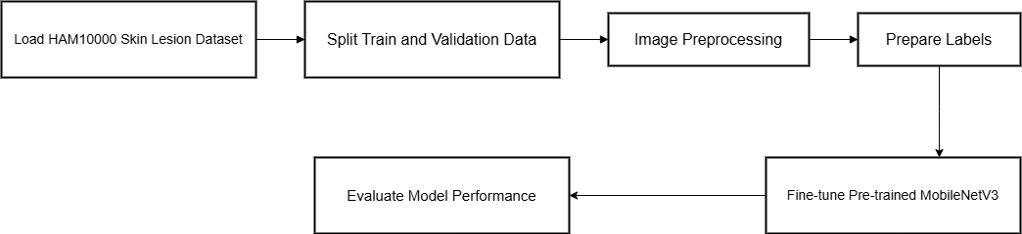
Figure 5.6: Block diagram of the MobileNetV3-Large–based skin disease classification system.

5.3.4 Generative Medical Chatbot
The proposed AI-driven generative medical chatbot is designed to provide safe, structured, and clinically conservative responses to health-related user queries. Unlike traditional rule-based systems, the chatbot leverages large language models to understand natural language input and generate context-aware medical guidance while strictly adhering to safety constraints. The system aims to enhance accessibility to preliminary medical information, support patient education, and reduce unnecessary clinical burden, without replacing professional medical diagnosis or treatment.
To achieve this, multiple generative language models were evaluated under different training strategies. A lightweight baseline chatbot based on TinyLLaMA was first developed to assess the feasibility of efficient parameter-efficient fine-tuning on limited hardware. Building upon insights from this baseline, a more advanced curriculum-based model, referred to as HealthLens Chatbot, was designed and trained to achieve superior reasoning accuracy, evidence grounding, and safety behavior. The chatbot pipeline transforms user queries into structured prompts, processes them through a fine-tuned transformer-based language model, and outputs medically appropriate, safety-aligned responses.

5.3.4.1 The Target Models
Two generative language models were investigated for medical chatbot development.
The first experiment employed TinyLLaMA-1.1B, a compact causal language model selected for its balance between computational efficiency and generative capability. TinyLLaMA was adapted for medical dialogue using Parameter-Efficient Fine-Tuning (PEFT) with Low-Rank Adaptation (LoRA), enabling deployment on resource-constrained environments such as NVIDIA T4 GPUs.
The second and final model, HealthLens Chatbot, is based on the larger Mistral-7B-Instruct-v0.2 architecture. This model was selected for its stronger reasoning capabilities and instruction-following performance. HealthLens Chatbot was fine-tuned using a curriculum learning strategy, progressively aligning the model with clinical reasoning, evidence-based justification, and safe conversational behavior. Only lightweight LoRA adapters were trained, leaving the base model parameters frozen, ensuring training efficiency and stability.

5.3.4.2 Dataset Preprocessing
Textual data preprocessing was performed to ensure safe, consistent, and reproducible model training. For both chatbot experiments, raw datasets were converted into structured instruction-based formats to enforce a medical assistant persona and safety constraints.
For the TinyLLaMA experiment, the lavita/ChatDoctor-HealthCareMagic-100k dataset was used. A subset of 20,000 samples was selected using a fixed random seed to ensure reproducibility. Each sample was reformatted using an instruction-tuning template that explicitly defined the assistant’s role as a conservative medical helper. The processed text was tokenized with a maximum sequence length of 512 tokens, and labels were aligned with input tokens for causal language modeling.
For our system’s proposed HealthLens Chatbot, multiple datasets were utilized across training phases, including MedQA, PubMedQA, and Medical Meadow. All datasets were converted into a unified chat-based format consisting of system prompts, user inputs, and assistant outputs. Tokenization was performed with a maximum sequence length of 2048 tokens. Padding and truncation ensured uniform batch shapes, while strict prompt formatting prevented data leakage during evaluation.
5.3.4.3 Model Core
The core of the proposed generative medical HealthLens Chatbot system is a transformer-based causal language model enhanced through parameter-efficient fine-tuning. In the baseline configuration, TinyLLaMA-1.1B is wrapped within a PEFT architecture, where LoRA adapters are injected into attention and feed-forward projection layers. This design enables efficient domain adaptation while maintaining low memory consumption through 4-bit quantization.
The final HealthLens system extends this approach by combining a larger base model with a curriculum-based training strategy. Input queries are first structured using a strict system prompt that enforces medical safety rules. The quantized base model processes the tokenized input, while LoRA adapters introduce task-specific knowledge acquired during each training phase. The generated output is constrained by the causal attention mechanism, ensuring responses are grounded in prior context.
Model outputs are evaluated using task-specific metrics, including multiple-choice accuracy for clinical reasoning, decision accuracy for evidence-based questions, and qualitative safety assessment for conversational behavior. By combining curriculum learning, parameter-efficient fine-tuning, and strict safety prompting, HealthLens achieves robust medical reasoning, explainability, and user safety, making it suitable for real-world deployment as an intelligent medical assistant.
To illustrate the internal structure and training workflow of the proposed HealthLens medical chatbot, Figure 5.7 presents a block diagram of the curriculum-based transformer architecture. The diagram highlights the integration of a 4-bit quantized causal language model with parameter-efficient LoRA adapters, as well as the sequential fine-tuning stages that progressively incorporate clinical reasoning, evidence grounding, and conversational behavior.

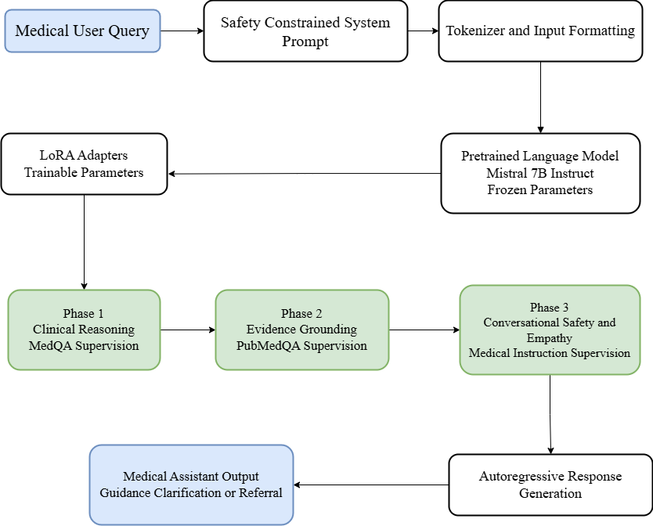
Figure 5.7: Block diagram of the Mistral-7B-based medical chatbot curriculum fine-tuning pipeline.

5.3.4.4 Key Findings and Conclusions
This experimental study demonstrates that curriculum-based fine-tuning using parameter-efficient techniques can successfully transform a safety-aligned general-purpose language model into a reliable medical conversational assistant without compromising safety or factual grounding. By progressively structuring the training process into three distinct phases; clinical reasoning alignment, evidence grounding, and conversational refinement, the HealthLens chatbot achieved strong task performance while maintaining conservative medical behavior.
The first fine-tuning phase effectively eliminated safety-aligned abstention observed in the base model by enforcing deterministic clinical reasoning through structured MedQA supervision. This phase established a robust reasoning backbone, enabling the model to confidently select medically appropriate answers in multiple-choice clinical scenarios. Subsequent fine-tuning on PubMedQA introduced evidence-grounded justification, significantly improving the model’s ability to support decisions with scientifically coherent explanations derived from biomedical abstracts.
The final conversational fine-tuning phase, conducted using medical instruction and dialogue data, refined response fluency, empathy, and natural interaction patterns while preserving the reasoning and evidence-based behaviors acquired in earlier stages. Importantly, post-Phase-3 evaluation confirmed that conversational adaptation did not degrade performance on clinical reasoning or evidence-based question answering tasks. The final model achieved a MedQA accuracy of 1.00 and a PubMedQA accuracy of 0.80, validating the effectiveness of the curriculum strategy and demonstrating resistance to catastrophic forgetting.

Chapter 6: Testing

6.1 Introduction
This chapter presents a comprehensive experimental evaluation of all artificial intelligence components developed within the HealthLens platform. While Chapter 5 focused on the architectural design, model formulation, and methodological foundations of the proposed systems, this chapter is dedicated exclusively to assessing their empirical performance, robustness, and clinical reliability.
Each AI module is evaluated independently using task-appropriate metrics and validation strategies, reflecting its intended clinical role. Quantitative performance results are complemented by explainability analyses to ensure transparency and interpretability, which are critical requirements for medical decision-support systems. The evaluation protocol emphasizes generalization performance, conservative decision behavior, and alignment with established clinical principles.

6.2 Multi-Class Eye Disease Classification Evaluation

6.2.1 Experimental Setup
Multiple deep learning experiments were conducted to evaluate the effectiveness of different model architectures and training strategies for multi-class eye disease classification using retinal fundus images. The evaluated approaches included a convolutional neural network trained from scratch, a DenseNet121-based transfer learning model, and a fully fine-tuned EfficientNet-B3 model.
All experiments employed stratified train–validation splits to preserve class balance. Evaluation focused on the macro-averaged F1-score, selected as the primary metric due to its robustness to class imbalance and its clinical relevance in multi-class medical classification tasks.

6.2.2 Quantitative Results
The baseline CNN trained from scratch demonstrated limited performance, reflecting the absence of prior visual knowledge and reduced generalization capability. Transfer learning with DenseNet121 significantly improved feature extraction and classification accuracy, confirming the benefit of pretrained representations.
The best-performing configuration employed an EfficientNet-B3 architecture with full fine-tuning, advanced data augmentation, mixed-precision training, cosine annealing learning rate scheduling, and AdamW optimization. This model achieved superior performance across all disease categories, with a best validation macro-averaged F1-score of 0.961, indicating strong and consistent classification capability.
Table 6.1 summarizes the experimental configurations and validation results for the evaluated models.
Table 6.1 - Comparison of Eye Disease Classification Experiments
Exp | Model | Training Strategy | Input Size | Pretraining | Augmentation | Optimizer | Epochs | Validation Split | Best Metric (Macro-F1)
E1 | DenseNet121 | Transfer learning (frozen + fine-tuning) | 224×224 | ImageNet | Basic (flip, rotation, zoom) | Adam | ~80+ | 80 / 20 | ≈0.89
E2 | CNN (from scratch) | Fully supervised (no pretraining) | 224×224 | None | Moderate (flip, rotation, zoom) | Adam | ~60 | 80 / 20 | ≈0.85
E3 | EfficientNet-B3 | Transfer learning (full fine-tuning) | 384×384 | ImageNet | Advanced (Albumentations) | AdamW + Cosine | 30 | 85 / 15 | 0.961

6.2.3 Explainability Analysis
To enhance interpretability and clinical trust, Gradient-weighted Class Activation Mapping (Grad-CAM) was applied to the EfficientNet-B3 model. The resulting heatmaps highlighted retinal regions that contributed most strongly to model predictions, such as vascular abnormalities and structural irregularities. These visual explanations confirmed that the model’s decisions were driven by clinically relevant features rather than spurious patterns.

6.3 Keratoconus Detection and Refractive Surgery Decision Support Evaluation
This section presents a comprehensive experimental evaluation of the Eye Surgery Analysis system, a multi-stage machine learning framework designed for keratoconus detection and refractive surgery decision support. Unlike Chapter 5, which detailed the architectural design and methodological formulation of the system, this section focuses exclusively on quantitative performance assessment, clinical behavior analysis, and model explainability.
The Eye Surgery Analysis system is composed of two sequential yet independent machine learning modules: a keratoconus detection module and a refractive surgery suitability decision module. Each module is evaluated independently using task-appropriate metrics, while their combined behavior is analyzed to assess the system’s suitability for real-world clinical decision-support scenarios.

6.3.1 Evaluation Dataset and Experimental Setup
The evaluation dataset consists of ORBSCAN corneal imaging data collected across multiple patients and eyes, accompanied by structured clinical measurements. For each eye, four corneal map types are utilized: anterior elevation, posterior elevation, axial curvature, and pachymetry.
All corneal images undergo a standardized preprocessing pipeline prior to evaluation, including spatial resizing to a fixed resolution, noise reduction using Gaussian and bilateral filtering, automatic corneal region cropping, intensity normalization, and contrast enhancement via Contrast Limited Adaptive Histogram Equalization (CLAHE). Preprocessed images are stored persistently to ensure reproducibility and eliminate repeated preprocessing overhead.
In parallel, structured clinical variables - including patient age, central corneal thickness, keratometry values, astigmatism magnitude, and corneal asphericity - are cleaned, type-corrected, and aligned with corresponding imaging data using patient and eye identifiers.

6.3.2 Multimodal Feature Representation Analysis
The Eye Surgery Analysis system employs a three-branch feature extraction strategy, combining heterogeneous data sources into a unified multimodal representation.
Deep convolutional features are extracted using a pretrained EfficientNet-based convolutional neural network employed strictly as a feature extractor. Global average pooling is applied independently to each corneal map type, producing compact deep representations that capture complex corneal geometry and structural patterns.
In parallel, classical image features are extracted from each processed corneal image, including texture descriptors derived from Gray-Level Co-occurrence Matrices (GLCM), color statistics and histograms, and horizontal and vertical symmetry measures. These handcrafted features provide complementary low-level and mid-level visual cues that enhance interpretability.
Finally, clinical numeric features - such as age, keratometry values, corneal thickness, astigmatism, and asphericity - are incorporated directly without transformation to preserve their clinical meaning.
All feature groups are concatenated into a single fused multimodal feature vector with a total dimensionality of 5,857 features, as summarized in Table 6.2.
Table 6.2 - Eye Surgery Analysis Feature Composition
Feature Group | Source | Description | Dimensionality
Deep CNN features | EfficientNet-based extractor | Global average pooled deep representations from anterior, axial, posterior, and pachymetry maps | ~5120
Classical image features | Handcrafted descriptors | GLCM texture, color statistics, histograms, and symmetry measures | ~700
Clinical numeric features | Structured patient data | Age, keratometry, corneal thickness, astigmatism, asphericity | 9
Total fused feature vector | — | Concatenation of all feature groups | 5857

6.3.3 Keratoconus Detection Model Evaluation
The keratoconus detection task is implemented using an XGBoost classifier trained on the fused multimodal feature vectors. Instead of producing a binary class label, the model outputs a continuous keratoconus probability, enabling uncertainty-aware downstream reasoning and avoiding rigid diagnostic thresholds.
Model performance is evaluated using accuracy, precision, recall, and F1-score under a stratified train–test split. Experimental results demonstrate strong classification performance, achieving approximately 96% accuracy on held-out test data. Both precision and recall for the keratoconus class are high, indicating reliable detection of pathological cases without excessive false positives.
Table 6.3 - Keratoconus Detection Model Performance
Metric | Value
Model | XGBoost (binary classifier)
Input | Fused multimodal feature vector (5857-dim)
Output | Keratoconus probability
Accuracy | ≈ 96%
Precision (KC class) | High
Recall (KC class) | High
F1-score | High
Evaluation strategy | Stratified train–test split
Explainability | SHAP (global + per-sample)

6.3.4 Refractive Surgery Decision Support Evaluation
Following keratoconus detection, separate XGBoost models are evaluated for refractive surgery suitability prediction. Each surgical option - LASIK, PRK, IntraLase, and abstention (no surgery) - is modeled independently as a continuous suitability function, enabling confidence-aware and risk-sensitive recommendations.
Evaluation focuses on accuracy, precision, and recall, with particular emphasis on conservative behavior in borderline or high-risk cases. The LASIK and PRK suitability models achieve high accuracy and recall for suitable cases, indicating reliable identification of appropriate surgical candidates. In contrast, the IntraLase and no-surgery models exhibit more conservative behavior, characterized by lower recall but higher precision. This behavior aligns with real-world clinical risk management, where avoiding unsafe recommendations is prioritized.
Table 6.4 - Refractive Surgery Suitability Model Performance
Surgery Type | Accuracy | Precision | Recall
LASIK | 94.9% | High | 98.5%
PRK | 91.1% | Balanced | Balanced
IntraLase | 62.5% | Moderate | Low
No Surgery | 82.9% | High | Low

6.3.5 Evaluation and Explainability
Model evaluation demonstrates strong and clinically consistent behavior across surgical categories. LASIK and PRK suitability models achieve high accuracy and recall for suitable cases, while more conservative behavior is observed for borderline procedures such as IntraLase and no-surgery recommendations. This conservative bias aligns with real-world clinical risk considerations.
SHAP-based explanations are employed extensively within the system to improve model transparency and clinical interpretability. At a global level, SHAP analysis is used to identify the most influential decision factors contributing to model predictions across the dataset. At the individual level, it enables the explanation of patient-specific recommendations by quantifying the contribution of each feature to a given prediction. Additionally, SHAP explanations serve as a validation mechanism to ensure that the model’s reasoning process aligns with established clinical knowledge and ophthalmic principles.
Figure 6.2 presents a global SHAP analysis illustrating the relative importance of clinical decision features across the test dataset.
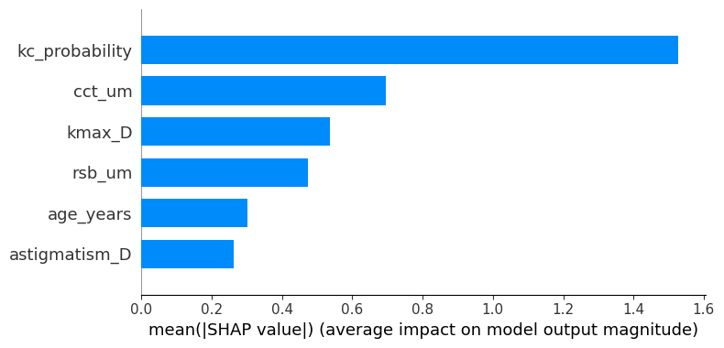
Figure 6.2: Global SHAP feature importance for the refractive surgery decision -support model, showing the average impact of each clinical feature on model predictions.
To complement the global analysis, Figure 6.3 provides a local SHAP explanation for an individual patient case.
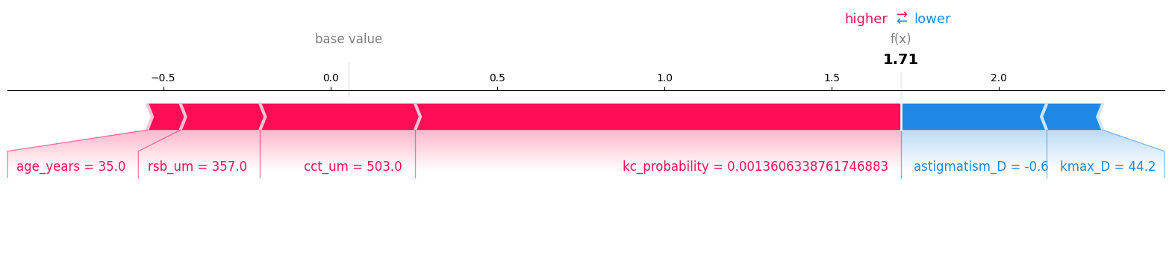
Figure 6.3: Local SHAP explanation for an individual case, illustrating how specific clinical features contribute positively or negatively to the final surgery suitability prediction.
Together, these SHAP analyses confirm that the model’s decision-making process is driven by clinically meaningful factors and remains transparent at both the population and individual levels.
This emphasis on explainability ensures that Eye Surgery Analysis functions not as a black-box predictor, but as a transparent decision-support system suitable for integration into clinical workflows.

6.4 Multi-Class Skin Disease Classification Evaluation

6.4.1 Experimental Setup
Multiple convolutional neural network architectures were evaluated on the HAM10000 dataset, including EfficientNetV2-L, ConvNeXt-Tiny, and MobileNetV3-Large. All models were trained under identical optimization settings to ensure fair comparison. Evaluation focused on Top-1 and Top-3 accuracy, reflecting the clinical relevance of ranked predictions in dermatological screening.

6.4.2 Quantitative Results
EfficientNetV2-L achieved moderate validation performance, indicating sensitivity to dataset size and optimization constraints. ConvNeXt-Tiny demonstrated strong training accuracy but exhibited a noticeable generalization gap, suggesting a higher tendency toward overfitting.
The MobileNetV3-Large model achieved approximately 84% Top-1 validation accuracy and consistently strong Top-3 performance (≈97%), outperforming the other architectures in terms of generalization and deployment efficiency.
Table 6.5 summarizes the comparative results.
Table 6.5 - Comparative Performance of Skin Disease Classification Models
This table reports training and validation performance metrics for EfficientNetV2-L, ConvNeXt-Tiny, and MobileNetV3-Large models, evaluated using Top-1 and Top-3 accuracy to reflect clinically relevant ranked prediction behavior.

Model | Accuracy (%) | Validation Top-1 (%) | Validation Top-3 (%)
EfficientNetV2-L | 64.80 | 48.0 | 71.2
MobileNetV3-Large (Phone-Optimized) | 79.0 | 84.0 | 97.0
ConvNeXt-Tiny | 100.0 | 83.0 | 96.0

6.4.3 Key Findings and Conclusions
This multi-model experimental study demonstrates that effective skin disease classification can be achieved using lightweight deep learning architectures without sacrificing diagnostic performance. While EfficientNetV2-L and ConvNeXt-Tiny provide valuable insights into model capacity and feature representation, MobileNetV3-Large emerges as the most suitable architecture for the proposed HealthLens system due to its superior generalization, efficiency, and mobile readiness.
By combining transfer learning, realistic smartphone-oriented augmentation, and careful model selection, the proposed framework offers a robust and scalable solution for multi-class skin disease classification and establishes a strong foundation for future mobile and clinical deployment.

6.5 Generative Medical Chatbot Evaluation

6.5.1 Baseline Evaluation
The TinyLLaMA-1.1B baseline chatbot was evaluated to assess the feasibility of lightweight generative medical dialogue using parameter-efficient fine-tuning. The model was fine-tuned using LoRA adapters with 4-bit NF4 quantization and trained for two epochs.
Evaluation focused on training convergence and instruction-following behavior. Training loss decreased from 2.57 to 1.60, indicating successful adaptation to medical conversational patterns. While the baseline model demonstrated stable learning behavior, its reasoning depth and safety-aligned response quality remained limited, motivating the exploration of more advanced training strategies.

6.5.2 Curriculum-Based Model Evaluation
The proposed HealthLens Chatbot was evaluated after each phase of the curriculum learning strategy. Performance was assessed using controlled subsets of benchmark datasets to verify progressive capability improvement without catastrophic forgetting.
Final evaluation demonstrated an accuracy of 1.00 on a controlled MedQA evaluation subset (n = 300) and strong performance on PubMedQA (accuracy = 0.80). In addition to quantitative accuracy, the model successfully passed all predefined safety evaluations, including correct emergency escalation behavior and refusal of unsafe or diagnostic medical advice.
Compared to the TinyLLaMA baseline, the curriculum-trained model exhibited substantially improved clinical reasoning, evidence grounding, and safety alignment, confirming the effectiveness of the multi-phase fine-tuning approach.

To consolidate the experimental findings, Table 6.6 presents a comparative summary of the evaluated generative medical chatbot configurations, highlighting differences in model scale, training strategy, parameter efficiency, and final performance outcomes.

Table 6.6 - Comparative Summary of Generative Medical Chatbot Experiments
Exp | Model | Training Strategy | Precision | Trainable Parameters | Dataset(s) | Optimizer | Key Result
E1 | TinyLLaMA-1.1B | LoRA (PEFT), single-stage fine-tuning | 4-bit (NF4) | ~4.38% (50.4M) | ChatDoctor (20k) | Paged AdamW | Final loss = 1.60
E2 | Mistral-7B | Curriculum QLoRA (3 phases) | 4-bit (NF4) | ~0.19% (~13.6M) | MedQA + PubMedQA + Meadow | Paged AdamW + Cosine | MedQA acc = 1.00; PubMedQA acc = 0.80

6.6 Discussion of Results
Across all evaluated modules, the experimental results demonstrate that carefully selected architectures and conservative evaluation strategies yield strong generalization performance while maintaining clinical safety. Lightweight, task-optimized models consistently outperformed larger architectures in deployment-relevant settings. Explainability analyses confirmed that model decisions were grounded in clinically meaningful features.

Chapter 7: Conclusion
This thesis presented HealthLens, a comprehensive AI-powered medical diagnostic ecosystem designed to address the growing demand for accessible, rapid, and intelligent health screening in the domains of dermatology and ophthalmology. By integrating state-of-the-art deep learning (DL) techniques with natural language processing (NLP), the proposed system demonstrates the practical feasibility of deploying artificial intelligence as a supportive tool for early-stage clinical triage and patient-centered healthcare delivery.
The HealthLens platform consolidates multiple diagnostic capabilities within a unified and scalable architecture. These include automated skin lesion classification, general eye disease detection, and a specialized refractive surgery decision support module based on Orbscan corneal topography analysis. This multimodal diagnostic pipeline enables objective and efficient preliminary screening while delivering instant risk assessments directly to users through a mobile-first interface. The incorporation of confidence scores and structured explanations enhances interpretability and transparency, allowing users to better understand AI-generated outcomes prior to seeking professional medical consultation.
A significant contribution of this work lies in the integration of a dedicated Orbscan analysis module that supports early detection of corneal pathologies such as keratoconus and provides data-driven guidance regarding refractive surgery eligibility. This functionality extends beyond conventional image classification by combining ophthalmic imaging with clinical parameters to support informed surgical decision-making. Complementing the imaging-based diagnostics, the interactive AI chatbot serves as a centralized interface for contextual medical guidance, while the integrated specialist directory bridges the gap between automated analysis and real-world clinical care by enabling users to identify and contact relevant healthcare professionals.
From a systems and architectural perspective, HealthLens emphasizes security, scalability, and usability. Robust data protection mechanisms - including token-based authentication and secure API communication - were implemented to safeguard sensitive medical images and personal health information. The user-centric, mobile-first design ensures accessibility for individuals with varying levels of technical proficiency, reinforcing the platform’s suitability for broad public adoption. Overall, the HealthLens ecosystem demonstrates how AI-driven diagnostic assistance can enhance the efficiency, reach, and responsiveness of early-stage medical screening, aligning with the broader digital transformation of modern healthcare systems.

Chapter 8: Future Work
Despite the contributions and validated feasibility of the proposed system, several opportunities remain to further enhance the clinical reliability, functionality, and societal impact of HealthLens.
Future iterations of the platform will extend beyond static image analysis to incorporate real-time video-based diagnostics, enabling continuous assessment of skin lesions and ocular structures from multiple angles. This enhancement has the potential to reduce diagnostic errors associated with lighting variations, image capture instability, and limited viewpoints. To further strengthen clinical trust and adoption, explainable artificial intelligence (XAI) techniques - such as Gradient-weighted Class Activation Mapping (Grad-CAM) - will be integrated to provide intuitive visual explanations of model attention and decision-making processes.
In recognition of connectivity limitations in underserved and remote regions, future work will explore offline diagnostic capabilities through model quantization and edge AI deployment. Lightweight, compressed models running directly on mobile devices would reduce dependence on cloud infrastructure and improve accessibility. Diagnostic accuracy and personalization will also be enhanced through multimodal learning, combining medical images with structured clinical metadata such as patient age, symptom duration, and family medical history within unified neural architectures.
Beyond diagnostic support, HealthLens will evolve toward a more integrated healthcare pathway by incorporating intelligent appointment scheduling synchronized with physicians’ calendars, enabling seamless transitions from AI-based screening to clinical consultation. Support for rare and low-prevalence diseases will be expanded using few-shot and data-efficient learning techniques, increasing the system’s applicability in specialized medical contexts. Furthermore, integration with wearable devices and physiological sensors will enable continuous health monitoring and longitudinal analysis, opening new possibilities for early detection of systemic conditions through combined visual and biometric data.
In summary, while the current implementation of HealthLens validates its technical feasibility and clinical relevance, the outlined future developments position the platform as a robust foundation for next-generation intelligent healthcare systems that are transparent, personalized, scalable, and globally accessible.

References
Abadi, M., Barham, P., Chen, J., Chen, Z., Davis, A., Dean, J., Devin, M., Ghemawat, S., Irving, G., Isard, M., Kudlur, M., Levenberg, J., Monga, R., Moore, S., Murray, D. G., Steiner, B., Tucker, P., Vasudevan, V., Warden, P., & Zheng, X. (2016). TensorFlow: A system for large-scale machine learning. Proceedings of the 12th USENIX Symposium on Operating Systems Design and Implementation (OSDI ’16), 265–283.
Abràmoff, M. D., Lavin, P. T., Birch, M., Shah, N., & Folk, J. C. (2018). Pivotal trial of an autonomous AI-based diagnostic system. NPJ Digital Medicine, 1, Article 39. https://doi.org/10.1038/s41746-018-0040-6
Ada Health GmbH. (2023). AI symptom assessment system. https://ada.com
Aho, A. V., Lam, M. S., Sethi, R., & Ullman, J. D. (2006). Compilers: Principles, techniques, and tools (2nd ed.). Pearson Education.
Akter, M. S., et al. (2023). Multi-class skin cancer classification using deep learning. arXiv. https://arxiv.org/
Alotaibi, A., et al. (2025). Skin cancer detection using transfer learning and attention mechanisms. Diagnostics.
Askell, A., et al. (2021). A general language assistant as a laboratory for alignment. arXiv. https://arxiv.org/abs/2112.00861
Bahdanau, D., Cho, K., & Bengio, Y. (2015). Neural machine translation by jointly learning to align and translate. arXiv preprint arXiv:1409.0473. https://arxiv.org/abs/1409.0473
Baydin, A. G., Pearlmutter, B. A., Radul, A. A., & Siskind, J. M. (2018). Automatic differentiation in machine learning: A survey. Journal of Machine Learning Research, 18, 1–43.
Behara, K., et al. (2024). An improved skin lesion classification using hybrid deep learning models. Diagnostics.
Bierman, G., Abadi, M., & Torgersen, M. (2014). Understanding TypeScript. In R. Jones (Ed.), Proceedings of the European Conference on Object-Oriented Programming (ECOOP) (pp. 257–281). Springer. https://doi.org/10.1007/978-3-662-44202-9_11
Bishop, C. M. (2006). Pattern recognition and machine learning. Springer.
Bondy, J. A., & Murty, U. S. R. (2008). Graph theory. Springer.
Chacon, S., & Straub, B. (2014). Pro Git (2nd ed.). Apress.
Charland, A., & Leroux, B. (2011). Mobile application development: Web vs. native. Communications of the ACM, 54(5), 49–53. https://doi.org/10.1145/1941487.1941504
ClinicalCamel Project. (2023). Open-source medical language model. https://clinicalcamel.github.io
Clark, A. (2024). Pillow documentation. https://pillow.readthedocs.io/
Codd, E. F. (1970). A relational model of data for large shared data banks. Communications of the ACM, 13(6), 377–387. https://doi.org/10.1145/362384.362685
Codd, E. F. (1972). Further normalization of the database relational model. In R. Rustin (Ed.), Data base systems (pp. 33–64). Prentice Hall.
Comer, D. (1979). The ubiquitous B-tree. ACM Computing Surveys, 11(2), 121–137. https://doi.org/10.1145/356770.356776
Crockford, D. (2008). JavaScript: The good parts. O’Reilly Media.
Date, C. J. (2003). An introduction to database systems (8th ed.). Addison-Wesley.
Devlin, J., Chang, M.-W., Lee, K., & Toutanova, K. (2019). BERT: Pre-training of deep bidirectional transformers for language understanding. arXiv preprint arXiv:1810.04805. https://arxiv.org/abs/1810.04805
Dettmers, T., et al. (2023). QLoRA: Efficient finetuning of quantized LLMs. arXiv. https://arxiv.org/abs/2305.14314
Doddi, G. (2022). Eye diseases classification dataset. Kaggle. https://www.kaggle.com/datasets/gunavenkatdoddi/eye-diseases-classification
ECMA International. (2023). ECMAScript® 2023 language specification (ECMA-262). https://www.ecma-international.org/publications-and-standards/standards/ecma-262/
El-Rami, H., et al. (2025). Explainable AI for refractive surgery decision support. Bioengineering, 12(11), Article 1174. https://doi.org/10.3390/bioengineering12111174
Expo. (2024). Expo documentation. https://docs.expo.dev/
Fielding, R. T. (2000). Architectural styles and the design of network-based software architectures (Doctoral dissertation, University of California, Irvine). https://www.ics.uci.edu/~fielding/pubs/dissertation/top.htm
Fielding, R. T., & Taylor, R. N. (2002). Principled design of the modern Web architecture. ACM Transactions on Internet Technology, 2(2), 115–150. https://doi.org/10.1145/514183.514185
Feng, R., et al. (2021). KerNet: A novel deep learning approach for keratoconus and sub-clinical keratoconus detection. IEEE Journal of Biomedical and Health Informatics.
Goodfellow, I., Bengio, Y., & Courville, A. (2016). Deep learning. MIT Press.
Gulshan, V., Peng, L., Coram, M., et al. (2016). Development and validation of a deep learning algorithm for detection of diabetic retinopathy. JAMA, 316(22), 2402–2410. https://doi.org/10.1001/jama.2016.17216
Hornik, K., Stinchcombe, M., & White, H. (1989). Multilayer feedforward networks are universal approximators. Neural Networks, 2(5), 359–366. https://doi.org/10.1016/0893-6080(89)90020-8
Jin, Q., et al. (2019). PubMedQA: A dataset for biomedical research question answering. EMNLP-IJCNLP.
Lazouni, S., et al. (2025). Multimodal keratoconus detection using fused topography and machine-learning features. Investigative Ophthalmology & Visual Science, 66(7). https://iovs.arvojournals.org/
Li, F., et al. (2019). Deep learning-based automated detection of retinal diseases in OCT images. PLOS ONE. https://pmc.ncbi.nlm.nih.gov/articles/PMC6913386/
Manning, C. D., et al. (2008). Introduction to information retrieval. Cambridge University Press.
Martínez-Abad, A., et al. (2019). Machine learning–based keratoconus detection using tomographic corneal parameters. Journal of Ophthalmology.
MedAlpaca Project. (2023). Medical Meadow Flashcards Dataset.
Nori, H., et al. (2023). Capabilities of GPT-4 on medical challenge problems. arXiv. https://arxiv.org/abs/2303.13375
Syta, A., et al. (2025). Machine learning-assisted early detection of keratoconus. Scientific Reports, 15, Article 09694. https://doi.org/10.1038/s41598-025-09694-5
Tschandl, P., Rosendahl, C., & Kittler, H. (2018). The HAM10000 dataset. Scientific Data, 5, 180161.
Vaswani, A., et al. (2017). Attention is all you need. Advances in Neural Information Processing Systems, 30, 5998–6008.
Vieira, J., Mendonça, F., & Morgado-Dias, F. (2025). Deep learning approaches for skin lesion detection. Electronics, 14(14), Article 2785. https://www.mdpi.com/2079-9292/14/14/2785
Wei, J., et al. (2022). Finetuned language models are zero-shot learners. arXiv. https://arxiv.org/abs/2203.02155
Wolf, T., et al. (2020). Transformers: State-of-the-art NLP. EMNLP.
Zhang, Y., et al. (2025). Identification of eye diseases through deep learning. Diagnostics, 15(7), 916. https://doi.org/10.3390/diagnostics15070916

ملخص
تعتمد التطبيقات الصحية الحديثة بشكل متزايد على تقنيات الذكاء الاصطناعي لدعم اتخاذ القرار الطبي؛ إلا أنّ العديد من الأنظمة القائمة تعاني من بنى معمارية جامدة وقابلية محدودة للتوسّع. يقدّم هذا المشروع نظام HealthLens، وهو منصّة رعاية صحية مدعومة بالذكاء الاصطناعي، صُمِّمت لتوفير تحليلات طبية ذكية واستشارات تفاعلية ضمن إطار آمن قائم على التحكم بالوصول وفق الأدوار. يدمج النظام تطبيقًا متنقّلًا متعدد المنصّات مع خلفية مركزية، بما يتيح للمستخدمين الموثَّقين الوصول إلى مجموعة من الخدمات الطبية المعتمدة على الذكاء الاصطناعي، في حين يتولى المدراء إدارة المنصّة عبر لوحة تحكّم خلفية مخصّصة.
يوحِّد النظام أربع وظائف للذكاء الاصطناعي ضمن طبقة خدمات واحدة، تشمل: نظامًا توليديًا للمحادثة الطبية لتقديم الدعم التفاعلي، ووحدة لتصنيف أمراض الجلد اعتمادًا على الصور، ووحدة لتصنيف أمراض العين، ووحدة توصية جراحية قائمة على البيانات تعتمد على التصوير العيني والمعطيات السريرية.
تحقّق وحدة تصنيف أمراض الجلد، المبنية على معمارية MobileNetV3-Large المُحسّنة للعمل على الأجهزة المحمولة، دقّة تحقق من أعلى-1 تقارب 84% ودقّة أعلى-3 تبلغ نحو 97%، بما يعكس قدرة عالية على التعميم في ظل تعزيـزات بيانات واقعية موجّهة لاستخدام الهواتف الذكية.
وتستخدم وحدة تصنيف أمراض العين نموذج EfficientNet-B3 مُعاد الضبط، وتُسجّل قيمة F1 متوسّطة كلية (Macro-averaged) مقدارها 0.961 في تصنيف أمراض الشبكية متعددة الفئات.
أما وحدة الكشف عن القرنية المخروطية، فتعتمد استراتيجية دمج سمات متعددة الوسائط مع أشجار قرار معزَّزة بالتدرّج، وتحقق دقّة تصنيف تقارب 96%، مع تقديم تنبؤات قابلة للتفسير من خلال شروحات قائمة على SHAP.
ويستند روبوت المحادثة الطبي في HealthLens إلى نموذج لغوي قائم على المحوّلات، جرى ضبطه الدقيق باستخدام استراتيجية تعلّم منهجية ثلاثية المراحل تشمل الاستدلال السريري، وإسناد الأدلة، وسلامة المحادثة. وتُظهر التقييمات النهائية دقّة كاملة في مهام الاستدلال المُتحكَّم بها ضمن MedQA، وأداءً قويًا في أسئلة PubMedQA القائمة على الأدلة، مع التزام ثابت بقيود السلامة الطبية.
يفرض نظام HealthLens ضوابط صارمة للتحكم بالوصول وفق الأدوار، وتصميمًا معياريًا للنظام، وآليات آمنة لمعالجة البيانات الطبية بما يضمن القابلية للتوسّع وسهولة الصيانة وقابلية التطوير مستقبلًا. ومن خلال دمج قدرات طبية متعددة مدعومة بالذكاء الاصطناعي ضمن معمارية متماسكة واحدة، يبرهن HealthLens كيف يمكن للأنظمة الصحية الذكية دعم مجالات طبية متنوّعة بكفاءة وقابلية تفسير وملاءمة للتطبيق العملي في دعم القرار السريري.

الجامعة العربية الدولية

الجامعة العربية الدولية AIU جامعة سورية خاصة أُحدثت عام 2005، خططها الدراسية والوثائق الصادرة عنها معتمدة ومصدقة من قبل وزارة التعليم العالي في الجمهورية العربية السورية.

تعمل الجامعة على تحقيق الأهداف الآتية:
- إعداد جيل متميز من الخريجين الجامعيين القادرين على تلبية الحاجات النوعية للمجتمع والنهوض به.
- الإسهام في البحوث العلمية النظرية والتطبيقية التي تخدم أغراض التنمية الوطنية، ويتم العمل على حث الأساتذة والعاملين الأكاديميين على البحث العلمي والمشاركة في المؤتمرات والندوات التي تنظم الأبحاث.
- تحقيق الشراكة مع الجامعات العربية والأجنبية المرموقة بهدف التطوير والتحديث المستمرين للعمل الأكاديمي والقيام ببحوث علمية مشتركة.
- استقطاب الكفاءات الأكاديمية والبحثية المتميزة عن طريق توفير البيئة المناسبة لعملها.
الجامعة العربية الدولية من الجامعات السورية الأولى التي جرى تأسيسها وافتتاحها، وقد تمكنت من اجتذاب الكفاءات التعليمية والبحثية والإدارية المتميزة، لإنشاء صرح متكامل من النواحي الأكاديمية والتنظيمية والإدارية. وتمكنت من تخريج كوادر من المبدعين والمتميزين من خلال توفير بيئة تعليمية ترتكز إلى مقومات نوعية ومادية فريدة منها:
- الخطط الدراسية الحديثة والمتطورة المستندة إلى نظام الساعات المعتمدة.
- الأطر التعليمية المنتقاة بعناية كبيرة.
- المختبرات العلمية الحديثة، ومختبر للمكتبات الإلكترونية.
- المحفزات المادية والمعنوية للطلبة.
- تطبيق طرائق التدريس التفاعلي.
- التوجيه والإرشاد الأكاديمي والتربوي.
- مجموعة كبيرة من اتفاقيات التعاون العلمي مع جامعات محلية وإقليمية ودولية ذات سمعة مرموقة.
- اتفاقيات ومذكرات تفاهم متعددة مع العديد من مؤسسات المجتمع المدني.
- الحرم الجامعي اللائق والمزود بكافة المرافق العلمية والرياضية والترفيهية، والذي نشجعك على زيارته والتعرف على مزاياه.
- الأنشطة والأندية الطلابية بمختلف أنواعها: الرياضية والثقافية والعلمية والاجتماعية.
في الجامعة العربية الدولية سنوات الحياة الجامعية هي وقت للاستثمار في مستقبل الطالب. فالمعارف والخبرات التي يحصلها في قاعة المحاضرات والمختبرات ستساعده في تطوير ذاته، وستمنحه أسباب النجاح في التخصص الذي اختاره، والنشاط الطلابي الذي يمارسه سيساعده في توسيع أفقه، وفعاليات التدريب والأندية والرياضة ستمكنه من تطوير مواهبه، ولربما تساعده في اكتشاف مواهب جديدة.
ليستثمر وقته وذهنه وروحه في جامعتنا كي يجني فوائد عمله والوقت الذي كرسه في السنين القادمة. ونحن سوف نكون بجانب طلبتنا في كل خطوة على دربهم.



الجامعة العربية الدولية
كلية الهندسة المعلوماتية والاتصالات
مشروع التخرج
HealthLens
تم تقديمه إلى
قسم الهندسة المعلوماتية
تقديم
عبدالله الميداني جلال اوسقان
محمد أسامه الخطيب
بإشراف
المهندسة سوزان محمود الدكتور طارق برهوم
كانون الثاني 2026

