
NAME: A. KARTHIK SUBJECT: WEB TECHNOLIGIES
REG.NO: 23BCE20130 SLOT: L2+L3
FACULTY: MONALISA SAHU ASSIGNMENT: WEEK 7

- Develop an HTML5 web page that demonstrates the use of Geolocation API and Drag and Drop API as shown in the sample output below. The web page should contain two sections: Geolocation Section: A button labeled “Get My Location” On clicking the button, retrieve and display the user’s: Latitude and Longitude. Drag and Drop Section: Display an image provide a dashed rectangular drop area labeled “Drop Here” Enable the image to be dragged and dropped into the drop area using HTML5 Drag and Drop events. Apply appropriate HTML and CSS styling to clearly separate both sections as shown.
CODE:
<!DOCTYPE html>
<html lang="en">
<head>
<meta charset="UTF-8">
<title>Geolocation and Drag-Drop Demo</title>
<style>
body {
font-family: Arial, sans-serif;
margin: 20px;
background-color: #f4f4f4;
}

h2 {
margin-bottom: 10px;
}
.section {
background: #ffffff;
padding: 20px;
margin-bottom: 30px;
border-radius: 8px;
box-shadow: 0 0 10px rgba(0,0,0,0.1);
}
button {
padding: 8px 15px;
font-size: 14px;
cursor: pointer;
}
#locationResult {
margin-top: 10px;
font-weight: bold;
}
#dragImage {
width: 400px;
cursor: grab;
margin-bottom: 15px;
}
#dropArea {
width: 400px;
height: 200px;
border: 2px dashed #555;
display: flex;
align-items: center;
justify-content: center;
font-size: 18px;
color: #555;
background-color: #fafafa;
}
.highlight {
border-color: green;
background-color: #e6ffe6;
}
</style>
</head>
<body>
<div class="section">
<h2>1. Geolocation</h2>
<button onclick="getLocation()">Get My Location</button>
<div id="locationResult"></div>
</div>
<div class="section">
<h2>2. Drag and Drop</h2>
<img src="vitap.jpeg"
id="dragImage"
draggable="true"
alt="Sample Image">

<div id="dropArea"
ondrop="drop(event)"
ondragover="allowDrop(event)"
ondragenter="highlight(event)"
ondragleave="removeHighlight(event)">
Drop Here
</div>
</div>
<script>
function getLocation() {
const result = document.getElementById("locationResult");
if (navigator.geolocation) {
navigator.geolocation.getCurrentPosition(
function(position) {
result.innerHTML =
"Latitude: " + position.coords.latitude + "<br>" +
"Longitude: " + position.coords.longitude;
},
function(error) {
result.innerHTML = "Error retrieving location.";
}
);
} else {
result.innerHTML = "Geolocation is not supported by this browser.";
}
}
const image = document.getElementById("dragImage");
const dropArea = document.getElementById("dropArea");
image.addEventListener("dragstart", function(event) {
event.dataTransfer.setData("text", event.target.id);
});
function allowDrop(event) {
event.preventDefault();
}
function highlight(event) {
event.preventDefault();
dropArea.classList.add("highlight");
}
function removeHighlight(event) {
dropArea.classList.remove("highlight");
}
function drop(event) {
event.preventDefault();
const data = event.dataTransfer.getData("text");
const draggedElement = document.getElementById(data);
dropArea.innerHTML = "";
dropArea.appendChild(draggedElement);
dropArea.classList.remove("highlight");
}
</script>
</body>
</html>

OUTPUT:
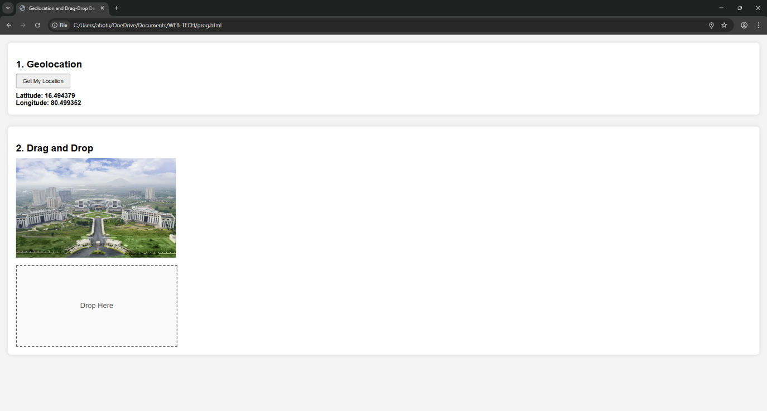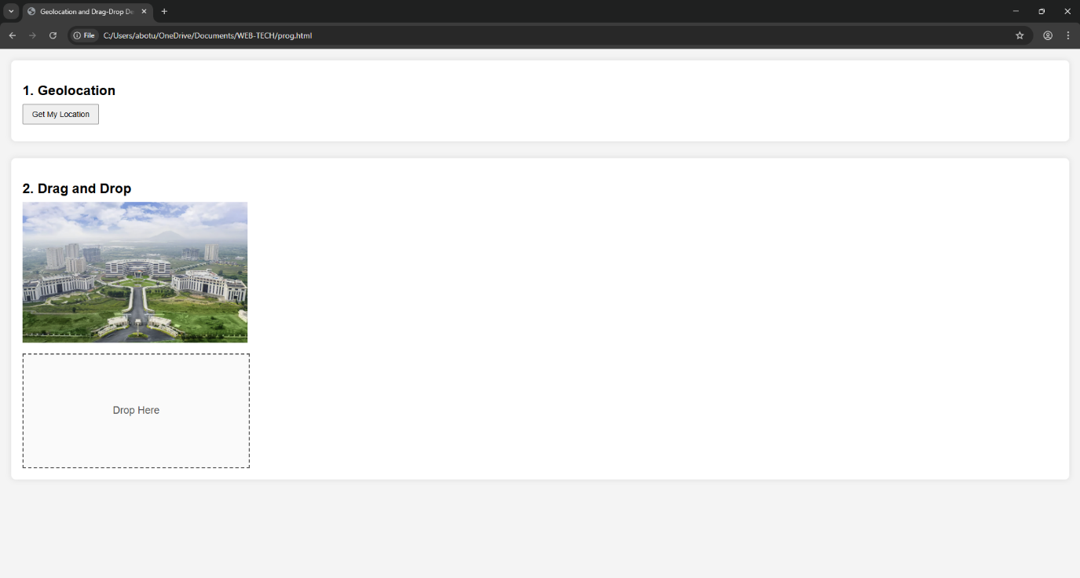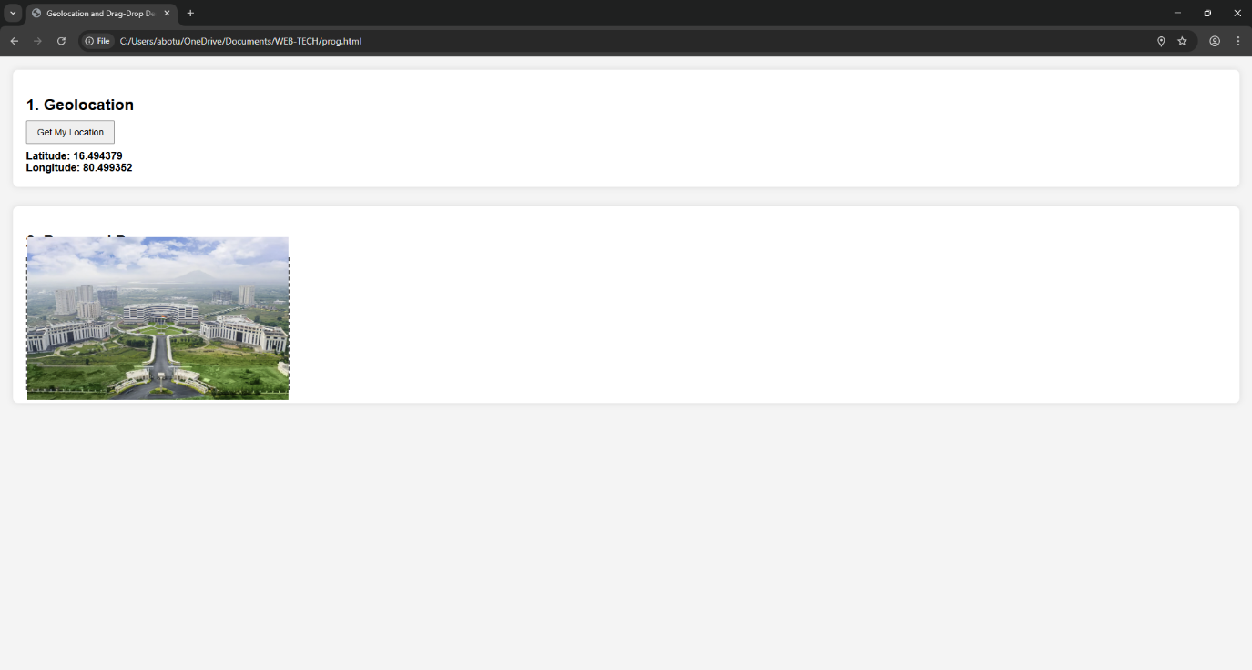

- Develop a Course Enrollment Form using HTML, CSS, and JavaScript with the following requirements:
• Fields:
- Full Name, - Phone Number, - Address, - Gender (Radio Button) - Department (Dropdown)
• Validate using JavaScript:
-Name must not be empty,
- Phone number must contain exactly 10 digits,
- Address must not be empty,
- Gender must be selected,
- Department must be chosen,
- Display error messages near the respective fields
• On successful validation:
- Store the user details in a JavaScript object
- Display the submitted details dynamically below the form
CODE:
<!DOCTYPE html>
<html lang="en">
<head>
<meta charset="UTF-8">
<title>Course Enrollment Form</title>
<style>
body {
font-family: Arial, sans-serif;
background-color: #f4f4f4;
padding: 20px;
}
.container {
background: #fff;
padding: 20px;
width: 450px;
border-radius: 8px;
box-shadow: 0 0 10px rgba(0,0,0,0.1);
}
h2 {
text-align: center;
}
.form-group {
margin-bottom: 15px;
}

label {
display: block;
margin-bottom: 5px;
}
input[type="text"],
textarea,
select {
width: 100%;
padding: 8px;
box-sizing: border-box;
}
.error {
color: red;
font-size: 13px;
}
button {
padding: 8px 15px;
cursor: pointer;
}
#output {
margin-top: 20px;
padding: 15px;
background: #e6f7ff;
border-left: 4px solid #1890ff;
}
</style>
</head>
<body>
<div class="container">
<h2>Course Enrollment Form</h2>
<form id="enrollForm">
<div class="form-group">
<label>Full Name:</label>
<input type="text" id="name">
<div class="error" id="nameError"></div>
</div>
<div class="form-group">
<label>Phone Number:</label>
<input type="text" id="phone">
<div class="error" id="phoneError"></div>
</div>
<div class="form-group">
<label>Address:</label>
<textarea id="address"></textarea>
<div class="error" id="addressError"></div>
</div>
<div class="form-group">
<label>Gender:</label>
<input type="radio" name="gender" value="Male"> Male
<input type="radio" name="gender" value="Female"> Female
<div class="error" id="genderError"></div>
</div>
<div class="form-group">
<label>Department:</label>
<select id="department">
<option value="">-- Select Department --</option>
<option value="Computer Science">Computer Science</option>
<option value="Electronics">Electronics</option>
<option value="Mechanical">Mechanical</option>
<option value="Civil">Civil</option>
</select>
<div class="error" id="departmentError"></div>
</div>
<button type="submit">Submit</button>
</form>
<div id="output"></div>
</div>
<script>
document.getElementById("enrollForm").addEventListener("submit", function(event){
event.preventDefault();
document.querySelectorAll(".error").forEach(e => e.innerHTML = "");
let isValid = true;
let name = document.getElementById("name").value.trim();
let phone = document.getElementById("phone").value.trim();
let address = document.getElementById("address").value.trim();
let department = document.getElementById("department").value;
let genderElement = document.querySelector('input[name="gender"]:checked');
let gender = genderElement ? genderElement.value : "";
if (name === "") {
document.getElementById("nameError").innerHTML = "Name must not be empty";
isValid = false;
}
let phonePattern = /^[0-9]{10}$/;
if (!phonePattern.test(phone)) {
document.getElementById("phoneError").innerHTML = "Phone number must contain exactly 10 digits";
isValid = false;
}
if (address === "") {
document.getElementById("addressError").innerHTML = "Address must not be empty";
isValid = false;
}
if (!gender) {
document.getElementById("genderError").innerHTML = "Please select your gender";
isValid = false;
}
if (department === "") {
document.getElementById("departmentError").innerHTML = "Please choose a department";
isValid = false;
}
if (isValid) {
let student = {
fullName: name,
phoneNumber: phone,
address: address,
gender: gender,
department: department
};
document.getElementById("output").innerHTML = `
<h3>Submitted Details:</h3>
<p><strong>Full Name:</strong> ${student.fullName}</p>
<p><strong>Phone Number:</strong> ${student.phoneNumber}</p>
<p><strong>Address:</strong> ${student.address}</p>
<p><strong>Gender:</strong> ${student.gender}</p>
<p><strong>Department:</strong> ${student.department}</p>
`;
document.getElementById("enrollForm").reset();
}

});
</script>
</body>
</html>

OUTPUT:
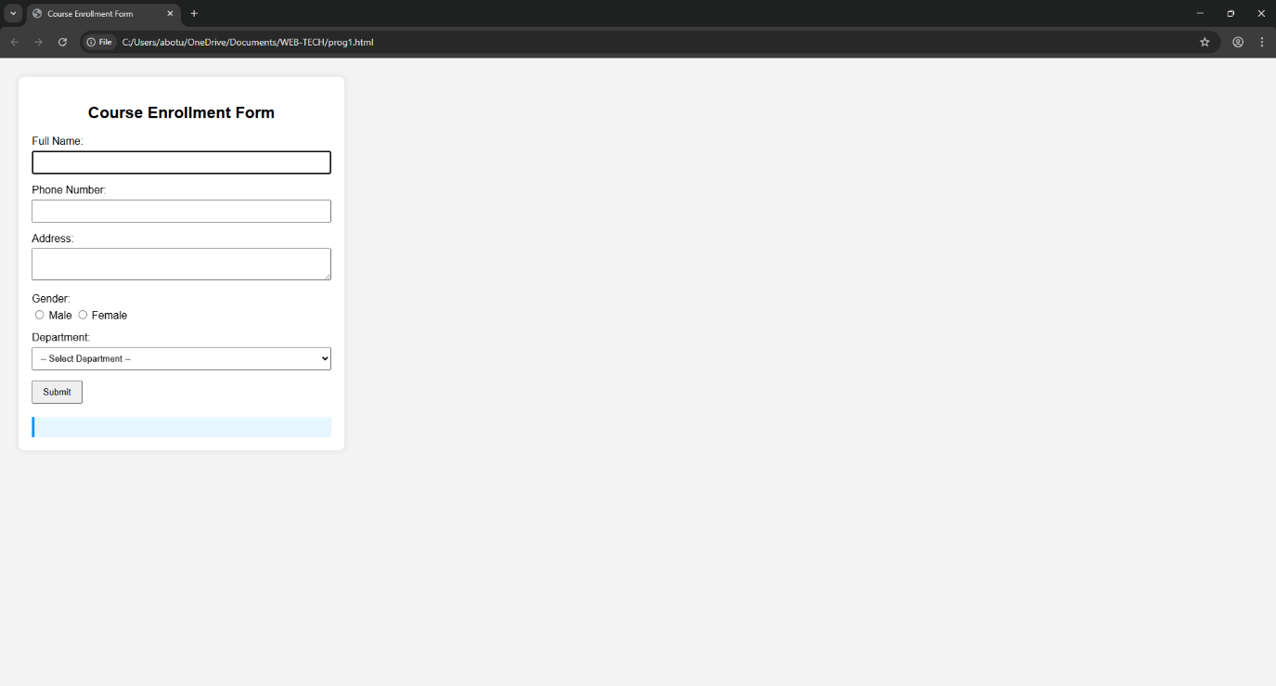
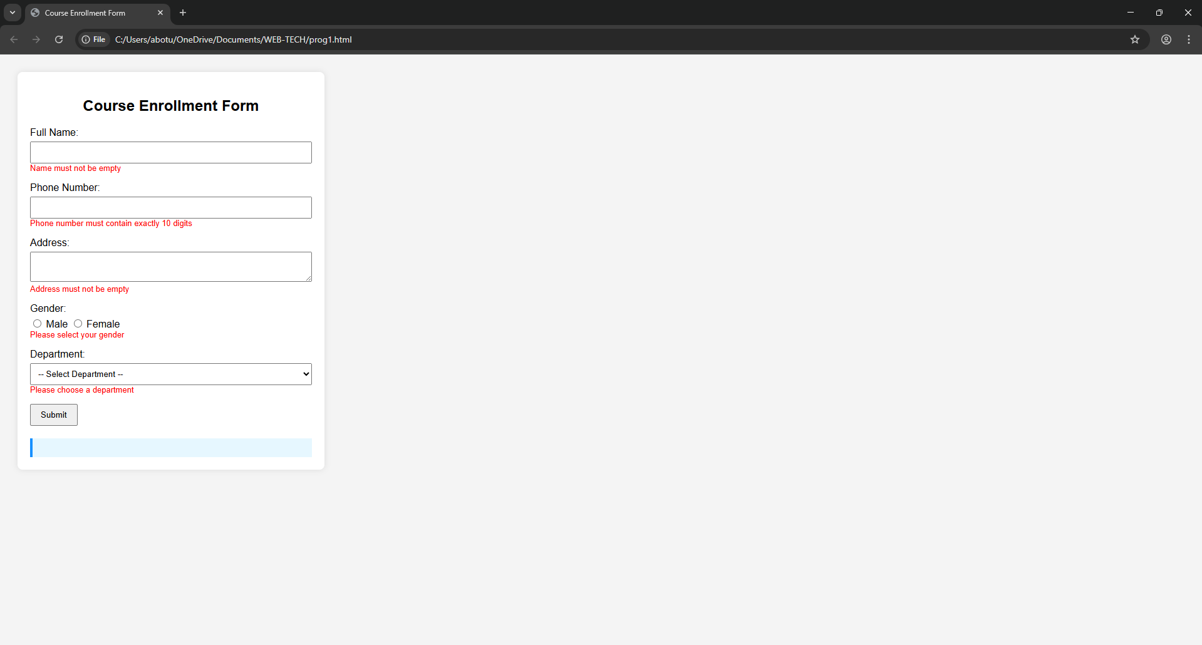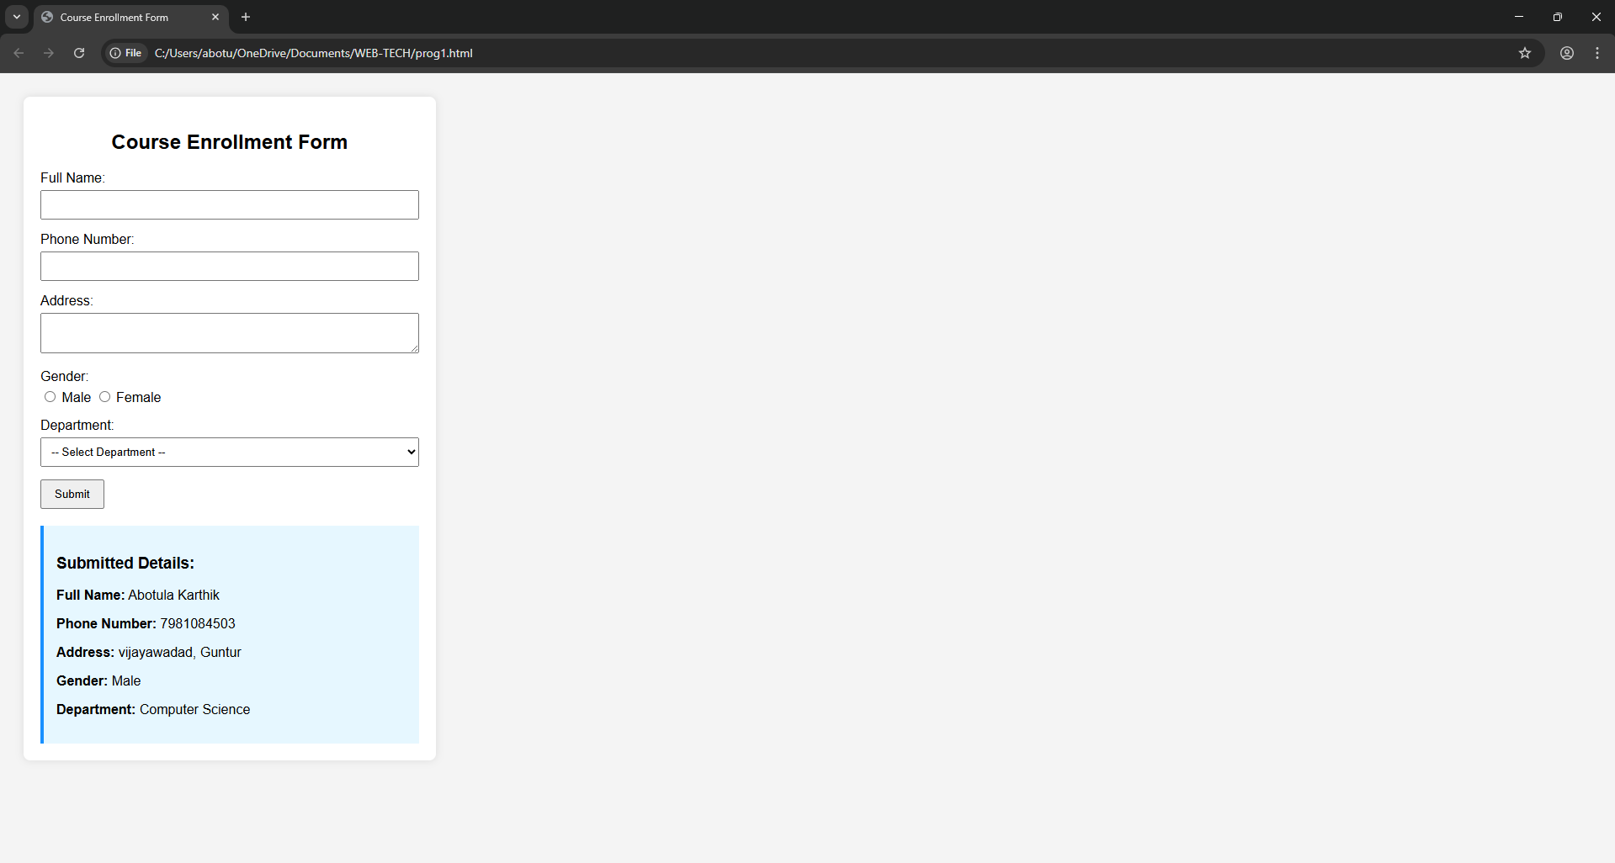

3. A finance company wants a “Loan Interest Calculator” web page. Create a form using HTML and CSS with textboxes for: • Loan Amount (A) • Rate of Interest (R) • Time Period in Years (T) Read the values entered by the user. Write a JavaScript function in an external file that calculates the Total Amount Payable using the formula: 𝑇𝑜𝑡𝑎𝑙 = 𝐴 + 𝐴 × 𝑅 × 𝑇 100 Display the result inside an
tag with: • Light green background • Dark blue text The calculation should happen when the user clicks the “Calculate Total” button.

CODE:
Index.html ---
<!DOCTYPE html>
<html lang="en">
<head>
<meta charset="UTF-8">
<title>Loan Interest Calculator</title>
<link rel="stylesheet" href="style.css">
</head>
<body>
<div class="container">
<h2>Loan Interest Calculator</h2>
<label>Loan Amount (A):</label>
<input type="number" id="amount" placeholder="Enter Loan Amount">
<label>Rate of Interest (R):</label>
<input type="number" id="rate" placeholder="Enter Rate of Interest">
<label>Time Period in Years (T):</label>
<input type="number" id="time" placeholder="Enter Time in Years">
<button onclick="calculateTotal()">Calculate Total</button>
<h3 id="result"></h3>
</div>
<script src="script.js"></script>
</body>
</html>
Style.css ----
body {
font-family: Arial, sans-serif;
background-color: #f4f4f4;
padding: 30px;
}
.container {
width: 400px;
background: #ffffff;
padding: 20px;
border-radius: 8px;
box-shadow: 0 0 10px rgba(0,0,0,0.1);
}
label {
display: block;
margin-top: 10px;
}
input {
width: 100%;
padding: 8px;
margin-top: 5px;
}
button {
margin-top: 15px;
padding: 8px 15px;
cursor: pointer;
}

#result {
margin-top: 20px;
padding: 10px;
background-color: lightgreen; /* Light green background */
color: darkblue; /* Dark blue text */
}

Script.js -----
function calculateTotal() {
let A = parseFloat(document.getElementById("amount").value);
let R = parseFloat(document.getElementById("rate").value);
let T = parseFloat(document.getElementById("time").value);
if (isNaN(A) || isNaN(R) || isNaN(T)) {
document.getElementById("result").innerHTML =
"Please enter valid numeric values!";
return;
}
let total = A + (A * R * T) / 100;
document.getElementById("result").innerHTML =
"Total Amount Payable: " + total.toFixed(2);
}

OUTPUT:
