Blue: Kp: 0.01 Setpoint: 10,000

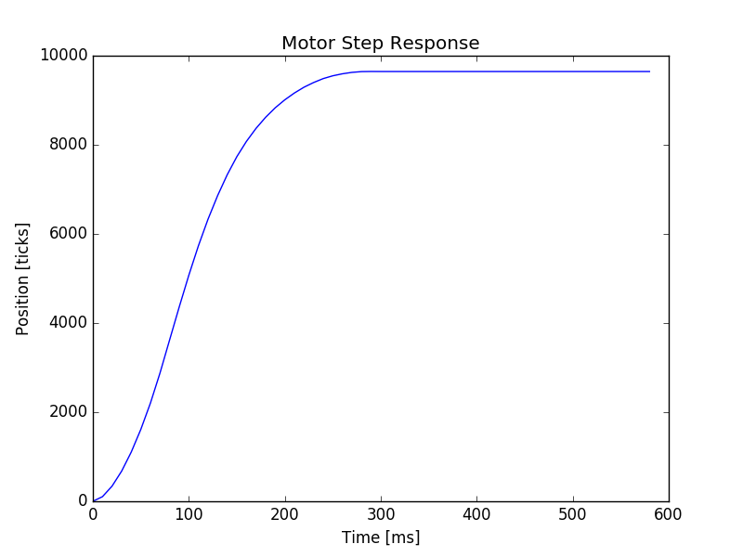
Blue: Kp: 0.1 Setpoint: 10,000

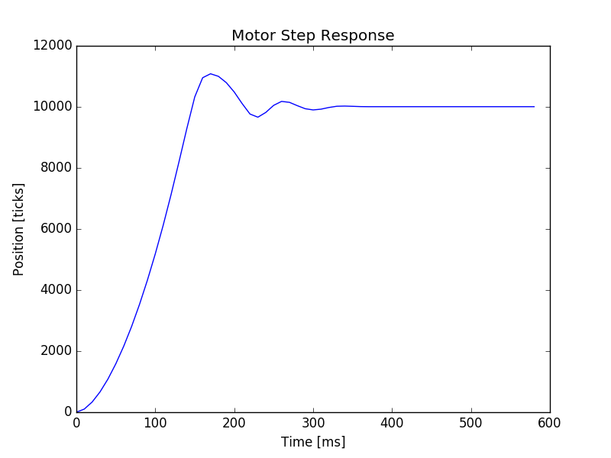
Blue: Kp: 0.05 Setpoint: 10,000

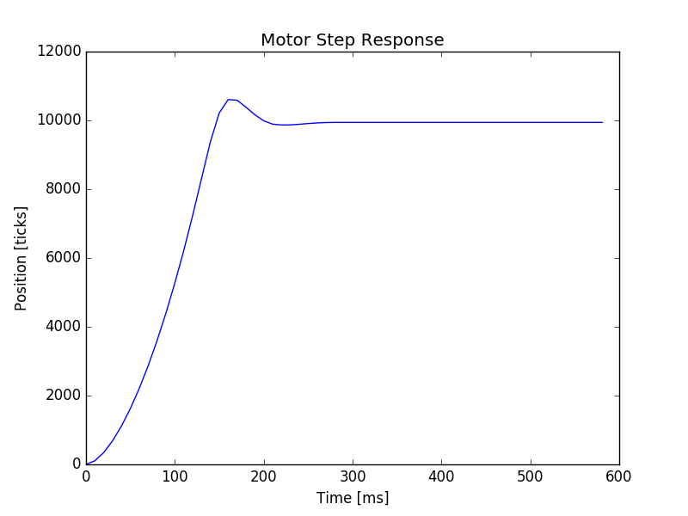

Blue: Kp: 0.03 Setpoint: 10,000

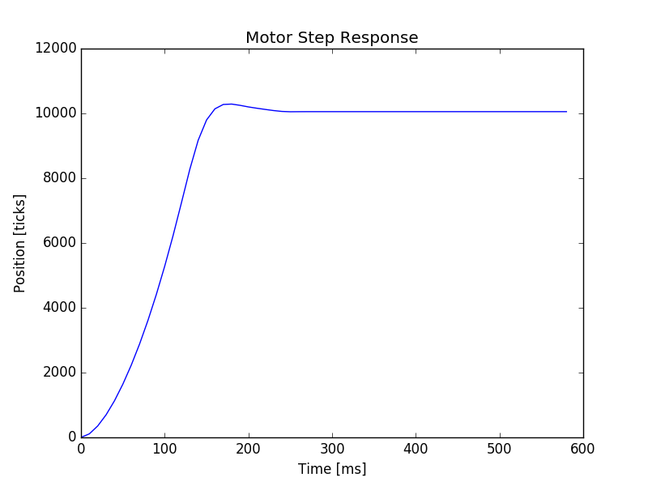
Blue: Kp: 0.02 Setpoint: 10,000

