# Ⅰ PART1

1. **s1.sh**

The script first builds a new directory foo in the current directory (the one contains s1.sh), then creates two files: "name.txt" containing your name; "stno.txt" containing your student number. Finally, it makes a copy of "name.txt" and "stno.txt" in the same directory of foo.

Source code with explaination:

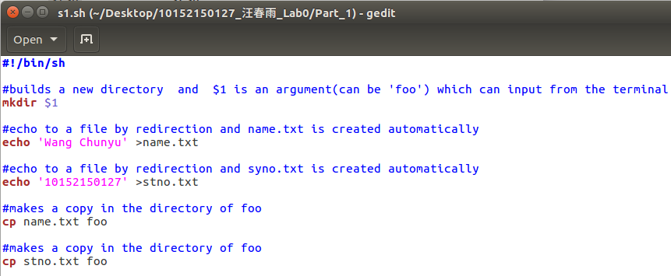

Now we run this shellscript:

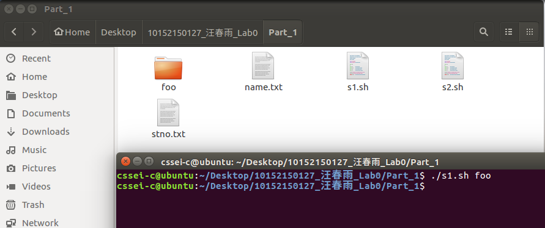

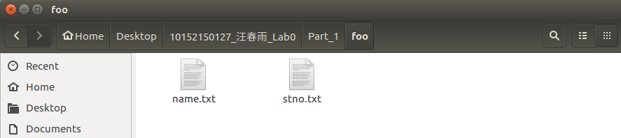

Files and directory have been created.

1. **s2.sh**

It generates a text file output. Each row of output represents a file in directory /bin, and contains three fields which are name, owner and permission of that file. The fields should be separated by white spaces. Furthermore,

* All file names in output should start with letter "b" (other files should be excluded)
* The file output is sorted by the file name field (in order of alphabet, from small to large)
* The file output is read only for other users

Source code with explaination:

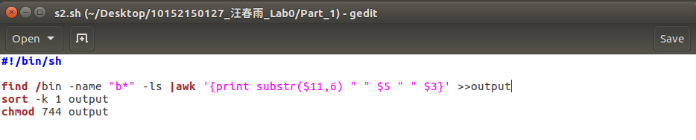

1.Accomplish with pipeline an redirection

2.sorted by the file name field (in order of alphabet, from small to large)

3.only for other users

And used function substr() to delete “/bin/” in the front.

Now we run this shellscript:

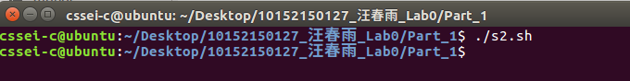

Content in the file ‘output’

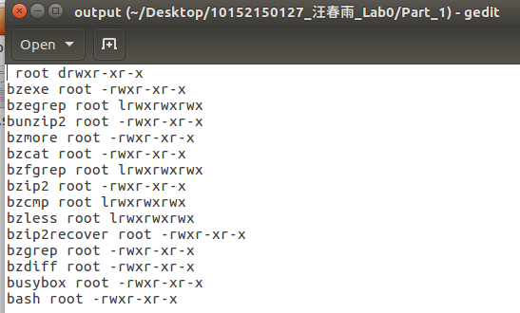

# Ⅱ PART2

We have a C program [set_operation.c](http://ybwu.org/ecnu-oslabs/projects/linux_warmup/src/set_operation.c), which contains several implementation bugs. You will first try to compile/run the program, then detect and correct the bugs using the gdb debugger.

* set_operation.c computes (A−B)∪(B−A)(A−B)∪(B−A), where AA and BB are two sets input by users.
* The algorithm is simple:
  + copy AA to a temporary set A2A2
  + compute A=A−BA=A−B and B=B−A2B=B−A2
  + union AA and BB
* There are two sub-functions: output and check
  + "output" is used to output all elements in a linked list
  + "check" is used to check if an integer belongs to a linked list

We gcc this program and error appears as following:

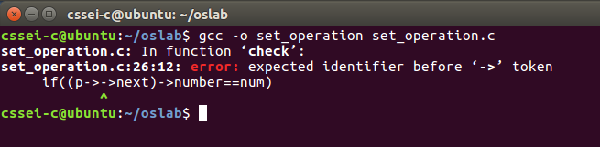

Then we locate line26 and find errors;

So we change this line to ‘if(p->number==num)’

Now we gcc it again and execute it:

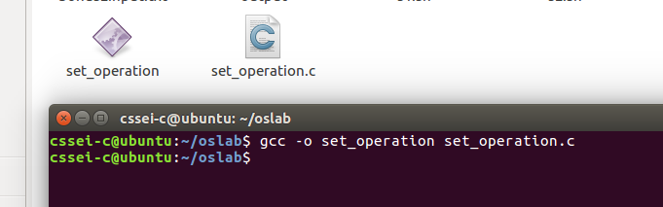

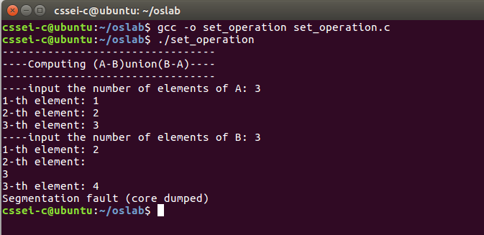

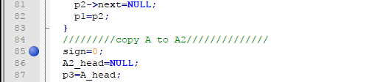

Open gdb

Load executable file

and set a breakpoint at line 85

Then run it

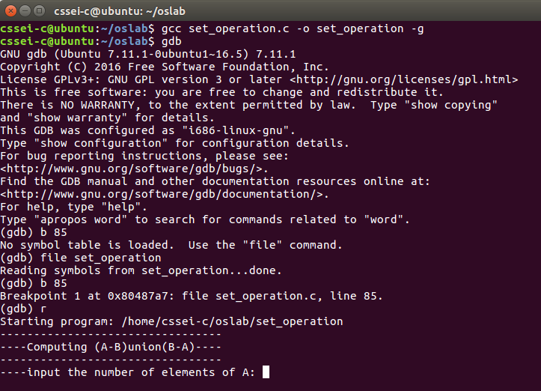

Input some arguments:

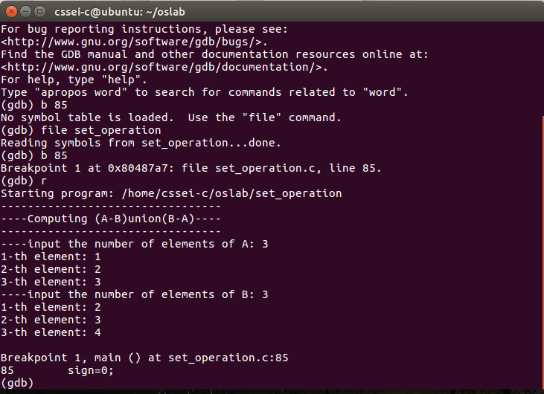

Now we will check set A ans set B if them is all right

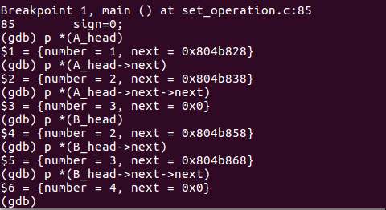

Nothing wrong with sets A and B;

Set another breakpoint at line 104 and continue;

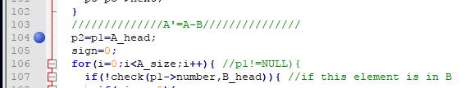

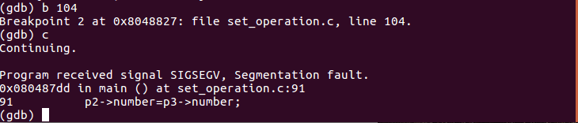

Something wrong in the step “copy A to A2”

We have changes at line 89 ‘for(i=0;i<A_size;i++){‘ (delete “=”)

Set a breakpoint at line 130 and run it again

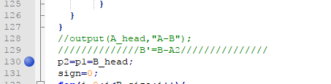

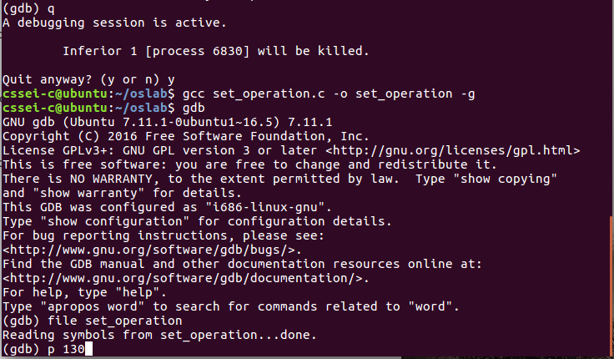

We check set A

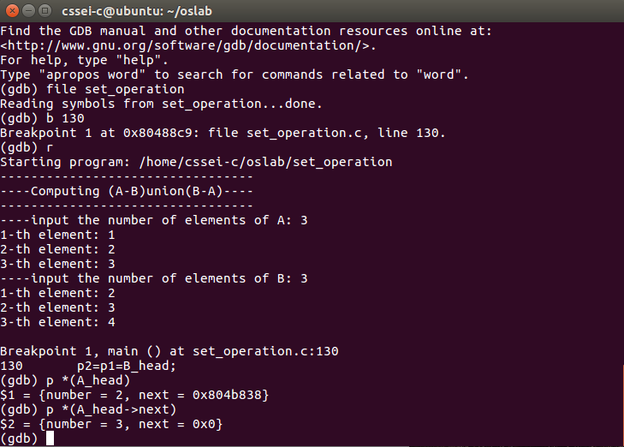

The number show be 1 rather than 2 and 3, it shows opposite result.

Something wrong with IF

We have the changes below at line 107 and 133:

if(check(p1->number,A2_head)){ (delete !)

run it again:

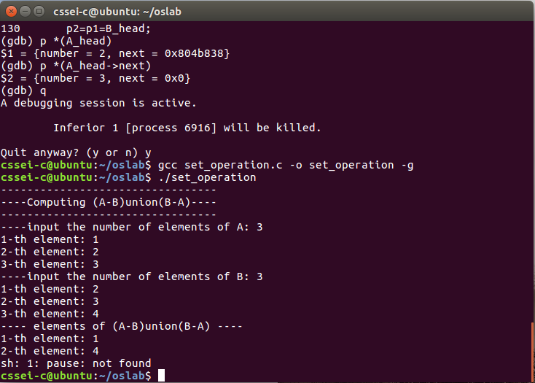

Correct!

**LIST ALL BUGS:**

Line26: if((p->->next)->number==num)

Line89: for(i=0;i<=A_size;i++){

Line107&133: if(!check(p1->number,A2_head)){

**Changes:**

Line26: if(p->number==num)

Line89: for(i=0;i<A_size;i++){

Line107&133: if(check(p1->number,A2_head)){

# Ⅲ BONUS1

Using awk to print the 10th line of a file. For example, assume that a file has the following content

Shellscript:

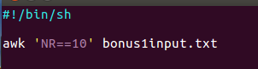

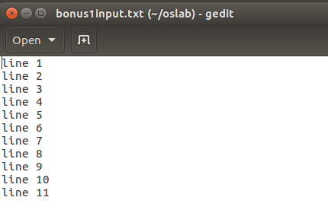

We run this shellscript:

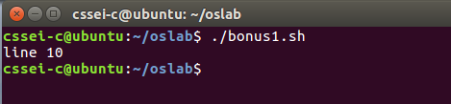

# Ⅳ BONUS2

Given a text file, transpose its content. The file is in "column format", which contains a bunch of rows, each row has a fixed number of columns, and the columns are separated by the '   ' character. For example, if a file has the following content:

Text given in bonus2input.txt:

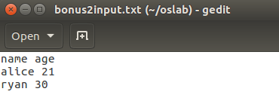

Shellscript :

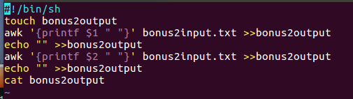

Now we run it:

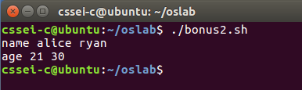

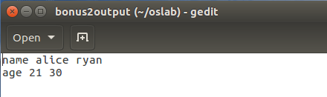

DONE!

END