
AY2025/26 SEMESTER 1: SC2002 Objected-Oriented Design & Programming

Declaration of Original Work for SC2002/CE2002/CZ2002 Assignment

We hereby declare that the attached group assignment has been researched, undertaken, completed, and submitted as a collective effort by the group members listed below.

We have honored the principles of academic integrity and have upheld Student Code of Academic Conduct in the completion of this work.

We understand that if plagiarism is found in the assignment, then lower marks or no marks will be awarded for the assessed work. In addition, disciplinary actions may be taken.

Name | Course  (SC2002/CE2002 CZ2002) | Lab  Group | Signature /Date
Wu Yuexin | SC2002 | SBAC2 | 
Yee Rong Kun | SC2002 | SBAC2 | 
Meng Linghao | SC2002 | SBAC2 | 
Tee Kai Yang | SC2002 | SBAC2 | 

1. Design Considerations
1.1. Overall Design Philosophy
The core design philosophy of this system is one that targets a clean, modular, extensible architecture supporting long-term maintainability while guaranteeing clarity and ease of understanding for developers. This was not only to satisfy some functional requirements for internship management but to build an application exemplifying sound object-oriented design principles and industry-standard software engineering practices. During the course of designing this system, we focused on separation of concerns, well-defined roles for every component, and a focus on what each class and interface should do in the system. Embedded herein is an explicit layering of responsibility. Business entities like Student, CompanyRep, Staff, and Internship constitute the domain model; storage concerns are abstracted by repositories, while service classes encapsulate business workflows; menu classes handle interaction logic but should remain thin-they are just delegates to proper services that implement the business logic. This way, individual components are easy to reason about, test independently, and extend without impacting other parts of the system that do not need the enhancement. Guided by principles such as SOLID, abstraction, and encapsulation, the final design minimizes coupling, maximizes cohesion, and provides broad support for future growth-development of new user roles, new workflows, or any alternative persistence mechanism-with minimal disruption of existing code.

1.2. Object-Oriented Model Principles
1.2.1. Abstraction
Abstraction is applied everywhere to hide internal complexity, only exposing what's absolutely necessary to interact with. Because of the usage of interfaces like IMenu, UserRepository, InternshipRepository, and ApplicationRepository, high-level components depend on simplified behaviours, not on implementation details. For instance, service classes depend on repository interfaces without taking any interest in how data is stored, how to read from a CSV file, or how an ID should be generated; menu classes call service methods without any idea of how validation and error handling are performed, how to execute business rules, and so on. Such separation allows developers to work with clear, stable APIs, while the underlying logic stays safely encapsulated within implementation classes. Thus, abstractions notably reduce cognitive load, make the system easier to grasp, and support a cleaner modular structure that will make it easier to modify over time.
1.2.2. Encapsulation
Encapsulation is rigidly implemented across all model classes: Student, Internship, CompanyRep, and Application. Attributes are declared private; they are accessed only through controlled getter and setter methods to ensure the state of each object cannot be changed at will. Critical state transitions—like the change of status of an application, the visibility toggle for an internship, or confirming a placement—are encapsulated within dedicated methods so that state transitions follow predefined rules. Sensitive information like password data is managed via the PasswordService and never directly exposed, adding to secure data management. This judicious use of encapsulation prevents the accidental misuse of the internals of objects, improves the integrity of the data, and isolates the external use of classes from the changes in internal logic.
1.2.3. Inheritance
Inheritance is used to represent natural hierarchies and to promote code reuse across related components. Core user roles of Student, CompanyRep, and Staff inherit from the abstract User class so that common attributes such as ID, name, and password are shared while each subclass can define behaviour specific to its respective role. The menu classes make use of inheritance, where StudentMenu, CompanyRepMenu, and StaffMenu extend from BaseMenu, which centralizes shared behaviours like password management and input handling. Furthermore, Internship extends Opportunity to share core opportunity-related attributes while allowing further specialization. This inheritance structure reduces duplication, improves logical organization, and makes extensions-such as adding new user roles or even new types of opportunities-much easier.
1.2.4. Polymorphism
Polymorpism is a core method offering flexibility and modular behaviour in the system. In the authentication process, a User reference is always returned regardless if it is a Student, CompanyRep or Staff. This type is then known to the menuFactory to instantiate the right menu, as all menus are manipulated in a consistent manner and rely on the IMenu interface. This allows the system to call the start() method without knowledge on the concrete type of menu. Menus rely on abstractions of the services rather than the concrete service implementations. Therefore, behaviour can be replaced or extended without modifying the calling code. This polymorphism allows dynamic behaviour at runtime, supports the ease of introducing new roles and or features, and keeps the system open for extension, all the while being able to maintain a clean and structured way of interacting between components.

1.3. Design Principles
1.3.1. Single Responsibility Principle
The Single Responsibility Principle was a major driver in system architecture. In early versions, classes like DataManager and all the menu classes had multiple responsibilities-from handling user input to creating objects, validating those objects, filtering, and persisting them. The result was tightly coupled code, with a greater chance of bugs-in particular, duplicated internships when loading the persistence. Responsibilities have, therefore, been distributed in such a way that as many focused components as possible, adhere to SRP. For example, the Menu classes (StudentMenu, CompanyRepMenu, StaffMenu) are responsible only for user interaction and navigation; service classes within services directory encapsulate individual business workflows, such as creating an internship, filtering it, and managing its applications; Repository classes encapsulate CRUD logic and abstract the data layer. Lastly, CsvPersistenceService maintains full responsibility for reading and writing CSV files. As a result of this restructuring, each class has only one reason to change, and maintainability is much better because changes made to the system have less impact.
1.3.2. Open-Closed Principle
According to the Open–Closed Principle, a module is considered open for extension but closed for modification. This is achieved in the system through interfaces, abstract services, and factory implementations. The first way this is achieved is through the user management model. All user types—Student, Staff, and CompanyRep—derive from an abstract User class. Therefore, if a new user type were to be introduced in the future (such as a career coach), only a new subclass would need to be created to extend User. There wouldn’t need to be changes in the current user structure or DataManager logic. The result is that the system can incrementally grow as new user roles emerge, without breaking existing functionality. The second way this principle is implemented in the system is that the menu subsystem is clearly designed for extension. All menus implement the common IMenu interface to allow behaviour interchangeability and share behaviour through BaseMenu as a common base class. If, later on, it is desirable to support a new role or corresponding menu, for instance, CoachMenu, the system can accommodate such an extension without needing to change Main.java, provided this new menu extends BaseMenu. Thirdly, the system anticipates growth in internship-related features by generalizing opportunity types. The Opportunity superclass captures shared attributes—title, description, level, dates—while Internship extends this abstraction with additional fields such as preferred major, company, and slots. If the platform later includes Full-Time Jobs or Part-Time Roles, they can be introduced simply by creating new subclasses of Opportunity. The rest of the system (menus, services, persistence) already depends on the abstract type and therefore requires no modification. Lastly, repository interfaces such as UserRepository, InternshipRepository, and ApplicationRepository abstract data-access functionality. If ever the system migrates from CSV to a relational database, only new repository implementations are needed. The existing business logic and menus remain unchanged, as they depend on abstractions rather than concrete implementations.

1.3.3. Liskov Substitution Principle
The Liskov Substitution Principle asserts that an object of a subclass should seamlessly substitute an object of its superclass without altering the expected behaviour of the program. In our implementation, the Liskov Substitution Principle is upheld primarily through the design of the User hierarchy. Subclasses of User override or extend behaviour without violating parent expectations. Every subclass preserves valid behaviour and does not weaken superclass invariants, ensuring that substituting one user type for another does not cause unexpected runtime behaviour. The system also applies the Liskov Substitution Principle through the inheritance hierarchy of the menu system. BaseMenu encapsulates all common user-interaction utilities, most notably the change password flow, input handling helpers, and a shared Scanner instance. Each concrete menu overrides only the high-level start() method and implements its own role-specific commands. Because all menu classes provide consistent behaviour defined by BaseMenu, any subclass (StudentMenu, StaffMenu, or CompanyRepMenu) can safely be used wherever a BaseMenu reference is expected. For example, the MenuFactory returns a BaseMenu reference, and the caller does not need to know which specific menu type it received. Calling shared operations such as changePasswordFlow() works uniformly across all menus without requiring special handling.
1.3.4. Interface Segregation Principle
The Interface Segregation Principle is applied in the way the system keeps away from huge, generic interfaces and instead defines several small, cohesive ones. In the storage layer, if there was supposed to be one repository with all possible persistence operations, the system defines three role-specific interfaces: UserRepository, InternshipRepository, and ApplicationRepository. Every interface will include only the methods that make sense for its own domain, knowing that classes like DataManager and service layer depend on the operations they actually use. This separation prevents unnecessary coupling, reduces the impact of changes, and makes further expansion easier since new repositories and behaviours can be added without changing these interfaces. Similar segregation is used in the menu subsystem: rather than forcing all menus to implement one huge interface containing many unrelated operations, the system utilizes a minimal interface called IMenu with only one method, start(). What this gives assurance for is that StudentMenu, StaffMenu, CompanyRepMenu, and MainMenu implement only what they strictly need; their other common behaviours, such as password management, were placed in BaseMenu to avoid code duplication. In general, keeping interfaces small, role-specific, and free from unnecessary obligations makes the whole design more modular, easier to extend, and far clearer for developers to maintain.

1.3.5. Dependency Injection Principle
The system consistently uses DIP to ensure high-level components are depending on stable abstractions rather than concrete implementations. One of the most evident examples exists in Main.java, the application entry point: instead of directly instantiating one of the concrete menu classes, like StudentMenu, StaffMenu, or CompanyRepMenu, the system routes all users through the IMenu interface. Depending on the user type, the MenuFactory determines the concrete menu implementation to return, while Main.java interacts only with the IMenu abstraction. This dramatically reduces coupling, as the main driver does not need to know what kind of concrete menu exists or how many roles the system supports. Another clear example of DIP application is found in the data management layer. Rather than binding itself to some specific storage mechanisms, the DataManager collaborates with three repository interfaces, namely, UserRepository, InternshipRepository, and ApplicationRepository. Even though the current implementation uses in-memory repositories, that is, InMemoryUserRepository, InMemoryInternshipRepository, and InMemoryApplicationRepository, respectively, the DataManager interacts strictly through the interfaces. This means that the underlying storage strategy can be replaced by CSV-based repositories, a relational database, or even a remote API without needing any modification in the business logic or service layer. Regardless of how the data is persisted, the high-level workflow remains intact.

2. Class & Sequence Diagram
Please check Class Diagram and Sequence Diagram in the Diagrams folder.

3. Additional Functionalities
In addition to providing only the basic functionality for internship management, there are many enhancements that were added to the system to aid its usability, real-world accuracy, and robustness. The main enhancement to its functionality is the data persistence subsystem which allows the storing of accounts, internships, and applications across instances of the program. Instead of storing data in memory, the system reads and writes information via 3 CSV files: users.csv, internships.csv, and applications.csv. The persistence layer manages the reconstruction of relationships such as student application to the internship created by the company at time of program launch and the confirmed placement. This restores the application to where it was left, maintaining integrity of the overall data. This allows the platform to function as a real-world system where user progress and administrator actions are not lost when the application exits. Secondly, a role-based menu was constructed; it offers a different menu to each user type focusing on their respective duties. These menus are appropriately backed up by an overly documented service layer that allows for a standard separation of core business logic and presentation layer logic.

4. Reflection
4.1 Difficulties Faced
One major challenge was how to structure the menus, services, and data management logic so that they remained cohesive and modular. In the original system, all responsibilities were placed inside a single Menu class and an increasingly large DataManager. As the application grew, these files had become hard to maintain because of bloated logic and strong coupling. It was necessary to carry out careful planning for refactoring the system with assurance that existing functionality would be preserved. We should break down the code into smaller components while avoiding a situation in which regressions were introduced without violating the SOLID principles. Another difficulty encountered was designing the service layer and repository abstractions. Initially, too much of the behaviour was strongly coupled to implementation details, as in how one would go about loading CSV files or generating IDs. During refactoring, we often faced situations where, if we moved the logic to services or into the repository, there were either circular dependencies appearing or inconsistent behaviour, such as internship duplication or mismatched state restoration. All these were improved after multiple iterations with detailed debugging and several rethinks about how responsibilities should be distributed. Being compatible with the already implemented menus and logic—without rewriting the whole system—added even more pressure and demanded a very deliberate, step-by-step decomposition strategy.
4.2 How These Challenges Were Overcome
To address these issues, we adopted a layered, decomposition-first approach. Firstly, we extracted common menu behaviours into BaseMenu; this reduced duplications across Student, Staff, and Company Representative menus. Then, we extracted the business logic into small single-purpose service classes that allowed menus to serve purely as orchestrators rather than holders of application logic. For data management, we introduced repository interfaces such as UserRepository, InternshipRepository, and ApplicationRepository, and we provided in-memory implementations that separate persistence from the business rules. In this way, DataManager can delegate to the repositories while still exposing the same public API to the rest of the application, hence preserving backward compatibility. We also introduced extensive testing via runtime verification of internship IDs, created internship lists, and application flows that make sure the system would remain consistent after restructuring. The ability to chunk the work, undertaking small, controlled, refactoring steps, and validating behaviour at every opportunity enabled us to gradually converge to a cleaner and more maintainable architecture without losing any existing functionality.
4.3 Knowledge Learned
The project gave us hands-on experiences with applying object-oriented design principles like abstraction, encapsulation, inheritance, and polymorphism in real-world systems. The process really underscored how SOLID contributes to both maintainable and extensible software. As examples, application of the Single Responsibility Principle influenced us to extract individual workflows into dedicated service classes, and Dependency Inversion created the impetus to introduce repositories and interface-based design. We also learned design techniques, such as designing for extension over modification, extending new user roles, or menu types via the IMenu and MenuFactory without changes. This project also enhanced our technical awareness of specific language features in Java, like interface-driven design, organizing code into packages, refactoring techniques, and using CSV for persistence. Building custom persistence, as well as consistently reconstructing state, offered rich experience in solving real-world problems about data integrity. As a result of this project, our appreciation for clean architecture, modularity, and the way patterns are able to reduce complexity over time grew significantly.
4.4 Further Improvement
Future work can be spent continuing to improve the user experience and automating more processes within the system. For example, one option would be to substitute the existing CSV persistence layer with either a relational database or ORM-based technology to reduce manual parsing logic and allow for the scalability of the solution. As part of improving user experience and automation, it may be useful to implement automated emails or notifications (e.g., notifying students when their application status has changed, or notifying companies when an applicant's deadline is approaching) that will help facilitate the student's experience with the system. For example, such features could incorporate the Observer pattern so that interested parties could subscribe for notifications on internships or applications. Furthermore, having the ability to implement role-based dashboards with summarized statistics, will significantly help make quick decisions without having to search through the system. Examples include pending applications, internship visibility status, or bottlenecks in approvals. Also, the usage of stronger mechanisms for validation and error handling will enhance robustness. In the future, the system could also support testing frameworks like JUnit to support regression testing and ensure that any future refactoring does not face the difficulties faced initially.
4.5 Overall Insights
This project showed how early architectural decisions are crucial for future maintainability. Our experience provided confidence that tightly coupled designs become difficult to extend very quickly, while small cohesive classes, which are supported by well-defined interfaces can develop with significantly less friction. The journey of refactoring also reinforced the principle of incremental changes, continuous testing and clear separation of concerns. By applying good design practices and exploiting OO concepts effectively, we achieved a system that is not only functionally complete but also modular, extensible, and structurally sound-quality features that will be very valuable for subsequent projects.

Project Link
The project can be accessed here: https://github.com/Aboyang/InternshipHub.git

Appendix – Result for Test Cases
No. | Test Cases | Expected Behaviour | Output Screenshot
1 | Valid User Login | User should be able to access their dashboard based on their roles | 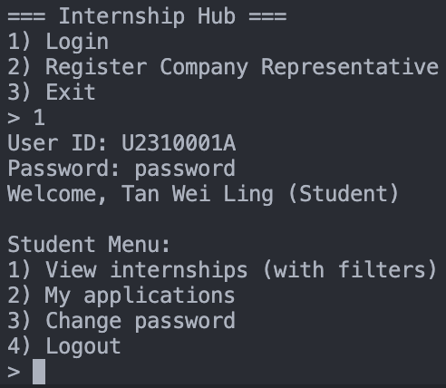
2/3 | Invalid ID / Incorrect Password | User receives a notification about incorrect ID / System should deny access and alert the user to incorrect password | 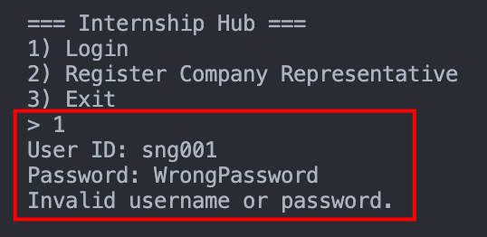
4 | Password Change Functionality | System updates password, prompt re-login and allows login with new credentials | 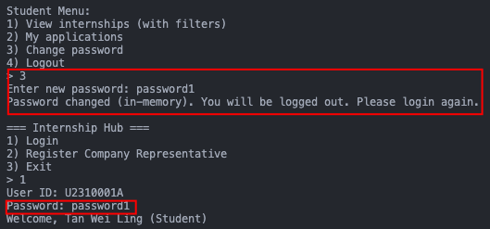
5 | Company Representative Account Creation | A new Company Representative should only be able to log in to their account after it has been approved by a Career Center Staff | Step 1: Company Rep register account  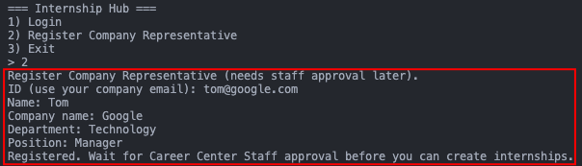  Step 2: Staff Approve  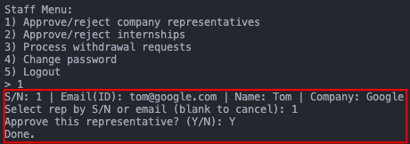  Step 3: Company Rep can log in now  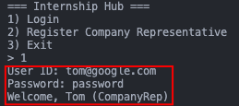
6 | Internship Opportunity Visibility Based on User Profile and Toggle | Internship opportunities are visible to students based on their year of study, major, internship level eligibility, and the visibility setting | Step 1: Company Rep create a CS internship opportunity  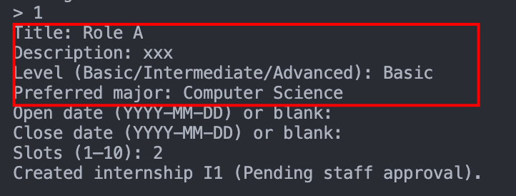  Step 2: Staff approve internship (The internship becomes visible)  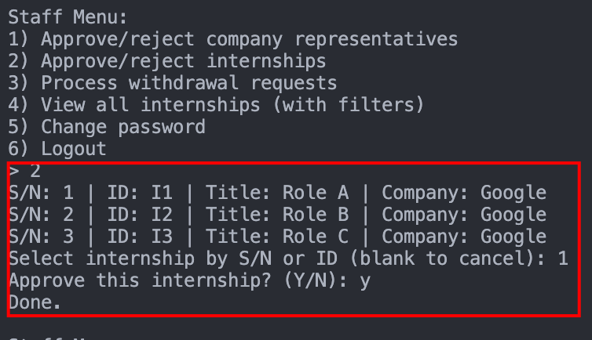  Step 3: Log in as a Y1 CS Student Can see the internship  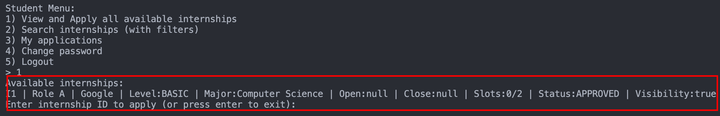  Step 4: Log in as a Y2 Data Science Student Cannot see the internship  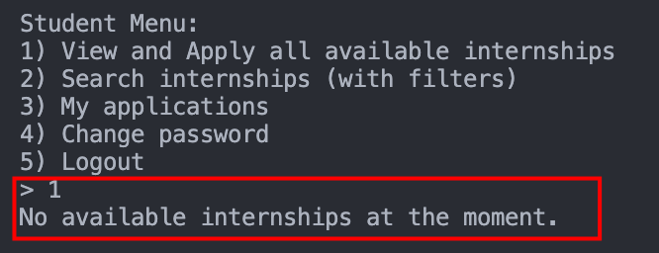  Step 5: Company Rep to turn off the visibility  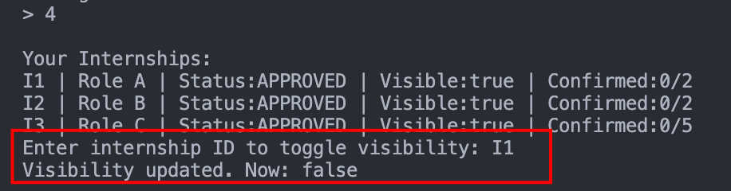  Step 6: Log in as a Y1 CS Student Cannot see the internship
7 | Internship Application Eligibility | Students can only apply for internship opportunities relevant to their profile (correct major preference, appropriate level for their year of study) and when visibility is on | Same as test case 6, since students can only view and apply the list of internship opportunities relevant to their profile and when visibility is on, they can only apply for these internship opportunities. Under
8 | Viewing Application Status after Visibility Toggle Off | Students continue to have access to their application details regardless of internship opportunities’ visibility. | Step 1: Apply for internship  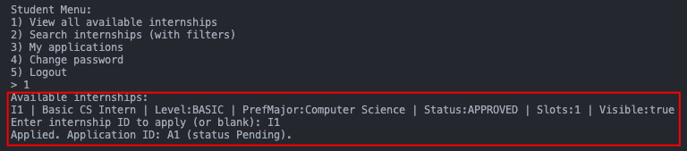  Step 2: Company Rep turn off the visibility  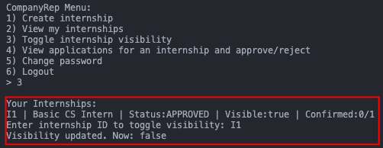  Step 3: Verify student can still see his application  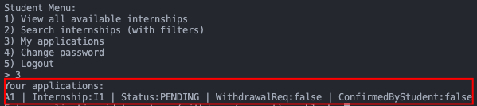
10 | Single Internship Placement Acceptance per Student | System allows accepting one internship placement and automatically withdraws all other applications once a placement is accepted | Step 1: Student applies for 3 internships  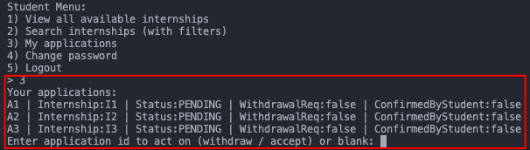  Step 2: Company Rep approve application  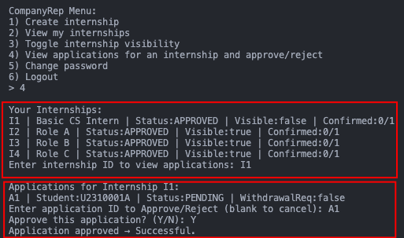  Step 3: Student accept the offer  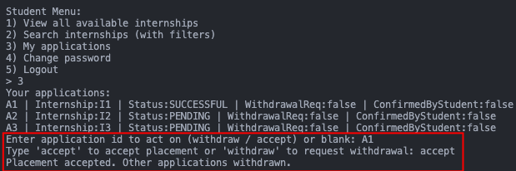  Step 4: Verify other offers are unsuccessful and can only be withdrawn, not accepted  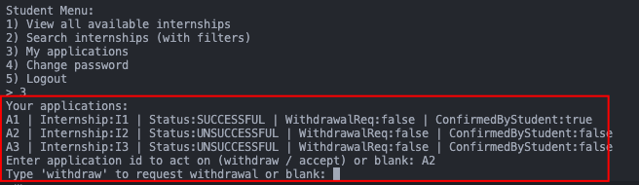
13 | Company Representative Internship Opportunity Creation | System allows Company Representatives to create internship opportunities only when they meet system requirements | Test Invalid Input: Missing Title, Invalid Slots (>10), Reach Max 5 Internship  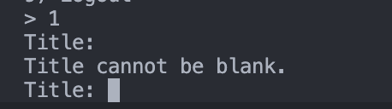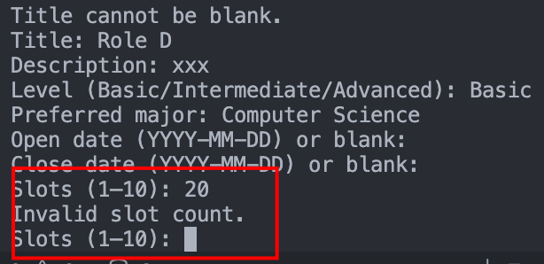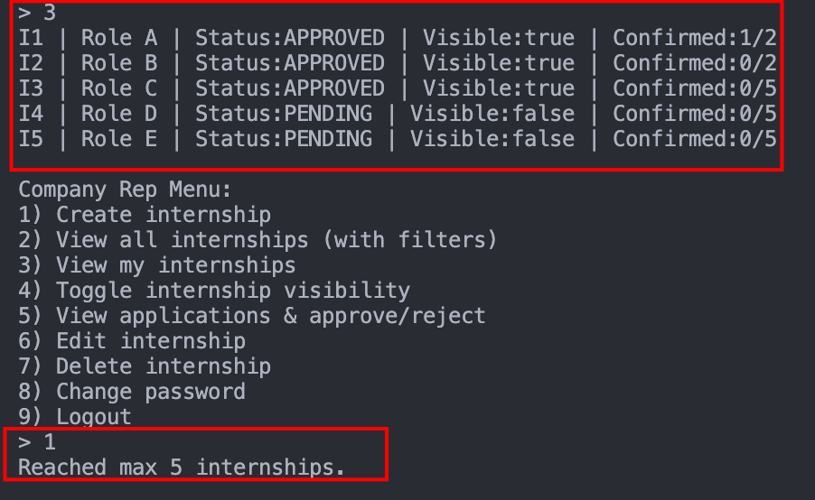
14 | Internship Opportunity Approval Status | Company Representatives can view pending, approved, or rejected status updates for their submitted opportunities | 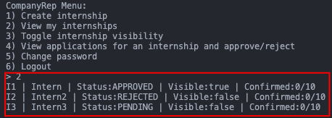
15 | Internship Detail Access for Company Representative | Company Representatives can always access full details of internship opportunities they created, regardless of visibility setting | Company Rep can see both visible and invisible internship.
16 | Restriction on Editing Approved Opportunities | Edit functionality is restricted for Company Representatives once internship opportunities are approved by Career Center Staff | 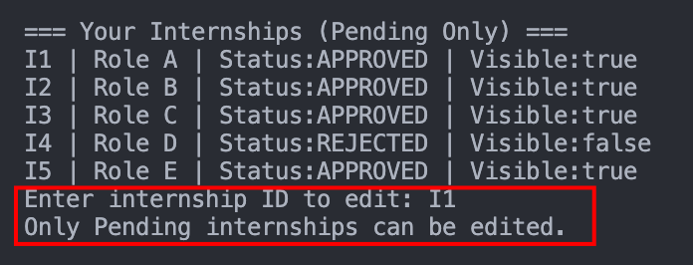
18 | Student Application Management and Placement Confirmation | Company Representatives retrieve correct student applications, update slot availability accurately, and correctly confirm placement details | Step 1: Student applied for internship  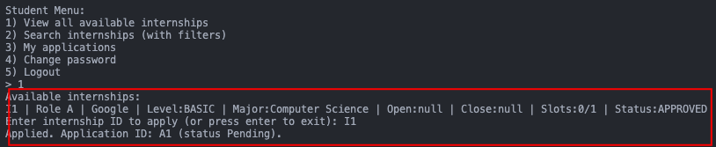  Step 2: Company Rep approve the application  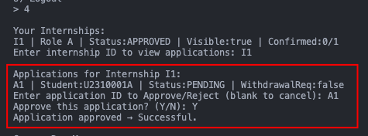  Step 3: Student accept the offer  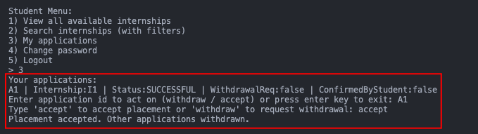  Step 4: Company Rep check updated placement details  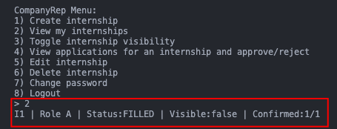
19 | Internship Placement Confirmation Status Update | Placement confirmation status is updated to reflect the actual confirmation condition | Status and confirmation details reflected correctly under student’s account  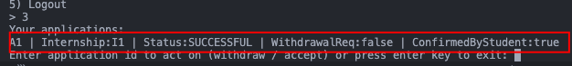
20 | Create, Edit, and Delete Internship Opportunity Listings | Company Representatives should be able to add new opportunities, modify existing opportunity details (before approval by Career Center Staff), and remove opportunities from the system | Create Internship / Edit Internship / Delete internship  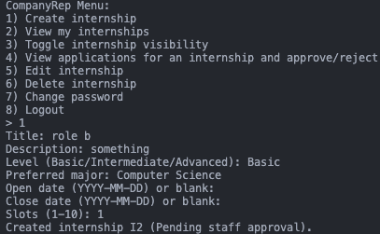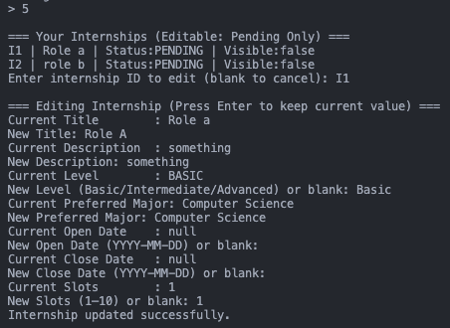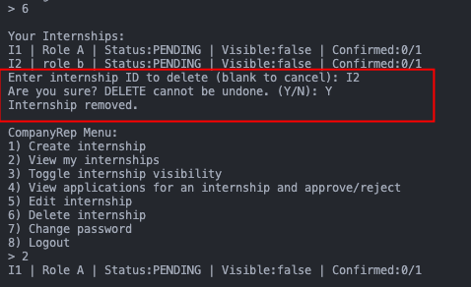
21 | Career Center Staff Internship Opportunity Approval | Career Center Staff can review and approve/reject internship opportunities | Refer to Test Case 6 Step 2
22 | Toggle Internship Opportunity Visibility | Changes in visibility should be reflected accurately in the internship opportunity list visible to students | Before turning off visibility, student applies for the internship  After Company Rep turns off visibility, student can see the change under “My Application”  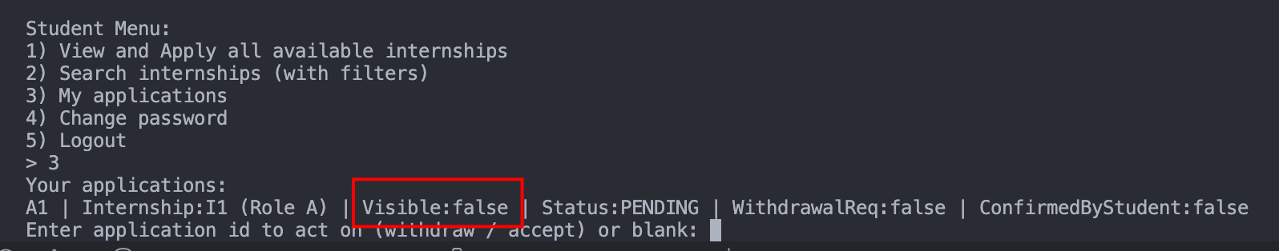
23 | Career Center Staff Internship Opportunity Management | Withdrawal approvals and rejections are processed correctly, with system updates to reflect the decision and slot availability changes | Test 1: Company rejects student application  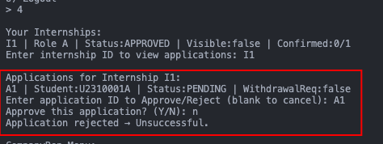  Test 2: Company approves:  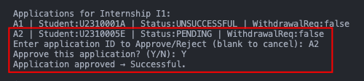  But student withdraws:  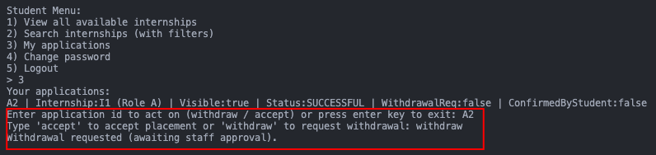  Company Rep see the withdrawal request:  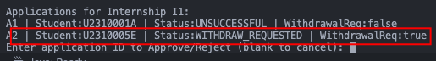  Staff approve the withdrawal request:  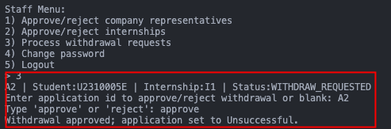  Company Rep sees the application status updated to Unsuccessful:  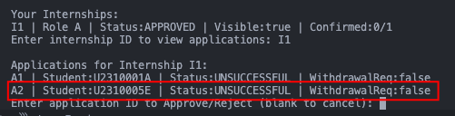
24 | Generate and Filter Internship Opportunities | Accurate report generation with options to filter by placement status, major, company, level, and other specified categories | Step 1: Created and approved 5 internship:  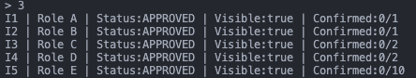  Step 2: Company Rep filter  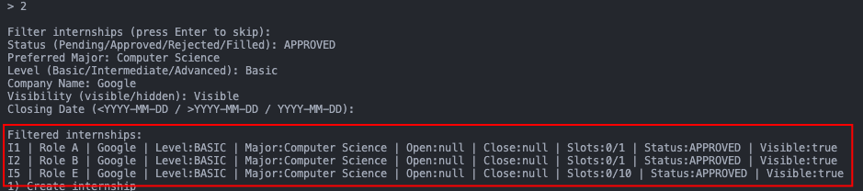  Step 3: Student filter:  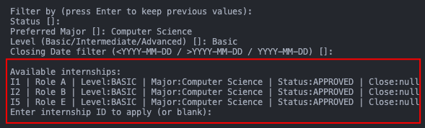  Step 4: Staff filter:  