Sohaib Sohail (28994)
GP screenshots.
Syscall output:
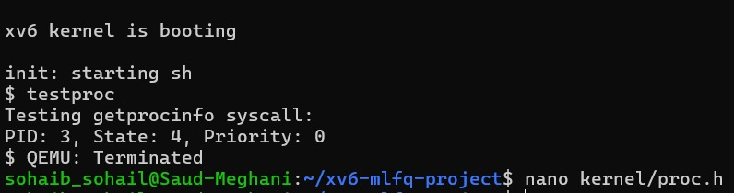
Demo outputs:
GetProcInfo:

CPU BOUND:
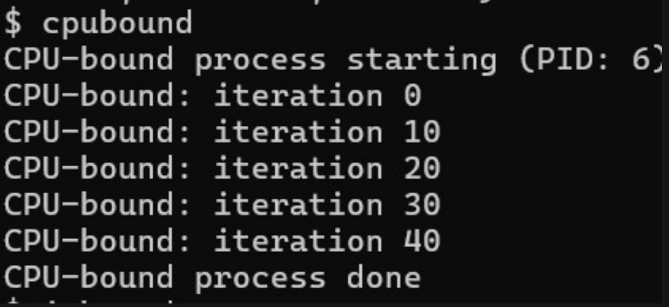

IO BOUND:
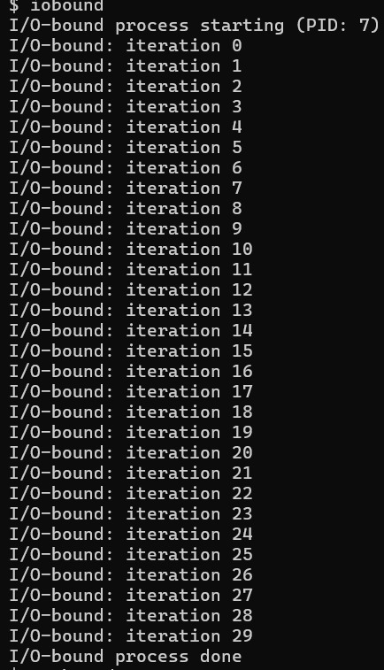
All together (mlfqtest):
