**Chicken Invaders Code Explanation**

**Tools:**

I used the **Turtle** Library to make this game. **turtle** is a pre-installed Python library that enables users to create pictures and shapes by providing them with a virtual canvas. The onscreen pen that you use for drawing is called the **turtle** and this is what gives the library its name.

**STEPS:**

**Step 1: Importing the turtle module that is used to make the game and setting up some variables. (Line 1-16)**

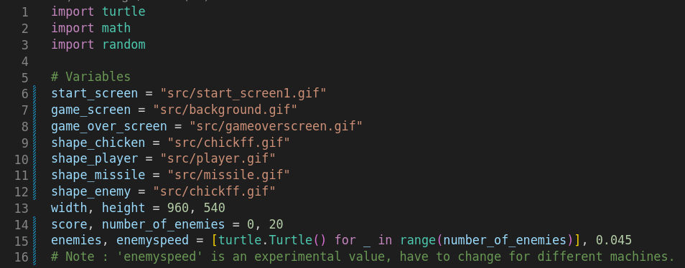

**Step 2: Game window and player setup (Line 19-40)**

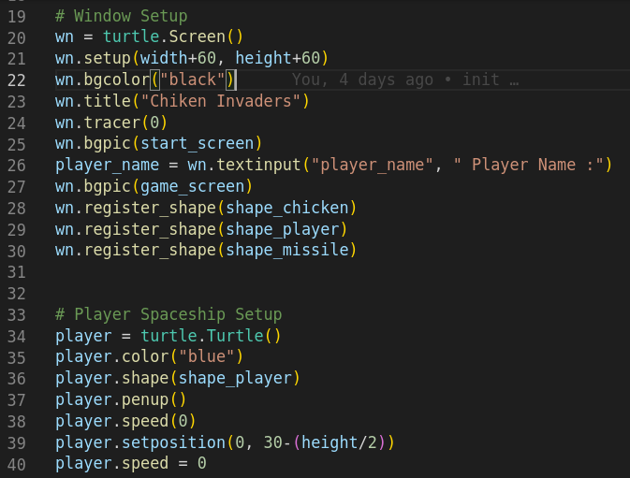

**Step 3: Creating the bullet for player, and setting up enemies in random position on screen (Line 42-61)**

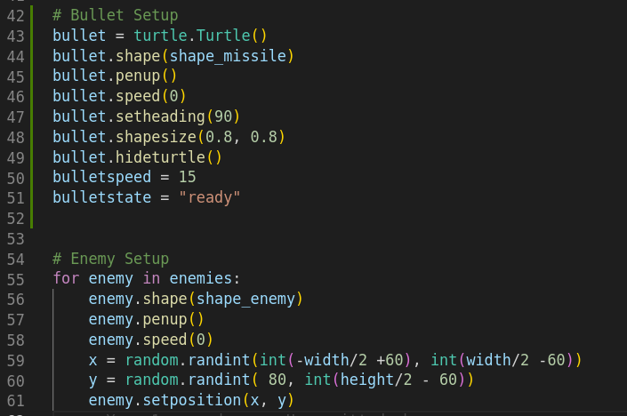

**Step 4: Defining functions to update the score and move the player to right and left. (Line 66-88)**

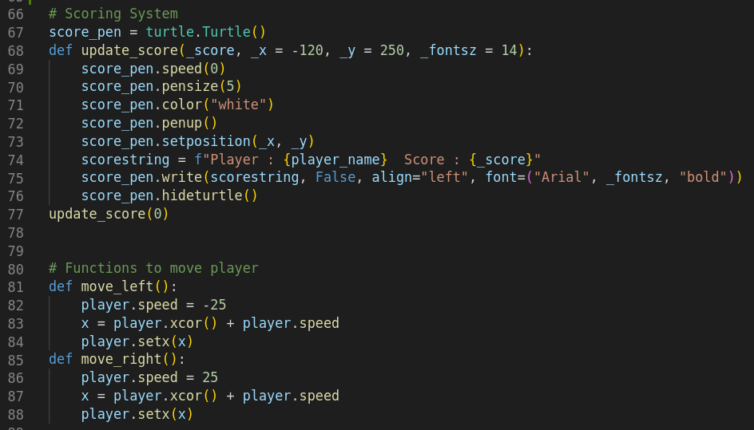

**Step 5: Defining a function to fire bullets, and another function to check collision between any two objects (Bullet vs Enemy or Enemy vs Player). Finally setting up keyboard bindings for moving players and firing bullets. (Line 91-111)**

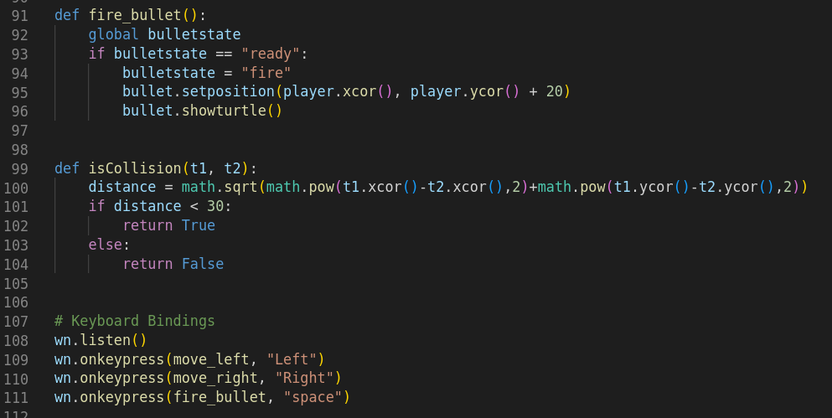

**Step 6: Main Game Loop. First, we update the bullet if** **it is firing or reset if it goes out of screen. Then, we update the enemy's position. If any enemy hits a wall, move every enemy down 50 pixels, and increase their speed a bit. (Line 114-144)**

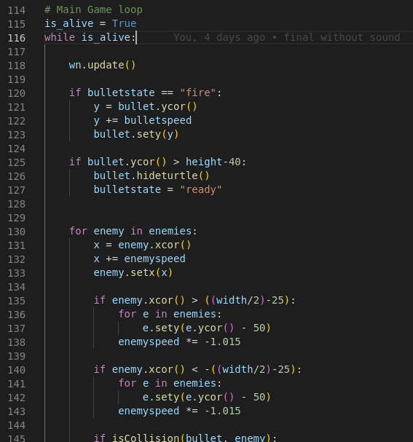

**Step 7: For each enemy, check for collision with enemy and player****. In the first case, we relocate the enemy and increase the score. In the case of the latter, we end the game and show a game over screen with scores. (Line 114-170)**

