Approval Anomaly at ClearCheck Technologies
Analysis of technician approval-timing patterns for the negligence review
Prepared for company administrators and counsel | Team submission, BDA-640

1. Executive Summary
ClearCheck Technologies pays three licensed technicians -- Gary Arnold, Juan Mendez, and Matt Shawn -- per approved case. Administrators suspect some technicians may be approving cases without adequate review, and an attorney is weighing a class-action negligence claim. We analyzed 64,230 approval timestamps across 15 non-continuous monthly extracts (Feb 2019 - Sep 2021) covering all three technicians.
Key findings:
- The gap between consecutive approvals is extremely right-skewed for all three technicians (skewness 12-158): most approvals happen within seconds of the previous one, punctuated by long gaps between work sessions.
- Median time between approvals is 4.0 sec for Arnold, 29.0 sec for Mendez, and 6.0 sec for Shawn -- all far below any of the four industry standards tested (1, 2, 5, 10 minutes).
- The mean-based one-sample t-tests, as specified by the case, do NOT reject the null hypothesis that average duration meets the standards for most technician/standard pairs, because a small number of very long inter-session gaps inflate the mean and its variance. This is a critical, non-obvious result: the literal test the case asks for is not powerful enough to detect the pattern the median-based evidence shows clearly.
- The 'batch approval' defense is only partly supported by the data. Technicians do work in blocks (runs of approvals under 10 minutes apart) -- but the median time spent per case *inside* a block is still well under a minute for all three (Arnold ~11s, Mendez ~40s, Shawn ~24s), which leaves very little room for genuine per-case review if that review happened only at the moment of approval.
- Only Gary Arnold's data spans the June 2020 payout change ($50 -> $17); Mendez's and Shawn's extracts are entirely from 2019. For Arnold, the mean-based t-test shows no significant change (p=0.94), but a distribution-free Mann-Whitney test shows a highly significant shift toward FASTER approvals after the pay cut (p<0.0001) -- the median duration dropped from 5 seconds to 4 seconds.
- What the data cannot show: whether any pre-review occurred off-system before an approval was clicked, the quality of any review that did occur, or how many cases were rejected (only approvals are recorded). Timestamps are evidence of approval speed, not proof of negligence on their own.

2. Data and Methodology
The dataset consists of 15 Excel extracts (one per technician per month on file), each with a case number, an approval timestamp, and the technician's name. Files used inconsistent column names and, in a few cases, mixed data types; these were normalized before analysis. Only approved cases are recorded -- there is no information on rejected cases, and no record of what a technician did between two consecutive approvals.
Important coverage gap: the 15 extracts do not form a continuous 15-month window for every technician. Gary Arnold has files from Feb-Nov 2019 and Jan-Sep 2021; Juan Mendez has files from Feb-Nov 2019 only; Matt Shawn has a single file from Feb 2019. As a result, only Arnold's data can be used for the pre/post payout-change comparison -- this is a limitation of the extracts provided, not a finding about Mendez or Shawn.
Definitions used throughout this report:
- Duration: the time in seconds between an approval and the immediately preceding approval by the same technician. The very first approval on file for each technician has no duration and is excluded from duration statistics.
- Block: a run of consecutive approvals by the same technician where every gap to the prior case is under 10 minutes. A new block starts whenever a gap is >= 10 minutes (or at a technician's first approval on file).
- Within-block gap: the duration for a case that continues an existing block. This excludes each block's opening case, whose 'duration' actually reflects the (often long) gap since the end of the previous session, not review time within the current one.

3. How Long Is a Review? Distribution of Approval Durations
For each technician we derived the duration of every approval (gap since the previous approval) and examined its distribution, including the share of approvals under five speed thresholds.
Technician | N | Mean | Median | Skewness | % < 2s | % < 5s | % < 10s | % < 30s | % < 60s
Gary Arnold | 42,645 | 32.8 min | 4.0 sec | 157.7 | 5.0% | 53.0% | 77.2% | 86.6% | 91.6%
Juan Mendez | 17,468 | 24.9 min | 29.0 sec | 131.6 | 0.2% | 1.2% | 5.2% | 50.5% | 80.2%
Matt Shawn | 4,114 | 9.6 min | 6.0 sec | 11.9 | 0.9% | 11.0% | 66.4% | 80.4% | 87.3%

All three distributions are strongly right-skewed (skewness far above the 0 expected for a symmetric distribution): a large mass of very fast approvals, plus a long tail of multi-hour and multi-day gaps between work sessions. This means the arithmetic mean is not a reliable summary on its own -- the median and the threshold percentages below tell the more meaningful story.
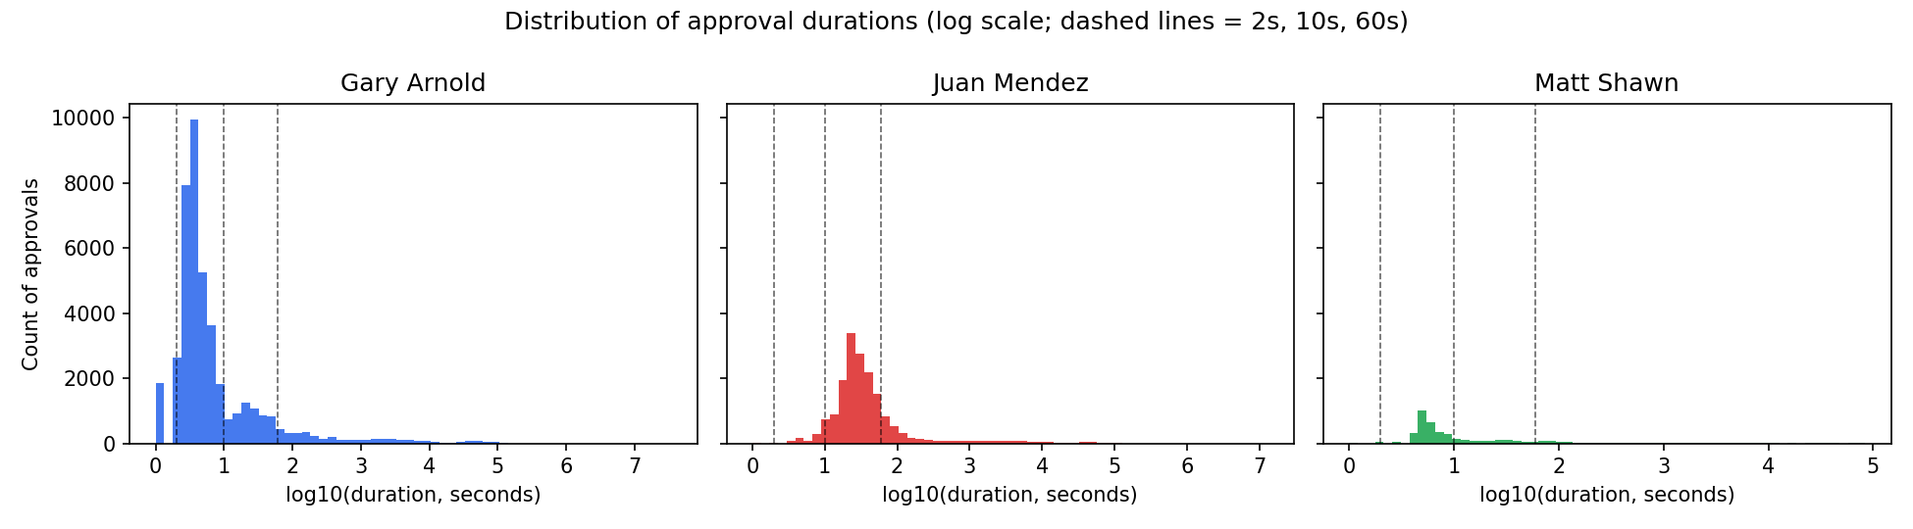
Figure 1. Approval-duration histograms (log10 scale) by technician.
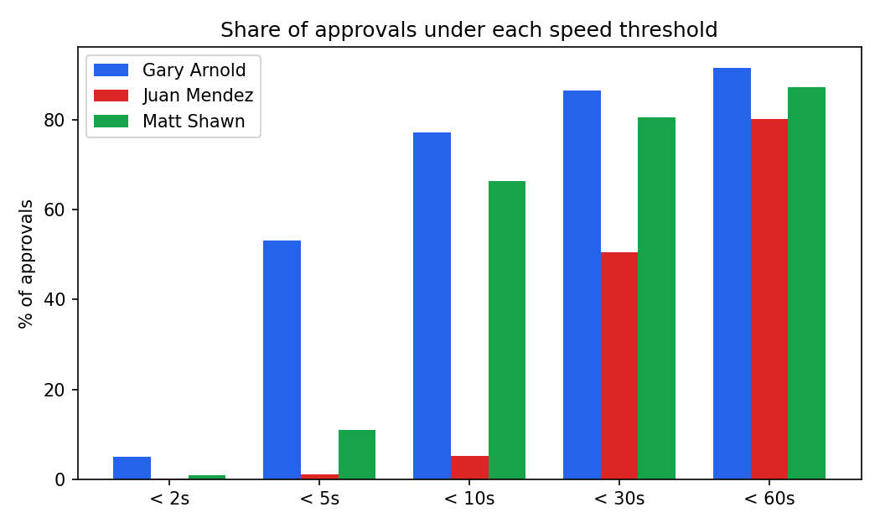
Figure 2. Share of approvals under each speed threshold, by technician.
Gary Arnold has the highest share of very fast approvals (about 5% under 2 seconds and over half under 5 seconds); Juan Mendez's approvals skew slower (about half fall between 10 and 60 seconds); Matt Shawn sits between the two. For all three, roughly 80-92% of approvals occur within 60 seconds of the prior one.

4. Do They Meet the Standard? One-Sample T-Tests
We tested, for each technician, whether mean review duration meets four industry-suggested minimums (10, 5, 2, and 1 minute) using a one-sample t-test (H0: mean duration = standard; a technician failing the standard would have a mean significantly BELOW it).
Technician | Standard (min) | Sample Mean | t-stat | p (one-sided) | Meets Standard? | Sig. Below?
Gary Arnold | 10 | 32.8 min | 1.48 | 0.9302 | Yes | No
Gary Arnold | 5 | 32.8 min | 1.80 | 0.9642 | Yes | No
Gary Arnold | 2 | 32.8 min | 2.00 | 0.9770 | Yes | No
Gary Arnold | 1 | 32.8 min | 2.06 | 0.9803 | Yes | No
Juan Mendez | 10 | 24.9 min | 1.18 | 0.8807 | Yes | No
Juan Mendez | 5 | 24.9 min | 1.57 | 0.9421 | Yes | No
Juan Mendez | 2 | 24.9 min | 1.81 | 0.9648 | Yes | No
Juan Mendez | 1 | 24.9 min | 1.89 | 0.9705 | Yes | No
Matt Shawn | 10 | 9.6 min | -0.35 | 0.3641 | No | No
Matt Shawn | 5 | 9.6 min | 3.78 | 0.9999 | Yes | No
Matt Shawn | 2 | 9.6 min | 6.25 | 1.0000 | Yes | No
Matt Shawn | 1 | 9.6 min | 7.08 | 1.0000 | Yes | No

As specified, these tests use the raw duration series (which includes the multi-hour and multi-day off-shift gaps discussed above). Because of the extreme skew and the huge variance those outliers introduce, the mean-based test has very little power here: sample means (driven up by rare enormous gaps) sit at or above every standard for Arnold and Mendez, so the tests fail to detect a significant shortfall despite median durations of just a few seconds. Only Matt Shawn's mean falls below two of the four standards with statistical significance (5-minute and shorter standards).
Caution for the reader: "meets standard" in this table is a statement about the average of ALL inter-approval gaps, most of which are off-shift breaks, not about typical review speed. Section 3's threshold percentages and Section 5's within-block figures are the more direct evidence of how quickly cases are actually being approved back-to-back.

5. Is the Batch Defense True? Block-Based Analysis
Technicians say fast approvals reflect a real practice: pre-reviewing several cases, then approving them together. We define a block as a run of approvals with gaps under 10 minutes and treat each block as one review session.
Technician | Blocks | Avg Cases/Block | Median Cases/Block | Avg Sec/Case (in block) | Median Sec/Case (in block) | % Blocks <2s/case | % Blocks <5s/case
Gary Arnold | 1,556 | 27.4 | 11.0 | 20.3 sec | 11.0 sec | 0.3% | 13.0%
Juan Mendez | 1,075 | 16.3 | 6.0 | 57.3 sec | 39.9 sec | 0.0% | 0.0%
Matt Shawn | 176 | 23.4 | 8.0 | 42.3 sec | 23.9 sec | 0.0% | 0.0%

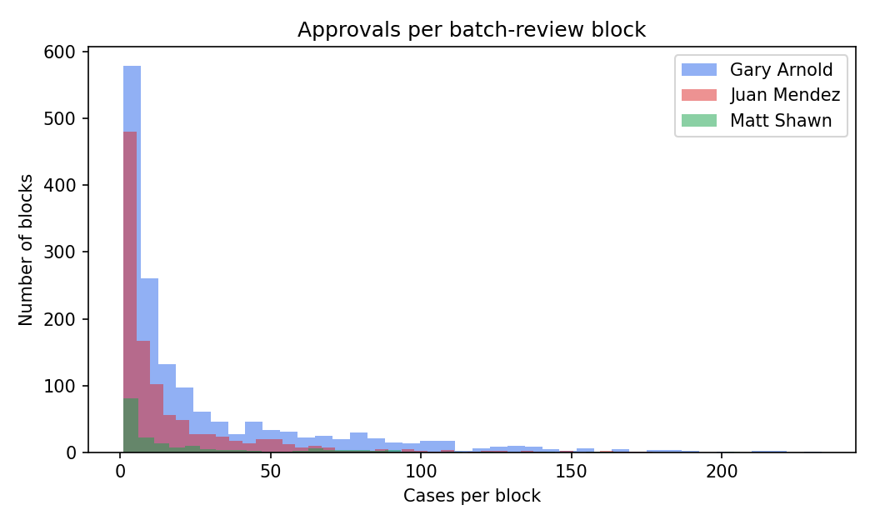
Figure 3. Distribution of cases per block.
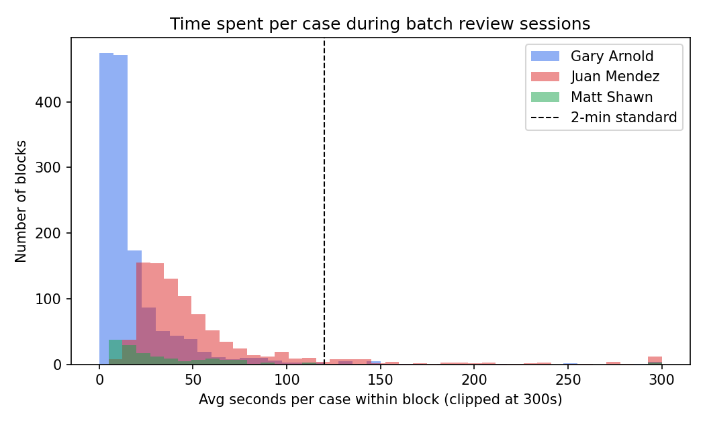
Figure 4. Average seconds spent per case within a block, vs. the 2-minute standard (dashed line).
Blocks are real and typically substantial: technicians average 16-27 cases per block, with some blocks exceeding 200 cases. This is consistent with a genuine bulk-approval workflow. But the arithmetic does not fully support the claim that pre-review happens at the point of approval: the median time between approvals WITHIN a block is 11 seconds for Arnold, 40 seconds for Mendez, and 24 seconds for Shawn -- all far under any of the four industry standards, and none of the technicians clears the 2-minute standard on a typical block.
This does not disprove the batch defense outright: if a technician genuinely reviewed a batch of cases beforehand, the review time would not show up as time between approval clicks at all -- it would happen earlier and be invisible in this dataset. The data can confirm that bulk approval happens; it cannot confirm or rule out whether adequate review preceded it.

6. Did the Money Change Behavior? Payout Policy Analysis
Per-approval pay dropped from $50 to $17 on June 1, 2020. We compared review durations before and after this date with a two-sample t-test, supplemented with a Mann-Whitney U test (a distribution-free check that is far less sensitive to the extreme outliers present in this data).
Coverage limitation: only Gary Arnold's extracts include approvals from both sides of the policy change (2019 and 2021). Juan Mendez's and Matt Shawn's files are entirely from 2019, so no before/after comparison can be computed for them from this dataset.
Metric | Pre ($50) | Post ($17)
N | 12,603 | 30,042
Mean duration | 34.5 min | 32.1 min
Median duration | 5.0 sec | 4.0 sec

Welch two-sample t-test: t = 0.076, p = 0.9398 -- not statistically significant.
Mann-Whitney U test: p = <0.0001 -- highly statistically significant.

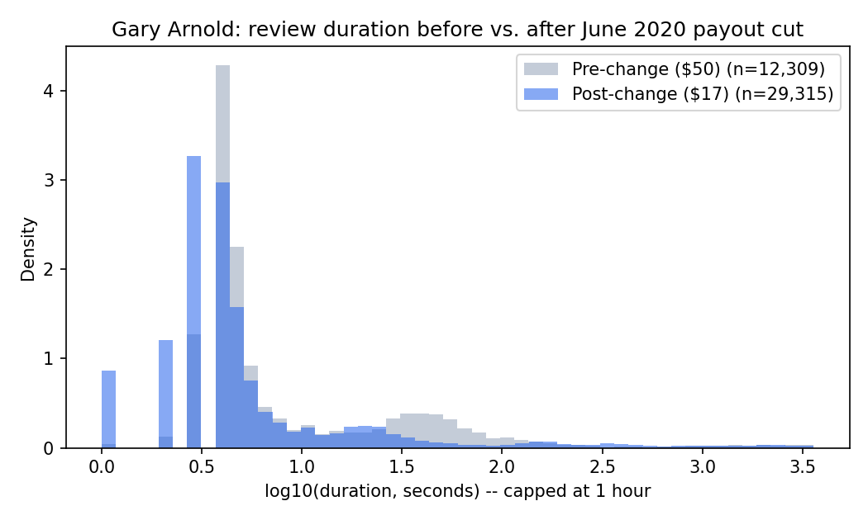
Figure 5. Gary Arnold's approval-duration distribution, before vs. after the payout cut.
The two tests disagree, and the disagreement itself is informative. The t-test compares means, and both periods contain a handful of extremely long, multi-day gaps that dominate the variance and swamp any signal in the bulk of the data -- so the mean-based test finds 'no significant difference.' The Mann-Whitney test compares the full distributions directly and detects a real, statistically robust shift: after the pay cut, a larger share of Arnold's approvals cluster at very short durations (visible in Figure 5 as more mass near the left of the post-change curve), and the median duration fell from 5 seconds to 4 seconds. This is consistent with a technician compensating for a lower per-case rate by moving through cases faster -- exactly the behavior administrators were concerned about.

7. Additional KPIs
Beyond the metrics requested directly by the case, we tracked:
- Fast-approval ratio (% of approvals under 2/5/10/30/60 seconds) -- the clearest, outlier-resistant measure of how often a technician approves near-instantly.
- Block frequency and size (blocks/month, cases/block) -- indicates how technicians structure their work into sessions, and whether block sizes changed over time.
- Within-block seconds/case vs. cross-block seconds/case -- separates 'time inside a working session' from 'time between sessions,' which the raw duration column conflates.
- Top approval days and hourly volume -- surfaces unusually high-volume days that merit closer, case-level audit and shows whether approvals cluster inside normal business hours.
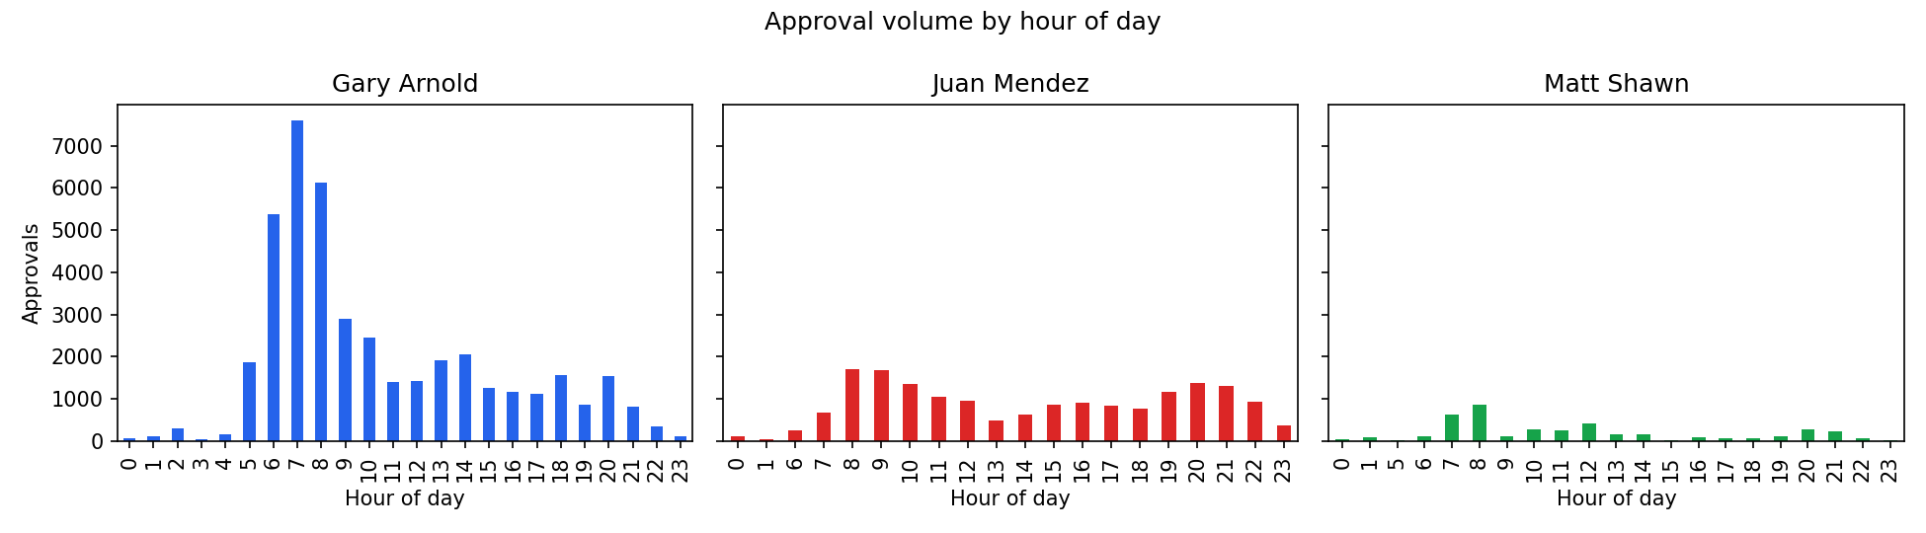
Figure 6. Approval volume by hour of day.
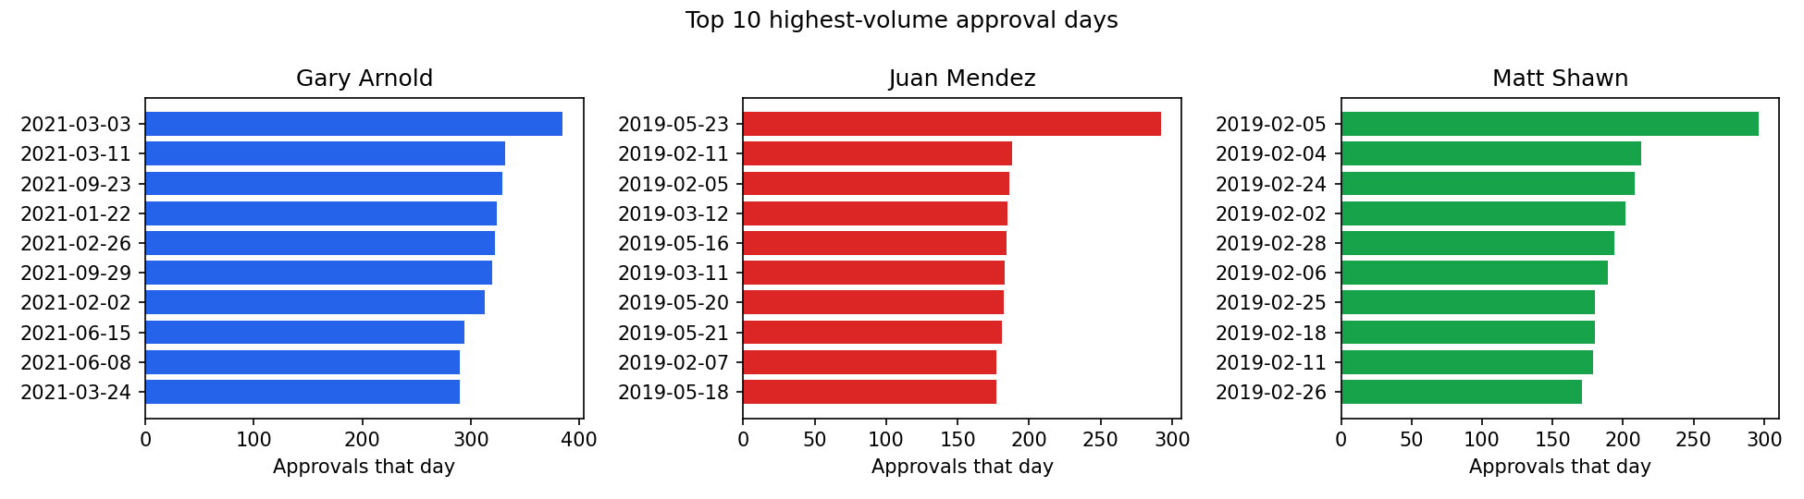
Figure 7. Top 10 highest-volume approval days per technician.

8. Conclusions and Recommendations

What the evidence demonstrates
- Approvals are frequently made in very rapid succession: 80-92% of approvals occur within 60 seconds of the previous one, across all three technicians.
- Within batch-approval blocks, the typical (median) time between approvals is well under a minute for all three technicians -- far below every industry standard tested.
- For the one technician (Arnold) where a before/after comparison is possible, the distribution of review times shifted measurably faster after the per-case payout was cut from $50 to $17.

What the evidence suggests, but does not prove
- The speed and volume patterns are consistent with technicians prioritizing throughput over per-case diligence, especially after the payout cut -- but consistency is not proof of negligence.
- The mean-based t-tests required by the case understate this pattern because of extreme outlier gaps; a reader relying only on those tests could mistakenly conclude behavior is within standard.

What the evidence cannot resolve
- Whether technicians performed genuine review work before clicking 'approve' (e.g., during a pre-review pass that this data would not capture at all).
- The outcome or quality of any review -- there is no record of rejected cases, so we cannot assess false-approval rates or compare approval speed against rejection speed.
- Root cause: whether fast approvals reflect rushed review, an efficient but legitimate workflow, or a system that pre-populates checks the technician confirms rather than performs from scratch.

Recommendations
- Do not rely on the raw-gap one-sample t-test alone as evidence of compliance; report the median and threshold-based statistics alongside it, since they are far less distorted by off-shift gaps.
- Instrument the review portal to log time-on-case directly (e.g., time the review screen was open) rather than relying on approval timestamps as a proxy -- this would resolve the central ambiguity in this analysis.
- Audit a sample of the fastest within-block approvals (under 2-5 seconds) manually against the underlying scans to establish whether review quality actually suffered.
- Revisit the per-case payout structure: the data is consistent with the 2020 pay cut correlating with faster approvals for at least one technician, which is a plausible mechanism worth testing further with cleaner, continuous data.
- Obtain continuous monthly extracts for all three technicians (not just Arnold) spanning the payout change, so the before/after comparison can be run for Mendez and Shawn as well.

