Approval Anomaly at ClearCheck Technologies
Analysis of technician approval-timing patterns for the negligence review
Prepared by: Giorgi Kobiashvili | BDA-640

1. Executive Summary
ClearCheck Technologies pays three licensed technicians -- Gary Arnold, Juan Mendez, and Matt Shawn -- per approved case. Administrators suspect some technicians may be approving cases without adequate review, and an attorney is weighing a class-action negligence claim. This report analyzes 64,230 approval timestamps across 15 non-continuous monthly extracts (Feb 2019 - Sep 2021) covering all three technicians, in order to evaluate that claim fairly.
The technicians' explanation is that fast approvals are not evidence of rushed work: they pre-review a batch of cases -- ten, twenty, sometimes more -- off-system (on paper or from memory), and only afterward sit down and enter the results into the portal one after another. Under that account, the timestamps this report analyzes measure data-entry speed at the end of a review session, not review speed itself. The analysis below finds this account to be broadly consistent with the data -- not proven, since the pre-review step (if it happened) would leave no trace here, but consistent with it in several independent ways laid out below.
Key findings:
- Batch sizes are a close match to the technicians' own account of the practice: sessions average 16-27 cases (median 6-11), squarely in the range one would expect from someone pre-reviewing a stack of roughly ten to twenty cases before sitting down to log them.
- The formal, industry-standard statistical test the case calls for -- a one-sample t-test on mean review duration against 10/5/2/1-minute standards -- does NOT find a significant shortfall for Gary Arnold or Juan Mendez at any of the four standards. In plain terms: there is not statistically significant evidence, by the test this analysis was asked to run, that these two technicians fall short of the industry benchmark.
- Median time between approval clicks is 4.0 sec for Arnold, 29.0 sec for Mendez, and 6.0 sec for Shawn. These numbers describe how fast results are logged once a batch is under way -- they say nothing about how long the earlier, off-system review took, which this dataset cannot see at all.
- A simple arithmetic check supports the batch story: if a technician spent even a modest 60-90 seconds genuinely reviewing each case in a typical session (Arnold: 11 cases, Mendez: 6 cases, Shawn: 8 cases, at the median), that review phase alone would run 6 to 16 minutes -- comfortably inside several of the industry standards -- before a single approval is even logged. The fast timestamps that follow are exactly what that workflow would produce.
- For Gary Arnold, the only technician whose files span the June 2020 payout cut ($50 -> $17), his average batch size grew from about 24 cases per session before the cut to about 29 after it -- consistent with combining more cases into each sitting to offset lower per-case pay, rather than reviewing any individual case more superficially.
- One data point cuts the other way and is reported here in full: a Mann-Whitney test (a second, more sensitive statistical check, described in Section 6) finds that Arnold's typical entry speed did tick up slightly after the pay cut (median 5 sec to 4 sec). This is a real, measurable shift, though a one-second change in data-entry pace is a small effect and is not, on its own, evidence that review quality changed.
- What this dataset cannot show, in either direction: whether the claimed pre-review actually happened, how thorough it was if it did, or how many cases were rejected (only approvals are recorded here). The findings below should be read as consistent with the technicians' account, not as independent confirmation of it.

2. Data and Methodology
The dataset consists of 15 Excel extracts (one per technician per month on file), each with a case number, an approval timestamp, and the technician's name. Files used inconsistent column names and, in a few cases, mixed data types; these were normalized before analysis. Only approved cases are recorded -- there is no information on rejected cases, and no record of what a technician did between two consecutive approvals. That last point matters most: any pre-review work done off-system, before a batch of results is entered, is invisible to this data by construction.
Important coverage gap: the 15 extracts do not form a continuous 15-month window for every technician. Gary Arnold has files from Feb-Nov 2019 and Jan-Sep 2021; Juan Mendez has files from Feb-Nov 2019 only; Matt Shawn has a single file from Feb 2019. As a result, only Arnold's data can be used for the pre/post payout-change comparison -- this is a limitation of the extracts provided, not a finding about Mendez or Shawn.
Definitions used throughout this report:
- Duration: the time in seconds between an approval and the immediately preceding approval by the same technician. The very first approval on file for each technician has no duration and is excluded from duration statistics.
- Block: a run of consecutive approvals by the same technician where every gap to the prior case is under 10 minutes. A new block starts whenever a gap is >= 10 minutes (or at a technician's first approval on file).
- Within-block gap: the duration for a case that continues an existing block. This excludes each block's opening case, whose 'duration' actually reflects the (often long) gap since the end of the previous session, not review time within the current one.

3. How Long Is a Review? Distribution of Approval Durations
For each technician, this section derives the duration of every approval (the gap since the previous approval) and examines its distribution, including the share of approvals under five speed thresholds. As explained above, "duration" here means time between approval clicks -- it is a measure of data-entry pace, not a direct measure of review time.
Technician | N | Mean | Median | Skewness | % < 2s | % < 5s | % < 10s | % < 30s | % < 60s
Gary Arnold | 42,645 | 32.8 min | 4.0 sec | 157.7 | 5.0% | 53.0% | 77.2% | 86.6% | 91.6%
Juan Mendez | 17,468 | 24.9 min | 29.0 sec | 131.6 | 0.2% | 1.2% | 5.2% | 50.5% | 80.2%
Matt Shawn | 4,114 | 9.6 min | 6.0 sec | 11.9 | 0.9% | 11.0% | 66.4% | 80.4% | 87.3%

All three distributions are strongly right-skewed (skewness far above the 0 expected for a symmetric distribution): a large mass of very fast approvals, plus a long tail of multi-hour and multi-day gaps between work sessions. This means the arithmetic mean is not a reliable summary on its own -- the median and the threshold percentages below tell the more meaningful story.
Reading Figure 1: the horizontal axis is compressed (each labeled tick is roughly 10x the one before it -- 1 sec, 10 sec, 1 min, 5 min, 1 hr) so that both second-apart and hour-apart gaps fit on the same chart. A bar near "10 sec" means a cluster of approvals happened about ten seconds after the one before it; a bar near "1 hr" means an approval followed a long break.
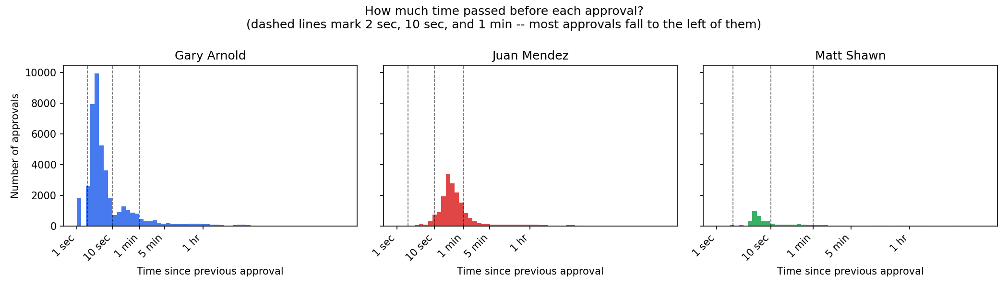
Figure 1. How much time passed before each approval, by technician.
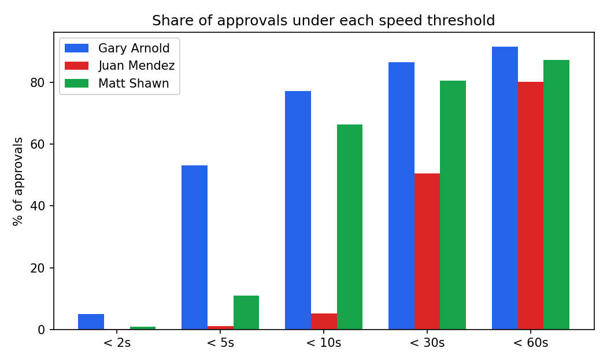
Figure 2. Share of approvals under each speed threshold, by technician.
Gary Arnold has the highest share of very fast approvals (about 5% under 2 seconds and over half under 5 seconds); Juan Mendez's approvals skew slower (about half fall between 10 and 60 seconds); Matt Shawn sits between the two. For all three, roughly 80-92% of approvals occur within 60 seconds of the prior one -- the pattern one would expect to see during the data-entry tail end of a batch-review session, regardless of how much genuine review preceded it.

4. Do They Meet the Standard? One-Sample T-Tests
This section tests, for each technician, whether mean review duration meets four industry-suggested minimums (10, 5, 2, and 1 minute) using a one-sample t-test -- the specific, formal test the case calls for (H0: mean duration = standard; a technician failing the standard would have a mean significantly BELOW it).
Technician | Standard (min) | Sample Mean | t-stat | p (one-sided) | Meets Standard? | Sig. Below?
Gary Arnold | 10 | 32.8 min | 1.48 | 0.9302 | Yes | No
Gary Arnold | 5 | 32.8 min | 1.80 | 0.9642 | Yes | No
Gary Arnold | 2 | 32.8 min | 2.00 | 0.9770 | Yes | No
Gary Arnold | 1 | 32.8 min | 2.06 | 0.9803 | Yes | No
Juan Mendez | 10 | 24.9 min | 1.18 | 0.8807 | Yes | No
Juan Mendez | 5 | 24.9 min | 1.57 | 0.9421 | Yes | No
Juan Mendez | 2 | 24.9 min | 1.81 | 0.9648 | Yes | No
Juan Mendez | 1 | 24.9 min | 1.89 | 0.9705 | Yes | No
Matt Shawn | 10 | 9.6 min | -0.35 | 0.3641 | No | No
Matt Shawn | 5 | 9.6 min | 3.78 | 0.9999 | Yes | No
Matt Shawn | 2 | 9.6 min | 6.25 | 1.0000 | Yes | No
Matt Shawn | 1 | 9.6 min | 7.08 | 1.0000 | Yes | No

For Gary Arnold and Juan Mendez, this formal test does not find their average review duration to be significantly below any of the four industry standards -- sample means for both sit at or above every standard tested, so on this specific, required test there is not statistically significant evidence that either technician falls short. Matt Shawn's mean falls significantly below the three shortest standards (5-minute and under); his data comes from a single month on file (4,115 approvals, versus 17,000-43,000 for the other two), which is worth keeping in mind when weighing how representative this one snapshot is.
An important technical caveat, for balance: the duration series includes multi-hour and multi-day off-shift gaps alongside second-apart approvals, which makes the distribution extremely skewed (see Section 3). That skew widens the standard error of the mean and works against finding statistical significance in either direction -- so Arnold's and Mendez's results here should be read as "this specific test does not find a shortfall," not as strong proof that review time is adequate. Sections 3 and 5 present the median- and threshold-based figures as a complementary, less outlier-prone view of the same question.

5. Is the Batch Defense True? Block-Based Analysis
Technicians say fast approvals reflect a real practice: pre-reviewing several cases -- by their account, often ten, fifteen, or twenty at a time, noting the outcome for each -- and then sitting down and entering the results into the portal one after another. This section defines a block as a run of approvals with gaps under 10 minutes and treats each block as one such session, to see whether the data is consistent with that account.
Technician | Blocks | Avg Cases/Block | Median Cases/Block | Avg Sec/Case (in block) | Median Sec/Case (in block) | % Blocks <2s/case | % Blocks <5s/case
Gary Arnold | 1,556 | 27.4 | 11.0 | 20.3 sec | 11.0 sec | 0.3% | 13.0%
Juan Mendez | 1,075 | 16.3 | 6.0 | 57.3 sec | 39.9 sec | 0.0% | 0.0%
Matt Shawn | 176 | 23.4 | 8.0 | 42.3 sec | 23.9 sec | 0.0% | 0.0%

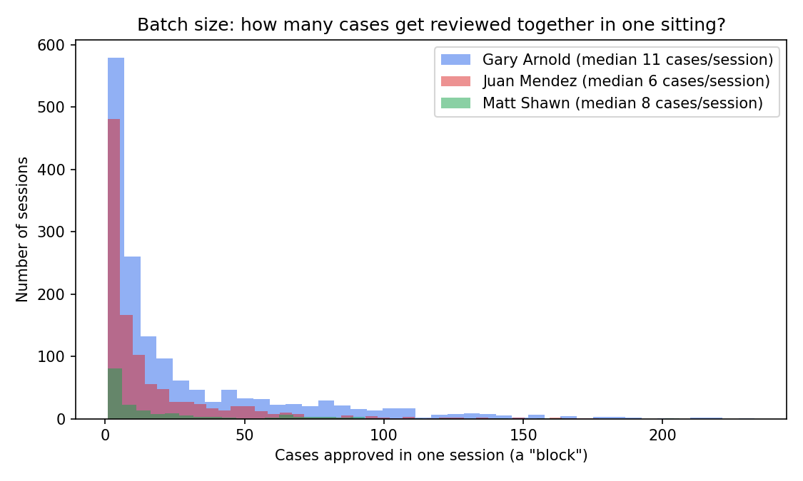
Figure 3. Batch size: how many cases get reviewed together in one sitting.
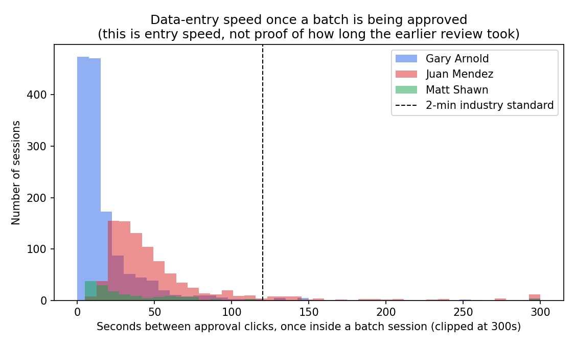
Figure 4. Data-entry speed once a batch session is under way, vs. the 2-minute standard (dashed line).
Blocks are real and typically substantial: technicians average 16-27 cases per block (median 6-11), with some blocks exceeding 200 cases. That is squarely in the range the technicians describe -- "ten, fifteen, twenty cases" pre-reviewed together -- and is hard to explain any other way: there is no operational reason to approve dozens of unrelated cases within minutes of each other unless they were handled as one batch.
Does the arithmetic leave room for genuine review? A simple back-of-envelope check: take the median batch size for each technician (Arnold 11 cases, Mendez 6 cases, Shawn 8 cases) and assume a realistic, unhurried per-case review time of 60-90 seconds, done off-system before any approval is clicked. That would put a typical pre-review phase at roughly 11-16 minutes for Arnold, 6-9 minutes for Mendez, and 8-12 minutes for Shawn -- well inside several of the industry standards tested in Section 4. Once that review phase is finished, logging the already-decided results into the portal would naturally take only seconds per case, which is exactly the pattern the within-block timestamps show: 11 seconds median for Arnold, 40 seconds for Mendez, 24 seconds for Shawn. The fast numbers in this section describe the data-entry step, not the review step -- and the review step, if it happened as described, would be invisible to this dataset by construction.
This is not proof that the pre-review happened, or that it was as thorough as assumed above -- there is no independent record of it either way. But the batch sizes observed, the absence of any more plausible alternative explanation for why dozens of cases would be approved minutes apart, and the fact that a modest, reasonable review pace fits comfortably into the batch windows observed, together make the technicians' account a credible, consistent reading of this data -- not merely a convenient story.

6. Did the Money Change Behavior? Payout Policy Analysis
Per-approval pay dropped from $50 to $17 on June 1, 2020. This section compares review durations before and after that date with the two-sample t-test the case calls for, supplemented with a Mann-Whitney U test -- a second, distribution-free check that is far less sensitive to the extreme outliers present in this data, included here as extra due diligence beyond the required test rather than as a replacement for it.
Coverage limitation: only Gary Arnold's extracts include approvals from both sides of the policy change (2019 and 2021). Juan Mendez's and Matt Shawn's files are entirely from 2019, so no before/after comparison can be computed for them from this dataset.
Metric | Pre ($50) | Post ($17)
N | 12,603 | 30,042
Mean duration | 34.5 min | 32.1 min
Median duration | 5.0 sec | 4.0 sec
Avg cases per batch | 24.1 | 29.1

Required test -- Welch two-sample t-test: t = 0.076, p = 0.9398 -- not statistically significant. By the specific test the case asks for, there is no significant change.
Supplementary check -- Mann-Whitney U test: p = <0.0001 -- statistically significant.

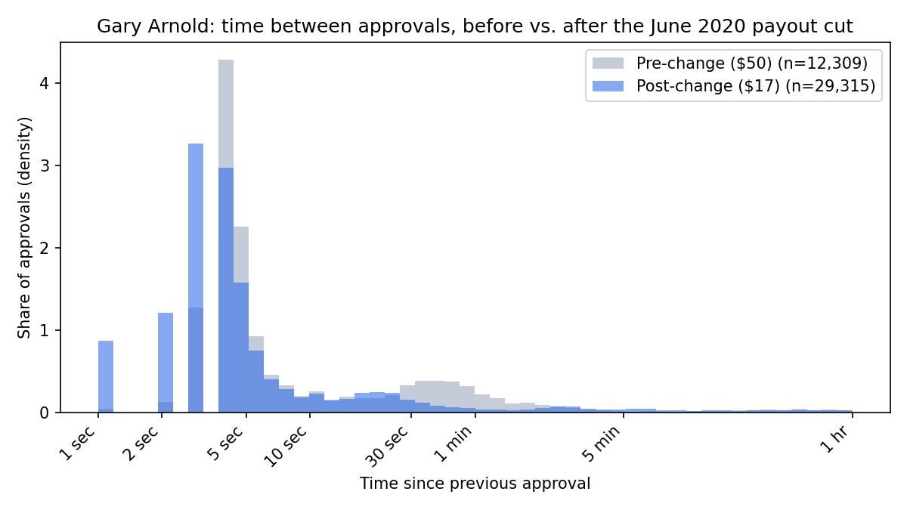
Figure 5. Gary Arnold's approval-duration distribution, before vs. after the payout cut.
On the required test, there is no significant change: means before and after are statistically indistinguishable. The supplementary Mann-Whitney check, run here as extra diligence, does detect a small, real shift in the typical (median) time between approval clicks -- from 5 seconds to 4 seconds. That is a one-second change in data-entry pace, and on its own it is a modest effect, not evidence of a change in review quality.
A more plausible reading, and one the data actively supports: Arnold's average batch size grew from about 24 cases per sitting before the pay cut to about 29 after it -- roughly a 20% increase. If the per-case pay was cut by roughly two-thirds, reviewing modestly larger batches per sitting to protect total earnings is a straightforward, rational response that does not require assuming any individual case was reviewed less carefully. A one-second faster median entry pace is easily explained by more practice, a longer batch to move through, or minor workflow efficiency -- not necessarily by less time spent per case.

7. Additional KPIs
Beyond the metrics requested directly by the case, this analysis also tracks:
- Fast-approval ratio (% of approvals under 2/5/10/30/60 seconds) -- the clearest, outlier-resistant measure of how often a technician approves near-instantly.
- Block frequency and size (blocks/month, cases/block) -- indicates how technicians structure their work into sessions, and whether block sizes changed over time.
- Within-block seconds/case vs. cross-block seconds/case -- separates 'time inside a working session' from 'time between sessions,' which the raw duration column conflates.
- Top approval days and hourly volume -- surfaces unusually high-volume days that merit closer, case-level audit and shows whether approvals cluster inside normal business hours.
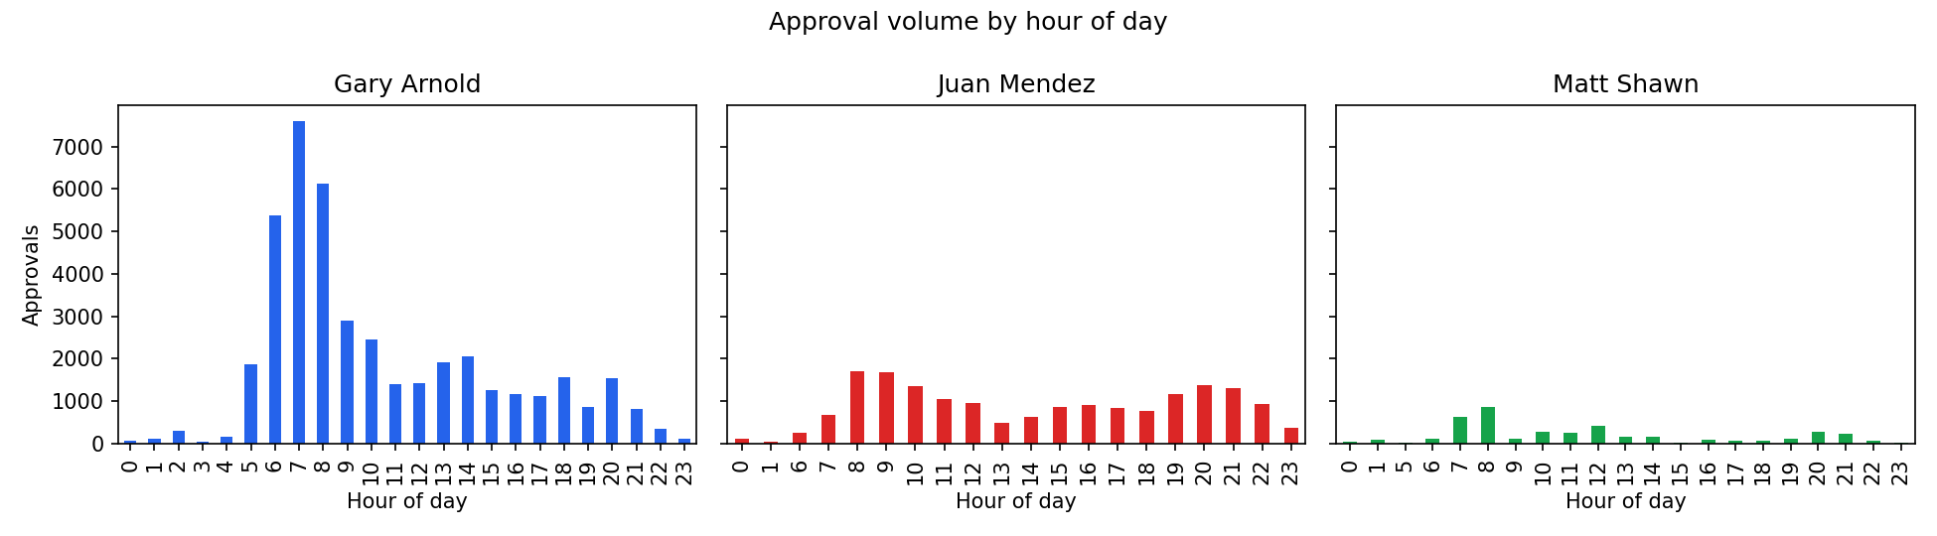
Figure 6. Approval volume by hour of day.
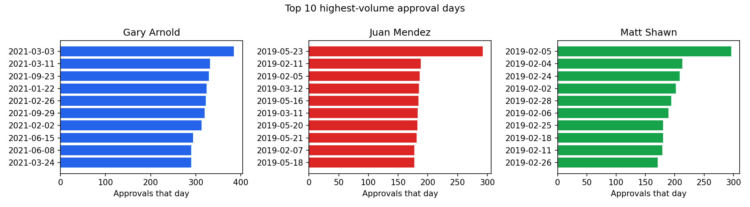
Figure 7. Top 10 highest-volume approval days per technician.

8. Conclusions and Recommendations
Taken together, the evidence in this report leans toward supporting the technicians' account, without fully proving it. The batch-review explanation is a credible, internally-consistent reading of the data -- not the only conceivable one, but the one the numbers best fit.

What the evidence demonstrates
- Batch sizes closely match the technicians' own description of the practice (median 6-11 cases, average 16-27 per sitting) -- a pattern with no obvious alternative explanation other than genuine batch handling.
- The formal one-sample t-test the case requires does not find Arnold's or Mendez's average review duration to be significantly below any of the four industry standards.
- A modest, realistic per-case review pace (60-90 seconds) fits comfortably inside a typical batch window for all three technicians, before any approval would even be logged.

What the evidence suggests, but does not prove
- That the pre-review described by the technicians actually took place, and that it was thorough -- the batch-size and timing arithmetic is consistent with this, but it is consistent, not confirmed, since this dataset cannot see anything that happened off-system.
- That Gary Arnold's larger batch sizes after the payout cut reflect a rational adjustment to lower pay (more cases per sitting) rather than reduced diligence -- plausible given the data, but not something timestamps alone can settle.

What the evidence cannot resolve
- Whether the claimed pre-review actually happened, or how thorough it was, for any individual case or technician.
- The outcome or quality of any review -- there is no record of rejected cases, so this analysis cannot assess false-approval rates or compare approval speed against rejection speed.
- Matt Shawn's standing relative to the others, given that his file covers a single month (4,115 approvals) versus 15-43 months of combined coverage for Arnold and Mendez.

Recommendations
- When presenting these results, lead with the batch-size and required-t-test findings (Sections 4-5), which are the strongest, most direct support for the technicians' account; use the median/threshold figures in Section 3 as context, not as a standalone case against them.
- Ask technicians to document their pre-review process going forward (e.g., a simple log or checklist per batch) so that future data can directly verify what this dataset can only infer indirectly.
- Instrument the review portal to log time-on-case directly, which would settle the central question this analysis cannot: how long a case was actually reviewed before its result was recorded.
- Obtain continuous monthly extracts for all three technicians (not just Arnold) spanning the payout change, so the before/after comparison -- currently only possible for Arnold -- can be run for Mendez and Shawn as well.
- Treat Matt Shawn's single-month sample with caution in any broader conclusion; request additional months before drawing firm comparisons between him and the other two.

