**THE EFFECT OF LETTER CASE OF LOGOTYPE ON CONSUMERS’ PERCEPTIONS OF LUXURY FASHION BRAND**

# Abstract

Luxury goods consumption has been an important activity among the human history . Fashion has dominated most of the industrial undertakings with key needs to have a focus on brands, logos and letter cases among the fashion industry in China. This study examines the influences of uppercase and lowercase letters on luxury fashion brand logotypes and how this impacts Chinese consumers’ brand perception. A total of 302 respondents are included in two studies, which are: Stereotype Content Model (SCM) and analysing conspicuousness. The results show that letter cases impact the luxury fashion brands’ perception: the logotypes set in uppercase can increase the competence perception of luxury fashion brands and at the same time, are more conspicuous than the lowercase logotype.

Keywords: *letter cases, logotype, China Luxury fashion branding, luxury perception, self-identity, perceived self-congruity*

Table of Contents

Abstract 2

List of tables 4

List of Figures 4

Introduction 5

1.1 Introduction 5

1.2 Research Problem 6

1.3 Research objectives 7

1.4 Purpose 8

1.5 Contribution 8

1.6 Model 8

LITERATURE REVIEW AND HYPOTHESES DEVELOPMENT 10

2.1 The concept of Letter cases 10

2.2 Luxury fashion in China 10

2.3 The Perception of Luxury in Fashion 11

2.4 Naturalness and affective response toward the brand 12

2.5 Brand conspicuousness and Letter Cases 13

2.6 Effects of consumers' self-identity and perceived self-congruity with the brand 14

METHODOLOGY 16

3.1 Study 1 16

3.2 Participants and procedure 16

3.2.2 Procedure 16

3.3 Variables 17

3.4 Results 17

3.5 Study 2 20

3.6 Participants and procedure 20

3.6.1Sample 20

3.6.2 Online survey 20

3.7 Variables 21

3.8 Results 21

CONCLUSION AND IMPLICATION 24

4.1 Two different letter cases 24

4.2 Conspicuousness of upper- and lower-case logo types and consumers perception 24

RESEARCH LIMITATIONS AND FURTHER STUDIES 25

5.1 Limitation 25

5.2 Further studies 25

References 26

# List of tables

**Table 1: Descriptive statistics** 16

# List of Figures

**Figure 1: SCM Model** 8

Figure 2: Income 17

Figure 3: Perception 18

Figure 4: Age 18

Figure 5: Gender 19

Figure 6: Letter cases conspicuousness 21

# Introduction

## 1.1 Introduction

Given the dynamic growth, increase in market, competition and luxury goods to a wider consumer group than ever before, the luxury market has transformed from the traditional conspicuous consumption model to a new experiential luxury sensibility marked by a change in its method. The sales of luxury fashion products have risen sharply in recent years with the rapid growth of demand in emerging Asian economies, especially China. World Luxury Association (WLA) shows that the potential market for luxurious products in China reaches US$6 billion each year, and it is still growing (Bain, 2017). In 2021, China became the second-largest luxury market worldwide (McKinsey, 2018). The rapid economic development and the desire of material possession, therefore, the increase in purchasing luxury items as well as conspicuous products (Liao & Wang, 2009). Various design elements in the logotype design make appropriate typefaces are more preferable by consumers (Doyle & Bottomley, 2006).

Most high-end luxury fashion brands often apply uppercase letterform as their identity, such as “LOUIS VUITTON”, “CHANEL”, and “TOM FORD”. While some apply with lowercase, for instance, “roberto cavalli”. Recently, several luxury fashions rebranded and changed their logotype into all uppercase like “Berluti–BERLUTI”, and “Dior–DIOR”. As Yu (2021) explained: Uppercase make a brand feel more premium, especially in the application of high-end items. Therefore, this study investigates to comprehend the commercial implication of different letter cases of the luxury fashion brands’ logotype. The proliferation of so many luxuries fashion logotype design with uppercase accompanied by a surprisingly small amount of study on their influence and impact (Xu, Chen, & Liu, 2017). Furthermore, the lack of study on the influence of letter cases on luxury brands is also mentioned by the scholar (Teng et al., 2021).

Some findings concentrate on logo features in the context of marketing research, for instance, previous research investigated the difference in letterforms, their roundness and sharpness, the color differentiation, hue and saturation level, the degree of boldness, and upright and slanting logotype (Wei, Wang, Feng, & Ding, 2018). Previous research shows that brand logos can promote consumer emotion and behavioral reaction effectively (Müller, Kocher, & Crettaz, 2013). The study also finds that consumers perceive uppercase logotypes with more authority and lowercase logotypes with more warmth (Xu et al., 2017), Hence, the uppercase logotype may influence the consumer’s perception. On this basis, the researcher further pays attention to the impact of capital logos of luxury fashion products on Chinese young people. To better describe the consumers’ perception, the researcher applies the Stereotype Content Model in the research framework. Warmth and competence are the two factors that are constructed in the Stereotype Content Model (Abele & Wojciszke, 2007). The basic concept of this model is that one’s perception of outside objects or other people is composed of competence and warmth (Cislak & Wojciske, 2008). Therefore, the research employs these two dimensions to measure consumers’ perception of letter cases in luxury fashion brand logotype.

## 1.2 Research Problem

It can be complex to change and shift a well-known brand and logo type and a customers' perception of the company (Yeo & Youssef 2010). It is also deemed to be complex to identify if it is necessary to change logotype and brand image and not just for the sake of change (Aaker 2010). According to Gelman, (2017); and Fionda & Moore (2009), one problem that is deemed to be assessed in this research is the luxury company way of communication and presenting its logo in a way that is appealing to the consumers. The goal of every logo and the letter cases towards signing and appealing to the consumers.

Further, proponents like Sarker & Roy (2015) stated that there is a risk that some of the existing customers may not have a brand identity on the new logo that has been designed by the company. The need to developing letter cases on logotypes is a process and order need to be maintained in order to attain competitiveness in the market that is ever dynamic. Putting into consideration the challenges that exist, need to understanding brand awareness and having consumer loyalty is a key aspect that should be considered to attain an effective brand awareness and in maintain customers over years. (Miller et al.,2014).

In most cases, as postulated by scholars like Kong et al.,2021) luxury fashion brands are often referred to as status brands and the customers who are set to associate with these brands are deemed to be high quality, prestige and high-class individuals who are attached to them.  
Further Vanacker et al., (2022) stated that brands are always selected to be a representation of the status visually. According to Jin, & Choi, (2022). and Gentina et al. (2016) stated that with luxury products, having a logo type and various letter cases on the logo creates awareness and makes the brand attractive and appealing to customers. further Lee & Watkins (2016) gives a demonstration that humans show successful appearance and level of confidence that makes them build self-confidence known as the (Ibid). In most cases, consumers will always get inspired by the identity they obtain from a group. Wearing the right luxury fashion brand makes consumers feel the presence and belonging to a particular group. According to Melović et al., (2020) for a company to promote brand, an advert should always be created to create an effective brand awareness among the group. Brands created through the logo should always be a reflection and reference to a group and create an attractive message that is key to the group. Challenges that fashion brands and common in many brands is that in most cases they tend not to control who purchases their products. For example, in England, when football fans purchase clothes with the Burberry chequered pattern (either originals or copies) in 2003(Olteanu 2020) it creates a certain form of identity among the group. This form of brand was deemed to create a bad reputation and in order many ceased to purchase as it led to negative brand identity .in order to revert the process, rebranding was key to ensure that a key brand that people want to identify to is created

In as much as brands are created, the key challenge that one needs to solve is whether having letter cases on logotypes have a key impact on how brands have been created in the society. In many cases, luxury fashion industry works towards creating effective brands that in most cases should work to creating better brand awareness. These means that as a system, one should always create a better brand that should appeal to customers an in most cases create a better reputation regarding the brand. The research on luxury fashion brand and effects of letter cases and logotypes on customer perception has focused on brands and how it affects how customers perceived brands is key and optimal and there is a need to create better communication. The key features of corporate brands on luxury are determined by the letter cases and how it is appealing or non-appealing to consumers is key as it is viable for brand identity. Therefore, these research focuses on its effects and how it is key for consumer perception towards recognition and like of the brands.

## 1.3 Research objectives

These research aims at achieving the following key objectives:

1. To assess the effects of letter case of logotype on consumers’ perceptions of luxury fashion brand
2. To determine how younger consumers experience luxury brands, how have they perceived the logo letter cases to their buying behavior?

## 1.4 Purpose

The main purpose of these research is to assess the effects of letter case of logotype on consumer perception of luxury fashion brand. As many firms work towards creating new bands, there is a need to pay more attentions on the logotypes and letter cases. Some of the existing literatures like the work of (Tarnovskaya & Biedenbach 2018; Sarker & Roy 2015; Merrilees & Miller 2008; Muzellec et al. 2003) have focused on rebranding and logotypes and letter cases. Therefore, it is relevant to find out how to implement logotypes and letter cases and how it is effective in perceived by customer.

## 1.5 Contribution

This paper will contribute to scientific research specifically in the field of marketing and textile industry regarding luxury fashion brands and how logos and logotypes affects the viability and consumer perception. The subject is interesting and important and but there is no much that has been done within the academic area (Tarnovskaya & Biedenbach 2018). There are still gaps that exist within the research with regard to logotypes, letter cases and how impact it has on customer’s perception of luxury products (Fionda & Moore 2009). Successful creation of a logo type with letter cases aids in maintaining customer perception. This is therefore an information which is valuable to marketers and management of the luxury fashion brands to use in their creation of logos and towards creating customer appealing.

## 1.6 Model

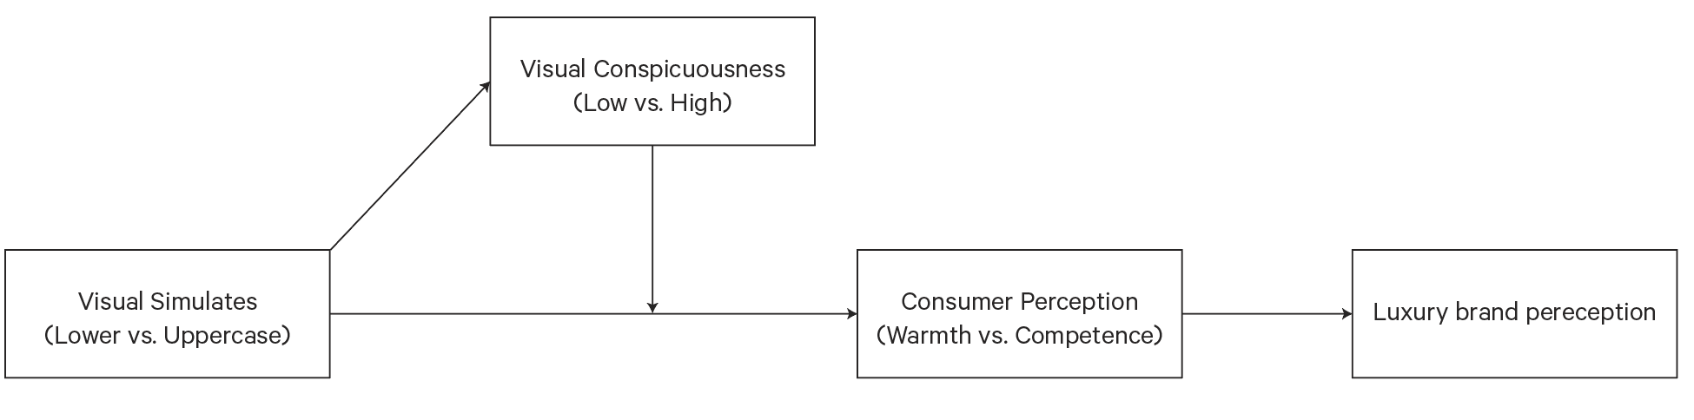

**Figure 1: SCM Model**

# LITERATURE REVIEW AND HYPOTHESES DEVELOPMENT

## 2.1 The concept of Letter cases

According to Walsh, Winterich, & Mittal, (2011) design elements in a brand logo are recognized to identify and differentiate the brand. Letter case is the difference between upper- and lower-case letters. As in daily writing, the upper case is used at the beginning of the sentence, name, or in an acronym (Teng et al., 2021). Uppercase stands for the application of capital letters (e.g., ABC), whereas lowercase letters are written in a small form (e.g., abc). Specifically, uppercase is used in warning and notice to get people’s attention and keep them away from a certain location. While lowercase letters constantly appear to build a closer relationship (Xu et al., 2017).

***H1: Uppercase and lowercase letters affect consumers’ perceptions of the brand.***

## 2.2 Luxury fashion in China

The concept of luxury varies from scholar to scholar. Goody (2006) defines luxury as “refined enjoyment, of elegance, of things desirable but not essential.” Adam Smith states that consumption falls into four sectors: necessary, basic, affluence, and luxury consumption (Smith, 1776). However, the luxury fashion is far more than the material of its attribute (Berthon et al., 2009); but contains the significance of social status as well. At the same time, the expensiveness enhances this indicator of social status and wealth (Li et al., 2012). As Colin Campbell (1987) suggested, fashion provides a socially valid standard of taste, which is solely based on personal preference as well as a choice of the member of “community taste”. Simmel theorized fashion as the byproduct of the social ladder, imitation of the elites by their social inferiors, and styles changed when the elite reacted to the popularization of their style. As Simmel said:

“… the fashions of the upper stratum of society are never identical with those of the lower they are abandoned by the former as soon as the latter prepare to appropriate them...Fashion..., is a product of class distinction...” (Simmel 1981:7)

Luxury fashion, especially for the high-end, top brands like LOUIS VUITTON, can be explained by two factors: Distinction (to prove people’s high social status) and Elitism (very few people can have access to them) (Barnier et al., 2012). Luxury goods are a tool for Chinese buyers to show their social status. The belief that “face is the spiritual creed of the Chinese people” has deeply rooted in Chinese society’s norms. Therefore, luxury item (expensive price and branded item) carries symbolic meaning (Hung et al., 2020).

With the economy growing, the “new rich” emerged (Gao et al., 2009), which is attractive to luxury sales teams in China. For young Chinese consumers, the consumption of luxury fashion items is more commonplace than ever before. In the process of buying luxury fashion products, great self-realization, a great sense of self-identity, higher social status, and more significant hedonic value is achieved. Among the young generation in China, the correlation between social perception and perceived luxury value and purchase intention in luxury consumption is stronger than that in non-luxury consumption (Shan, Juan; Jiang, Ling; Wei, William X.). The importance of luxury fashion is to delight, rather than merely satisfy, consumers (Chitturi, Raghunathan, & Mahajan, 2008). Chinese Gen Y (young populations) hold a more positive attitude toward high-price hedonic products and designer brands, willing to pay an additional amount for these status brands, said Choi (2008). Chinese Mainland consumers buy to impress others, “…the Chinese speak the international language of shopping”. This new trend and transformation in luxury consumption were continuously reported by the New York Times in 2006.

*h2: Luxury consumption has a positive relationship with new market trends*

## 2.3 The Perception of Luxury in Fashion

One of the most important points when it comes to luxury and fashion is that they have an important position in both social and economic life of an individual and an economy. In most cases, both the luxury and fashion tools are for differentiation and Kapferer & Bastien (2009) stated that, fashion in today’s world is not fashion, which is a tool for social hierarchy, but it is deemed to be a luxury in the society. Fashion is also classified to spread in different ways to a group of masses. To consumers, it is luxury and not fashion that will create difference. In as much as there is harmony at the basis of fashion, at the basis of luxury, there is perceived difference through reaching to the products and services that few people can have access to it. Fashion at this point is deemed to be a function of transformative elements to some consumers lifestyle periodically and theoretically. Fashion in most cases is deemed to be a phenomenon to the luxury world until 19th century. Since people outside a restricted elite class are deemed not to buy new items until it become unusable. In the 20th century, there was a distinction that exist between luxury and fashion. In assessing the development of luxury fashion, Gabrielle Coco Chanel viewed as the work of deign in 1910 in Paris and expanded her work by creating a niche market within a short time. in 1889, Jeanne Lanvin opened a house that was designed and in 1904 Paul Poiret and in 1927, Elsa Schiaparelli also did the same. Some of the key brands like Cartier, Louis Vuitton, Burberry, Chanel and Prada, are still deemed to be active luxury fashion brands that exist within the market which were deemed to emerge in 19th and 20th century. According to Okonkwo, (2007) brand have worked towards changing their services and products by adhering to the historical values that were set by the company. This is because these brands are still the pioneers of the luxury fashion industry today. In the late 1990s, the concept of luxury has been changing and evolving and has become one of the unified economic sectors. Some of the luxury brand groups that operates in the world include Louis Vuitton, Gucci, and Richemont. In the process of development, globalization, wealth creation, digital communication, international trade expansion of luxury brands consumer base and barrier reduction to market entry has grown and lead to increase in sector competition in all the luxury category products (Okonkwo, 2009).

The concept of luxury is summed under the names of classic luxury, modern and contemporary. In the period of 1950s, some of the key products that were being worn by nearly 2million women was “*haute couture”*, which is the clothing style that originate from bourgeois woman. In the 19th century, the "classical luxury" was deemed to be dominant by the objects that were seen an observed in France. During these times, it was contented that large fashions houses tend to boast having fashions which was deemed as cloth of phenomenon view. The main phenomenal process of influencing the process was deemed to be the object of beauty and creation of reputation among the users. "The phenomenon of modern luxury" has played a significant role and his understanding is based on value creation and gain important gesture and signature value which was key in creating design that surpasses taste of consumers. Therefore, the “contemporary luxury process" has played a significant role in shaping how people perceive luxury in the fashion-based industries.

*H3: Luxury fashion positively affect the luxury industry*

## 2.4 Naturalness and affective response toward the brand

Research on logo strategy has underline some key pros of using pictorial logos.   
According to, Schechter (1993), the author postulated that logos are suggestive and when a recognizable object is added, it increases the value of the brand which they work into representing it. According to Henderson & Cote (1998), they also postulated that logos act as a representative of objects that have familiarity and can be recognized more effective which in the long run produces a correct and positive recognition more than the logo abstract. Logos is a depict of experienced objects. The differentiation that exists between culture and organic features of an object is key when differentiating brands. Among the luxury products, creation of effective brand is key.

Based on the information presented by the semiotics, figurativeness and its opposite endpoint, abstractness, are deemed to be a reflection of the degree at which such logos depicts sensitive information to the public. On the contrary, signs are also said to be figurative  
(Greimas& Courtés, 1993). Figurative signs give a representation of the deep culture that is rooted on the logo. From the semiotic classification, logo strategy definition is also made up of elements which include letter cases and logo type as a strategy that works towards creating an effective and efficient system to give a logo representation. According to Henderson & Cote, (1998; Pittard *et al.*, (2007), distinct classification of logo designs gives more accurate and reflective degree to which the logo designs represent in the natural and cultural environment. In the fashion luxury industry, the need to have an effective brand with letter cases and key logotypes creates an effective recognition.

On the other hand, meaningless and abstract logos may be difficult to recognize and abstract designs may be more difficult to comprehend (Koen, 1969; Nelson, 1971; Seifert, 1992). These findings are supported by the natural shapes acknowledged aesthetic primacy in logo design. In reality, people who are in close proximity to a common natural environment develop comparable unconscious rule systems that affect their preferences for design, according to Veryzer's theory of aesthetic response. A wide variety of universally acquired preferences can be depended upon in the same way that a shared physical environment can. Because they depict biological or other actual phenomena that take place in our environment, natural logos are anticipated to be the most well-liked logos.

Based on earlier research, we predicted that consumers would have different impressions of natural vs. abstract logos. We expected logo concepts that feature natural or authentic components to have more effect than those that use abstract stuff (Henderson and Cote, 1998; Lancaster, 1997; Landry, 1998). Henderson and Cote (1998) and Henderson et al. (2003) agree that naturalness (or figurativeness) elicits a more positive affective response, highlighting the significance of natural designs. Thus, we hypothesize that:

*H4: Affect toward natural logo designs will be greater than affect toward abstract designs*

## 2.5 Brand conspicuousness and Letter Cases

According to Veblen (1973), the conspicuousness of a certain product refers to its social visibility and how noticeable it is. And conspicuous consumption means the consumption and use of premium goods publicly. Consumers buy luxury goods for their functionality and to meet social needs, deliberately showing off wealth and status. Nelissen and Meijers (2011) found that the people who value more conspicuousness are willing to spend more effort on acquiring and wearing luxury fashion clothes. Furthermore, wealth and social status relate to conspicuous consumption directly, especially in the Chinese collective culture environment. Conspicuous consumption generally increases perceptions of competence but undermines inferred warmth (Scott et al. 2013), especially towards lower-status individuals. Scott (2013) indicated that conspicuousness, as one of the psychical and visual cues, affects competence judgment. Therefore, an individual’s symbolic display via conspicuous consumption cues can be associated with perceived competence (Cheng and Tracy, 2013). Moreover, Chinese acceptance of social inequality index is much higher than the developed countries like USA or UK, the conspicuous consumption is often time associate with social perception and status of brands. The social dimension of luxury items is also critical factor in conspicuousness, it also displaying a positive perceived uniqueness and higher prices of luxury items (Parguael, 2016).

Uppercase and lowercase letters have different functions in daily communications. The uppercases are used to warn, emphasize and attract peoples’ attention (Berlyne, 1974). One of the reasons why uppercase letters look more noticeable is that uppercases are visually bolder and larger than lowercase and thus they attract more recognition (Henderson, Giese, and Cote 2004). Visual appearance and perception play an important role in the how the entire brand been perceived by the consumers, and the easy recognition is the key in it. Chinese consumers are enjoying in conspicuous consumption ever than before, since it associates with social status, success and wealth. Therefore, converting the logotype into uppercase might increase the visual conspicuousness, thereby enhancing the perception of competence. The researcher proposes the following hypothesis:

***H5:*** *An uppercase (vs. lowercase) luxury fashion brand logo will increase (vs. decrease) visual*

*conspicuousness and perceive more (vs. less) competence.*

## 2.6 Effects of consumers' self-identity and perceived self-congruity with the brand

Self-concept and identity are a significant concept that lies on the fact of consumer identity and brand awareness. Consumers tend to use products which tend to demonstrate their self-concept and identity and should be congruent to their likes. Through purchase and use of the products that lifts the identity of the consumer, it creates an effective use and application of maintaining self-worth. The self-concept notion is defined as the sum of person’s thought and feelings about one pertaining other which can also take two forms, that is the “actual self” and the “ideal self”. The actual self gives a description of an individual preference of perception regarding (me as I am”), and on the other hand, the self-concept gives an explanation of how one wants to perceive themselves (“the perfect me”) (Choi & Rifon, 2012; Jeong & Koo, 2015). Self-congruence, which is the state in which a person's ideal or actual self-coincides with a brand's image or personality, also has a major impact on how people view themselves (Aaker, 1999; Sirgy, Grewal, & Mangleburg, 2000; Sirgy et al., 1997; Sirgy & Su, 2000; Tukej, Golob, & Podnar, 2013). Another aspect that affects one's self-concept is self-esteem, which is the drive to improve oneself and pursue one's ideal self-image. People frequently raise their self-esteem by emphasizing certain positive aspects of their lives through affiliations with specific products or brands. This concept is well-knowingly illustrated by conspicuous consumption, such as living in an opulent hotel or using a symbolic brand.

*H6: In a Chinese environment, a functional brand using a Chinese rather than a Western celebrity endorser is likely to increase a more favorable attitude towards the brand*

# METHODOLOGY

This is the methodology section. In order to verify the above hypothesis, right tests need to be done. The research will perform quantitative experimental study. Study 1 and study 2 will be performed differently for the two studies. The result confirmed that the luxury fashion brand logotype in uppercase were getting more attention than lowercase, furthermore, the greater the competence perception, therefore, the mediating effect also supported.

Study 1: Two different letter cases

Study 2: Conspicuousness of upper- and lower-case logo types and consumers perception. The results from the two tests will confirm whether the letter case affects the brand and consumer perception of the products among the Chinese consumers.

## 3.1 Study 1

Study 1 investigated the influence of upper and lowercase on consumers’ perceptions. The letter case is taken as the independent variable and the consumers’ perception of competence and warmth as the dependent variable. Based on the criteria from Heine (2010), the luxury consumers are deemed as people who at least own five luxury products (and each one costs more than $500). The logotypes are chosen from the most popular luxury fashion brands based on their sales in China, for instance, Giorgio Armani, Chanel, Louis Vuitton, Dior, Gucci, and Prada.

## 3.2 Participants and procedure

**3.2.1Sample**

The first used a sample of 200 participants, that is through an online participation to complete the survey of the study.

### 3.2.2 Procedure

The age of the participants was from age 18 years to 55 years. This shows that the participants within a certain age and limit is key and given the survey to fill, they tend to give a response as to whether they like or don’t like letter cases and how it affects their level of perception as clients. The research objects include white-collar workers and professionals, self-employed or businessmen in small and medium-sized enterprises, and government leaders for they are defined as China’s middle class. With an average age of 18-55 and an annual income of $20,000 to $150000, they have a relatively high income. They are also described as the main force in boosting luxury goods sales, accounting for 13.5% of China's total population (McKinsey &amp; company, 2017). In Study 1, the same brands were applied in this test. All participants were assessed based on their like and dislike of letter cases to a certain brand, a scale of 5 is used where 1 = Like very much, 2=Like ,3=Neutral, 4=Dislike and 5= Don’t Like at all). The result shows that the brand’s logotype is suitable for this study. Then the participants, according to the instructions, completed the competence and warmth questionnaire with the Likert scale rating and multiple checks, as well as demographic information.

## 3.3 Variables

Perception on different letter cases, Upper and lower cases. In study 1, based on the previous research, the competence and warmth perception were measured on seven points of the Likert scale and different factors were applied to measure the competence and warmth. The “capable”, “confident”, “competent”, “efficient”, “intelligent”, and “organized” were the six main factors to evaluate the competence level. At the same time, the warmth perceptions were measured by other six factors, namely, “friendly”, “enthusiastic”, “caring”, “sincere”, “warm”, and “good-natured” (Aaker, Vohs, & Mogilner, 2010). Moreover, previous literature stated that wealth and success are positively related to competence, so the factors “wealthy” and “successful” are also included.

## 3.4 Results

The following are the results from the survey undertaken:

**Table 1: Descriptive statistics**

| **Descriptive Statistics** | | | | | |
| --- | --- | --- | --- | --- | --- |
|  | N | Minimum | Maximum | Mean | Std. Deviation |
| Gender | 200 | 1.00 | 2.00 | 1.6300 | .48402 |
| Income | 200 | 15000.00 | 1.28E5 | 6.5365E4 | 31826.71977 |
| Age | 200 | 18 | 55 | 31.12 | 10.689 |
| Perception | 200 | 1.00 | 5.00 | 2.0000 | 1.26412 |
| Valid N (listwise) | 200 |  |  |  |  |

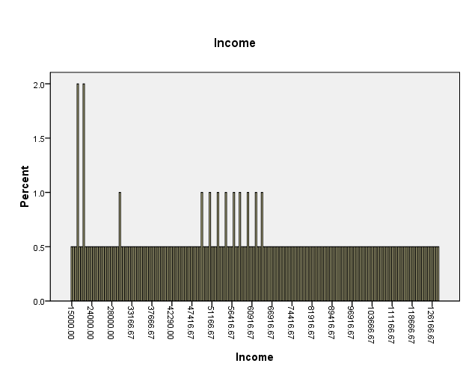

Figure 2: Income

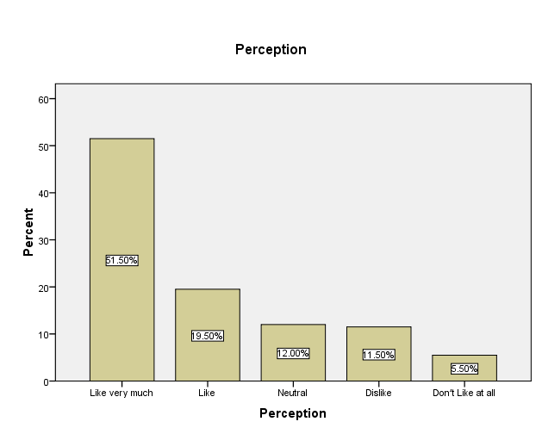

Figure 3: Perception

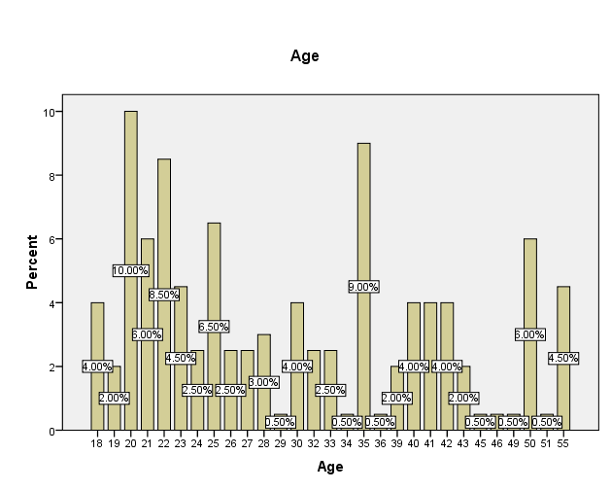

Figure 4: Age

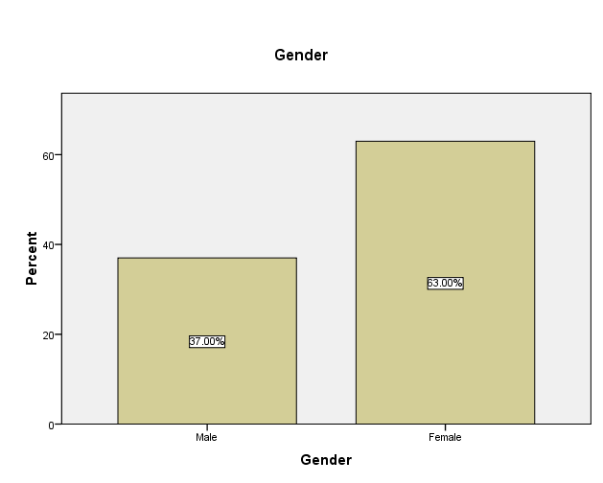

Figure 5: Gender

From the results, it shows that 37% of the respondent were male and 53% female, age 20% accounts for 10% and most of the respondent,51.5% have a higher perception of liking the brands letter cases and deemed it significant.

## 3.5 Study 2

The Study 2 examines the relationship between the letter case and the visual conspicuousness of luxury fashion brand logotypes. In the Study 2, hypothesis 2 to 6 was tested by quantitative research and a questionnaire. The luxury fashion logotype has also been used in China’s top 10 brands, and its conspicuousness has been tested.

## 3.6 Participants and procedure

### 3.6.1Sample

A sample size of 200 participants was also tested and the key towards such a test is to determine its viability and key implications towards brand.

### 3.6.2 Online survey

The participants in the Study 2 were from a total of 102 participants completed the questionnaire for this study online. Participants ranged in age from 18 to 55, with an average age of 36.5 years old, 81% of whom were women. The characteristics of the participants were the same as those in study 1.

In the Study 2, participants were asked to rate the visual conspicuousness of the logotypes of China’s top 10 luxury fashion brands in uppercase and lowercase. (“conspicuousness”, 1 = very stable, 7 = very conspicuousness).

The participants then follow the instructions to complete the competence and warmth questionnaire with the Likert scale rating and multiple checks, and demographic information. Each logotype presented on the cloth, T-shirt and store signage in order to simulate the real-world application, the participants would see those application first and finish the multiple chose and Likert chart rating under the instruction.

## 3.7 Variables

Conspicuousness of upper- and lower-case logo types and consumers perception. The competence and warmth perception were measured by seven points on the Likert scale. Conspicuousness level was evaluated by factors including “noticeability”, “prominence”, and “visibility”. The previous research did by Parguel (2016) also found that the price is also associating with conspicuousness as well, so in this research, the participants also been asking to rate the price low to high (“price”, 1 = lowest, 7 = highest). Mianzi (face) is also a key element in the conspicuous consumption, therefore, it includes in the Study 2 as well (“mianzi”, 1 = little or none, 7 = a lot).

## 3.8 Results

The result of the Study 2 suggests that uppercase letters have more visual conspicuousness than the lowercase letters (*M*upper = 5.42, *M*lower = 4.22, *t* (102) = 8.54, *p* < 0.001). The result supported hypothesis 2 and also confirmed the findings of Xu (2017) that the uppercase letters are more conspicuous than the lowercase letters. Study 2 investigated further into the luxury fashion logotypes.

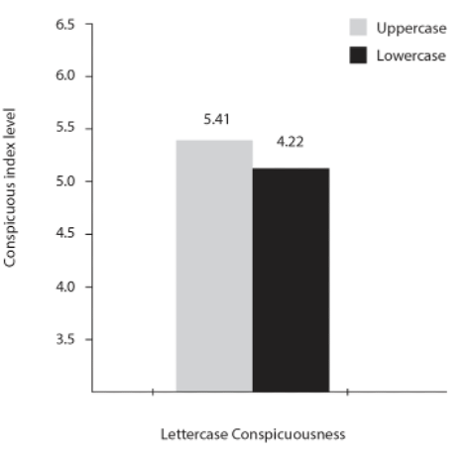

Figure 6: Letter cases conspicuousness

The Study 2 shows that the uppercase letters have more conspicuousness than the lowercase letter in luxury fashion brands’ logotypes. In the Study 2, the letter case as the independent variable, conspicuousness as the mediator, and the brand perception as the depend variable. The result reveled that the consciousness as the mediator that had more influence on the uppercase logotype, compare to the lowercase logotype, which supports the hypothesis 2. The two new factors “price” and “mianzi” also have the positive effect in the overall conspicuousness evaluation. To be more specific, Chinese consumers are perceived the uppercase letter with more “mianzi” and think it pricier than lowercase. The interaction of letter case and conspicuousness on brand competence perception was significant ((*M*competence-upper = 6.24, *M*competence-lower = 5.62; *F* (1, 102) = 11.72, *p* < 0.001), it further supports that hypothesis 2 assumed Chinese consumers perceived more competence in a more conspicuousness from uppercase than lowercase in luxury fashion logotype. Moreover, the result of study 2 also revealed the mediation effect of conspicuousness on brand competence perception (indirect effect = -0.782; 94.3% CI = [-1.8301, −0.2069]). Clearly, visual conspicuousness plays a mediating role in the relationship between logotype letter case and brand perception, as previous researches suggested. This provided the insight to why consumer prefer the uppercase letter in luxury fashion brand logotype, and further support that uppercase can enhance brand competence perception.

The result concluded when Chinese consumers are encountered with different letter case in luxury fashion logotype, the conspicuousness is higher in uppercase, and the data validated the interaction between the conspicuousness and competence perception in luxury fashion brand. The reason to explain this is Chinese consumers are more sensitive to the conspicuousness and related it to the brand perception, as Kirkman’s (2009) research suggested that “They (Chinese consumers) respect and trust more of uppercase logotype.” Capital letters are less frequently used in daily life, so people have low relativity and familiarity with them (Wen & Lurie, 2018). Therefore, Chinese consumer pay more attention when it appears, especially when they sense more and appreciate the power and authority from it compare to American. Chinese consumers also hold the more positive brand perception and attitude from the luxury fashion logotype applied in uppercase letter.

# CONCLUSION AND IMPLICATION

## 4.1 Two different letter cases

This study investigates the effect of upper and lowercase letters on the luxury fashion brand logotype, and what are the consumers’ perceptions of them. The findings from the analysis shows that uppercase logotype was perceived with more competence than lowercase letters on the SCM model and the uppercase logotype is more noticeable than the lowercase logotypes. The existing research mainly focuses on handwritten typefaces (Schroll et al., 2018), and there are few studies on letter cases but not in the luxury sector. This study sheds new light on this domain and stimulated further studies, based on the increasing consumption of luxury fashion items. Based on the research from Teng (2021), this result also shows the greater consumer perception difference in the application of upper and lowercase letters in luxury fashion logotypes than in ordinary daily commodities and items (i.e., headphone and non-luxury perfume). It also shows that women have perception when it comes to letter cases and in fashion industry. Branding is a key aspect and the need to developing better brands is key in the long run. In as much as the study has its focus on the age and also effectiveness to the logo design, there is much consistency that has been drawn from the study which is consistent with what was postulated by (Lambert-Pandered and Laurent, 2010; Lambert Pandraud *et al.*, 2005). The results also shows that there is a positive relation between age and letter cases on logo and the design. Increase in age, people tend to give a demonstration of greater affects towards various designs. Age and logos of version are geared towards women and this shows that at the age between 25 to 35 years, there is a high likelihood of women having geared towards various letter cases and on logo designs.

## 4.2 Conspicuousness of upper- and lower-case logo types and consumers perception

In terms of practical application, the need to having logotypes and its conspicuousness to the logo types and consumer design is key. The literatures give a suggestion that letter cases have a significant impact on consumers’ perception and interpretation of brands (Walsh, Winterich, & Mittal, 2010, 2011). Therefore, brand management should be treated with caution. In this study, the results show that managers should consider using uppercase and lowercase letters in luxury fashion brands. In addition, uppercase logos in luxury fashion are more noticeable than lowercase logos. If target consumers consider more about the power and competence, luxury fashion may consider using capital letters in their logotype. When Chinese consumers encounter luxury brands or items, the uppercase can increase the positive brand perception and competence. However, when dealing with the lowercase logotypes, one should be very careful and considerate as lowercase may dilute the image of luxury fashion brands. From the assessment, it shows that the first study demonstrates the brand and letter cases have an implication on the perception of the consumers. This mechanism underlies the identity of the second study and therefore, there is an ultimate implication on the consumer needs which is key towards attaining an effective brand recognition. The psychological distance (far vs. close) is deemed to ultimately affect the consumers perception as presented by the letter cases on the logos. Changes the letter cases affects consumer’s perception under different levels of power and distance beliefs of individual and national levels on how it affects how consumers’ competence and warmth perceptions impact their brand attitudes.

# RESEARCH LIMITATIONS AND FURTHER STUDIES

## 5.1 Limitation

One of the key limitations of these research is that it focuses on two studies, and procedures which requires separate analysis and therefore data is collected for the two studies. This limitation offers the research gap for further studies that needs to be undertaken. This study does not include the case of mixed letters. The combination of uppercase and lowercase letters can be used for brand identification at the same time. Some luxury brands like “Maison Margiela”. In addition, future studies can investigate the area and study the letter case combination.

## 5.2 Further studies

Furthermore, the researcher only studied some luxury fashion brands. And many statistics show that consumption in the luxury industry as a whole is increasing. Therefore, further research in the future can investigate different categories of luxury goods, such as cars and hotels. There is also a need to focus on luxury products not only in fashion but also in a high-end products like specific car brands which are categorized and associated with a specific class.

# References

Aaker, D. A., & Equity, M. B. (1991). Capitalizing on the Value of a Brand Name. *New York*, *28*(1), 35-37.

Abele, A. E., Cuddy, A. J., Judd, C. M., & Yzerbyt, V. Y. (2008). Fundamental dimensions of social judgment. *European Journal of Social Psychology*, *38*(7), 1063-1065.

Abele, A. E., Cuddy, A. J., Judd, C. M., & Yzerbyt, V. Y. (2008). Fundamental dimensions of social judgment. *European Journal of Social Psychology*, *38*(7), 1063-1065.

Bazi, S., Filieri, R., & Gorton, M. (2020). Customers’ motivation to engage with luxury brands on social media. *Journal of Business Research*, *112*, 223-235.

Berlyne, D. E. (1974). *Studies in the new experimental aesthetics: Steps toward an objective psychology of aesthetic appreciation*. Hemisphere.

Campbell, C. (1987). *The romantic ethic and the spirit of modern consumerism* (p. 89). Oxford: Basil Blackwell.

Cheng, J. T., & Tracy, J. L. (2013). The impact of wealth on prestige and dominance rank relationships. *Psychological Inquiry*, *24*(2), 102-108.

Chitturi, R., Raghunathan, R., & Mahajan, V. (2008). Delight by design: The role of hedonic versus utilitarian benefits. Journal of Marketing, 72, 48−63.

Choi, T. M., Liu, S. C., Pang, K. M., & Chow, P. S. (2008). Shopping behaviors of individual

Cialdini, R. B., & Goldstein, N. J. (2004). Social influence: Compliance and conformity.

Cislak, A., & Wojciszke, B. (2008). Agency and communion are inferred from actions serving interests of self or others. European Journal of Social Psychology, 38(7), 1 103–1110. Mainland to Hong Kong. Tourism Management, 29(4),811–820.

De Barnier, V., Falcy, S., & Valette-Florence, P. (2012). Do consumers perceive three levels of luxury? A comparison of accessible, intermediate and inaccessible luxury brands. *Journal of Brand Management*, *19*(7), 623-636.

Dhaliwal, A., Singh, D. P., & Paul, J. (2020). The consumer behavior of luxury goods: A review and research agenda. *Journal of Strategic Marketing*, 1-27.

Fionda, A. M., & Moore, C. M. (2009). The anatomy of the luxury fashion brand. Journal of brand Management, 16(5), 347-363.

Fionda, A. M., & Moore, C. M. (2009). The anatomy of the luxury fashion brand. Journal of brand Management, 16(5), 347-363.

Fiset, D., Blais, C., Ethier-Majcher, C., Arguin, M., Bub, D., & Gosselin, F. (2008). Features

for identification of uppercase and lowercase letters. Psychological Science, 19(11),

Gazzola, P., Pavione, E., & Pezzetti, R. (2017, February). Sustainable consumption in the luxury industry: Towards a new paradigm in China’s high-end demand. In *Proceedings of the 2nd Czech-China Scientific Conference 2016*. IntechOpen.

Gentina, E., Shrum, L. J., & Lowrey, T. M. (2016). Teen attitudes toward luxury fashion brands from a social identity perspective: A cross-cultural study of French and US teenagers. Journal of Business Research, 69(12), 5785-5792.

Giessner, S. R., & Schubert, T. W. (2007). High in the hierarchy: How vertical location and

Goody, J., 2006. From misery to luxury. Social Science Information 45 (3), 341–348.

Hagtvedt, H., & Adam Brasel, S. (2017). Color saturation increases perceived product size.

Hauck, W. E., & Stanforth, N. (2007). Cohort perception of luxury goods and services. Journal of Fashion Marketing and Management: An International Journal.

Heine, K. (2012). The concept of luxury brands. Retrieved from

Henderson, Pamela W., Joan L. Giese and Joseph A. Cote (2004), “Impression Management Using Typeface Design,” Journal of Marketing, 68 (4), 60–72.

Hofstede, Geert (2001), Culture’s Consequences: Comparing Values, Behaviors, Institutions,

<http://www.conceptofluxurybrands.com/content/Heine_TheConceptofLuxuryBrands.>

<https://www.mckinsey.com/∼/media/McKinsey/Industries/Retail/Our%2520Insights/>Luxury%2520in%2520the%2520age%2520of%2520digital%2520Darwinism/The- age-of-digital-Darwinism.ashx

Hu, M., & Rucker, D. D. (2013). What makes a luxury brand: The effect of competence and warmth cues on luxury perception. *ACR North American advances*.

Hu, M., & Rucker, D. D. (2013). What makes a luxury brand: The effect of competence and warmth cues on luxury perception. *ACR North American advances*.

Hua, W., Tao, W., Wenting, F., & Qian, D. (2018). The impact of straight and tilted brand logo on perception and attitude of consumers. *Management Review*, *30*(2), 136.

Hung, K., Qiu Zhang, H., Guillet, B. D., & Wang, L. (2020). China watching: luxury consumption and its implications. *Journal of Travel & Tourism Marketing*, *37*(5), 577-592.

Jiang, Y., Gorn, G. J., Galli, M., & Chattopadhyay, A. (2016). Does your company have the right logo? How and why circular-and angular-logo shapes influence brand attribute judgments. *Journal of Consumer Research*, *42*(5), 709-726.

Jiang, Y., Gorn, G. J., Galli, M., & Chattopadhyay, A. (2016). Does your company have the right logo? How and why circular-and angular-logo shapes influence brand attribute judgments. *Journal of Consumer Research*, *42*(5), 709-726

Jin, M., & Choi, S. Y. (2022). Chinese Gen Z’s emotional dimensions for fashion design during the pandemic. *International Journal of Fashion Design, Technology and Education*, 1-11.

Jun, J. W., Cho, C. H., & Kwon, H. J. (2008). The role of affect and cognition in consumer evaluations of corporate visual identity: Perspectives from the United States and Korea. *Journal of brand management*, *15*(6), 382-398.

Kapferer, J. N. (1997). Managing luxury brands. *Journal of brand management*, *4*(4), 251-259.

Kapferer, J. N., & Bastien, V. (2012). *The luxury strategy: Break the rules of marketing to build luxury brands*. Kogan page publishers.

Kapferer, J. N., & Bastien, V. (2017). The specificity of luxury management: Turning marketing upside down. In *Advances in luxury brand management* (pp. 65-84). Palgrave Macmillan, Cham.

KAYA, Ö. Ü. Ö. THE CHANGE OF THE PERCEPTION OF LUXURY IN FASHION.

Kervyn, N., Chan, E., Malone, C., Korpusik, A., & Ybarra, O. (2014). Not all disasters are equal in the public's eye: The negativity effect on warmth in brand perception. *Social Cognition*, *32*(3), 256.

Kirkman, B. L., Chen, G., Farh, J. L., Chen, Z. X., & Lowe, K. B. (2009). Individual power distance orientation and follower reactions to transformational leaders: A cross-level, cross-cultural examination. *Academy of management journal*, *52*(4), 744-764.

Kong, H. M., Witmaier, A., & Ko, E. (2021). Sustainability and social media communication: How consumers respond to marketing efforts of luxury and non-luxury fashion brands. Journal of Business Research, 131, 640-651.

Lee, J. E., & Watkins, B. (2016). YouTube vloggers' influence on consumer luxury brand perceptions and intentions. *Journal of Business Research*, *69*(12), 5753-5760.

Li, G., Li, G., & Kambele, Z. (2012). Luxury fashion brand consumers in China: Perceived value, fashion lifestyle, and willingness to pay. *Journal of business research*, *65*(10), 1516-1522.

Lian, H., Ferris, D. L., & Brown, D. J. (2012). Does power distance exacerbate or mitigate the effects of abusive supervision? It depends on the outcome. *Journal of applied psychology*, *97*(1), 107.

Liao, J., & Wang, L. (2009). Face as a mediator of the relationship between material value and brand consciousness. *Psychology & marketing*, *26*(11), 987-1001.

Liberman, N., & Trope, Y. (1998). The role of feasibility and desirability considerations in near and distant future decisions: A test of temporal construal theory. *Journal of personality and social psychology*, *75*(1), 5.

Matsumoto, D., Yoo, S. H., & Nakagawa, S. (2008). Culture, emotion regulation, and adjustment. *Journal of personality and social psychology*, *94*(6), 925.

Melović, B., Jocović, M., Dabić, M., Vulić, T. B., & Dudic, B. (2020). The impact of digital transformation and digital marketing on the brand promotion, positioning and electronic business in Montenegro. *Technology in Society*, *63*, 101425.

Merrilees, B., & Miller, D. (2008). Principles of corporate rebranding. *european Journal of Marketing*.

Miller, D., Merrilees, B., & Yakimova, R. (2014). Corporate rebranding: An integrative review of major enablers and barriers to the rebranding process. *International Journal of Management Reviews*, *16*(3), 265-289.

Müller, B., Kocher, B., & Crettaz, A. (2013). The effects of visual rejuvenation through brand logos. *Journal of Business Research*, *66*(1), 82-88.

Muzellec, L., Doogan, M., & Lambkin, M. (2003). Corporate rebranding-an exploratory review. *Irish Marketing Review*, *16*, 31-40

Nelissen, R. M., & Meijers, M. H. (2011). Social benefits of luxury brands as costly signals of wealth and status. *Evolution and human behavior*, *32*(5), 343-355.

Nelissen, R. M., & Meijers, M. H. (2011). Social benefits of luxury brands as costly signals of wealth and status. *Evolution and human behavior*, *32*(5), 343-355.

Olteanu, L. (2020). Rebranding strategies and their boomerang effect—The curious case of Burberry. *The Journal of World Intellectual Property*, *23*(5-6), 777-797.

Oyserman, D. (2006). High power, low power, and equality: Culture beyond individualism and collectivism. *Journal of Consumer Psychology*, *16*(4), 352-356.

Park, M., Im, H., & Kim, H. Y. (2020). “You are too friendly!” The negative effects of social media marketing on value perceptions of luxury fashion brands. *Journal of Business Research*, *117*, 529-542.

Roy, M. K., Salam Sarker, M., & Parvez, S. (2015). Sustainability in Banking Industry: Which way to move?. *ASA University Review*, *9*(2).

Scott, M. L., Mende, M., & Bolton, L. E. (2013). Judging the book by its cover? How consumers decode conspicuous consumption cues in buyer–seller relationships. *Journal of Marketing Research*, *50*(3), 334-347.

Simmel, G., & Sproles, G. B. (1981). Perspective on Fashion.

Sreejesh, S., Sarkar, A., & Roy, S. (2016). Validating a scale to measure consumer’s luxury brand aspiration. *Journal of Product & Brand Management*.

Tarnovskaya, V., & Biedenbach, G. (2018). Corporate rebranding failure and brand meanings in the digital environment. *Marketing Intelligence & Planning*.

Teng, L., Xie, C., Liu, T., Wang, F., & Foti, L. (2021). The effects of uppercase vs. lowercase letters on consumers’ perceptions and brand attitudes. *Journal of Business Research*, *136*, 164-175.

Teng, L., Xie, C., Liu, T., Wang, F., & Foti, L. (2021). The effects of uppercase vs. lowercase letters on consumers’ perceptions and brand attitudes. *Journal of Business Research*, *136*, 164-175.

Tinker, M. A., & Paterson, D. G. (1928). Influence of type form on speed of reading. *Journal of Applied Psychology*, *12*(4), 359.

Torelli, C. J., & Cheng, S. Y. (2015). Culture and brand iconicity. *Ng, S.–Lee, AY (szerk.): Handbook of Culture and Consumer Behavior. Oxford University Press, New York*, 274-296.

Trope, Y., & Liberman, N. (2010). Construal-level theory of psychological distance. *Psychological review*, *117*(2), 440.

Tyler, T. R., Lind, E. A., & Huo, Y. J. (2000). Cultural values and authority relations: The psychology of conflict resolution across cultures. *Psychology, Public Policy, and Law*, *6*(4), 1138.

Vanacker, H., Lemieux, A. A., & Bonnier, S. (2022). Different dimensions of durability in the luxury fashion industry: An analysis framework to conduct a literature review. *Journal of Cleaner Production*, *377*, 134179.

Veblen, T., & GALBRAITH, J. K. (1973). *The theory of the leisure class* (p. 154). Boston: Houghton Mifflin.

Walsh, M. F., Winterich, K. P., & Mittal, V. (2011). How re‐designing angular logos to be rounded shapes brand attitude: consumer brand commitment and self‐construal. *Journal of Consumer Marketing*, *28*(6), 438-447.

Wang, X., Wang, X., Fang, X., & Jiang, Q. (2018). Power distance belief and brand personality evaluations. *Journal of Business Research*, *84*, 89-99.

Wiedmann, K. P., Hennigs, N., & Siebels, A. (2009). Value‐based segmentation of luxury consumption behavior. *Psychology & Marketing*, *26*(7), 625-651.

Winterich, K. P., & Zhang, Y. (2014). Accepting inequality deters responsibility: How power distance decreases charitable behavior. *Journal of Consumer Research*, *41*(2), 274-293.

Winterich, K. P., Gangwar, M., & Grewal, R. (2018). When celebrities count: Power distance beliefs and celebrity endorsements. *Journal of Marketing*, *82*(3), 70-86.

Wojciszke, B. (1994). Multiple meanings of behavior: Construing actions in terms of competence or morality. *Journal of personality and social psychology*, *67*(2), 222.

Wojciszke, B., Bazinska, R., & Jaworski, M. (1998). On the dominance of moral categories in impression formation. *Personality and Social Psychology Bulletin*, *24*(12), 1251-1263.

Xu, X., Chen, R., & Liu, M. W. (2017). The effects of uppercase and lowercase wordmarks on brand perceptions. *Marketing Letters*, *28*(3), 449-460.

Yeo, R. K., & Youssef, M. A. (2010). Communicating corporate image into existence: the case of the Saudi banking industry. *Corporate Communications: An International Journal*.

Yu, Y., Zhou, X., Wang, L., & Wang, Q. (2022). Uppercase premium effect: The role of brand letter case in brand premiumness. *Journal of Retailing*, *98*(2), 335-355.

Yu, Y., Zhou, X., Wang, L., & Wang, Q. (2022). Uppercase premium effect: The role of brand letter case in brand premiumness. *Journal of Retailing*, *98*(2), 335-355.

Zhang, Y., Winterich, K. P., & Mittal, V. (2010). Power distance belief and impulsive buying. *Journal of Marketing Research*, *47*(5), 945-954.