FitSense - Personalized fitness recommendations powered by AI.
Team ID : SWTID-2026-8170
Team Leader : NAVEEN KUMAR V
Team member : ARAVINDAN K
Team member : ABRAHAM V
Team member : BUVANESH KUMAR A
Description
FitSense is a secure, scalable, and AI-enabled fitness management application designed to help users record their workouts and receive personalized fitness guidance. The system is developed using Node.js, Express.js, MongoDB, and Mongoose and provides RESTful APIs for user authentication, workout management, workout searching, and AI-based fitness assistance.
The application is designed using the Model-View-Controller (MVC) architecture, which separates the major components of the system and makes the application easier to maintain and expand. JSON Web Token (JWT) authentication is used to protect user accounts, while bcrypt.js is used to securely hash passwords before they are stored in the MongoDB database. Protected APIs verify the user’s authentication token through middleware before providing access to personal fitness information.
A major feature of FitSense is its integration with Google Gemini AI. The AI service uses information such as the user’s age, fitness objective, and workout experience to generate suitable workout recommendations. It can also examine workout statistics, including the number of workouts completed, average workout duration, and calories burned, to provide useful fitness insights.
The backend uses standardized JSON responses, allowing it to communicate easily with web applications, mobile applications, and other external services. Input validation, error handling, authentication middleware, and modular service components improve the reliability, security, and maintainability of the system.
Scenario-Based Case Study
Background
Aravind is a fitness enthusiast who follows a regular exercise routine but maintains his workout information manually through notebooks and spreadsheets. As his workout history increases, he finds it difficult to keep his records organized and accurately monitor his progress. He also needs assistance in selecting workouts that match his fitness level and personal goals.

Problem
- Maintaining workout information manually is difficult and time-consuming.
- Scattered records make it harder to track workout history accurately.
- Personal fitness information requires secure user authentication.
- Finding previous workout records manually is inefficient.
- Users do not receive recommendations based on their individual fitness goals.
- It is difficult to understand overall workout performance without proper analysis.
- Manually calculating workout duration and calories can consume additional time.
- Users may not know which type of exercise is appropriate for their experience level.
Solution
FitSense provides a centralized fitness management system where users can securely create an account, log in, and manage their workout records through RESTful APIs. Authenticated users can add new workouts, view existing records, modify workout details, remove unwanted records, and search their workout history.
The integration of Google Gemini AI allows the system to generate personalized workout recommendations using user information such as age, fitness goal, and experience level. The AI service can also analyze workout statistics and generate fitness-related insights to help users better understand their activity patterns.
The application incorporates security mechanisms such as JWT-based authentication, password hashing, protected API routes, authorization middleware, input validation, centralized error handling, and MongoDB schema validation.
Usage
User Usage
A new user can register with the application by providing the required account details. After successful registration, the user can log in using their credentials. The system generates a JWT authentication token, which is used to access protected fitness-related APIs.
Using authenticated APIs, users can:
- Add new workout records.
- View their previously recorded workouts.
- Retrieve individual workout details.
- Modify existing workout information.
- Delete unwanted workout records.
- Search workouts by name, category, or date.
- Request AI-powered workout recommendations.
- Generate fitness insights from workout statistics.

AI Usage
The FitSense AI module integrates with Google Gemini through a dedicated service component. This allows the application to generate fitness recommendations based on information provided by the user.
Users can enter details such as:
Age
Fitness objective
Workout experience
The AI processes these details and can provide:
Customized workout plans
Weekly exercise recommendations
Exercise suggestions according to experience level
Motivational fitness guidance
General workout safety recommendations
Users can also provide workout-related statistics, including:
Number of workouts completed
Average workout duration
Total calories burned
The AI service evaluates these statistics and generates personalized fitness insights that can help users understand their workout patterns and make informed adjustments to their exercise routine.
Outcome
FitSense provides an organized and intelligent approach to fitness tracking by replacing manual workout record management with a centralized digital system. Users can securely maintain their workout information while receiving AI-assisted recommendations based on their personal details and workout activity.
The authentication and authorization mechanisms ensure that protected workout information is accessible only to authenticated users. At the same time, the Gemini AI integration adds personalized guidance that can help users plan and improve their exercise routines.
The use of a modular MVC architecture makes the application easier to maintain and extend. Future versions of FitSense can incorporate additional capabilities such as nutrition monitoring, BMI tracking, wearable-device integration, exercise reminders, progress visualization, and advanced fitness analytics without requiring major changes to the existing architecture.
- 1. Software Requirements
- The FitSense application requires a set of software tools and technologies for development, testing, database management, and execution. The system is designed to operate across commonly used desktop operating systems.
- Operating System: Windows 10/11, macOS, or Linux. The application supports cross-platform development and execution.
- Node.js (v16 or later): Provides the runtime environment required to execute the backend application and handle server-side operations.
- Npm (v8 or later): Used for installing, managing, and maintaining the Node.js packages and project dependencies.
- Express.js: A Node.js web framework used to create RESTful APIs, define application routes, and manage HTTP requests and responses.
- MongoDB: A NoSQL database used to store user accounts, workout records, fitness information, and related application data.
- Mongoose: Provides schema-based data modeling and simplifies communication between the Node.js application and MongoDB database.
- Google Gemini AI: Used to generate personalized workout recommendations and fitness insights based on user information and workout statistics.
- Postman: Used for testing and validating REST API endpoints, request parameters, authentication, and response data.
- Visual Studio Code: Recommended code editor for developing, debugging, and managing the FitSense project.
- 2. Hardware Requirements
- The following hardware configuration is suitable for developing and running the FitSense application:
- Processor: Intel Core i5 (8th Generation or later), AMD Ryzen 5, or an equivalent processor.
- RAM: Minimum 8 GB. 16 GB or more is recommended for smoother operation when running the development server, MongoDB, code editor, and other supporting tools simultaneously.
- Storage: At least 1 GB of free storage for the project files, dependencies, database-related files, and development tools.
- Internet Connection: A stable internet connection is required for accessing external AI services such as Google Gemini and for installing project dependencies.
Epic 1: Project Architecture

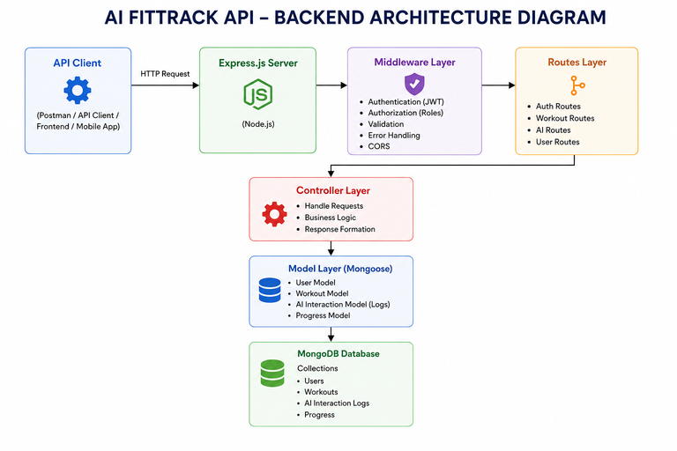

The FitSense application uses a layered backend architecture based on the Model–View–Controller (MVC) design pattern. The system separates routing, application logic, database operations, middleware, and AI functionality into distinct modules. This separation makes the application easier to develop, maintain, test, and expand.
When a client sends an HTTP request, the Express.js server receives the request and directs it to the appropriate API route. If the requested resource is protected, the authentication middleware verifies the JWT token before allowing the request to proceed. After successful validation, the controller processes the request and executes the required business logic. Depending on the operation, the controller communicates with the Mongoose models, application services, or the Google Gemini AI service. Once processing is complete, the server sends the result back to the client as a structured JSON response.
This architecture promotes separation of concerns, improves security, and allows individual modules to be modified or extended without significantly affecting other parts of the application.
Overall Architecture Components
- Client Application / API Client
- Express.js Server
- REST API Routes
- Authentication and Authorization Middleware
- Controllers
- Service Layer
- Google Gemini AI Service
- Mongoose Models
- MongoDB Database
Each component communicates through well-defined interfaces, ensuring loose coupling and easier future enhancements.
Components Definition
The FitSense backend is organized into independent modules, with each component handling a specific responsibility. This separation makes the system easier to maintain, test, and scale. When a request is received, it passes through the required application layers before reaching the database or AI service, helping ensure secure and consistent processing.
- Client Layer (Frontend / API Consumer)
The Client Layer represents the application or tool that communicates with the FitSense backend. It may be a web application, mobile application, or API testing platform such as Postman. The client sends HTTP requests to the backend and receives responses in JSON format.
Responsibilities
Sends HTTP requests to the FitSense APIs.
Displays workout and fitness information to the user.
Maintains the authentication token received after successful login.
Requests AI-generated workout recommendations.
Requests AI-based fitness insights.
Displays successful results and appropriate error messages.
APIs Accessed
User Authentication APIs
Workout Management APIs
Workout Search APIs
AI Recommendation APIs
Fitness Insight APIs
- Express.js Server Gateway
The Express.js server functions as the central communication point between the client and the backend components. It receives incoming HTTP requests, applies the configured middleware, processes request data, and forwards each request to the appropriate API route and controller.

Responsibilities
- Initializes and runs the HTTP server.
- Processes incoming JSON requests.
- Enables Cross-Origin Resource Sharing (CORS).
- Registers and manages application routes.
- Connects the required middleware components.
- Handles application-level errors through centralized error handling.
- Routes requests to the appropriate API endpoints.
- Sends the processed JSON response back to the client.
- Request Processing Flow
- A typical request handled by the Express.js server follows this sequence:
- Receive the HTTP request.
- Process and validate the request format.
- Apply the required middleware.
- Forward the request to the corresponding route.
- Process the request through the appropriate controller.
- Return a JSON response to the client.
- 3. Authentication Middleware
- The Authentication Middleware is responsible for protecting private FitSense APIs. It verifies the JSON Web Token (JWT) included with requests before allowing users to access protected resources.
- When a user attempts to access a secured endpoint, the middleware checks the authorization information provided in the request. A valid token allows the request to continue, while an invalid, missing, or expired token results in the request being rejected.
- Responsibilities
- Read the authorization information from the HTTP request.
- Extract the JWT from the authorization header.
- Verify the authenticity of the token.
- Decode the relevant user information from the token.
- Attach authenticated user details to the request object.
- Block requests containing invalid or missing authentication credentials.
- Benefits
- Protects personal workout information from unauthorized access.
- Ensures protected APIs are available only to authenticated users.
- Provides a consistent authentication mechanism across multiple routes.
- Keeps authentication logic separate from individual controllers.
- Improves the overall security and maintainability of the backend.
4. Route Layer
- The Route Layer defines the REST API endpoints provided by the FitSense backend. It receives incoming HTTP requests and directs them to the appropriate controller based on the requested operation. Each group of routes corresponds to a particular feature of the application.
- Authentication Routes
- The authentication-related routes handle user account operations such as:
- Registering a new user
- Authenticating an existing user
- Retrieving authenticated user information
- Workout Routes
- The workout routes provide operations for managing user workout records:
- Create a new workout
- Retrieve all workouts
- Search for workouts
- Retrieve a specific workout using its ID
- Modify an existing workout
- Remove a workout record
- AI Routes
- The AI-related endpoints provide intelligent fitness functionality:
- Generate personalized workout recommendations
- Generate fitness insights from workout statistics
5. Controller Layer
- The Controller Layer acts as an intermediary between the API routes and the application’s core operations. It receives requests from the route layer, performs the necessary validation, communicates with services or database models, and sends the appropriate JSON response back to the client.
- Authentication Controller
- The Authentication Controller manages operations related to user accounts.
- Responsibilities:
- Registering new users
- Processing user login requests
- Retrieving authenticated user profile information
- Managing authentication-related responses
- Workout Controller
- The Workout Controller is responsible for managing the user’s workout data.
- Responsibilities:
- Creating new workout records
- Retrieving stored workout records
- Modifying existing workout information
- Removing workout records
- Searching and filtering workout history
AI Controller
- The AI Controller manages requests that require AI-based processing.
- Responsibilities:
- Preparing user fitness information for AI processing
- Sending appropriate requests to Google Gemini
- Receiving AI-generated recommendations
- Processing fitness insight results
- Returning AI responses to the client in JSON format
6. Service Layer
- The Service Layer contains reusable application functionality that can be called by different controllers. It keeps specialized operations separate from request-handling logic and improves the organization and maintainability of the FitSense backend.
- Gemini AI Service
- The Gemini AI Service manages the interaction between FitSense and Google Gemini AI.
- Responsibilities:
- Building prompts using user fitness information.
- Sending requests to Google Gemini.
- Receiving AI-generated results.
- Processing and formatting recommendations.
- Providing personalized workout plans and fitness insights.
- JWT Service
- The JWT Service handles token-related operations required for secure user authentication.
- Responsibilities:
- Generating JWT authentication tokens.
- Setting appropriate token expiration periods.
- Verifying the validity of authentication tokens.
- Supporting secure identification of authenticated users.
- Password Service
- The Password Service manages password security during registration and authentication.
- Responsibilities:
- Hashing user passwords before database storage.
- Comparing submitted passwords with stored password hashes during login.
- Preventing plain-text passwords from being stored in the database.
7. Database Layer
- The Database Layer manages the persistent information used by the FitSense application. MongoDB is used as the primary NoSQL database, while Mongoose provides an object data modeling (ODM) layer that enables the Node.js backend to interact with MongoDB using defined schemas and models.
- Collections
- The main collections used by FitSense include:
- Users Collection – Maintains registered user information and authentication-related data.
- Workouts Collection – Stores workout details and records associated with users.
- Advantages
- The MongoDB-based database architecture provides several benefits:
- Flexible Data Structure – Allows fitness-related data to evolve as the application grows.
- Efficient Data Access – Supports quick storage and retrieval of workout records.
- Easy Integration – Works efficiently with Node.js through Mongoose.
- Scalability – Provides a suitable foundation for expanding the application with additional fitness features.
- Schema Validation – Mongoose schemas help maintain consistency in stored application data.
Entity Relationship (ER) Diagram Description
The AI FitTrack backend consists of two primary collections that are logically connected through a one-to-many relationship.

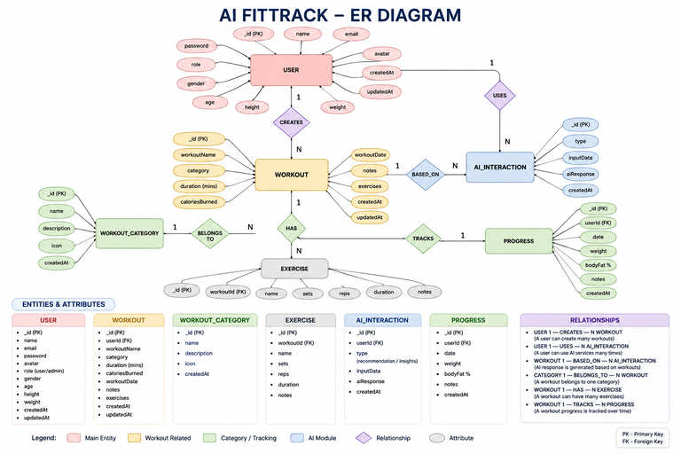

1. User Entity
The User entity stores authentication and profile information.
Attributes
Field | Type | Description
_id | ObjectId | Primary Key
name | String | User Name
email | String | Unique Email Address
password | String | Encrypted Password
createdAt | Date | Record Creation Time
updatedAt | Date | Last Updated Time
Constraints
- Email must be unique.
- Password is encrypted using bcrypt.
- Name is mandatory.
- JWT token is generated after successful login.
2. Workout Entity
The Workout entity stores workout-related information for each authenticated user.
Attributes
Field | Type | Description
_id | ObjectId | Primary Key
user | ObjectId | References User Collection
workoutName | String | Workout Name
category | String | Workout Category
duration | Number | Duration (Minutes)
caloriesBurned | Number | Calories Burned
workoutDate | Date | Workout Date
createdAt | Date | Created Timestamp
updatedAt | Date | Updated Timestamp
Relationship
User → Workout
Relationship Type: One-to-Many
A single user can create multiple workout records. Each workout belongs to only one authenticated user.
Example:
John Doe
- Morning Running
- Evening Jogging
- Upper Body Strength
- Cycling Session
This relationship is maintained using the user field inside the Workout schema, which stores the ObjectId of the corresponding user.
Key Features
The FitTrack AI provides a complete backend solution for workout tracking and AI-assisted fitness guidance.
1. Secure Authentication
The application implements JWT-based authentication.
Features include:
- User Registration
- Secure Login
- Password Encryption
- JWT Generation
- Protected APIs
2. Workout Management
Users can perform complete CRUD operations.
Supported Operations
- Add Workout
- View Workout
- Update Workout
- Delete Workout
Each workout is linked to its authenticated user.
3. Workout Search
Users can search workouts using:
- Workout Name
- Workout Category
- Workout Date
This improves accessibility of workout history.
4. Google Gemini Integration
The backend communicates with Google Gemini AI to generate intelligent workout recommendations.
Input
- Age
- Fitness Goal
- Experience Level
Output
- Weekly Workout Plan
- Suggested Exercises
- Training Tips
- Safety Recommendations
5. AI Fitness Insights
The AI module analyzes workout statistics.
Input
- Total Workouts
- Average Duration
- Calories Burned
Output
- Performance Analysis
- Improvement Suggestions
- Motivational Advice
- Fitness Progress Summary
6. Centralized Error Handling
The application returns meaningful JSON error responses for:
- Invalid Credentials
- Missing Authentication Token
- Validation Errors
- Database Errors
- Internal Server Errors
7. RESTful API Design
The backend follows REST principles.
Supported HTTP Methods
- GET
- POST
- PUT
- DELETE
Responses are returned in JSON format.
8. Modular Architecture
The project separates responsibilities into
- Models
- Controllers
- Routes
- Middleware
- Services
- Configuration
This improves maintainability and scalability.
Roles and Responsibilities
The AI FitTrack backend supports one primary role.
Authenticated User
Responsibilities
- Register an account.
- Login securely.
- View profile information.
- Add workout records.
- View workout history.
- Search workouts.
- Update workouts.
- Delete workouts.
- Request AI workout recommendations.
- Request AI fitness insights.
Permissions
Operation | Permission
Register | Yes
Login | Yes
View Profile | Yes
Add Workout | Yes
Get Workouts | Yes
Search Workouts | Yes
Update Workout | Yes
Delete Workout | Yes
AI Recommendation | Yes
Fitness Insights | Yes
User Flow

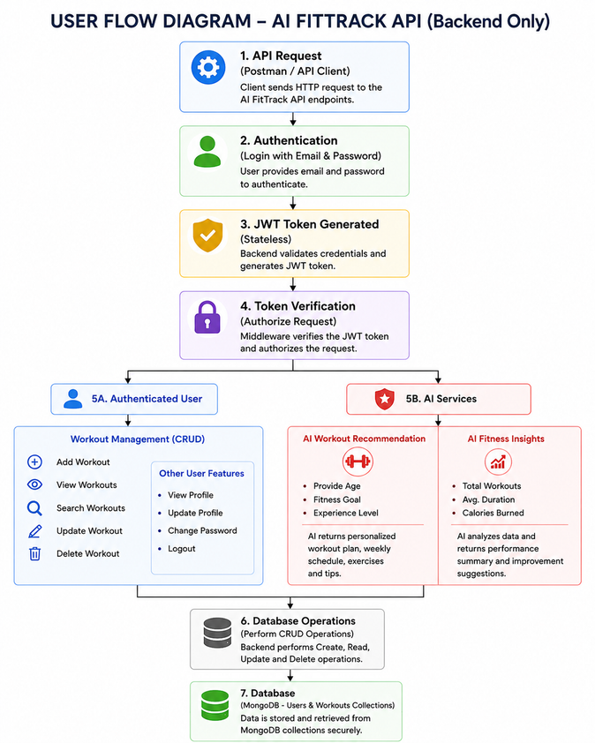

MVC Architecture Pattern
The FitTrack AI is designed using the Model–View–Controller (MVC) architecture pattern. This architecture separates application logic into independent components, improving code organization, maintainability, and scalability.

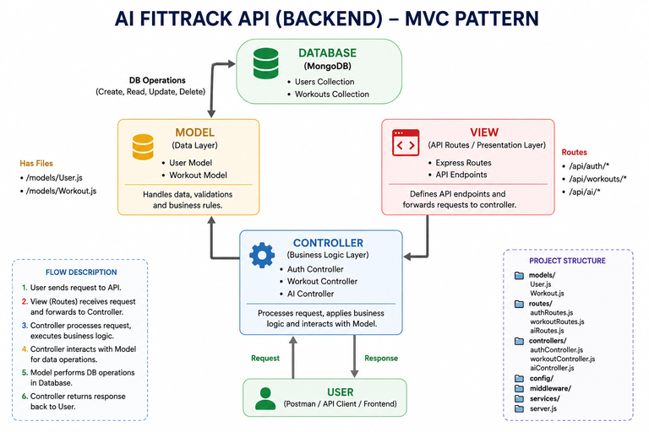

Model Layer (Data Layer)
Model Layer (Data Management)
The Model Layer is responsible for organizing and managing the application’s data. It uses Mongoose schemas to define the structure of information stored in MongoDB. It also handles database communication and performs operations related to user accounts and workout records.
Models used in the FitSense project:
User Model
Workout Model
Responsibilities:
Define data structures and schemas.
Validate data before storing it.
Perform CRUD operations (Create, Read, Update, Delete).
Manage communication with MongoDB collections.
Maintain data consistency.
View Layer (API Interface)
FitSense is a backend application that provides RESTful APIs instead of traditional user interface pages. The View Layer represents the applications and tools that communicate with the backend, such as web applications, mobile applications, and Postman.
Clients send HTTP requests to the backend to access fitness-related features. The server processes these requests and returns the results in JSON format.
Responsibilities:
Send HTTP requests to the backend.
Receive JSON responses from the server.
Display fitness and workout information through the client application.
Manage user interactions with the application.
Controller Layer (Business Logic)
The Controller Layer acts as a communication link between the View Layer and the Model Layer. It receives incoming API requests, processes user input, and coordinates the required operations through models and services.
In FitSense, controllers manage user authentication, workout records, and AI-related requests. After processing each request, they send an appropriate JSON response to the client.
Responsibilities:
Handle incoming API requests.
Validate user input and request data.
Coordinate operations between models and services.
Manage workout and user-related operations.
Process AI recommendation requests.
Return appropriate JSON responses.
Handle errors and communicate their details to the client.
Epic 2: Project Setup and Configuration
The FitTrack AI project follows a well-structured backend architecture that separates business logic, routing, database operations, middleware, and AI services into individual modules. This modular design improves code readability, maintainability, and scalability while making the project easier to debug and extend.
The backend is developed using Node.js and Express.js, with MongoDB as the primary database and Google Gemini AI for intelligent fitness recommendations.
Creating Project Folder
Step 1: Create the Project Folder
Create a new folder with the project name.
AI-FitTrack-API
Step 2: Open the Project
Open the project folder in Visual Studio Code.
Step 3: Create the Server Folder
Inside the project directory, create a folder named:
server
All backend source code will be maintained inside this folder.
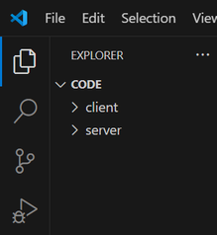

Step 4: Initialize Node Project
Open the terminal inside the server folder and execute:
npm init -y
This command generates the package.json file containing project metadata and dependency information.
Step 5: Install Required Packages
Install the required dependencies.
npm install express mongoose dotenv bcryptjs jsonwebtoken cors
Install Nodemon as a development dependency.
npm install --save-dev nodemon

Environment Variables
Sensitive information is stored in the .env file.
Example
PORT=5000

MONGO_URI=mongodb://localhost:27017/aifittrack

JWT_SECRET=your_secret_key

GEMINI_API_KEY=your_google_gemini_api_key
Using environment variables improves security by preventing sensitive information from being exposed in source code.
Epic 3: Backend Development
Backend development focuses on implementing REST APIs that allow authenticated users to manage workouts and interact with Google Gemini AI.
The project is divided into multiple modules that collectively perform authentication, workout management, AI integration, and database operations.
Major modules include:
- Server Configuration
- Database Configuration
- Authentication
- Workout Management
- AI Recommendation
- Middleware
- Error Handling
Video Link: https://drive.google.com/file/d/1KswrctSaPI0eOYyJ3GkbbVHvHsU3EfZJ/view?usp=sharing
Epic 4: Database Configuration
The FitTrack AI uses MongoDB as its primary NoSQL database for storing user credentials and workout information. Mongoose serves as the Object Data Modeling (ODM) library, enabling seamless interaction between the application and the MongoDB database. Mongoose provides schema validation, middleware support, data relationships, and simplified CRUD operations.
The database layer is responsible for maintaining data integrity, validating incoming requests, and ensuring secure storage of user information.
MongoDB Configuration
MongoDB stores application data in collections rather than traditional relational database tables. The FitTrack AI maintains separate collections for users and workouts.
Database Collections
- Users Collection
- Workouts Collection
Each collection stores JSON-like documents (BSON format), allowing flexible schema design while maintaining efficient data retrieval.
Installing Mongoose
Install Mongoose using npm.
npm install mongoose
Mongoose acts as the bridge between the Node.js application and MongoDB by providing schema definitions, validation, and database methods.
MongoDB Connection
The database connection is configured inside the config/db.js file. This module establishes a connection to the MongoDB server when the application starts.

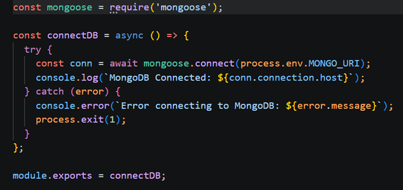

Responsibilities
- Connect to MongoDB
- Handle Connection Errors
- Display Connection Status
- Export Database Connection

Advantages
- Centralized database configuration
- Reusable connection module
- Automatic connection management
- Simplified error handling
Mongoose Schemas
The AI FitTrack backend contains two primary Mongoose schemas:
- User Schema
- Workout Schema
Schemas define the structure, validation rules, and relationships for MongoDB documents.
1. User Schema (models/User.js)
The User schema stores authentication information for registered users.

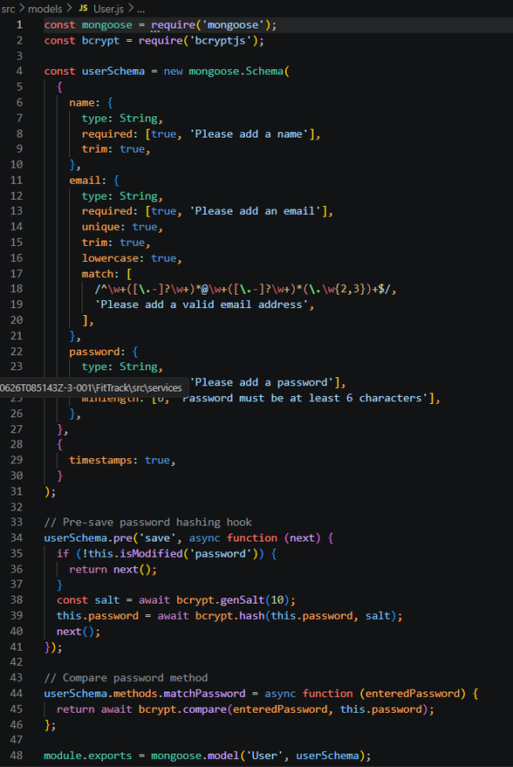
Validation Rules
- Name cannot be empty.
- Email must be unique.
- Password is mandatory.
- Password is encrypted using bcrypt.js before saving.
- Automatic timestamps are enabled.
User Schema Features
- Email uniqueness validation
- Password hashing
- Automatic timestamps
- Secure authentication support
- JWT integration
2. Workout Schema (models/Workout.js)
The Workout schema stores workout information created by authenticated users.

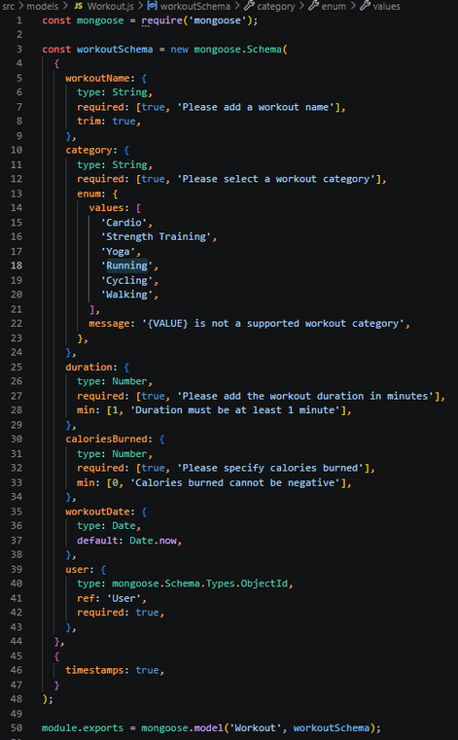
Validation Rules
- Workout Name is mandatory.
- Category is mandatory.
- Duration must be greater than zero.
- Calories Burned must be greater than or equal to zero.
- Workout Date is required.
- Every workout belongs to one authenticated user.
Workout Schema Features
- Schema validation
- Automatic timestamps
- User relationship
- Easy search support
- Efficient CRUD operation
Epic 5: Project Execution
· Install Postman or ThunderClient (VS Code extension).
· Start the backend server:
“npm start”
API Testing
API testing ensures that every endpoint functions correctly and returns the expected response. The FitTrack AI is tested using Postman, allowing developers to verify request handling, authentication, database operations, and AI integration.
Testing is performed in the following order:
- Authentication APIs
- Workout APIs
- AI APIs

Authentication API Testing
Register User

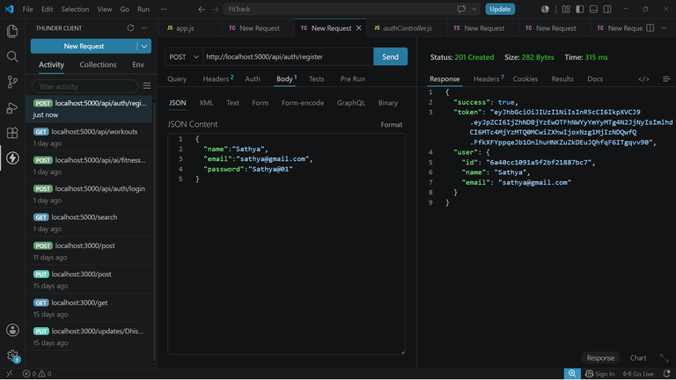

Login User

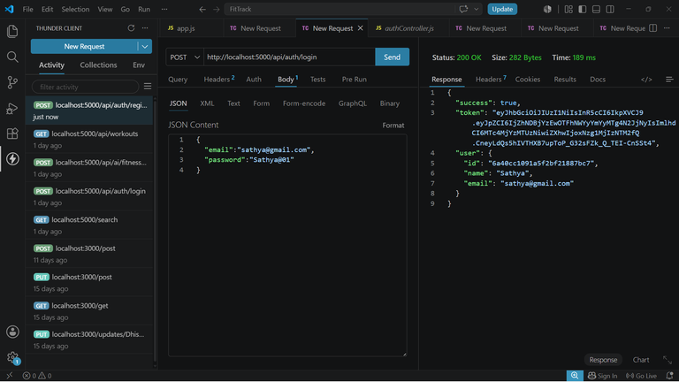

Get Profile

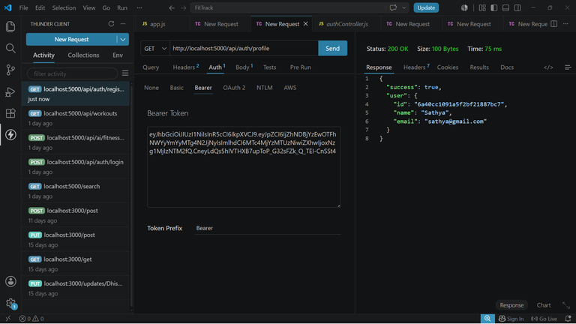

Workout API Testing
Add Workout

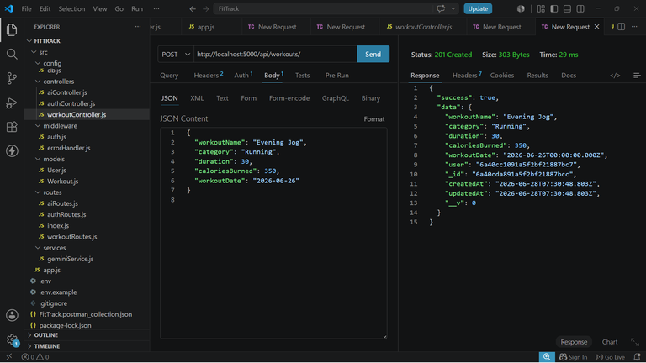

Get All Workouts

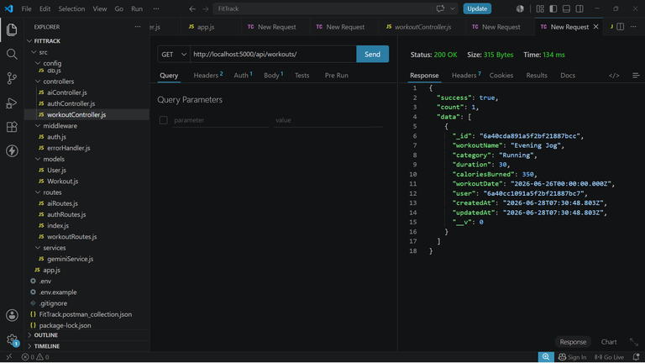

Get Workout By ID

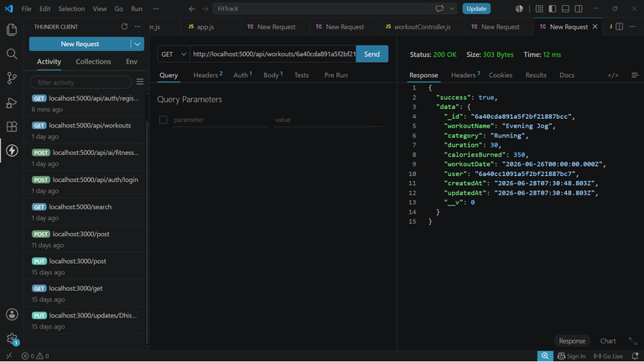

Update Workout

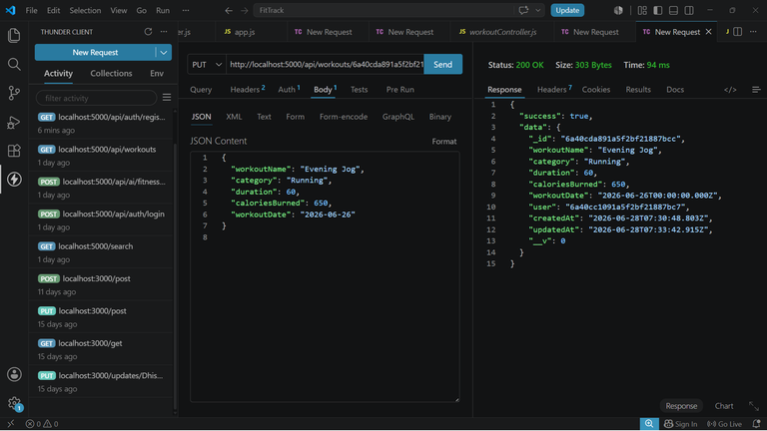

Delete Workout

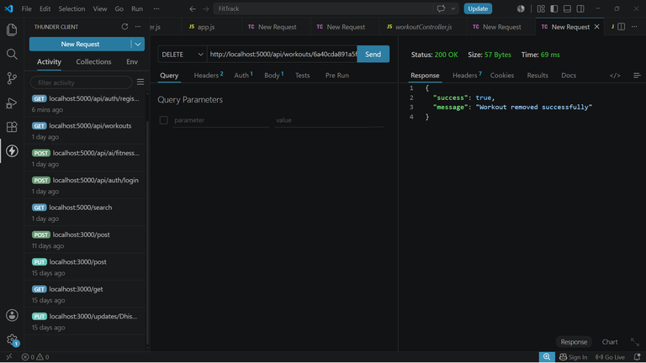

AI API Testing
Workout Recommendation

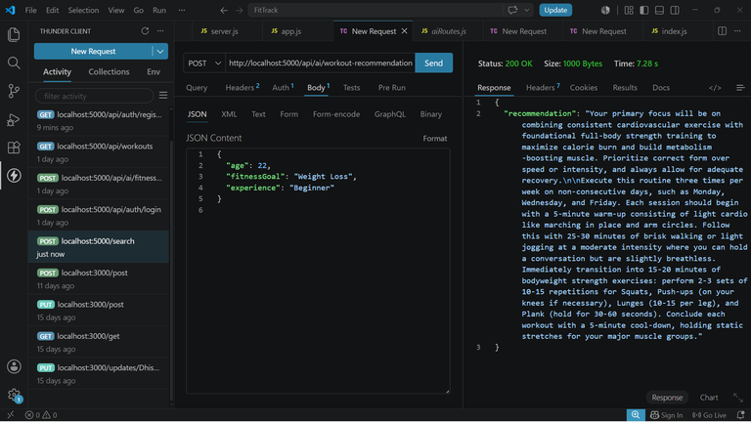

Fitness Insights

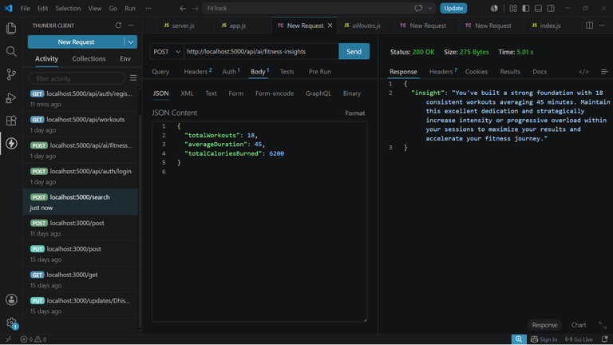

API TESTING VIDEO : https://drive.google.com/file/d/1_pbQY2h_bV5l5U-wXaccgIOTRDJwNbzS
CodeDrive:https://drive.google.com/drive/folders/1hwmKxkHQkUI62JR1svI3xCQ2ShZ6Lj9y.

