How To Hack Your Way Into Hackthebox

By Abraham Cain

# Introduction to Hackthebox

Hackthebox.eu is a European website that acts as a virtual environment for hackers and cybersecurity enthusiasts to hone their hacking skills. The website features trainings, games, and live machines to hack into with wikis and a points system to make things fun and competitive.

To be able to compete in these cyber games and hack these machines, you must past a test to be eligible to create your account. You must hack the website to find an invite code to sign up for an account. There is more than one way to do this, but the way that I will show you will be possible 100% from the browser (Google Chrome) instead of having to use a terminal or other tools/programs. The method tests successfully in the new Microsoft edge and older internet explorer as well. To follow along easily, I recommend downloading chrome.

The Instructions will split at one point as encoding type is randomly assigned in the first string.

# Instructions

1. Click the **Hack Your Way In** button.

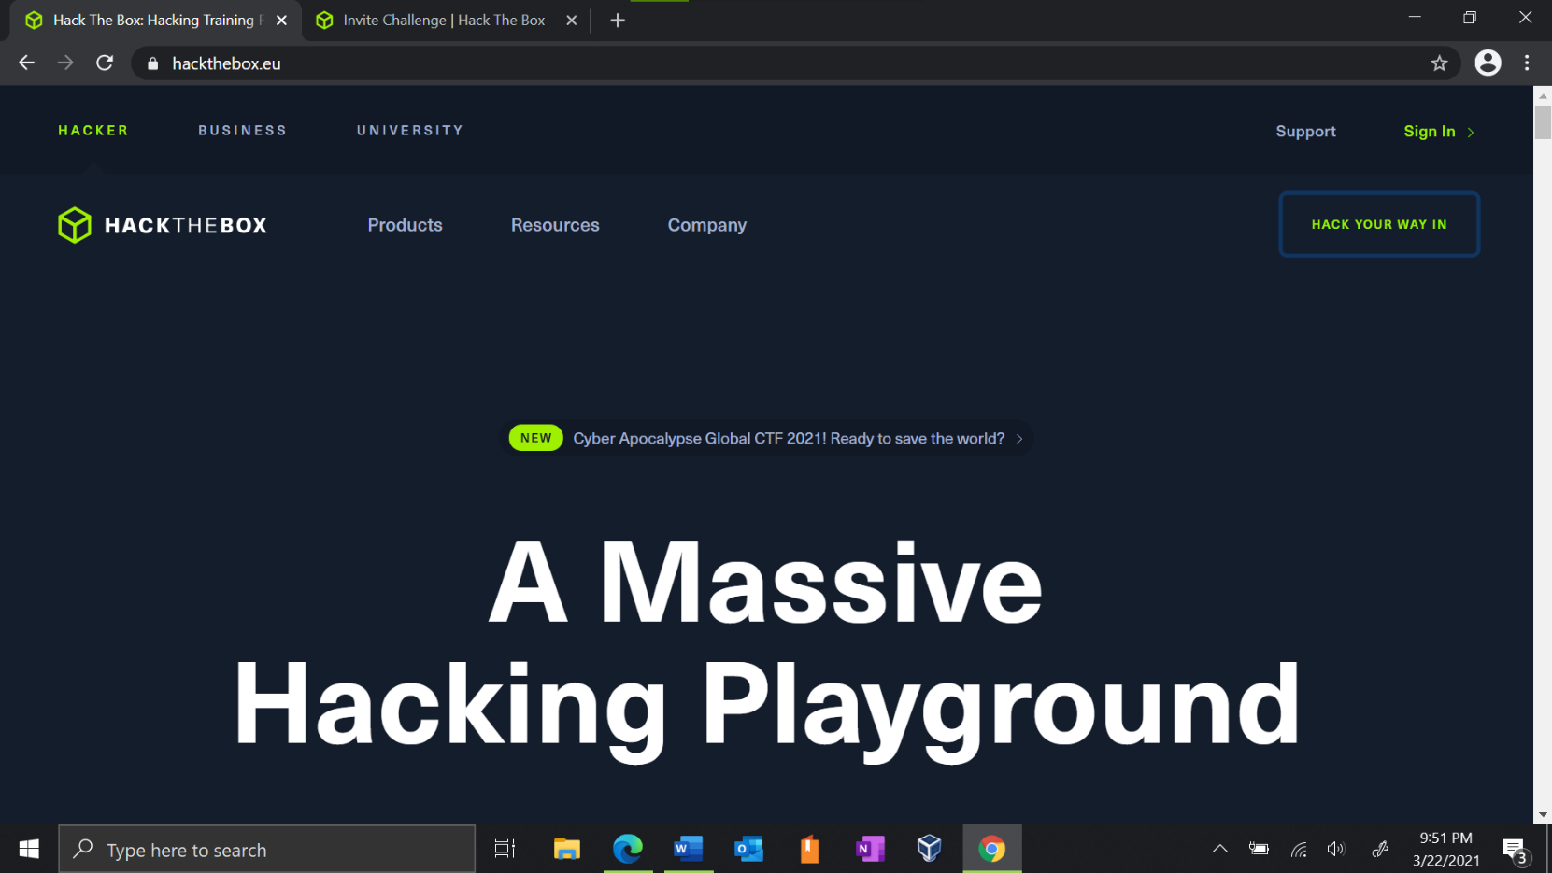

1. 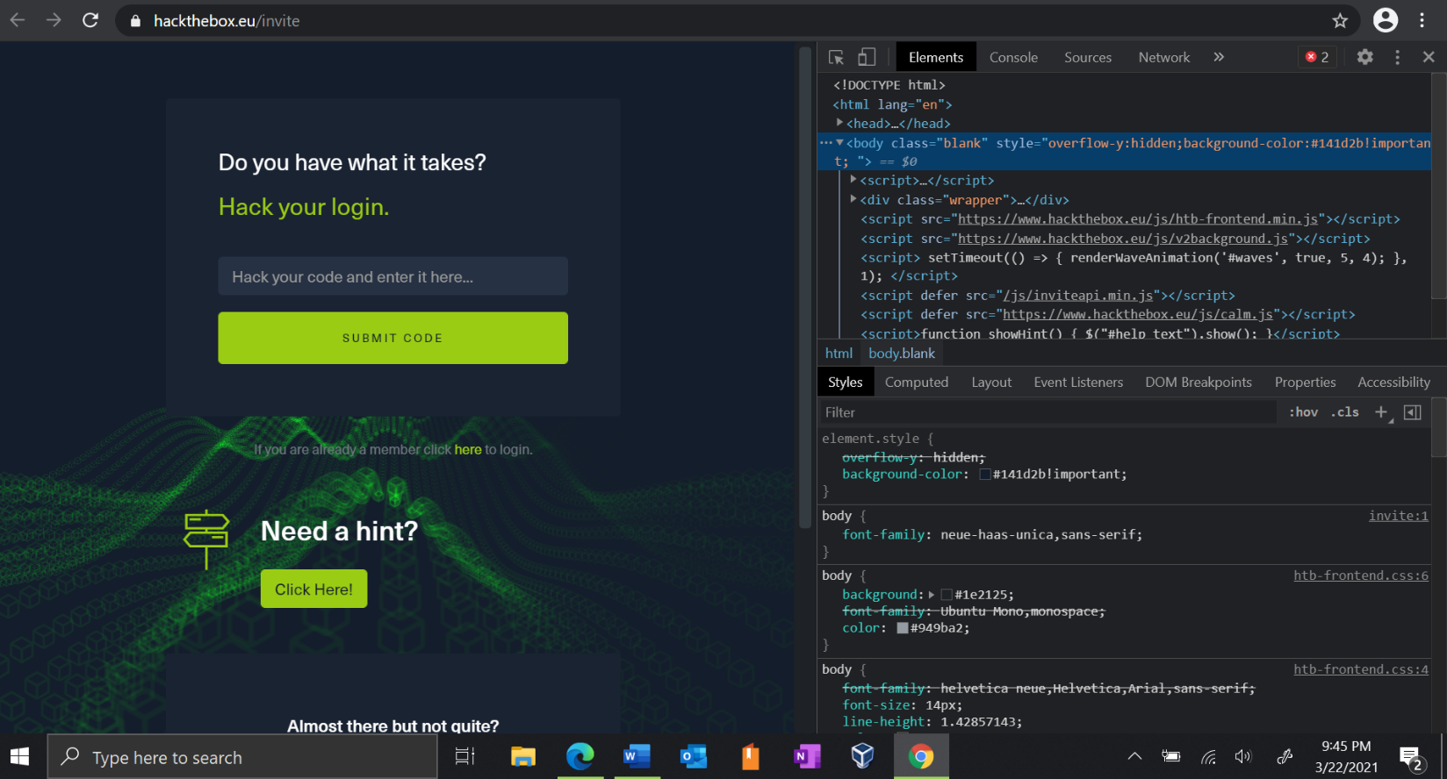Press the **i** key while holding down the **Ctrl** and **Shift** keys.
2. 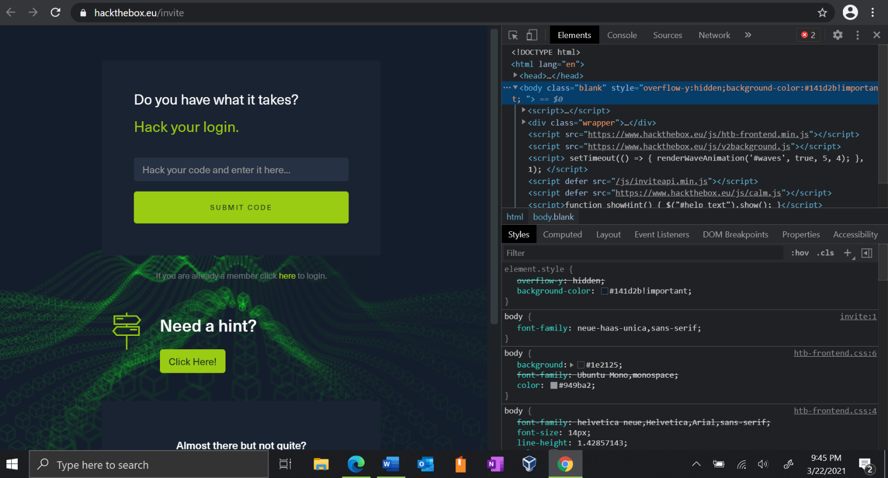Click on the **Console** tab.
3. 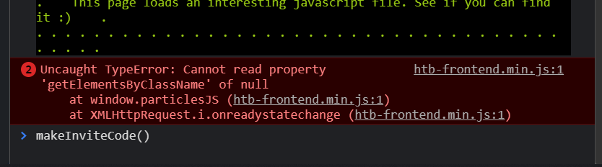Enter **makeInviteCode()** in the console at the bottom of the screen and hit the **Enter** key.



1. 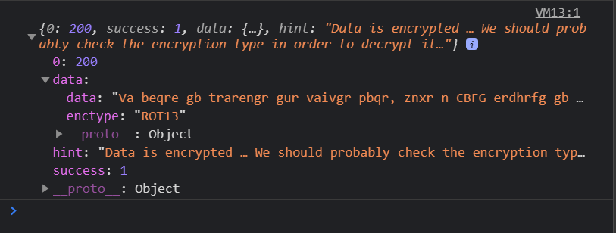 Click the icons until you see the word **enctype** in magenta.

* Take note of the word in quotes next to **enctype**.

 OR

* I will refer to this as your **Encoding Type** later on and the data as the **String.**

1. 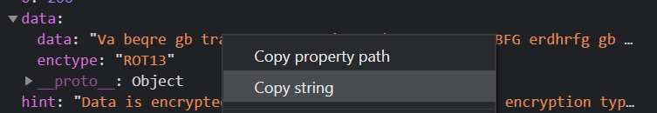Right click the scrambled words next to **data:** and click **Copy string**.

* If your Encoding Type is **ROT13**, *follow* steps 7-8 and *skip* steps 9-11.
* If your Encoding Type is **BASE64**, *skip* steps 7-8 and *follow* steps 9-11.

1. 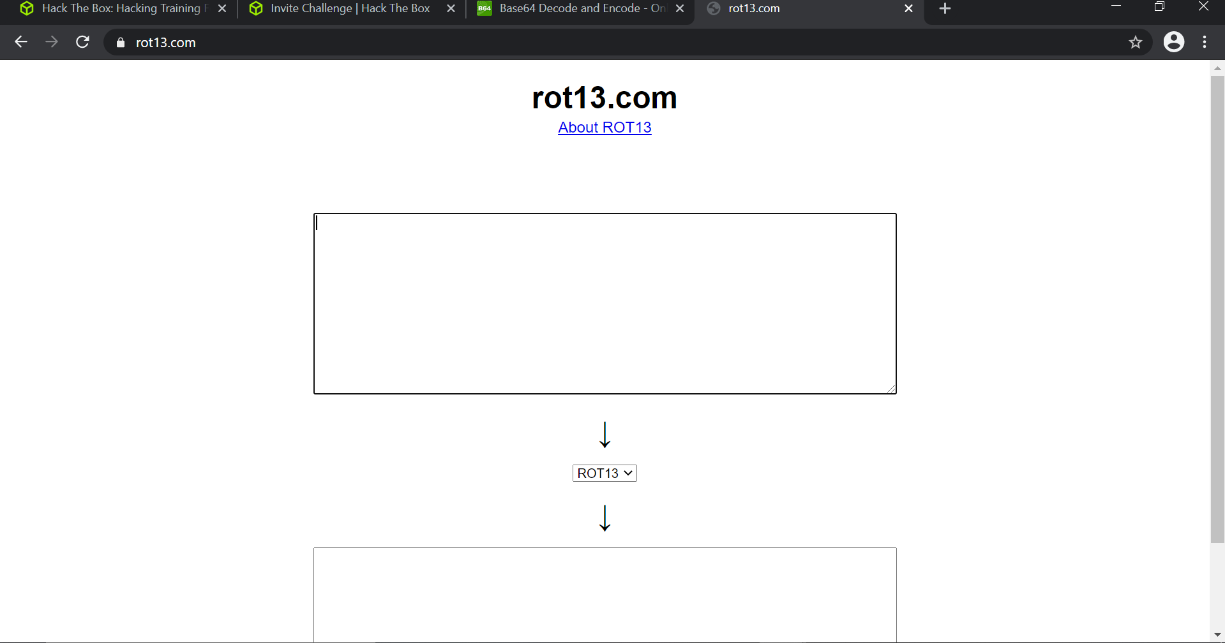Browse to **rot13.com** in a new browser tab.
2. Paste the String into the top box and copy the results from the bottom box.

* 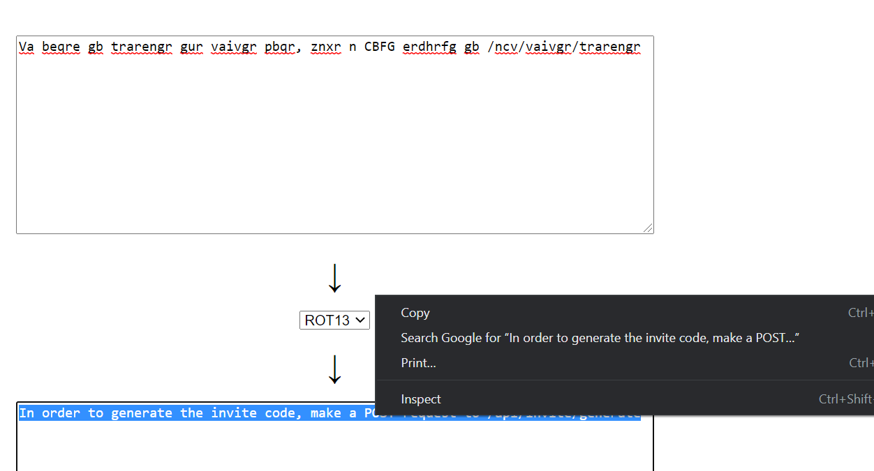You may need to click the rot13 button to get it to refresh if your code doesn’t appear immediately.

1. 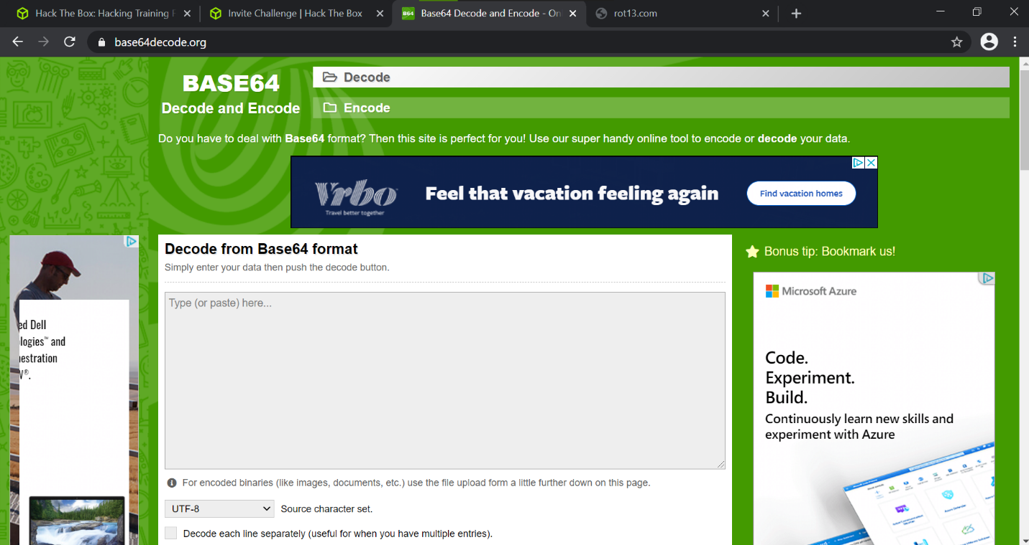Browse to **base64decode.org** in a new browser tab.
2. 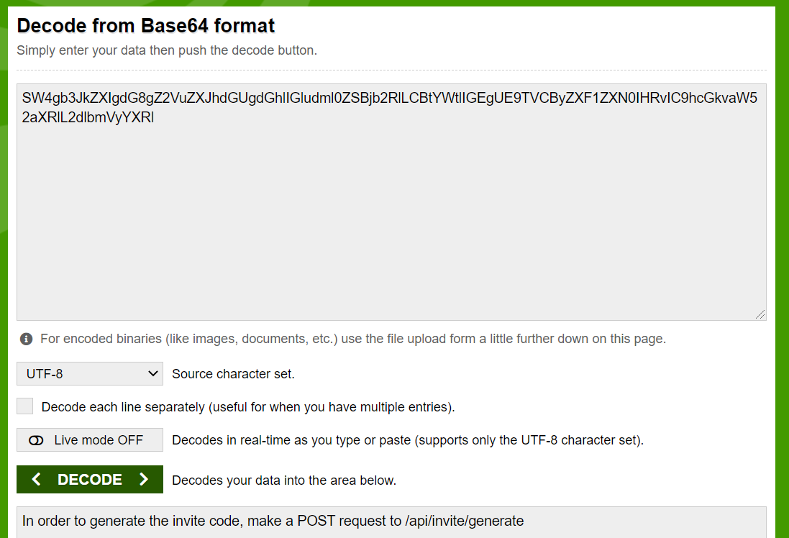Paste your string in the top box, click Decode, and copy the result from the bottom box.
3. 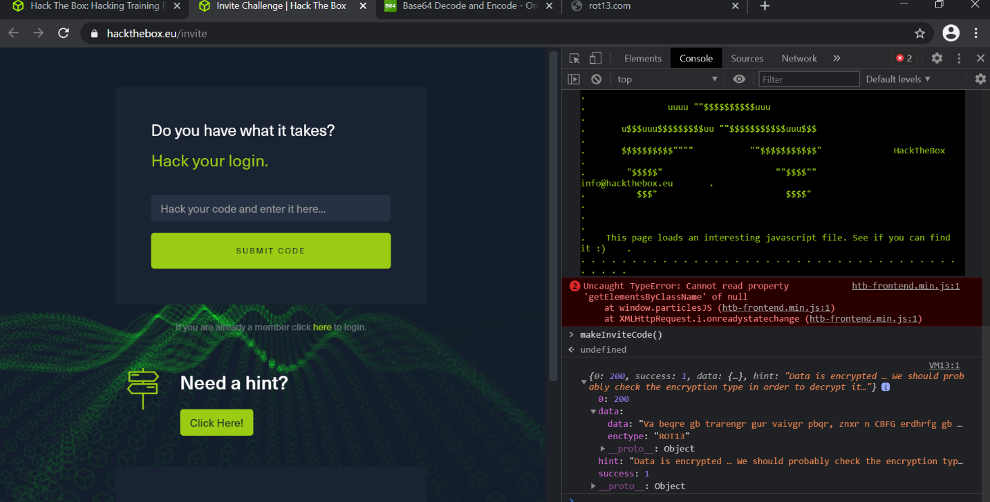Navigate back to our tab with the **console window**.
4. Enter the following **CASE SENSITIVE** code below into the console:

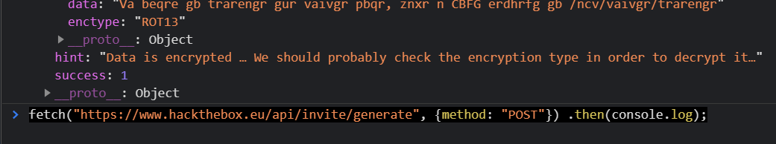fetch("https://www.hackthebox.eu/api/invite/generate", {method: "POST"}) .then(console.log);

1. 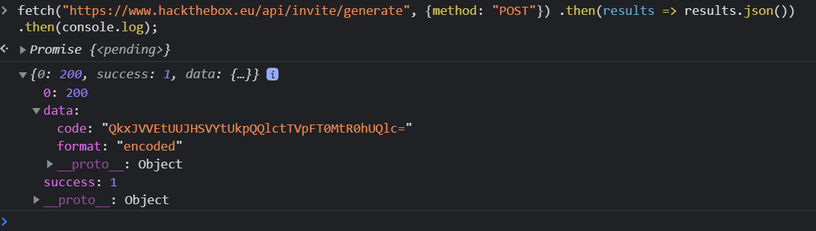Click the icons until you see the word **code** in magenta.
2. Right click the scrambled words next to **code:** and click **Copy string**.

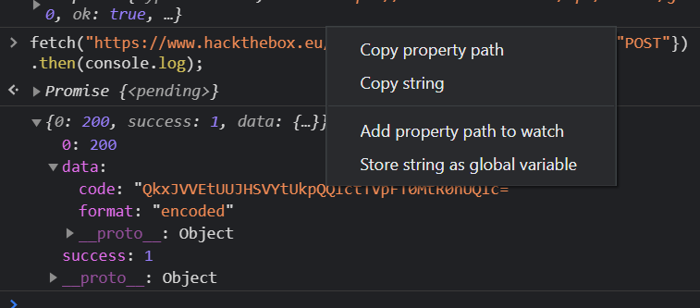

1. Browse to **base64decode.org** in a new browser tab.
2. Paste your string in the top box, click Decode, and copy the result from the bottom box.

* In the bottom box you will see your 25 digit invite code with other numbers or letters instead of **X.**
* XXXXX-XXXXX-XXXXX-XXXXX-XXXXX

1. 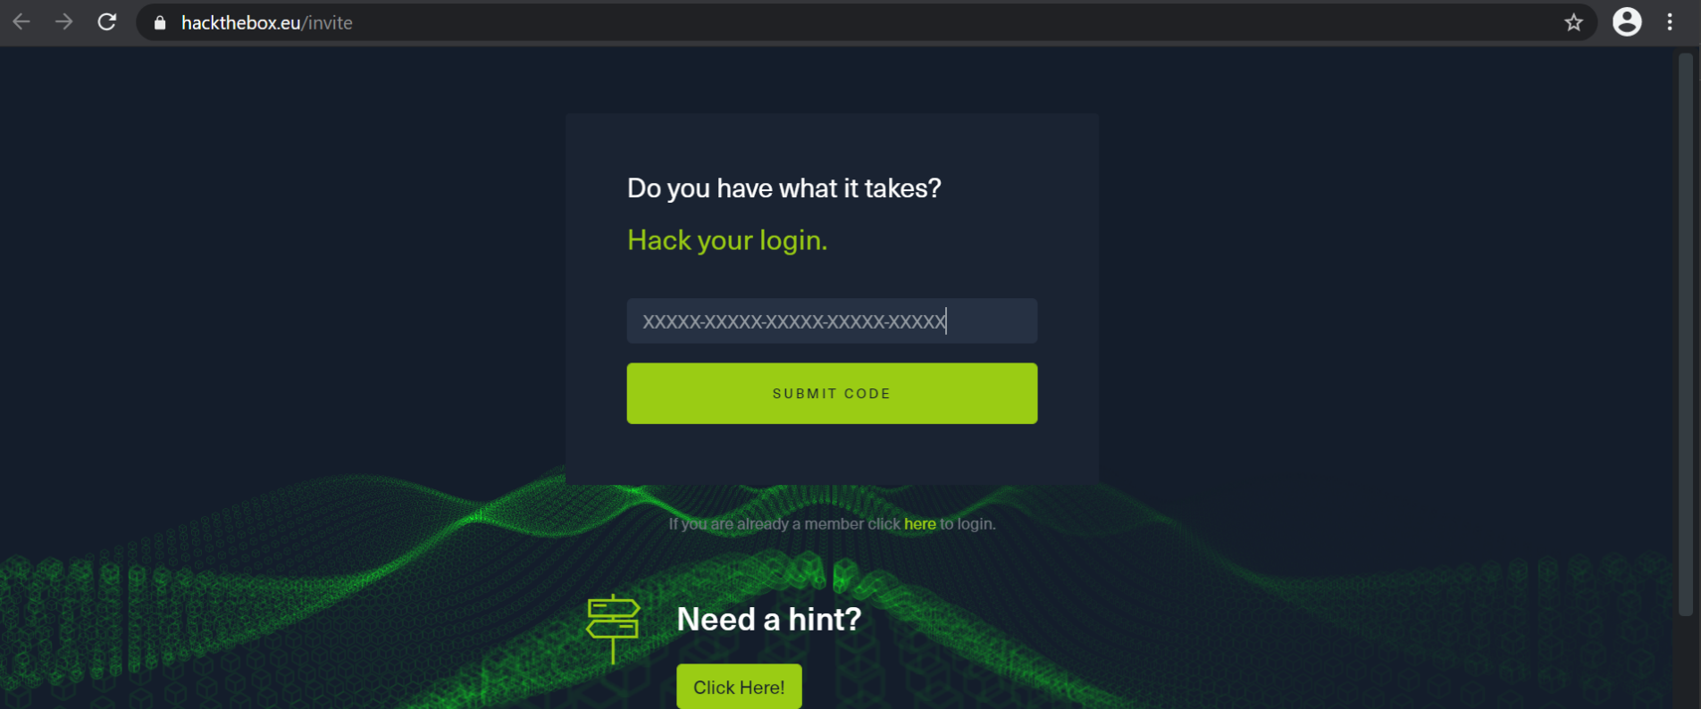Copy this code and paste it into the box at **hackthebox.eu/invite.**
2. Click **Submit Code** and you will be allowed to create an account.