**Trilogy - Student Presentation Filming Protocol**

Congratulations Instructors/TAs! You’ve made it to another big day. Student presentation are a great way to step-back and see the fruits of your hard work. Across the board, our students put tremendous work and create stunning applications. It’s awesome being able to see just how much progress they’ve made. For all these reasons, it’s incredibly important that we document their success in an audio/visual format.

Please review the guide below on general steps for using the camera and audio equipment provided to ensure a high quality recording. Feel free to reach out to the Trilogy Academic Staff if you have any questions.

**1-2 Days in Advance:**

1. **Check your equipment.** At this point, you should have each of the following pieces of equipment in your possession:
   * Camcorder
   * 64 GB SD Card (in camcorder)
   * Wall Charger
   * Extension cable or outlet
   * Tripod
   * Handheld Condenser Microphone
   * Camcorder Earpiece (for listening to camcorder sound – live)
   * Extended Auxiliary Cable OR Wireless Transmitter/Receiver
   * If Wireless Transmitter/Receiver: Two Backup 9V Batteries.

Additionally, you should have one of the following pieces of software available to create high-resolution screen recordings. Experiment a bit with your recording software to ensure you know how to record the screen AND audio. (The audio from this recording will be used to sync the sound with the audio from the camcorder, ensuring we have two streams of audio).

* QuickTime
* Camtasia Editor

**Day of Presentations (Setup):**

Use the following guide when setting up the equipment.

1. **Toggle the camcorder lens cap.**

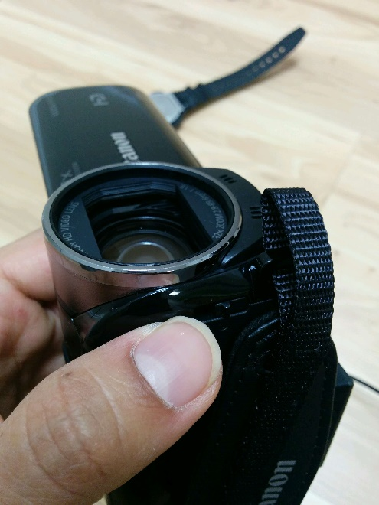

1. **Plug in the wall charger into the camcorder.**

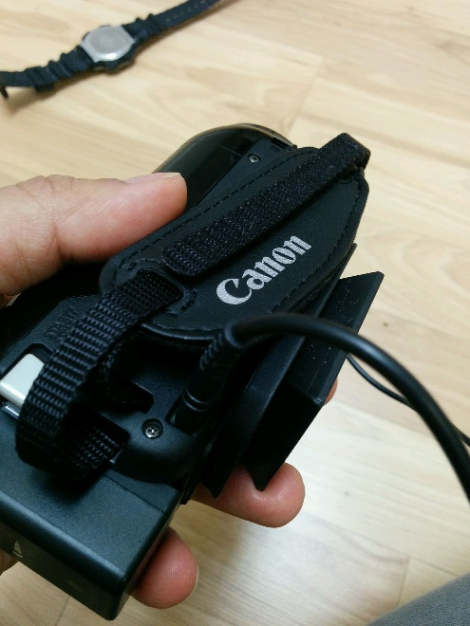

1. **Clear any existing recordings on the camcorder.**

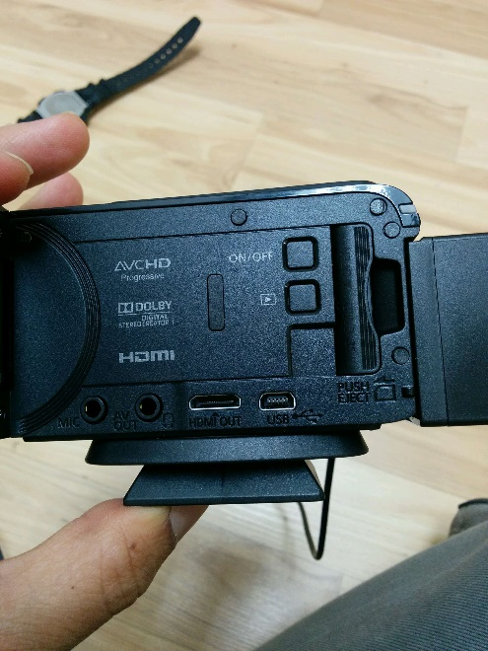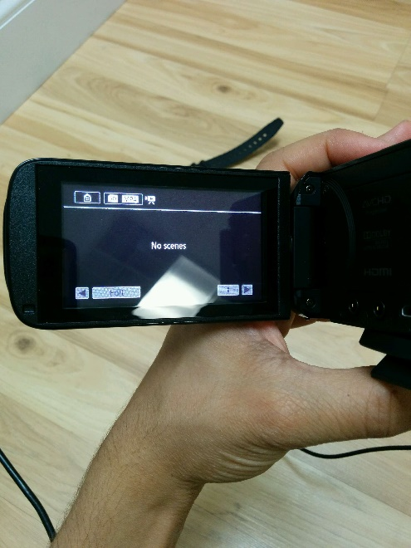

1. **Plug in the auxiliary cable from the condenser microphone into the MIC in of the camcorder.** IMPORTANT: Double confirm that the microphone is connected to the MIC in and not the AV OUT. Note:If you were provided a special high-end WR-PRO wireless microphone you can use this instead.

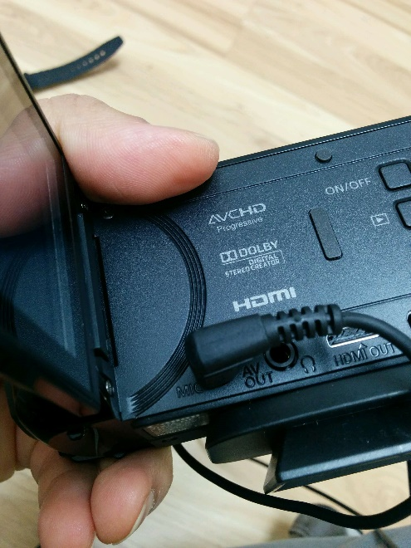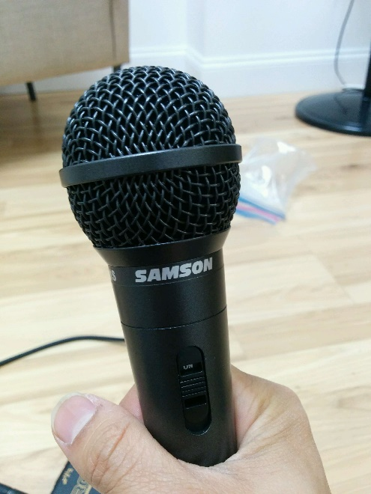

1. **Connect the Earpiece into the AV OUT of the mic.** Use this earpiece to test that the microphone is working correctly. NOTE: You must use the earpiece that came with the camera. A standard set of headphones will not work.

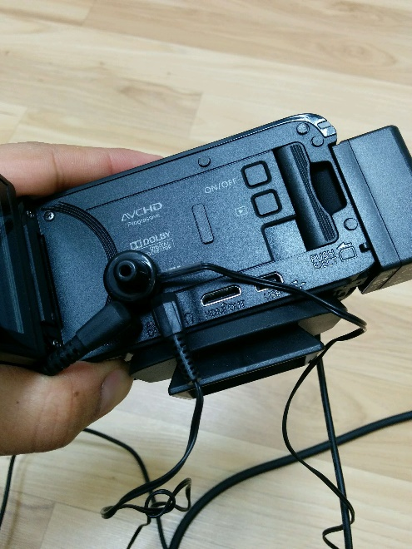

1. **Setup the camcorder on the tripod.**
2. **Hit the record button on the camcorder when ready to begin.** IMPORTANT: Do NOT create cuts in the recording. Keep the camcorder on for the entirety of class with the exception of your lunch-break. This is easier for us to video produce.

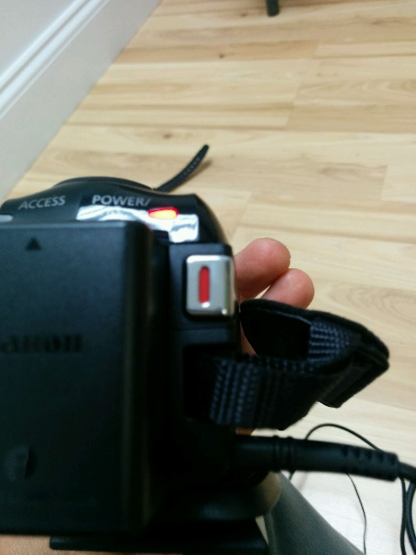

**Day of Presentations (Live):**

For the most part, recording the presentations should be straightforward. Just remember:

* To have both the screen recording software AND the camcorder running at all times during the presentation.
* Constantly, remind students to speak INTO microphone. This is critical for high-quality audio.
* DO NOT attempt to do fancy panning or zooming with the camcorder. Keep the camera focused on the students at all times, and try to move the camcorder as little as possible. This creates a more professional recording.

**Day of Presentations (Post):**

After presentations are complete, pack up all the AV equipment and return it to a member of the Trilogy Academic Staff or Student Success Team.

**1-7 Days After Presentation:**

Follow any instructions provided by the Trilogy Academic Staff regarding uploading and sharing the video and screen-recordings. Trilogy will handle all of the video editing and production.

Stay tuned! You’ve pulled off an incredible amount of work here!