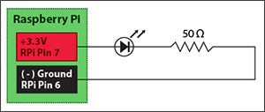

TURN ON

import RPi.GPIO as GPIO ## Import GPIO library
GPIO.setmode(GPIO.BOARD) ## Use board pin numbering
GPIO.setup(7, GPIO.OUT) ## Setup GPIO Pin 7 to OUT
GPIO.output(7,True) ## Turn on GPIO pin 7

BLINKING

import RPi.GPIO as GPIO
import time #essetialy delay from arduino
GPIO.setmode(GPIO.BOARD)
GPIO.setup(7, GPIO.OUT)
blink_speed=float(raw_input(“Duration:”))
iterations=int(raw_input(“no of blinks required”))
for i in xrange(iterations):
GPIO.output(7,True)
time.sleep(blink_speed)
GPIO.output(7,False)
time.sleep(bink_speed)
GPIO.cleanup()#just to be safe

PWM
Duty Cycle =Turn ON time/ (Turn ON time + Turn OFF time)
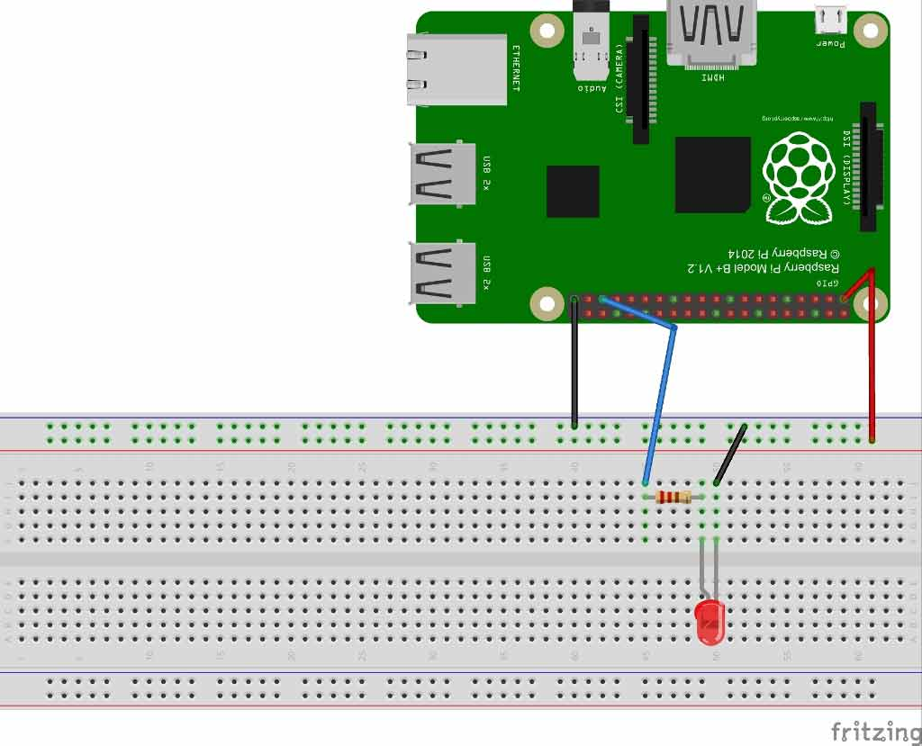
220Ω or 1KΩresistor

import Rpi.GPIO as pin
import time
pin.setwarnings(False)
pin.setmode(pin.BCM)
pin.setup(19,pin.OUT)
analog=pin.pwm(19,100)#19 as pwm with 100 Hz
analog.start(0)#pwm with 0 percent duty cycle
while(1):
for i in range(50):
analog.ChangeDutyCycle(i)#increase from 0 to 50
time.sleep(0.2)
for i in range(50):
analog.ChangeDutyCycle(50-i)#decrease from 50 to 0
time.sleep(0.2)

ULTRASONIC SENSOR
Distance= (Time x Speed of Sound in Air (343 m/s))/2

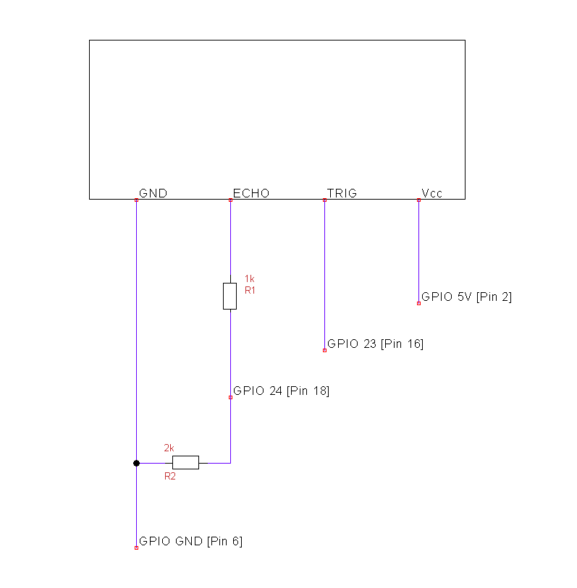

program
impor Rpi.GPIO as pin
pin.setmode(pin.BCM)
import time
trig=23
echo =24
pin.setup(trig,pin.OUT)
pin.setup(echo,pin.IN)
pin.output(trig,False)#enusure trigger is false
time.sleep(2)#sensor to settle
pin.output(trig,True)
time.sleep(0.00001)
pin.ouput(trig,False)
while pin.input(echo==0):
start_time=time.time()
while pin.input(echo==1):
stop_time=time.time()
p_d=stop_time-start_time
distance=round((p_d*17150)/2)
print “distance”,distance,”cm”
pin.cleanup()

Servo

