

Praktikum Pemrograman Web Angkatan 2021

TUGAS MODUL 3



July 20, 2023

Abraham Leo c.m.l

312110030

TI.21.B.1

**SOAL**

1. Write a PHP script to extract the user name from the following email ID.

Sample String : 'budi@mhs.pelitabangsa.ac.id'

Expected Output : 'budi'

1. Write a PHP script to get the filename component of the following path.

Sample path : "https://informatika.pelitabangsa.ac.id/dosen/"

Expected Output : 'dosen'

**JAWABAN**

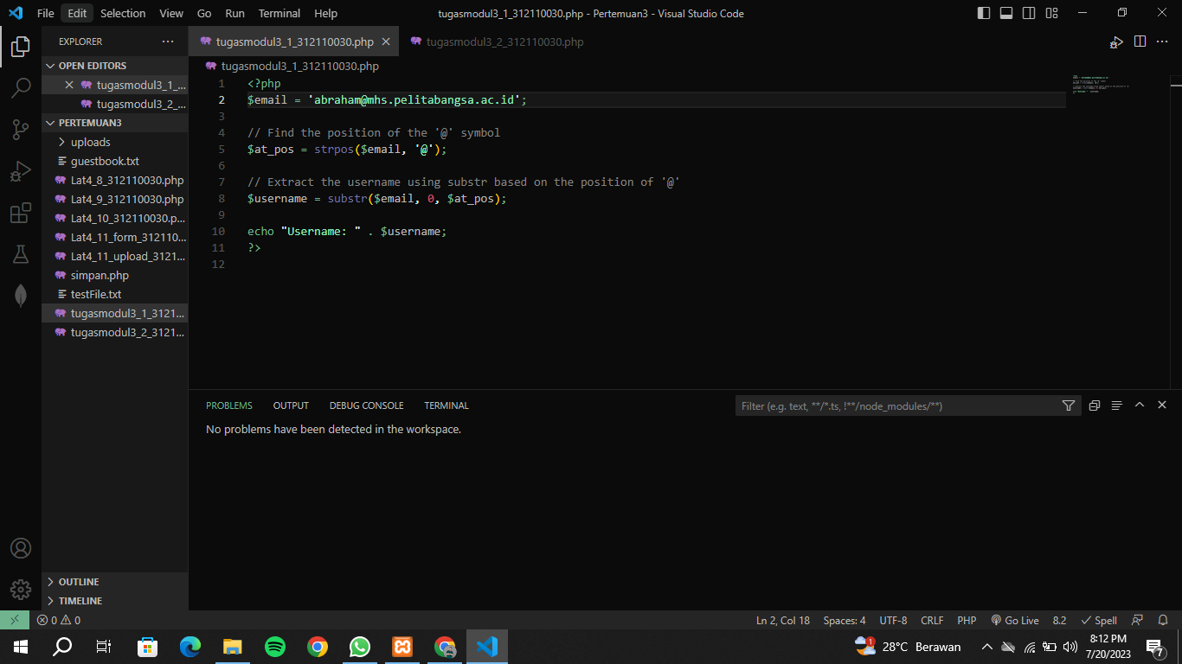

Figure 1 Codingan Soal Nomor 1

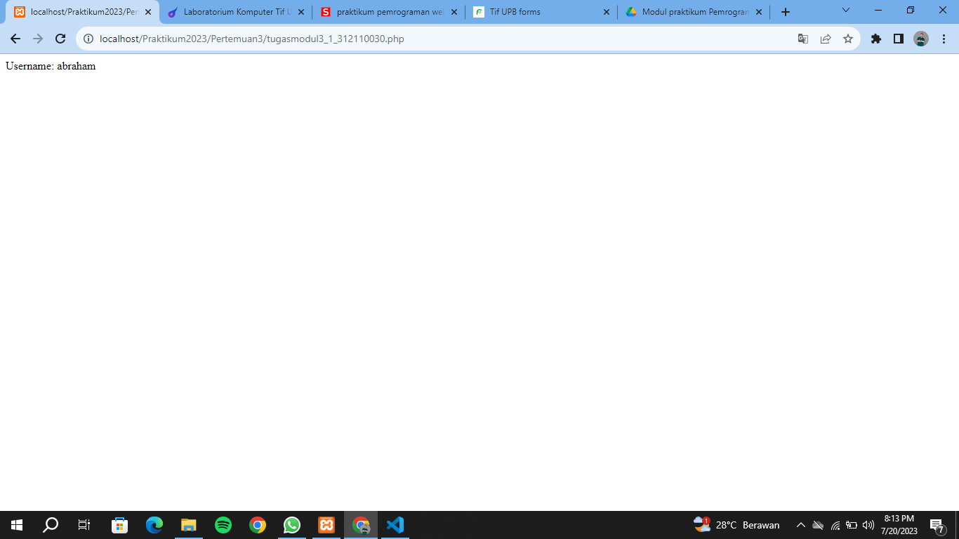

Figure 2 Hasil Coding Soal Nomor 1

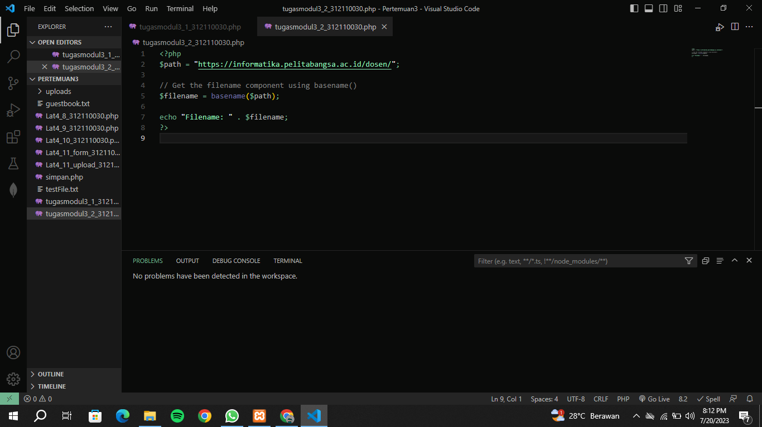

Figure 3 Codingan Soal Nomor 2

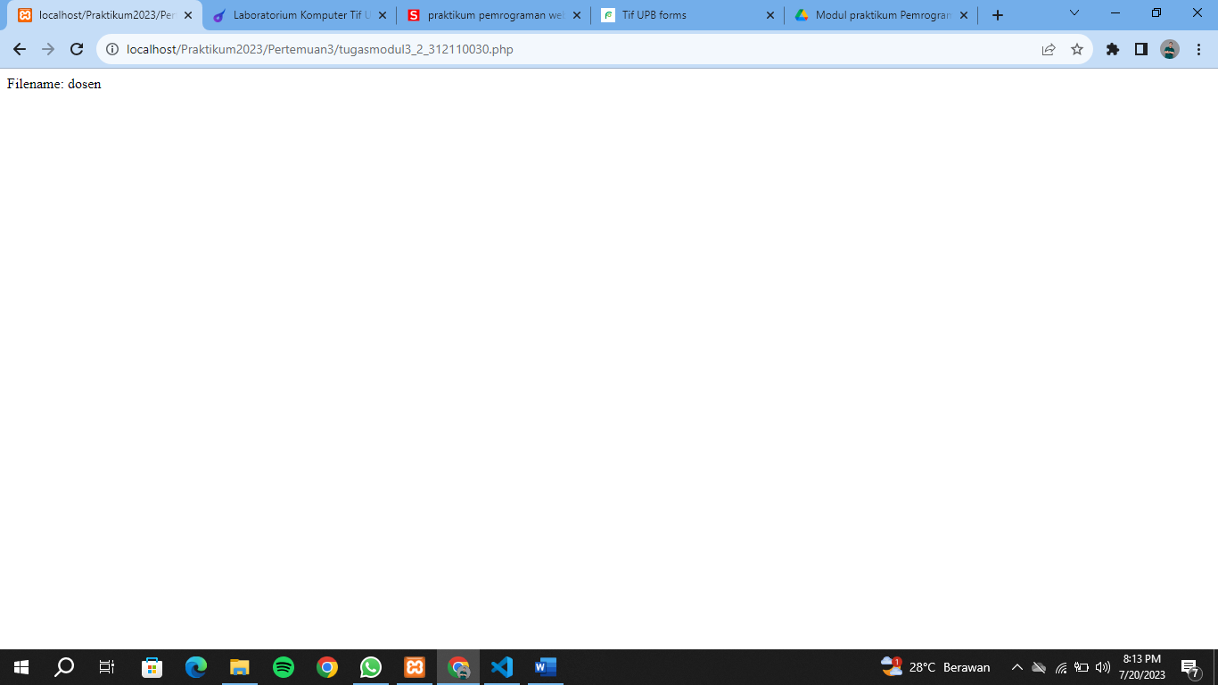

Figure 4 Hasil Coding Nomor 2