**MOBILE BENCHMARK**



**ABRAHAM LUGO**

**LEIDER PINEDA**

**MIGUEL JULIO**

**UNIVERSIDAD DEL NORTE**

**DIVISIÓN DE INGENIERÍAS**

**DEPARTAMENTO INGENIERÍA DE SISTEMAS**

**COMPUTER STRUCTURE II**

**BARRANQUILLA**

**2019-2**

**Huawei P Smart 2018 Samsung Galaxy J6 2018**

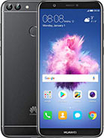 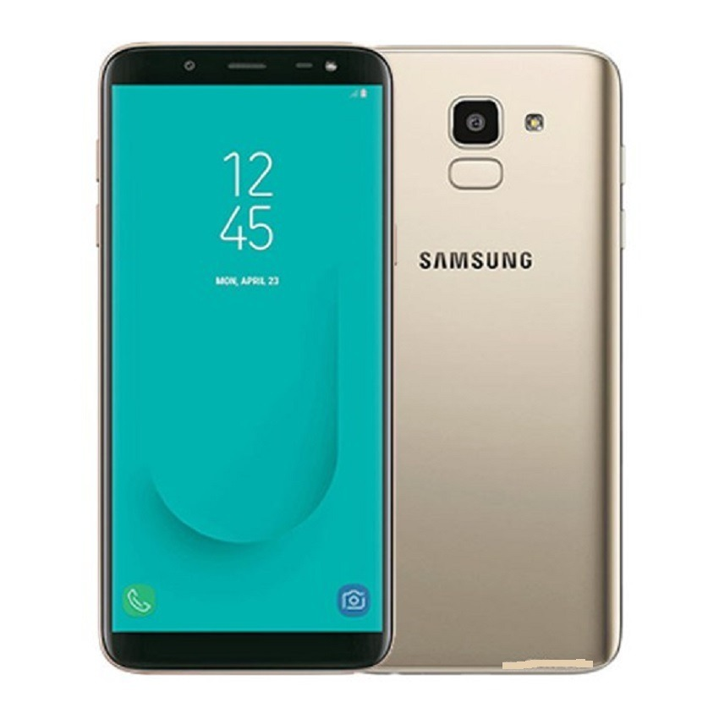



**Benchmark to use**

**GeekBench 4** is a cross-platform processor benchmark, with a scoring system that separates single-core and multicore performance, and workloads that simulate real-world scenarios.

**Antutu** is a Chinese software benchmarking tool commonly used to benchmark phones and devices.

Before using Benchmark to compare the two smartphones (Huawei P Smart 2018 and the Samsung Galaxy J6 2018). We thought that the best smartphone was the Huawei Smart, this because just by comparing the specifications between these two devices, we draw the proper conclusions.

**Device**

|  |  |  |  |  |  |
| --- | --- | --- | --- | --- | --- |
| **Phone** | **Model** | **OS** | **GPU** | **Resolution** | **Display PPI** |
| Huawei P Smart | HUAWEI FIG-LX3 | Android 9 | Mali-T830 | 1080 x 2160 | 428 |
| Samsung Galaxy J6 | samsung SM-J600G | Android 9 | Mali-T830 | 720x1480 | 294 |

**Using GeekBench**

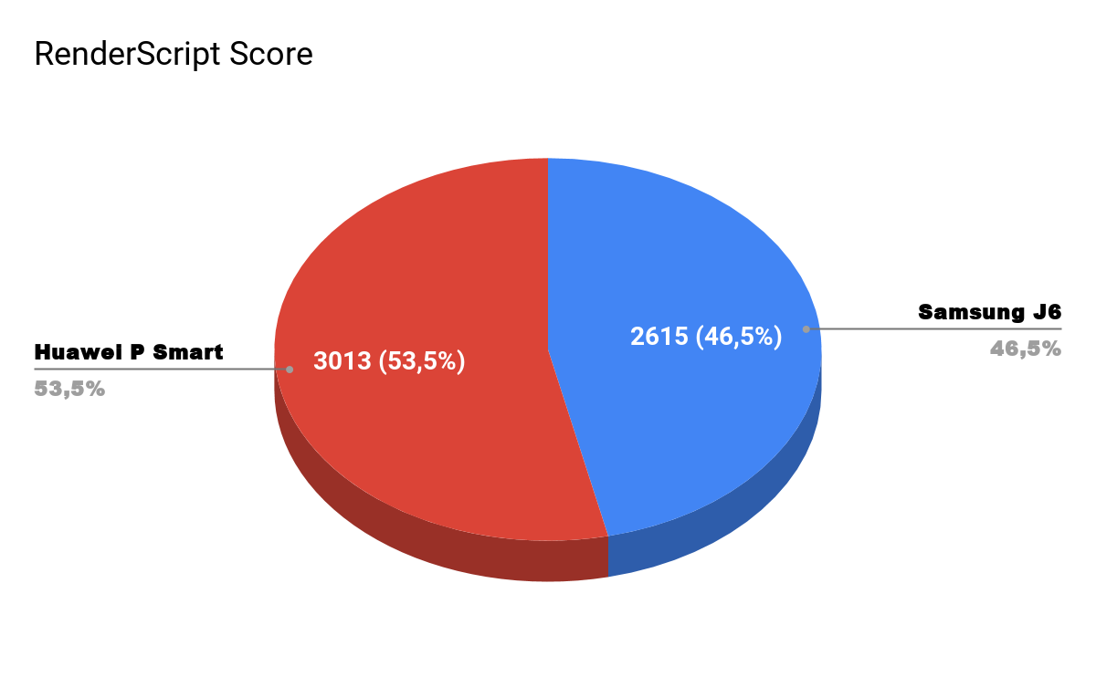

The **Samsung Galaxy J6 (2018)** mobile phone test scored 2615 points. This is due to the use of a Samsung Exynos 7 Octa 7870 chipset, having an ARM Cortex-A53 main processor with 64-bit architecture and the ARM Mali-T830 MP2 graphics processor.

The test of the **Huawei P Smart** mobile phone scored 3013 points. This is due to the use of a Huawei HiSilicon KIRIN 659 chipset, having a main processor 4x 2.36 GHz ARM Cortex-A53, 4x 1.7 GHz ARM Cortex-A53 with 64 bit architecture and the ARM Mali-T830 MP2 graphics processor.

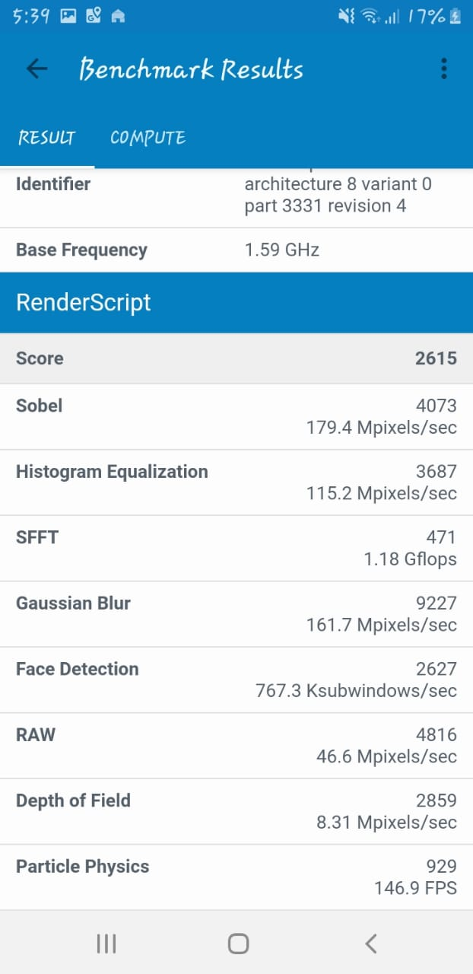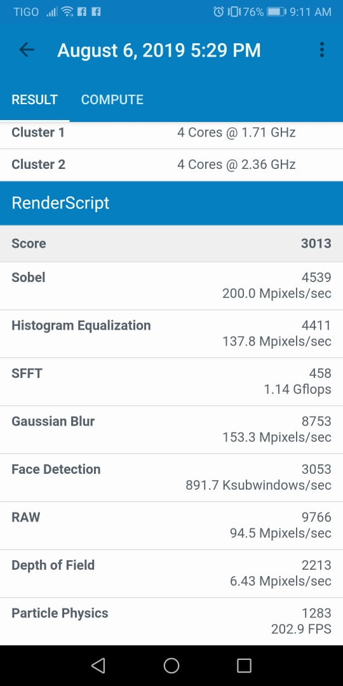

*In the images we can see the difference in score of each cell, giving the Huawei P Smart a great advantage over the Samsung J6.*

**Using AnTuTu**

First, we compared the RAM capabilities and saw that the Huawei P Smart has greater capacity than the Samsung J6, 3 Gigas and 2 Gigas respectively. From this perspective, the conclusion was that the performance and speed of running applications would be much higher for the Huawei P Smart compared to the Galaxy J6.

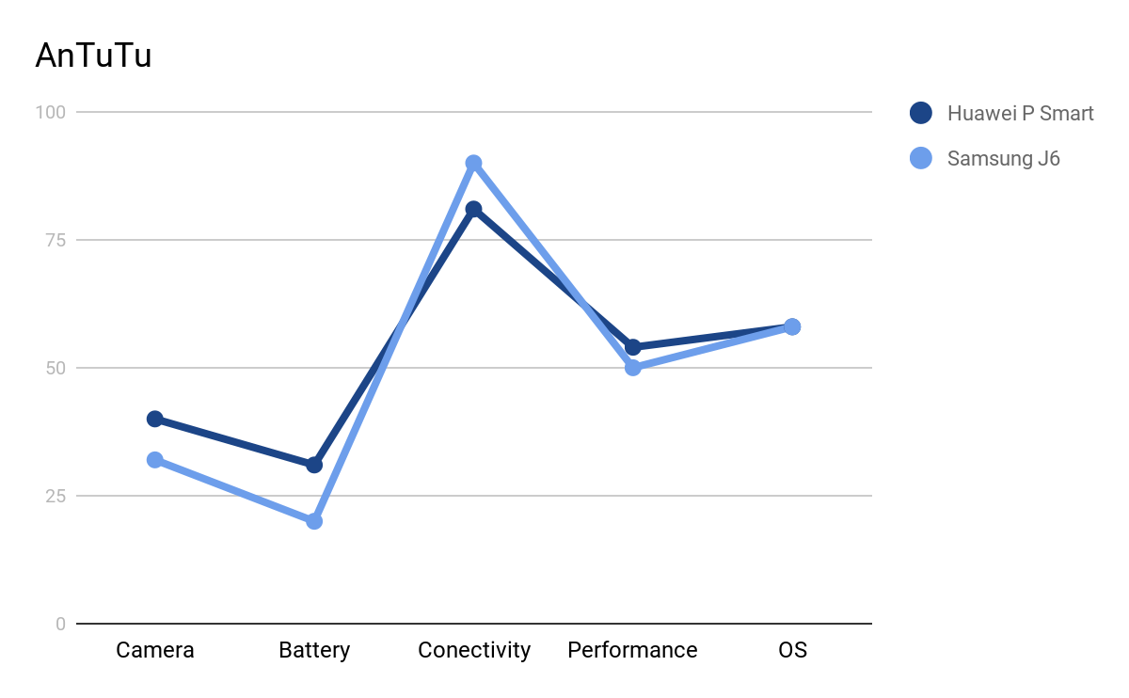

Secondly, we compare the processor speeds, although these speeds are very different, for the Huawei 2.6GHz while for the Galaxy J6 1.6GHz, then we notice that there is a significant difference, so it would be unfair to compare the two smartphones from this perspective, for this reason we could say that the best performance would be the Huawei P Smart.

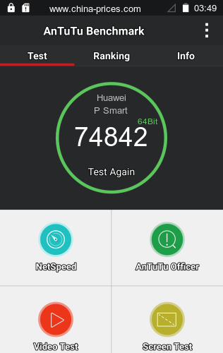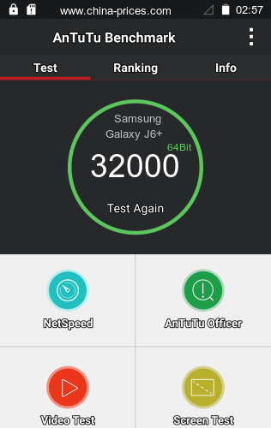

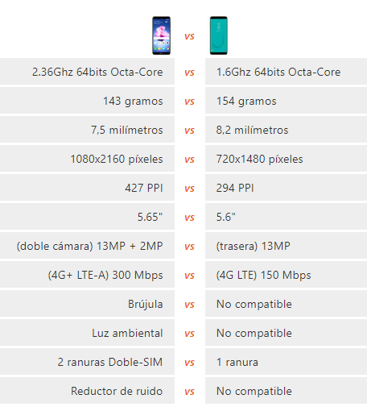

On the other hand we notice that in GPU the two smartphones have the same specification, as well as the same operating system, although things like screen resolution and display change. All these characteristics seen only by box specifications led us to take these conclusions. However, the experience of using the phones also helped a lot to make this decision.

## Referencias

AnTuTu Benchmark - Know Your Android Better. (2019). Retrieved 8 August 2019, from http://www.antutu.com/en/index.htm

Geekbench 4 - Cross-Platform Benchmark. (2019). Retrieved 8 August 2019, from https://www.geekbench.com/

Huawei P Smart vs Samsung Galaxy J6. (2019). Retrieved 8 August 2019, from https://www.movilcelular.es/comparar/moviles/huawei-p-smart-fig-lx3-vs-samsung-galaxy-j6-sm-j600f/8260069