**CS544 Module 2 Assignment**

Abraham Cepeda Oseguera

U75425818

Boston University

MET CS 544: Foundations of Analytics and Data Visualization

Professor Hong Pan

October 21, 2022

**Part 1**

1. **What is the probability that a randomly selected person in this survey will have a BMI of above 30?**
   1. 36.17%
2. **If a randomly selected person had a BMI of above 30, what is the probability of that person being in the age group 18-34 years?**
   1. 29.36%
3. **If a randomly selected person had a BMI of above 30, what is the probability of that person being in the age group 35-49 years?** 
   1. 47.28%
4. **If a randomly selected person had a BMI of above 30, what is the probability of that person being in the age group 50-64 years?** 
   1. 18.14%
5. **If a randomly selected person had a BMI of above 30, what is the probability of that person being in the 65 years & over?**
   1. 5.23%

**Part 2**

1. **The sum of the rolls is greater than 6 but less than 10**

1. **All the three rolls are identical.**

1. **Only two of the three rolls are identical.**

1. **None of the three rolls are identical.**

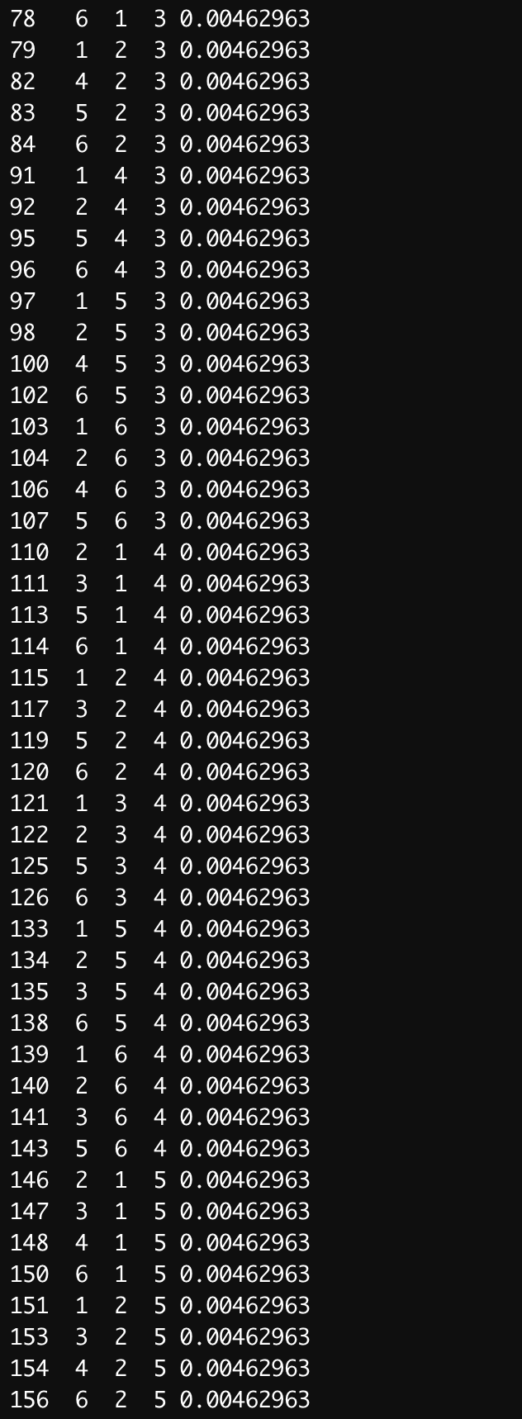

1. **Only two of the three rolls are identical given that the sum of the rolls is greater than 9.**

**Part 3**

1. **Using a for loop or a while loop, write your own R function, sum_of_first_N_odd_squares (n)**

1. **Without using a for loop or a while loop, write your own R function, sum_of_first_N_odd_squares_V2 (n)**

